Sunila Khan: 1813037
Lecturer: Ernest Ovia
BMSK 5001: Developing Workplace Critical Thinking
Date: 24 July 2020

Content list

Table of Contents
Introduction 3
Section 1: 3
What are Values 3
What is Belief 3
What are Attitudes 3
Personal Beliefs, Values and Attitude 4
Impact on Personal Values, Beliefs and Attitude in Workplace 5
Section 2 6
X and Y Management Theory 6
Theory X 6
Theory Y 7
Difference Between Theory X and Theory Y 7
Theory X and Y in Workplace 8
Amazon 8
Theory X Cons 8
Google 9
Theory Y Pros 9
Theory Y cons 9
Theory X and Y Management Style 10
Values of Theory X and Y in Morden Days 10
Opinion About Theory 10
Section 3: 10
Critical Thinking 11
Inductive and deductive reasoning 11
Red Model 12
Core Values 12
Conclusion 13
Reference List/Bibliography 14

Introduction
This report highlights values, beliefs and attitude. It briefly discusses how individual values and belief impact on our work life and gives examples and recommendations about values.
The report discusses management theory which is theory X and theory Y and the pros and cons of the theory and discuss about benefits and their impact on individual and organisations. Report highlighted how theory used for olden days and modern days and discuss what is the value of the theory nowadays. Report is also highlighted personal critical thought development through the module. How critical thinking help us to make our difficult decision. Finally explain red model inductive and deductive reasoning some explanation about core value.

Section 1:

What are Values
Values is something important for us. Everyone values are different, but some common values are family, friends, religious, education, money, food, house, respect etc. It is all depend on our circumstances, lifestyle and our decision which we make in our life. Values help us to find our purpose and give us a clear picture what kind of things is most important to us. Values help to make a right decision. Values impact our behaviour. Values give us motivation. “Values are socially approved desires and goals that are internalized through the process of conditioning, learning or socialization and that become subjective preferences, standards, and aspirations.” (IEduNote 2017)

What is Belief
Beliefs definition is your thinking to be true. Belief is depending our personal principal values or matter of faith. Beliefs come from different sources like personal experience or culture, religion. Belief is depending personal circumstances. Every person has a different belief, values depends on their circumstances.

What are Attitudes
Attitude is words, thoughts, and action influence by values and beliefs. Attitude is evaluating things in different way like decision making, problem solving or issues. Attitude come from experience or observations. It is a way you express your thought because of your values and belief. Attitude is related from belief and value. Something value to your belief and belief in value decide your attitude.

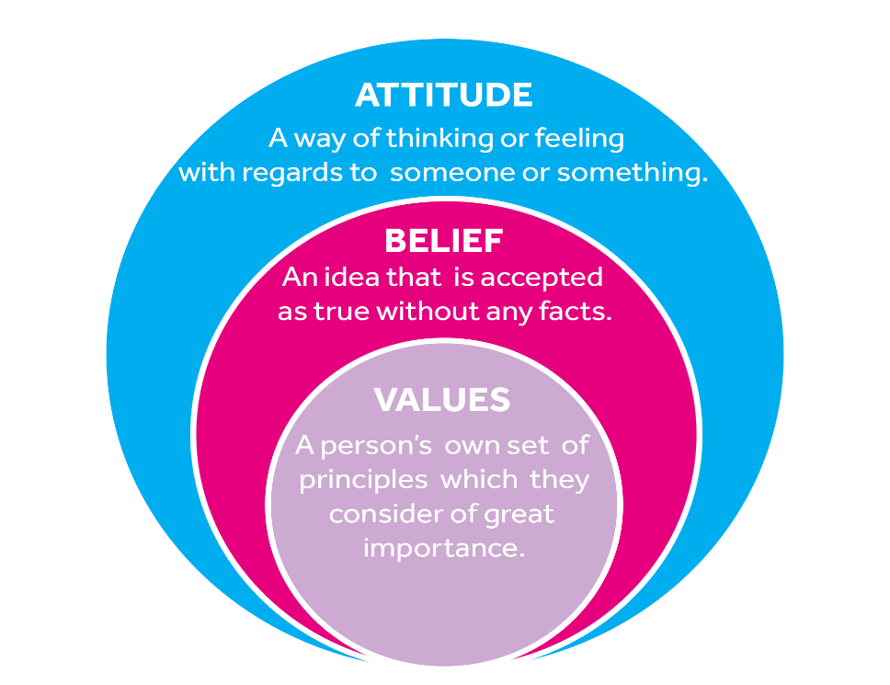

(Source: University of reading 2020)
Some Examples
Values | Beliefs | Attitude
- Education.  - Personal growth  - Family | - Education improve your self-personality and help to get wiser.  - Get the degree  - Love, connection, support | - Everyone should learn new and different skills.  - Finding a better job  - Always keep in touch

Personal Beliefs, Values and Attitude
As a human being we all have different interest, hobbies, habits to each other. It is all depend how we experience the life and, in our lifestyle, way we are thinking, our upbringing and how we view the world. Depending how these values are used as a personal and professional life and how it is impacts in our lifestyle. For example, when I went to work, I always dress smart. In my point of view when we dressed smart, we think smart, we act smart, it is also impact in workplace good. Our managers and co-workers have a positive opinion about us.
According to Peluchette, Karl and Rust, (2006), “The value like you dress smart the impact of attire on workplace and outcomes will be better. Your effort and planning involved in dressing appropriately for workplace, give us a chance to have a better career like promotion. Dress up smart made you feel happy, however impression to the management and other workplace colleague is admirable.”
Another example, some time in workplace because of negativity atmosphere, or the pressure of the work we are feeling low, feeling anxious and anxiety, whenever I feel anxiety in my workplace, I recite some of the chapter in book holy book, (Quran), which make me feel better and help my anxiety level go down. This is my belief toward to the Quran and impact of Quran is so powerful.
According to Mottaghi, Esmaili, and Rohani “There are several medical and non-medical method to reduce people anxiety. One of the most important non-medical procedure is Quran. Holy book Quran is the most beautiful reciting that can be used to reduce anxiety.

Impact on Personal Values, Beliefs and Attitude in Workplace
Personal values, beliefs and attitude, they give us a huge impact in workplace sometimes negative and sometimes positive but it all up to us how we carry our believes and attitude in workplace because everyone is different they have their own values and attitude we have to respect other values and attitude in workplace to maintain positivity in work place and avoid any conflicts.
“personal values have an impact on our interest, choice and particular types of work and organisation. Values determine how we interact with other people values may or may not match your values, but we must respect everyone value. (The Open University 2015)
These are some of the list in my values, beliefs and attitude:
- Time management.
- Freedom
- Honesty
- Teamwork
- Family
- Religion
- Flexibility
Time management is value for me. If I work overtime and spend lots of time in the workplace and pick up extra shifts, looks good in my workplace but in my family lifestyle it effects negative. My work point of view looks good on me to comes on time to do some extra work for them but for my family members not good for them. I cannot be able to spend the quality time with them, so time impact of my life positive and negative both ways.
According to Morgan, (2017) (page no 57) “Prioritisation is the act of deciding which actives to undertake or which goals to aim for at the expense of less important goals and activities.
Freedom is another value of mine. I like to work freely. It is making me feel better, think better, motivate and committed to my work. If management keep inspection me all the time it effects on my work performance and productivity because I feel nervous and panic.
“If organizations may let employee set their own schedules and choose how to do their work the results of the freely work are impressive. Potential benefits are including greater employee commitment, better performance, improved productivity and lower turnover.” (Business News Daily 2020)
I also believe work as a teamwork. As teamwork we get better ideas, job done quickly, better performance, new inventions, problem solving and decision making. If I work in my workplace as a team, I work better, and I learnt from others which gives me positive impact of my work and experience. Also benefit good way to communicate with other peoples. To get the better results, we need a good understanding of each other team.
According to Delarue, Hootegem, Procter, and Burridge, (2008) “The review shows that teamworking has a positive impact of organizational performance and outcome.”

Section 2

X and Y Management Theory
X and Y theory was introduced by Douglas McGregor in 1960. Douglas McGregor was management professor in M.I.T Sloan school of management and president of Antioch college (1948-1954). It is a theory of motivation used in organisation to motivate the employees for the better performance. Theory used in olden days and modern days to achieve their goals. McGregor explained the theory X and Y psychological view of humankind, basically he applied two sets of assumptions to give ideas of two types of workers and two types of management styles to run the organization.
“Douglas McGregor formulated Theory X and Theory Y based on two parts of human behaviour at work, or in other words, two different views of individuals (employees): one of which is negative, called as Theory X and the other is positive, so called as Theory Y. According to McGregor, the perception of managers on the nature of individuals is based on various assumptions.” (Management Study Guide 2020)

Theory X
Theory X describe people does not like work and do not like take responsibility because of organisational achievement and fulfil management requirements employee need to control the system by punishment to match the organizational goal.
According to McGregor (1960) “Because of this human nature they do not like work, that is the reason people need to be controlled, directed, and threatened with punishment to meet the criteria toward the achievement of organisational objectives.”

Theory Y
Theory Y is about employee freedom and freely to work in workplaces without any pressure. Theory Y is about work is like rest and play. If employee mentally healthy, they will be providing better performance and more involvement into the work activities. People who take responsibilities individually, these kinds of people more motivate to their work and always work hard.
According to Mohamed, and Nor, (2013) “Theory Y is explaining that employees must be forced to do what management want and that they will not be beneficial for the company for the long terms. People cannot work in stressful environment. Theory Y states that employees become more productive when more trust and responsibility is delegated to them. however, if give them to more opportunity they will seek more responsibility and will be more productive.”

Difference Between Theory X and Theory Y

Theory X | Theory Y
- Employee does not like their work.  - Less interest.  - Employee do not like responsibilities.  - Demotivate factors.  - Forced to work.  - Strictly supervised.  - Not ambitious.  - One-way communication.  - Short tempers and loud management.  - Poor management  - Zero concern about staff welfare. | - Employees happy to take responsibilities.  - More motivation factors involved.  - Teamwork.  - More involvement to their job.  - Problem solving and decision-making skill.  - Accept all challenging work.  - Open minded and friendly management.  - Give chance to people to personal growth.  - Freely to think.  - More productivity.

Theory X and Y in Workplace
Most of the managers like theory X and theory Y bit of both, but some situation, managers apply only theory X and some are applied only theory Y

Amazon
Amazon is the biggest well-known store in modern days. Company start to begin by 1995 in July. They used theory X most rather than theory Y. Employees of the Amazon treated like a slave in the company. People have long hours shift pattern. Employees of Amazon are not allowed to socialise because of work burden. The treatment of Amazon employees is bad, depending on personal issues as well. Night shift is like a nightmare for the workers. Employees have long hours and many tasks and responsibilities to get the job done. Pressure level is too high for the employees and it is affecting their mental health. Even Amazon have no sympathy for pregnant women workers.
According to Hadas, (2015) “Amazon distinction is to take both theories to their extreme. On the Y side, such leadership principles as “hire and develop the best” and “never settle” show that employees are expected to be exceptional. On the other, executives mostly live in the intensity of an extreme X-world. They are constantly monitored and evaluated. Big carrots of money and respect alternate with frightful sticks of shame and dismissal.”

Theory X Pros
- Work can be done on time.
- No time wastes.
- Management take more responsibilities.

Theory X Cons
- Limited time.
- Strict management.
- Robotic treatment to the employees.
- Rest not allowed.
- All the time supervision.
- Less communicate to the management.
- Poor job satisfaction.
- Staff turnover.
- Health and safety to be ignored.
- Less communication.
- Pressure becomes toxic.
- Not appreciate work

Google
Google is a well-known worldwide company. It is known as an international company in modern days Google have over 40 offices in more than 40 countries and lots of customer care base office to help their costumer. Google employees are from different backgrounds, race and religion. They use theory Y in their organisation to motivate the employees and they also use famous Herzberg’s two factor theories which is based on hygienic factors and motivation factors. According to Alshmemri, Shahwan-Akl and Maude, (2017) “The concept of the theory based on motivation factors and hygiene factors. Hygiene factors are considered less important to job satisfaction than motivation factors.”
Google employee freely to work, freely to think and work in happy environment place. Google management always admire new talent in the company. They happy to welcome new people with their unique ideas. Google give many benefits to their staff to increase the productivity. Google provide several benefits their workers and team members to maintain the sensibility.
“Google has provided an awesome working place and benefits to their staff to keep them motivate. Google Inc has applied the fun and laughter at workplace. For example, Google Inc. has prepared fun stuff around the office, including bocce ball courts, bowling alleys, and a giant climbing wall. Furthermore, the pool tables and video games also available in many places for the staff to use. They also provide free meal for their staffs. Google also set a room which provides massage chairs for the employee’s relaxations uses. (Essays UK 2018)

Theory Y Pros
- Employee love and enjoy their work.
- Commitment.
- Motivation.
- Innovation.
- Time flexibility.
- Better problem solving and decision making.
- Better customer service.
- Responsible staff.
- Can do attitude.
- Built trust between managers and staff.

Theory Y cons
- Lazy management.
- Environment is not good for every employee.
- Less supervision.
- Time waste elements.

Theory X and Y Management Style
No one likes to work in full of pressure and stressful atmosphere. Theory X management style is so harsh, and their behaviour is so rude towards to the employees. compared to both theories theory Y management style is more appropriate tool to use in management department, that way employees and managers built a strong relationship in workplace. Happy environment brings positive vibes into the workplace. Both department, employees and managers they can achieved their goal successfully to apply theory Y. “Many managers apply theory X in their organization and generally get poor results. If they apply theory Y it is produces better performance, result and allows people to grow and develop.” (Business Ball 2019)

Values of Theory X and Y in Morden Days
In modern days most of the organizations prefer theory Y rather than theory X. But in olden days they used theory X most of the time. Olden days employee has no rights. For example, Illness is not allowed. Managers do not care about their health and safety. That time human welfare resources and labour unions was not applied to the organization. Employees have no job security. Managers used employee as a slave and robot. But now in modern days employee have lots of rights, unions social workers maybe that is a one reason they used theory Y most.

Opinion About Theory
In my point of view theory Y is better than theory X but sometimes we must balance both side of theories because of situations and circumstance. It is not necessary we used things in extreme level to maintain the balance. In some cases, managers must use theory x because some people need some extra push to work hard and they need to be supervision otherwise they become lazy, but in some organizations we cannot use theory X at all. For example, in health care departments, hospitals, school etc.
Overall theory Y is more convenient to me. If people are happy, they act happy, they behaved happy and they give better performance. If people are stress, we cannot force them to be involved to the task because unhappy people do not meet the criteria of organization. stress is affecting their brain and job performance. Unhappy employees not good for the long terms is well. I personally believe humanity is first rather than being horrible and nasty. We all human end of the day.
According to Wesarat, Sharif, and Abdul Majid (2014). “Happiness at the workplace is improving productivity in any organization. Happy people are more productive people while those people who are unhappy may not pay full attention to any task and unhappy people does not maintain long term sustain productivity.”

Section 3:
Throughout this module my critical thinking is improved very much. I learned new stuff and experience new things, which change my way of thinking. these are some example which I learned from Moodle:

Critical Thinking
In our daily routine system, we make our decision on daily basis some decision is small, and some are big. Using one technique is critical thinking which improves the way we are thinking and give us a clear idea to make a good decision. There are many ways to approaching critical thinking to help us solve a problem. Examples are:
- Decide what you are looking for.
- Gather your information.
- Apply the information you gattered.
- Keep in mind short term and long term.
- Observe other points of view.
I learned this module critical thinking which is useful for me very much. Whenever I feel stuck on my decision, I think critically to solve the problem. It helps me in my day to day activities and in my workplace
According to Brookfield, (1987) “Developing critical thinkers has three central aims. The first is research to help understand critical thinking and observe people action the second aim is to examine the various methods, techniques, and approaches and third one is aim to explore the opportunities.”

Inductive and deductive reasoning
I also learned inductive and deductive reasoning which give me an idea it is not necessary our conclusion is all the time right. Sometime our argument is right, but conclusion is not right but sometime our argument is not accurate, but conclusion is realistic. This technique helps me to think more critically.

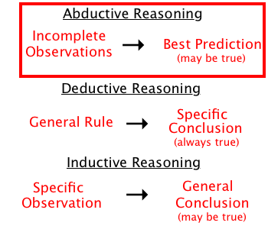
(Source: Dudovskiy 2019)

Red Model
Through the module, I learn red model which help me to think critically in areas such as problem solving, decision making, time management, planning and manage things. Red model defines as think logically using approach to evaluate the argument focus on conclusion with the relevant information. Red model based on Over 80-year research and after that they identify three keys to think critically which called red model.

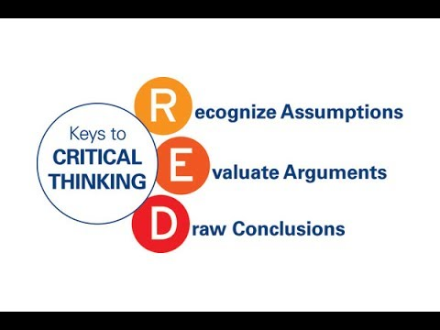

(Source: Air university 2019)

Core Values
I learned about core values in this module and whenever I feel stuck to difficult situation the core value helps me to decide. Specially time of stress, I keep in mind my core values which helped me to problem solving. Core value give me a guidance in my daily routine. It is providing me a description of my behaviour and give me a quick result. I can decide more easily what thing are wrongs or which things are right for me.
According to Mindtool (2020) “Core values are the guiding principles that are most important to you about the way that you make decision. Core values deeply held principles to choose between right and wrong and they help you make important decisions and career choices.”

Conclusion
In this report I found everyone have their own beliefs, value and attitude, but as human being we must respect each other values. Our values help us to decide and it is impacting our beliefs and attitude. In this report I found we must respect each other values to get better result, better performance and improve productivity.
I also found management theory which is called theory X and theory Y. Theory based on two style of management and employees. Theory Y is about to give employees a chance to work and think freely without any stress. Employees can share their ideas with the organisation, and they communicate with management direct. Theory X is based on harsh rules. Managements do not care about employees. They treated them as a machine. Some strictly rules of time management.
In this report my recommendation is critical thinking has helped us so much in our day by day decisions. It is giving us better solution to make our decision easy. I also find core values, red model and management theories which help us so much to improve our thinking.

Reference List/Bibliography

Alshmemri, M., Shahwan-Akl, L. and Maude, P., 2017. Herzberg’s two-factor theory. Life Science Journal, 14(5), pp.12-16. [Accessed 18 July 2020]
Air university 2019. Available at: https://www.google.com/search?q=red+model+critical+thinking&tbm (Accessed 22 July 2020)
Business ball 2019 [online] Available at https://www.businessballs.com/improving-workplace-performance/mcgregors-xy-theory-of-management/ [Accessed 18 July 2020]
Brookfield, S.D., 1987. Developing critical thinkers: Challenging adults to explore alternative ways of thinking and acting. Jossey-Bass.
Business News Daily 2020. Employee Freedom Breeds Loyalty and Commitment. [online] Business News Daily. Available at: <https://www.businessnewsdaily.com/609-employee-freedom-breeds-loyalty-commitment.html> [Accessed 20 July 2020].
Dudovskiy, J., 2019. Available at: https://www.google.com/search?q=inductive+and+deductive+reasoning&tbm (Accessed 21 July 2020)
Delarue, A., Van Hootegem, G., Procter, S. and Burridge, M., 2008. Teamworking and organizational performance: a review of survey‐based research. International Journal of Management Reviews, 10(2), pp.127-148.
Essays, UK. (November 2018). Google Company Motivation Theory. Retrieved from https://www.ukessays.com/essays/business/the-two-factor-theory-of-frederick-herzberg-business-essay.php?vref=1 [Accessed 16 July 2020].
Hadas, e., 2015. Edward Hadas: Amazon’s Ultra-XY Management Style. [online] breakingviews.com. Available at: <https://www.breakingviews.com/columns/edward-hadas-amazons-ultra-xy-management-style/> [Accessed 16 July 2020].
iEduNote.com. 2017. Values: Definition, Characteristics, Importance, Types of Values. [online] Available at: <https://www.iedunote.com/values> [Accessed 19 July 2020].
Managementstudyguide.com. 2020. Theory X and Theory Y. [online] Available at: <https://www.managementstudyguide.com/theory-x-y-motivation.htm> [Accessed 14 July 2020].
McGregor, D., 1960. Theory X and theory Y. Organization theory, 358, p.374. [Accessed 1 July 2020]
Mindtools.com. 2020. Understanding Workplace Values: ― Finding the Best Cultural Fit. [online] Available at: <https://www.mindtools.com/pages/article/understanding-workplace-values.htm> [Accessed 20 July 2020].
Mottaghi, M. E., R. Esmaili, and Z. Rohani. "Effect of Quran recitation on the level of anxiety in athletics." Quarterly of Quran & Medicine 1, no. 1 (2011): 1-4.
Morgan, P. (2017) The business student’s guide to study and employability (page 57)
Mohamed, R.K.M.H. and Nor, C.S.M., 2013. The relationship between McGregor's XY theory management style and fulfilment of psychological contract: A literature review. International Journal of Academic Research in Business and Social Sciences, 3(5), p.715. [Accessed 18 July 2020]
Open.edu. 2015. Week 2: Values and Beliefs: View as Single Page. [online] Available at: <https://www.open.edu/openlearn/ocw/mod/oucontent/view.php?id=21013&printable=1> [Accessed 19 July 2020].
Peluchette, J.V., Karl, K. and Rust, K., 2006. Dressing to impress: Beliefs and attitudes regarding workplace attire. Journal of Business and Psychology, 21(1), pp.45-63. [Accessed 19 July 2020]
University of reading 2020. Available at : https://www.google.com/search?q=attitude+beliefs+and+values&tbm (Accessed 20 July 2020)
Wesarat, P.O., Sharif, M.Y. and Abdul Majid, A.H., 2014. A conceptual framework of happiness at the workplace. Asian Social Science, 11(2), pp.78-88. [Accessed 18 July 2020]

