University of Wales. Trinity Saint David

Student: Gyula Andras Zelend - 1814617
Lecturer: Mr Md Kalam

Training and Development needs of HR

Presentation
Slides:
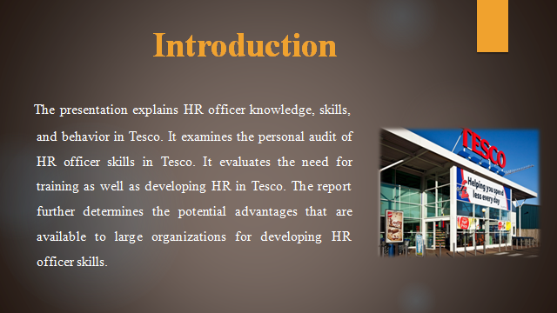
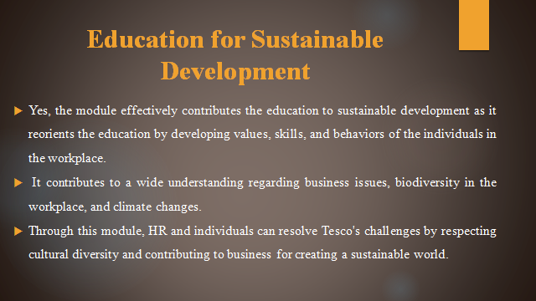
ESD usually promotes the knowledge, action, skills, and values development for creating a sustainable workplace in the business that ensures surrounding protection by promoting social equity and encouraging economic sustainability (Swart, 2010). This module is ESD oriented as it stimulates questions, analyzes business requirements and HR thinks is critical for making good decisions.
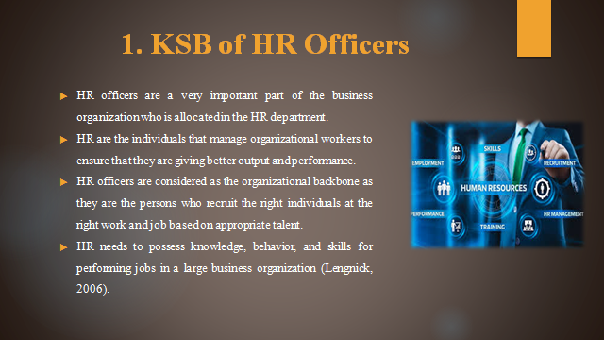
HR officers in Tesco need to confront themselves with major challenges that are required for minimizing to come out as achievers. HR can demonstrate responsible and professional behaviors to workers and Tesco. If any obstacle arises in the Tesco workplace then they have skills for handling such situations and issues. Negotiation as well as liaison is considered important HR functions in Tesco for maintaining professional behaviors. Tesco expects certain skills, behaviors, and knowledge of HR in the workplace. HR professionals focus on planning, directing, and then managing workers' activities for better performance and results of Tesco. Knowledge, as well as efficiency, is helpful for HR offices in Tesco to complete tasks within a certain time frame. While working in Tesco, HR needs to have basic knowledge regarding workers and corporate because only theoretical knowledge is not sufficient (Latham, 2011).
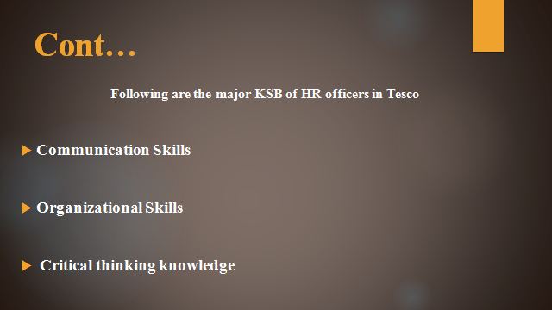
Communication skills: The major function of HR includes the facilitation of appropriate discussion among Tesco employers and employees. If HR does not communicate properly then they will not achieve success because of oral as well as written sills relay Tesco information in an effective way. It also gives an edge to HR for resolving conflict in Tesco's workplace. This is very important for negotiating workplace solutions by keeping things on track.
Organizational skills: HR skills management and development is the juggling act for Tesco. Effective skills help HR to manage the workplace structure of Tesco very effectively. They cultivate the workplace of Tesco where the workforce can work together for improving organizational performance.
Critical thinking knowledge: HR professionals have knowledge and skills of thinking in a critical way that bridges skill analyzes of workers in Tesco. They balance complex issues in Tesco's workplace by critical solutions. HR come from depth as well as the depth of the numerous background and experiences (Kase, 2009).
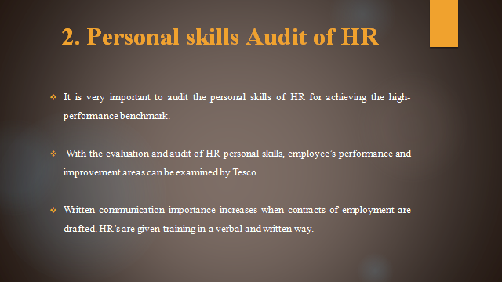
The skills audit helpful to me to analyze my skills and knowledge that is important for HR such as communication skills, problem-solving, and decision-makers. I also focus on getting better analytical that helps to analyze the several problems of the firm. Continuous assessing the knowledge and skills is helpful within an organization and it also helps to develop employee careers and improve the retention rates (Swart, 2010).
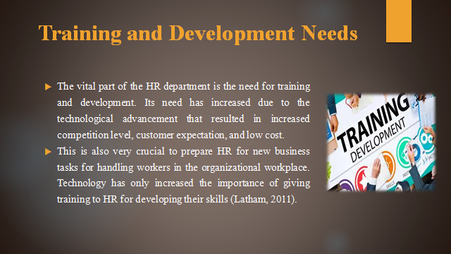
Training is crucial as it develops the HR progress that motivates them to work in Tesco business organization apart from money aspects. HR requires training regarding market trends and employment policy changes. Training and Development have become an important part of performance management in the Tesco workplace that takes place when a change in technology happens based on new strategies, changes resources, and manpower. Training and development usually improve the skills of HR by increasing Tesco's performance.

Address weakness: Every HR in the business organization is weak at certain knowledge and skills that need to be addressed. HR skills can be improved and enhanced with training by hiring and assigning them tasks. With training and development, HR stands out to the expectations of the Tesco business organization.
Improve performance: When HR gets the desired skills they need tasks for executive their knowledge. This execution helps training turns their weak points into strengths that help in better understanding the organizational and workers' aspect by significantly executing innovative ideas.
Enhance satisfaction: When HR gets appropriate skills as well as knowledge through training and development, they become and feel confident. It is important to train and develop HR so that they can effectively perform an organizational task by innovative new strategic options for executing a particular task. This often builds satisfaction levels among workers.
Reduce turnover: Training and developing HR also reduces organizational time and money. Once the HR gets appropriate knowledge then they can provide immense revenue to the Tesco. This reduces the frustration level among HR and organization. As experts bring quality work by develop organizational through adequate training.
Foster Growth: HR growth can be achieved if organizations pay an equal kind of attention to development. With training and development, HR gets ambitious to handle any business hurdle and situation. By giving training, HR gets the space for growth through learning (Grunig, 2013).
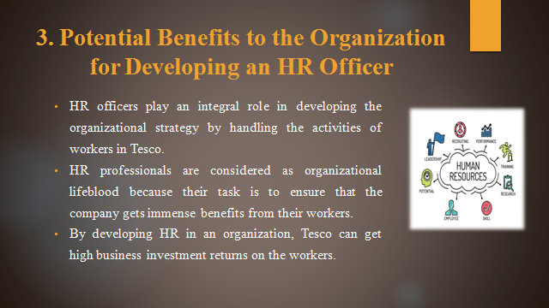
I will appreciate the training helps to build new skills, improve their job performance and potentially towards the more challenging roles and also values through employee from all ages groups as successful business performance. Effective communication skills are also importance through digital workforce helpful to experience of all employees. Tesco Company also focus on high tech training and development classes for employee that help to increase their knowledge and skills.

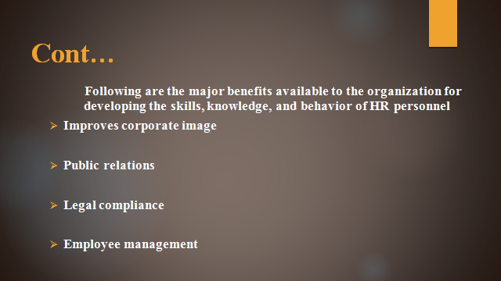
Improves corporate image:
Business organization wants to improve their picture in the marketplace. HR training and development can improve the corporate image as with this they can balance the qualified applicants by selecting and retaining talented workers.
Public relations: Every business organization establishes itself as a contender for building public relations. By developing HR, an organization can make them arrange business seminars, meetings for complying with the strategy to get success in comparison to competitors in the target market (Grunig, 2013).
Legal compliance: They are considered as labor laws that are major HR responsibility. When HR skills are developed then they can give appropriate information regarding state and union laws based on break time, overtime, minimum wages, and discrimination aspects. The business organization gets tune with the changes in government regulations and legislations by developing HR officers.
Employee management: Developing HR in Tesco helps them to maintain the satisfaction of workers by engaging them and maintaining an appropriate atmosphere in the workplace. When HR knowledge and skills are properly developed then can effectively look after employee incentive and benefits that help increase organizational productivity. Because satisfied workers give more output and return to the organization.



