

Database Systems
(ACCA7002)

Data storage investigation

Name: Zhao Weiyu
Student code: 2203629
Tutor: Dr Stephen Hole
Department: Software Engineering

Summary
In today's human society, there is a huge amount of data and information generated every moment, which not only reaches a certain level of quantity, but also has a wide variety of information, which needs to be stored and managed in a timely and effective manner. Since its introduction in the 1980s, relational databases have become the mainstream database system of the day. However, with the rapid changes in the information age, the volume of data and the increase in data types, relational databases will have a series of problems such as inefficient access and poor scalability. So far, the application of relational databases in certain domain scenarios is no longer so efficient. Non-relational databases (NoSQL) have emerged. NoSQL databases are rich in data models and easily scalable; NoSQL has the advantage of being able to "cope" with the problems associated with very large scale and diverse data types.
This paper firstly introduces the theoretical basis and classification of NoSQL in detail, and highlights the advantages and application scenarios of NoSQL in comparison with relational databases. Afterwards, by designing a simple test with PostgreSQL representing a relational database and Mongo DB representing a non-relational database, the difference between relational and non-relational databases is visually demonstrated from the perspective of time consumption. The reasons for this are also analyzed.

Content

1. Introduction 5
2. NoSQL 6
2.1 CAP 7
2.2 BASE 8
3. NoSQL Types 9
3.1 Column-family 10
3.2 Key-value 10
3.3 Document 11
3.4 Graph databases 12
4. NoSQL Benefits 13
5. Application Scenarios 14
6. Simple performance tests 15
6.1 Data models 16
6.2 Insert test 17
6.3 Query test 18
7. Reference 22

- Introduction
Relational databases are database systems that support the relational model and have grown over the decades since their inception, becoming more mature and widely used in various industries because of their ease of understanding, simplicity of operation and ease of maintenance[1].
But with the development of the Internet, Web 2.0 was born. In the age of Web 2.0, users have replaced website staff as the main creators of website content, and the frequent sharing and communication between users has led to a dramatic increase in the amount of data on websites, and the types of data on websites have become richer and more uncontrollable[2]. The structured system of traditional relational databases has become increasingly ineffective. Relational databases are facing unprecedented challenges. For example:
Frequent write requests: Websites like Facebook and Sina Weibo dynamically generate large amounts of data from users every day, and when relational databases are faced with frequent write data operation requests, their efficiency can drop dramatically or even become unbearable.
Massive data access requests: Querying is a critical application for users, and when users perform query operations in huge database tables, the response time will not be able to meet the needs of users.
Data diversity expansion needs: Relational databases require data models to be designed in advance and table structures to be defined in advance for the storage of data, while the data generated by the user-led generation of data Web 2.0 sites are often semi-structured or unstructured data, facing the diversity of data, the expansion needs of relational database has encountered a bottleneck.
To solve these above problems, non-relational databases (NoSQL) are starting to attract much attention. Based on different data models, NoSQL can be roughly divided into Key-Value, Column, Document, Graph and Object databases. Each of these databases has its own characteristics and scope of application, but the common denominator for all types of NoSQL databases is that they do not have a fixed table structure, which is the biggest difference from relational databases.

- NoSQL
The two most accepted interpretations of NoSQL are "non-relational", meaning a database that is weakly “relational” as opposed to a relational database, and "not only SQL"[3], meaning not just structured query language, also as opposed to relational data[4]. It is well known that one of the features of relational databases is the use of structured query languages.
NoSQL databases are generally considered to be a simplification of relational databases; they are generally less "relational", meaning that there is no need to build a database model in advance and the database model structure can be modified at any time. The aim is to remove the constraints of the relational model in order to achieve powerful distributed deployment capabilities. At the same time, NoSQL databases are no longer based on ACID theory[5], but on the CAP theorem and BASE distribution theory[6], which reduces the requirements in data manipulation and only guarantees the consistency of the final data.
NoSQL databases generally provide distributed storage of data, unified management and maintenance of data tables, and the ability for fast distributed writes and simple queries, but generally do not directly support complex queries and processing of data.
2.1 CAP
CAP theorem contains three parts as follows[7]:
- Consistency: means that the database system can feed the updated data information back to the client after the successful execution of the operation to ensure the consistency of the data. In all concurrent systems, data consistency is a problem. For database operators, consistency refers to how the updated data is fed back to them in a timely manner after concurrent operations have taken place, and for database systems, consistency requires ensuring that the data modified by a series of operations is accurately stored in the system to ensure that the data is ultimately consistent.
- Availability: means that the database can receive and execute instructions in a timely manner to provide good service to the user after the database user has issued them.
- Partition Tolerance: means that when there is a failure problem such as network fluctuation or hardware damage in some partitions of the database, the distributed database can still work properly to provide consistency and availability of data.
For database systems, both relational and non-relational databases cannot satisfy all three elements of the CAP theorem at the same time, and can only be compatible with two of them. NoSQL databases can only satisfy two elements, Availability and Partition Tolerance, and are in AP mode.
2.2 BASE
Since the CAP theorem only defines problems such as after data operations are updated in a distributed storage database system, it does not clearly give a better solution to the trade-off between data consistency and availability. The BASE theory[8] therefore remedies these deficiencies in the CAP theorem by presenting a feasible solution to the trade-off between A and C.
The core of BASE theory is outlined as follows: even if strong consistency is not achieved, each application can rely on its own business characteristics and adopt an appropriate approach to achieve ultimate consistency.
- BA (Basically Available): Distributed database systems can sacrifice some of their availability to ensure that the core functions of the database can function properly in the event of unforeseen circumstances and failure problems.
- S (Soft state): It is an intermediate state of the database and this intermediate state allows for a certain time lag between hosts while not destroying the integrity of the data and the database system still operates normally.
- E (Eventual Consistent): requires the system data copies to be consistent eventually, without the need to guarantee data copy consistency in real time.

- NoSQL Types
There are four main types of common non-relational databases: column-family, key-value, document, and graph databases[9].
3.1 Column-family
Column-based stores store all data in columns as a stream. For any record, an index can quickly fetch the data on the column; column stores support row retrieval, but this requires fetching matching column values from each column and reconstituting the rows. This approach makes the system more scalable and makes operations simpler and more convenient. Column-based storage is well adapted for large volumes of data, a feature that is compatible with the relevant requirements needed for cloud computing. A typical example is Cassandra.
Take Cassandra as an example.
Storing data with Cassandra without having to define fields in advance allows you to add and remove fields at will while the system is running. Scaling system capacity with Cassandra can point new members directly to a server cluster without the need to restart, or migrate data. Lay out multi-data centre recognition with Cassandra, with each record replicated in a backup at the alternate data center. With Cassandra's distributed read and write capabilities, data can be read and written centrally at any time and from anywhere, without a single point of failure.
3.2 Key-value
A key-value pair is the simplest form of storage in a non-relational database.[10] It is a collection of keys and values, like a hash table in a data structure, where each key corresponds to a value, but it is worth noting that values can be stored in a variety of data types, such as a string, a number, or even other key-value encapsulated objects. A typical example is Redis.
Using Redis as an example.
The Redis system operates in memory, periodically outputting the database to the hard disk for storage through asynchronous operations. it can provide over 100,000 reads and writes per second, making it the fastest performing Key-Value database available. Redis supports operations on a wide range of data types, including Strings, Lists, Hashes, Sets and Ordered Sets. The maximum limit for a single value is 1GB, and Redis can perform a variety of functions, such as using a List as a FIFO bi-directional chain to implement a lightweight, high-performance message queue service, and it can also provide advanced functions such as sorting. Also, due to the nature of Redis, it cannot read or write fast to large amounts of data, as the capacity of Redis databases is limited by physical memory, so it is usually limited to high performance operations and computing on smaller amounts of data.
3.3 Document
Document storage is classified as either unstructured or semi-structured[11], where documents are used as the basic unit for storing data and information. Semi-structured documents have a specific storage file format, such as JOSN, and data can be embedded with keys, making the document stores database more efficient than the key-value database when dealing with more complex web data. These databases allow for fast querying of data in large volumes of data. A typical column is Mongo DB.
Mongo DB uses JSON-like BSON as the format for storing and transferring data[12]. BSON supports nested objects and arrays. It is distributed and supports storage of large amounts of data, while also offering strong read and write performance (independent of data volume). According to tests, when the data volume reaches 50GB or more, MongoDB is more than 10 times faster than MySQL in terms of access speed, and can handle 5000-15,000 read and write requests per second in the case of a database. Mongo DB cannot manage memory, it leaves the memory size to the operating system, and the memory usage must be monitored in the operating system while the system is running.
3.4 Graph databases
The problems that graph databases address are related to graphs and graph theories. Graph stores use the graph model and are characterized by their flexibility and their ability to support multiple server extensions. The graph store has three fields: nodes, relations and attributes, and is designed to provide users with a better way to manage complex, reticulated data.
Take Neo4j as an example.
Neo4j uses graphs to represent mapping relationships between entities, each entity is stored in a node of the database, and relationships are stored in edges in the form of directed graphs, usually entities and other relationships are stored in the network data structure of the database. This way, it is possible to efficiently find the connections between multiple nodes, starting from one node and working through the node-to-node relationships.

- NoSQL Benefits
The advantages of NoSQL database over traditional relational database are mainly reflected in the following aspects[13]:
- Flexible data storage structure: traditional relational databases can only store data by determining the relational structure in advance due to the relatively fixed table structure, which is poorly scalable. NoSQL databases have a variety of storage mechanisms, such as a rich variety of data types, which can store complex data including images, websites, etc., and on the other hand, variable table types, which can be modified at any time.
- High scalability: traditional relational databases are created and the table structure cannot be modified, making them extremely unscalable. NoSQL databases, however, support the addition or deletion of table structures at any time, allowing for scalability, and also support the management of large data volumes and multiple types of data storage.
- Low cost of deployment: most of the popular NoSQL is open source and free, which can be seen as a reflection of the 'spirit of the internet'. This means that the cost of using these software tools is low, encouraging users to try them out before making a choice.

5. Application Scenarios
NoSQL databases are typically used in the following scenarios.
- Management and query of large amounts of log data, business data or monitoring data.
For example, managing user access logs and transaction records for e-commerce websites, collecting and managing data collection and monitoring control system data from the Internet. This data is typically collected and accumulated on an ongoing basis and is therefore extremely voluminous. NoSQL uses a key-value pair, schema-free data model to handle this type of data, which is simpler.
- Simplification of special or complex data models.
The relationship between web pages and links on the Internet can be abstracted as a directed graph, and there is a class of "graph databases" in NoSQL databases that optimise this data structure.
- As a data warehouse, data mining system.
NoSQL databases do not usually have aggregation or data mining capabilities, but most data pre-processing and data mining tools support reading data from a variety of NoSQL databases. In particular, NoSQL databases may already store data evenly across multiple nodes, which makes parallel data mining relatively easy.

- Simple performance tests
The report selects PostgreSQL, a relational database, for a performance comparison with Mongo DB, a non-relational database.
The performance comparison includes both read and write parts, so tests were conducted using inserts and queries.
Insert part: 100, 1,000, 10,000 and 100,000 data are inserted into the user table to test the write speed respectively.
Query section: divided into complex and simple. Simple queries involve only one object type of data, complex queries involve multiple fields, join queries and aggregate functions.
There will be two simple queries, the first choosing to select the name of the user by the primary key; the second retrieving the name of the user by any of the non-primary key fields. In addition, there will be two complex queries, the first retrieving user information and all information about the book being traded; the second retrieving the number of users of a random book by its title.
6.1 Data models
The experimental data consists of three objects: users, assets and transaction information. Users buy assets through transactions, a user can own multiple assets and an asset can be bought by multiple users.
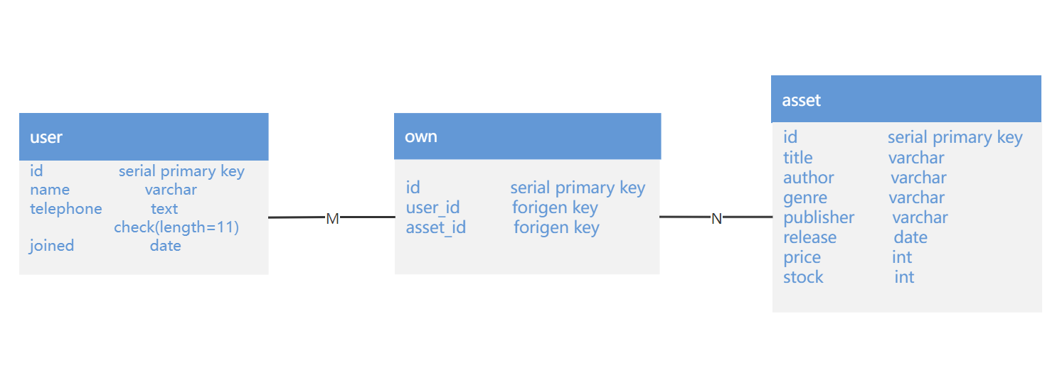
Figure1 PostgreSQL

Unlike relational databases, Mongo DB collections do not support multi-table queries and so need to be stored in other ways in Mongo DB. Mongo DB has two methods for representing relationships between data: referencing and embedding documents[14]. The relationships between stored data are referenced by links or references from one document to another. Applications can use these references to access related data. Reference is used here to store relationships between embodied objects.
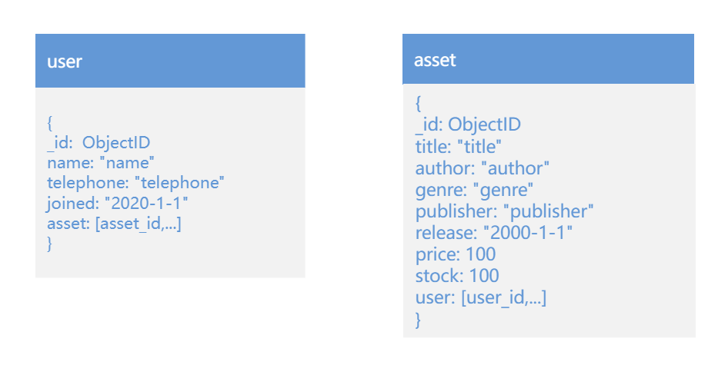
Figure2 Mongo DB

6.2 Insert test
The results of the test are put into a graph, shown in the figure, which shows the overall performance of the insertion, namely the average time taken to insert.
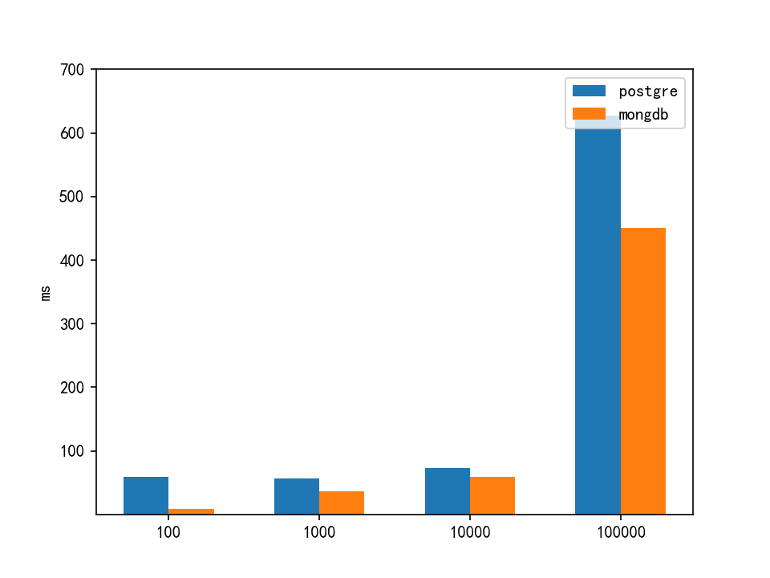
Figure3 Insert

The graph shows that Mongo DB and PostgreSQL are faster at writing 10w data, especially as the volume of data gets larger. This report concludes that the reason for this performance difference may be due to the ACID property that PostgreSQL follows. This means that for PostgreSQL each data insert needs to be checked for the presence of relevant data in other tables.

6.3 Query test
The time for each of the four queries is represented in the graph, which shows the overall performance of the reads, which is the average time for the query.
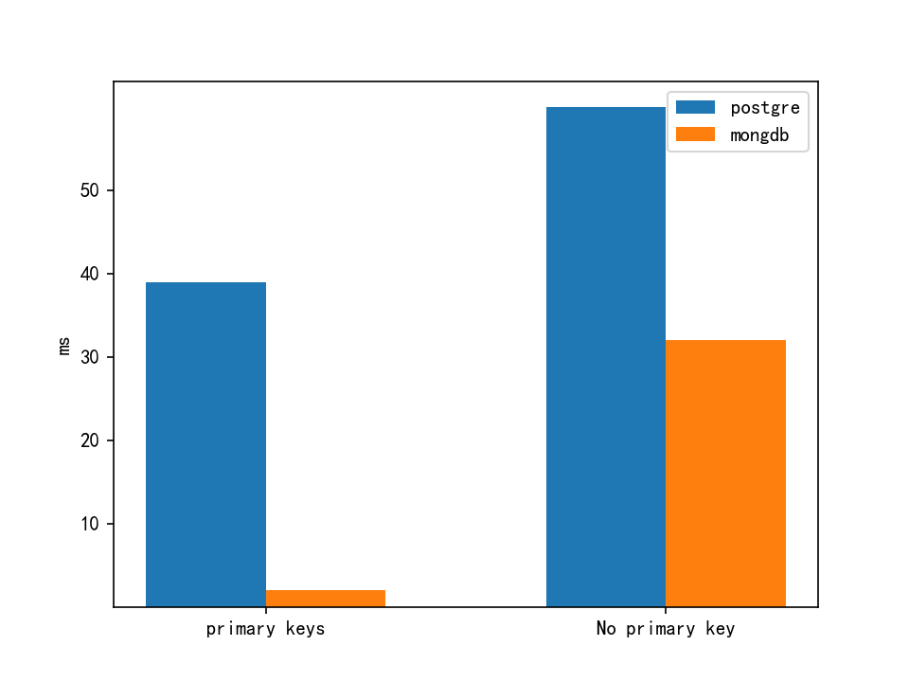
Figure4 Simple Search
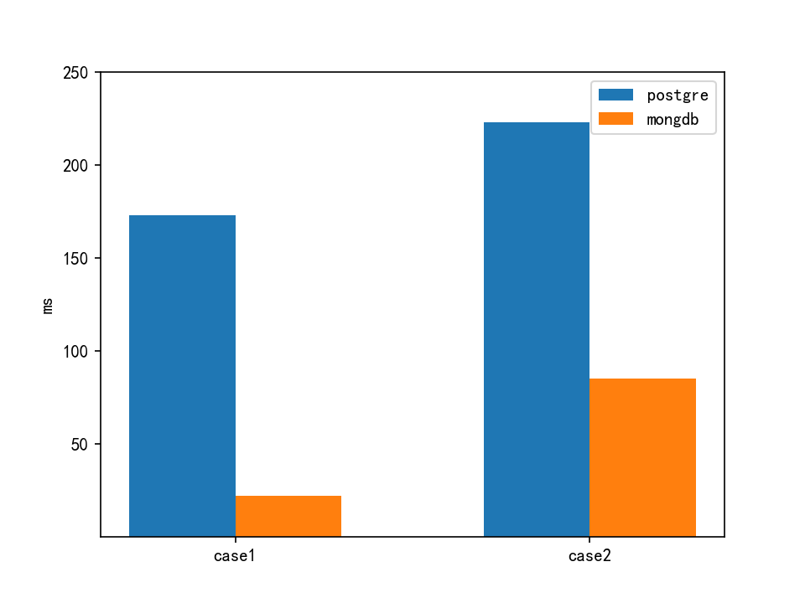
Figure5 Complex queries
The two graphs above show the execution times of both databases for simple and complex queries, and it can be seen that Mongo DB outperforms PostgreSQL.
The reason for this performance difference is mainly due to the difference in the way the two databases process queries. The main difference between them is that Mongo DB uses an in-memory view (private view) to respond to queries, whereas PostgreSQL reads query data from disk. Reading from memory is faster than reading from disk, resulting in Mongo DB being faster than PostgreSQL in this case.

The above comparative study of non-relational databases and relational databases shows the difference in data processing performance in different environments. Mongo DB is a document-oriented, key-value pair, object and other storage methods, which are more suitable for storing certain types of data and have better development prospects.

- Reference
[1] Rasheed, Y., Qutqut, M., & Almasalha, F. (2019). Overview of the current status of NoSQL database. Int. J. Comput. Sci. Netw. Secur, 19(4), 47-53.
[2] Raut, A. B. P. D. (2017). NOSQL database and its comparison with RDBMS. International Journal of Computational Intelligence Research, 13(7), 1645-1651.
[3] Nayak, A., Poriya, A., & Poojary, D. (2013). Type of NOSQL databases and its comparison with relational databases. International Journal of Applied Information Systems, 5(4), 16-19.
[4] Mukherjee, S. (2019). The battle between NoSQL Databases and RDBMS. Available at SSRN 3393986.
[5] MUS, M. (2019). Comparison between SQL and NoSQL databases and their relationship with big data analytics.
[6] Han, J., Haihong, E., Le, G., & Du, J. (2011, October). Survey on NoSQL database. In 2011 6th international conference on pervasive computing and applications (pp. 363-366). IEEE.
[7] Mapanga, I., & Kadebu, P. (2013). Database management systems: A nosql analysis. International Journal of Modern Communication Technologies and Research, 1(7), 265849.
[8] He, C. (2015). Survey on NoSQL database technology. Journal of Applied Science and Engineering Innovation Vol, 2(2), 50-54.
[9] Sharma, V., & Dave, M. (2012). Sql and nosql databases. International Journal of Advanced Research in Computer Science and Software Engineering, 2(8).
[10] Ramzan, S., Bajwa, I. S., & Kazmi, R. (2019). Challenges in NoSQL-based distributed data storage: a systematic literature review. Electronics, 8(5), 488.
[11] Li, Z. (2019). NoSQL Databases.
[12] Li, Y., & Manoharan, S. (2013, August). A performance comparison of SQL and NoSQL databases. In 2013 IEEE Pacific Rim Conference on Communications, Computers and Signal Processing (PACRIM) (pp. 15-19). IEEE.
[13] Radoev, M. (2017). A comparison between characteristics of NoSQL databases and traditional databases. Computer Science and Information Technology, 5(5), 149-153.
[14] Membrey, P., Plugge, E., Hawkins, T., & Hawkins, D. (2010). The definitive guide to MongoDB: the noSQL database for cloud and desktop computing. springer.

