Financial Management for the Hotel Industry
BMIH5007
Business Report - Comparison of Two Hospitality Organisations
Lecturer: Jaliya De Silva

Student name: Georgiana Cucu
Student id: 2213957
Word count: 2195

Table of Contents
1. Introduction 3
2. Theoretical framework 3
3. Analysis 4
4. Evaluation of the hotels 5
5. Growth potential 7
6. CSR initiatives 8
7. Conclusion 9
8. Recommendation 10
9. References 11

- Introduction
This report looks to contrast Corinthia Hotels and Ibis Hotels in term of their approaches to financial management. Established in 1962 by the Pisani family of Malta, Corinthia Hotels stands for understated elegance and sophistication in some of the most renowned cities and locales on the planet. This brand is dedicated to keeping family values by showing benevolence, providing excellent service, and having a profound appreciation for the significance of hospitality (Corinthia, n.d.). Reflecting its ambitions on a global scale, Corinthia has registered new entities in the United States and Italy to increase its international presence. Furthermore, to accommodate operational requirements, a newly established office has been established in Dubai, in conjunction with the procurement of a corporate office in London. The worldwide expansion of Corinthia Hotels demonstrates the company's commitment to growth and its strategic positioning in key markets (Corinthia, 2022). On the other hand, Ibis Hotels, a subsidiary of Accor, an internationally recognised hotel corporation, focuses on the economy sector and maintains a presence in a multitude of nations. As of 2023, Accor's organisational structure is characterised by its divisional approach, wherein Ibis, in addition to other brands, is categorised within the "Premium, Midscale, and Economy" division (Accor, 2022). Ibis capitalises on Accor's dominant market positions in Asia-Pacific, Europe, Latin America, and the Middle East to further its development via brand revitalization and franchise expansion.

- Theoretical framework
Key financial management theories, including but not limited to revenue management, market segmentation, sustainable growth, and CSR, are vital in influencing the business strategies of hotel corporations such as Corinthia and Ibis Hotels within the hospitality industry. Revenue management, an essential financial strategy, maximises revenue from available inventory by selling the proper product to the appropriate customer at the appropriate time and for the appropriate price (Atrill, 2021). This approach entails recognising and predicting demand, setting up prices corresponding with that, and overseeing inventory in order to optimise revenue generation (Guilding, 2014). Market segmentation, which entails the identification of discrete clusters within a market that possess comparable attributes or requirements, is another important financial indicator (Walker, 2021). Hotels such as Corinthia and Ibis employ segmentation strategies to customise their offerings and promotional initiatives towards distinct customer segments, thus maximising their market penetration and financial gains. This approach eases the precise concentration of marketing endeavours and the tailoring of service provisions to cater to the varied requirements of distinct customer segments. CSR and sustainable growth are interrelated notions that stress ethical business practices that take into account social, economic, and environmental impacts (Abram and Jarzabek, 2016).

- Analysis
The financial performance and total revenue of Accor's Ibis Hotels can be assessed in the context of the entire Accor portfolio. Accor, a multinational corporation specialising in enhanced hospitality, manages a wide array of hotel brands spanning various market segments. These brands consist of Ibis, Ibis Styles, and Ibis Budget, all which appeal to distinct customer preferences and requirements within the economy segment (Accor, 2022). As of the second quarter of 2022, the RevPAR of the Premium, Midscale, and Economy division, of which Ibis Hotels is a part, increased by 26%.Compared to the initial quarter of 2022, the division's RevPAR grew by 60%. The main factors contributing to this growth were the resurgence of occupancy rates and the sustained ability to set competitive prices. Compared to the initial quarter of 2022, the Europe North Africa (ENA) region, a crucial market for this division, reported a 54% increase in RevPAR. Significantly, the room revenue of the region, comprising 46% of RevPAR in France, remained strong, supported in particular by the return of international visitors to Paris (Accor, 2023). Notwithstanding the difficulties posed by strikes, particularly in March, the effect on the performance of the hotel industry was negligible. In the year 2022, Corinthia generated a cumulative revenue of €238.2 million. The hotels division experienced a substantial revival for the organisation, as evidenced by the hotels segment's 95% year-on-year growth (Corinthia, 2022). The aggregate revenue amounted to 89% of the value recorded in 2019, signifying a robust recovery in the wake of the obstacles presented by the COVID-19 pandemic and additional market circumstances (Corinthian, 2021).The group's recovery can be attributed to its strategic initiatives to weather the economic repercussions of the pandemic and inflation, in addition to its endeavours to enhance and broaden the Corinthia brand on an international scale. Upon comparison, it becomes apparent that both Corinthia and Ibis Hotels have effectively operated through the repercussions of the pandemic, prioritising recovery and expansion. The significant surge in revenue observed at Corinthia can be attributed to the hotel's effective recovery and strategic placement in the luxury market segment (Corinthia, 2021). On the other hand, the performance of Ibis Hotels, which is part of the Accor portfolio, demonstrates the efficacy of its operational strategies in the economy sector. The company took advantage of the dynamics of market recovery and maintained competitive pricing (Accor, 2022). Moreover, the revenue patterns exhibited by Corinthia and Ibis Hotels are indicative of their unique market positions and strategic strategies. A strategic expansion into key global markets and a targeted recovery strategy that prioritises quality over quantity have resulted from Corinthia's concentration on the luxury and premium markets (Corinthia, 2022). On the other hand, Ibis Hotels derives revenue-generating advantages from Accor's extensive network and emphasis on the economy segment through strategic pricing, market penetration, and volume. Both groups' revenue generation is impacted by market positioning, brand strategy, and the capacity to quickly adjust to shifting market dynamics. In contrast to Corinthia, which capitalises on its luxurious reputation and exclusive offerings, Ibis pursues growth by utilising Accor's vast network and emphasising accessibility, affordability, and strategic expansion.

- Evaluation of the hotels
A comparative analysis of the market positions of Corinthia and Ibis in the hospitality sector of the United Kingdom is presented by Statista in 2023. Fig 1 presents an overview of the predominant hotel brands in the United Kingdom during the third quarter of 2023. Based on the data, Ibis holds a significant 39% of the preference of the respondents. Nevertheless, this classification does not include the Corinthia brand, indicating that its level of public recognition may be comparatively less substantial than that of the other brands included. On the other hand, the digital domain is the subject of thefig 2, presented by Statista (2023), which ranks the top lodging brands according to the number of subscribers they gained on YouTube as of March 2021. Corinthia Hotel London shows itself with 1,950 subscribers, demonstrating the efficacy of its online content strategy and its ability to captivate an audience on this social media platform. Ibis's noticeable omission from this list suggests a possible domain for development in its digital marketing approach or a deliberate decision to concentrate on alternative platforms for endorsing the brand (Statista, 2023). Thus, it becomes clear that Ibis's broad appeal may be attributable to its extensive recognition and potentially its value-oriented products. On the contrary, the existence of Corinthia on YouTube shows a focused and potentially upscale digital approach that might resonate with clients attracted to luxurious and premium experiences. The diverse range of strategic approaches adopted by hotel brands to attract and retain their specific target markets is highlighted by these unique market positions. Ibis seems to exploit its broad allure to a varied clientele, whereas Corinthia appears to employ a niche marketing strategy, possibly targeting a more affluent clientele.
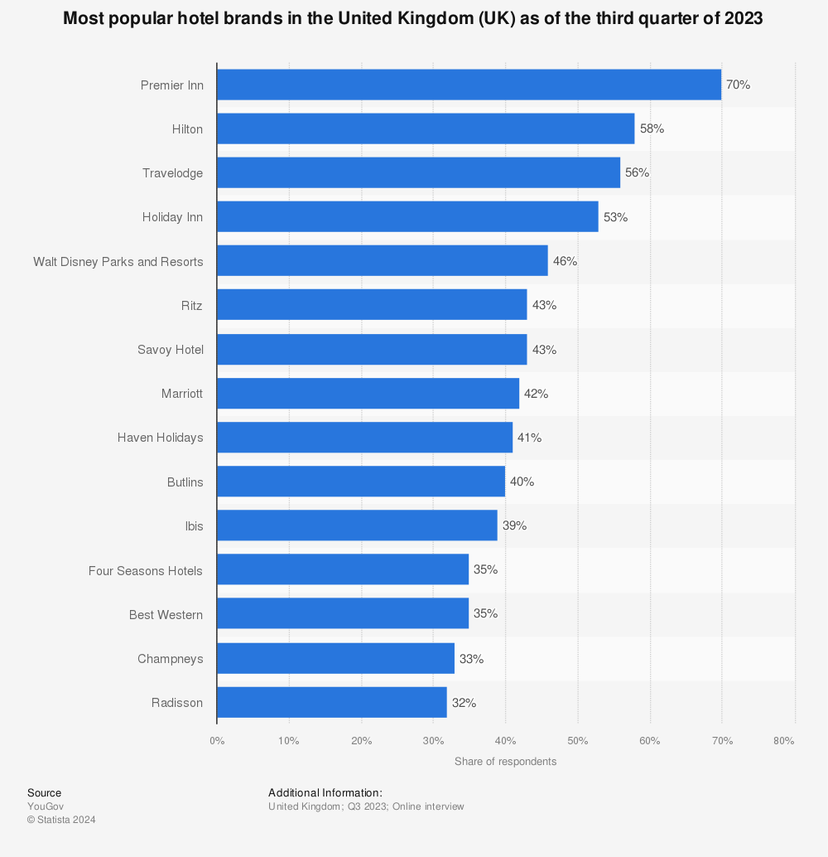
Fig 1. Statista (2023). Most popular hotel brands in UK.
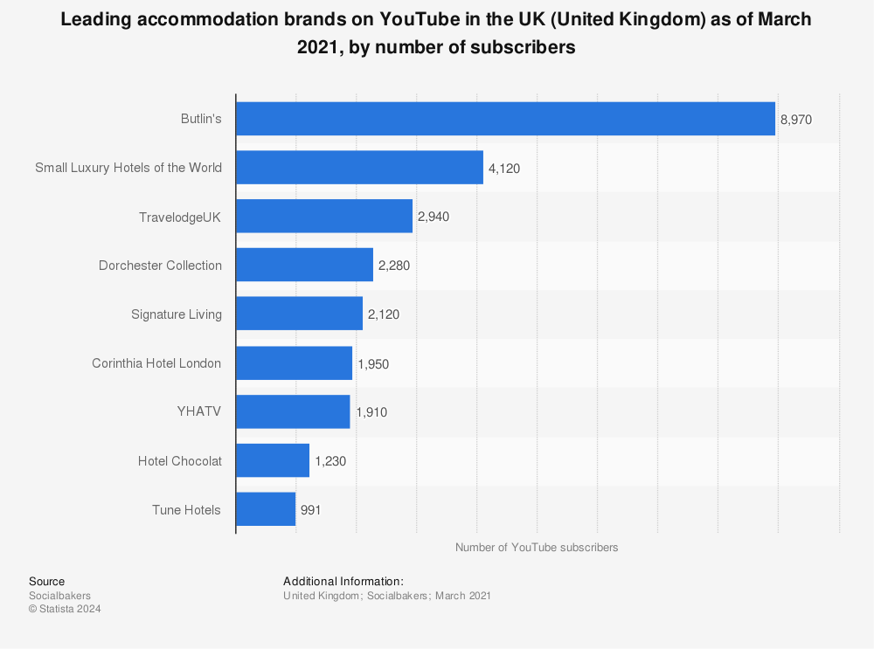
Fig 2. Statista (2023). Leading accommodation brand on the YouTube in the UK.

- Growth potential
International Hotel Investments PLC, which owns Corinthia Hotels, demonstrates substantial growth potential via a succession of strategic expansions and developments. The hotel chain has initiated a trajectory of expansion, and it is anticipated that ongoing negotiations will lend the organisation greater prominence and excellence. Corinthia is particularly enthusiastic about augmenting its footprint in Libya, acknowledging the nation's immense prospective for development (Corinthia, 2022). This aspiration is a component of a more ample approach that aims to facilitate the growth of each subsidiary in multiple domains such as hotel operations, project management, and development, while also investigating potential investments. Moreover, the organization's ongoing hotel developments in Rome, Brussels, New York, and Bucharest, all of which are undergoing renovations and construction and are scheduled to open in the first half of 2024, supply additional support for its expansion strategy (Corinthia, 2023). With the objective of realizing a leading position in their respective luxury markets, these advancements demonstrate the brand's dedication to expansion and superiority. Alternatively, Accor subsidiary Ibis Hotels has also exhibited a distinct emphasis on expansion, specifically within the United Kingdom market. Accor's declaration of intention to augment its Ibis portfolio in the United Kingdom by seven hotels signifies a resolute dedication to the expansion of its economy hotel division (Accor, 2023). This expansion is following the brand's strategic objective of expanding its market presence and accommodating a wide range of consumer requirements. Furthermore, as one of AccorInvest's key Asset Management projects, the Ibis Styles Szczecin Stare Miasto in Poland demonstrates the brand's dedication to employee welfare and environmental performance, in that way illustrating how Ibis Styles hotels are incorporating sustainability into their expansion strategies (Accor Group, 2020). Potential impediments to expansion for both Corinthia and Ibis Hotels comprise the unstable situation of the worldwide hotel sector, which is characterised by intense consolidation, economic and political instability in specific markets, and the difficulty of sustainably upholding elevated standards (Walker, 2021). Corinthia recognises the existence of its activities in both established and developing economies, as well as volatile or emergent markets, which signifies a diversified risk profile and increased operational intricacy. In the same manner, Ibis and other brands operating under the Accor name may encounter obstacles linked to worldwide economic volatility, rivalry, and the imperative for creative ways to sustain market supremacy and customer contentment.

- CSR initiatives
Corinthia Hotels exhibits a robust dedication to CSR by means of a multitude of strategies that centre on ethical business conduct, community involvement, and sustainability. A Head of Sustainability has been appointed by the group to develop policies and coordinate initiatives with respect to hotel operations. By addressing the aspirations of staff, funders, customers, and regulatory parameters, this initiative ensures that sustainability practices are integrated throughout the entire organisation (Corinthia, n.d.). Furthermore, to formulate a broad CSR strategy, Corinthia London collaborated with a highly regarded consulting firm. This strategy encompasses various aspects such as social community engagement, responsible procurement, sustainability, philanthropy, charity work, and staff welfare. Under the guidelines of lockdowns, this endeavour, known as Corinthia Connects, looked to preserve employee relations by providing daily engagement sessions on a variety of subjects. Hosting and sponsoring events for ailing and disadvantaged children in Hungary, organising used-clothes collections, and gathering cash donations for the Csodalampa Foundation, which assists children with terminal illnesses, are additional social and community activities in which Corinthia is involved (Corinthia, 2023). On the other hand, the Accor Group's Ibis Hotels demonstrates its dedication to CSR via the Planet 21 initiative, which delineates strategies to mitigate environmental impacts. Over 3,500 Accor hotels feature eco-friendly utilities, over 1,200 urban vegetable gardens, and 690 electric vehicle charging stations as part of the company's CSR initiatives (Accor, 2022). Furthermore, Accor Solidarity is dedicated to fostering the economic and social empowerment of disadvantaged communities by means of professional integration initiatives and training programmes. By means of an Ethics and CSR Charter, Accor has formalised its approach to CSR and established guidelines for accountability with regard to teams, society, and the environment. This charter functions as a mechanism through which partners and the ecosystem can implement responsible and sustainable practices (AccorInvest, n.d.).

- Conclusion
The report compares the focus on luxury by Corinthia Hotels and the attention on budgeting by Ibis Hotels, both of which are managing finances in the hospitality industry. Established in 1962, Corinthia places a high value on sophistication and international expansion through strategic openings in key markets. Ibis, a subsidiary of Accor, augments brand and franchise expansion by capitalising on its extensive reach. Their operational achievements are consistently supported by financial strategies, which encompass revenue management and market segmentation. Both brands prioritise recovery, expansion, and CSR in the face of economic difficulties, showcasing their strategic planning and adaptability. The distinct market positions of Corinthia and Ibis, which are defined by their respective approaches to quality and accessibility, respectively, dictate their trajectories in the fiercely competitive hotel industry.

- Recommendation

- Using development partnerships and management agreements in important areas, Corinthia Hotels should prioritise sustainable growth. Enhancing brand awareness and market positioning may be achieved by focusing on luxury and premium categories, integrating environmental standards, and growing digital marketing. CSR initiatives would also draw in socially concerned customers (Tranter, Stuart Hill and Parker, 2014).
- Ibis Hotels need to adopt Accor's approach, emphasising franchise growth and revitalization of the brand in the low-cost market. Ibis Styles Szczecin Stare Miasto is one project that demonstrates how sustainability may be integrated, which is essential for both operational effectiveness and market attractiveness. Brand loyalty and market share will increase by enhancing digital interaction and operational models in accordance with changing customer preferences (Mintel, 2023).

- References

Abram, M. and Jarzabek, J. (2016). Corporate social responsibility in hotel industry : environmental implications. ECOCYCLES, [online] 2(2), pp.9–16. Available at: http://real.mtak.hu/43898/.
‌Accor (2022). Consolidated Financial Statement 2022. Available at: https://group.accor.com/en/finance/results-and-publications/financial-result
Accor (2022). Climate Change 2022. Available at: https://group.accor.com/-/media/Corporate/Group/Documents/2023/04/06/Accor_CDP_Climate_2022.pdf.
Accor (2023). Accor Group Third-quarter 2023. Available at: https://group.accor.com/en/finance/results-and-publications/financial-result
Accor (2023). Accor Global Development Summary - Premium, Midscale & Economy Division. Available at: https://group.accor.com/-/media/Corporate/Hotel-development/PDF-for-pages/HP-hotel-development/EN_AccorGlobalDevelopment_SummaryPitch_PremiumMidscaleEconomy_March2023.pdf

Accor Group (2023). Why invest in ibis. (2020). Available at: https://group.accor.com/-/media/Corporate/Hotel-development/PDF-for-pages/Ibis/2020/S1/01_EN_Why-Invest-in-ibis_Accor-Global-Development_FEB2020.pdf [Accessed 25 Jan. 2024].

AccorInvest. (n.d.). Environmental, Social, and Governance (ESG) • AccorInvest. [online] Available at: https://www.accorinvest.com/environmental-social-and-governance/.

Atrill P, McLaney E (2021) Management Accounting for Decision Makers, FT Prentice Hall
Corinthia. (n.d.). About Corinthia | Corinthia Hotels International | Corinthia.com. [online] Available at: https://www.corinthia.com/en-gb/our-story/.

Corinthia. (n.d.). SUSTAINABILITY AT CORINTHIA. [online] Available at: https://www.corinthia.com/en-gb/sustainability/.

‌Corinthia (2021). Corinthia Group 2021 Annual Report and Financial Statements. Available at: https://www.corinthiagroup.com/wp-content/uploads/2022/05/Corinthia-Annual-Report-2021.pdf
‌Corinthia (2022). Corinthia Group 2022 Annual Report and Financial Statements. Available at: https://www.corinthiagroup.com/wp-content/uploads/2023/06/37547-CORINTHIA-ANNUAL-REPORT-2022_WEB-min.pdf
Corinthia (2023). ESG in Investing - Corinthia. [online] Available at: https://corinthiagm.com/esg-in-investing/ [Accessed 27 Feb. 2024].

Guilding,C.(2014) (3rd Edition) Accounting Essentials for Hospitality Managers, London, Routledge
Mintel (2023). Hotels UK 2023. Industry Report. Available at: https://store.mintel.com/report/uk-hotels-market-report
Statista. (2023). Leading accommodation brands on YouTube in the UK 2021. [online] Available at: https://www.statista.com/statistics/772347/leading-accommodation-brands-on-youtube-in-the-uk/ [Accessed 25 Jan. 2024].

Statista (2023). Most Popular Hotel Brands in the UK 2019. [online] Statista. Available at: https://www.statista.com/statistics/951262/most-popular-hotel-brands-uk/.

Tranter,K. Stuart-Hill,T. Parker,J. (2014) Introduction to Revenue Management for the Hospitality Industry, London, Pearson

Walker J (2021) Introduction to Hospitality, Harlow, Pearson

