Changemakers: Creativity and Value Creation

COMPONENT 2: WRITTEN ASSIGNMENT (REPORT)
Module code: BMHP5014
Hira Ahmed
Student No. 2426399
Lecturer: Zarah Ahmed

Contents
Part 1: Poster 2
Part 2: Written Pitch 3
Introduction 3
The Need for Innovation in Nursing Education 3
How the Innovation Works 4
Benefits for Learners, Healthcare Organisations and Society 4
Critical Comparison with Existing Training Methods 4
Creativity, Innovation and Entrepreneurship 5
Critical Evaluation of the Innovation 5
Policy, Regulation and Professional Standards 6
Conclusion 6
Refrence: 8

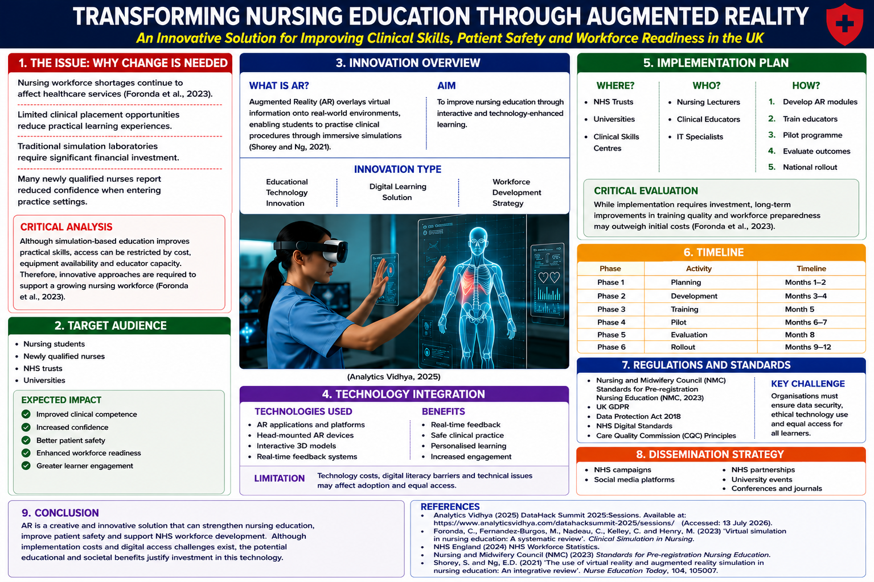
Part 1: Poster

Part 2: Written Pitch
Written Pitch: Transforming Nursing Education Through Augmented Reality (AR)

Introduction
The UK healthcare sector continues to face challenges relating to nursing workforce shortages, increasing patient demands and the need to maintain high standards of care. NHS workforce data highlights ongoing recruitment and retention pressures, emphasising the importance of preparing competent healthcare professionals for modern clinical environments (NHS England, 2024). Therefore, innovative educational approaches are needed to enhance nursing education and workforce development.
This proposal advocates the implementation of Augmented Reality (AR) technology within nursing education across UK universities and healthcare organisations. AR overlays digital information onto real-world environments, allowing students to engage with realistic clinical scenarios in a safe and controlled setting (Shorey and Ng, 2021). The innovation aims to improve clinical competence, enhance patient safety and create value for learners, healthcare organisations and society.

The Need for Innovation in Nursing Education
Nursing education plays a vital role in preparing future healthcare professionals. However, traditional teaching methods and simulation laboratories can be limited by resource constraints, placement availability and access to specialist equipment. These challenges may restrict opportunities for repeated practice and experiential learning (Foronda et al., 2020).
Research suggests that immersive technologies such as AR can improve learner engagement, confidence and knowledge retention by providing realistic learning experiences (Shorey and Ng, 2021). AR enables students to practise clinical procedures repeatedly without placing patients at risk, supporting the development of practical skills before entering real healthcare environments. Consequently, AR offers a potential solution to existing educational challenges while supporting workforce development within the NHS.

How the Innovation Works
The proposed AR system would utilise mobile devices, tablets or AR headsets to create interactive healthcare simulations. Students would engage with virtual patients and clinical scenarios while receiving immediate feedback on their performance. Activities could include medication administration, wound care, infection prevention procedures and patient assessment techniques (Padilha et al., 2019).
The innovation would initially be introduced through pilot programmes within selected nursing courses before wider implementation across educational settings. Collaboration between universities, NHS organisations and technology providers would be essential to ensure successful integration into existing curricula and learning environments.

Benefits for Learners, Healthcare Organisations and Society
AR has the potential to provide significant benefits for learners, healthcare organisations and society. For learners, the technology can improve confidence, competence and engagement by providing opportunities for repeated practice within a safe learning environment. Students can develop practical skills and receive immediate feedback, supporting readiness for professional practice (Shorey and Ng, 2021).
Healthcare organisations may benefit from improved workforce preparedness and patient safety through enhanced training outcomes. Better-prepared graduates may contribute to reduced clinical errors and improved quality of care.
From a societal perspective, AR contributes to the common good by supporting the development of a skilled healthcare workforce and improving patient outcomes. Enhanced educational quality may ultimately strengthen healthcare services and increase public confidence in care delivery.

Creativity, Innovation and Entrepreneurship
The proposed AR initiative demonstrates creativity by applying emerging technology to address challenges within nursing education. Creativity involves generating novel and useful ideas that solve existing problems (Green, 2024). According to Tidd and Bessant (2021), innovation involves the successful implementation of new ideas that create value. AR provides an innovative learning approach that enhances traditional educational methods through immersive and interactive experiences.
The innovation can be analysed using Rogers’ Diffusion of Innovation Theory. Rogers (2003) argues that successful adoption depends on factors such as relative advantage, compatibility and complexity. AR demonstrates a relative advantage by providing flexible learning opportunities and realistic clinical simulations. However, resistance to change and technological complexity may influence adoption within some educational settings.
The Value Proposition Canvas developed by Osterwalder et al. (2020) further demonstrates how AR creates value. The technology addresses key challenges experienced by nursing students, including limited access to simulation facilities and restricted opportunities for repeated practice. At the same time, it creates value through improved confidence, competence and learner engagement.
Entrepreneurship is also central to the proposal. Successful implementation would require funding, strategic planning and collaboration between universities, NHS organisations and technology providers. The initiative reflects principles of social entrepreneurship because its primary aim is to improve healthcare education and patient outcomes rather than generate profit alone (Hisrich and Kearney, 2014). Furthermore, the technology has the potential to be scaled across other healthcare professions, increasing its long-term value and impact.

Critical Evaluation of the Innovation
Despite its benefits, AR presents several challenges. Initial implementation and maintenance costs may be substantial, particularly for organisations with limited budgets. Digital inequalities may also affect access, as not all students possess suitable devices or reliable internet connections.
Ethical considerations must also be addressed. The collection and storage of learner data through digital platforms creates responsibilities relating to privacy, confidentiality and cybersecurity. Furthermore, while research indicates that AR can improve engagement and confidence, evidence regarding long-term impacts on clinical competence and patient outcomes remains limited (Shorey and Ng, 2021).
Compared with traditional simulation, AR offers greater flexibility and repeatable practice without requiring costly equipment or limited laboratory access. It also integrates learning into real-world environments more effectively than virtual reality. However, AR cannot fully replicate patient interaction, teamwork, emotional intelligence or clinical experience developed through real placements. Therefore, AR should complement rather than replace traditional educational approaches.

Policy, Regulation and Professional Standards
The proposed Augmented Reality (AR) innovation aligns with key UK healthcare policies and professional standards. It supports the Nursing and Midwifery Council (NMC) Standards for Pre-registration Nursing Programmes by providing safe, evidence-based learning experiences that enhance clinical competence (NMC, 2023). The innovation also aligns with the NHS Long Term Workforce Plan, which promotes workforce development and innovative training approaches to address staffing challenges (NHS England, 2023). Furthermore, AR supports the NHS digital transformation agenda by developing digital skills among future healthcare professionals. Implementation must comply with the Health and Care Act 2022, UK GDPR, and the Data Protection Act 2018 (UK Government, 2018) to ensure data security, privacy, and ethical use of technology in healthcare education.

Conclusion
Augmented Reality represents a creative and innovative solution to challenges within nursing education. By improving learner engagement, clinical competence and workforce readiness, AR creates value for students, healthcare organisations and society. Although challenges relating to cost, digital inclusion and evidence limitations exist, these can be addressed through effective planning and partnership working. Overall, AR offers a practical and forward-thinking approach to strengthening nursing education and supporting the future sustainability of UK healthcare services.

Refrence:
Foronda, C., Fernandez-Burgos, M., Nadeau, C., Kelley, C. and Henry, M. (2023) ‘Virtual simulation in nursing education: A systematic review’, Clinical Simulation in Nursing.
Green, A.E. (2024) ‘The Process Definition of Creativity’, Creativity Research Journal. Available at: https://www.tandfonline.com/doi/full/10.1080/10400419.2023.2254573 (Accessed: 13 June 2026)
Hisrich, R.D. and Kearney, C. (2014) Managing Innovation and Entrepreneurship. London: SAGE Publications Ltd.
NHS England (2023) Data Security and Protection Toolkit. Available at: https://www.dsptoolkit.nhs.uk/ (Accessed: 13 June 2026).
NHS England (2023) NHS Long Term Workforce Plan. London: NHS England. Available at: NHS England Workforce Plan (Accessed: 13 July 2026).
NHS England (2024) NHS Workforce Statistics. Available at: https://digital.nhs.uk/data-and-information/publications/statistical/nhs-workforce-statistics (Accessed: 12 June 2026).
Nursing and Midwifery Council (2023) Standards for pre-registration nursing programmes. London: Nursing and Midwifery Council. Available at: https://www.nmc.org.uk/standards/standards-for-nurses/standards-for-pre-registration-nursing-programmes/ (Accessed: 12 June 2026).
Osterwalder, A., Pigneur, Y., Bernarda, G. and Smith, A. (2020) Value Proposition Design. Hoboken: Wiley.
Padilha, J.M., Machado, P.P., Ribeiro, A., Ramos, J. and Costa, P. (2019) ‘Clinical Virtual Simulation in Nursing Education: Randomized Controlled Trial’, Journal of Medical Internet Research, 21(3), e11529. https://doi.org/10.2196/11529.
Shorey, S. and Ng, E.D. (2021) ‘The use of virtual reality and augmented reality simulation in nursing education: An integrative review’, Nurse Education Today, 104, p. 105007.
Tidd, J. and Bessant, J. (2021) Managing Innovation: Integrating Technological, Market and Organisational Change. 7th edn. Chichester: Wiley.
UK Government (2018) Data Protection Act 2018. Available at: https://www.legislation.gov.uk/ukpga/2018/12/contents (Accessed: 13 June 2026).

