

An issue inside Private Healthcare sector

Student Name: Ivone Amorim
Student Number: 1818223
Module: Problem Solving and Decision Making
Module Number: BMHP4004_LON
Lecture Name: Yajesh Kumar

Table of Contents
Introduction 3
Private Healthcare Organizations 3
Problems inside Healthcare Agencies 3
Communication between Agency and workers 3
Communication between Clients and Organization 3
Lack of training 4
Staff Behaviour 4
Technology 4
Different backgrounds 4
Study case - Whistleblowing and Communication inside Private Healthcare sector 4
Case study Analysis 5
SWOT analysis 5
PESTLE analysis 6
Fishbone Diagram 6
PMI Proposals 8
Healthcare Organizations stakeholders 9
Organizational Control 9

Introduction
The aim of this report is to study private healthcare organizations and problems that can occur inside of the same. After collecting information’s, it will describe some problems and the importance of identifying them to understand the possible impacts on healthcare private sector. Analysing the problems will help to implement a plan in the process of decision making. Some important tools will be used has Swot Analise, Pestle and Fishbone Diagram, the objective it is to take in consideration all the aspects to interpret and create a tool that will help stakeholders work, this techniques will monitoring and evaluate the future outcomes and how organizations can benefit of it.

Private Healthcare Organizations
Private organizations are working alongside with NHS public sector, they work in accordance with the government and NHS. Public sector has an enormous list of patients and cannot answer rapidly with the support they need delegating cases to private sector where they are responsible to recruit healthcare professionals to provide care service. According to each individual needs and specifications, agencies will provide the right training and qualifications to healthcare workers that can be allocated has bank staff in hospitals, GP’s, communities, care homes, or patients own property (Kpicare,2020)

Problems inside Healthcare Agencies

Communication between Agency and workers
Staff feels the need of more contact with agencies, considering impersonal talking about tasks, duties and problems by phone or email (in case of prove). They only see their managers, co-ordinators, or nurses when something comes up or invited to the office. Some of them also think office is always rushing and trying to end calls, keeping them nervous and with not enough time to clear explain the issue, misunderstood can occur (East, 2017).

Communication between Clients and Organization
Patients tend to complain about lack of communication with agencies, they are not present and only calling to schedule a meeting when something needs to be discussed. There are no compliments, birthday congratulations or nice conversations. Work staff is responsible for their care and to keep communication open between agency and patient (East, 2017).

Lack of training
Every patient is unique with different physical and psychological needs, care staff need to be update with different requirements, skills and trainings although, agencies are already providing training in some cases is not enough, one day training does not give experience and confidence necessary for work, basic skills related to homecare must also be considered (East, 2017).

Staff Behaviour
Care staff consider themselves in a comfortable situation with clients after they build a relationship, that can confuse their rule, boundaries, and conduct. Staff need to keep in mind to follow organization procedures, to keep a distance from work and relationships, to understand they are at work and respect all the contents (East, 2017).

Technology
The increase of technology became an important asset between organizations, clients, and workers, it unable a good communication and to keep information and folders update. The negative impact it concerns when technology is been used excessive, workers are using mobiles, tablets for their own personal use, breaking the rules, and spending more time with their interests than with the client (East, 2017).

Different backgrounds
Working in healthcare requires to wire staff from different cultures, backgrounds, and habits. Diversity is good and allows everyone to learn other perspectives, but can also be a barrier including language, hygiene, food preferences and habits (East, 2017).

Study case - Whistleblowing and Communication inside Private Healthcare sector
Two healthcare assistants belonging to the same private healthcare organization were working with the same patient at his own home. The organization provides patient care after discharge from hospital, the patients stay at their own residences and trained workers are placed to provide services.
The patient in question needed complex care, involving tracheostomy care, oxygen therapy, catheter care and others. Sandy was working with this patient for almost 5 years and she knew the client well, Maria was only working for him 1 year. Both carers were trained in the same agency, same contexts, same rules, and both carers had the same nurse degree background overseas but different cultures.
Sandy started noticing that Maria was flushing the patient catheter without training or following the agencies regulations, so Sandy started to make notes to Maria has they do not meet at work, because they work in different shifts. Maria did not accept the comments and started to get upset and replying messages, Maria thought she could do, has she is a nurse on her country overseas and also the patient wife is asking her to do it. The situation started to escalate, and Sandy reported to the office.
The agency started an investigation and Maria was replaced while the investigation was on, also all complex care qualifications were taken. The investigation occurred around 3 months and while it was happening other complains and reports were coming to the table between both, the feedback was short, and nothing was clear.
To understand some factors, it is important to mention that agencies provide training, practical and theorical, with support paper information’s, but healthcare assistants do not work inside the office, they are placed according to specific training. The communication between agency and workers is based on phone calls, emails, mail, once or twice a year for refreshment training.

Case study Analysis
According to the case study above the organization needs to do an assessment of the situation and start an investigation, some important tools can be used to identify the internal and external issues.

SWOT analysis
The tool will identify the strengths, weakness, opportunities and treats of the problem, analyse, and give an outcome. This tool can make an important impact on the organization improvements. Internal situations as strengths can be encouragement to rise a concern, learn from the outcome, build confidence, report for better care provide, prevent incidents, improve care, reduce misunderstood, errors and improve communication, Weakness: people might be scared to raise voice, lead to misunderstood, emotional impact, it can rise discussion, rise conflicts, lack of organization contact, lack of transparency and gaps on trainings, External factors are divided in two - Opportunities: learning from outcomes, new trainings, increase motivation and support programs, improve communication between staff and office, and Treats: risk of being suited, risk of being fired, lose skills qualifications (Mirzoev,T. and Kane,S. 2018),( Arshad, Noordin, and Othman, 2017).

PESTLE analysis
This analyse will examine the impact of Political factors, Economic, Social, Technological, Legal and Environment and how it can affect organizations (Rastogi, and Trivedi, 2016).
Political factors: Political changes, possibility of wars, diseases, Government dishonesty affecting healthcare sector, law enforcement, tax payments, changes of wage practice, Brexit (leaving Europe can decrease lifestyle and stop finding staff overseas), reduce or cut healthcare supplies.
Economic factors: work costs, Brexit economical causes, commercial finances and increase of prices, reduce contracts, cut staff work, increase work hours.
Social factors: lifestyle changes, more people getting older than new-borns, increase of different cultures, need of skills improvements, knowledge and education required, healthcare awareness, appropriated behaviours.
Technological factors: improvement of technology in healthcare sector and the impact on clients, workers, organizations, changes required inside organizations, costs with technology implementations and reduce cost in long term use.
Legal factors: Data information, Data protection and confidentiality, healthcare policies and laws, taxes inflation, changes on healthcare regulations and employment. Environment factors: climate oscillations, pollution laws and policies, product waste changes in healthcare, adoption of new anti-pollution measures (Rastogi, and Trivedi, 2016).

Fishbone Diagram
The Fishbone Diagram tool will identify and recognize different causes and factors in an internal and external perspective that will lead to the consequence (Coccia, 2018).
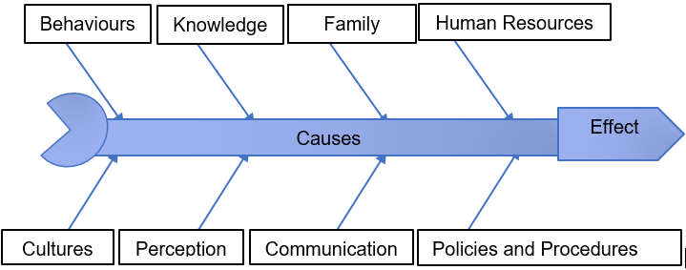

Applying the Fishbone Diagram to the case study, it can be observed that many causes can lead to that conflict situation. The behaviours apresented could be well managed if both carers were open to understand each other side, insted of rising conflits and complains, they could ask for informations, support, to clearify doubts or misunderstoods, they also should be humble and admit they can be wrong, as people is always learning, the lack of interest can also interfere. Different cultures, behaviours and perspectives learned from different societies can be a cause, if they leaved in a more strick community, they will not be so open to communication. The knowledge accquired from training can be retained or not, some people obsorve more information than others, some need more training and experience to retain details, also the learning context given on the training can be different from the one they learned on their country has both professionals had a degree in nursing, and those laps can lead to confision or not acceptation of policies. The perception will also be different if there is a language barrier, or if they assume from the beginning they know everything, or even if the training has not properly cover or explained. Communication can be poor between placement staff and office, lack of interest from managers/coordinators, short phone calls, inconsistence on feedback, short time to handover or staff rushing can lead to misunderstood and conflicts, the involvement of patients family can also be difficulty to manage and lead professionals to be benevolent and say yes when they should say no, the pressure of the moment and the lack of support, having another team member or manager to help in the moment can lead to that. The Human resources can find difficulty to manage conflict when both parts are reluctant to discuss the issue in a meeting , when they are not open to admit the errors and help each other’s has they should be a team even without working in the same shift. In the process with decision making the feedback is slow and not relevant increasing the stress, challenges managing different staff, staff turnover, lack of training opportunities and lack of training staff, undervalue staff. The contact with the office staff is considered impersonal, professionals want more interaction to express their ideas or share problems, but the feedback is short, rushed and delayed on emails responses, long wait on phone calls leading to stress and misunderstood. Policies and Procedures include inconsistence on training delivery, poor practice training, lack of resources or gaps, lack of supervision and interaction, lack of knowledge and skills, and miss interpretation of rules. Effects: misunderstood, lack of honesty, poor communication, poor trainings, and capacity to understand the other side can rise conflicts between staff, lead to unprofessional battles and lead to complaints reports.

PMI Proposals
Analysing all tools, hypotheses and perspectives, the use of PMI is important to identify all the positive points (P-Plus), the negative(M-Minus) and the interesting(I) points. Using Bono’s PMI tool will help to clarify and implement ideas for the resolution of problems with healthcare private staff (Kivunja, 2015).
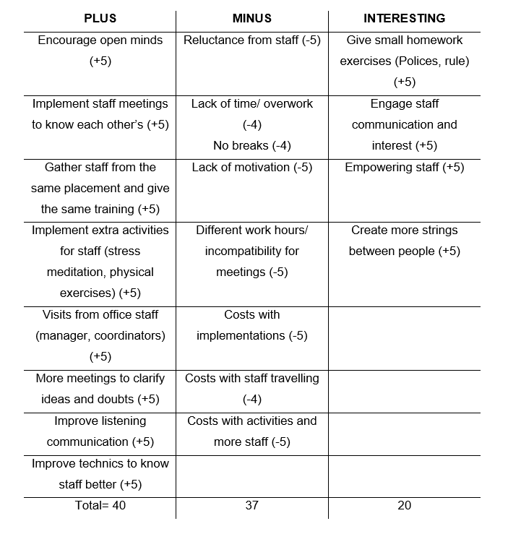

Source: (De Bono,1982)

Healthcare Organizations stakeholders
According to all this information’s and suggestions, now it is time for stakeholders to analyse and to decide if it is advantageous to implement or not, and all the pros and cons with the intuited of optimize the organization and their interested.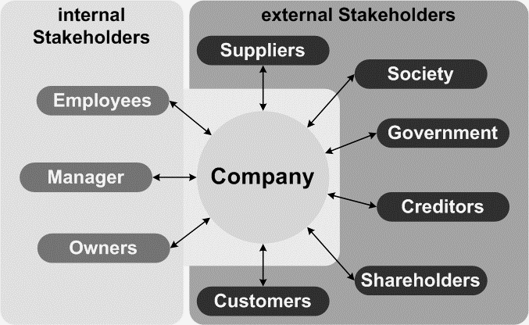 Source: ( Bright Hub PM.ALL 2020)
Analising the pros and cons they will observe the impact of all situations and undertake a decision making process in the benefit of the organization, they also need to take in consideration all the human aspects. Involving staff, enganging them, creating a better place to work, improving relationships, communication, recognise staff work and effort can help the organization to grow. According to PMI it is vantageous to start implementing changes in the organization and give more value to work professional staff, a happy place to work is the motivation needed. Stakeholders will negotiate plans and strategies through meetings, face to face negotiations and formal emails.

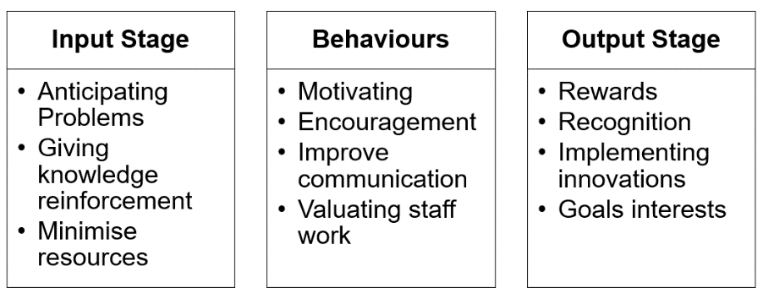
Organizational Control

Organizations need to control all situations synchronising the human factor with the organization goals. Motivating and encouraging human positive behaviours to coordinate all interests, supervising, anticipating possible problems, managing problems in all contexts, and managing the issues after, resolving it, and promoting positive welfare. In this phase of control organizations can find some resistance to control and to future changes, they need to intervene applying positive measures, objectives, and effective communication (Askay, 2017) and (Subramanian, 2018).
References:
Askay, D., (2017) A Conceptual Framework for Investigating Organizational Control and Resistance in Crowd-Based Platforms. Available at: https://scholarspace.manoa.hawaii.edu/bitstream/10125/41364/1/paper0215.pdf (Accessed: 17th April 2020)
Arshad, A., Noordin, M.B. and Othman, R., (2017). A synthesis on swot analysis of public sector healthcare knowledge management information systems in Pakistan. (IJACSA) International Journal of Advanced Computer Science and Applications, 8(8). Available at: https://s3.amazonaws.com/academia.edu.documents (Accessed: 10th April 2020)
Bright Hub PM.ALL (2020) Explaining the Different Types of Stakeholders. Available at:https://www.brighthubpm.com/project-planning/93262-stakeholders-in-project-management/ (Accessed : 15th April 2020)
Coccia, M.(2018). The Fishbone diagram to identify, systematize and analyse the sources of general-purpose Technologies. Journal of Social and Administrative Sciences, 4(4), pp.291-303. Available at: https://papers.ssrn.com/sol3/papers.cfm?abstract_id=3100011 (Accessed: 14th April 2020)
East, A. (2017) Common Problems with Home Health Care Agencies. Available at: https://caringpeopleinc.com/blog/common-problems-home-health-care-agencies/ (Accessed: 29th March 2020)
Kivunja, C. (2015). Using de bono’s six thinking hats model to teach critical thinking and problem-solving skills essential for success in the 21st century economy. Creative Education, 6(03), p.380.https://www.scirp.org/html/12-6302477_54681.htm#p390 (Accessed: 14th April 2020)
Kpicare, (2020) Delivering excellence to clients and candidacts. Available at: http://kpicare.co.uk/ (Accessed: 04th April 2020)
Mirzoev, T. and Kane, S. (2018). Key strategies to improve systems for managing patient complaints within health facilities–what can we learn from the existing literature? Global health action, 11(1), p.1458938. Available at: https://www.ncbi.nlm.nih.gov/pmc/articles/PMC5912438/ (Accessed: 08th April 2020)
Rastogi, NIT.A.N.K. and Trivedi, M.K., (2016). PESTLE technique–a tool to identify external risks in construction projects. International Research Journal of Engineering and Technology (IRJET), 3(1), pp.384-388.Available at: https://s3.amazonaws.com/academia.edu.documents (Accessed: 10th April 2020)
Subramanian, B., (2018). A review of organizational control and innovation. Rajagiri Management Journal, 12(1), pp.57-80. Available at: file:///C:/Users/IC-FA/Downloads/270-Article%20Text-780-1-10-20181217.pdf (Accessed: 18th April 2020)

Appendix Power Point





