Mohammed Nadeem 2221254
ACCA4025: Learning in the Digital Era

Contents
Task 1: Page 2 written summary
Task 2: Page 4 E- Portfolio
Task 3: Page 5 Mendeley Refencing tool
Task 4: Page 7 Behaviour poster

In this assignment, I will be exploring the essential skills in my academic studies and career and how I can develop these skills to be able to achieve this. I will also use technology to support and enhance my skills. I will document my tasks on Microsoft Word and then put it all on my E-Portfolio.

Assignment 1
Essential skills for study and Employment
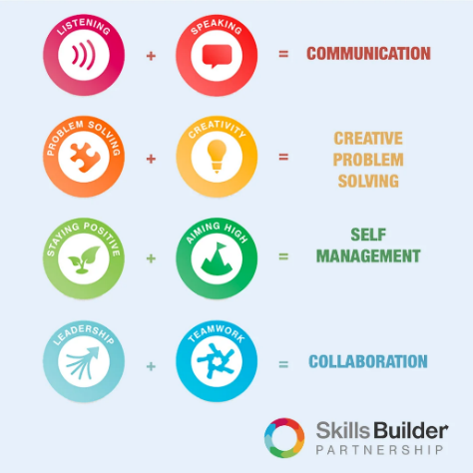
Essential skills are skills that are beneficial in both my studies and as I progress onto my career. It is “highly transferrable skills” that is the foundation enabling personal and professional development for these technical and job-specific skills required [Ferguson, 2020].
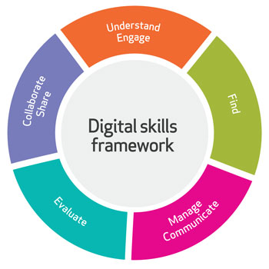
My first essential skill that I will be discussing is digital skills. Digital literacy is highlighted as the “ability to use information effectively, in all formats, in a largely digital information environment” in which certain competencies such as knowledge, skills and attitudes is required to be able to do so [Bawden and Robinson, 2012]. I develop myself professionally on this skill through using digital applications in my studies to enable me to understand the importance of this in this digital economy as well as my career once I graduate as this is highlighted as being needed in future work environments due to it being a “major driver of changing skill” [Cedefop, 2018].
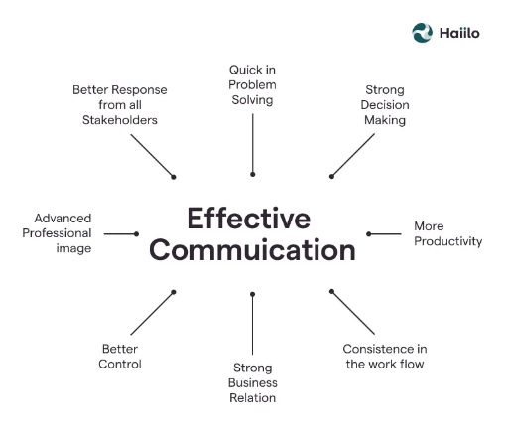
Alongside this, effective communication is indicated as an important skill due to its many benefits in developing individual and team success and reducing conflict in the workplace [Indeed, 2021]. I utilize this skill in my studies through conducting presentations using multiple skills and developing my skill and also in the workplace in which I would be using this skill in my day to day life and in my career with my team members in board meetings, group projects etc. achieving productivity and success as an effective skills can result in impactful results which employers would be keen to see in this skill with clients negotiation and persuasion [Page, 2023).
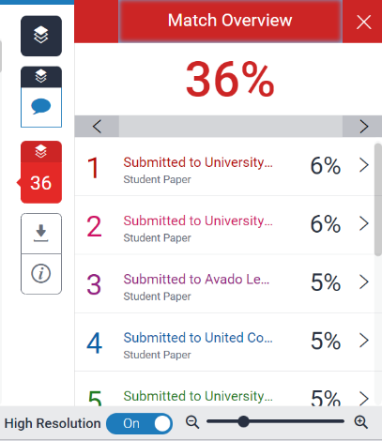
1b)

My similarity score is 36% whereas the university states the score should be less than 30%. However, if I filter my work to exclude bibliography on Turnitin, this reduces my score to 6% which is a acceptable score. I can improve my score by reducing the direct quotations in my assignment through using different literature and paraphrasing tools to help in paraphrasing.
I would mark myself at 80% (Excellent) as I have used a variety of credible literature and different sources increasing its credibility. I have also used the university guide in helping me to accurately reference, thus meeting the criteria.

Reference list:
Bawden, D. and Robinson, L. (2012). Digital literacy. [online] Cambridge University Press. Available at: https://www.cambridge.org/core/books/abs/introduction-to-information-science/digital-literacy/0E7D24731A6D30ECF017F8D9B2621F1C [Accessed 27 Feb. 2023].
Blackburn, J. (2022). Learning Resources: Employability Skills: Persuading, Influencing & Negotiation. [online] libguides.wigan-leigh.ac.uk. Available at: https://libguides.wigan-leigh.ac.uk/c.php?g=667800&p=4736456 [Accessed 27 Feb. 2023].
Carlisle, S., Ivanov, S. and Digkmans, C. (2021). The digital skills divide: evidence from the European tourism industry. [online] doi:https://doi.org/10.1108/JTF-07-2020-0114.
Cedefop (2018). Insights into skill shortages and skill mismatch: learning from Cedefop’s European skills and jobs survey. Publications Office of the European Union. [online] Available at: https://op.europa.eu/en/publication-detail/-/publication/8d1a7959-2284-11e8-ac73-01aa75ed71a1/language-en [Accessed 27 Feb. 2023].
Ferguson, H. (2020). Essential skills need to be recognised and developed by education providers and employers. [online] CIPD. Available at: https://www.cipd.co.uk/news-views/news-articles/essential-skills-framework#gref [Accessed 27 Feb. 2023].
Indeed Editorial Team (2021). Why Is Communication Important? (And How To Improve It). [online] Indeed Career Guide. Available at: https://uk.indeed.com/career-advice/career-development/why-is-communication-important [Accessed 27 Feb. 2023].
Page, M. (2023). The importance of good communication in the workplace | Michael Page UK. [online] Michael Page. Available at: https://www.michaelpage.co.uk/advice/management-advice/development-and-retention/importance-good-communication-workplace [Accessed 27 Feb. 2023].
Task 2: eportfolio
Link: https://sway.office.com/EoLvYmJmfeYjl7p2

Task 3: Referencing Guide
Step 1: 1. Google: The first step is to type “download Mendeley” on Google Search and click on download once on the Mendeley.com website.
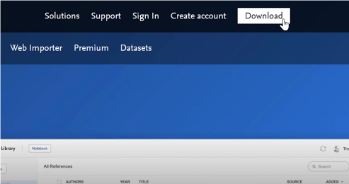
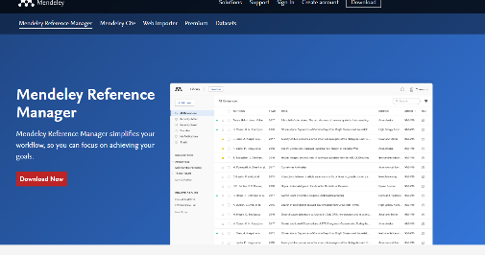
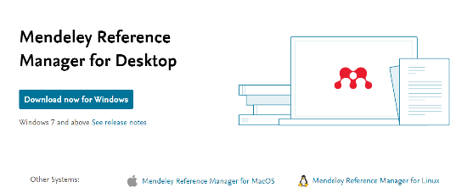



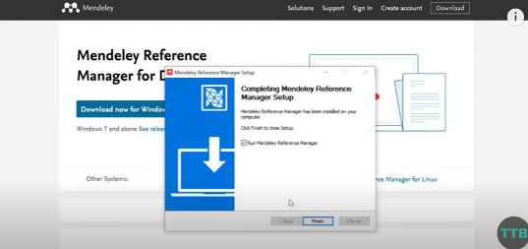
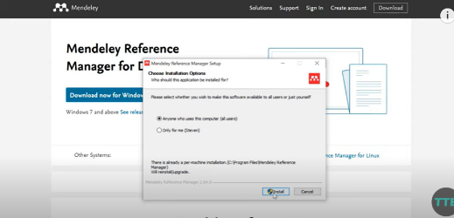
2. Install the application once download has finished

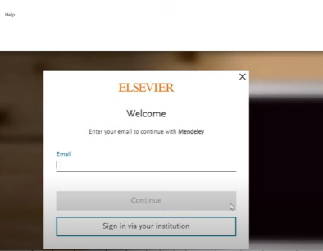
3.Create an account and then register an account
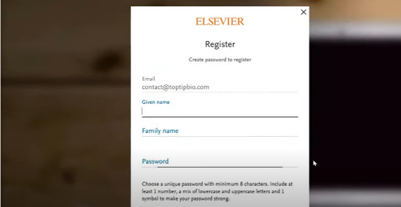
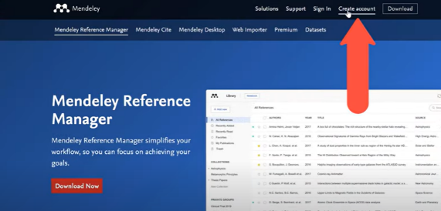

4.Then, on the top left icon- click on “Add new” and then “Add entry manually” which will enable you to provide the details for your individual references
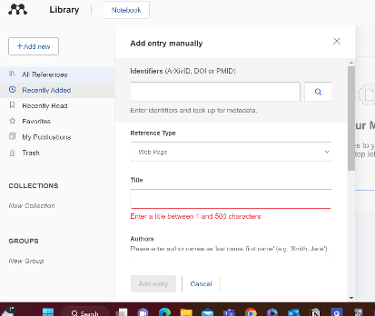
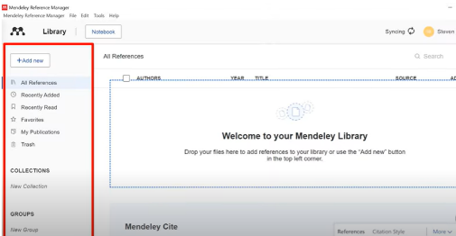
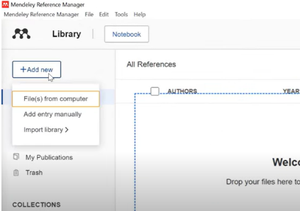

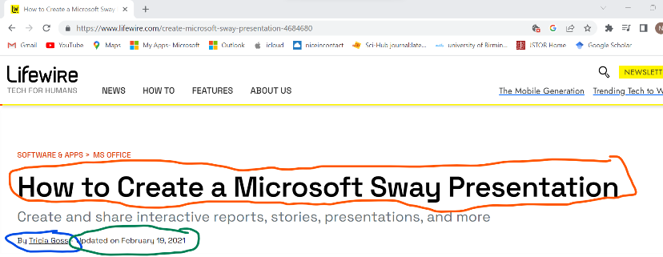
- Find website author, and date of publishing which is usually on the top of the website of on the bottom
Key:
Title
Author
Date it was published

- Insert findings on Mendeley to create the reference and continue this process for further references.
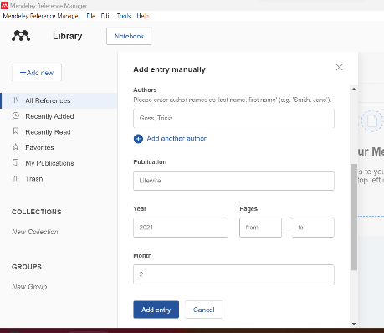
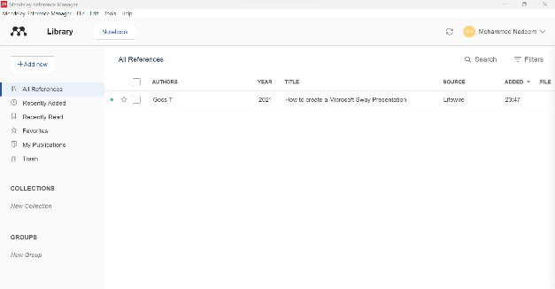

Mendeley references:
AUT Library New Zealand (2023) Mendeley, [online] AUT Library. Available at: https://aut.ac.nz.libguides.com/mendeley/word [Accessed 06 Mar. 2023].
Chuang, S.-F. (2013) Essential Skills for Leadership Effectiveness in Diverse Workplace Development, Online Journal for Workforce Education and Development. [online] ResearchGate Available at: https://www.researchgate.net/publication/325995352_Essential_skills_for_leadership_effectiveness_in_the_diverse_workplace_development [Accessed 06 Mar. 2023].
GradCoach (2023) How to use Mendeley 101: Desktop, Web Importer & the MS Word Plugin. Available at: https://gradcoach.com/how-to-use-mendeley/ [Accessed 06 Mar. 2023].
University of Leeds (2023) Referencing explained. Available at: https://library.leeds.ac.uk/info/1402/referencing/47/referencing_explained#:~:text=Referencing%20is%20an%20important%20part,you%20use%20someone%20else's%20idea. [Accessed 06 Mar. 2023].

Task 4
“To change a habit, make a conscious decision, then act out the new behavior” Maxwell Maltz- https://www.azquotes.com/quotes/topics/behavior.html
Teamwork skills involve the ability of an individual “to work cooperatively with others” used as it promotes success in both academic and career life (Doyle, 2022). My chosen teamwork skill to discuss in this task is behaviour. Behaviour is highlighted as being an important skills as it is based on the actions of an individual towards people or society (Vyas et al., 2019). Behavior has many influences such as familiar beliefs and traits an individual has grown up with firsthand, societal traits, emotional factors, experiences etc. and so this causes them to behave differently in certain situations and in having their own individual traits (NSW Health, 2020). It is important for us to behave appropriately in certain settings such as academic and in our careers to ensure we can gain success through following policies in place. Academically, it is important to follow the university ‘Code of Conduct’ which sets out guidelines for us to follow such as professionalism and respect to provide a “safe and inclusive environment” to enable us to have a suitable learning environment (UWTSD, 2021). Through positive behaviour by myself and my peers, we can ensure we have a positive learning environment as negative behaviour can affect our ability to learn and can have a negative effect on others (Thompson and Media 2023). Positive behavioral traits in the workplace involve the communication between colleagues and clients and how they treat each other and also in the way they complete tasks in which if positive behavioral traits are shown, this will enable the company to have success as the “customer satisfaction rates, productivity and culture” will all improve (Indeed, 2023). I have exhibited positive behavioral traits during this team work activity by ensuring to remain professional, maintaining respectful attitudes and accomplishing my set tasks given by my team in a timely manner.
(However, I did create this poster by my self as the team was not all at present at lectures, I ensured to complete my set task despite the challenges faced.)
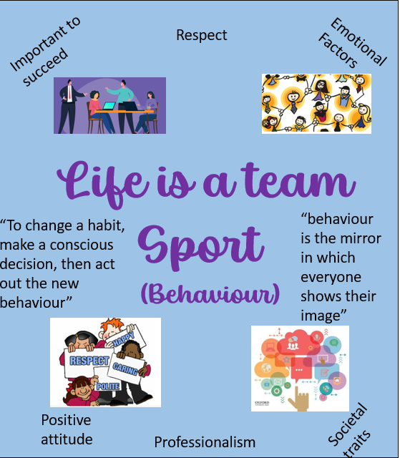

References:
Doyle, A. (2022). What Are Teamwork Skills? [online] The Balance. Available at: https://www.thebalancemoney.com/list-of-teamwork-skills-2063773 [Accessed 6 Mar. 2023].Indeed (2023). Cultivating Positive Workplace Behavior. [online] www.indeed.com. Available at: https://www.indeed.com/hire/c/info/cultivating-positive-workplace-behavior#:~:text=The%20term%20%E2%80%9Cworkplace%20behavior%E2%80%9D%20encompasses [Accessed 6 Mar. 2023].NSW Health (2020). What factors can affect behaviour? - Principles for effective support. [online] www.health.nsw.gov.au. Available at: https://www.health.nsw.gov.au/mentalhealth/psychosocial/principles/Pages/behaviour-factors.aspx [Accessed 6 Mar. 2023].Thompson, V. (2023). How Can Behavior Affect Academics for Students? [online] How Can Behavior Affect Academics for Students? Available at: http://jano.us/ngms/support/How%20Can%20Behavior%20Affect%20Academics%20for%20Students_%20_%20Everyday%20Life%20-%20Global%20Post.pdf [Accessed 6 Mar. 2023].University of Wales Trinity Saint David (2021). This document sets out the standards of conduct that are expected of students at UWTSD. [online] UWTSD STUDENT CODE OF CONDUCT. UWTSD. Available at: https://www.uwtsd.ac.uk/media/uwtsd-website/content-assets/documents/student-experience/UWTSD-Student-Code-of-conduct-2021.pdf [Accessed 6 Mar. 2023].Vyas, S., Rashod, P.V., Modh, J. and Koradia, N. (2019). Designing and Testing of the SNJP Behaviour Assessment Scale. [online] Available at: https://www.researchgate.net/publication/364102684_Designing_and_Testing_of_the_SNJP_Behaviour_Assessment_Scale [Accessed 6 Mar. 2023].

To conclude, there are many essential skills which I can develop through personal research and my experiences to benefit my personal life and academic and professional career.

