
BMMB7028
Business Research

Name: SK MD SHOIB HASAN
ID: 2505891

Research Proposal Topic

The Effectiveness of Social Media Marketing on Customer Gaining: A Case Study of Nike Inc. in the UK

Contents
1. Introduction 1
1.1 Research rationale 2
1.2 Research background 2
1.3 Research aims and objectives 4
1.4 Research Questions 4
2. Literature review 5
2.1 Introduction 6
2.2 Social media marketing strategies 6
2.3 Customer engagement in digital marketing 8
2.4 Effectiveness of social media marketing 11
2.5 Conceptual framework 13
3. Methodology 15
3.1 Introduction 16
3.2 Research philosophy 17
3.3 Research approach 17
3.4 Research method 18
3.5 Data source 18
3.6 Data collection tool 18
3.7 Significance of the research 19
3.8 Ethical consideration 19
3.9 Gantt chart 20
3.10 Methodology summary 21
4. References 22
5. Appendix 30
5.1 Literature review summery 31

List of figures
Figure 1: Current trends in social media marketing 3
Figure 2: Conceptual Framework 13
Figure 3: Research onion model 16
Figure 4: Gantt Chart 20

List of tables
Table 1: Methodology summary 21
Table 2: Literature review summery table 31

1. Introduction

1.1 Research rationale
Social media marketing is regarded as a significant business tool in the present-day digital era. Businesses are turning to social networks like Instagram, TikTok and YouTube. The companies utilise these social media sites to reach the customers through advertisements of their products. Nike Inc. is one of the top corporations in this region, and it is very active in the UK market. Nike uses social media as a means of creating brand awareness, relationships and influencing customer behaviour. The background of this study can be explained by the increased relevance of customer contact in modern marketing (Kautish et al., 2025). Customer engagement entails the interaction of customers with a brand in terms of likes, comments, shares, etc. Customer loyalty, good brand perception and sales increase could be achieved by high engagement. Thus, it is relevant to comprehend the implications of social media marketing on the process of customer interaction. Despite the high costs that are being incurred by numerous businesses in this field to connect with the customers effectively. Doubts exist regarding its effectiveness. There is some research which indicates that social media enhances degree of reach to the customers and increase the number of loyal customers. Other studies, however, claim that high engagement is not necessarily translated into purchases and financial results (Harken et al., 2025). This leaves businesses at a crossroads as they deliberate on the degree to which they should invest in social media marketing. The other reason why the author did this research is that there is no company-specific study. A significant proportion of the current research is done on general industries or several companies. Little literature is available specifically on Nike Inc., particularly in the UK. Nike enjoys a good reputation in the area of digital marketing and partnerships with influencers, and it is an appropriate case to study. Lastly, this study has some practical and academic significance. It will assist businesses in knowing the effective social media strategies. It will also help in the field of academics as it will fill gaps in available literature.

1.2 Research background
The last ten years have seen social media marketing evolve very fast. It has transformed the manner of communicating with customers in businesses. Such conventional marketing channels as television or print advertising are nowadays supported or substituted by digital media. Social media enables businesses to access a wide audience at a low cost.
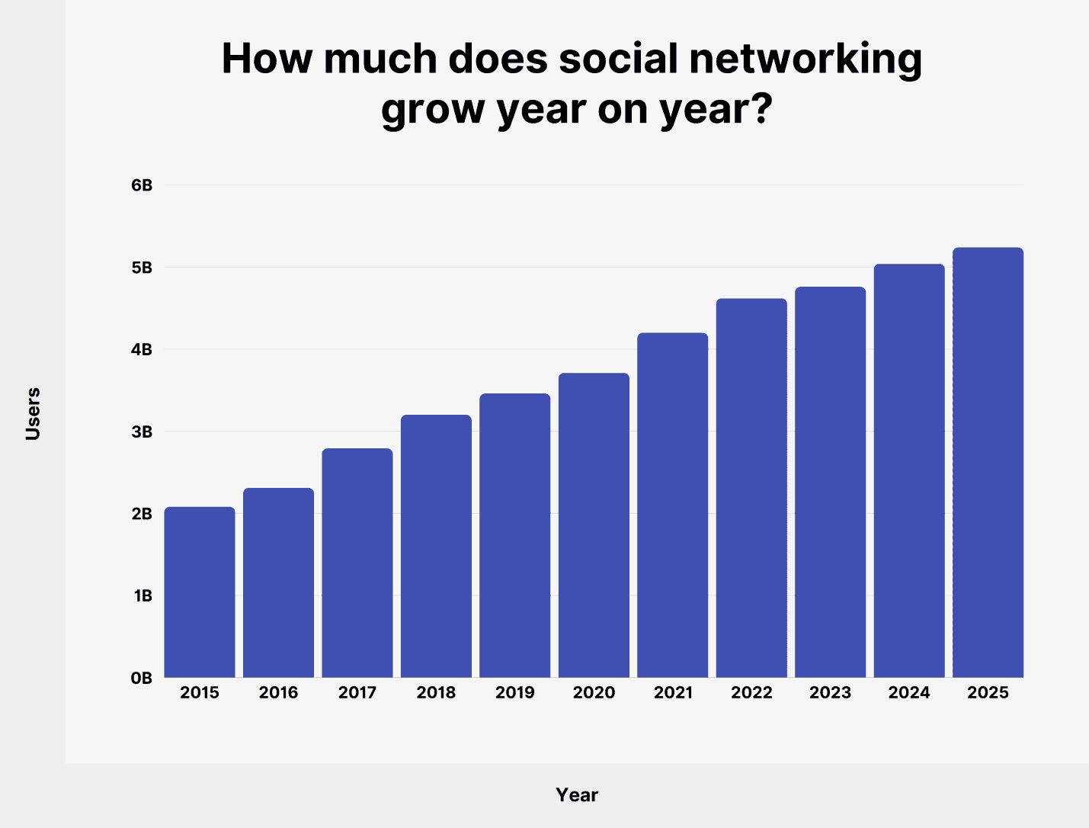
Figure 1: Current trends in social media marketing
Source: (Abid et al., 2025)
One of the most effective brands in terms of utilising social media marketing is Nike Inc. The company is international and has a high presence in the UK. Instagram, Twitter (X), and YouTube are some of the platforms that Nike relies on to market its products and brand values. Its marketing campaigns are usually driven by motivation, performance, and social issues. The campaign of Nike that can be used as an example of the usage of emotional storytelling is the campaign Just Do It. The company also collaborates with sportspeople and influencers to advertise its products (Ali et al., 2025). The tactics can assist Nike in reaching younger generations who use social media. Marketers have placed a lot of emphasis on customer engagement. Customers who are engaged will tend to believe in a brand and refer it to others. Social media offers two-way communication in which customers get a chance to directly communicate with brands. This communication is used to establish good relations. Nonetheless, there are also difficulties. The level of competition in social media platforms is high, and companies can hardly be distinguished. There are constant changes in the algorithms, and this influences the presentation of content to the user. Moreover, it is hard to evaluate the efficiency of social media marketing. The number of likes and shares is not invariably an indication of true business success. The consumers in the UK market are very active on social media. This renders the need of firms such as Nike to establish strategies that are effective stratgies. Thus, the analysis of Nike’s social media marketing and its effectiveness in terms of interaction with customers is topical and timely.

1.3 Research aims and objectives
The goal of the study will be to assess the usefulness of social media marketing in enhancing customer interactions within Nike Inc. in the UK. The aims of the research are written down below:
- To find out the impact of Nike Inc. on the social media sites in the UK.
- To find out things that make customers interact with Nike content.
- To find out the level of effectiveness of the Nike social media strategies in enhancing engagement.
- To find out some of the challenges to social media marketing practice at Nike.

1.4 Research Questions
Some questions have been developed to undergo the research smoothly. The questions are provided below:
- What is the role of Nike Inc. on the social media platforms in the UK?
- What makes customers interact with Nike content?
- What is the degree of effectiveness of the Nike social media strategies in enhancing engagement?
- What are some of the challenges to social media marketing practice at Nike?

2. Literature review

2.1 Introduction
The literature review investigates one of the main concepts associated with social media marketing and customer engagement. It is concerned with the way in which businesses engage with customers using social media and enhance the performance of the brand. The review is organised in three key categories, which include strategies of social media marketing, customer participation in digital marketing, and the effectiveness of social media marketing. These themes are directly connected with the research aim and questions. To see the application of these concepts in the real business setting, the case of Nike Inc. is believed to be taken into consideration. The review also reveals some of the major debates as well as gaps in the research that are available.

2.2 Social media marketing strategies
According to Apasrawirote et al. (2022), social media marketing is the utilisation of social media to advertise products and services, and the values of the brand. Wong et al. (2022) have stated that social media incorporates applications that are run on internet. It enables users to generate and distribute content. The businesses take advantage of these platforms to communicate with the customers and create relationships. According to Ibrahim and Aljarah (2024), there are almost 5 billion social media users in the world. It is very convenient for companies to undertake social media marketing activities as it provides significant reach at the lowest possible cost. Content marketing is one of the key tactics in this type of marketing activity. Some of the content may be in the form of images, videos, blogs and short videos. Quality content can be used to capture the interest of customers and retain them. It also generates trust and credibility.
To illustrate, Nike Inc. creates aesthetically powerful and inspirational content which resonates with the brand values. This form of communication stimulates customers to visit the brand. Moedeen et al. (2024) have added that influencer marketing also has crucial value. Influencers refer the people whom a huge amount of people follow on social media. They advertise products and services to their visitors. As they are public figures, people can follow them. Besides, influencers are usually trusted more than conventional advertisements. The brand ambassadors of Nike Inc. include famous athletes and celebrities. According to Balaji et al. (2023), the revenue of Nike increased by $300 million after signing Tiger Woods. Besides, Michael Jordan has earned more than a billion USD for Nike Inc. as a brand ambassador. Nonetheless, this strategy is debatable. Influencer marketing may decrease trust if it seems to be overly commercial.
Social media marketing is also extensively done via paid advertising. According to Stam (2023), Social media like Instagram and Facebook enable companies to appeal to certain audiences. Businesses can choose target users according to their age, geographic locations and interests. This brings about effectiveness and efficiency in marketing. To illustrate, Nike will be able to reach young sports-lovers in the UK. Nevertheless, the paid advertising involves a monetary investment. It might not necessarily ensure the involvement or loyalty of the customer. Another important strategy is user-generated content. Liu et al. (2025) have mentioned that, as an example, customers can leave pictures or videos of Nike products. Such content is relevant in that it enhances authenticity. Customers would tend to believe information that has been provided by fellow customers. It also promotes communal development. Nike frequently encourage user-created hashtags and campaigns on which people can share their experiences. Social media marketing also involves storytelling. Bonilla (2022) has added that stories are used by businesses to reach customers on their emotions. Emotional attachment will be able to enhance involvement and brand loyalty. Nike Inc. has a famous storytelling approach. Its advertising campaigns are usually based on motivation, equality, and personal accomplishment. These messages are very emotional, and they stimulate customer interaction.
Various social media platforms have to be treated differently. Instagram is predominantly a visual-based platform, where pictures and brief video clips have been utilised. TikTok is centred on entertaining and creative short videos. Long videos and narration are done through YouTube. Companies have to know how to utilise each platform. Maduku (2024) has analysed that Nike reach 1.7 billion potential customers through these social platforms. Another factor that is of relevance to social media marketing is consistency. Safeer (2024) has said that companies must keep consistent updates to keep customers interested. Unstable posting may decrease the visibility. The posts should be posted at the time when the target audience is the busiest. This enhances the probability of participation. Although these are the advantages, social media marketing has a number of challenges that are associated with its use. Al-Abdallah et al. (2025) have added that content saturation is one of the major challenges. Social media is being utilised by a majority of businesses, thereby generating a great deal of competition. It is made hard to capture attention. The other issue is the problem of changing algorithms. The social media tend to alter the presentation of the content. This has an influence on the number of people viewing a post.
The question of the effectiveness of these strategies is also debatable. Though other researchers feel that social media marketing enhances brand awareness and customer relationships, some believe that it does not necessarily increase sales. As an illustration, a post can get numerous likes but not lead to purchases. This makes success measurement a challenge. Chen (2024) has described that, at Nike Inc., the firm employs a mixture of various strategies. It is a blend of content marketing, influencer collaboration, storytelling and user-created content. Such a combined strategy assists Nike in remaining strong in the UK market. Its campaigns are frequently viral, and this means that they gain visibility and reach. Lopes et al. (2025) have added that social media marketing strategies are critical to contemporary businesses. They enable accessibility to the consumers and the development of strong relations. Their success, however, is dependent on the effectiveness of their implementation. Firms need to constantly keep changing their strategies depending on the trends and tastes of their customers.

2.3 Customer engagement in digital marketing
So et al. (2024) have defined customer engagement as the level of collaboration and relationship of consumers with a particular brand. Customer engagement incorporates the cognitive, emotional, and behavioural aspects. It does not just involve mere purchasing behaviour but also encompasses liking, comments, sharing and engaging in content on online platforms. When applied to social media, customer engagement becomes a crucial aspect in establishing good relationships between businesses and customers. Kumar et al. (2025) have described three major ways of customer engagement. The first one is cognitive engagement, which is associated with customer thinking regarding a brand. It entails the knowledge, curiosity, and awareness. As customers constantly consume content from a brand, they become more conversant with the content. Indicatively, as long as users in the UK often consume Nike Inc. content, they gain knowledge regarding its products and values.

The second one is emotional engagement. Hazzam (2022) has stated that customer perceptions towards a brand are regarded as emotional engagement of the customers. Excitement, trust, and inspiration are some of the emotions that can help to reinforce the relationship between the customers and a company. Kulikovskaja et al. (2023) have described that 92% of the loyal customers tend to have emotional engagement with the brands they buy. Nike Inc. is recognised as one that produces emotionally powerful content. Its campaigns are usually motivation and achievement-based, and social issues are addressed by its campaigns. The third one is the behavioural engagement. Hsu (2023) has described that the behavioural engagement involves posting likes, comments, sharing, clicking links, and online discussions. Social media metrics are usually used to determine behavioural engagement. It helps in creating more loyal customers. Nike Inc. has more than 100 million loyal customers throughout the world. Chen, (2024) has stated that social media sites are significant in customer interaction. They offer a two-way communication space. Social media enables customers to communicate directly with brands, unlike traditional marketing, where there is one-way communication. Customers can question, give feedback, and share their opinions. This communication aids in the development of trust and transparency. Customer engagement is measured using several metrics. According to Abbasi et al. (2024), customer engagement in 2024 in Nike Inc. was high as measured by customer retention rate, churn rate and customer satisfaction score, which is also known as CSAT. The high retention level ensured by the repeat purchases and loyalty programmes was a sign of high brand attachment. Its churn rate was not that high (it was approximately 9.5% in the benchmarks of the same industry), and it indicated that fewer customers ceased to buy because of the effective engagement practices. Moreover, Roy et al. (2023) have found that Nike recorded a high CSAT of approximately 88%, indicating that the majority of the customers were content with what the company offered, including products and services, a factor that enhances long-term relationships and brand loyalty. There are a number of advantages to businesses of customer engagement. First, it enhances brand loyalty. According to García-Magro et al., (2023), customers who are engaged will have better confidence in a brand and remain loyal to purchase its products. It also enhances brand awareness. Customers are able to share content, and this reaches more people. Third, interaction makes companies know the preferences of customers. Interactions and feedback give an important understanding of the customer requirements. Although these advantages exist, it is not easy to attain good customer engagement. Strong competition exists in the market. Aljuhmani et al., (2023) have stated that there are a lot of brands that customers are exposed to, and it is hard to capture their attention. Companies need to develop original and imaginative content in order to be unique. The other one is that of consistency. It needs time and resources to post regularly to keep the customers interested.
Content relevance is another issue. When there is no relevance in the content, there will be low levels of engagement. That is why companies should know who their audience is and adjust their content to the target audience. Ju (2024) has mentioned that authenticity is another important customer engagement aspect. Customers would like to see authentic and sincere communication. When the content seems to be over-promotional or unnatural, it can lower trust. This is especially significant in influencer marketing. In the event that the customers ignore the authenticity of the influencers, engagement might decrease. Das, and Narayan, (2025) added that customer involvement is significant in the marketing strategy of Nike Inc. in this case. Social media is seen to help the company establish a great emotional connection with the audience. It posts inspirational material that drives the customers. It is also participatory with the help of campaigns and hashtags. The use of athletes and influencers is used by Nike to make the experience more engaging. People are connected with personalities who are famous, and this bond makes them relate to the brand. Besides that, Nike is working with interactive media, including videos, challenges, and live sessions. Such activities ensure that the users are engaged. Nike, too, however, has its challenges. Hsu (2023) has mentioned that people may use social media to reduce brand reputation in a short time through negative feedback. Moreover, to keep the level of engagement high, it is necessary to be innovative and creative all the time. The firm should forever be responsive to emerging trends and preferences of customers. Babu, and Prasad, (2025) have added that customer engagement and its relation to business performance are also topics of debate. Other researchers are of the view that when there is high engagement, then sales and profitability increase. There are other arguments that engagement does not necessarily translate to purchases. As an example, the customers can engage in the content but not purchase products. This makes it hard to know the actual worth of engagement. Rabbanee et al. (2023) have stated that, in general, customer engagement is a necessary component of digital marketing. Social media offers numerous avenues through which companies can engage clients. Nevertheless, to have effective engagement, it is important to plan, to be creative and to understand customer behaviour. With Nike Inc., the company has been able to leverage social media and has created high levels of engagement, but still requires more adjustment to the changing times in order to be on par.

2.4 Effectiveness of social media marketing
Marketing effectiveness in social media marketing has emerged as a significant issue of discussion in marketing research. According to Nanik Wahyuningtiyas and Tri Sugiarti Ramadhan (2023), companies have used a lot of resources in social media to market their products as well as establish business relationships with their customers. Nevertheless, the effectiveness of such efforts in terms of fulfilling business goals is still disputed. Effectiveness can be interpreted in respect to brand recognition, customer involvement, customer loyalty and financial performance. Sudhaker et al. (2022) have added that social media marketing helps in spreading awareness about the product and its features. Social networks enable companies to communicate with a high number of people within a short period of time. Sharing of content is possible, and hence visibility is heightened. Indicatively, Nike Inc. regularly involves more than 1 million customers throughout social media. Jayashree et al. (2025) have mentioned that The Company involves itself in international campaigns, which tend to trend. Such campaigns will ensure that the company targets millions of users in the UK and elsewhere. The enhanced visibility assists in enhancing brand awareness and market share. Ouyang (2024) has added that social media offers a channel of personal contact between a customer and a business. The strong levels of involvement mean that customers take an interest in the brand. The likes, comments, and shares present an indication that users are actively consuming content. In Nike Inc., the strategies of participation are motivated by emotional narratives, athlete promotions, and interactive advertisements. The company earn more than $5 million through media value. Ma et al. (2025) have mentioned that social media marketing also determines customer loyalty. The satisfied customers will have more chances of building trust in a brand. Repetitive purchases and long-term relationships may be achieved through trust. Social media enables companies to keep in constant touch with the customer, and this enhances loyalty. To illustrate, Nike posts regular and inspirational content they share that correlates with their brand values. This will assist in creating customer base loyalty in the UK market.

Although these have been the benefits, there is controversy on whether social media marketing is causing actual sales. Certain scholars opine that only higher level of customer engagement cannot enhance financial performance. Balaji et al. (2023) have stated that a post can be liked and shared by a large number of people, but this does not ensure that products are bought by the customers. This poses a problem of determining the actual value of social media marketing. Another important issue is the return on investment (ROI). Companies must learn to know whether their marketing activities are creating value. Nevertheless, social media marketing is difficult to measure ROI on. Kethuda, and Ayoubi, (2026) have mentioned that Nike has experienced 300% ROI on investment in influencers and social media marketing. The conventional measures that include sales revenue are not sufficient in measuring the effect of engagement and brand recognition. Consequently, companies tend to make use of such indirect indicators as reach and the degree of interaction. This renders it cumbersome to tell the precise financial gains of social media activities. Besides, it has enabled the company 26% new customers in the last year. Nevertheless, social media marketing has a number of weaknesses that lower its effectiveness. Elfi et al., (2025) have specified that content saturation is one of the challenges. Social media platforms have numerous brands that are competing over who will go online. This complicates the ability of businesses to shine. The content that customers are being exposed to is quite high, and hence, they may lose interest.
Alteration of algorithms is also another challenge. According to Dao et al., (2025), the algorithms used in social media are often changed and have an influence on the presentation of content. This has the capacity of making posts less visible, although the content might be of high quality. Strategies need to be changed continuously to ensure the effectiveness of the businesses. There is also the risk of negative feedback. Ferreira et al., (2026) have added that through social media, customers are able to air their views. Negative remarks or reviews may go viral and hurt the reputation of a brand. Both companies are forced to act swiftly and be cautious about their presence on the internet. Long-term effectiveness is also a question. According to Chen et al., (2025), social media marketing has short-term advantages, including the increase in visibility. Nevertheless, customer relationships and consistent value provision would make it successful in the long-term. Companies need to aim for short-term interaction and long-term brand development.

Social media marketing is, in general, a powerful means of spreading brand awareness and reaching customers. But the effect it has on financial performance is not as obvious. Social media marketing success is determined by numerous factors, which include the quality of content, the use of the platform and the behaviour of the audience. At Nike Inc., the company has effectively taken advantage of social media as a means of creating a strong brand and reaching out to customers. Nevertheless, it should keep up with the demands of such obstacles as competition, changes in algorithms, and measurement challenges.

2.5 Conceptual framework
The conceptual framework of this research paper explains why social media marketing is correlated with customer engagement. It establishes the most important variables that determine the effectiveness of the marketing techniques used by Nike Inc. in the UK
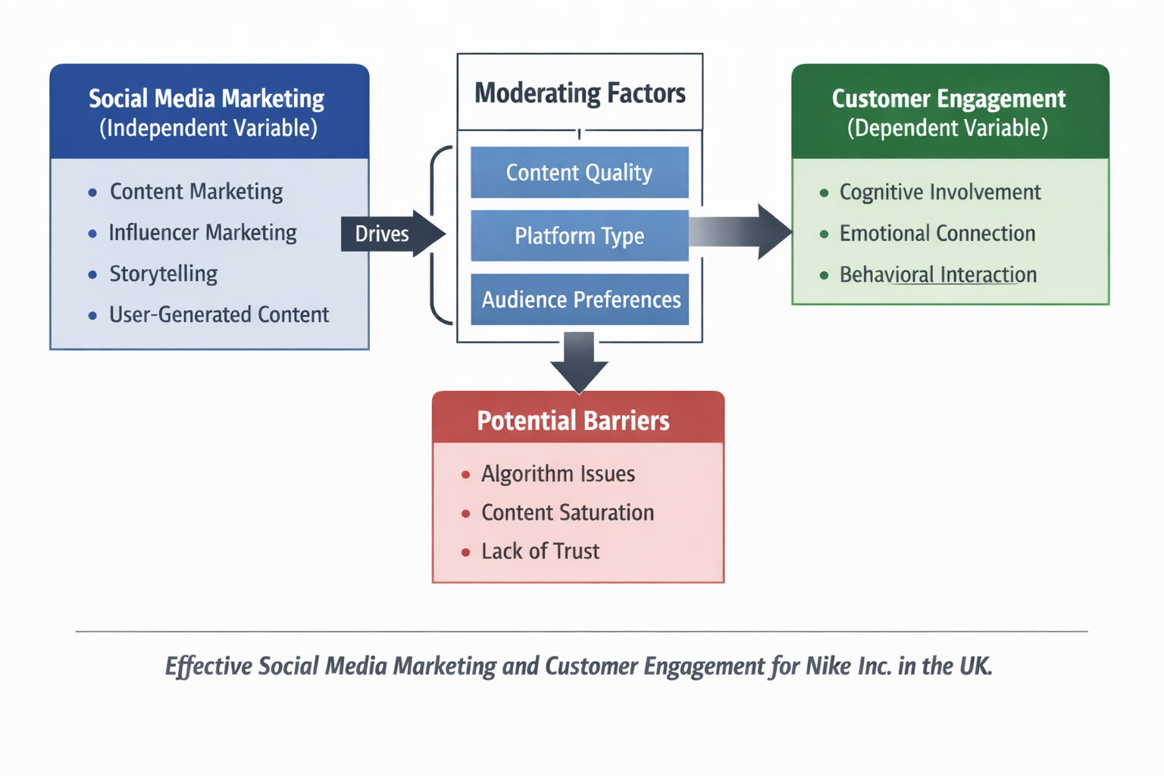
Figure 2: Conceptual Framework
Source: (Ferreira et al., 2026)
Social media marketing is the independent variable in this research. Some of the strategies included in it are content marketing, influencer marketing, storytelling, and user-generated content. The strategies should impact the customer interactions. The dependent variable is customer engagement. Senzo et al., (2026) have mentioned that it encompasses the cognitive, emotional, and behavioural involvement, awareness, emotions and interactions with the content. Moderating factors are also taken into consideration in the framework. These are the quality of content, the type of platform, and the preferences of the audience. In case the high-quality and relevant content is more likely to increase engagement. In the same fashion, various social media sites might generate varying degrees of interaction. Moreover, errors in algorithms, content oversaturation, and lack of trust, among other issues, can also impact the effectiveness of social media marketing on customer engagement. The marketing efforts can be diminished by these factors. In general, the conceptual framework demonstrates that effective customer engagement may be achieved by using effective social media. Nevertheless, the result of this is affected by various factors. This model leads to the analysis of Nike Inc. in this paper.

3. Methodology

3.1 Introduction
The methodologies that will be followed to conduct the research will be proposed here. It explains the techniques and strategies used in attaining the research aim and objectives. The paper will examine the effectiveness of social media marketing in customer engagement at Nike Inc. in the UK.

Figure 3: Research onion model
Source: (Musundire, 2025)
The study is organised on the model of the Research Onion created by Saunders. This paradigm offers a definite outline of how to choose the right research techniques. It comprises various layers which include research philosophy, research approach, research strategy, data collection and data analysis. The Research Onion has each layer that assists in guiding the process of the research. It makes sure that the research methods picked to answer the research questions are appropriate. The current research is systematic in a bid to attain reliability and validity. Each methodological choice is described in the following sections.

3.2 Research philosophy
Research philosophy refers the views and ideas regarding the formation of knowledge. The research philosophy of this study is interpretivism. Interpretivism is concerned with the interpretation of human behaviour and social interactions. It fits well in this study, since the engagement of customers is associated with personal experience, perception and feelings (Bayuo et al., 2025). Under Nike Inc., customer interaction is pegged on the interpretation of individuals with regard to social media content. The same marketing strategy may not receive similar responses in the eyes of different customers. Hence, one should learn the subjective experiences. The interpretivism approach enables the researcher to delve into customer behaviour to its deeper meanings. It assists in the evaluation of the imapct of social media marketing plans on engagement. This method is more relaxed than positivism, which deals with numerical data. On the whole, the interpretivist philosophy is suitable for this study because it aims at comprehending the view of customers and their interactions in a real-life setting.

3.3 Research approach
Research approach is defined as the production of knowledge. That means it shows a comprehensive plan for collecting data and analysing it. The research approach applied in this study is inductive. Inductive research is where data are gathered, and patterns, themes and conclusions are made. It is not beginning with a certain theory.
Inductive approach would work well in this research since it seeks to investigate the impact of social media marketing on customer engagement. It will enable the researcher to collect data and determine patterns surrounding Nike Inc. (Gomal Journal of Medical Sciences, 2025). The inductive approach, in contrast to the deductive one, constructs new knowledge based on the data as opposed to testing the existing theories. This comes in handy in regions where limited research is conducted on the company. The study under analysis is about Nike in the UK, so it has the advantage of being an exploratory study. Qualitative analysis is also backed by the inductive approach. It assists in determining customer behaviour themes and marketing strategies, as well as effectiveness. Thus, it is suitable for attaining the research aim and objectives.

3.4 Research method
The methodologies of data collection and analysis are known as research methods. The proposed study uses a qualitative research method. Qualitative research concentrates on the meanings, experiences and interpretations and not the numerical data. The qualitative approach would be appropriate in this investigation since it examines customer engagement and social media marketing policies at Nike Inc. These concepts are the human behaviour and perceptions that cannot be quantified by using figures (Bayuo et al., 2025). It is a case study based on Nike in the UK. This can be analysed in a detailed and in-depth manner. The secondary sources include academic journals, company reports, and online materials obtained as sources of qualitative data. It also endorses the thematic analysis method, which assists in identifying patterns and themes of the data. All in all, the qualitative research method is suitable for investigating the research problem and fulfilling the study objectives.

3.5 Data source
The research is based on secondary data sources to analyse the research problem. Such sources are academic literature, industry reports and information related to the company. Theoretical knowledge of social media marketing and customer engagement can be obtained through academic journals. These are peer-reviewed sources that are considered to be reliable. Industry reports give an insight into the trends in the market and consumer behaviour in the UK. They assist in comprehending the use of social media by businesses and customers. Organisational reports like Statista are beneficial in statistical data (D’Mello et al., 2026). Besides, the official site of the company and the reports of Nike Inc. are also used to gather company-specific data. This entails data on marketing plans and the internet. Recent information is also provided on online articles and news sources. Nevertheless, such sources are critically assessed to avoid any lack of credibility. In general, the utilisation of multiple sources enhances the validity of the research and its reliability.

3.6 Data collection tool
Secondary data collection tools employed in this study will collect the relevant information. The secondary data is the data that has been gathered by other organisations or researchers. The primary resources utilised are academic databases, reports of companies, and the Internet. Academic journals and articles are accessed using Google Scholar. These materials give theoretical information regarding social media marketing and customer interaction. Moreover, industry reports provided by other sources, including Statista, are utilised to learn about the existing trends in the UK market (Srinidhi, 2025). The tools also include company reports and the official websites of Nike Inc. These are the sources of information on the marketing strategies and performance of Nike. Such tools work well since they offer sound and broad data. They, however, are not always expected to present specific information with respect to the research objectives. As a result, there should be selective and careful use of sources so as to guarantee the quality of data.

3.7 Significance of the research
The research has significance in both academic and practical fields. It shows the way Nike use social media marketing to influence customer engagement. The paper focuses on a specific company instead of focusing on the overall industry. The author has analysed the literature available based on this topic. This may help in feel the gap of company based research. Findings of the research may help businesses to have a better understanding and knowledge of social media marketing. Besides, the way of using it to gain customer attraction and engagement can also be noticed. It may help businesses to improve their performance regarding social media marketing. Besides, the research includes key challenges and obstacles of social media marketing. Thus, the research would be valuable for students, business professionals and researchers at the same time. Discussion in this research may help in developing social media marketing and may enhance competitiveness in the digital marketing sector.

3.8 Ethical consideration
The ethical aspects are significant in research. This paper is guided by ethical standards which will make it to be of integrity and reliability. There is no direct participation of the subjects since the research is based on secondary data. Nevertheless, ethics are yet to be addressed. Plagiarism is one of the issues to be avoided. The references to all sources are adequate in order to credit the original authors. This guarantees academic honesty. The accuracy of data is another problem. The study only uses credible and reliable sources (Bond et al., 2025). The issue of confidentiality is also taken into account. Though the study utilises the publicly available data, it does not misuse any sensitive information. The research also reports information sincerely and impartially. Misinterpretation of data is also avoided in the study. When analysing the information, the analysis is done meticulously in order to make appropriate conclusions. In general, ethical considerations are applied in the course of research to make sure that it can be considered credible and trustworthy.

3.9 Gantt chart
The research is planned and managed using a Gantt chart. It assists in planning activities and getting the study through within the timeline allocated. It is hoped that the research will be done in about 19 weeks.
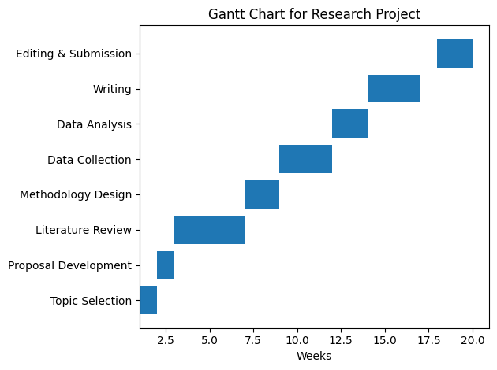
Figure 4: Gantt Chart
Source: (Fetz et al., 2025)
The initial step is the selection of a topic and proposal development. This is followed by a literature review, which is the most time-consuming. The second step is methodology design, which involves choosing research methods. Secondary sources are used to collect the data. Thematic analysis is then used to analyse data. The results are then drafted and tabulated into a report. Lastly, before submitting the research, it is revised and edited. The Gantt chart will make sure that every stage is done in time. It also assists in the detection of any delays. The right time management enhances the quality of the research on Nike Inc.

3.10 Methodology summary
The methodology summary is provided below:
Table 1: Methodology summary
Aspect | Description
Research philosophy | Interpretivism approach
Research approach | Inductive approach
Research method | Qualitative method
Data collection tool | Secondary
Data source | Different journals, articles, reliable websites, news, etc.

The methods selected by the researcher are appropriate for attaining the research aim and objectives. They enable one to understand customer engagement and marketing in a very detailed manner. Reliability is maintained by observing ethical considerations. In general, the methodology is clear and well-structured in performing the research and addressing the research questions in an appropriate manner.

4. References

Abbasi, A.Z. Qummar, H., Bashir, S., Aziz, S., andTing, D. H. (2024) “Customer engagement in Saudi food delivery apps through social media marketing: Examining the antecedents and consequences using PLS-SEM and NCA,” Journal of retailing and consumer services, 81. Available at: https://doi.org/10.1016/j.jretconser.2024.104001.
Abid, A. Roy, S. K., Lees-Marshment, J., Dey, B. L., Muhammad, S. S., and Kumar, S. (2025) “Political social media marketing: a systematic literature review and agenda for future research,” Electronic commerce research, 25(2), pp. 741–776. Available at: https://doi.org/10.1007/s10660-022-09636-7.
Al-Abdallah, G. Barzani, R., Omar Dandis, A., and Eid, M. A. H. (2025) “Social media marketing strategy: The impact of firm generated content on customer based brand equity in retail industry,” Journal of marketing communications, 31(8), pp. 1025–1054. Available at: https://doi.org/10.1080/13527266.2023.2300076.
Ali, F. Suveatwatanakul, C., Nanu, L., Ali, M., and Terrah, A. (2025) “Social media marketing and brand loyalty: exploring interrelationships through symmetrical and asymmetrical modeling,” Spanish journal of marketing-ESIC, 29(1), pp. 114–135. Available at: https://doi.org/10.1108/SJME-08-2023-0219.
Aljuhmani, H.Y. Elrehail, H., Bayram, P., and Samarah, T. (2023) “Linking social media marketing efforts with customer brand engagement in driving brand loyalty,” Asia Pacific journal of marketing and logistics, 35(7), pp. 1719–1738. Available at: https://doi.org/10.1108/APJML-08-2021-0627.
Apasrawirote, D., Yawised, K. and Muneesawang, P. (2022) “Digital marketing capability: the mystery of business capabilities,” Marketing intelligence & planning, 40(4), pp. 477–496. Available at: https://doi.org/10.1108/MIP-11-2021-0399.
Babu, K.V. and Prasad, V.N. (2025) “Nike’s Metaverse Foray: Exploiting a Revenue Opportunity or Riding a Fad?,” IUP Journal of Brand Management, 22(1), pp. 73–90. Available at: https://doi.org/10.71329/IUPJBRM/2025.22.1.73-90.
Balaji, M.S. Behl, A., Jain, K., Baabdullah, A. M., Giannakis, M., Shankar, A., and Dwivedi, Y. K. (2023) “Effectiveness of B2B social media marketing: The effect of message source and message content on social media engagement,” Industrial marketing management, 113, pp. 243–257. Available at: https://doi.org/10.1016/j.indmarman.2023.06.011.
Bayuo, J. Nyande, F. K., Awunyo, W., and Akpalu, E. (2025) “The longitudinal qualitative research design in nursing, health, and social care research: philosophy, methodology, and methods,” BMC medical research methodology, 26(1). Available at: https://doi.org/10.1186/s12874-025-02736-6.
Bayuo, J. Wong, F. K. Y., Li, Y., Lu, W., and Wong, A. K. C. (2025) “Framing the Multi‐Centre Qualitative Research Design as a Novel Methodology for Nursing and Healthcare Research: Reflections and A Methodological Discussion,” Journal of advanced nursing, 81(8), pp. 5196–5207. Available at: https://doi.org/10.1111/jan.16548.
Bond, C., Watson, A. and Jackson, D. (2025) “Addressing Potential Researcher Distress in Nurse‐Led Research: Ethical Considerations and Practical Strategies,” Journal of advanced nursing, 81(4), pp. 2159–2164. Available at: https://doi.org/10.1111/jan.16799.
Bonilla, B. (2022) “How a relatively unknown digital agency won the Nike media account; PMG goes from ‘well-kept secret’ to ‘threat,’” Ad Age, 93(13), p. 14.
Chen, H Lou, C., Wang, Y., and Lee, Y. (2025) “Social Virtual Influencer Effectiveness: Environmental Factor and Source Trust,” Social marketing quarterly, 31(3), pp. 199–219. Available at: https://doi.org/10.1177/15245004251342800.
Chen, T. (2024) “A study on Nike’s digital marketing strategy based on the 4Ps theory and analysis of competitiveness maintenance methods,” SHS web of conferences, 207, p. 1007. Available at: https://doi.org/10.1051/shsconf/202420701007.
D’Mello, C. Milroy, H., Papageorgiou, A., Coleman, M., Dudgeon, P., Anderson, P., Batty, D., and Lin, A. (2026) “Implementing Cultural Safety in Research Methodology: The Co‐Design Process of a Brief Therapeutic Intervention for Aboriginal and Torres Strait Islander Young People Who Engage in Self‐Harm and/or Suicidal Behaviours,” The Australian journal of rural health, 34(1), pp. e70152-n/a. Available at: https://doi.org/10.1111/ajr.70152.
Dao, T.C. Liao, Y.-K., Chen, G., Luu, T.-M.-N., and Le, T. M. (2025) “The Influence of B2B Social Media Marketing and Relationship Marketing on Customer Relationship Management Effectiveness, WOM and Loyalty: A Mediator Analysis,” International review of management and marketing, 15(1), pp. 71–81. Available at: https://doi.org/10.32479/irmm.17340.
Das, S. and Narayan, P. (2025) “The Impact of Augmented Reality Marketing on Customer Engagement: A Comprehensive Analysis of Social Media Metrics,” Journal of the Institution of Engineers (India) Series C, 106(5), pp. 1469–1482. Available at: https://doi.org/10.1007/s40032-025-01234-4.
Elfi Elfi, Sabrina O. Sihombing and Ferdi Antonio (2025) “Illuminating the Pathway from Social Media Marketing Stimuli to Skincare Brand Choice Through Product Effectiveness,” Asia Marketing Journal (Online), 27(1), pp. 18–38. Available at: https://doi.org/10.53728/2765-6500.1646.
Ferreira, A.G. Crespo, C. F., Ribeiro, F. M., and Barreiros, P. (2026) “The social media theatre: New guidelines to foster parasocial interactions with followers and improve influencer marketing communication effectiveness,” Journal of marketing communications, 32(2), pp. 120–144. Available at: https://doi.org/10.1080/13527266.2024.2318696.
Fetz, K., Rutetzki, J. and Lefering, R. (2025) “How to: correctly read scientific articles : Research design and methodology,” Zeitschrift für Rheumatologie, 84(4), p. 302. Available at: https://doi.org/10.1007/s00393-025-01653-9.
García-Magro, C., Martín-Peña, M.-L. and Sánchez-López, J.M. (2023) “Emotional mechanics of gamification and value co-creation: the digital platform Nike+ as a B2B2C ecosystem,” The Journal of business & industrial marketing, 38(2), pp. 414–428. Available at: https://doi.org/10.1108/JBIM-12-2021-0568.
Gomal Journal of Medical Sciences (2025) “IMPACT OF RESEARCH METHODOLOGY WORKSHOPS ON KNOWLEDGE AND SKILLS IN RESEARCH DESIGN, SAMPLING AND STATISTICAL TESTING AMONG CONSULTANTS IN MAJOR CITIES OF PAKISTAN: A QUASI-EXPERIMENTAL STUDY,” 23(4), p. 372. Available at: https://doi.org/10.46903/gjms/23.4.1990.
Harken, S., Mertins, V. and Urselmann, M. (2025) “Online Fundraising for Nonprofit Organizations via Social Media Marketing: A Critical Success Factors Analysis in Germany, Austria, and Switzerland,” Journal of Philanthropy, 30(3). Available at: https://doi.org/10.1002/nvsm.70028.
Hazzam, J. (2022) “The moderating role of age on social media marketing activities and customer brand engagement on Instagram social network,” Young consumers, 23(2), pp. 197–212. Available at: https://doi.org/10.1108/YC-03-2021-1296.
Hsu, C.-L. (2023) “Enhancing brand love, customer engagement, brand experience, and repurchase intention: Focusing on the role of gamification in mobile apps,” Decision Support Systems, 174. Available at: https://doi.org/10.1016/j.dss.2023.114020.
Ibrahim, B. and Aljarah, A. (2024) “The role of social media marketing activities in driving self–brand connection and user engagement behavior on Instagram: a moderation–mediation approach,” European journal of innovation management, 27(5), pp. 1723–1742. Available at: https://doi.org/10.1108/EJIM-08-2022-0452.
Jayashree, R., Vishal, C.S.S. and Krishna, S.V. (2025) “The Impact Of Social Media Marketing On Consumer Purchasing Decisions On Nike Shoes,” International journal of management research and reviews, 15(2), pp. 66–72.
Ju, X. (2024) “A social media competitive intelligence framework for brand topic identification and customer engagement prediction,” PloS one, 19(11), p. e0313191. Available at: https://doi.org/10.1371/journal.pone.0313191.
Kautish, P., Radia, K.N. and Radia, S. (2025) “Social Media Marketing Activities and Self-Brand Connection: The Role of Customer Engagement and Brand Authenticity,” Journal of promotion management, 31(8), pp. 1158–1178. Available at: https://doi.org/10.1080/10496491.2025.2596369.
Kethuda, O. and Ayoubi, R. (2026) “Perceived Market Leadership and Customer Engagement for IT Companies in the Enterprise Software Market: Evaluating the Role of Social Media Marketing,” Journal of business-to-business marketing, 33(1), pp. 147–166. Available at: https://doi.org/10.1080/1051712X.2024.2446812.
Kulikovskaja, V. Hubert, M., Grunert, K. G., and Zhao, H. (2023) “Driving marketing outcomes through social media-based customer engagement,” Journal of retailing and consumer services, 74. Available at: https://doi.org/10.1016/j.jretconser.2023.103445.
Kumar, A. Rayne, D., Salo, J., and Yiu, C. S. (2025) “Battle of Influence: Analysing the Impact of Brand-Directed and Influencer-Directed Social Media Marketing on Customer Engagement and Purchase Behaviour,” Australasian marketing journal, 33(1), pp. 87–95. Available at: https://doi.org/10.1177/14413582241247391.
Liu, Y., Wang, X. and Chen, Y. (2025) “Does Inconsistency Between Influencer‐Generated and User‐Generated Content Hurt Brands? The Role of Perceived Content Credibility,” Psychology & marketing, 42(9), pp. 2444–2472. Available at: https://doi.org/10.1002/mar.22240.
Lopes, J.M. Silva, L. F., Massano-Cardoso, I., and Galhardo, A. (2025) “Running Towards a Better Brand Attitude: How Gamification in Nike Run Club Can Help?,” Journal of the knowledge economy, 16(4), pp. 15427–15455. Available at: https://doi.org/10.1007/s13132-024-02398-7.
Ma, C. Wang, B. W., Dai, L., Guan, X., and Yang, Z. (2025) “What determines the effectiveness of social media influencer marketing? An fsQCA-based study of influencer characteristics and content features’ configurational effects,” Journal of business research, 189. Available at: https://doi.org/10.1016/j.jbusres.2024.115170.
Maduku, D.K. (2024) “Social media marketing assimilation in B2B firms: An integrative framework of antecedents and consequences,” Industrial marketing management, 119, pp. 27–42. Available at: https://doi.org/10.1016/j.indmarman.2024.04.003.
Moedeen, S. Aw, E. C.-X., Alryalat, M., Wei-Han Tan, G., Cham, T.-H., Ooi, K.-B., and Dwivedi, Y. K. (2024) “Social media marketing in the digital age: empower consumers to win big?,” Asia Pacific journal of marketing and logistics, 36(1), pp. 66–84. Available at: https://doi.org/10.1108/APJML-09-2022-0784.
Musundire, A., (2025). Understanding the Research Onion and Its Application in Educational Leadership and Management Research: Making Use of Saunders' Research Model. In Research Methods for Educational Leadership and Management (pp. 355-384). IGI Global Scientific Publishing.
Nanik Wahyuningtiyas and Tri Sugiarti Ramadhan (2023) “EFFECTIVENESS OF SOCIAL MEDIA MARKETING AND E-SERVICE QUALITY ON REPURCHASE INTENTION THROUGH BRAND LOYALTY,” IJEBD (International Journal of Entrepreneurship and Business Development) (Online), 6(5). Available at: https://doi.org/10.29138/ijebd.v6i5.2421.
Ouyang, K. (2024) “Analysis of Nike and Adidas Marketing Strategies on TikTok,” SHS web of conferences, 207, p. 1018. Available at: https://doi.org/10.1051/shsconf/202420701018.
Rabbanee, F.K. Roy, R., Roy, S. K., and Sobh, R. (2023) “Consumers’ digital self-extension and pro-brand social media engagement – the role of culture,” European journal of marketing, 57(9), pp. 2199–2236. Available at: https://doi.org/10.1108/EJM-01-2022-0074.
Roy, S.K Singh, G., Sadeque, S., Harrigan, P., and Coussement, K. (2023) “Customer engagement with digitalized interactive platforms in retailing,” Journal of business research, 164. Available at: https://doi.org/10.1016/j.jbusres.2023.114001.
Safeer, A.A. (2024) “Harnessing the power of brand social media marketing on consumer online impulse buying intentions: a stimulus-organism-response framework,” The journal of product & brand management, 33(5), pp. 533–544. Available at: https://doi.org/10.1108/JPBM-07-2023-4619.
Senzo, M.K., Chitamba, A. and Mbona, S. (2026) “Assessing the effectiveness of digital and social media marketing in grocery retail: Insights from SPAR in Durban,” International journal of business ecosystem & strategy, 7(6), pp. 106–115. Available at: https://doi.org/10.36096/ijbes.v7i6.1071.
So, K.K.F. Li, J., King, C., and Hollebeek, L. D. (2024) “Social media marketing activities, customer engagement, and customer stickiness: A longitudinal investigation,” Psychology & marketing, 41(7), pp. 1597–1613. Available at: https://doi.org/10.1002/mar.21999.
Srinidhi, B. (2025) “Expanding the Horizons of Research Methodologies in Accounting—Introducing Design Science,” Accounting horizons, 39(3), pp. 79–84. Available at: https://doi.org/10.2308/HORIZONS-2023-181.
Stam, A. (2023) “Ad Age A-List Awards 2023; Agency won Nike’s North America media business, capping off its 12th consecutive year of double-digit growth,” Ad Age, 94(4), p. 18.
Sudhaker, P. Madhavedi, S., Anusha, G., and Chakradhar, G. (2022) “A STUDY ON EFFECTIVENESS OF SOCIAL MEDIA MARKETING CAMPAIGNS IN REACHING AND ENGAGING TARGET AUDIENCES, ANALYZING METRICS, AND ROI,” NeuroQuantology, 20(22), p. 4295. Available at: https://doi.org/10.48047/NQ.2022.20.12.NQ77755.
Wong, L.-W. Tan, G. W.-H., Hew, J.-J., Ooi, K.-B., and Leong, L.-Y. (2022) “Mobile social media marketing: a new marketing channel among digital natives in higher education?,” Journal of marketing for higher education, 32(1), pp. 113–137. Available at: https://doi.org/10.1080/08841241.2020.1834486.

5. Appendix

5.1 Literature review summery
Table 2: Literature review summery table
S/N | Reference | Major Findings | Research Gaps
1 | Apasrawirote et al. (2022) | Social media marketing creates business strength and enhances competency in digital marketing. | Does not specialise in particular industries such as sports brands such as Nike.
2 | Wong et al. (2022) | The social media platforms provide user-generated content and customer interaction between the customer and firm. | Minimal debate as to long-term outcomes of engagement.
3 | Ibrahim & Aljarah (2024) | The social media marketing will enhance user interaction and brand loyalty. | Lacks attention to financial performance effects.
4 | Moedeen et al. (2024) | Influencer marketing would help to reach and connect with masses. | Problems of trust and over-commercialisation not investigated.
5 | Balaji et al. (2023) | The content and source of the message influence the engagement; the influencers will be able to boost the revenue. | Lacks and fails to explicitly connect engagement with actual sales conversion.
6 | Stam (2023) | Paid advertising enhances the targeted coverage and marketing effectiveness. | Disregards loyalty of customers and depth of engagement.
7 | Liu et al. (2025) | Third-party content creates believability and credibility. | Lacks short-term brand loyalty levels.
8 | Bonilla (2022) | The use of stories builds emotion among the customers. | Lacks clinical measure of effectiveness.
9 | Maduku (2024) | The social media increases the market coverage. | Lacks no engagement analysis.
10 | Safeer (2024) | Posting the advertise regularly helps in gaining more customer attention. | No attention to the quality vs quantity of content.
11 | Al-Abdallah et al. (2025) | The problem of content saturation diminishes success of social media marketing. | The few strategies offered to conquer saturation.
12 | Chen (2024) | The combination of approaches enhances competitiveness and interaction. | Does not compare strategy effectiveness on a case-by-case basis.
13 | Lopes et al. (2025) | The social media approaches improve brand relationships and interactions. | Little emphasis on ROI measurement.
14 | So et al. (2024) | Customer engagement comprises of cognitive, emotional and behavioural factors. | Fails to associate dimensions of engagement with business performance.
15 | Kumar et al. (2025) | The types of engagement affect customer behaviour and purchase intention. | The real-life case application of Lacks such as Nike.
16 | Hazzam (2022) | Brand relations are enhanced through emotional involvement. | Disregards differences of digital platforms.
17 | Kulikovskaja et al. (2023) | Customers are loyal through emotional involvement. | Lacks no negative engagement effects.
18 | Hsu (2023) | Online interactions and gamification as a measure of behavioural engagement. | Minimum attention paid to risks like negative feedback.
19 | Abbasi et al. (2024) | The retention and satisfaction metrics are enhanced through customer engagement. | Targeted in particular sector (food apps), lack of generalisation.
20 | Roy et al. (2023) | Satisfaction with customers enhances customer relationships. | Fails to take into account social media-specific.
21 | García-Magro et al. (2023) | The belief results in brand loyalty and co-creation of values. | Lacks target the new platforms such as TikTok.
22 | Aljuhmani et al. (2023) | Brand loyalty is boosted through the use of social media. | The impact of competition is not thoroughly analysed.
23 | Ju (2024) | Original information enhances interaction and forecasting systems. | The low practical use in firms.
24 | Das & Narayan (2025) | AR creates more customer interest. | Issues of technology adoption that have not been pursued.
25 | Babu & Prasad (2025) | Interaction does not necessarily result in profitability. | Empirical financial data of Lacks.
26 | Rabbanee et al. (2023) | Engagement behaviour is dependent on culture. | Lacks no attention to UK specific context.
27 | Nanik Wahyuningtiyas & Ramadhan (2023) | Social media enhances the loyalty and repurchase intention. | Minor attention to measurement tools.
28 | Sudhaker et al. (2022) | Brand awareness and reach is enhanced using social media. | Measurement of ROI is not clear.
29 | Jayashree et al. (2025) | Campaigns on social media have an effect on buying. | Specialiding in Nike shoes alone.
30 | Ouyang (2024) | Social media improves person-to-person communication and interaction. | Lacks connectivity of financial performance.
31 | Ma et al. (2025) | The effectiveness of marketing depends on the features of influencers. | The intricate model makes the model impractical.
32 | Kethuda & Ayoubi (2026) | Social media marketing enhances ROI and acquisition of customers. | Minimal information in industries.
33 | Elfi Elfi et al. (2025) | Decisions are affected by product effect and marketing stimuli. | Lacks no engagement metrics.
34 | Dao et al. (2025) | The modifications of algorithms impact the marketing performance and appearance. | Lacks competitive solutions to companies.
35 | Ferreira et al. (2026) | Parasocial relationships are developed as a result of influence communication. | Sustainability not discussed in the long-term.
36 | Chen et al. (2025) | The social media marketing has short term benefits of visibility. | It is inconclusive in the long term.
37 | Senzo et al. (2026) | The engagement is based on the quality of content, platform, and preference of the audience. | Less emphasis on brand-centered approach such as Nike.

