Short Film Production
Starting off

We started with watching a few short films to get the idea of how to tell a story in 10 minutes or less. It seemed like it will be an easy thing to do, however after watching last year's short films, I became quite worried. From watching all the films, I realised that communication is going to be the key in making this project work to our advantage.
The entire process seemed like it would be a quite straightforward, however once we started discussing ideas, it started to become more challenging the further we went. Because all of us are such different people and are into different types of films, it was quite challenging to agree on on two types of genres and settle on them. Initially, for our first idea, we thought we would do an AA meeting type of film, which would be quite interesting to go into each character's backgrounds and make them as twisted as we could. This would give me the opportunity to research more into how addicts mind works and how some of them manage to get over their illness. However, after the feedback we were given when we started talking about ideas, which was that it was a good idea, but quite depressing and the other groups focused on quite horrific topics, we decided that we wanted to bring more fun to the film making process. Therefore, we went the Christian Youth Group route that Benji suggested. The entire film would be filmed like a mocumentary and the reason they are filming, is because either the new vicar has joined, or a troubled kid joined, who chose the church instead of jail. The film would be located in the back church room which would be filmed in the university's older building. Each of the characters have their own troubles and dark secrets and everything comes to light because the vicar, who has a drinking problem, spiked the punch. However, because we have a shortage of people in our group and because of the current safety restrictions, we decided to ask one of our classmates from another group to play a young vicar and we made the new kid Timmy to be spiking the punch. This process so far took us about two weeks to get done, because we did not plan out the timings too well and ended up writing the second idea in a few days' time, when we wanted to write it over a week.
The second idea was to follow a student throughout his day during lockdown. It was a very simple idea, which I think can be executed quite easily if all of us are able to be in the same place at the same time. However, because all the in-person lessons have been suspended, we are having to come up with a way to film it ourselves. The whole idea was based around how we are surviving this whole pandemic and focus on one student who has no light in his life, apart from his drug dealer. He is the only one who keeps it real with him and brings a bit of happiness into his life. So, with that in mind, we decided that all the scenes and/or costumes will be different compared to the mood of the scene, so when he is by himself or he is with his friend the scenes are dark and gloomy, but when he’s with his dealer, the colours are bright, and everything seems brighter and lighter. This idea was a lot harder to execute because of the pandemic and we collectively agreed, that if the first idea falls through, we will somehow need to change this idea completely or think of something else, because filming dialogues when you are in different parts of the country can be quite the challenge.

Planning & Executing

I believe that the more difficult part of the process was to think of how to make both films COVID friendly. Because both plays are mostly written to be filmed in person, I think the first idea of the church group would be easier to do online. When making the pitches, I realised that I personally like the first idea more, because we can play around with it more and make it much more interesting and add the comedic value to it. The entire process of creating the pitches was eye opening, because in the weeks that we were discussing both ideas, I did not realise how little I knew about the films and its characters. Of course, the first pitch is the one we paid more attention to, and I believe it showed when we were presenting them. However, I still did not know the minor details about my character, and it was quite worrying. Normally, by this point in the production, I have research done on any characters I have been playing and have a clear understanding about them and their situation, this time I was not on the top of my ‘game’. I believe this happened, because I am not in my normal setting of ‘lessons’ and do not have an actual routine when it comes to lessons and my learning environment.
Despite this fact, I still managed to pitch a few ideas and suggest some ideas for posters for both films. The first idea for ‘Sinners’ was a picture of an old bible that can look more vintage with photoshop and have everyone’s names, title and tag line. And for the second ‘Isolated’ a medical mask on the grass with title and tag line on top and names at the bottom. I personally like the second poster the most because of its simplicity and directness. Because I am not too fond of photoshop (mostly because I never learnt how to use it appropriately) the ‘Sinners’ poster ended up looking like a ten-year-old made it on ‘Paint’. Which is why we decided that Elliot should take charge of the poster and use his strengths for this part of the production.
During one of the rehearsals, we decided the father could say something to show the audience that she is being watched over and controlled what she says and does, at first, I thought I could use my own father but he does not like to ‘intervene’ in my work and so I decided to ask Charlie for help, which turned out to be a great decision. I wrote him a short script and said to do a few versions of the phrases written, so Elliot when editing would have a lot of options to chose from. As well as Evan, who is one of the musicians of the class wrote a theme song for the film, which sounded really good and I was surprised how quickly he wrote it, I think the best thing for a project is when you discover new talents from your peers and yourself and they are kind enough to help you.

To understand more about the interview type of shots I decided to watch ‘The Office U.S’ which was okay, I only watched a few episodes, but the second hand embarrassment was too much for my mental health, therefore after I took down some notes on how they talk to the camera, for example, mostly ignoring the camera or looking straight at it when they feel something important is happening or happened to them to highlight the moment even more, I moved on from it. Initially we were going to film in university and have the film in the similar format to ‘The Office’, however after seeing how things are going with the virus, we started making a few decisions on how we’re going to do this covid friendly. It was devastating that we couldn’t film in person, because personally, I do not like being in front of the camera, so I thought that this would be my chance to get used to it and perhaps learn how to be in front of the camera without feeling uncomfortable. However, after we all pitched our ideas, which I will give my feedback in the appendix, we concluded that we are going to have to take out all the filer shots and only keep the interviews and figure out a smart way to tell the whole story that way.
With the help of our lecturers, we concluded on how the film can be set out and its structure. Initially, I was very worried, that this will look very odd and will not make sense. Because most of us have little to no experience in writing scripts. I personally wrote a few scripts, but they were more like transcripts from our improv scenes from last year, so it was quite easy to do, because I just had to copy what we did and said on to paper. But because film and theatre scripts and structure are so different, it was quite a challenge to make it make sense. I know that our lecturer noticed that, because he was helping quite a lot, which to me was embarrassing, I understand that we’re still in learning process, but I did not feel comfortable in how much help we needed.
I decided to do some research on what they do in church youth groups, we first asked Benji, because he opened up to us that he was part of a church group few years ago, so we had someone with firsthand experience onto what is happening there. It all sounded more like camp jus after school and you could go home after. Personally, I do not really understand what they want to achieve from the church groups, because what they do is just play games and tell stories. Which to me sounds like a lot of time wasted, when that time could be used for something more useful that can help in life. But to find out for myself, I decided to look up some church groups and what are the activities during the meetings are. And my assumptions were correct. It is interesting how they look at themselves and what they are promoting. Because I do not see the point in the youth groups apart from keeping the kids occupied for a certain amount of time per week.
Moving on to my character, to help me understand her more, because I could not relate to her in any way, I decided to use Uta Hagen’s 6 steps to help me empathise with her as much as I could.

- I am Deborah, I am 17 and I am quite nervous and sad. I think I can do more with my life, but I don't know how to. I am wearing a grey sweater and jeans that my mum picked out so that I do not pick something that will make my father upset.
- It is 1pm on a Sunday, we just came back from church to do the interview. I am in my room, where I feel the most comfortable with my teddy bears. I was just asked about the church group and the fete and what happened at the fete. But my father is watching over what I say.
- I am close with all the people that are participating in the interview, because we have been in the same group for over 5 years. Apart from Timmy, I don't know him.
- I want to confess about what happened that day and be forgiven for my sins. As well as for my father to hear it from me so that he would know the whole story.
- My need for control and my sinful thoughts that cloud my mind.
- I must remind myself that I must do this for God, otherwise my father will disown me.

Furthermore, to understand what kind of family my character lives in, I found a forum, where people from strict families share their stories with others. And after reading them, it made it more clear to me, but also that a lot of those strict Christian parents use the Bible as an excuse for their bad temper and lack of care for their children, which is heartbreaking. Yes, there are people who look at it all from a positive side, even after saying that their parents would not let them do basic things like listening to music was not allowed and was not ‘Christian’ mis mind blowing to me.
The feedback that I was given originally about this character was that I need to focus on her dialogue and have her speak a certain way that was completely different from all the other characters. Originally, the idea was that she was tying herself up whenever he felt stressed or that she is doing something bad, it would be her way to punish herself. However, after a while that idea dissolved, because there was no way to include her disturbing side into the film and still make it make sense. In the original idea, where we were going to film in the university it would have worked. However, I had to let go of that idea and perhaps store it for another character that might come along later in life.
Overall, the entire process was very eye opening and stress inducing, however it made me learn quite a lot about myself, like what camera angles work for me and which don’t and that I need to be nicer to myself and be more confident in my ideas and abilities. As well as I let my doubts in myself hinder my performance and I could see that in the rough cut of the film. I did not give my full attention to my character and let other things in my life affect my work, which I understand is not a professional thing to do and I am still learning to separate my personal and professional lives. However, after seeing the reel I can imagine how the whole film will look like and if the editing will work out well, the film will look great. It was a very hard process to get through, but I am very glad I did, because now I have the experience that I will need moving forward.

Appendix

My reviews of the short films.

“Room 8” by James W Griffiths

  - Great way of showing the prison systems, how you never get out, even if you do get out. As well as, if you try to escape from your problems that you got yourself into, it will catch up to you soon enough.
  - Gives me the vibe of the show ‘Black Mirror’.
  - Could’ve used less dialogue, because a lot of the silent moments gave me more than the spoken ones.
  - Liked the way they used the camera to their advantage when it came to showing the drawer with all of the match boxes.

“Work” by Aneil Karia

  - Very difficult to watch without getting angry, like those types of movies that bring my emotions out.
  - Happy that they chose to show an ordinary day of this character, that unfortunately that is a daily occurrence for some.
  - Shows how much stuff can one person handle and it all reflects in your work.

“Two + Two = Five” by Babak Anvari

  - Gave me a reality check on the current situations in the world that do not get talked about enough, like the dictatorships.
  - No freedom of speech
  - Hint of Hitler with the arm bands
  - The silent rebellion at the end is what helping the people who do not believe in their living situations to survive.
  - The invisible guns confused me, but also can be taken as killing without weapons.

“Dust” by Ben Ockrent & Jake Russell

  - First thought – how paedophiles work, also Alan Rickman was an amazing choice.
  - No dialogue was my favourite part, because I like when stories can be told without dialogue, and so well too. Also did not notice that there was no dialogue after the 2nd time watching.
  - The CGI of the wings was questionable.

“Operator” by Caroline Bartleet

  - One if the most difficult jobs there is in my opinion.
  - How do they stay so detached??
  - Loved the close-up shots, the side angle worked the best.
  - Interesting story line, horrific, but not that much to not traumatise the viewers.

All of these films gave me a great understanding on how to get a story condensed enough for it to make sense. It is interesting how much you can tell from just ten minutes or less. Because I tend to overexplain everything in life, that seems like it will take me a while, but because my group and I communicated with each other so well and took the advice that was given seriously, I believe we managed to create something good.

Self-Assessment

After watching the reel, I realised how much I let my personal issues affect my work, because on the filming day, I was having a bad day, it showed a lot in my character. I need to learn how to detach myself from my personal issues when working, because this was not the first time it has happened.
In terms of technicalities, I think the whole set up could’ve been better, the quality seemed quite bad and cloudy, the light was a bit too bright and at times I was too quiet.
The character itself was noticeable, but I did not give her enough energy and I did not portray the oppression as much as I used to in rehearsals. I believe if I was filming in normal settings it would’ve turned out better, because self-directing was one of the hardest things to do. The only time I do that is for audition monologues, and still, I ask for help.
Overall, if I were to do it again, I would chose different settings, done more research into the character and relaxed more on myself and try to have fun with the process and not look at it like it is such a burden.

Peer Assessment

As a group, I think we worked quite well. Everyone pitched when it came to deciding on ideas and working out kinks in the process.
Benji I believe was the most helpful because he and I worked well before in the past, so we managed to get the ideas flowing a bit faster. He was helpful when it came to the minor details in the script and making things make sense.
Tessa was surprisingly involved, and I like that she finally is pitching in, because from working with her in the past, she tends to follow directions more. It was nice to see her take action when it came to her work.
Tom B is interesting to work with, because he tends to repeat what you just said but in a different way and it looks like he doesn’t notice it. It can get annoying at times, because sometimes you just need to get things done and get some new ideas. However, he was good when it came to getting the work done, when it came to group calls, we didn’t have to hunt him down to get him to join, which was nice and made him not as difficult to work with.
Vinny was a different story; he was participating in the beginning quite a lot and then after a few weeks it became a challenge to get him to join group calls and participate in things and then be confused when things were changed. Most of our calls were spent trying to hunt him down to join the call. Which was time consuming and demotivating. He did try to do his part of the work, but I would’ve liked if he chose to participate more with the group.

Deborah’s mood board for ‘Sinners’.
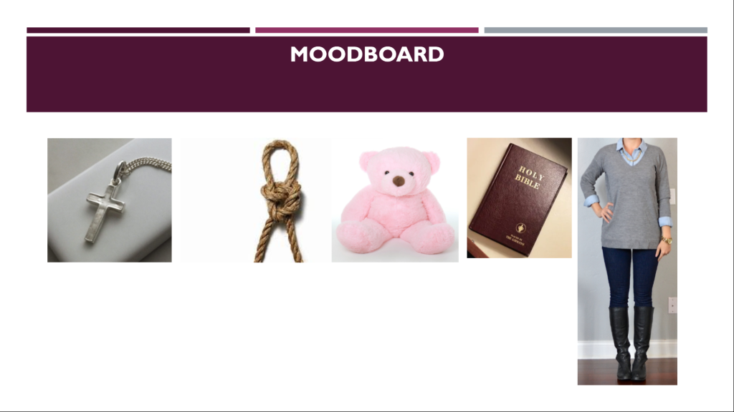

Costume.
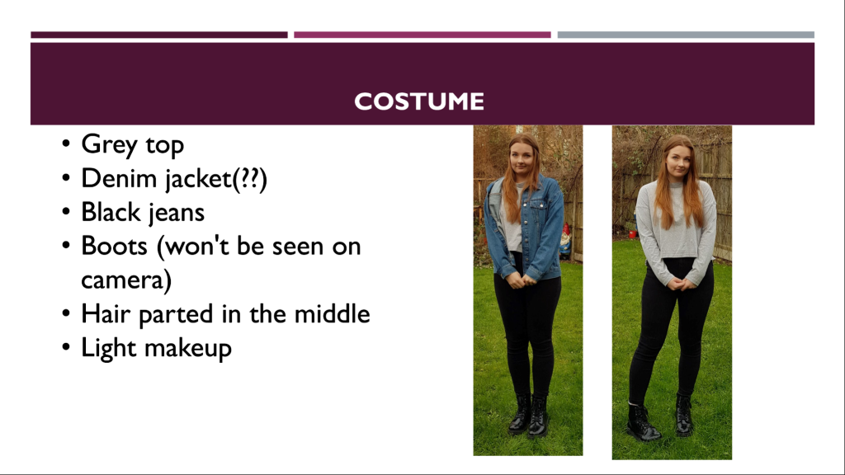

Background.
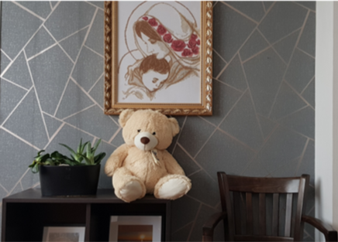

The poster I made for ‘Isolated’ which was the second idea.
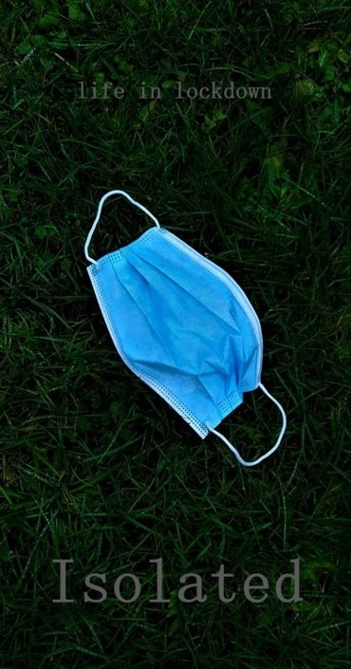
Bibliography:
Bombay Sapphire Global | 2013 | Room 8 - Winner of the BAFTA for Short Film 2014 | [online video] | Available at:
https://www.youtube.com/watch?v=WJj_NMhYwf0 (Accessed: 03/03/2021)
Short of the week | 2019 | Work | BAFTA-Nominated Short Film by Aneil Karia | Short of the Week | [online video] | Available at:
https://www.youtube.com/watch?v=nkqgjsMDYho (Accessed: 03/03/2021)
Pendoon | 2013 | 2+2=5 | Two & Two - [MUST SEE] Nominated as Best Short Film, Bafta Film Awards, 2012 | [online video] | Available at:
https://www.youtube.com/watch?v=EHAuGA7gqFU (Accessed: 03/03/2021)
Jake Russel | 2014 | DUST - Short film starring Alan Rickman & Jodie Whittaker | [online video] | Available at:
https://www.youtube.com/watch?v=LDop0Je7svk (Accessed: 03/03/2021)
Saatchi & Saatchi New Creators Showcase | 2016 | Caroline Bartleet | Operator | [online video] | Available at:
https://www.youtube.com/watch?v=OHttwpafBQE (Accessed: 03/03/2021)

Learn Religions | 2020 | 3 Things To Look For In A Church Group | Available at:
https://www.learnreligions.com/things-to-look-for-in-a-church-youth-group-712596 (Accessed: 03/03/2021)

Grow Church | 2016 | Top 10 Church Youth Group Game And Activity Ideas – Easy & Fun! | Available at:
https://growchurch.net/top-10-church-youth-group-game-and-activity-ideas-easy-fun (Accessed: 03/03/2021)

The Student Room | 2017 - 2021 | Strict Christian Family and other religions | Available at:
https://www.thestudentroom.co.uk/showthread.php?t=6936372 (Accessed: 03/03/2021)

Woman’s Day | 2016 | 15 Strict Parents Who Took It Too Far | Available at:
https://www.womansday.com/relationships/family-friends/a56202/strict-parents-who-took-it-too-far/ (Accessed: 03/03/2021)

