ACDB4011: THEMOCHEMISTRY
Risk Assessment
Before starting the experiment, you need to carry out a safety check and respond to the following statements.

I Craig Maclellan
Hereby agree to the following statements:
- I have taken part in the lab induction session with Mark and Ewa
- I agree to follow all rules and instructions therein
- I have received my PPE
- I understand that I must wear safety goggles, gloves and fastened lab coat for the duration of the entire experiment.
- I understand not to touch my face and/or eyes while wearing gloves as they can be contaminated with chemicals.
- I am aware of the risk associated with the handling of laboratory glassware such as cuts from broken or damaged glass and potential burns from hot glassware/ Bunsen burners.
- I understand the COSHH hazards associated with the chemicals but if I am unsure, I will ask Mark or Ewa.
- I understand that should I have an issue that may prevent me from doing the practical’s (such as illness, pregnancy or injury) I will inform Mark or Ewa in good time before the session so alternate arrangements can be made.
- That I will report unsafe behaviour in a confidential and professional manner.
- I also understand that should I fail to adhere to instructions/ guidance, I will be putting myself and others at risk and could be removed from the practical which may affect my course grades. This removal will also be reported to the Academic Liaison Officer and, by extension possibly your parent company.

Signed…………………… 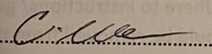…………………………………………..

Date……………14/11/2022……………………

Lab Quiz
- The hazard(s) associated with the chemicals/equipment used in this experiment are:
Bunsen burner fire risk, hot water risk, cuts from broken glass
- Where would I find the hazard information for a chemical? (2 answers)
COSHH Hazards or ask lecturer/ person in charge.
- If there is a fire, what are my (your) responsibilities?
Turn off Bunsen burner, leave lab, close door but don’t lock door.
- Why must glassware be labelled (2 reasons):
To identify the contents of the chemicals. To stop cross contamination. Aware of risk of chemicals your using.
- Name 5 instructions for clothing and hair in the lab:
Wear gloves, goggles (Eye cover), Lab coat, tie back hair/beard cover, no visible skin i.e. shorts
- What are the precautions when working with Bunsen burners?
Leave on safety flame, don’t get too close.

Student name & number: Craig Maclellan 2114212

Student signature:

Lab assistant: I don’t know the names of the 2 people I was working with and have no way of contacting them.
AIM OF THE EXPERIMENT: To measure the specific heat capacity of a metal.

INTRODUCTION
Heat is a type of energy. Exchange of heat between an object and its surroundings causes a measurable change of temperature of both. In this experiment, the “object” is a piece of metal, but it can also be the dissolution of an ionic compound, or a chemical reaction. The surrounding of a metal object in this experiment is water placed in a closed Styrofoam coffee cup equipped with a thermometer and stirring rod as shown in Figure 1. The assumption is made that the object and its surroundings form an isolated system that does not exchange energy and matter with what is around it. Please note that the word “object” has been intentionally put in quotation marks since it does not only refer to a physical object (e.g. a piece of metal) but also to a physical/chemical process (e.g. chemical reaction).
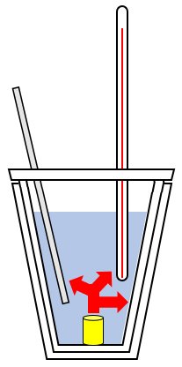
Figure 1. Schematic of the calorimeter used in this practical. The calorimeter is made of two stacked Styrofoam coffee cups, a lid with a thermometer and a stirring rod. A hot object (in yellow) releases heat (in red) to the cold water (in blue) and calorimeter (cups, thermometer, and rod).
When a hot piece of metal is immersed in cold water in a coffee cup calorimeter, heat is transferred from the metal to the water. As a result, the metal cools down while the calorimeter (water, cups, thermometer, and stirring rod) warm up until thermal equilibrium is reached and they all have the same temperature.
The heat change Q (in joules, J) of an object (here the piece of metal) is defined using three parameters according to Eq.1, where m is the mass (in grams, g), ΔT is the temperature change (in degree Celsius, °C), and c_{p} is the specific heat capacity (in J per g per °C) of the object:
Q = m × c_{p} × ΔT | (Eq.1)
The specific heat capacity c_{p} is defined as the amount of heat needed to raise the temperature of 1 g of an object by 1 °C (the term “specific” is used to indicate that a quantity is normalised per unit of mass). ΔT is negative when the object cools down, and positive when it warms up (and so are the signs of the corresponding values of Q); the same applies to the surroundings.
According to the First Law of Thermodynamics, energy may never be created or destroyed, it can only be transferred between object and its surrounding. In other words, the heat lost by an object or process must be gained by the surroundings, and vice-versa. In this experiment, the heat lost by the metal (Q_{METAL}) is the heat gained by the water and the calorimeter (Q_{water} + Q_{calorimeter}):
- Q_{metal} = Q_{water} + Q_{calorimeter} (Eq.2)
The negative and positive signs in Eq.2 represent the direction of heat flow; when the heat is lost, the sign is negative (-Q_{metal}), when the heat is gained, the sign is positive (Q_{water} + Q_{calorimeter}). In this example Q_{metal} < 0, Q_{water} > 0, Q_{calorimeter}> 0. Note that Eq.2 is valid under the assumption that metal, water, and calorimeter form an isolated system.
Combined Eq.1 and Eq.2 give the following relationship:
m_{metal} × c_{p metal} × ΔT_{metal} = (Eq.3)
= - (m_{water} × c_{p water} × ΔT_{water} + HC_{calorimeter} × ΔT_{calorimeter})
where HC_{calorimeter} is the heat capacity of the calorimeter that must be measured experimentally, as described in the next section.
Eq.3 can be used to determine the specific heat capacity of a metal, c_{p} _{metal}, when all other parameters in the equation are found (masses and temperatures are measured experimentally, c_{p} _{water} is 4.186 J/(gºC)).

PROCEDURES
In this experiment, the following calorimetric measurements will be performed:
- Measure the value of the heat capacity of the calorimeter (HC_{calorimeter})
- Measure the specific heat capacity of a metal (c_{p} _{metal})

IMPORTANT: Record all your data and calculation in the data sheets at the end of this script.

- Measure the value of the heat capacity of the calorimeter (HC_{calorimeter})
Obtain two Styrofoam coffee cups (one inside the other) with a lid, a thermometer, and a stirring rod, to build the calorimeter. Set up the calorimeter using a stand and clamp, as shown in Figure 2. The goal of this experiment is to measure how much heat this apparatus absorbs.
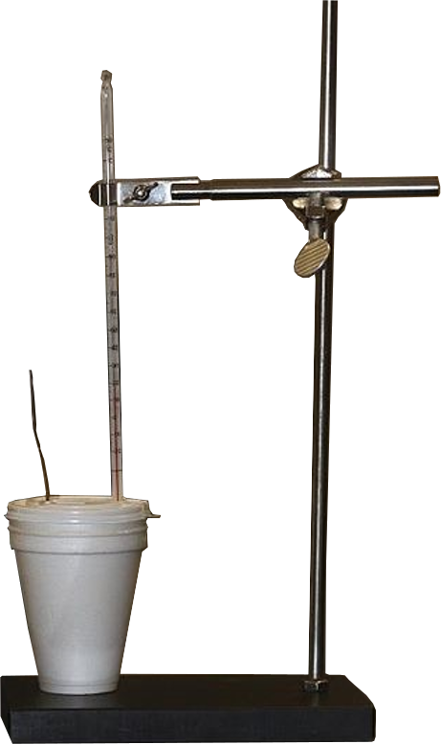
Figure 2. Apparatus used to perform all calorimetric measurements. The calorimeter consists of two stacked Styrofoam coffee cups, a lid, a thermometer, and a stirring rod. A stand and clamp are used to keep the calorimeter in place.
Procedure to measure HC_{calorimeter}:
- Add 50.0 mL of water to the Styrofoam coffee cups, and close with a lid. Add the thermometer and stirring rod to set up your calorimeter.
- Take 50.0 mL of water in a separate beaker and heat to about 80 °C. Close the gas and wait till the temperature reaches 60 °C. When the "hot water" is ready, record its temperature as T_{hot}.
- Measure the temperature of the water in the calorimeter, and record it as T_{cold}.
- Add the hot water to the water in the calorimeter, and mix thoroughly, while watching the thermometer. Record the maximum equilibrium temperature of the mixture, record it as T_{max}.
- Calculate the heat capacity of the calorimeter, HC_{calorimeter} , using Eq. 1, Eq.6, and Eq.7:
- Q_{hot-water} = Q_{cold-water}+ Q_{calorimeter} (Eq.6)
Q_{calorimeter} = HC_{calorimeter} × ΔT_{calorimeter} (Eq.7)
where Q_{hot-water} is the heat lost by the hot water, while Q_{Cold-water} and Q_{calorimeter} are the amounts of heat gained by the cold water and calorimeter, respectively. Calculate Q_{hot-water} and Q_{cold-water} with Eq.1, then use Eq. 6 to find Q_{calorimeter}, and finally Eq.7 to obtain the value of heat capacity of the calorimeter, HC_{calorimeter}.
Note: The mass (m) and temperature change (ΔT) for both the hot and cold water can be obtained from the experimental data, also the ΔT of the calorimeter can be found from the same data. For example, ΔT_{cold-water} = T_{max} – T_{cold}. Assume that the calorimeter is in thermal equilibrium with the water during the experiment. The specific heat capacity of water is c_{p} _{water} = 4.186 J/(gºC). Always specify the units of the results obtained from your calculations.

- Measure the specific heat capacity of a metal (c_{p metal})
Procedure to measure c_{p} _{metal}:
Use the same apparatus as before (Figure 2).
- Obtain a piece of the metal sample. Weigh the metal and record its mass as m_{metal}.
- Set up a water bath, heat the water until boiling, and then carefully put your metal into it. Keep boiling for another 5 minutes, to allow the metal to reach the same temperature as the water. Try to avoid heating the metal directly! To reduce the effect of direct heating, close the gas after 5 min and wait 2 minutes for the temperature of boiling water and piece of metal to equilibrate.
- While this is being done, measure 30.0 mL of water and add it to the calorimeter. Measure the temperature of the water in the calorimeter, as done previously, and record it as T_{cold}.
- Once the metal has reached "thermal equilibrium" with the boiling water, measure and record the temperature of the hot water as T_{hot}, and quickly add the metal to the water in the calorimeter using the tongs.
- Stir the water and record the temperature every 10 seconds, filling in the datasheet provided at the end of this script with the entries (time, T_{water}). The temperature will increase at the start. Continue until the temperature of the water has reached a maximum and then cooled down by about 2 ºC. Record the maximum temperature reached by the water as T_{max}.
- Calculate c_{p} _{metal} the specific heat of the metal using Eq.3 and the value of heat capacity of the calorimeter found previously. Assume that calorimeter and water are in thermal equilibrium, c_{p} _{water} = 4.186 J/(gºC), and always give the units of the results of your calculations.

DATA SHEETS to RECORD CALCULATIONS and RESULTS
STUDENT NUMBER & NAME: 2114212 CRAIG MACLELLAN
PARTNERS’ NAMES: N/A (Can get names next time I am at UWTSD)

REPORT IS DUE NOVEMBER 22, 2022 by e-mail

- Measure the value of the heat capacity of the calorimeter (HC_{calorimeter})
Use these entries to record your experimental data, results, and calculations.
T_{HOT} = 60°C m_{HOT-WATER} = 50g (50ml) ΔT_{HOT-WATER} = -17°C
T_{COLD} = 24°C m_{COLD-WATER} = 50g (50ml) ΔT_{COLD-WATER} = 19°C
T_{MAX} = 43°C ΔT_{CALORIMETER} = 19°C
Q_{COLD-WATER} = 3959.6 J Q_{HOT-WATER} = -3542.8 J Q_{CALORIMETER} = -7502.4 J
HC_{CALORIMETER} = -394.86 J/(g°C)
Write the calculations for Q_{HOT-WATER} , Q_{COLD-WATER} , Q_{CALORIMETER} , and HC_{CALORIMETER} :

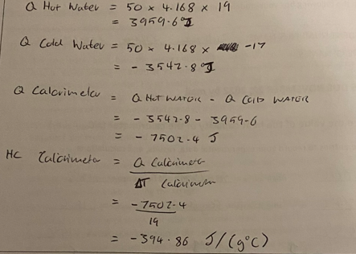
- Measure the specific heat capacity of a metal (c_{p metal})
Use these entries to record your experimental data, results, and calculations.
Type of metal = Aluminium
T_{hot} = 81°C m_{metal} = 18.5g (18.5ml) ΔT_{metal} = -50.5°C
T_{cold} = 24°C m_{water} = 30g (30ml) ΔT_{water} = 6.5°C
T_{max} = 30.5°C ΔT_{calorimeter} = 6.5°C
c_{p metal} = 4.24 J/(g°C)

time (s) | T_{WATER} (ºC) |  | time (s) | T_{WATER} (ºC) |  | time (s) | T_{WATER} (ºC)
0 | 40 |  | 90 | 30.5 |  | 180 | 30.5
10 | 33 |  | 100 | 30.5 |  | 190 | 30.5
20 | 32 |  | 110 | 30.5 |  | 200 | 30.5
30 | 31 |  | 120 | 30.5 |  | 210 | 30.5
40 | 30.5 |  | 130 | 30.5 |  | 220 | 30.5
50 | 30.5 |  | 140 | 30.5 |  | 230 | 30.5
60 | 30.5 |  | 150 | 30.5 |  | 240 | 30.5
70 | 30.5 |  | 160 | 30.5 |  | 250 | 30.5
80 | 30.5 |  | 170 | 30.5 |  | 260 | 30.5

Write the calculations for Q_{HOT-WATER} , Q_{COLD-WATER} , Q_{CALORIMETER} , and HC_{CALORIMETER} :

Cp metal =
$$\frac{-(m water x cp water x ∆T water + HC calorimeter x ∆T Calorimeter)}{m metal x ∆T metal}$$
$$\frac{\begin{aligned} \\ -(30 x 4.168 x 7.6 + -394.86 x 7.6)\end{aligned}}{(18.5 x-50.4)}$$
Cp metal = 4.24 J/(g°C)

If the calculations were done properly, the value of determined cp for Al would be in good agreement with the actual cp (Al) = 0.861 J/g-degC (16% error) -15p

