12/13/2024
Ioana-Mihaela Andrei-2220660
People management- Rebbeca francis
TechInnovate
Case study. (word count 2180)

Contents
Introduction 3
Part A – critical evaluation 4
1.Challenges 4
1.1 Recruiting and retention 4
1.2 Company culture 5
1.2.1 Denison organizational culture 5
1.3 Diversity and inclusion 7
1.4 Onboarding and training 7
Part B 8
1.People Management Work 8
2.Management of Performance 8
3.Employee Reward 8
4.Engagement of Employees 9
Recommendations 10
Conclusion 11
References 12

Introduction

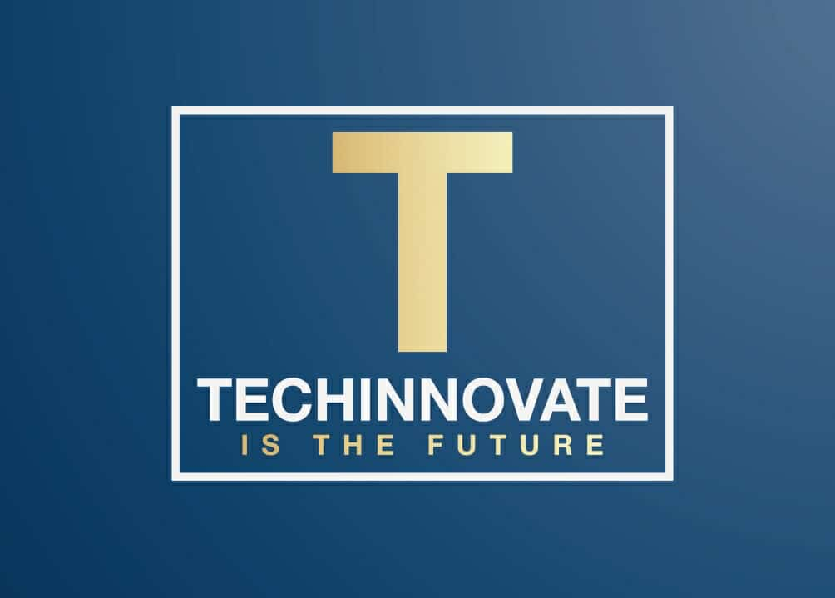

The objective of this report is to provide Techinnovate with recommendations to guarantee that managers possess the necessary skills to effectively manage performance, including effective people management, performance management, employee reward and engagement.
Techinnovate is facing several challenges as: diversity and inclusion, company culture, recruitment and retention, onboarding and training, performance, and people management which I will explain down below.
The company started five years ago, beginning with fifty employees, and expanding to two hundred individuals. As time passed by the company began to expand, drawing significant clients, although everything thereafter deteriorated. Only 18 months ago, an HR professional was appointed to manage the issue but is now inundated with the recruitment process, onboarding, and benefits administration.

Part A – critical evaluation

1.Challenges

1.1 Recruiting and retention
Techinnovate is a small business that started in 2019 and is situated in South Wales. You oversaw hiring and all HR-related issues, yet you just hired an HR specialist 18 months ago, which seems a little late. It would have been wise to foresee this situation when the caseload started to grow.
You tackled the informal collaborative atmosphere in a way that let employees be themselves, and the right people were not hired. There are no strict rules or policies, so people are free to communicate and work together however they see fit.
At first, this strategy made sense because of the limited workforce. But as the number of clients grew, it became necessary to create a hierarchy, offer more training, set boundaries, set goals, communicate clearly and openly, and finally, hire more staff to serve all the clients and increase the company's profit.
A matrix structure, in my opinion, would be beneficial for your business to keep everything under control and give each manager 50 employees to oversee and care for to make them feel appreciated, to inspire, to ensure that he takes care of their well-being, and to increase their productivity and loyalty to the company.
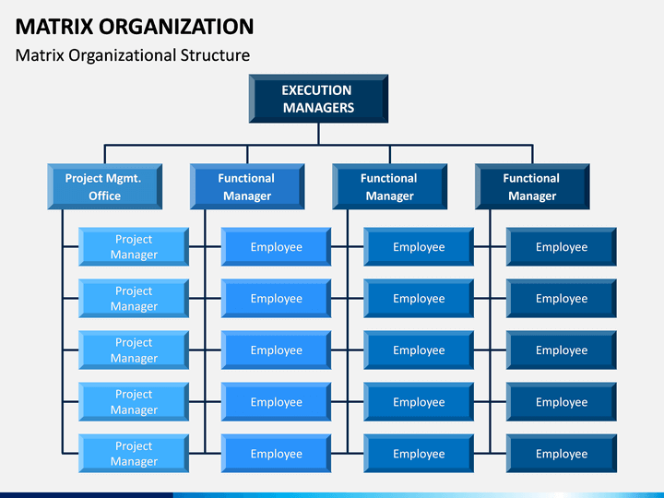

1.2 Company culture
A company's culture is something of which we are well-aware. Most companies have realised in the last few decades that a strong company culture is critical to their success. Plus, they are beginning to understand that managing their culture requires the same level of expertise and focus as managing their strategy, finances, and other critical performance indicators.
Most of the time, the employer fails to provide a clear explanation of the expectations for the newly recruited employee, assuming that the employee is aware of the expectations. Additionally, there is no training provided or the culture that is currently in place at that organisation is extremely negative:
For Ex: we not supposed to do that officially, but we do it anyway because is easier for me in this way. - and this type of behaviour is tolerated and there are no consequences in place.
Peter Drucker stated culture eats strategy for breakfast, emphasising its importance to strategic goals. Drucker believed that no matter how good a strategy, its success.
Individuals within an organisation execute strategic plans. If they do not understand or support the idea, their efforts may be unsuccessful or intermittent.
Leaders should prioritise creating and maintaining a positive, flexible, and purpose-driven culture, foster cooperation, trust, and strategic alignment.
Drucker emphasises that culture is crucial to an organisation. Culture matters more than strategic planning since no strategy succeeds without people's support.
There is no teamwork, cheerful outlook, or attention on employee welfare, which is crucial to working at your best potential, being efficient, and feeling valued.
The Iceberg Model helps TechInnovate detect cultural issues and understand their causes. Examples of apparent difficulties include high personnel turnover, discontent, and team communication breakdowns.

1.2.1 Denison organizational culture

The Denison Model of organisational culture finds four important traits that a company must have to work well. The model is based on the organization's "Beliefs and Assumptions." These are the deeply held parts of an organization's character that are tough to get to.
The Denison Model has four traits: Mission, Adaptability, Involvement, and Consistency. These traits measure how people act based on the ideas and assumptions that make up an organization's culture. These traits grouped by colour to help you figure out important things about the culture of your company.
GOAL: Do we know where we are going?
ADAPTABILITY: Are we adapting to the outside world or the market?
INCLUSION: Are our employees on the same page and interested?
CONSISTENCY: Do we have the right values, methods, and procedures in place to build use?
If the answer to all questions is NO, then you need this model.
This map is offering cultural analysis, forecast, and counselling to help your business achieve Its goals.

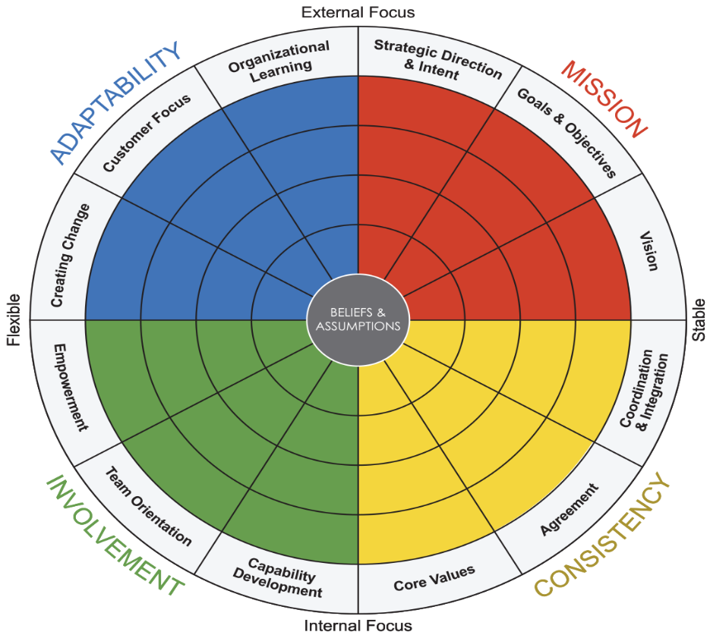
Credit: Daniel R. Denison, Ph.D. & William S. Neale, M.A.

1.3 Diversity and inclusion
Diversity, equality, and inclusion are three values that many organisations hold dear. These values help all kinds of people, including those of different races, religions, abilities, genders, and sexual orientations.
Diversity and inclusion are not only ethical orders, but also business rules. Organisations that prioritise diversity and inclusion are more likely to innovate, attract the best employees, and thrive in competitive markets. To achieve success, organisations must incorporate diversity and inclusion into their culture, policies, and strategies, guaranteeing that each employee can contribute their distinctive strengths and perspectives.
Also, when you promoted to management role your early employee you also should offer the new one to give them a chance to include them in your team to be equal and fair.
For example, on my department my manager is recruiting two deputies, and she sent the job offer not only to the senior staff on the ward she sent it as well to the new employee that just joined the team, no favouritism and there is fairness, people feel treated equally. (true story from my job Royal Gwent Hospital))

1.4 Onboarding and training
All the early employees who have been promoted to management roles have not received the appropriate training and assistance that they should have received. They are particularly good at the technical parts of their responsibilities; nevertheless, they are not confident and do not have a managerial position. Additionally, there has been a rise in conflict within the workplace, and there is experience in managing people. This, in turn, has resulted in a significant impact on the level of productivity.
To ensure that the employee can meet the standards that you have set, you should not put an employee in a management job who has not received the appropriate training. The reason it is so vital to have rules and regulations in place is so that the employee is aware of what is expected of them and at what standards they are expected to perform.
As soon as you put up with a terrible employee, you will lose a fantastic one and this is exactly what you have done, that is why all your great employee has left.
People do not want to go to a place of employment where there is no positivism, where there is no good communication between the staff and the managers, and where they are just being placed under pressure without being asked how they are doing, if they require something, or if they are having difficulty in personal life.

Part B
To successfully implement all my advice, you must focus on the following four subject:

1.People Management Work
Managing people well is the key to making an organisation that is productive and does well. Clear communication, trust, and goals that are in line with those of the organisation are all important parts. It means making sure that employees feel valued and free to do their best work in a supportive setting.

2.Management of Performance
Performance management is the ongoing process of telling workers what is expected of them, keeping an eye on their work, and giving them feedback to help them reach their goals and help the company succeed. Important parts include:
Setting Goals: Individual and team goals that are well-defined and in line with business goals.
Regular Feedback: Talking about growth, accomplishments, and ways to improve all the time.
Formal Reviews: Regular evaluations of an employee's work to see what they have contributed, find ways they can improve, and talk about job advancement.
Development Plans: Customised plans to help workers fill in skill gaps, build on their strengths, and get ready for future roles.

3.Employee Reward
Employee awards are ways to recognise and encourage excellent work, which keeps employees motivated and keeps them on the job. Some of these are:
Money rewards include competitive pay, bonuses, and the chance to buy stock.
Non-monetary rewards include praise from others, extra duties, or chances to learn and grow.
Health insurance, retirement funds, and wellness programs are all part of the benefits package.
Custom incentives are rewards that are made to fit the needs of each person, like flexible work schedules or money for professional growth.
When reward systems work well, they match with both the company's goals and the preferences of its employees. This makes things fair and encourages employees to do their best.

4.Engagement of Employees
Employee involvement is a way to measure how emotionally committed workers are to their jobs and the company. High engagement is linked to more work getting done, keeping employees, and overall company success. Some ways to get people more involved are:
Clear Communication: Making sure that everyone knows what their job is and how it fits in with the overall goals of the company.
Recognition and Appreciation: Regularly thanking people for their efforts.
Opportunities for Growth: Giving people chances to learn new skills, get a guide, and move up in their careers.
Inclusive culture means creating a place of work that values differences, teamwork, and respecting each other.
Feedback Mechanisms: Asking employees for feedback on a regular basis and acting on it through polls, focus groups, or one-on-one talks.
By focussing on these pillars, companies can make the workplace a place where workers feel supported, motivated, and in line with the goal of the company. Would you like more information or tools on how to put these habits into action?

Recommendations
Following our discussion, I would like to offer the following suggestions:
-Form a specialised recruiting team or collaborate with professional recruitment firms that specialise in technology talent.
-Establish an incentive-based employee referral program.
-Conduct exit interviews to ascertain and resolve the causes of employee departures.
-Establish a structured induction program that includes explicit milestones and timelines.
-Assist new employees in their transition by assigning them mentors who are more experienced, to assist at least one month before you put him in the number.
-Develop training modules that are customised to the specific responsibilities of key positions, with an emphasis on the technical and company-specific processes.
-Establish a formal performance evaluation process that includes annual evaluations and regular one-on-one meetings.
-Establish transparent metrics for career advancement and performance, every six months.
-Implement a feedback mechanism to facilitate ongoing improvement.
-Organise company-wide events and team-building activities to cultivate camaraderie and collaboration at least once a year.
-Utilise internal communication and recognition initiatives to reinforce fundamental principles.
-Conduct consistent employee satisfaction surveys to identify and resolve any issues, every six months.
-Offer training programs on communication skills, conflict resolution, and leadership to new managers.
-Create a coaching system or support network for managers to exchange best practices.
-Offer feedback and additional training as necessary to monitor and evaluate managerial performance, every three months.
-Establish quantifiable objectives to enhance the diversity of the recruiting process, with a particular emphasis on technical and leadership positions.
-Collaborate with educational institutions and organisations to access talent pools that are under-represented, because due to the area where are you located the IT area is not very developed compared with England , but there are many
- I think you should work with universities in South Wales, like Cardiff University and Swansea University. These schools have great computer science and IT programs that can help you find new employees.
Research and innovative ideas are driven by partnerships between colleges and businesses.
-Conduct training sessions on unconscious bias for both employees and hiring administrators.
- I think there should be four supervisors, each of them should oversee fifty employees.

Conclusion

In conclusion, Techinnovate is confronted with substantial obstacles that are the result of its rapid expansion and the absence of initiative-taking strategies to address critical aspects of people management, company culture, diversity and inclusion, recruitment, induction, and training. These concerns have affected the overall efficacy of the organisation, as well as employee retention and engagement.
To guarantee a successful turnaround, the organisation must implement a structured and strategic management approach that prioritises equitable policies, plain communication, comprehensive training, and a positive workplace culture. In addition to enhancing employee satisfaction and retention, the implementation of the recommended measures, including structured induction, targeted training programs, transparent performance management, and inclusivity initiatives will also significantly improve overall productivity and business outcomes. Techinnovate can establish a high-performing, supportive, and inclusive work environment that is consistent with its strategic objectives and ensures long-term success by prioritising these changes.

References

- J. Makos, “What is PESTLE Analysis? (Free Template),” PESTLE Analysis, Sep. 13, 2024. Available: https://pestleanalysis.com/what-is-pestle-analysis/
- Armstrong, M. (2020). Armstrong's Handbook of Performance Management: An Evidence-Based Guide to Delivering High Performance.
- D. Todd, “A Large (But Disconnected) Team Won't Survive Tough Times — But a Close-Knit Team Will. Here's Why.,” Entrepreneur, May 10, 2023. Available: https://www.entrepreneur.com/leadership/dont-let-culture-fall-to-the-wayside-in-tough-times/450004
- “What is diversity, equity, and inclusion?” McKinsey & Company, Aug. 17, 2022. Available: https://www.mckinsey.com/featured-insights/mckinsey-explainers/what-is-diversity-equity-and-inclusion
- “MindTools | Home.” Available: https://www.mindtools.com/a8im94b/the-cultural-web
- O. Jurevicius, “McKinsey 7S Model,” Strategic Management Insight, Dec. 03, 2023. Available: https://strategicmanagementinsight.com/tools/mckinsey-7s-model-framework/
- J. Martins, “What Are SMART Goals? Examples and Templates [2024] • Asana,” Asana, Feb. 03, 2024. Available: https://asana.com/resources/smart-goals
- E. Schein, Denison Consulting, and D. Denison, DENISON ORGANIZATIONAL CULTURE SURVEY INTERPRETATION GUIDE.
- NPC - New Philanthropy Capital, “The Iceberg Model - NPC,” Think NPC, Feb. 15, 2024. Available: https://www.thinknpc.org/resource-hub/systems-practice-toolkit/the-iceberg-model/
- A. Hogarth and C. McCartney, “Resourcing and talent planning report 2024,” report, 2024. Available: https://www.cipd.org/globalassets/media/knowledge/knowledge-hub/reports/2024-pdfs/8662-resource-and-talent-planning-2024-report-web.pdf
- Coursera, “10 Essential Managerial Skills and How to Develop Them,” Coursera, Jun. 12, 2024. Available: https://www.coursera.org/enterprise/articles/essential-managerial-skills
- Mehrdad Oroei, Abolfazl Danaei, & Seyed Hasan Kia. (2013). A study on relationship between knowledge management and organizational culture based on Denison model: A case study of PVC industry. Management Science Letters, 3(6), 1571–1574. https://doi.org/10.5267/j.msl.2013.05.034
- Ahmady, G. A., Nikooravesh, A., & Mehrpour, M. (2016). Effect of Organizational Culture on knowledge Management Based on Denison Model. Procedia, Social and Behavioral Sciences, 230, 387–395. https://doi.org/10.1016/j.sbspro.2016.09.049
- Fatemeh Abdavi, Hasan Fateh, & Sajjad Pashaie. (2018). The Effects of Denison’s Model of Organizational Culture on Customer Relationship Management (CRM): Case Study of Ministry of Sports and Youth in Iran. International Journal of Management, Accounting & Economics, 5(6), 461–472
- Cunningham, T. R., & Jacobson, C. J. (2018). Safety Talk and Safety Culture: Discursive Repertoires as Indicators of Workplace Safety and Health Practice and Readiness to Change. Annals of Work Exposures and Health, 62(Supplement_1), S55–S64. https://doi.org/10.1093/annweh/wxy035
- P. Lalwani, “What Is Performance Management? Definition, Process, Cycle, and Best Practices for Planning,” Spiceworks Inc, Jan. 26, 2024. Available: https://www.spiceworks.com/hr/workforce-management/articles/what-is-performance-management/
- C. Crail, “The Onboarding Process: A Step-By-Step Guide,” Forbes Advisor, May 28, 2024. Available: https://www.forbes.com/advisor/business/onboarding-process/
- J. Dublino, “What Your Business Can Learn From Peter Drucker,” business.com, Nov. 05, 2024. Available: https://www.business.com/articles/management-theory-of-peter-drucker/
- M. Fraraccio, “The Management Theory of Peter Drucker: Key Terms,” business.com, Dec. 10, 2024. Available: https://www.business.com/articles/management-theory-of-peter-drucker-key-terms/.
- J. Pretzer, “Schemas, Assumptions, and Beliefs, Oh My!,” Behavior Online, Feb. 23, 2023. Available: https://behavior.net/2014/02/schemas-assumptions-and-beliefs-oh-my/.

