MARKETING MANAGEMENT ASSESSMENT A2
SUBMITID BY -BHAWNA BHAWNA

STUDENT NAME: BHAWNA BHAWNA
STUDENT ID NUMBER: 2214179
MODULE: MARKETING MANAGMNET 25% A2
LECTURER: TUSHARA BALENDRAN
COURSE: MASTERS OF BUSSINESS ADMINSTRATION GENERAL
SUBMISSION DATE: 4TH JAN 2023
PAGES: 13

Executive summary
This essay seeks to look into TESCO, the biggest chain of numerous outlets in the UK. We initially examined TESCO's operations in the UK to build a critical analysis, starting with the first supply chain operations and moving forward to a supply chain that became productive and successful over time. The management strategies employed by Tesco to oversee its global operations and the challenges it faced in upholding a unified brand image were then examined. It was found that Tesco has been making crucial adjustments to its service operations, such as continuous replenishment, worldwide logistics, and international warehouse management, to maintain a stable system of service delivery all over the world.

Table Of Contents

Introduction 4
A brief overview of company 4
Conduct an environmental marketing analysis taking into consideration the key external influencing drivers together with an analysis of the internal environment and the role that marketing plays within the organisation 5
PESTEL 5
SWOT 7
Porter’s five forces 8
Marketing mix 7Ps 9
Recommendations 10
Conclusion 10
References 11

Introduction
"Marketing environmental analysis" is an analytical technique that aids in identifying external as well as internal elements that have an impact on an organization's capacity to operate successfully (Aiello et al.,2020). Management teams create the command chart, environment, and regulations to give workers information is important. The success of the company, however, is dependent on how it manages any prospective externalities.
When making judgments based on their analysis of the marketing environment, proactive marketers need to have a solid grasp of both microeconomic and macroeconomic concerns. This is because these factors have a huge impact on how beneficial the promotional campaign is (Azan, and Karimah, 2022). Therefore, a marketing and sales environment pressure may significantly affect the effectiveness of its image, positioning strategies, and other business operations.

A brief overview of the company
Tesco Plc is a significant global retailer of daily necessities. In addition to its online presence, the company offers a variety of storefront configurations. It runs many store kinds, such as big, intermediate, entrepreneurs only, and one-stop stores, which are identified by their magnitude and the variety of goods they provide (Chen, 2022). Tesco provides a broad variety of goods, respectively food- as well as non-food-related, such as fresh food, beverages, confectionery, general merchandise, household supplies, toys, baby products, apparel, and small appliances. It also sells items for pets, commercial electrical goods, electronics, and domestic goods. Additionally, through Tesco Bank in the UK, it provides retail banking, consulting, and financial services. The business is active in the UK and throughout all of Europe. Welwyn Garden City, Greater London is home to the Tesco corporate headquarters.
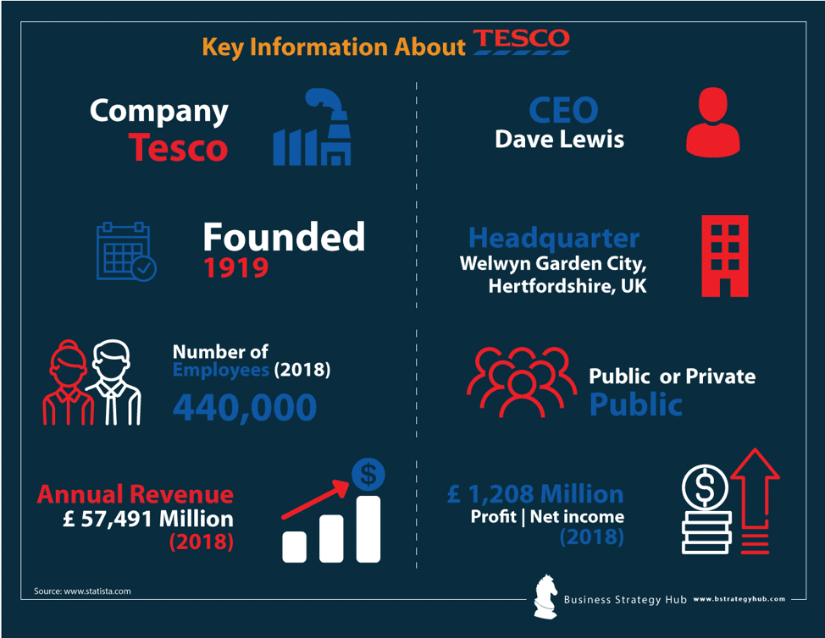
Figure 01: TESCO PLC
(Source: bstrategyhub.com,2022)

Conduct an environmental marketing analysis taking into consideration the key external influencing drivers together with an analysis of the internal environment and the role that marketing plays within the organisation

PESTEL
Political | - Tesco involves bringing about growth in the economy.  - It increases the competition in the market and broadens its labour force.
Economical | - The company still has a significant reliance on the UK market, where it has a 30% market share.  - Instead of emphasising the more costly products, Tesco now focuses primarily on promoting its value brands.
Social | - The range of non-food items sold at Tesco has increased.  - Tesco is responding to change by supplying the market need for organic goods (Foabeh, and Achaleke, 2020).
Technological | - The establishment and use of solutions for home delivery for online purchases.  - For customers, self-service checkout terminals have made shopping simple and hassle-free.
Environmental | Tesco has revealed that it wants to reduce its carbon impact by half by the year 2020. (Guo, and Wang, 2019).
Legal | Tesco gives its customers discounts on the petrol they purchase.

Political
Tesco is designed to check the changing political environments in each country where it does business because to its global operations. Good governance is an essential factor. The likelihood of making a transaction increase with political stability. Modifications to tax regulations in the different supply nations will have an effect on the profitability of the company.

Economic
It is crucial that the firm take a watchful watch on any financial changes that happen in the nations where it does business since these are factors that will affect the cash flow, purchases, allocation, and earnings. The establishment should be notified of all tax justice system that can disseminate them for its own gain (Monte, 2021).
Social
People seek to grab all at once as a result of the rushed pace of life. Tesco has redesigned its shops to match for these trends in bulk buying. The firm currently sells non-food items in addition to its basic culinary goods. Their social pull or background traits have an influence on the demands for particular things from the varied consumers. A purchaser's prolonged sensitivity to diverse cultural elements may also have an impact on the products they choose.
Technological
Tesco has experimented with a slew of features of marketing, many of which have had some extent of success. websites for shopping, internet advertising, etc. all influence the customer by providing a broad range of technical benefits. Given that 43% of its clients presently make online purchases and that the brand has been effective in altering consumers' buying habits by offering to send their items to their houses.
Environmental
Tesco has implemented a multitude of projects aimed at promoting ecological sustainability and foster solidarity. The enterprise has put in place a number of strategies to cut back on or discontinue using non-recyclable polyethylene while also looking for new uses for the plastic that is still in circulation. As little more than a nutshell, a closed-loop application will be implemented, which will lessen the amount of waste that may accumulate in refuse.

Legal
Government policy changes have a strong bearing on the organisation's functions. Its operations must adhere to both domestic and foreign market restrictions for them to be unimpeded. In to safeguard its standing, these rules must be carefully considered and adhered to. It is highly expensive to repair a company's reputation after it has been tarnished.

SWOT

Strengths  - Leading market share in the UK's largest food retailer  - Outstanding use of innovation | Weaknesses  - Operation failures in the US and Japan  - The accounting scandal and the fraud trial
Opportunities  - Strategic partnerships with other companies  - Cashless retail. | Threats  - Referendum on Brexit  - Competing with the biggest supermarkets.

Strength
Tesco is the world's finest and best - known supermarket retailer in UK. It has stronger margins and sales compared to comparable British supermarket companies. Tesco uses technology as effectively as possible to enhance the shopping experiences of its customers. A brand-new Sensor barcode system has been designed to precisely count the objects. Modern mobile payment software and M-commerce features are also included.
Weaknesses
Tesco was forced to withdraw from the Japanese and American markets in 2012. After nine years in Japan and five years in the US, the firm was forced to shutter operations due to its poor export tries (Rosnizam et al.,2020). Tesco imposed heavy in 2017 as a result of the false accounting statement and fabrication of earnings.
Opportunities
Tesco may expect to make significantly by implementing innovative collaborations with respectable companies. Firm is able to offer better products and entice more customers as a consequence. First cashless store has been established.
Threats
Tesco is now at stake from trade agreements and cost difficulties as a result of Britain's departure from the EU. The growth and success of Walmart, Carrefour, and Aldi, who just acquired ASDA, are the primary competitors of Tesco endangers Tesco's competitiveness.

Porter’s five forces
Bargaining power of Buyer  (Low/High) | Because the UK market is fragmented, customers have little negotiating leverage, and switching to stores like Asda and Sainsbury's is unlikely to be helpful. Tesco thinks the sector enticing owing to this. Due to the sheer number of competing companies vying for the same clients and because some of those competitors are less priced than Tesco, several analysts claim that supermarket customers in the UK have significant negotiation leverage.
Bargaining power of Supplier  (Low) | Tesco engages with more than 2,500 suppliers in the UK and many more abroad. However, given the sheer number of providers, they are incapable of having a significant impact on Tesco (SPARKS, 2018). Tesco actively pursues supplier agreements in an effort to increase its growth.
Threat of new entrants (Low) | The chance of fresh rivals joining the UK grocery market is quite weak as a result of significant capital needs. Since those benefits from economies of scale and has its own core skills, Tesco should likewise not be concerned about any new competitors.
The threat of substitute (Low) | Tesco extends its customers a broad catalogue of items. In particular with regard, it provides the majority of the choices for purchase (Student, 2021). Ultimately, it follows that the risk posed by Tesco's alternative items and functions is basically inconsequential.
Rivalry amongst Tesco’s existing competitors (High) | Tesco faces a number of fierce rivals in UK. The branding and other means of sales that these competitors use cost a lot of money. Even though Tesco leads the world in sales, its peers are huge players. The price wars between Aldi and Lidl have an impression on Tesco's sales as well.

Marketing mix 7Ps
The marketing mix is simply a set of tactics that companies develop and employ to sell their goods and services to their potential customers.
Products from Tesco
Tesco provides a variety of products, including food, clothing, housewares, pens and paper, toiletries, technology, and business institutions (Tesco, 2022). Big kudos to its ever-expanding product lines, it can satisfy any imaginable customer requirement. It provides products from respected brands in almost every product category. It also manufactures its own products.
Price and Pricing policies
Differentiation strategy is the basis behind Tesco's costing. As a result, the process carries without sacrificing quality, the company strives to keep the cost of its goods and services as low as feasible (Yawson, and Yamoah, 2022). Tesco benefits from scale advantages and routinely collaborates with its vendors to enhance supply chain effectiveness and cut corners.

Place/Distribution strategies of Tesco
Like most other merchants, Tesco uses both online and offline distribution techniques. Nearly 7000 concrete places are used by it internationally (Moura, 2021). Tesco's offline stores fall into six categories. It is the main traditional advertiser in the UK food retail industry.

The promotion strategies of Tesco
Tesco's marketing efforts benefit considerably from its strong brand recognition. Utilizing publications, network news, and certain other mediums, the company reaches out to its customers. It dedicates the most on the food retail business in the UK uses conventional ads. Tesco employs a number of promotional methods in as well as advertising. There is frequently a buy one, get one free offer promotion on a number of its products, for example in the case.

Process in Tesco
A process refers to a series of steps conducted in order to achieve a desired outcome. Customers visit Tesco's physical stores to pick up their products and then pay customer care agents. They may also use self-service equipment to make payments.

People of Tesco
More than 420,000 individuals work at Tesco. Company hires a high number of customer care agents, who are fundamental to the success of the company (Xinyun, 2018). Tesco commits a ton of cash, as well as expertise, to the education and advancement of its workers, many of whom have a lot of experience. Additionally, Tesco offers fantastic employee reward plans.

Physical evidence of Tesco

Tesco has a wonderful emblem that makes good use of colour. Since offline businesses are well-organized and simple to navigate, customers may readily find their goods there. The Tesco website is likewise quite user-friendly and enticing.

Recommendations
I could still advocate Tesco strengthen and increase their consumer penetration. To persuade Tesco needs to improve its customer interactions if it wants customers to spend more time and money in Tesco stores and on Tesco items. Tesco may do this, as previously suggested, by updating its rewards programme. Customers may enjoy cheaper rates and higher discounts as a result of the reward programme. Tesco benefits from the technique in terms of client growth and information gathering regarding customer purchasing habits. This information will enhance Tesco's efficiency and profitability by enabling management to adapt Shifting energy and capital allocation to changing market trends and customer inclinations there are several areas where considerable work might be improved. Prior to everything else, Tesco must increase the visibility for the entire logistics system. Tesco has to communicate with suppliers more effectively on topics like volume and prospects. More actionable So to make better judgments across the board, including the amount of food given to avoid unnecessary wastage, statistics must be acquired. Tesco must also raise the standard of the practises used in the warehouse operations. Often when, food waste may be the result of a lack of technology.

Conclusion
Tesco has a solid track record of success in the UK. Tesco employs a range of tactics inside the business to promote economic growth and job creation. Its major objective is to draw in new customers while keeping the ones who are already doing business with it. In order to comprehend the clients' needs, sentiments, and personal preferences, several technical procedures have been conducted to assess the patrons. All of its branches have adopted the same specific design for it. Tesco invests significant funds in advancing its digitization, which has generated revenue and allowed it a dominant market position.

References

Aiello, L.M., Quercia, D., Schifanella, R. and Del Prete, L., 2020. Tesco Grocery 1.0, a large-scale dataset of grocery purchases in London. Scientific data, 7(1), pp.1-11.https://www.nature.com/articles/s41597-020-0397-7
Azan, M.E.M. and Karimah, W.N., 2022. The Relationship between Customer Loyalty Program and Customer Retention at Tesco. Research in Management of Technology and Business, 3(2), pp.174-184.https://publisher.uthm.edu.my/periodicals/index.php/rmtb/article/download/9730/2951
Chen, J.J., 2022. Tesco Plc. In International Cases of Corporate Governance (pp. 27-44). Palgrave Macmillan, Singapore.https://link.springer.com/chapter/10.1007/978-981-19-3238-0_3
Evans, B. and Mason, R., 2018. The lean supply chain: managing the challenge at Tesco. Kogan Page Publishers.https://books.google.com/books?hl=en&lr=&id=drN7DwAAQBAJ&oi=fnd&pg=PP1&dq=tesco+supermarket&ots=BzsJ4H2jIj&sig=CqaBR4JSFhXZlehksy3BPm_s_4k
Foabeh, P.A. and Achaleke, H.F., 2020. ATTITUDES AND PERCEPTIONS OF SHOPPERS’GROCERY SUPERMARKET CHOICES: A COMPARATIVE ANALYSIS BETWEEN BIG C AND TESCO LOTUS.https://pdfs.semanticscholar.org/2c0a/93893464555ab21f04d3a9b02efbf7329b57.pdf
Guo, L. and Wang, Z., 2019. Ratio analysis of J Sainsbury plc financial performance between 2015 and 2018 in comparison with Tesco and Morrisons. American Journal of Industrial and Business Management, 9(2), pp.325-341.https://www.scirp.org/journal/paperinformation.aspx?paperid=90798
Monte, A., 2021. A study of value chain reconfiguration processes under Covid-19 pressures: the case of Tesco PLC in the United Kingdom.http://tesi.luiss.it/31586/1/261361_MONTE_ALESSANDRO.pdf
Moura, M.B.L.D., 2021. Equity Research in Food & Retail Industry-TESCO PLC (Doctoral dissertation, Instituto Superior de Economia e Gestão).
Rosnizam, M.R.A.B., Kee, D.M.H., Akhir, M.E.H.B.M., Shahqira, M., Yusoff, M.A.H.B.M., Budiman, R.S. and Alajmi, A.M., 2020. Market opportunities and challenges: A case study of Tesco. Journal of the Community Development in Asia (JCDA), 3(2), pp.18-27.http://ejournal.aibpm.org/index.php/JCDA/article/viewFile/807/772
SPARKS, L., 2018. Tesco’s chain management supply 07. Logistics and Retail Management: Emerging Issues and New Challenges in the Retail Supply Chain, p.183.https://books.google.com/books?hl=en&lr=&id=vU51DwAAQBAJ&oi=fnd&pg=PA183&dq=tesco+supermarket+strategic+management&ots=FeseIeiqk_&sig=M62JgpjhNTJuLtoMDsV-WEmGoRw
Student, A., 2021. To examine the added value of implementing Corporate Social Responsibility practices on the UK supermarket industry, a case study of Tesco PLC 2015-2020 (Doctoral dissertation, University of Chichester).https://eprints.chi.ac.uk/id/eprint/5909/
Tesco, 2022, https://www.tesco.com/
Xinyun, T., 2018, December. A Multimodal Critical Analysis in Business Discourse: the Case of the Corporate Annual Report of Tesco. In 5th International Conference on Education, Language, Art and Inter-cultural Communication (ICELAIC 2018) (pp. 433-440). Atlantis Press.https://www.atlantis-press.com/article/55910349.pdf
Yawson, D.E. and Yamoah, F.A., 2022. The TESCO Club Card Loyalty Programme: The Gold Standard. In Contemporary Retail Marketing in Emerging Economies (pp. 77-87). Palgrave Macmillan, Cham.https://link.springer.com/chapter/10.1007/978-3-031-11661-2_3

