University of Wales Trinity Saint David

Module Name: Professional Career Development

Module Code: BMSW4005

Module Leader: Anita Nan

Student Name: Angel Moises Pichardo Garcia

Student Code: 2021158

Table of Contents
Introduction 2
Play Role Reflection 3
Description - 3
Feelings – 3
Evaluation - 3
Analysis - 3
Conclusion - 4
Action Plan - 4
Self-Motivation 6
Learning Style 6
Swot Analysis 7
Life line 8
Smart and Objective 9
Conclusion 9
Refences 10
Appendix 12

Introduction

The aim of this report it is to reflect on my on my play role conducted in class, and my personal Professional Career Development plan. This paper required a specific method to conduct my reflection; therefore I had chosen the reflection cycle model of Gibbs. The cycle model of Gibbs is a famous model and method of reflection, that will help me to describe my experience through six different stages that are: description, feelings, evaluation, analysis, conclusion and action plan (The University of Edinburg, 2022). Those six steps will lead the reader to have a better compression of my experience with my play role and the plan of my career development.
There will also be the usage of different tools, to reinforce my paperwork, and I learned the usage of them during my semester at the University of Wales Trinity Saint David at the London Campus.

Play Role Reflection

Description -
The role play was a part that, me and my selected classmate from the course of Professional Career Development, had to play virtually in front of all class and be given feedback by our module leader Anita Nan.
This role play consisted in and job interview that will see us, as the employer and the possible candidate, and then swap the position from one to the another. Regarding the employer role, it was about to create and ask 5 questions base on the application form provided from the candidate and skill, while the candidate will need to answer.
The candidate needed to answer those question, based on their personal life experience and the skill required.

Feelings –
Before the role play I had so many questions and doubt regarding how it should be correctly played, for the module requirement, because it is something that I already do at my work, in real life. That is why this task was trained between me and my classmate at my house, we will meet up after lunch and practicing several times; therefore I was ready for it. After I realised that was not much different between my real life at work and this task, I could feel that some question are actually similar to the one that I do at my work; therefor that helped me a lot. During the examination I felt very relaxed and confident, because of the previous experience, the homework and the good partnership that had build with my classmate from previous presentations. When I receive my feedback I was very happy about it, of course I thought I could have done better at some part, but I can also understand that it is always good to try to do better. Looking back to this experience, I feel very proud about myself as I feel that another barrier has been broken.

Evaluation -
The part that was perfect about it, it is that me and my colleague live very close to each other so was very easy to meet up. Regarding the part that I did not really enjoy was to feel the pressure from and noise of other classmates, while developing the job as it is very uncomfortable having external interrupting while we were presenting.

Analysis -
Analysing the situation, it is also very good to say, that in my role play I choose to apply for a position that I have already; therefore it is also something that I have already expedience on. The decision of using a position that I had already experience with it is kind of play safe, but it was also very contradictory because I found this is not as it exactly happen in real life. The role play can be very useful on the learning process (Erturk, 2022); while for me, as I am already doing that in real life, it was very contradictory to the reality that I face at work when I do interview my candidate.

Conclusion -
About my learning acquisition I can say that during my reading regarding role play I found and learn a lot more, then do the actual role play, and I believe it is a very useful way to learn but in other ambit or curses.

Action Plan -
Next time I will have to do a role play I will try to choose a job that I have never done, perhaps will make it more intrusting and with a new knowledge acquisition that can be more intellectual.

Self-Motivation

About that my motivation and what is keeps me going it is my family, what they had done for me, and how they still believe in me.
Motivation is that “why” I do thing for my future, the force that keep driving me through all the obstacle and the cause that commit me to and action (Christian, 2022).
There are many factor that also help me go through day by day, that can be simple the happiness of my friends or my partners; while other times can be the simple achievement of the short terms goals and how would it make me proud of myself. Certainly motivation it is something that I need in all my life days, otherwise I could not carry on in what I am doing every day while, and also I can say without motivation I will have no purpose and without purpose I will be lazy and go with the flow. When flow come to my mind it is also coming to me the quote “Only dead fish go with the flow”, that is meant to let everything to fall in place by itself and trust the whole process of life (Kamath, 2022).
Regarding myself motivation I not totally agreed with that, because life it is cruel and not because it is cruel and hard I need to let it be; therefore I facing it every day with harder attitude that life shows me, by keep my self motivated with a positive mind and also remind myself what my family did and sacrifice for me to be where I am now.

Learning Style

During class we did an exercise, that I have also done many times before with different method, that would help me understand my learning style.
Learning Style it is the way of which individual orientate to problem solving, and the term arrive from a general psychology; also is good to know that exist different form and method of it, that can be good for some and terrible for others (Xu, 2022); that is why is it very important to know our own leaning style.
Regarding the result of the exercise in class I found out that my result is it the same, of other exercises I did before, and it is Visual and Auditory.
Students with Visual Learning styles prefer to read books, look at words on the blackboard, or see other teaching tools; also a result, they prefer to listen to the teacher more than to see him/her write (Xu, 2022).
In formal instruction settings, auditory learners, also referred to as verbal learners, prefer listening to seeing; therefor for them, talking with others can be enjoyable, but they may dislike reading books; therefore they would rather listen rather than see (Xu, 2022).
In my personal Learning Style I can say that I combine both Visual and Auditory, it is always depended on the occasion and how complex or easy it is the lesson or the skill that I need to learn.

Swot Analysis
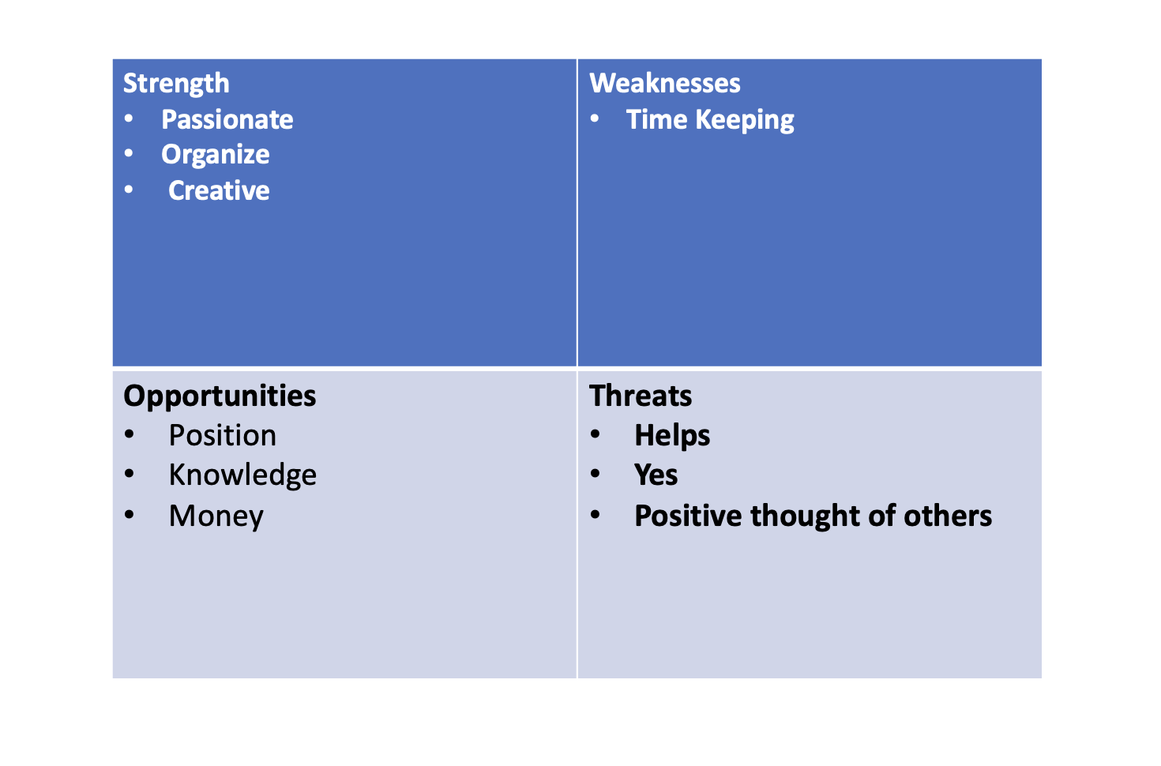

The SWOT Analysis is this business strategy tool, historically attributed to Albert Humphrey in the 1960s, though the exact date of origin is debated; also SWOT Analysis assesses how an organization compares to its competitors and it divided in the following four points: strengths, weaknesses, opportunities, threats (An, Sanvictores and Teoli, 2022).
Regarding my personal SWOT Analysis that I have done for this module it is:
Strength: I am very passionate about my job, I am good with creating and organizing.
Weaknesses: Time management.
Opportunities: I achieve a better position, have a richer knowledge and higher salary.
Threats: One of the common threat that I always face at my work it always say yes to everything; while another it is letting people take advantage of me and another is it not asking for help.

Life line
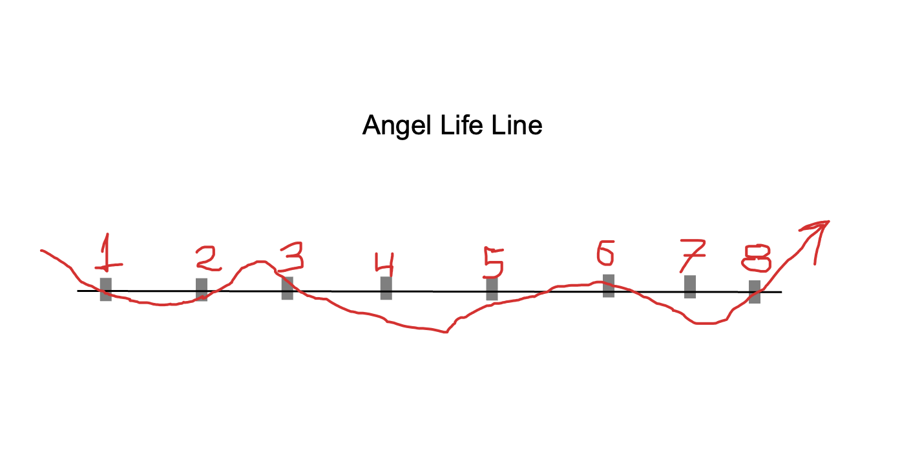
This was an exercise that my class mate did on class on the first day, and unfortunately for some miss communication of the IT service missed; therefore my class mate explained to me how to do it.
The Life line it is related to my life process and it is define the steps in my life that bring me here, the moments are described and from there I take the good and the bad that happened in my personal life.

- I had the operation on my legs and it was hard for my family to put money together.
- My mother married my step father, which I consider my real father, and he offers to help on the expenses of my operation.
- We decided to move to Italy, that it is were my new father it is coming from.
- I feel home sick and the racist population of this small village does not make it better, and also at school I have no one to play because of my colour of skin.
- My mother decide to take my grandmother to live in Italy with us, which this give me some hope and happiness.
- I finally found a friend and a girlfriend among all those racist people.
- I move to London with my girlfriend because their parents do not want a negro on their family, and we can also finally live our love story in peace, even if last for six more other month only. After those five year and six month in London we brake up and I found my self lost in a city that I do not know anyone, and while having a monte with some people that could had been new friends, I receive a text with the information that my friend it is dead and my grandma is fight for her life.
- After a long recover in Italy and help my family, I do my suit case again a decide to come back to London more stronger then ever and with new purpure and goals in life.

Smart and Objective

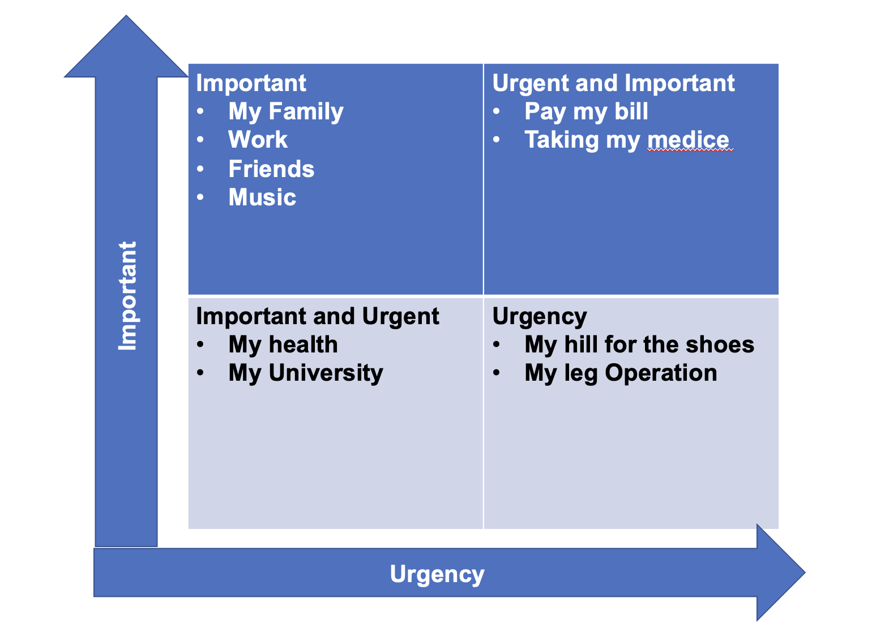

Smart and Objective stands for specific, measurable, attainable, realistic, and time-bound; it is an acronym that can be used to help individuals and organizations set goals in an effective and productive way. Specific, measurable, and time-bound objectives define the success of an initiative or project; achievable and realistic objectives drive employee engagement (Managers.org.uk, 2022).

Conclusion

It is fascinating how many tool are exiting to conduct the work on the daily basis of many companies; however it is much appreciate to know them and learn how to use them. While for me in the position that I applied for not many of them are used and also we need to think that hospitality it is a job that we need to be fast on the problem solving situation, and goals can be set up but not always achieved in the company that you started; therefor it good to always take a look to other opportunities.
It was useful to learn about the technical part of work and I am glad that I have the opportunity to participate, but also we need to keep on mind that the theorical part it is very different then the practical; especially in ambient like hospitality.
I also think that my action plan it no need here, as my action plan it was sing up for university and right now it is already in action.

Refences

The University of Edinburgh [2022]. Gibbs' Reflective Cycle. [online] Available at: https://www.ed.ac.uk/reflection/reflectors-toolkit/reflecting-on-experience/gibbs-reflective-cycle [Accessed 8 January 2022].

Erturk, E., 2022. Role Play as a Teaching Strategy. [online] ResearchGate. Available at: https://www.researchgate.net/publication/284166003_Role_Play_as_a_Teaching_Strategy [Accessed 6 January 2022].

Christian, L., 2022. The Key to Self Motivation: Stay Driven and Meet Your Goals. [online] SoulSalt. Available at: https://soulsalt.com/self-motivation/ [Accessed 8 January 2022].

Kamath, A., 2022. Do only dead fish go with the flow?. [online] Linkedin.com. Available at: https://www.linkedin.com/pulse/do-only-dead-fish-go-flow-anuradha-kamath [Accessed 10 January 2022].

Xu, W., 2022. Learning Styles and Their Implications in Learning and Teaching. [online] Academypublication.com. Available at: https://www.academypublication.com/issues/past/tpls/vol01/04/15.pdf [Accessed 8 January 2022].

An, J., Sanvictores, T. and Teoli, D., 2022. SWOT Analysis. [online] Europepmc.org. Available at: <https://europepmc.org/article/med/30725987> [Accessed 9 January 2022].

Managers.org.uk. 2022. [online] Available at: https://www.managers.org.uk/wp-content/uploads/2020/03/CHK-231-Setting_Smart_Objectives.pdf [Accessed 10 January 2022].

Appendices

Job application form

Application for [Bar Manager] -

Your details

Name: Angel Pichardo

Education and training
Please give details:

Wine
Spirit and Distillation
Allergies
Health and safety
Fire
Managing purpose and training and speed service

Qualifications
Please give details:

High School
WSET level 2
Molecular mixing

Employment history

Your current or most recent employer

Name of employer:Decimo

Job title: Head Bartender

Length of time with employer: 2 years and 6 months

Reason for leaving: Better position or new challenge

Duties:

Service and attention to the guest
Training new members staff
Ensure the correct service
Pay attention to details
Creation and innovation of drinks and service

Previous employers
Please tell us about other jobs you have done and about the skills you used or learned in those jobs.

Soho house
I used to use be trained for the barista and taking care of the events venue and promoters contact.

Supporting statement
Please tell us why you applied for this job and why you think you are the best person for the job.

I applied because I am looking for a new challenge and I believe I am the right person because my of my experience and qualifications with a good knowledge in the sector.

Right to work in the UK
Do you need a work permit to work in the UK? Yes

References
Please give the names and contact details of 2 people who we can ask to give you a reference. We may ask them before an employment offer is made. We will not ask your current employer until we get your permission.

Declaration
I confirm that to the best of my knowledge the information I have provided on this form is correct and I accept that providing deliberately false information could result in my dismissal.

Name:Angel Pichardo

Signature: Angel

Date: 03//11/21



