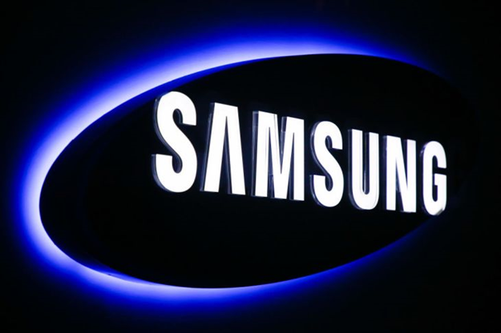

Student name: Nathaniel Odoi

Student Number: 1810442

Module: BMMMB7103D

Date: 15th December 2019

Strategic Analysis of SAMSUNG

STRATEGIC MANAGEMENT

Table of Contents

Table of Contents 1
Executive Summary 2
1. Background 3
1.1 Introduction 3
1.2 Vision and mission 3
1.3 The case for strategic management at Samsung 4
2 Situational analysis 5
2.1 PESTLE framework 5
2.2 Porter’s Five forces analysis 7
2.3 SWOT analysis of Samsung 9
3 Strategic direction 11
3.1 Competitive strategy 12
3.2 Strategic clock 13
3.2.1 Limitations of generic strategies 14
4 Corporate strategy 15
4.1 Ansoff’s Matrix 15
4.2 Vertical Integration 17
5 Change Management 18
5.1 Why Change Management (survey conducted on change management) 19
6 Conclusion 19
7 Recommendations 20
8 References 21

Executive Summary

Samsung was founded by Lee Byung-chul in 1938 in South Korea. Growing from an uncertain trading business into a multi-national corporation of an annual sales of almost $100 billion in 1997. Samsung is among the world’s leading manufacturer of smart phones and leader in technology and innovations. A strategic analysis of the company’s external environment using the PESTEL reveal the company is plagued with some political issues having sponsored a presidential aspirant in a National election. Porter’s five forces has been used to analyse the authority the company has when it comes to Bargaining power of suppliers. The company’s threats and opportunities has also been identified using SWOT analysis. The threat of facing suits and allegation from their main competitor Apple. And opportunity of launching their new air conditioning Triple Protection Proposition. Samsung’s competitive strategy has been analysed using Porter’s (1980) generic strategies and the use of the strategic clock. Vertical integration has been discussed as Samsung’s biggest strength over their rivals making the company gain competitive advantage, as the company is in charge of its supplies and the manufacturing of chips and semiconductors.

Background

Introduction
Samsung Electronics Co. Ltd. will be referred to as Samsung or the Company throughout this report. Samsung was founded in 1938 by Lee Byung-chul as a trading company situated in a city known as Taegu now South Korea (Burris, 2019). The company got bigger and expanded to Seoul in 1947 but left when the South Korean war begun. Samsung begun electronics in the 1960’s with the formation of various electronics-kingpin segregations namely Samsung Electro Mechanics, Samsung Electro Devices, Samsung Semiconductor and Telecommunication and Samsung Corning (Burris, 2019). Samsung started manufacturing, shipping and selling wide range of electronic products and appliances worldwide. The company’s growth was rapid and impressive in the 1980’s (Referenceforbusiness.com, 2019). Samsung has 56 subsidiaries globally and operates in three main markets which are electronics, chemicals and engineering. The company employs in over 60 countries. The company’s sales reached $26 billion and net profit climbing to $4.7 billion in the year 2000 (Samsung UK, 2019). According to Forbes report in May 2019, Samsung is among the top 3 digital companies and also top seven most valuable brands in the world (Forbes, 2019).

Vision and mission
Samsung’s vision is inspiring the World with their innovative Technologies, design and products that enhances the lives of people and contribute to wellbeing of the society and creating a new future (Samsung Electronics America, 2019). Analysing the company’s vision brings into light the position of the leadership and how it handles the market and improve life with their products and services. It also has some characteristics:

- Inspiring the world. Samsung does not just build their product but with the idea to inspire and this is done by taking into account the various diversities worldwide regardless of where customers are.
- Focusing on innovations. Samsung has got a very good reputation in producing highly innovative products with the bar been raised in their designs of electronics, some of the products are mobile phones and personal computers.
- Contributing to social prosperity. Samsung is focused on changing the way of life of people and making it better. This could be done in the way people work and carry on with their day to day activities. For that reason, the company factor all these into consideration when designing their products to suit societal living (Samsung Electronics America, 2019).

The case for strategic management at Samsung
Samsung has become successful in terms of revenue and branding and it is as a result of very good strategy in all fields. Strategy is said to be the guidance and liberty of a company over the long term which attain advantage in a dynamic environment through alignment of resources and competences with the aim of accomplishing stakeholder expectations (Johnson and Scholes, 2001). Johnson et al. (2011, p11) are of the opinion that “strategic management is concerned with complexity arising out of ambiguous and no routine situations with organisation wide rather than operation specific task”. Samsung has got current issues and these will not just disappear but rather it will take a bit of time over a longer period from battery fire to update programme locking customers phone in the US Anon (Forbes.com, 2019). The current ranking and performance of Samsung establish the fact that critical and strategic analysis should be taken by the company in order to soar higher and gain competitive advantage over its competitors.
Very important academic literature and theory will enable the company to get an in-depth strategic analysis and strategic management of Samsung. These frameworks will include PESTLE, SWOT, Ansoff’s Growth Matrix and vertical integration.

Situational analysis

Both macro and micro conditions of Samsung need to be considered and understood in order to have better understanding of the company’s situation. In this report, a PESTLE analysis has been conducted to analyse the external factors of the company. Porter’s five forces has been conducted to detail the micro factors of the industry where Samsung operates. Both the PESTLE and Porter’s five forces will bring insight onto the SWOT analysis.

PESTLE framework
According to Shaw, (2011) PESTLE analysis is a method for assessing the macro environment (external forces that clashes a company’s ability to plan). The PESTLE mnemonic stands for Political, Economic, Social, Technological, Legal and Environmental Anon (PESTLE Analysis, 2019). Detailed PESTLE analysis of Samsung is discussed below.
PESTLE Analysis of Samsung Summarised
P | Political factors like political stability, government reaction towards the industry and the organisation, home pressure groups as well as international pressure groups and military invasion affects the revenue and has long term effect on the prospective growth of the company directly or indirectly. Samsung has political scandal in South Korea, Uri Party representative officially admitted the receipt of some money in the form of bonds whereas it was also found out that the company sponsored the opposition Party Grand National Party in 2002 (Dudovskiy, 2019).  The former de facto head of Samsung Jay Y Lee was jailed in 2017 for his role in bribery and embezzlement of funds part of which led to eviction of the first female president of South Korea Park Geun-hye which may have severe detrimental effect on the brand image (Dudovskiy, 2019).
E | Profit of the company can be affected due to economic crisis. Samsung is expanding to developing countries to gain more global recognition but the economic instability of these countries affects the purchasing power of consumers. The problem here is that there is uncertainty within the macro environment Samsung operates and this calls for restructuring its strategy (Managementstudyguide.com, 2019). The good thing the company is doing is lessening its consumer disposal income in the developed countries by expanding into the emerging markets. Taxation, interest rate, inflation and changes in labour cost has direct financial consequence with Samsung.
S | Taking into account the beliefs and local culture of your market or customers is very prudent. Samsung is naturally a South Korean company but it has strategically done well by operating in flexibility and adopting policies that can make them acceptable globally (Marketing Dawn, 2019). Samsung operates in a market where lifestyle has effects on purchasing power of customers and these differ from country to country. The company has had to restructure its strategic policies to suit each market they operate especially in the emerging Market (Managementstudyguide.com, 2019).
T | Samsung is undoubtedly among the leading companies in innovation and technology. This means that the company has competitive advantage over its rivals for been the driver of innovative and technology for the sustainable market. Samsung’s strategy is being the first to enter the market with their latest product (Managementstudyguide.com, 2019). Their mission is always to enter the market with contemporary trends in the technological realm which always place them ahead of their rivals since all their products are technology driven (Marketing Dawn, 2019).
L | Samsung is a Global company and do not need to face much legal charges like copy and pirated issues especially when it has rivals like apple. The company has faced many penalties for allegations from apple about design copying (Marketing Dawn, 2019). The company has to come up with a strategy to come out of this perception from customers in the developed market.  In 2018, the company was faced with another lawsuit in France for misleading advertising for alleged workers violation (Kharpal, 2019).
E | The world is now a Global village and there are a lot of ethical issues going on. Due to that, every customer wants to see its favourite organisation being socially responsible and contribute to the betterment of the society. Samsung has a very good strategy when it comes to CSR with the company supporting local communities via systematic vocational education, Educating and empowering workers, spearheading Labour and Human rights, Waste Reduction and Recycling and being socially responsible corporate citizen (Dudovskiy, 2019)

Porter’s Five forces analysis
Michael Porter in 1979 described this framework in his Harvard Business Review article as the tool for understanding the competitive forces at work in an industry and which steers how economic value is divided between industries (Isc.hbs.edu, 2019). He suggested that these forces mould rivalry at strategic business components (Porter, 1980). He named them as Threat of substitute, bargaining power of Buyers, Bargaining Power of Suppliers, Rivalry Among existing Competitors and lastly Threat of New Entrants. Where the five forces are high then the industry is not attractive. The technology industry has been analysed below using the Porter’s five forces.

Threat of substitute: Threat of entry is practically low as there is a high barrier to enter into this industry. this is because an organisation will require a massive capital to set up a technology industry come to talk about the fact that they’ve got technology giants like Apple, Huawei and Samsung to compete with. In spite of all these Samsung still faces threats as there are comparatively alternative mobile phones that can serve as substitute for Samsung mobile and the same applies to Samsung TV as well (Dudovskiy, 2019). The threat becomes high if the alternative provides low and attractive products or price (Isc.hbs.edu, 2019).

Bargaining power of buyers: Prices can sometimes be force down by customers if the buyers are bigger as compared to competitors. In Samsung’s case is a bit of win-win situation as the customers need the company for their quality and reliable brand whereas the company also need the buyers to stick to their product rather than opting to buy from other rivals who also has quality products (Managementstudyguide.com, 2019). This is the time where the company needs customer loyalty in order to meet their targeted revenue.

Bargaining power of suppliers: Companies in each industry has a supplier they purchase from. Strong suppliers can demand more favourable terms or charge higher prices from industry rivals based on their negotiating leverage the fewer the suppliers the more power they have (Isc.hbs.edu, 2019). Samsung deals with 579 suppliers worldwide and because the company order large volume of inputs, they are able to negotiate prices (Dudovskiy, 2019). However, one of its suppliers of google has bargaining power in the production of android due to the fact that Samsung has no other option yet. The strategy Samsung implore is the maintaining of good communication with its suppliers in an initiative known as shared growth day and supplier dialogue fair (Dudovskiy, 2019). Samsung supplies most of its components and Raw materials and that account for this stage been at low risk and this gives the company an urge over Apple which is its main competitor.

Rivalry among existing competitors: The existing rivalry within the technology industry is intense which makes it difficult for others to penetrate. There are several brands like Apple, Huawei and LG and everyone one of these is strategically implementing ideas to stand firm in the market which will urge them to reduce their price in order to win buyers. The more the competition the more likely Samsung will have to drop their prices to have an urge over their rivals. Samsung will also have to enhance their technological innovation to overcome their cohort (Pratap, 2019).

Threat of new entrants: This force puts pressure on companies to reduce prices to retain customers. The introduction of new organisations into the industry reduces profit margin because companies will spend more to keep customers and also cost of keeping brand awareness (Isc.hbs.edu, 2019). Samsung has already established globally so for any newly created industry to penetrate is very difficult as policy legislation and also the capital involved to reach the height of Samsung is very difficult so the threat for Samsung is Low (Pratap, 2019).

SWOT analysis of Samsung
SWOT framework has been used by Consultants in developing strategy for clarification of areas such as sales and any department that needs to improve in an organisation (Zenker, 2019). This framework can be employed before committing to any business action or decision because it gives a 360 look of your organisation (Schooley, 2019). SWOT stands for strength, weakness, opportunities and threats of an organisation. These are grouped under two dimensions which are External which comprises of threats and opportunities and Internal factors which are strength and weaknesses (Gurel, 2019). These two dimensions has earlier been discussed from PESTLE and Porter’s five forces. Below is a summarised SWOT analysis for Samsung.

SWOT analysis of Samsung
Strength  Samsung foundation is solid due to innovative research and development which has seen the company exhibiting a wider range of product portfolio as compared to its rivals. The company has 34 Research and Development globally spending US$14.857 billion in 2017 (Bstrategyhub.com, 2019). Samsung has a credible backing as an award-winning brand having won top awards in consecutive years worldwide. | Weakness  Samsung depends heavily on the American market for sales. The decline in sales in the American market or a recession can cause a havoc with Samsung’s revenue (Bstrategyhub.com, 2019).  Samsung is currently faced with declined in smart phone sales despite moving more products to India. The company is solely depending on Android OS which weakens business capabilities (Martin, 2019).
Opportunities  Samsung strategically partners with software developers to boost the revenue of the company. Spotify has an agreement with the company in the streaming of music for their mobile devices (Martin, 2019). This is an external factor which also enhance the competitive advantage of the company through product variant. Samsung will soon launch its new air conditioning known as “Triple Protection Proposition” which will promote customer retention (Bstrategyhub.com, 2019). | Threats  Samsung faces competition from rivals like Apple and Huawei in the consumer electronics. Samsung is no exception from companies facing legal and governmental regulations globally.  Finally, Samsung has been involved in controversies with Apple which poses as threat to the company (Martin, 2019).

SWOT analysis framework is a very useful tool which organisations use strategically in management, however like every other tool it has its own disadvantages or limitations. The framework only talks about issues which are most certain to be strength, weakness, opportunity and threats but any other with two sided are not covered. The framework can also generate so many ideas but not help in choosing the best one (Business.qld.gov.au, 2019). In the case of Samsung, the company has done well by having vast product portfolio but has failed to have brand positioning unlike Apple (Heart of Codes, 2019). In a nutshell, the company has a good equity and the only thing they need to do is to capitalise on their opportunities to make the company soar higher. My recommendation here will be for Samsung to reduce investment for India, this is because the sale of computers in India dropped by 6% in 2015 because the Government has stopped delivering free laptops to students. Reducing investment in India will be the best strategic decision for a company to take instead of reducing unit prices (Myassignmenthelp.com, 2019).

Strategic direction

The evidential elements recognised place the ambience of competitive advantage of Samsung. Johnson et al. (2011), has identified 3 levels of business strategy in a sequential order thus lowest to the highest. These are Functional, Business and Corporate levels of strategies that exist in an organisation. Functional level of strategy is implemented by supervisors and first line managers it involves the making of decisions at the operational level and is targeted at a specific functional sector which could be Marketing, Production or Research and development Anon (Business Jargons, 2019). It is very common and prudent to see organisations with several distinct unit making decisions for their units to compete in that specific market. Business level is like the representation of the organisation with decisions made by the General Managers. Samsung has several distinct units like their mobile phone section so unique strategic decision need to be taken in order to compete in that market and that is referred to by Johnson et al. (2011) as business level strategy. This makes the smart phone section to directly compete with its rivals which is seldom known as competitive strategy. Samsung, with its global strength should also have an overarching long-term plan for all their various business units. Corporate level is formed by top level management and is directed at expansion, merging, takeovers, new areas for investment and acquisition. Samsung has moved from being a grocery store through to becoming giant in technology due to flexibility in Corporate level strategic decisions (Dudoviskiy, 2019).

Competitive strategy
The obvious aim of every business is to make and maximise their profit margin. The ability to achieve this is competing very well in the market with your rivals. This can be achieved by Business unit by using competitive advantage (Johnson et al., 2011). Porter proposed three generic strategies of which businesses can have competitive advantage and they are overall cost leadership, differentiation and focus (Porters, 1985). Samsung has used competitive strategies in achieving success in most of its units. Samsung strives to apply differentiation in their product to distinct themselves from its competitors, example is that the company has added a pod cast feature on its headset to make it stand out from others Anon (Brainmass.com, 2019).
A study of product differentiation in mobile services about smart phone features by Pawan Kalyani published in the Journal of Management Engineering and Information Technology (JMEI) talked about how the mobile phone manufacturing companies has gained customer attention by producing more sophisticated features. Features like touch screen, internal memory storage, quality camera pixel and many more. These has contributed to the Mobile phone firms gaining the higher market share, but to retain and maintain the market share, the mobile phone manufacturers are differentiating their products by adding more features such as dual camera, selfie camera and others. And this is been practiced by all the leaders in smart phone. It was concluded that as these features are been adopted by the Mobile device manufacturers, it has been welcomed by the customers and that led to the 53% increase of sales in India (Kalyani, 2019). Deduction from the study above is that Samsung faces competition from other mobile device manufacturing giants in the likes of Apple, Huawei, Sony, Lenovo and Microsoft so to gain more competitive advantage over them is to continue to stay on it toes with its wonderful features and quality products. Samsung’s product differentiation will be discussed into detail later.

Strategic clock
To explore the options of strategic positioning of an organisation, Bowman’s strategic clock is the best tool. Samsung is currently among the leaders in smartphone vendors globally with 20 percent market share in the smartphone market share globally. In 2019, the company’s unit sales in the smartphone exceeded 70 million units in the 25th quarter in a row (Statista, 2019). The company’s revenue has also increased due to solid sales of the galaxy S10 smartphone (News.samsung.com, 2019). This achievement has been feasible due to its positioning on the strategic clock. Consumers are persuaded to purchase a product based on the benefits of the product/services, the price and if its Value For money (VFM) Johnson et al. (2011). But some consumers are loyal to a specific brand and will still purchase regardless of it been expensive. So, the issue of VFM is relative and customer dependant. This strategy works very well for Apple but could be different for other firms in the same industry. ‘no frills’ strategy, low price strategy, differentiation, hybrid and focused differentiation strategy are shown on the strategic clock about positions of different customer demands (Johnson et al., 2011). Each of them is summarised in exhibit 3.1 below.
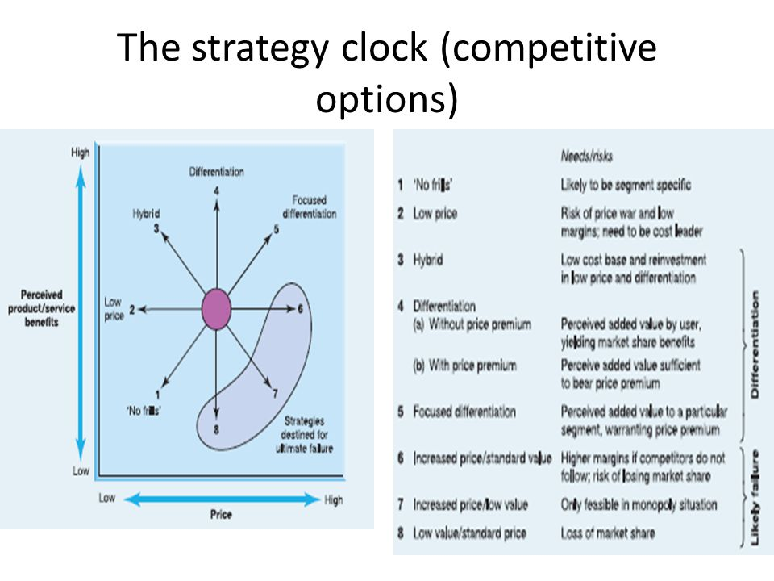
The Strategy Clock (Competitive Options)
Exhibit 3.1 The Strategic Clock - Source: (extracted from Johnson et al., 2011)
Strategic position of Samsung is very static currently moving from a cost-driven to authority in manufacturing. Samsung uses focused priced differentiation and increased price-standard product pricing that’s sometimes using the skimming pricing policy and competitive pricing to match that of its competitors (Grasset, 2015).

Limitations of generic strategies
Bowman’s (1992) strategic clock has been useful in many ways but it also has some setbacks. The prescription does not give a clear representation of the impact of profit moves around the customer matrix. The link between competitive positions and profitability is not given but rather it elaborates on competitive strategy and market performance. Because it does not consider cost position, the link to profitability is lost. What this means to Samsung and its related implication is that, the company’s revenue for second quarter of 2019 decreased by 56% as compared to that of the previous year (Android Central, 2019). Although Samsung is among the technology giant in the world and among the top seven in terms of revenue, they still need to work hard strategically to gain competitive advantage over its rivals like Apple. Samsung is known to have invested heavily in Research and Development and this is helping in achieving more differentiation. Samsung policy is “We will devote out Human resources and technologies to create superior products and services thereby contributing to a better global society”. (Rudenko, et al., 2008). Samsung has grouped its product differentiation into three different ways in order to attain competitive advantage over its rivals. The categories are firm linkages, products attributes and firm consumer relationship.

Corporate strategy

Samsung has implemented good corporate strategy in the dealing of all their business and that has yielded a positive result across board. Whilst competitive strategy discussed earlier focuses on single unit, in the case of Samsung is their smart phone section which has boost their sales for consecutive years, the corporate strategy considers the broader strategic business unit (SBU) of the organisation. Unarguably, Samsung’s corporate strategy is one of the best having seen the company from cost driven to authority in manufacturing.

Ansoff’s Matrix
Ansoff (1988), suggested two effective approaches in developing growth strategy. These are product growth that’s through fluctuating what is sold and market growth which is who the product is sold to Anon (Oxford College of Marketing Blog, 2019). Combining these together with the below Ansoff Matrix gives four different strategies with different risk at each level. This matrix provides alternative means of getting organisational growth achieved. The first one to talk about is increased penetration of existing markets. Another is Market development which involves the building of new market. Product development and diversification are the other two. Johnson et al., (2011) explains diversification as involving substantial widening of an organization’s capacity in terms of both product and services.
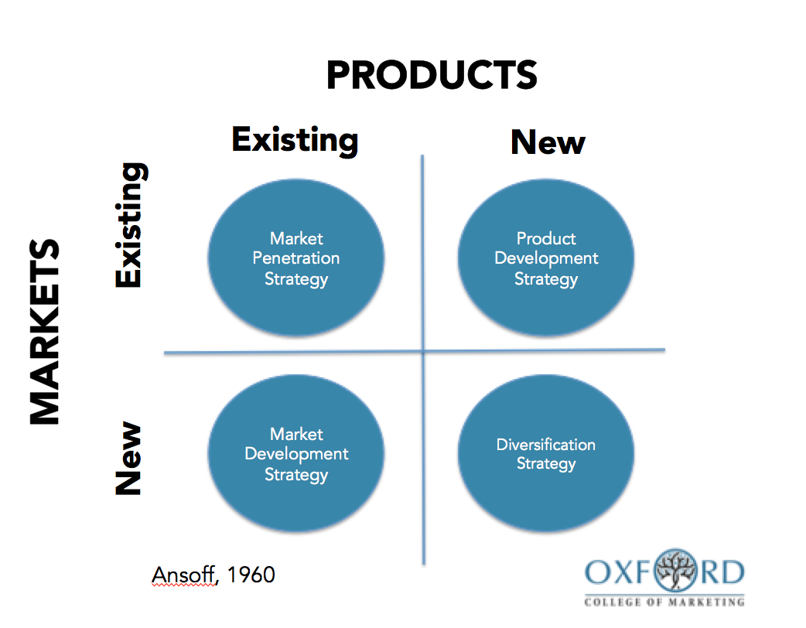

Exhibit 3.2 Ansoff’s Matrix - Source: Oxford college of marketing.com, (2016)
Market penetration strategy is primarily Samsung’s dependant revenue growth. Samsung has gained the strength in European Union’s Consumer Electronic Market because they already have operations so what they tend to do is to increase their revenue from the sales of products currently in the known market Anon (Panmore Institute, 2019). This will be considered as the lowest risk strategy. Product Development: Samsung is noted for the manufacturing of new product for its customers such as electrical gadgets like the rolling out of smartphone models with the Galaxy S10 generating huge sales currently. This is an intensive growth strategy for the company. Samsung regularly introduces improved versions of existing products (iterative innovation). The risk in this stage is higher so my recommendation will be for the company to embark on effective research on their customers and the market they are targeting Anon (Oxford College of Marketing Blog, 2019). Market Development: The nature of Samsung operations globally makes this strategy minor intensive for market growth simply because this strategy is about entering new market with the existing product, typical example is Samsung after gaining and relying a lot on the US market has extended to the Latin America market with the Galaxy tablet. This strategy works well depending on the value of the product (Martin, 2019). This stage has much risk than market penetration. My recommendation is that, Samsung should consider the standard of living of the New market before introducing a product to them as the value may hinder sales. Diversification: This is the riskiest out of all four as the firm is considering a new market with a new product however, this could turn out to yield the highest returns if related diversification is used to mitigate it Anon (Oxford College of Marketing Blog, 2019). Samsung rather engages in the acquisition of smaller business because of regulatory hurdles that may serve as stumbling block a typical example is Harman International Industries a subsidiary of Samsung (Martin, 2019).

Vertical Integration
Vertical integration is defined as the “… combination of technologically distinct production, distribution, selling and/or other economic processes within the confines of the firm” (Porter, 1980, p300). It is simply broken down as the strategy used by firms to have influence over its suppliers to be able to limit the cost of operations to be resilient in the marketplace (Jurevicius, 2019). There are two types of vertical integration backward and forward integration. The strategy of having control over a firm’s activities at the end of the supply chain is known as Backward integration. Example is smartphone manufactures who depend on third parties for chips will decide to produce themselves whereas gaining increased control over activities concerned away from the start of the supply chain is Forward integration. Example is a mining company owning its own metal factory (Amadeo, 2019).
Samsung has the urge over Apple when it comes to Vertical Integration. The company focuses and works around Vertical Integration. In a statement made by the Company’s China LED General Manager and Senior Vice President Dr Tang made it clear the focus is on 1W-5W high powered and 0.2W-1.2W mid powered LEDs and the manufacturing of core materials like phosphor and epitaxial wafer to contribute to product quality and technology upgrades Anon (Ledinside.com, 2013). Samsung always beat apple to bringing new products to the market, this is because the company is in total control of the manufacturing process from chips to screens and do not have to rely on suppliers before completing the supply chain process (Worstall, 2019). Samsung is also the biggest producer of semiconductors and memory chips and also supply to its biggest competitor Apple. The company also supplies LCD Panels to other TV manufacturing companies (Scribd, 2019).
Relevant Research
A study of Vertical integration and corporate strategy by Harrigan, Kathryn Rudie published in Academy of Management Journal (pre-1986). This study was about whether organisations through their business units should outsourced some goods or services or should be provided internally. As part of their findings, it was deduced that broadly interrupted SBU’s intensifies an organisation’s value-added margin significantly. Also, firms who handover large amount of SBU’s of their total outputs internally will be involved in enormous stages of processing as compared to firms with few. It was furtherly stated that limited amount of Vertical integration is rather advantageous. Uncertainty of demand for SBU’s can lead to decline in turnover in a firm (Harrigan, 1985).
Advice for Samsung is that, as much as Vertical integration is part of their success, the volatility of the industry should be taken into consideration in order not to loose their competitive advantage to its rivals.

Change Management

McKinsey, (1980) 7S model was created by consultants working for McKinsey & Company explaining the stages and steps for managing change in an organisation (Cleverism, 2019). Samsung embarked on a significant organisational change that saw the turnaround of the company. R&D projects were modernised around principal technology areas like nanotechnology, digital technology, optoelectronic and many more and all these were closely connected with the company’s business prospects. Samsung R&D projects reached 80% commercialisation in 2004 as compared to that of 66% in 2002 Anon (Bpir.com, 2019). This is because researchers were equipped with proper technological proficiency and business acumen and the R&D centres being associated with the company’s business unit which led to the improvement of value creation.

Leadership change: Change management can sometimes move hand in hand with change in Leadership as well to enhance quality organisational performance to bring strategic change. The frequency of staff or senior management change helps to stunned political, technological and social struggle (Ocasio, 1993).

Why Change Management (survey conducted on change management)
A research conducted in the Technology industry by Wadood et al, about the influence of change in the industry. The sample size was around 250 comprising of employees of Samsung Electronics, Google, Apple Inc and Rocket Internet. The variables were Technological innovation, change management, Leadership style and Management roles. The test was conducted to find the relationship between the independent variables and change management (dependent variable). At the end of the research, it was deduced that there is a positive relationship between change management and managerial roles as well as Technological innovations and leadership skills. This shows that for an organisation to perform well both by sales or and managerial performance, there is the need for change in structure and in production.

Conclusion

Samsung has made it to the top seven technology companies in terms of revenue and among the top three in terms of technology and innovations. This success has become feasible because the company has incorporated strategy as part of its DNA. Undoubtedly, Samsung operates in an increasingly volatile, uncertain, complex and ambiguous world with their industry full of competition and new innovation hence the need for strategic analysis for the company to be second to none. The company cannot dwell in excellence without considering the strategy of their rivals like Apple and Huawei are adopting. Finally, the outstanding position globally must also be attributed to the investment in their Research and Development programmes as well as their involvement in CSR. The company’s dominance in the implementation of Vertical integration has made producing and launching of new products a success and gaining advantage over its major rival Apple.

Recommendations

Unlike apple who produces their own iOS operating system along with wide ranging apps like iTunes and iClouds for its smartphones, Samsung still rely on Google’s android as their solely operating system. The company should consider producing their own operating system. Samsung rely a lot on the US market which also has limited customers. I recommend that attention should be channelled to other new markets like the Europe market and also Asia market to help in the maximisation of profit because of its rapid development. New consumer demographic can be achieved through this. The company’s success can also be related to their well-structured supply chain strategy. To gain more competitive advantage, I will recommend vendor specification for their local economy at this time (Myassignmenthelp.com, 2019). Samsung needs to expand and dominate into the African market as the market shows signs of rapid growth. Currently Apple is dominating due to its product quality. Samsung needs to produce quality products and reduce their price to obtain dominance in the market (Myassignmenthelp.com, 2019).

References

Android Central. (2019). Samsung's Q2 2019 profit falls by a staggering 56% after weak memory demand. [online] Available at: https://www.androidcentral.com/samsungs-q2-2019-profit-falls-staggering-56-after-weak-memory-demand [Accessed 12 Nov. 2019].

Brainmass.com. (2019). [online] Available at: https://brainmass.com/business/differentiation-strategies/samsung-product-differentiation-competition-strategies-381891 [Accessed 11 Nov. 2019].

Bstrategyhub.com. (2019). [online] Available at: https://bstrategyhub.com/swot-analysis-of-samsung-2019-samsung-swot-analysis/ [Accessed 8 Nov. 2019].

Burris, M. (2019). The History of Samsung (1938-Present). [online] Lifewire. Available at: https://www.lifewire.com/history-of-samsung-818809 [Accessed 20 Oct. 2019].

Business.qld.gov.au. (2019). Benefits and limitations of SWOT analysis | Business Queensland. [online] Available at: https://www.business.qld.gov.au/starting-business/planning/market-customer-research/swot-analysis/benefits-limitations [Accessed 10 Nov. 2019].

Business Jargons. (2019). What is Business Strategy? definition, levels and nature - Business Jargons. [online] Available at: https://businessjargons.com/business-strategy.html [Accessed 11 Nov. 2019].

Dudovskiy, J. (2019). Samsung PESTEL Analysis - Research-Methodology. [online] Research-Methodology. Available at: https://research-methodology.net/samsung-pestel-analysis-2-2/ [Accessed 20 Oct. 2019].

Dudovskiy, J. (2019). Samsung Corporate Social Responsibility - Research-Methodology. [online] Research-Methodology. Available at: https://research-methodology.net/samsung-corporate-social-responsibility/ [Accessed 26 Oct. 2019].

Dudovskiy, J. (2019). Samsung Porter's Five Forces Analysis - Research-Methodology. [online] Research-Methodology. Available at: https://research-methodology.net/samsung-porters-five-forces-analysis [Accessed 30 Oct. 2019].

Dudovskiy, J. (2019). Samsung Business Strategy and Competitive Advantage: effective exploitation of market readership - Research-Methodology. [online] Research-Methodology. Available at: https://research-methodology.net/samsung-business-strategy-competitive-advantage-effective-exploitation-market-readership/ [Accessed 11 Nov. 2019].

Forbes. (2019). Samsung Electronics on the Forbes World's Best Employers List. [online] Available at: https://www.forbes.com/companies/samsung-electronics/ [Accessed 20 Oct. 2019].

HARRIGAN, K.R., 1985. Vertical Integration and Corporate Strategy. Academy of Management Journal, 28(2), pp. 397.

Heart Of Codes. (2019). SWOT Analysis of Samsung | Samsung's SWOT Analysis. [online] Available at: http://heartofcodes.com/swot-analysis-of-samsung/ [Accessed 10 Nov. 2019].

Referenceforbusiness.com. (2019). Samsung Electronics Co., Ltd. - Company Profile, Information, Business Description, History, Background Information on Samsung Electronics Co., Ltd.. [online] Available at: https://www.referenceforbusiness.com/history2/16/Samsung-Electronics-Co-Ltd.html [Accessed 20 Oct. 2019].

Forbes.com. (2019). Warning As Samsung Smartphones Crippled By Latest Update, Factory Reset Needed. [online] Available at: https://www.forbes.com/sites/zakdoffman/2019/07/13/confirmed-samsung-galaxy-smartphones-crippled-by-update-factory-reset-needed/ [Accessed 20 Oct. 2019].

Gurel, E. (2019). [online] Available at: https://www.researchgate.net/publication/319367788_SWOT_ANALYSIS_A_THEORETICAL_REVIEW [Accessed 3 Nov. 2019].

Isc.hbs.edu. (2019). The Five Forces - Institute For Strategy And Competitiveness - Harvard Business School. [online] Available at: https://www.isc.hbs.edu/strategy/business-strategy/Pages/the-five-forces.aspx [Accessed 26 Oct. 2019].

Johnson, G., Whittington, R., Scholes, K. (2011) Exploring Corporate Strategy: Text and Cases, 9th ed. Harlow: FT Prentice Hall

Jurevicius, O. (2019). The Best Explanation of Vertical Integration Ever. [online] Strategic Management Insight. Available at: https://www.strategicmanagementinsight.com/topics/vertical-integration.html [Accessed 15 Nov. 2019].

Kharpal, A. (2019). Samsung hit with lawsuit over misleading advertising related to alleged human rights violations. [online] CNBC. Available at: https://www.cnbc.com/2018/01/11/samsung-hit-with-lawsuit-over-misleading-advertising-related-to-alleged-workers-rights-violations.html [Accessed 26 Oct. 2019].

Managementstudyguide.com. (2019). PESTLE Analysis of Samsung. [online] Available at: https://www.managementstudyguide.com/pestle-analysis-of-samsung.htm [Accessed 21 Oct. 2019].

Managementstudyguide.com. (2019). Porters Five Forces Analysis of Samsung. [online] Available at: https://www.managementstudyguide.com/porters-five-forces-analysis-of-samsung.htm [Accessed 30 Oct. 2019].

Marketing Dawn. (2019). PESTLE Analysis of Samsung. [online] Available at: http://marketingdawn.com/pestle-analysis-of-samsung/ [Accessed 26 Oct. 2019].

Martin, V. (2019). Samsung SWOT Analysis & Recommendations - Panmore Institute. [online] Panmore Institute. Available at: http://panmore.com/samsung-swot-analysis-internal-external-factors-recommendations [Accessed 8 Nov. 2019].

News.samsung.com. (2019). Samsung Electronics Announces First Quarter 2019 Results. [online] Available at: https://news.samsung.com/global/samsung-electronics-announces-first-quarter-2019-results [Accessed 11 Nov. 2019].

Oxford College of Marketing Blog. (2019). Using The Ansoff Matrix to Develop Marketing Strategy. [online] Available at: https://blog.oxfordcollegeofmarketing.com/2016/08/01/using-ansoff-matrix-develop-marketing-strategy/ [Accessed 15 Nov. 2019].

PESTLE Analysis. (2019). What is PESTLE Analysis? A Tool for Business Analysis. [online] Available at: https://pestleanalysis.com/what-is-pestle-analysis/ [Accessed 20 Oct. 2019].

Porter, M.E (1980). Competitive Strategy: Technique for analysing industries and Competitors, Free Press, 1980

Pratap, A. (2019). Samsung Five Forces Analysis. [online] notesmatic. Available at: https://notesmatic.com/2017/10/samsung-five-forces-analysis/ [Accessed 1 Nov. 2019].

Samsung Electronics America. (2019). Vision 2020 | Vision | Samsung US. [online] Available at: https://www.samsung.com/us/aboutsamsung/vision/vision2020/ [Accessed 19 Oct. 2019].

Samsung uk. (2019). History | Company | Samsung UK. [online] Available at: https://www.samsung.com/uk/aboutsamsung/company/history/ [Accessed 20 Oct. 2019].

Schooley, S. (2019). SWOT Analysis: What It Is and When to Use It. [online] Business News Daily. Available at: https://www.businessnewsdaily.com/4245-swot-analysis.html [Accessed 2 Nov. 2019].

Scribd. (2019). 292151513 Samsung Vertical Integration | Samsung | Apple Inc.. [online] Available at: https://www.scribd.com/document/362207279/292151513-Samsung-Vertical-Integration [Accessed 27 Nov. 2019].

Shaw, A. (2019). PESTLE Definition. [online] Strategic Planet. Available at: http://www.strategic-planet.com/2011/01/pestle-definition/ [Accessed 20 Oct. 2019].
Statista. (2019). Samsung smartphone sales 2010-2019 | Statista. [online] Available at: https://www.statista.com/statistics/299144/samsung-smartphone-shipments-worldwide/ [Accessed 11 Nov. 2019].

(Johnson and Scholes, 2001) - StudyBlue. [online] STUDYBLUE. Available at: https://www.studyblue.com/notes/note/n/3-2-the-definition-of-strategy-johnson-and-scholes-2001/deck/9415384 [Accessed 20 Oct. 2019].

Worstall, T. (2019). Why Samsung Beats Apple Or Perhaps Vice Versa. [online] Forbes.com. Available at: https://www.forbes.com/sites/timworstall/2013/09/09/why-samsung-beats-apple-or-perhaps-vice-versa/ [Accessed 15 Nov. 2019].

Zenker, P. (2019). SWOT or SOAR which is better?. [online] Tug Of War With Time. Available at: https://tugofwarwithtime.com/swot-or-soar-which-is-better/ [Accessed 2 Nov. 2019].

