International Financial Management in British Petroleum: Challenges and Approaches

Stefan Gheorghe-2024473

International Financial Management – LCBB 6002
Lecturer: Dr. Konstantina Mari
University of Wales Trinity Saint David
03.05.2023

Table of Contents
1.Introduction 3
2.Importance of IFM to British Petroleum 3
3.Dividend Distribution Policy 3
4.Efficient Market Hypothesis and BP's Operations 4
5.BP's Methods of Appraising Projects 5
6.Conclusion 6
7.References 7

1.Introduction
British Petroleum (BP) plc., founded in 1909, is a multinational oil and gas company headquartered in London, United Kingdom. Operating in over 70 countries, BP employs approximately 70,000 people and is led by CEO Bernard Looney. As one of the world's leading integrated energy companies, BP is engaged in the exploration, production, and refining of oil and gas, as well as the marketing and distribution of fuels, lubricants, and petrochemicals. Committed to transitioning to a low-carbon future, BP is also investing in renewable energy sources and innovative technologies to reduce its environmental footprint (BP Plc., 2023). As a multinational corporation, BP is exposed to various international financial markets, creating both opportunities and challenges. This report aims to critically analyse and evaluate the importance of International Financial Management (IFM) to BP, and critically analyses the company's dividend distribution policy. It presents after the efficient market hypothesis theory in BP’s operations and discusses the methods of appraising projects in international financial markets and support the discussion with relevant IFM theories and empirical evidence.

2.Importance of IFM to British Petroleum
IFM is crucial for multinational corporations like BP as it helps manage risks and uncertainties arising from operating in different countries and currencies. The importance of IFM to BP can be highlighted in the following aspects:
- Exchange Rate Risk Management
BP faces exchange rate risks due to its operations in different countries with varying currencies. By employing IFM techniques, such as currency hedging, BP can minimize the impact of currency fluctuations on its cash flows and profitability.
- International Capital Budgeting
BP invests in large-scale projects across the globe, requiring significant capital outlays. IFM helps the company to determine the optimal capital structure, effectively allocate resources, and evaluate the viability of international projects.
- International Tax Management
BP operates in various jurisdictions with different tax systems, making tax management a critical aspect of its financial strategy. IFM enables BP to minimize its global tax liabilities and optimize its tax planning strategies.

3.Dividend Distribution Policy
BP's dividend distribution policy reflects its commitment to returning value to shareholders while maintaining a strong balance sheet and investing in growth opportunities. With each quarter's results, the BP’s board determines the dividend level. If an interim dividend is declared, the dividend is paid approximately eight weeks after the announcement. A dividend's amount and timing may be altered at any moment without notice. Because a dividend is paid for each share, the amount shareholders receive is proportional to the number of shares they own. (BP Plc., 2023). The company's policy can be analysed through two IFM theories: the Dividend Irrelevance Theory and the Dividend Relevance Theory. BP's policy aligns with the dividend relevance theory, which posits that dividends are an essential determinant of a company's value, as it consistently pays dividends to its shareholders.
- Dividend Irrelevance Theory
Dividend policy, according to the Dividend Irrelevance Theory established by Modigliani and Miller (1961), has no effect on a company's market value (Miller & Modigliani, 1961). According to the hypothesis, investors are agnostic about dividends and capital gains, indicating that BP's dividend policy should have no effect on its market value.
- Dividend Relevance Theory
In contrast, Gordon in 1959 and Lintner in 1962 proposed that the dividend policy does affect a company's market value. This theory suggests that investors prefer a stable and predictable dividend policy, which provides a signal of a company's financial health and reduces uncertainty. Over the years, BP has maintained a stable dividend pay-out, as seen below in Fig1., even during challenging times in the oil and gas industry, reflecting its commitment to shareholder value. This has led to a positive market perception and a stable stock price, suggesting that BP's dividend policy is indeed relevant to its market value.
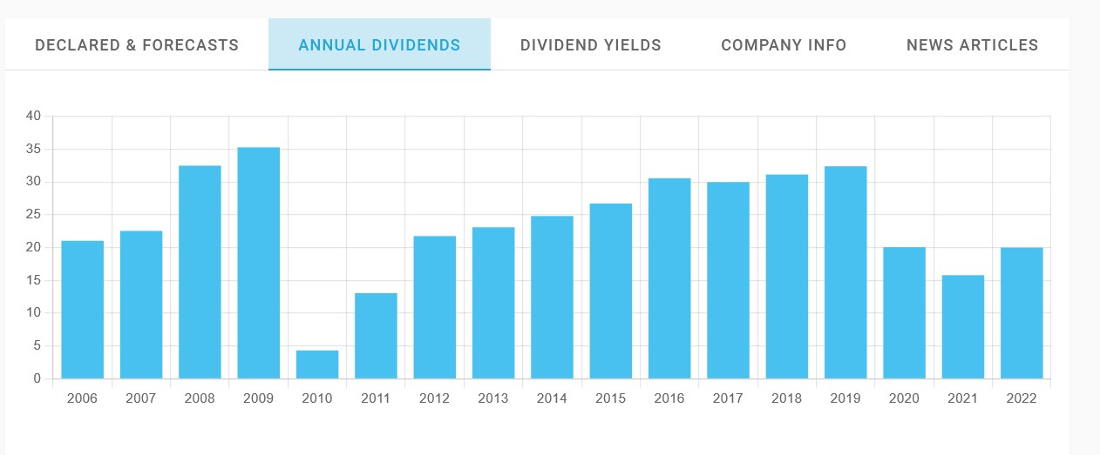
Fig.1 Annual Dividends BP (Source: (Dividendmax LTD, 2023)
Historically, the BP’s dividend policy has seen some adjustments made based on prevailing market conditions and prospects. This policy ensures that BP retains investor confidence and maintains a stable shareholder base, while also supporting the company's long-term growth and financial stability.

4.Efficient Market Hypothesis and BP's Operations
According to Fama (1970), the efficient market hypothesis (EMH) states that financial markets are efficient in reflecting all available information. EMH comes in three varieties: weak, semi-strong, and strong. In the context of BP's activities, the semi-strong form of EMH may be applicable, as it assumes that stock prices represent all publicly available information but not all private information.
- Weak Form Efficiency
Stock prices, according to weak form efficiency, already reflect all historical information, including prior prices and trade volumes. In the case of BP, the weak form efficiency implies that past financial performance cannot be used to forecast future stock price fluctuations.
- Semi-Strong Form Efficiency
Stock prices, according to semi-strong form efficiency, reflect not just past information but also publicly available information. This suggests that all public announcements, financial reports, and industry news should already be factored into BP's stock price, making it difficult for investors to regularly outperform the market using this information.
- Strong Form Efficiency
According to strong form efficiency, stock prices reflect all information, both public and private. This implies that even insiders with access to confidential information cannot consistently outperform the market. In the example of BP, strong form efficiency implies that any private knowledge about its operations or strategies is already reflected in its stock price.
BP operates in highly regulated and competitive markets, with numerous players and extensive public disclosure requirements. As a result, BP's stock price is likely to reflect all publicly available information, making it difficult for investors to earn above-average returns using fundamental or technical research on a consistent basis. However, BP's size and influence also mean that private information may impact its stock price, potentially leading to inefficiencies in the market. This highlights the importance of robust corporate governance and disclosure practices to maintain investor confidence and market efficiency.

5.BP's Methods of Appraising Projects
BP employs various methods for appraising projects that align with their business strategy, including net present value (NPV), internal rate of return (IRR), and payback period. NPV considers the time value of money, estimating the present value of future cash flows generated by a project (Brealey, et al., 2011). An investment's IRR is the discount rate that, when applied to its future cash flows, produces an NPV of exactly zero. Essentially, it represents the return on an investment opportunity (Atrill, 2011).
- Net Present Value
The net present value (NPV) is a popular approach for calculating a project's profitability by discounting future cash flows to their present value. BP utilises net present value (NPV) to analyse if a project is likely to generate positive net cash flows, which would increase shareholder value.
- Internal Rate of Return
The IRR is the discount rate at which the NPV of a project turns zero. The IRR is used by BP to analyse the profitability of various projects and to establish the required rate of return on investments. A higher IRR project is often regarded as more desirable.
- Payback Period
The payback period is the amount of time required for a project to regain its initial expenditure. BP evaluates the payback term when assessing project risk, as initiatives with shorter payback periods are often less risky.
BP's investment in renewable energy projects, such as wind and solar, demonstrates the company's strategic use of project appraisal methods. By employing NPV, IRR, and Payback Period calculations, BP has been able to identify and invest in projects that align with its long-term strategic goals and contribute to shareholder value. BP's use of these methods reflects the company's need to balance risk and return, as well as its commitment to sustainable development. These methods also help the company evaluate the impact of its investments on the environment and society, as part of its broader focus on sustainable development.

6.Conclusion
International Financial Management is essential to BP's success, as it enables the company to manage risks and capitalize on opportunities in a dynamic and complex global environment. BP's dividend distribution policy, adherence to the efficient market hypothesis theory, and use of various project appraisal methods demonstrate the company's commitment to balancing shareholder value with long-term growth and sustainability.
BP's experiences in international financial markets highlight the importance of robust risk management practices and a proactive approach to addressing challenges such as exchange rate risks, political risks, and regulatory risks. By leveraging IFM theories and best practices, BP can continue to navigate these challenges and ensure its ongoing success as a leading multinational corporation in the energy sector.
To maintain its position and continue to thrive, BP must remain vigilant in monitoring international financial markets, adapting its strategies, and enhancing its risk management practices. By doing so, the company will be well-positioned to overcome the challenges it faces and achieve long-term growth and success for its shareholders, employees, and other stakeholders.

7.References

Atrill, P., 2011. Internal Rate of Return. In: 6. Edition, ed. Financial Management for Decision Makers. Harlow: Financial Times Prentice Hall, pp. 145-154.
BP Plc., 2023. Dividend Policy. [Online]
Available at: https://www.bp.com/en/global/corporate/investors/information-for-shareholders/dividends/dividend-policy.html
[Accessed 02 05 2023].
BP Plc., 2023. Who We Are. [Online]
Available at: https://www.bp.com/en/global/corporate/who-we-are.html
[Accessed 30 04 2023].
Brealey, R. A., Myers, S. C. & Allen, F., 2011. Principles of Corporate Finance. Irwin: McGraw-Hill.
Dividendmax LTD, 2023. BP Plc. [Online]
Available at: https://www.dividendmax.com/united-kingdom/london-stock-exchange/oil-and-gas-producers/bp-plc/dividends
[Accessed 02 05 2023].
Fama , E. F., 1970. Efficient Capital Markets: A Review of Theory and Empirical Work. Journal of Finance, 25(2), pp. 383-417.
Miller, M. H. & Modigliani, F., 1961. Dividend Policy, Growth, and the Valuation of Shares. Journal of Business, 34(4), pp. 411-433.

