Changemakers: Creativity and Value Creation
(ACCA5033)

Assignment 2: Iteration and
Development

Michael Dawe (2206831)

Contents
Task E: 3
Task F: 6
Task G: 6
Task H: 7
References: 9

Task E:
Base model and exploring different colour options / skins.
Figure 1: Basic shape.
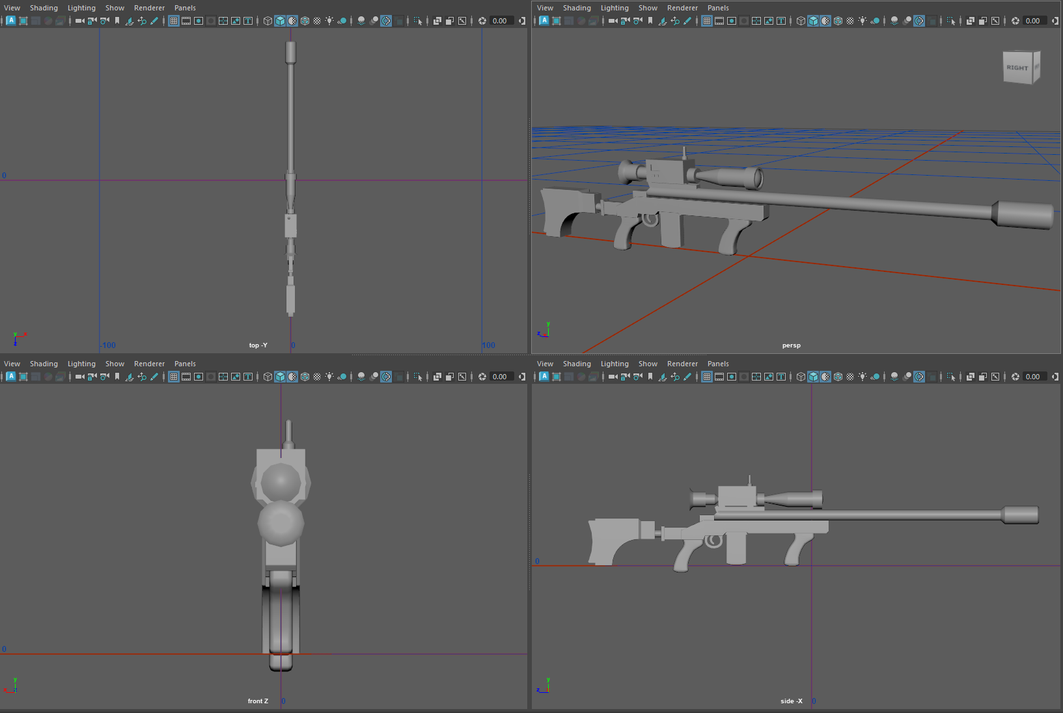

Figure 2: First coloured idea, featuring wooden grips, leather stock, and plastic and metal build. Note the white material is a standing for a shiny metal.
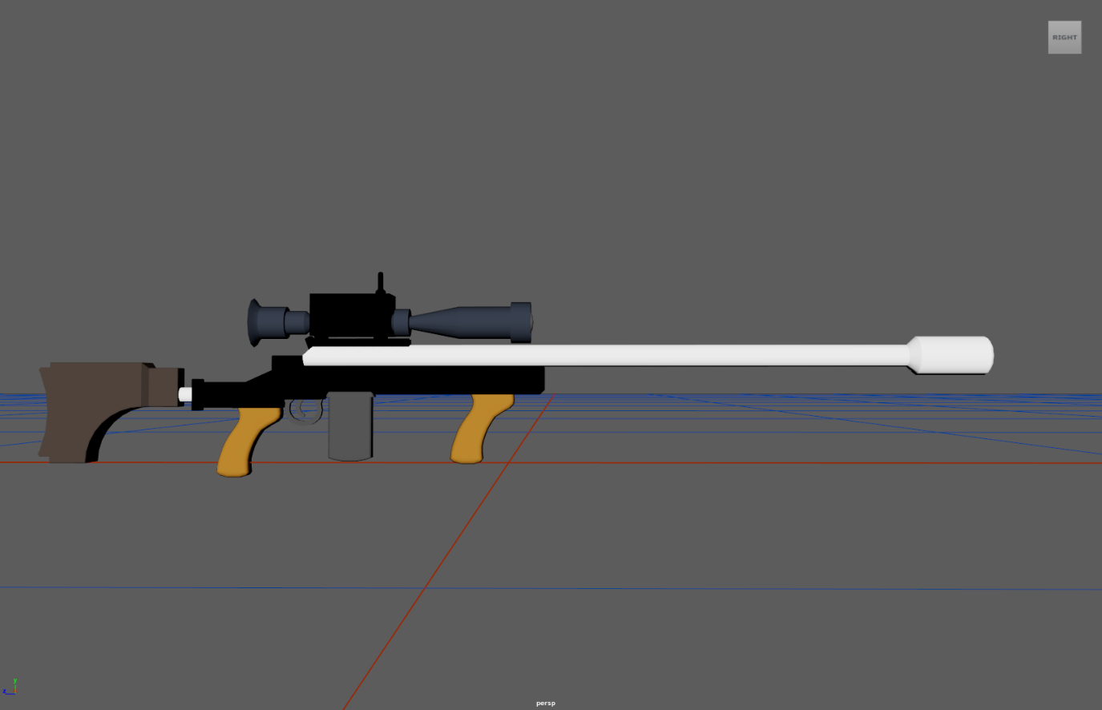
Figure 3: Another idea for colour scheme, all shades of grey, made from plastic and painted metal:
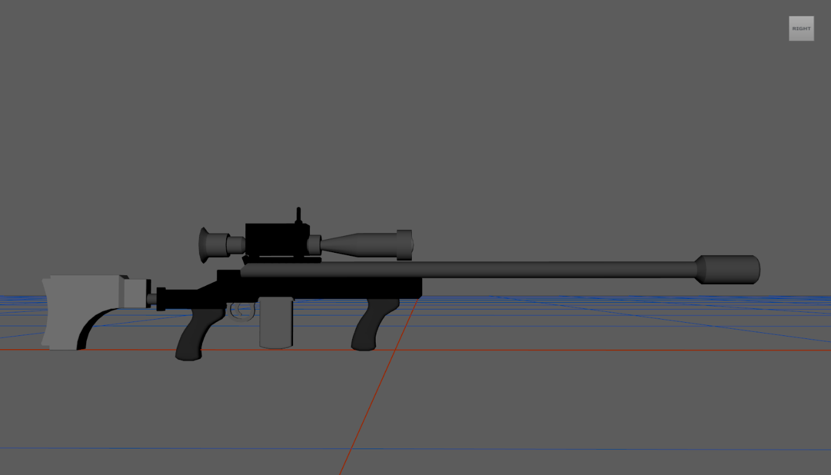

Figure 4: Example of camo skin:
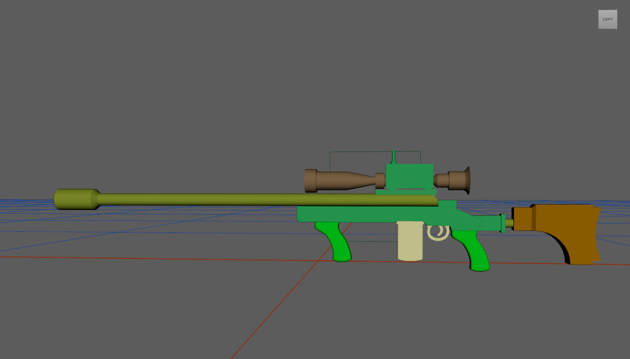
Figure 5: Example of customizable skin.
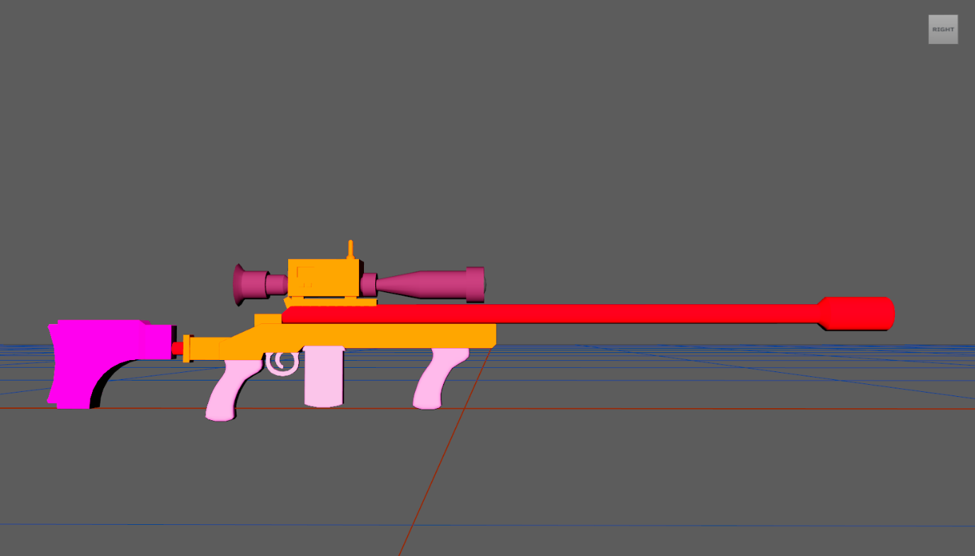

Task F:
Figure 6: Orthographic views.
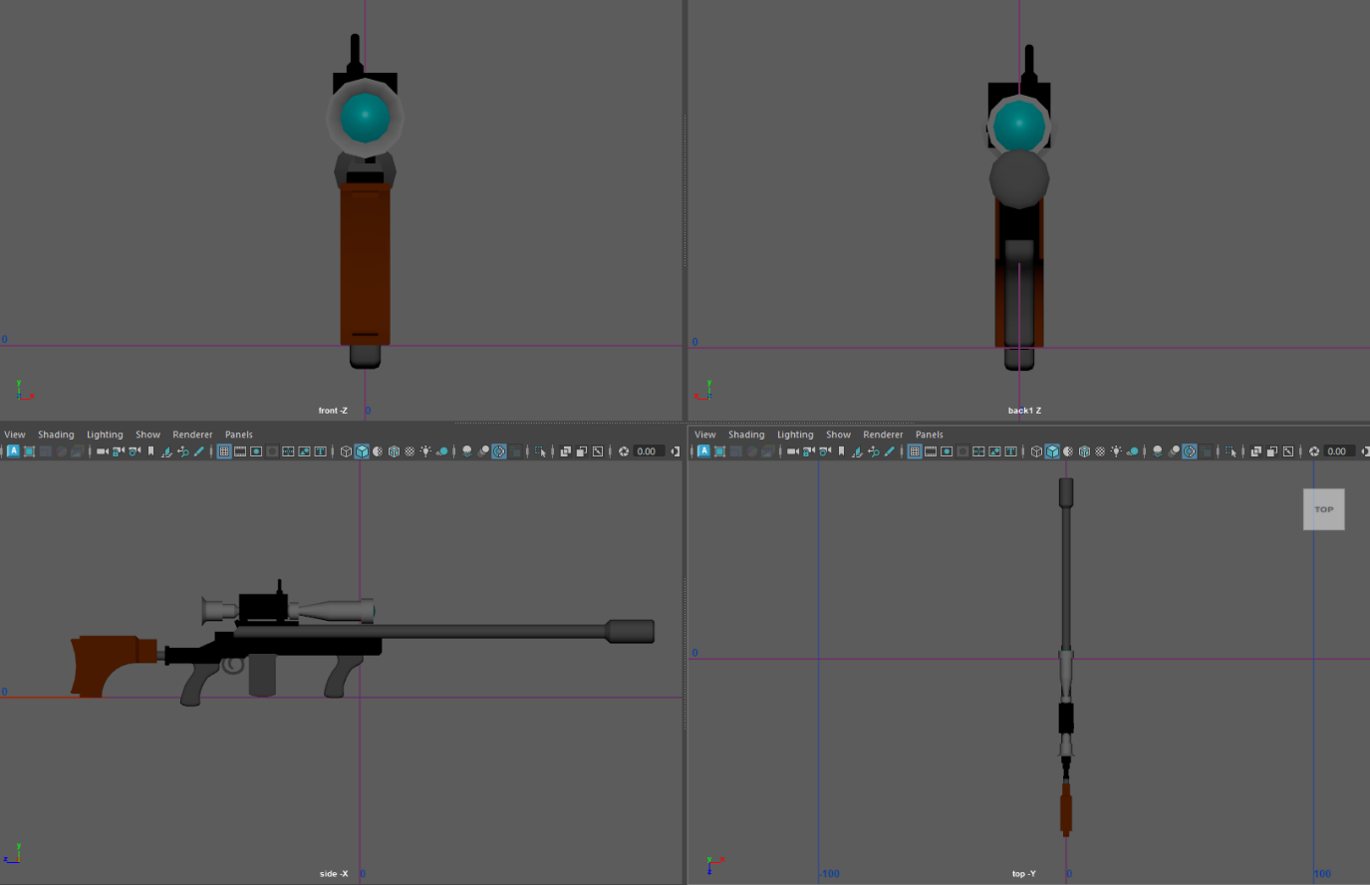

Task G:
Figure 7: Render of final textured 3D model.
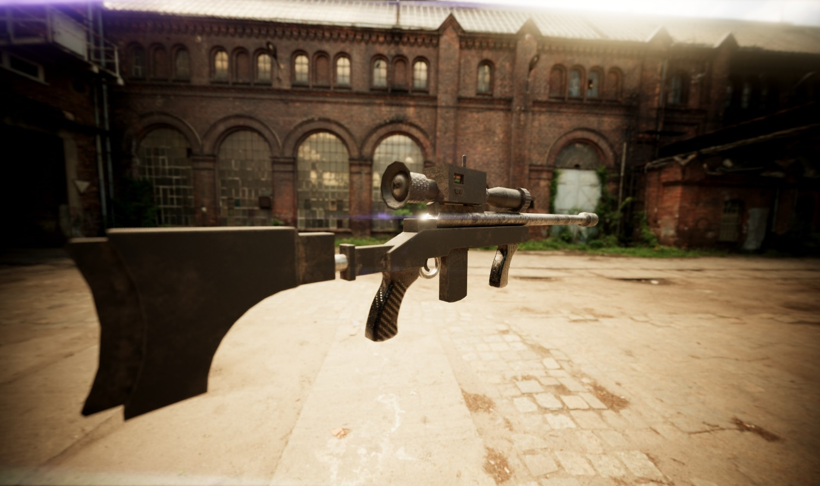

Task H:
I found that little iteration was needed on the design I had produce for part one of this assignment. I made some minor changes to the dimensions and then I moved to 3D modelling in Maya[1]. I used the orthographic sketch I made in Infinite Painter[2] scaled to the appropriate dimensions in the Maya[1] orthographic viewport as a template.
For task E, I experimented with coloured materials in the Maya[1] viewport. While I personally felt that the camo version was perhaps the nicest looking, I felt that a ‘basic’ design was more suited to this weapon’s lore. Due to its use as a missile defence system in its country of origin there is not much need to keep it hidden, for example from other forces on the ground etc.
For the construction in the final render, I went with a combination of a painted metal barrel, a plastic body and adjustable stock on a metal support, carbon fibre grips, and rubber adjustable rings on the scope. This is to keep it fairly lightweight while being built from reused parts. The whole model is covered in a light dust, as if it was used in a warm dry environment.
Figure 8 (below) shows the emissive texture on the display, this could be updated during gameplay and used as a stats screen. I would have liked this to look brighter, however it is already as bright as is possible within Adobe Substance Painter[3]. Most game engines would allow the brightness to be increased.
Figure 8: Display on automatic missile tracking system.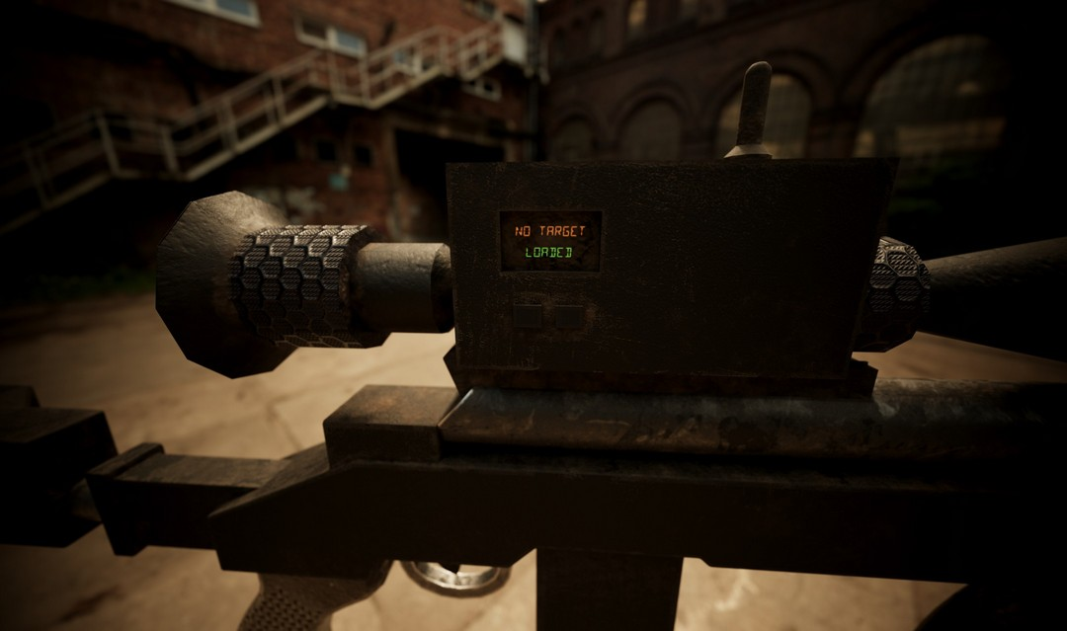
Figure 9 (below) shows the front lens of the scope, this is a reflective glasslike surface with dirt accumulated around the lower edge between the scope body and the lens. This is a feature that could be left out in a game environment as it is performance intensive to render reflections, and it is likely that it will be quite small in game. The front lens could be removed altogether in a singleplayer game, and the rear lens could be replaced with a distorted preview of the targeting system and the view through the scope.

Figure 9: Front lens of scope.
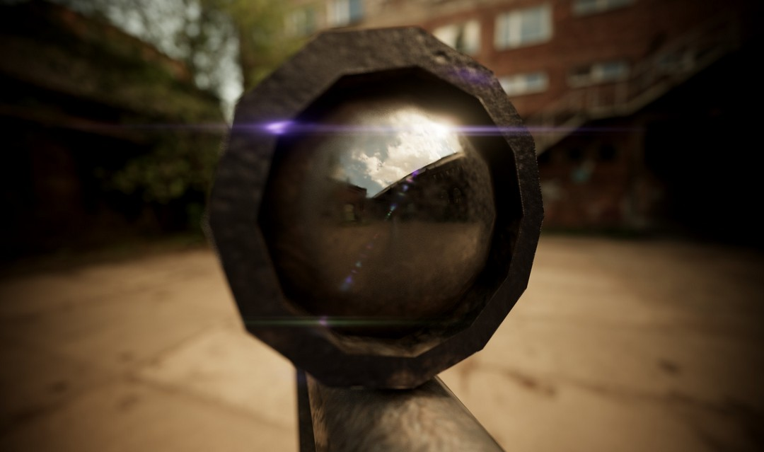
The model was textured in Adobe Substance Painter[3] and rendered using the Nvidia Iray[4] renderer.
I’m overall very happy with this model. If it were to be integrated into a game environment it could use some cleanup and reducing the number of polygons in certain areas where I used the Maya[1] bevel tool to smooth edges. It could also support multiple skins (as hinted at above) which would allow the player to customize it to their liking, for example a golden version, or a colourful pink version, etc.
It would also require some animation for reloading and firing as well as general movement.
I proposed an idea for the HUD / through the scope display in part 1 of the assignment. This could be built on, using a full screen overlay image and a movable overlay image for the calculated target points.

References:
[1] Maya, Version 2025, Autodesk: California, 2024.
[2] Infinite Painter, Version 7.0.49, Infinite Studio, 2023.
[3] Adobe Substance Painter, Version 9.1.3, Adobe: California, 2024.
[4] “Nvidia Iray Graphics Rendering,” NVIDIA. [Online]. Available: https://www.nvidia.com/en-us/design-visualization/iray/. [Accessed: 24-Apr-2024]

