Student name: Sarder Rahman Maruf
Student ID number: 2311256
Programme: BA Hospitality and Hotel Management
Module: Managing Food and Beverage Operations (Placement)
Module code: BMIH6011
Assignment Title: Portfolio 6 elements
Submission deadline: 28th of April 2026
Table of Contents Page No
Part 1: Reflective Supervisory Analysis 2
1.1. Introduction 2
1.2. Description 2
1.3. Feeling 3
1.4. Evaluation 3
1.5. Analysis 4
1.6. Conclusion 6
1.7. Action plan 6
1.8. Conclusion 6
Part 2: Hotel Mentor Feedback 7
Part 3: Placement Tutor Feedback 9
Part 4: Reflection on Hotel and Placement Tutor Feedback 11
4.1. Introduction 11
4.2. Understanding the feedback 11
4.3. Impact of the feedback 12
4.4. Action Steps for growth 14
4.5. Link of action plans to career development 15
5. Conclusion 15
References 16

Part 1: Reflective Supervisory Analysis

Introduction
This is a reflaction based on my personal experience of shadowing a shift supervisor at the Food & Beverage (F&B) department of the Novotel Hotel in Cardiff central. The shading was conducted as per my placement. I took part in daily activities and observed through participation in services in bars, restaurants, kitchen and events activities with team supervisors. This reflection, therefore, focuses on how supervisory parties influenced staff performance, customer satisfaction and operational efficiency.
For the critical analysis of my experiences, I have adopted Gibbs Reflective Cycle (1988) as presented on figure 1. In this reflaction, I have focused on leadership, communication, and service management within the F&B department. I have also used relevant theories and models such as SERVQUAL model, transformational leadership and Herzberg’s motivational theory to evaluate current practice and propose improvements in the F&B department with action plans. The broad aim of this reflaction is to demonstrate a systematic understanding of supervisory roles and identify strategies to enhance service quality and team performance in hospitality operations.
Figure 1. Gibbs reflective cycle model (1988)
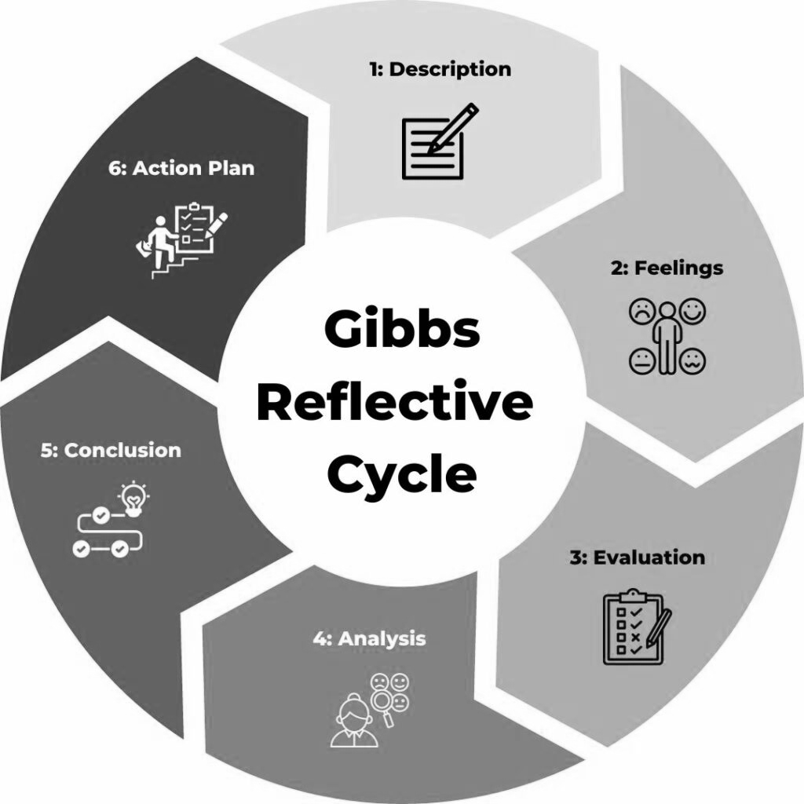
Source: (Channell,2025)

Description
During my placement at the Novotel hotel in Cardiff central, I shadowed F&B shift supervisors responsible for overseeing their daily operations, managing of staff and ensuring service quality. Supervisors coordinated team briefings, allocated roles, monitored service flow and handled customer issues. The F&B department operated in a dynamic environment mainly during breakfast service and event. While planning and scheduling were well structured, I observed several service failure. For example, customers often waited at the bar without being served and customised breakfast orders where significantly delayed. Communication gaps between staff and management were significantly evident leading to confusion and inefficiencies in services. The supervisors primarily focused on task completion rather than actively engaging with staff and customers. Although, operational planning was strong at the department, the execution of services lacked consistency, standard and thus customer satisfaction appeared compromised.

Feeling
At the beginning, I felt excited to observe a supervisory role expecting to see strong leadership and efficient coordination. However, I became concerned and somewhat got frustrated when I witnessed poor customer service and lack of urgency among the staff members. Watching customers being ignored or them leaving the services due to delay created a sense of discomfort as it contradicted the core hospitality principle of customer satisfaction (Mercier,2023). I also felt that the supervisors had the authority to address these issues but did not fully utilise it. However, I appreciated the structured planning and teamwork during event preparation, which shows that the department is highly potential. This contrast made me reflect critically on how leadership behaviour directly impacts service outcomes.

Evaluation
The placement experiences can be evaluated from both positive and negative aspects. Positive aspects of the placement at the F&B can be that there were effective staff scheduling and task allocation by the supervisors and management. There were strong event planning and coordination between the kitchen and management team to organise the event. There was also good level of operational flexibility that allowed staff to work with good level of autonomy. These strengths largely align with service operations theory that emphasises planning and resources management as key requirement for efficiency (Walker et al,2015).
However, negative aspects include poor service responsiveness, lack of supervisory control over staff during service delivery. There was also weak communication between team members and limited staff motivation and engagements. From a supervisory context, the main weakness was the gap between planning and execution which has significantly affected customer satisfaction at the hotel.

Analysis
My observational experiences can be critically analysed using management and service theory, the service quality model (SERVQAL) presented on figure 2.
Figure 2. The SERVQUAL Model
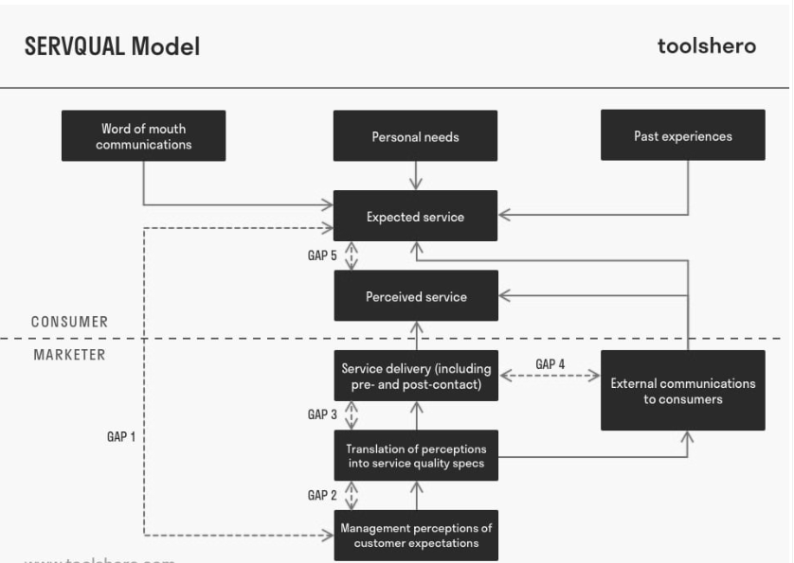
Source: (Toolshero,2021)
According to SERVQUAL model, service quality depends on reliability, responsiveness, assurance, empathy and capabilities (Jonkisz, Karniej & Krasowska,2021). However, I have found that F&B department showed high level of weakness in responsiveness with delay on service at the bar and during breakfast to serve customers. There was lack of empathy when staff members ignored customers at the bar for services and in restaurants for service of foods. There was also issue of reliability with inconsistency in service delivery at the department. All of these indicates that there is a service quality gap in the department where customers’ expectations are not fully met.
Looking from leadership perspectives, I see that supervisor demonstrated transactional leadership that according to Jaqua (2021) focuses on task compilation rather than motivating and inspiring staffs to carry out their tasks. Here transformational leadership style would have worked well that according to Bakker et al (2023), encourage, inspire staff engagement towards goals, improve service culture and enhance team motivation. Lack of proper leadership contributed to low accountability and poor service behaviour.
Staff demotivation can be analysed using Herzberg two factors theory (Nickerson,2025). The F&B staff disengagement largely suggest absence of motivators which are recognition, achievement and responsibility as well as hygiene factors including supervision quality and proper work environment (Nickerson,2025). This clearly explain why employees showed little initiatives to serve customers proactively, refrained from upselling of products and services and failed to improve service quality.
Figure 3. Herzberg two factors theory
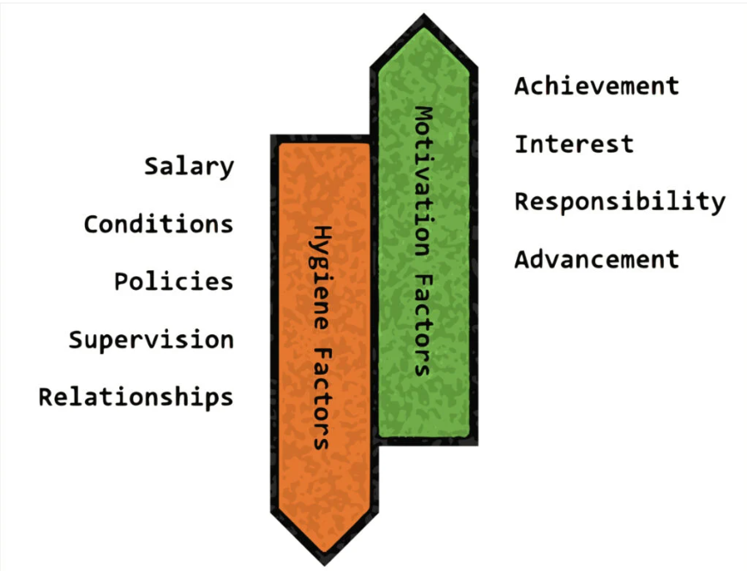
Source: (Nickerson,2025).
From operational perspective, poor communication largely reflects weak internal services. this is largely due to lack of coordination between staff and supervisors which resulted in delayed series, increase errors and resulted customers satisfaction. This is consistent with Service-Profit Chain theory (Figure 4) that suggests that employee satisfaction directly affects customers satisfaction, loyalty and profitability.
Figure 4. Service-profit chain Model
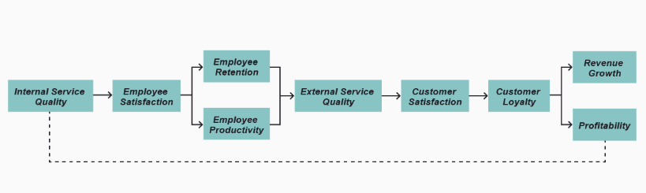
Source: (Stobierski,2025).
In evaluating supervisory effectiveness, it is understood that a key responsibility of a supervisor is real time service monitoring and intervention (Kidd & Smewing,2010). However, supervisors were found not to actively manage staff performance, failed to address poor services and lack visible leadership on the floor. This suggests that a passive supervisory approach that is highly ineffective in high contact service environment (Kidd & Smewing,2010).

Conclusion
The experience in F&B department highlighted that strong operational planning alone is insufficient without effective supervision and leadership during service delivery. The supervisors limited engagement resulted in poor service quality, low staff motivation a reduced customer satisfaction. This reflaction highlights leadership style, communication and employee motivation are critical factors in achieving successful operation. This means a more proactive and transformational leadership approach is needed to bring the gap between planning and execution of works at the department.

Action plan
In order to improve supervisors’ effectiveness and service quality, the F&B department would benefit from the following action plans.
- Adopt transformational leadership by supervisors and actively engage with staff members for better services with motivation feedback and recognition of staff for their contribution.
- Implement staff training programmes for customer services, communication and teamwork and handling of customers complaints.
- Introduce customer entered strategies to reduce waiting time and standard of the services and improve personalised customer services.
- Increase staff motivation through introducing incentive for good performance encourage qualities through rewards and recognising employee for their contributions.

Conclusion
From this reflaction of the work placement at the Novotel hotel F&B department, it is understood that communication and leadership is an important element in successful operation of hospitality outlets. Based on the experiences during the placement, I have learned that continued skills development through training is significant to maintain consistency in service standard. Communication is key to manage successful team and right leadership is essential to motivate, inspire employees at work. I have also learned that good team works between department is necessary to bring efficiency in service and much of this depends on supervisors and management capacity in mening work and building effective team though their leadership approach and style.

Part 2: Hotel Mentor Feedback

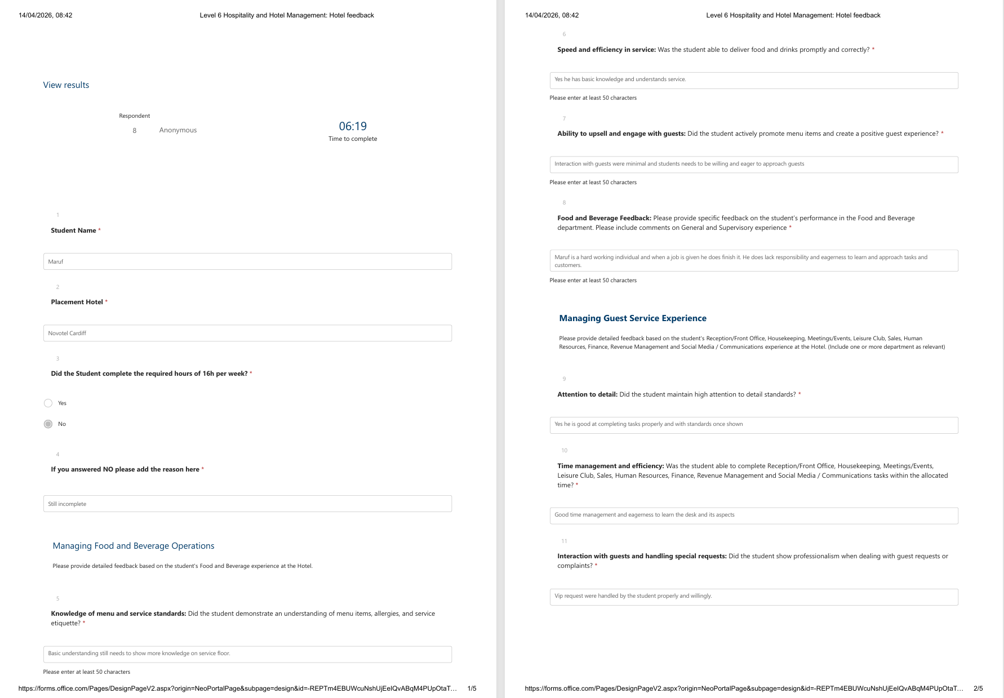
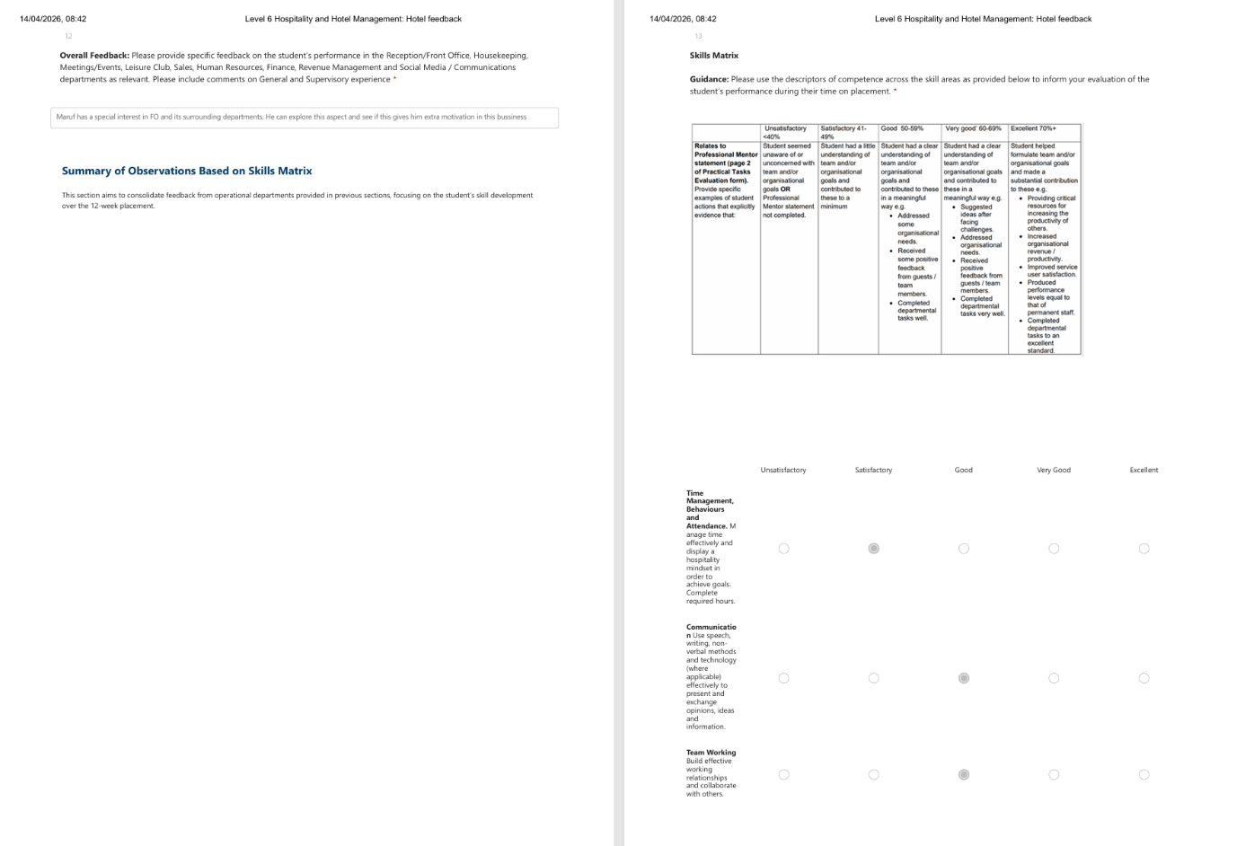
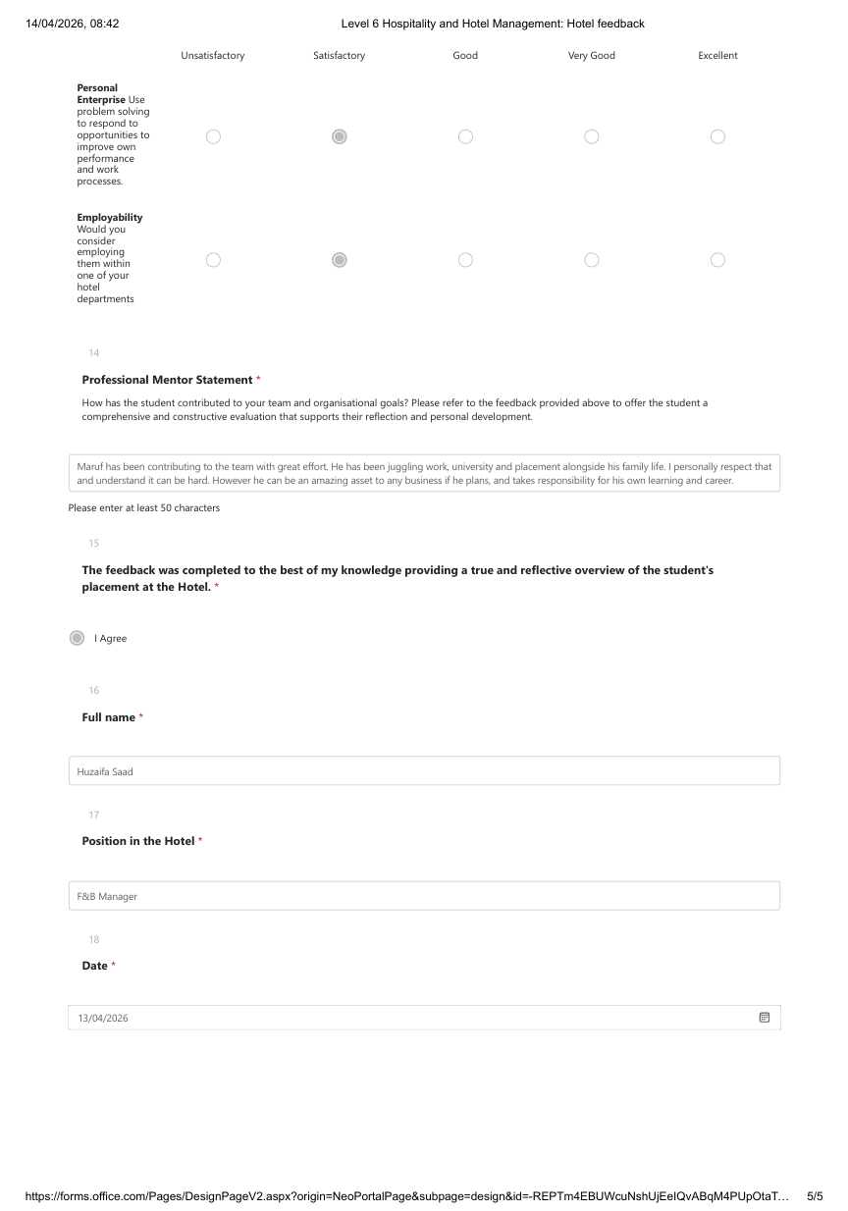

Part 3: Placement Tutor Feedback
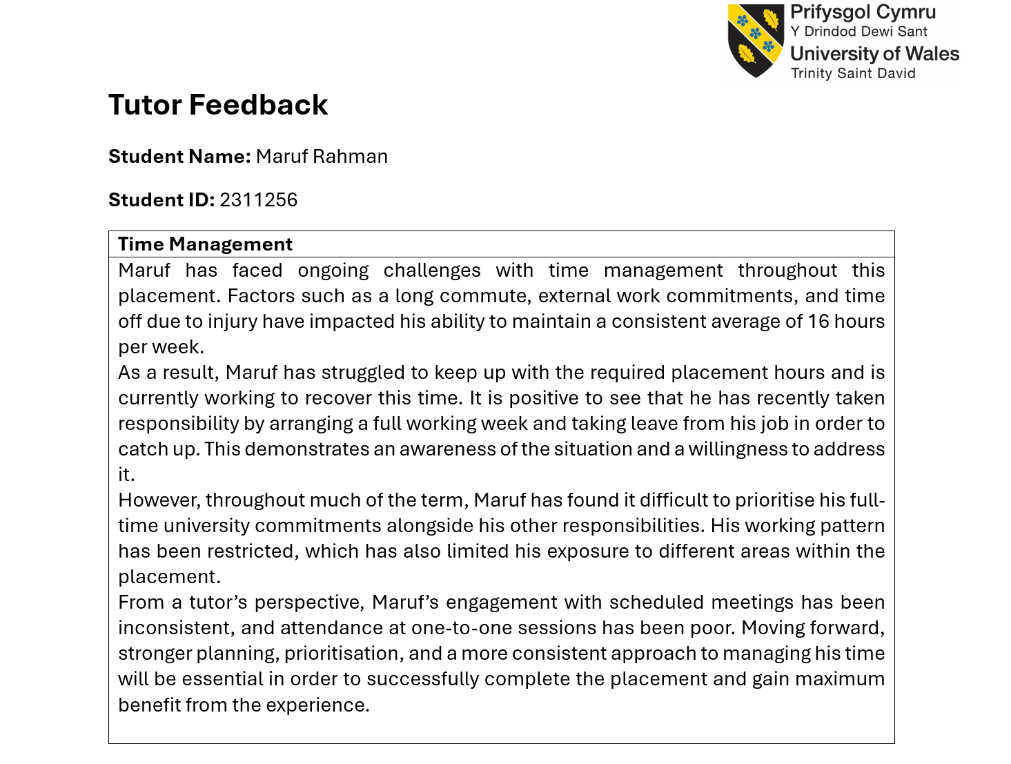
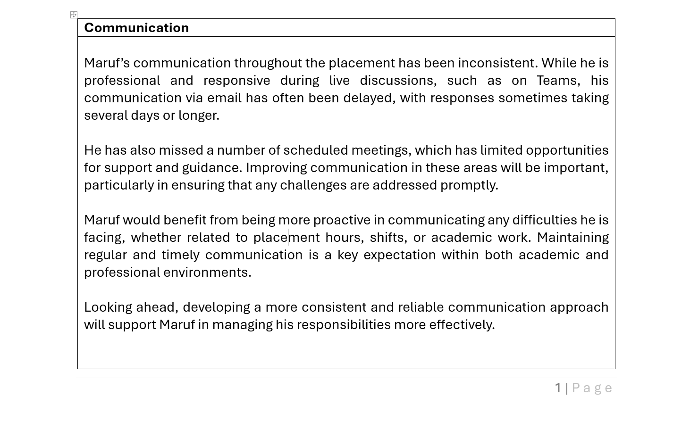
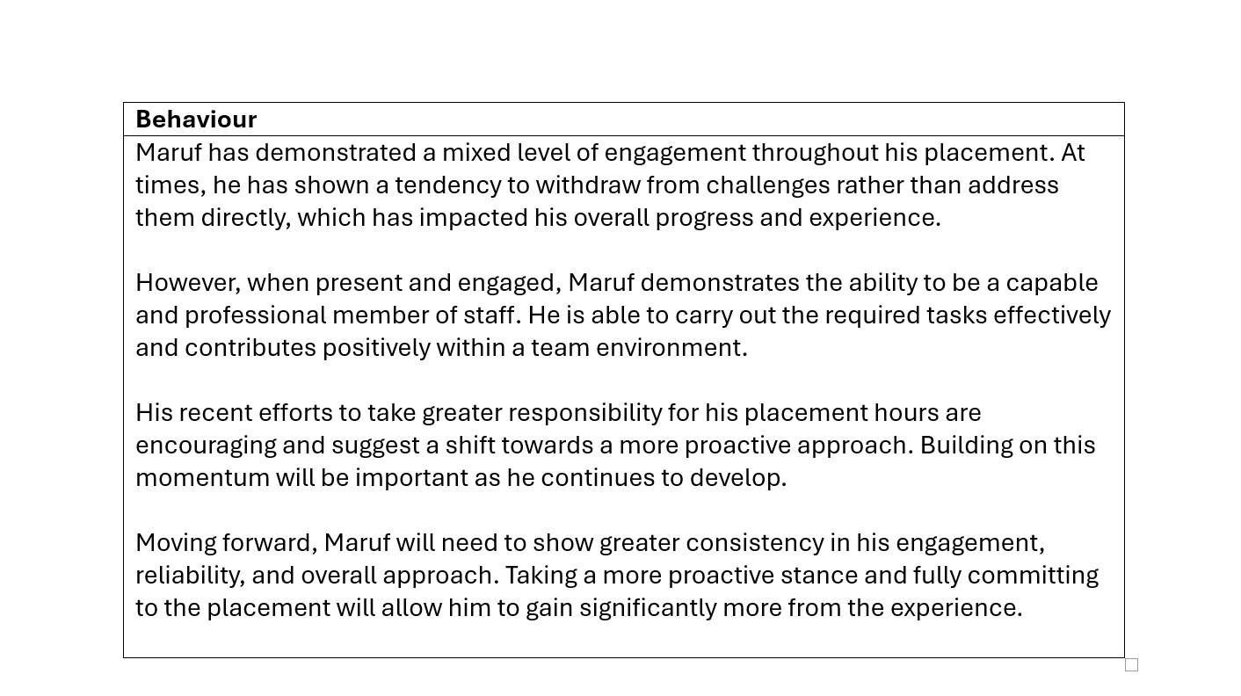
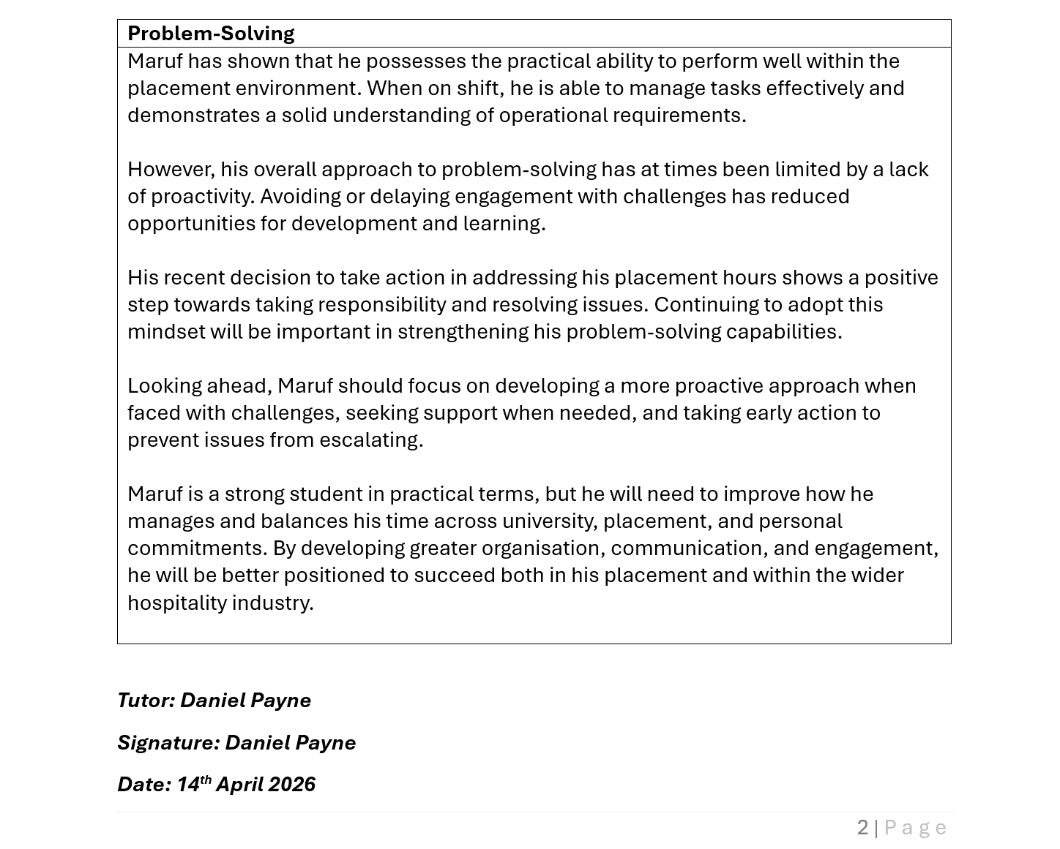

Part 4: Reflection on Hotel and Placement Tutor Feedback

4.1. Introduction
This part of the portfolio critically reflects upon the feedback that is received from both my hotel mentor who is the F&B Manager at the Novotel Hotel and my placement tutor at the university. Feedback plays an important role in identifying individual strengths, addressing weakness and supporting continuous professional development mainly service driven businesses such as Novotel Hotel.
The aim of this reflection is to evaluate the key themes that are identified from both sources of feedback and understand their impact on my performance and behaviour and identify any areas need improvement. With analysis of this feedback, I will develop a clear understanding of supervisory expectations within the Food and Beverage operations and outline practical steps to enhance my skills, professionalism and reediness for a future managerial role.

4.2. Understanding the feedback
The feedback from my hotel mentor has highlighted number of strengths in my performance within in the F&B department. I was recognised as hardworking individual with capacity of completing assigned tasks effectively. Once given instruction, I demonstrated the ability to carry out duties to the required standard that showed reliability and positive work ethics in me. Moreover, I have showed a basic understanding of service process and was able to deliver food and beverages with reasonable efficiency.
My mentor (F&B) manager has also identified several areas for improvement. These include my lack of initiatives and eagerness mainly in approaching customers and taking responsibility for tasks. My interaction with gusset were described as minimal that indicate a weakness in customers engagement and service delivery. Furthermore, my technical knowledge of menu items and service stand was considered basic, limiting my ability to provide a high-quality guest experience or contributing upselling. Overall, the mentor has suggested that I have strong potential, however, would need to take greater ownership of my learning and development.
The feedback from my placement tutor presents a broader evaluation of my performance. One of the key issues that was identified was poor time management as I straggled to maintain the required placement hours due to competing commitments such as university, works and personal responsibilities. My communication was also described as inconsistent mainly in relation to delayed email responses and missed meetings.
In term of behaviour, the tutor noted that my engagement was inconsistent and I sometimes avoid challenges instead of addressing them directly. This is consistent with Bergdahl (2021), where he pointed out in learning environment of students often plays an important role in their level of engagement and dealing with issues. However, similar to the feedback of mentor, my tutor also acknowledged that I am capable and professional when engaged and that my recent efforts to take responsibility for computing placement hours demonstrate a positive shift in attitude.
When comparing both sources of feedback, number of common themes has emerged. For instance, both the mentor and tutor have highlighted my strong practical ability and reliability in completing tasks. at the same time, they both emphasised a lack of initiative, responsibility and proactive engagement as key areas for improvement. My communication also appeared as shared concern from both, whether it is in terms of guest interaction as mentioned or professional communication.
There were also some differences between these two perspectives. For instance, the mentor has focussed more on operational performances and customer services mainly within the F&B environment while my tutor provided a wider view of my professional behaviour, time management and academic engagement. Both perspectives have therefore provided a comprehensive understanding of my performance.

4.3. Impact of the feedback
The feedback has supported my understanding better mainly in my ability to perform tasks effectively and work reliability within a team environment. Feedback have confirmed that I have solid operational foundation. According to Dalkhjav, B, et al (2024), feedback essential in hospitality industry to improve personal limitation and contribute for overall good for the business. I have also recognised that I am capable of performing at a professional level when I am fully engaged.
However, the feedback has also highlighted important weakness that I was fully unaware of. The most significant issues are my lack of proactiveness and initiative. While I was able to identify problems within the F&B context as poor customer services and delays, I did not actively take steps to address these issues. This according to Clements & Kamau (2018), suggests that I was operating at a task-based level rather than demonstrating supervisory behaviour.
Feedbacks have also identified weakness in my time management and communication. This has impacted both my placement and my overall development. For instance, missing meetings and delays in communication has limited my access to support and learning opportunities. Similarly, my challenges in balancing commitments reduced my exposure to different operational areas within the hotel.
All these insights can be directly linked to my personal experiences. For example, I have observed situations where customers were left waiting at the bar or experienced delay in services, yet I did not intervene or take initiative to improve the situation. This therefore reflect the feedback regarding my limited engagement and lack of leadership attributes.
The feedback has shifted my overall understanding of works in the F&B department. For instance, I am now more effective in hospitality services. I have become more proactive about completing tasks, taking initiatives, engaging with customers and contributing to service quality. My development has made me confident to take up at least a supervisory role in future as according to Carlo et al (2024), supervisory roles require a proactive mindset, strong communication and the ability to take responsibility for both team performance and customers satisfaction.

4.4. Action Steps for growth
Based on the feedback from both my hotel mentor and placement tutor, it is understood that my development needs to focus becoming more proactive, organised and customer focused. The actions identified are designed to address the key gaps in time management, communication, initiative, technical knowledge and problem solving.
Instead of making general improvements, this plan translates the feedback into specific, measurable and realistic steps that can be applied in future placements and employment. Each of these actions aligns with supervisory expectations in the food and beverage department and aims to support my progress from a task-oriented employee to proactive supervisor.
Development Area | Specific Action | How it will be implemented | Timeframe | Expected outcome
Time management | Improve scheduling and prioritisation | I shall use weekly planner and digital calendar to allocate time for placement, study and my works | Immediate and ongoing | Consistency in attendance, completion of required hours, improve reliability
Communication skills | Enhance professional and guest communication | I shall practice responding to emails withing 24 hours  Attend all meetings  Practice active guest interaction daily | Immediate and ongoing | Improve professionalism, stronger relationships with team guests
Proactiveness & Initiatives | Take ownership during service | Approach guests without being asked volunteer for tasks, support team during busy periods | Within 2-4 weeks | Increased confidence, visible leadership behaviour
Customer service skills | Improve guest engagement and service quality | I will practice greeting guests, handling requests and offering personalise service | Ongoing | High customer satisfaction and better service delivery
Technical knowledge | Strengthen menu and service knowledge | I shall study menu, allergens, and services standards outline shifts, shadow experience staff. | Within 1 month | Improve confidence in service and ability to assist customers effectively
Professional responsibility | Increase accountability and engagement | I shall attend all scheduled sessions, track progress weekly and set personal performance goals | Immediate and ongoing | Greater consistency, improved discipline, and stronger work ethics
Reflective practice | Continuous evaluate performance | I will practice use of different reflective models to assess own strength and weaknesses for personal improvements | Ongoing | Continuous and professional development

4.5. Link of action plans to career development
The above action plan directly supports my long-term goals of progressing into a supervisory and managerial role within hospitality businesses. Through improving these skills and key areas of capacity, I shall better equip myself to lead a team effectively, deliver high quality customer services, manage operations efficiently and continue to organise success. Overall, these steps shall help me to transition from a reactive them member to a proactive and competent future leader in food and beverage operations.

5. Conclusion
This portfolio of reflection has successfully provided valuable insights into my performance during my placement in the food and beverage department at the Novotel hotel. The feedback from both my hotel mentor and placement tutor has highlighted that although I possessed strong practical skills and solid work ethics, I need to improve my initiative, communication and time management.
The process of analysis of this feedback has largely helped me to recognise the significance of moving beyond task compilation and developing more proactive, responsible and customer-oriented focus approach. It has also emphasised the expectations associated with supervisory roles in hospitality. This reflection has defined clear areas for personal and professional growth. I am therefore committed to applying these lessons in future placement and roles with the aim of developing myself as an effective confident hospitality professional.

References
Bakker, A, B, et al. (2023). Daily transformational leadership: A source of inspiration for follower performance? European Management Journal. Vol 41 (5). Pp: 700-708. Available: https://www.sciencedirect.com/science/article/pii/S0263237322000603 (Accessed: 20th of April 2026).
Bergdahl, N. (2021). Engagement and disengagement in online learning. Computers & Education. Vol188. No: 104561. Pp: 15-25. Available: https://www.sciencedirect.com/science/article/pii/S0360131522001324 (Accessed: 20th of April 2026).
Clements, A, J & Kamau, C. (2018). Understanding students’ motivation towards proactive career behaviours through goal-setting theory and the job demands–resources model. Studies in Higher Education. Vol 33 (12). Pp: 2279-2293. Available: https://www.tandfonline.com/doi/full/10.1080/03075079.2017.1326022 (Accessed: 21st of April 2026).
Carlo, A, D, et al. (2024). Positive Supervisor Behaviours and Employee Performance: The Serial Mediation of Workplace Spirituality and Work Engagement. Front Psychol. Vol 24 (11). No: 1834. Available: https://pmc.ncbi.nlm.nih.gov/articles/PMC7393218/ (Accessed: 21st of April 2026).
Dalkhjav, B, et al. (2024). Enhancing Job Performance in the Hospitality Sector: Exploring the Role of Employee Engagement, Multitasking, Organizational Culture, and Recruiting Practices. Journal of Tourism and Hospitality and wellbeing. Vol 12 (2). Pp: 188–20. Available: https://www.researchgate.net/publication/384065001_Enhancing_Job_Performance_in_the_Hospitality_Sector_Exploring_the_Role_of_Employee_Engagement_Multitasking_Organizational_Culture_and_Recruiting_Practices (Accessed: 21st of April 2026).
Jonkisz, A, Karniej, P, & Krasowska, D. (2021). SERVQUAL Method as an “Old New” Tool for Improving the Quality of Medical Services: A Literature Review. Int J Environ Res Public Health. Vol 18(20). No: 10758. Available: https://pmc.ncbi.nlm.nih.gov/articles/PMC8535625/ (Accessed: 20th of April 2026).
Jaqua, E, E. (2021). Transactional Leadership. American Journal of Biomedical Science & Research 14(5). Pp: 399-400. Available: https://www.researchgate.net/publication/360288883_Transactional_Leadership (Accessed: 20th of April 2026).
Kidd, J, M, & Smewing, C. (2010). The role of the supervisor in career and organizational commitment. European Journal of Work and Organizational Psychology. Vol 10 (1).Pp: 25-40. Available: https://www.tandfonline.com/doi/abs/10.1080/13594320042000016 Accessed: 20th of April 2026).
Mulder, P. (2024). Service Model of Service Quality. Tools hero: 20th Dec. Available: https://www.toolshero.com/quality-management/servqual-model/ (Accessed: 20th of April 2026).
Matthew, C. (2025). Gibbs Reflective Cycle: A Practical Guide. TSW Training: 11th Jan. Available: https://www.tsw.co.uk/insights/gibbs-reflective-cycle/ (Accessed: 20th of April 2026).
Mercier, V. (2023). Transforming customer experience management: The power of hospitality. EHL Insight: 7th March. Available: https://hospitalityinsights.ehl.edu/transforming-customer-experience-management-hospitality (Accessed: 20th of April 2026).
Nickerson, C. (2025). Herzberg’s Two-Factor Theory of Motivation-Hygiene. Simple Psychology: 18th April. Available: https://www.simplypsychology.org/herzbergs-two-factor-theory.html (Accessed: 20th of April 2026).
Stobierski, T. (2025). Explaining the Service-Profit Chain: How Quality Drives Profit. Harvard Business Review: 25th March. Available: https://online.hbs.edu/blog/post/service-profit-chain (Accessed: 19th of April 2026).
Walker, H, et al. (2015). Theoretical perspectives in operations management: an analysis of the literature. International Journal of Operations & Production management. Vol 35 (8). Pp: 1182-1206. Available: https://www.researchgate.net/publication/281481889_Theoretical_perspectives_in_operations_management_An_analysis_of_the_literature (Accessed: 20th of April 2026).

