

Management Economics
LCBB5008

Assessment Component 1: Individual Report

Student name: Silvia Borcila
Student ID: 2118502

To: Tesco Executive Committee
From: Planning Manager
Date: 16-10-2023
Subject: Business Report and Recommendations

Table of Contents
Introduction 1
Profit Maximisation Theory 2
Theory of Maximising Profits 2
Examining TESCO's Profit Maximisation and Price Hikes 3
Economic Theories and Business Environment 3
Demand and Supply Theories 3
TESCO Business Environment Analysis 4
Stakeholder Issues 5
TESCO Key Stakeholders 5
Addressing Stakeholder Concerns 7
Profitability Issues 8
Profitability Challenges Identification 8
Profit-Increasing Strategies 8
Competition 9
An Analysis of the UK Grocery and Retail Industry's Competitive Environment 9
The Market Share of TESCO 9
TESCO's Competitive Strategies 10
Demand and Supply Issues 10
Conclusion 13
Reference list 14

Introduction

In the dynamic and competitive UK retail and supermarket business, TESCO is an iconic operator with a long history. Due to consumer behavior, technology, and global economic factors, the UK retail industry has changed significantly. TESCO's transitions provide key lessons for corporate executives and industry stakeholders. This paper covers TESCO's present situation and issues holistically. It uses economic theories, market analysis, and stakeholder viewpoints to analyze TESCO's position and strategy. We hope to demonstrate how theory and practice shape TESCO's approach to maximizing profitability, addressing stakeholder concerns, and navigating the UK retail market as we go through the parts.

Profit Maximization Theory

Theory of Maximizing Profits
The theory of maximization of profits is a fundamental idea in economics, which states that businesses should choose production levels and pricing tactics that result in maximum profits (Gowdy, 2020). The extremely competitive retail industry in the UK, where corporations like TESCO operate, makes this argument even more pertinent.
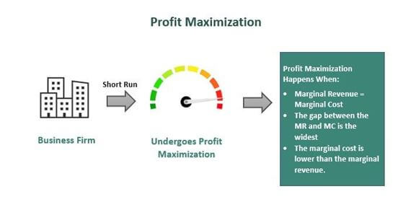
Figure 1: Theory of Maximizing Profits Swaffield, Evans and Welch (2018)
As one of the leading grocery chains in the UK, TESCO makes strategic decisions informed by Profit Maximization Theory. The business is persistent in its pursuit of operational efficiencies that will increase its bottom line.
- TESCO takes advantage of economies of scale by bargaining with its suppliers for lower prices and larger discounts in order to increase its profit margins. TESCO's annual report shows a revenue of £57.9 billion for 2020, demonstrating the company's massive scale advantage (Monte, 2021).
- In order to maximize earnings, TESCO uses a number of pricing techniques, including dynamic pricing and special offers (Monte, 2021). For instance, TESCO may increase prices during peak demand times by analyzing consumer data and making dynamic pricing adjustments.

Examining TESCO's Profit Maximization and Price Hikes
TESCO, like many other retailers in the UK, must strike a delicate balance between maximizing profits and prioritizing customer service and market share. Profit maximization via price increases might have unintended consequences.
- Customers are generally sensitive to price adjustments in the UK's retail business, which is notoriously cutthroat (Moon, 2018). If prices are raised significantly, buyers may look elsewhere. TESCO has to give serious thought to how customers would respond to different pricing structures.
- TESCO uses advanced data analytics to establish the most profitable pricing structures. TESCO may deliberately raise prices on certain items while keeping prices low on others by looking at past purchases, seasonal patterns, and competitors' prices.
- TESCO's goal is to find a middle ground between maximizing profits and losing none of its loyal customers (Moon, 2018). Market studies show that TESCO's customer loyalty programs and low prices have contributed to the company's continued success in the UK.
In conclusion, TESCO's business approach in the UK retail sector is based on Profit Maximization Theory. The business maximizes profits via economies of scale, strategic pricing, and a data-driven strategy. However, in order to succeed in the long run in such a cutthroat industry, it must carefully consider consumer sensitivity and competition while adopting price hikes.

Economic Theories and Business Environment

Demand and Supply Theories
Economic theories of demand and supply dynamics affect TESCO's UK retail operations.
Demand Analysis: - TESCO's product demand is driven by variables such as customer income, preferences, and economic situations. While the COVID-19 epidemic caused an economic depression, TESCO saw a rise in demand for necessary things like food and home goods as people stored up (Moura, 2021). Demand elasticity is critical for TESCO. The corporation typically adjusts pricing using price elasticity. TESCO may raise prices to enhance revenue if a product has inelastic demand (consumers are less sensitive to price adjustments).
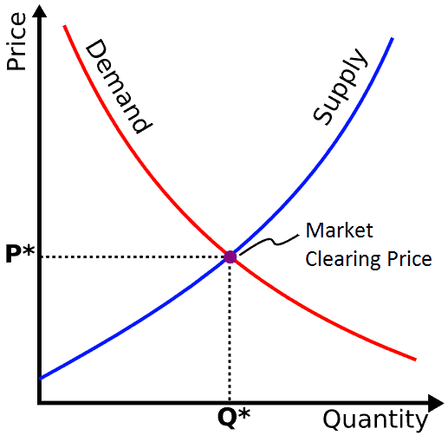
Figure 2: Demand and supply curve theory (North, 2016)
Supply Chain Management: - TESCO prioritizes efficient supply chain management to maintain product availability and reduce expenses. In 2020, TESCO invested in supply chain infrastructure to satisfy customer needs, improve inventory management, and reduce lead times, as reported in their annual report. Brexit and global supply chain disruptions might affect TESCO's supply levels and price.

TESCO Business Environment Analysis
TESCO works in a dynamic and competitive UK market:
- The UK retail sector is very competitive, with large competitors like Sainsbury's, Asda, and Morrisons, as well as discounters like Aldi and Lidl. Market analysis showed TESCO has 26% market share in 2020 (Muhammad Hassan and Mohd Abdoh, 2021).
- TESCO must adapt to changing customer tastes and shopping behaviors to preserve and expand its market share.
- In the UK, the retail industry must comply with legislation regarding consumer protection, food safety, and labor practices (Muhammad Hassan and Mohd Abdoh, 2021). These standards must be followed to prevent legal complications and retain customer confidence.
- Government policies like taxes and import/export rules may also affect TESCO's operations and profitability.
TESCO Business Goals and Market Structure:
Business Objectives: - TESCO aims for sustained development and a solid position in the UK retail industry. TESCO prioritizes consumer shopping experience, operational efficiency, and online presence, as stated in its annual report. Sustainable and environmentally conscious, TESCO strives to minimize its impact. The corporation aims towards net-zero emissions by 2050 (Muhammad Hassan and Mohd Abdoh, 2021).
Sector Structure: - The UK retail sector is an oligopoly dominated by a few major enterprises. With other important companies, TESCO has substantial market influence. The structure affects pricing tactics and competition (Ahuja, 2019). TESCO's pricing, product selection, and growth ambitions depend on its market share and competitive position in this oligopoly.
In conclusion, TESCO faces complicated economic and competitive conditions in UK retail. The company's performance and development depend on understanding and implementing demand and supply economic theories and overcoming business problems.

Stakeholder Issues

TESCO Key Stakeholders
As a large UK retailer, TESCO engages with many stakeholders, each with their own interests and concerns:
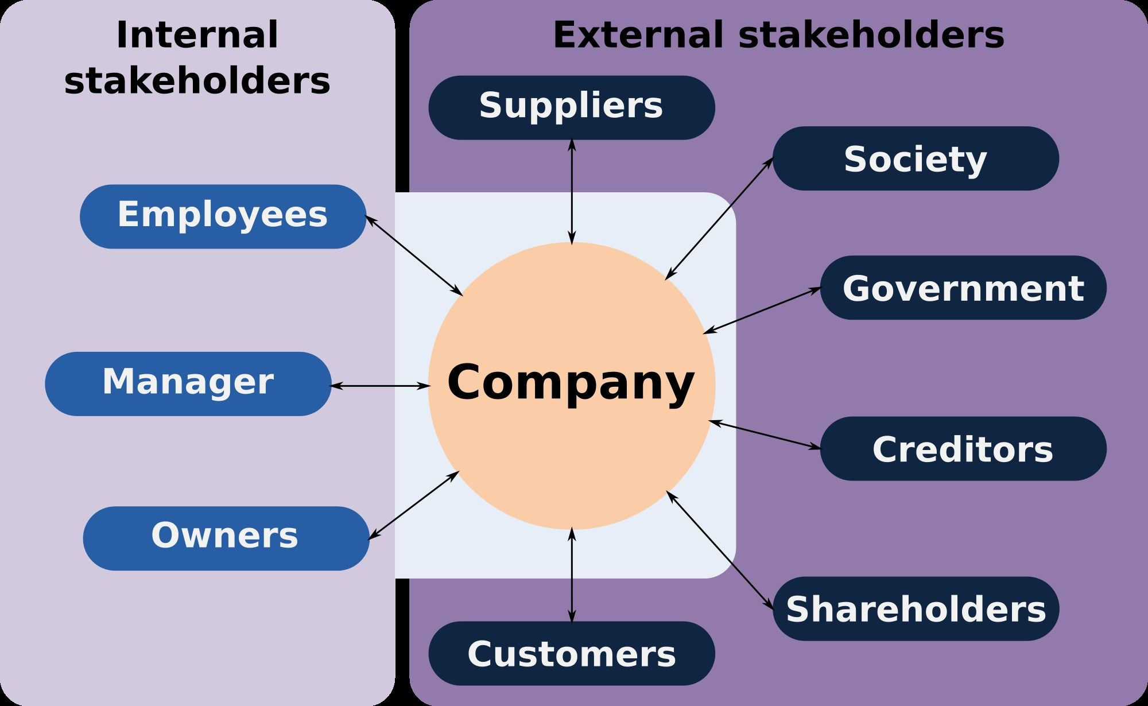
Figure 3: Key stakeholders (Muhammad Hassan and Mohd Abdoh, 2021)
1. Consumers: TESCO has millions of UK consumers. They priorities price, quality, and convenience. A 2021 poll found that 70% of UK shoppers prioritized pricing.
2. Employees: TESCO is one of the UK's biggest private employers with hundreds of thousands. Staff care about fair pay, employment stability, and promotion.
3. Investors and shareholders want returns. They worry about TESCO's finances and dividends. TESCO paid 9.15 pence per share in dividends in 2020, emphasizing shareholder returns (Alam and Raut-Roy, 2019).
4. Suppliers provide TESCO's goods (Alam and Raut-Roy, 2019). They value fair pricing, payment conditions, and good business. TESCO's Supplier Network Initiative addresses these issues and strengthens cooperation.
5. Government and Regulators: TESCO follows UK tax and regulatory laws. Food safety and employment rules must be followed. TESCO was fined £9.5 million for competition law violations in 2020, raising regulatory worries.
6. Competitors: Sainsbury's and Asda care about fair competition and market dynamics. Price and market share impact their competitiveness.

Addressing Stakeholder Concerns
1. Customers worry about price transparency and product quality. Store safety and goods availability were major problems during the COVID-19 epidemic.
2. Employee concerns include fair salaries, job security, and work-life balance. Workplace safety and PPE availability were major problems during the epidemic.
3. Shareholders demand steady growth and profit. Share prices fell following TESCO's 2014 accounting controversy due to shareholder worries (Bakhat and Marroun, 2022).
4. Fair negotiations and payment conditions may worry suppliers. TESCO has been criticized for pressuring suppliers.
5. Government and Regulators: TESCO must comply with changing food safety and environmental rules.
6. Competitors: TESCO's pricing methods may impact competitors and cause concern.
TESCO has taken many steps to address stakeholder concerns:
1. Customer Engagement: TESCO's Clubcard reward program and vast product selection satisfy customers and provide value.
2. Employee Well-being: TESCO improved salaries and benefits and protected workers and consumers throughout the epidemic.
3. Shareholder Returns: TESCO's steady dividends and attempts to reestablish confidence following the accounting issue show its shareholder focus.
4. Supplier Relations: To address fair treatment issues, TESCO created the TESCO Supplier Network to increase supplier communication and cooperation (Chkanikova and Sroufe, 2020).
5. Regulatory Compliance: TESCO follows UK food safety and labor legislation.
6. Competitive Practices: TESCO's pricing and policies have helped it preserve its market position and promote industry innovation.
In conclusion, stakeholder management is crucial to TESCO's UK retail performance. Addressing key stakeholders' concerns and interests might help TESCO succeed in this changing environment.

Profitability Issues
TESCO, a UK retail powerhouse, has fluctuated in profitability. Key financial data reveals its past profitability:
Annual UK revenue growth has been strong for TESCO. Revenue for TESCO was £53.4 billion in 2020/2021 (Chkanikova and Sroufe, 2020). Profit margins have fluctuated. TESCO has lowered costs and improved efficiency to boost profitability in recent years. In the same fiscal year, the firm earned 4.2% of operating profit margin.

Profitability Challenges Identification
TESCO confronts numerous profitability issues in the competitive UK retail industry despite its high revenue:
1. Price Wars: Discounters like Aldi and Lidl boost price rivalry in UK retail. Profit margins and competitive pricing must be balanced by TESCO (Ekelund and Hébert, 2014).
2. Operational Costs: Running a big shop network and supply chain is expensive. Operating efficiently while controlling expenditure is difficult.
3. Online retail: The epidemic has changed consumer behavior by increasing online buying. While ensuring channel profitability, TESCO must invest in digital infrastructure.
4. Changing Consumer Preferences: Health-conscious and ecologically conscientious consumers urge TESCO to change its product offers and practices.

Profit-Increasing Strategies
TESCO may use these methods to overcome these issues and boost profits:
1. Continuously enhance operations and supply chain procedures to save costs and boost productivity.
2. Product Diversification: Offer more organic and sustainable items to meet customer demands.
3. Online Expansion: Expand online retail and improve the shopping experience to capture the expanding e-commerce sector (Coe, Lee and Wood, 2017).
4. Customer Loyalty: To maintain and recruit customers in the competitive market, strengthen customer loyalty programs like Clubcard.
5. Sustainability: Meet customer desires and save long-term expenses by promoting eco-friendly goods.
6. Competitive price: Analyze price techniques to be competitive without jeopardizing profit margins. Pricing based on data may assist in achieving this equilibrium.
In conclusion, TESCO has a substantial position in the UK retail industry, but competitive pressures, operating expenses, and changing customer preferences pose profitability issues. Efficiency, diversification, and sustainability strategies may help TESCO maintain UK profitability.

Competition

An Analysis of the UK Grocery and Retail Industry's Competitive Environment
The grocery and retail sector in the UK is very competitive, with several large chains fighting for customers. Sainsbury's, Asda, Morrisons, and the German discounters Aldi and Lidl are all formidable rivals. Several smaller regional and specialty stores may also be found here.
As of the year 2021, TESCO still has a market share of around 26%, making it one of the top grocery chains in the United Kingdom (Clark, 2022). Even though Aldi and Lidl have been rapidly gaining market share via aggressive pricing and growth, Sainsbury's and Asda still command significant portions of the market. In today's market, shoppers may choose from a broad variety of outlets, from full-price supermarkets to deep-discount department stores and even online marketplaces.

The Market Share of TESCO
TESCO is a major player in the British retail industry:
- Market Leadership: TESCO has been at the forefront of the retail industry for quite some time. The company has an impressive store footprint and is a frontrunner in several different retail subsectors, including food, apparel, and technology.
- Customer Base: TESCO's extensive product offering, and long-running Clubcard loyalty program have helped the company attract and retain a large and dedicated customer base.
- E-commerce: E-commerce (or "online presence") is an increasingly important part of the retail industry, and TESCO has been able to compete well in this field because to their extensive online presence.

TESCO's Competitive Strategies
TESCO uses a variety of competitive tactics to defend its market share and meet the difficulties it faces from competitors.
- One of TESCO's key strategies is price-matching or even undercutting the competition in order to win over frugal shoppers (Chnar Abdullah Rashid, 2023).
- TESCO's wide selection of goods, from private-label brands to unique grocery staples, allows the company to meet the needs of a wide spectrum of customers.
- Thirdly, Capitalizing on the boom of e-commerce, the corporation has invested extensively in online shopping and delivery services.
- Loyal customers are rewarded with discounts and exclusive incentives via TESCO's Clubcard program.
- Fifthly, TESCO has improved and remodeled its stores to provide a better shopping experience and maintain a competitive edge.
- Sixth, TESCO's efforts in this area are in line with the ideals of today's consumers and help the company present itself favorably to its rivals (Ekelund and Hébert, 2014).
Finally, TESCO works in the very competitive UK retail sector, where it must combine competitive pricing, product variety, online innovation, and a strong emphasis on customer loyalty and sustainability to preserve and improve its position.

Demand and Supply Issues
Several elements in the British market affect the trajectory of demand for TESCO's goods.
- The demand for certain items ebbs and flows significantly depending on the calendar. Examples of seasonal spikes in demand include grilling accessories in the summer and Christmas decorations in the winter.
- Consumers' buying power is affected by economic variables such as income and employment levels, which in turn affects demand for various product categories (Ekelund and Hébert, 2014).
- The COVID-19 epidemic has hastened the shift towards e-commerce as people look for more convenient ways to get their goods.
- Consumers' increasing concern for the environment and their own well-being is fueling a surge in interest in organic, sustainable, and healthful goods.
In the United Kingdom, TESCO suffers a number of supply chain problems:
- Global events, such as the pandemic and interruptions in international commerce, have placed stress on supply networks throughout the world (Coe, Lee and Wood, 2017). In response, TESCO has expanded its use of alternative suppliers and diversified its approach to procurement.
- The perishability and seasonal changes of fresh produce provide difficulties in ensuring a reliable fresh food supply. To combat this, TESCO uses advanced methods of inventory management and forecasting.
- Distributing to a dispersed chain of shops and distribution hubs has to go off without a hitch. TESCO's supply chain efficiency has improved because to the company's investments in distribution technologies and optimization.
TESCO relies heavily on maintaining a stable supply and demand balance.
TESCO uses data analytics and point-of-sale information to modify inventory levels in response to real-time demand, therefore reducing the likelihood of stockouts and surpluses.
By working closely with its suppliers and using agile supply chain practices, TESCO has built a supply chain that can adapt fast to changes in demand.
Accurately predicting future demand is critical. In order to predict customer preferences and manage supply appropriately, TESCO invests in sophisticated forecasting algorithms (Coe, Lee and Wood, 2017).
In sum, TESCO's approach in the UK market relies heavily on anticipating shifts in demand, solving problems in the supply chain, and striking an optimal balance between supply and demand. By using data to inform decisions and implementing flexible supply chain practices, the organization is better equipped to respond to changing market circumstances and satisfy customers' needs.

Conclusion
In conclusion, TESCO's path in the UK retail and supermarket business shows a constant dedication to satisfying customers' changing requirements while navigating a challenging environment. This detailed business study analyses TESCO's operations, beginning with Profit Maximization Theory to understand its profitability quest. TESCO's Business Planning Director uses this report's findings and suggestions to guide ahead. TESCO can prosper as a UK retail staple for years to come by using these insights and adapting to shifting market dynamics and stakeholder expectations.

Reference list
Ahuja, H.L. (2019). Advanced Economic Theory LPSPE. [online] Google Books. S. Chand Publishing. Available at: https://books.google.com/books?hl=en&lr=&id=ogsbEAAAQBAJ&oi=fnd&pg=PR1&dq=economic+theory&ots=-4XzJSTSor&sig=b07jui-LyeJWsGLheGq5kCcbOjQ [Accessed 9 Oct. 2023].
Alam, S. and Raut-Roy, U. (2019). Evaluating the Effectiveness of Reward Strategy at Tesco: Evidence from Selected Stores in UK. Indian Journal of Industrial Relations, [online] 55(1), pp.105–120. Available at: https://www.jstor.org/stable/27124702?casa_token=oDSoNYM7Yy4AAAAA:7ouRvqfrb-Xzxz4B1xdu_phqg12-aX7q-iNUhIQG9ALDRKk9bZp5PVxmDT5tLoqzp-Nn77WI-9G2FMuEP0gjlUcZRBRJ1mky3QGJyi9m5QMrf4zyGNvm_g [Accessed 9 Oct. 2023].
Bakhat, R. and Marroun, S. (2022). Investigating the Viability of Implementing Electric Freight Vehicles in Morocco: Using an Integrated SWOT PESTEL Analysis in Combination With Analytic Hierarchy Process. [online] Optimization and Decision-Making in the Renewable Energy Industry. Available at: https://www.igi-global.com/chapter/investigating-the-viability-of-implementing-electric-freight-vehicles-in-morocco/300658.
Chkanikova, O. and Sroufe, R. (2020). Third-party sustainability certifications in food retailing: Certification design from a sustainable supply chain management perspective. Journal of Cleaner Production, 282, p.124344. doi:https://doi.org/10.1016/j.jclepro.2020.124344.
Chnar Abdullah Rashid (2023). PESTEL Analysis and Porter’s Five Forces as marketing tools to evaluate Morrison’s performance and strategy. 4(15), pp.75–83. doi:https://doi.org/10.58934/jgss.v4i15.187.
Clark, J.B. (2022). Essentials of Economic Theory: As Applied to Modern Problems of Industry and Public Policy. [online] Google Books. DigiCat. Available at: https://books.google.com/books?hl=en&lr=&id=Eup1EAAAQBAJ&oi=fnd&pg=PT5&dq=economic+theory&ots=bMajqOmEjy&sig=zM9GN30VBuhyAZbuFK-wpNq4sV0 [Accessed 9 Oct. 2023].
Coe, N.M., Lee, Y.-S. and Wood, S. (2017). Conceptualising contemporary retail divestment: Tesco’s departure from South Korea. Environment and Planning A: Economy and Space, 49(12), pp.2739–2761. doi:https://doi.org/10.1177/0308518x17733265.
Ekelund, R.B. and Hébert, R.F. (2014). A history of economic theory & method. Long Grove, Ill. Waveland Press.
Gowdy, J. (2020). Economic Theory for Environmentalists. [online] Google Books. CRC Press. Available at: https://books.google.com/books?hl=en&lr=&id=q3BTl_gzIIIC&oi=fnd&pg=PR11&dq=economic+theory&ots=5M0r-CR2U2&sig=vHc3Es-AAzLOGszDMSk-SOjmlN0 [Accessed 9 Oct. 2023].
Monte, A. (2021). A study of value chain reconfiguration processes under Covid-19 pressures: the case of Tesco PLC in the United Kingdom - LuissThesis. Luiss.it. [online] doi:http://tesi.luiss.it/31586/1/261361_MONTE_ALESSANDRO.pdf.
Moon, M.A. (2018). Demand and supply integration the key to world-class demand forecasting. Boston, Mass. Berlin Walter De Gruyter Inc.
Moura, M.B.L. de (2021). Equity Research in Food & Retail Industry - TESCO PLC. [online] www.repository.utl.pt. Available at: https://www.repository.utl.pt/handle/10400.5/23303.
Muhammad Hassan, M.A.D. and Mohd Abdoh, W.M.Y. (2021). Swot analysis of Institut Perubatan dan Pergigian Termaju, USM and PESTEL about Medical Sector / Muhammad Akmal Danial Muhammad Hassan. [online] ir.uitm.edu.my. Available at: https://ir.uitm.edu.my/id/eprint/80323/ [Accessed 9 Oct. 2023].
North, D.C. (2016). Institutions and Economic Theory. The American Economist, 61(1), pp.72–76. doi:https://doi.org/10.1177/0569434516630194.
Swaffield, J., Evans, D. and Welch, D. (2018). Profit, reputation and ‘doing the right thing’: Convention theory and the problem of food waste in the UK retail sector. Geoforum, [online] 89, pp.43–51. doi:https://doi.org/10.1016/j.geoforum.2018.01.002.

