- A Study of Cultivation of Chinese EFL Undergraduates’ Autonomous Learning Based on Flipped Classroom2.0: Creativity-driven learning

- Aims of the investigation
The overall aim of this project is to explore an advancement of early flipped classroom to foster non-English major’s autonomous learning in College English Curriculum.
Specific objectives are:
1. To gain a basic understanding of EFL educational practice;
2. To understand the concept of autonomous learning as it relates to L2/ FL learning;
3. To understand the relationship between learners’ autonomous competence and English proficiency;
4. To have better understanding of the nature and role of flipped classroom;
5. To reflect and refine ways to foster autonomous learning competence of language learners based on the flipped classroom

- The rationale and main conceptual themes for the investigation
1. The Necessity of fostering college students’ autonomous learning in EFL
The cultivation of students' autonomous learning competence at the school stage is not only a need for university learning, but also an inevitable requirement for lifelong learning in society. As early as 2004, English Curriculum Teaching Requirements (for Trial Implementation)"( Chen 2015) stipulated that the goal of College English is to "train students' comprehensive English application ability...and enhance their independent learning ability.", Since then, the "University English Curriculum Teaching Requirements" has been revised, but self-learning ability training as an important goal of the course has not cha006Eged . According to the latest “College English Teaching Guide" (2020 edition), the important mission of FL education in Chinese universities is not only to cultivate students’ cross-cultural communication awareness and enhance their FL application skills, but also to enhance their self-study ability. What’s more, teachers should make emphasis on constructing top-quality courses such as online-offline blended courses… and make a good connection between classroom learning and online learning’ .
However, the effect of EFL in universities has not has not yet come up to the expectation, which can be reflected in some studies.
Some studies point that students lacked the ability to use strategies for autonomy in language learning or lacked the ability for autonomy in language teaching (Shu ,2015). Xu (2004) investigated the autonomous English learning of 134 second-year non-English majors in 14 universities in China through questionnaires and interviews. The result found that Chinese college students' autonomous English learning ability is generally low. Feng Ling et al (2008 , cited in Shu Chunlan, 2015 ) investigated vocational college students who were enrolled in 2005 and 2006 in Beijing Union University, and found that students' usage of learning strategies is in low level, especially the learning strategies of memory and cognitive. Guo JiRong (2011) investigated 365 non-English major undergraduates from Xi’an Jiao Tong University, and found that the subjects have low abilities in setting learning goals though they have the potentials for autonomous learning. This findings were in line with other studies in literature , such as Lin Lilan(2008), Hu Yang, et al. (2006); Wang Duqing (2002), Lin Jianqiang,(2008) .
College Students’ low capabilities in autonomous learning is mainly due to the long-term influence of test-oriented education and traditional teaching models. Before entering universities, they have long been accustomed to passively accepting the information conveyed by the teacher, learning under the arrangement and guidance of the teacher, with great importance attached to highly competitive College Entrance Examination. This leads to the phenomenon of excessive dependence on the teacher, and thus loses their own learning initiative. Later, when students come to the university, and have more freedom in learning, most of them, do not know how to learn by themselves, and where to start and just cope with the tasks assigned by the teacher. Chinese students are thus characterized as dependent, lacking in intellectual initiative and inclining to favor rote learning over creative learning.
In recent years, EFL teachers in china are paying increasing attention to the serious problems mentioned above are making great efforts to improve the current situation. But there are still some negative phenomena that needs to be noticed. In 2019, under the arrangement of the Teaching Steering Committee of Higher Education Ministry of Education of China, Teaching Management and Teacher Development Section Revision Group of ‘College English Teaching Guide’ (the Guide) conducted a nationwide survey of college English teaching directors. According to the survey results, the following problems are more prominent: (Zhang Wenxia et al., 2020):
(1) In terms of teaching objectives and curriculum settings, there is a phenomenon that emphasizes language skills teaching (approximately 81%) and neglects output ability training (approximately 12%).
(2) In terms of teaching management informatization, only nearly half of colleges and universities (about 47%) require teachers to use online teaching management platforms, and a small number of colleges (about 10%) have not yet established online teaching management platforms.
(3) In terms of the workload of teachers, the problems of long hours (more than 40% of teachers have over 13 class hours per week) and large classes (about 24% of classes have more than 60 students) have not been significantly alleviated.
It can be seen from the above that it is of great significance to study how to make full use of the information-based teaching resource platform and integrate it into college English classrooms to improve their English learning ability. On the other hand, in practical perspective, promoting autonomy is not an aim but also a way to help improve the efficiency of language learning.
2. The concept of autonomous learning in EFL
The concept of "autonomous learning" has been proposed for 40 years. Different scholars have given different definitions from different perspectives. The most representative is Holec (1981), who first introduced the concept of autonomous learning into the field of foreign language learning. He regards autonomous learning (1981) as ‘an ability to take charge of one’s own learning’. He also lists the elements of autonomous learning as 1) determining the objectives; 2) defining the contents and progressions, 3) selecting methods and techniques to be used, 4) monitoring the procedure of acquisitions, and 5) evaluating what has been acquired”(p.3). This ability is not innate, but needs to be acquired through natural means or specialized systematic learning. (Holec, 1981).
From the perspective of the learning environment, Dickinson (1996:13) and Esch (1996: 36-37) believed that autonomy has relationship with learners’ environment, Dickinson (1996:13) thought no matter what kind the environment is, learners should be fully responsible for their studies, Esch (1996:36-37) thought that education institutes or teachers should offer learners better learning environment and chances to promote the development of learners’ autonomy in language learning; Zimmerman (1989) extended self-directed learning to the social field, and believed that self-directed learning is inseparable from the material, classroom environment and social environment where the learner lives.
From the perspective of cognitive psychology, Little (1991) summarized autonomy as the ability to think critically, make decisions, and implement independent action. Little (1994) further added “relatedness” to the concept of autonomous learning and stated that learner autonomy is “the product of interdependence rather than independence” (p.435)，emphasizing the role of teachers and cooperative learning in autonomous learning.
Dickinson (1987) emphasized that autonomous learning is not only a learning attitude, but also an independent learning ability.
In China, studies on learner autonomy and the way to promote it began about three decades ago. Pang (2003, cited in Cheng, 2018) summed up independent learning into two aspects: wanting to learn and knowing how to learn; Shu (2004) stated that autonomous foreign language learning includes three elements: attitude, ability; Guo (2011) defines autonomous learning as ‘the sum of the learners' willingness and ability to take responsibility for their own learning and their learning ability’.
Concerning the Chinese environment, Xu (2004; 64) proposed that the autonomous learning of college students involves the following five aspects:
-Understanding teachers’ teaching objectives and requirements;
-Setting goals and making a plan for one’s studies;
-Employing learning strategies effectively;
-Monitoring the effect of one’s learning strategies;
- Monitoring and evaluating one’s learning process
Accordingly, language teachers need to act as a facilitator providing technical support to help learners to plan and carry out their autonomy by means of needs analysis, goal-setting and strategy-selecting and monitoring; and psychological support to reduce learners’ frustration and being emphatic.
3. Flipped classroom and autonomous learning in EFL
The origin of flipped classroom can be traced back to the 1990s when Professor Eric Mazur in physics in Harvard University created Peer Instruction (Shu Chunlan, 2013:4). The actual practice of the flipped classroom began in a teaching experiment called the flipped classroom in Miami University in America in the mid- 1990, when Maureen J. Lage and Glenn J. Platt first brought forward the design of the flipped classroom and applied it into the Course of Principles of Microeconomics for sophomores; (Shu Chunlan, 2013:4, Wang Yu, 2018:5). But it was not until in 21 century that the flipped classroom became widely accepted and used in schools. In 2007, Jon Bergmann and Aaron Sams, the two chemistry teachers from "Woodland Park" high school in the Rocky Mountains, Colorado, U.S.A., began to use screen recording software to record the playback of Power Point presentations and the teacher's real-time explanation of the sound, and upload the video to the Internet for absent students to download or play, and make up lessons. Later, the two teachers gradually focused on letting students watch videos at home before class, and do exercises or experiments in class, freeing up class time to help those who encountered difficulties in completing homework or experiments. This model was welcomed by students and attracted more and more attention from schools, parents and all walks of life. In order to let more educators understand the operation of flipped classrooms, they held a flipped classroom "Open House" in 2012 which promoted the use of the flipped classroom. In addition, the promotion of flipped classroom also benefit from the Open Educational Resources (OER) movement. Since the Open Courseware Movement (OCW) of the Massachusetts Institute of Technology (MIT), a large number of high-quality teaching resources have emerged, such as Yale Open Classes, Khan Academy micro-videos, and TED education channel videos, which provide supported resources and further promoted the development of flipped teaching (Zhang Jinlei 2012)
With the popularization of flipped classrooms, researchers also found some problems and begun to explore the nature of flipped classrooms. The forerunners of "flipped classroom"— Bergmann and Sams emphasized that instructional videos are only part of the flipped classroom, and that the focus of flipped classroom is not the playback of instructional videos but the chance to allow students to learn on their own, leaving more face-to-face time for teachers-students and students-students interaction, so as to promote students' in-depth understanding and further develop their higher-level cognition Ability in Bloom’s target classification. For this reason, they later renamed the flipped classroom "flipped learning". This is the 1.0 version- Flipped Classroom 1.0.
After the concept of the flipped classroom was introduced into China, more and more education researchers and teachers began to use the flipped classroom teaching model. The team of Professor Wang Qiong of Peking University has provided online training course of the flipped classroom in the Chinese University MOOC for 35 academic terms with over 362 thousand enrolled people. Some researchers began to conduct flipped classroom experiments in college English courses, such as Wang Xiaodong (2013, Shi Mengmeng (2014), Lv Tingting ( 2016), Shu Chunlan (2015), Zhang Jing (2018), etc. They found that the teaching model of flipped classroom can improve students' English performance and autonomous learning ability as well. But at the same time we can see that the teacher’s teaching effectiveness is actually far from expectations. Although the flipped classroom gives students the opportunity to learn independently, but learning goals, tasks, and materials are all given by the teacher. Students lack the opportunity to decide in their initiative. Students' individualized learning and group collaborative communication are mainly confined to knowledge and skill learning, with few involving more advanced thinking training, and thus their students' autonomous development is limited. Some researchers have also begun to look for development paths and measures.
Zhu Z.T et al. (2016), based on Bloom’s Taxonomy of educational objectives, proposed an advancement of early flipped Classroom. According to this idea, the highest level of objective-‘creating’ (produce new or original work), is employed to stimulate learners’ intrinsic motivation to autonomous learning. By realizing the highest level of target, the lowest levels such as the remembering, understanding, applying etc. are completed autonomously. Students also complete self-realization in this process, which coincides with the need for self-realization advocated by autonomous learning. Zhu Z.T et al. (2016) provided a theoretical frame work to upgrade early flipped classroom but has not yet put it into practice. Cheng (2018) adopted and carried out this new version of flipped classroom in English classrooms for senior high school students. The result show that it played a greater advantage in improving students' autonomous learning ability.
Up to now, there are many studies on introducing flipped classrooms in college English curriculum to improve students' autonomous learning ability, but there are few studies concerning new innovations in using flipped classroom.
Then, here arise my research questions:
1. Can the revised model make a difference in improving EFL students’ autonomous learning competence?
2. What effect does the revised model have on Chinese EFL college learners’ development of autonomy learning?
3. What’s the relationship between learners’ autonomous learning competence and their English proficiency?
4. What are the implications of flipped classroom for College English curriculum?
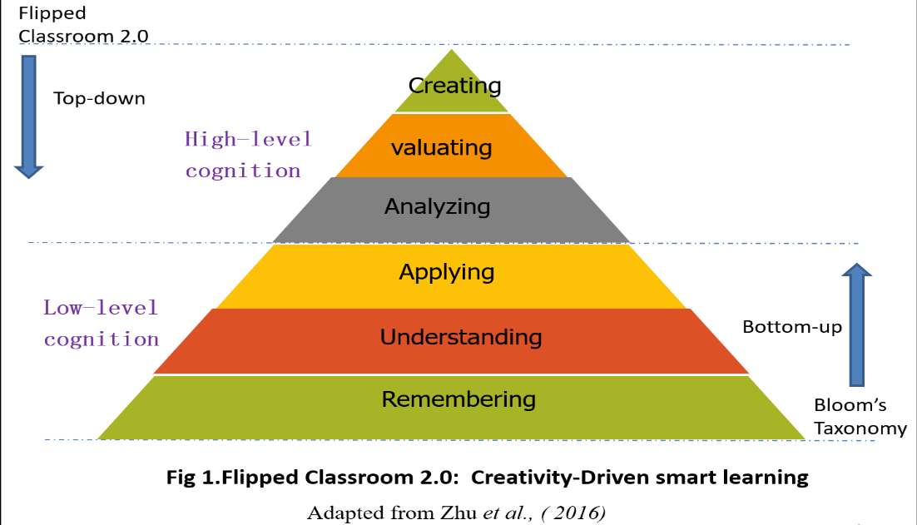
I will conduct a mini research project basing on Zhu Z.T.et al. (2016)’s revised model which moves towards Creativity-Driven smart learning. For example, teachers use the highest goal ‘creating’ - develop an ad. Campaign’ after reading a passage -as the starting point to encourage students to produce a new work of their own. It breeds a new teaching paradigm that merges with Maker Education, and forms a practical thinking that the "top-down" and "bottom-up" processes complement each other in Bloom's Taxonomy (see Figure 1).
This new model is also named Target Learning Modal driven by creativity (Zhu Z.T. et. al. 2016). In the process of achieving the goal of "creation”, the target shooter may unconsciously hit any link or links of remembering, understanding, applying, analyzing and evaluating( see Figure 2). Therefore, the focus of creating-driven learning lies in "creating" itself. As long as "creating" is achieved (no need to care about whether one or more of the cognitive abilities of remembering, understanding, applying, analyzing, or evaluating are available), we believe that they have successfully completed an autonomous learning. From the perspective of the achievement of teaching goals (or learning effectiveness), this kind of creation-driven targeted learning produces ripples through the bull's-eye (ie. creation), which in turn affects teaching goals such as evaluation, analysis, application, understanding, and memorization, giving rise to “ripples”. Change of learning effect. Therefore, as long as students complete the realization of creativity to creation, we can see that they have successfully completed an autonomous learning. Their autonomous learning ability will be gradually improved in the implementation of this model.

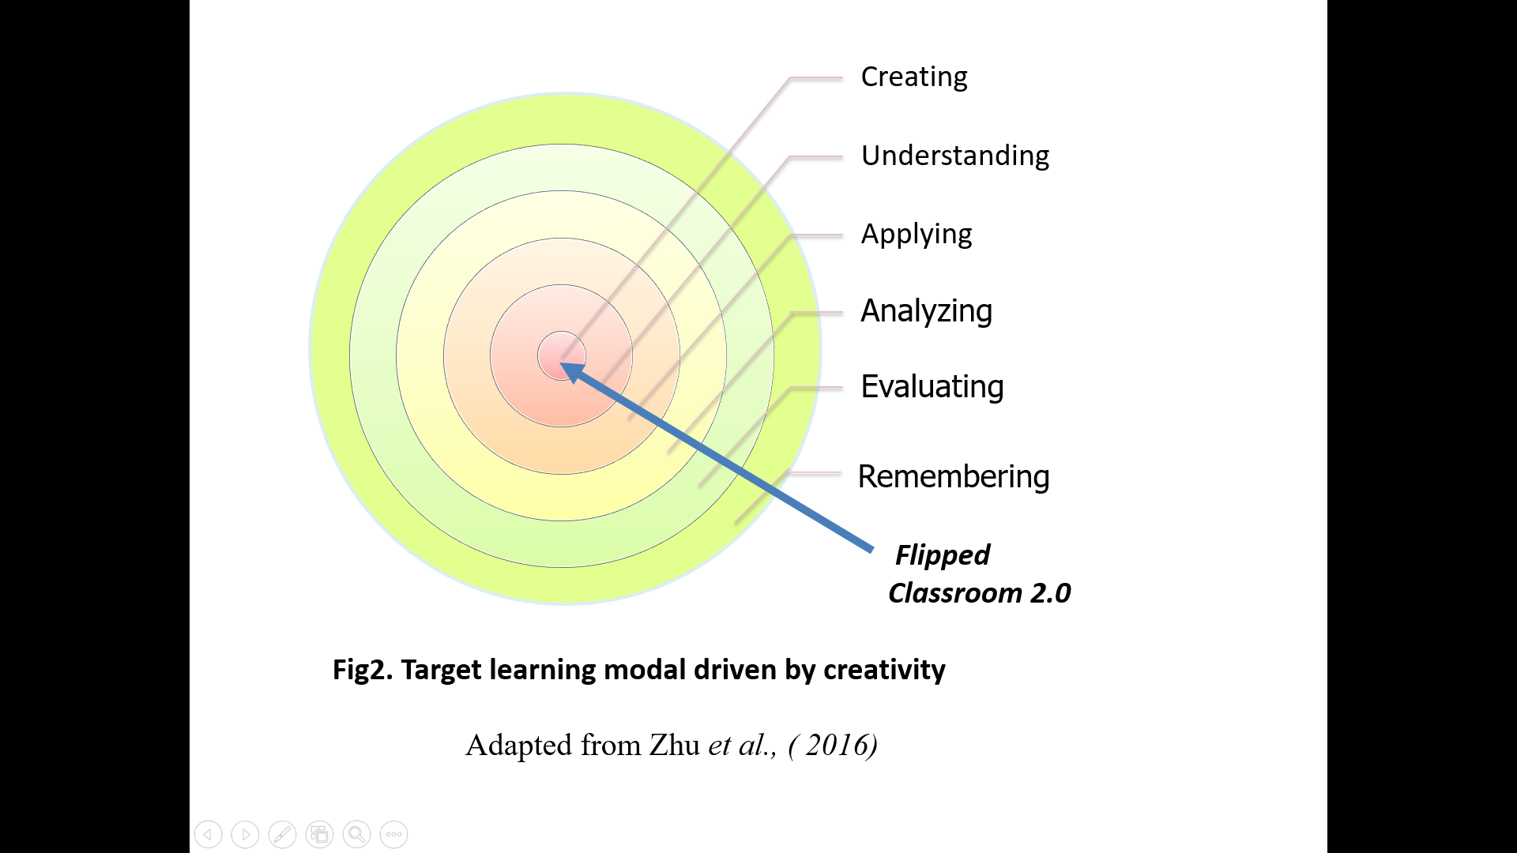
Basing this revised model, I will divide the pre-class and class of the flipped classroom into planning stage, preparation stage and realization stage (see Table 2).. At each stage, my students and I will have corresponding tasks and roles. At the planning phase, basing on the content of the textbook and unit objectives, I will design a number of creating task themes for students to choose, and provide them with learning materials for language learning. To make sure students are clear about the purpose and contents of learning, I will prepare a learning guide, covering or supported with a quiz for self-learning, a set of task themes that are sufficient enough for students to select to produce a work or video, grouping arrangements, and relevant instructions related to the task. At the preparation stage, the students begin self0learning. The learning materials link in this mode mainly revolves around the learning of the basic knowledge and skills needed to complete the creating task. After that, they will work in groups, make plans, and prepare for materials or other detailed jobs related with the creating task. At the realization phase, the students will complete and display their collaborative work, followed by comments, review and summary.
Table 2 Correspondence between the teaching procedures based on flipped classroom and the students' autonomous learning action
Stage of creative task | Student learning activities | Behavioral performance of autonomous learning
Planning phase  (Pre-class) | Claim tasks, establish contacts with peers, learn materials | Stimulate learning motivation; Clarify learning goals, Develop a learning plan and monitor the learning process
Preparation phase  (pre-class/ in class) | Scheme conception, material preparation, division of labor and collaboration | Choose learning content, use learning strategies, collaborative learning
Realization phase  (in class) | Complete works, works display, reflection evaluation | Monitor the learning process and evaluate the learning results

- A description of the evidence you intend to collect
For this project, I will collect data about
1. Learners’ autonomous competence before and after the project
2. Learners’ language competence before and after the project
3. The relationship between the learners’ autonomous competence and their English proficiency outcome.
The evidence to be collected is to answer the following questions:
1. Can the flipped-classroom model effectively improve Chinese EFL college learners' autonomous learning?
2. What effect does flipped-classroom have on Chinese EFL college learners’ development of autonomy learning?
3. What’s the relationship between the learners’ autonomous competence and their English proficiency?
4. What are the implications of flipped classroom for designing College English?

- The methods you expect to use to collect the evidence you collect
This project will use a combination of quantitative and qualitative research methods, using the following research tools:
1) Questionnaire survey
Questionnaire will be used to understand and analyze the student’s autonomous learning before the start of the experiment. After the experiment is completed, the questionnaire survey will be conducted again. After that, data will be analyzed and sorted to compare data differences, as feedback on training effectiveness.
The questionnaire is adaption of questionnaires of Xu J.F.(2004, 2009) and Chen X. R.(2014)’s Chinese non-English major‘s autonomous questionnaire, consisting of 40 items covering six aspects (Table 1). To test the validity of the questionnaire, a pilot study will be conducted on a small sample of respondents.
Table 1. Content description of the questionnaire
No. of parts | Content | No. of items
I | Concept of autonomy learning | 1-7
II | Understanding of the purpose and requirements of the teacher's teaching | 8-12
III | Goals-setting and plans-making | 13-17
IV | Strategy-using | 18-22
V | Strategy-monitoring | 23-29
VI | Learning evaluating | 33-39

To measure the degree of autonomy competence, the questionnaire options are graded in the form of a Likert five-point scale. According to different questions, the questionnaire options range from "very clear (5 points)" to "unclear (1 point)" or from "very good (5 points)" to "bad" (1 point)" and so on.
2) Language competence test
This project will use The National College English Test and Band 4 (CET-4) paper (June, 2022) as a test to judge the subjects’ English language proficiency before and after the experiment separately, to analyze whether the improvement of autonomous learning ability will affect the students' English development level and whether there is a positive correlation.
The reasons for the research used CET-4 as a test to judge the subjects’ English language proficiency are: 1) the items CET-4 can well reflect participants’ language proficiency in terms of listening comprehension, reading comprehension, writing, the mastery of vocabulary and grammar, as it is composed of five parts: writing, listening comprehension, reading comprehension, cloze, and translation; 2) CET-4 is a large-scale examination designed and held for Chinese non-English majors twice a year with high validity and reliability. Like CET-4, the National College Entrance Examination (NCEE) has a high validity and reliability since it is a large-scale test designed to examine the overall English language proficiency of middle school students before they are qualified to enter the university.
In the first week of the course, the subjects’ English scores in the NCEE will be collected to compare these two classes to find out if there are statistic significant difference in the subject’s language proficiency before the experiment is conducted.

3) Interview
The interviewees were 20 representatives. Among them, 10 students had the most significant improvement in self-learning ability after one school year, and the other 10 are chosen from those who had improved least significantly. Both group interviews and individual interviews will be adopted. The content of the interview will mainly center on the students' satisfaction with the "flipped classroom" teaching model, their suggestions for improvement, and the influencing factors of the development of autonomous English learning ability. Such as:
(1) Do you like the current English teaching model? (If you like) Is there anything else that needs to be improved? (If you don't like it) Why?
(2) Do you consciously try the learning methods and strategies introduced by the teacher? (If so) Do you usually think those methods are suitable for you? (If not) Why?

- A description of the settings in wish you plan to collect your evidence
1. Experimental hypothesis:
The improved version of Flipped classroom is more conducive to improving students' autonomous English learning ability than the traditional teaching model; At the same time, it is also conducive to improving students' English proficiency
2. Subjects
I will conduct experiments among non-English major undergraduates (Grade 2022, freshmen) in Hunan First Normal University. There are two main reasons to select them as the subjects. First, freshmen will benefit earlier and greater from the project in the first academic year than later on. Second, the NCEE has higher validity and reliability and save time than that of test hold by us.
3. Independent and Dependent variable
Dependent variable: students' autonomous English learning ability at the end of the experiment; language proficiency test in the first semester and the second semester.
Independent variable: Two different teaching modes- teaching model of the flipped classroom and traditional teaching mode.
4. Control methods
1) There is no significant difference in the English scores of the College Entrance Examination from the experimental classes and control classes selected from the non-English majors of the whole school.
2) Although the teaching and learning modal in the experimental class is different from that of other classes, the students are not aware of the experiments until at the endo of the experiment, with a purpose to avoid the Hawthorne effect and ensure the reliability of the experimental results
3) In order to reduce the differences in experimental results that may be caused by teacher’ individual differences, the same teacher undertakes the teaching tasks of one control class and one experimental class. There are 3 teachers in total.
4) The teaching materials used in the experimental class and the control class are the same "New Vision University English Reading and Writing Course" and "Test Listening and Speaking Course", the hours are equal, 4 hours a week, 15 weeks in total, the teaching progress remains the same;
5) The scoring teacher of the subjective question composition of the two final exams is not the subject's teacher, and is scored by two persons to avoid the adverse impact of subjective impression and subjective will on the objective score;

- The ethical issues you have to consider
Before the questionnaire survey, the students will be clearly informed that the questionnaire will be used for research, with a purpose to help them make better progress though the college English curriculum, and they can refuse to participate in the project if they are not willing to. For those who are willing to do questionnaires, I promise them to protect their privacy and treat their personal information confidentially when collect and analyze the data.
This project is for research use only. If the results of the research need to be published publicly, I will strictly abide by the "PRC Law of the People's Republic of China on the Protection of State Secrets", "Press and Publication Confidentiality Regulations" and other Chinese regulations and requirements regarding confidentiality, as well as the country where the publication is located Relevant laws and regulations to prevent the occurrence of leaks in publishing work.

- The methods you expect to use to analyze the evidence you collect
This project will use SPSS 20.0 tools to perform statistical analysis on the data obtained from the questionnaire, and analyze whether there are significant differences in the autonomous English learning ability between the experimental class and the control class before and after the experiment through independent samples and test comparisons; understand the experimental class through paired sample testing Whether there is a difference between the autonomous English learning ability before and after the experiment in the control class and the control class. At the same time, an independent sample test was carried out on the English test scores of the experimental class and the control class at the end of the first and second semesters to determine the differences in the English scores of the two groups of students.

- Timetable for the proposed project.
This project would begin in September 2021, and last for two academic terms (half a year). There are 14 weeks for the first academic term, and 16 weeks for the second academic term. There will have 4 periods each week. A period last 45 minutes.

References
- Bergmann, J. & Sams, A.2012. Flip Your Classroom: Talk to Every Student in Every Class Every Day[M].VA: International Society for Technology in Education.
- Dickinson, L. (1995). Autonomy and motivation. System, 23(2), 165–174.
- Benson, P. (2013). Learner autonomy. TESOL Quarterly, 47(4), 839–843.
- Dickinson, L. (1995). Autonomy and motivation. System, 23(2), 165–174.
- Dörnyei, Z. 2001.Motivational strategies in the language classroom Cambridge University Press, Cambridge (Cambridge Language Teaching Library).
- Esch, E. 1996. Promoting learner autonomy: criteria for the selection of appropriate methods. In R. Pemberton, E. S. L. Li, W. W. F. Or and H. D. Pierson (Eds.) Taking Control: Autonomy in Language Learning. Hong Kong: Hong Kong University Press.
- Holec, H. 1981.Autonomy and Foreign Language Learning. Oxford: Pergamon Press.
- Little, D. 1991.Learner Autonomy: Definitions, Issues and Problems. Dublin: Authentik.
- Nunan, D. (1996). Towards autonomous learning: Some theoretical, empirical and practical issues. In R. Pemberton, E. S. L. Li, W. W. F. Or, & H. D. Pierson (Eds.), Taking control: Autonomy in language learning (pp. 13–26). Hong Kong: Hong Kong University Press.
- Teng, F. 2019 Autonomy, Agency, and Identity in Teaching and Learning English as a Foreign Language-Springer Singapore (2019)
- Zimmerman, B.J & Schunk D.H (1898).Self-regulation of learning and academic New York Inc:5 .
- Zimmerman, B.J. 2001. Theories of self-regulated learning and academic achievement: An overview and analysis. In B.J. Zimmerman & D. H. Schunk (2ndEd).Self-regulated learning and academic achievement: Theory, research, and practice. Lawrence Erlbaum Associates, Inc. p.9.
- Cheng Xi (2018）Research on the Cultivation of Autonomous Learning Ability Bases on the Flipped Classroom. Dissertation for Master Degree. Jiang Nan University.
- Chen Xiao-ru (2014) An Empirical Study of Scaffolding Instruction For the Development of Chinese Non-English Majors’ Learning Autonomy. PhD thesis Shang Hai Foreign Language University.
- Guo Ji-rong (2011).Daxuesheng yingyu zizhu xuexi pingjia shizheng yanjiu. Foreign language world. No. 6, 2011
(English version ) Guo Ji-rong (2011) An Empirical Study on Evaluation of College Students' English Autonomous Learning. Foreign language world. No. 6, 2011
- Hua Wei-fen. 2002. On learner autonomy. Journal of Shenzhen University (Humanities & Social Sciences. Vol.10. No
- Lin Lilan(2008) Compilation and Testing of the Autonomous English Learning Ability Scale for College Students Based on Three-dimensional Construction. Foreign Language World. No．(4) 2013: 73-96.
- Lv Ting-ting & Wang Na( 2016) Jīyú SPOC+shùzìhuà jiàoxué zīyuán píngtái de fānzhuǎn kètáng jiàoxué móshì yánjiū—yǐ dàxué yīngyǔ wéi lì. China Audio-visual Education. Zhōngguó diànhuà jiàoyù. No5: 85-131
- (English version ) Lv Ting-ting ( 2016) A Study on the Establishment and Effect of the Flipped Classroom Mode for SPOC + Teaching Resource Platform as Applied in College English Teaching. China Audio-visual Education. No5: 85-131
- Pang Wei-guo (2011) Lun xusheng de zizhuxuexi Huadong shifandaxue xuebao
(English version ) Pang Wei-guo (2011) . On Students' Autonomous Learning. Journal of East China Normal University(Educational Science Edition) Vol(02) : 78-83.
- Shi Meng-meng (2014) Jīyú rènwù de fānzhuǎn kètáng jiàoxué móshì duì péiyǎng hùlǐ zhuānyè xuéshēng yīngyǔ zìzhǔ xuéxí nénglì de shízhèng yánjiū. Dàxué yīngyǔ. Vol(11) No2:197-2000
- Shi Meng-meng (2014) An empirical study on the role of task-based flipped classroom teaching model in cultivating nursing students' English autonomous learning ability. College English. Vol(11) No2:197-2000
- Shu Chun-Lai (2015) Autonomy-Oriented Flipped Classroom in College English Teaching. Dissertation for Master Degree.. Harbin normal university
- Teaching Steering Committee of Higher Education Ministry of Education of China. (2020).College English Teaching Guide’ Higher Education Press.
- Xu Jin-fen (2004) Fei Yingy zhuanye daxuesheng zizhuxing yingyu xuexi nengli d diaocha yu fenxi. Foreign Language Teaching and Research (bimonthly ) Vol.36 No.1
(English version) Xu Jin-fen (2004) Investigation and Analysis of Autonomous English Learning Ability of Non-English Majors. Foreign Language Teaching and Research (bimonthly) .Vol.36 No.1
- Xu Jin-fen (2010) Péiyǎng dàxué xīnshēng yīngyǔ zìzhǔ xuéxí nénglì de “sānwéi yītǐ” jiàoxué móshì —dàxué yīngyǔ jiàoxué móshì gǎigé shíyàn yánjiū. Foreign Language Education. Vol. 31 No.6:60-
(English version) Xu Jin-fen (2010) The "Three-Dimensional One" Teaching Model for Cultivating Freshmen's English Autonomous Learning Ability—An Experimental Research on the Reform of College English Teaching Mode . Foreign Language Education. Vol. 31 No.6:60-65
- Wang Xiao-dong, Zhang Chen-zai-qian (2013) Fanzhuan ketang zai daxue jiaoxe zhong de yingyong yanjiu –yi jiaoyujishuxuey zhuanye yingy kecheng weili . Modern Educational Technology. Vol. 23 No.8.
(English version) Wang Xiao-dong, Zhang Chen-zai-qian (2013) Research on the Application of "Flipped Classroom" in University Teaching—Taking the Professional English Course of Educational Technology as an Example. Modern Educational Technology. Vol. 23 No.8.
- Wang Yu (2016) Research on the Cultivation of Geography Autonomous Learning Ability of Senior High School Students Based on Flipped Class. Dissertation for Master Degree .Shandong Normal University Cultivation Research
- Zhang Jin-lei , Wang Ying & Zhang Bao-hui (2012) Fanzhuan ketang jiaoxue moshi yanjiu. Journal of Distance Education. No3.:46-51
(English version ) Zhang Jin-lei , Wang Ying & Zhang Bao-hui (2012) Introducing a New Teaching Model: Flipped Classroom. Journal of Distance Education. No3.:46-51
- Zhang Jing (2018) Research on Flipped Classroom and Cultivation of College Students' Autonomous Learning Ability in Foreign Languages. Dissertation for Master Degree. Heilongjiang University
- Zhang Wenxia, Li Shujing. XinShidai daxue yingyu jiaoxueguanli he jiaoshi fazhan de wenti yu duice 《daxueyingyu jiaoxuezhinan》 xiangguan yaodian jiedu Foreign Language World. No. 5, .2020
(English version ) Zhang Wenxia, Li Shujing. Problems and Countermeasures of College English Teaching Management and Teacher Development in the New Era.-Interpretation of relevant points in the College English Teaching Guide Foreign
- Zhu Zhi-ting, Lei Yun-he (2016 ) Fanzhuan ketang 2.0 : zouxiang chuagnzaoqudong d zhihuixuxi. Dianhua jiaoyu yajiu. No.3
(English version ) Zhu Zhi-ting, Lei Yun-he (2016 ) Flipped Classroom 2.0：Moving towards Creativity-Driven Smart Learning. Audio-visual Education Research. Vol(3) 2016 .

Appendix I
Questionnaire on Autonomous Learning for College Students
Dear classmates:
This is a questionnaire about autonomous learning. Each question is divided into five levels. Please read each question carefully, and select the corresponding option according to your subjective feelings and the degree of conformity with each question, and mark the box that best suits your situation‘√’. The answers to the following questions are not right or wrong. They are only used for scientific research and help us improve teaching methods. This questionnaire is anonymous, and please do NOT mark any personal marks on the questionnaire. Thank you for your cooperation!
I. Concept of learner autonomy
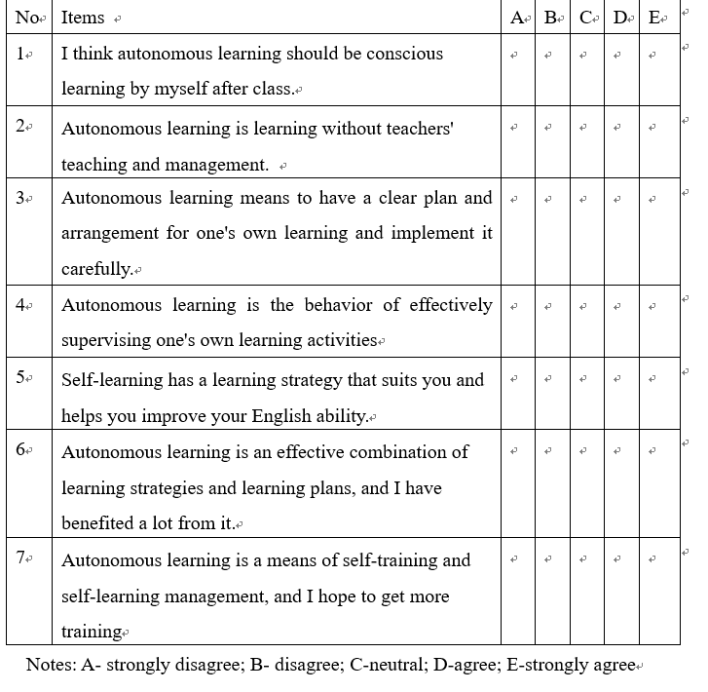

II. Understanding of the purpose and requirements of the teacher's teaching
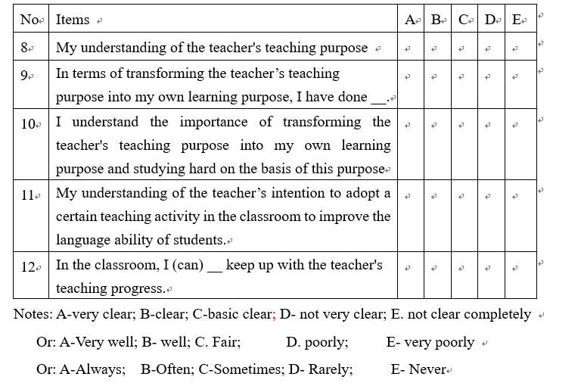

III. Goals-setting and plans-making
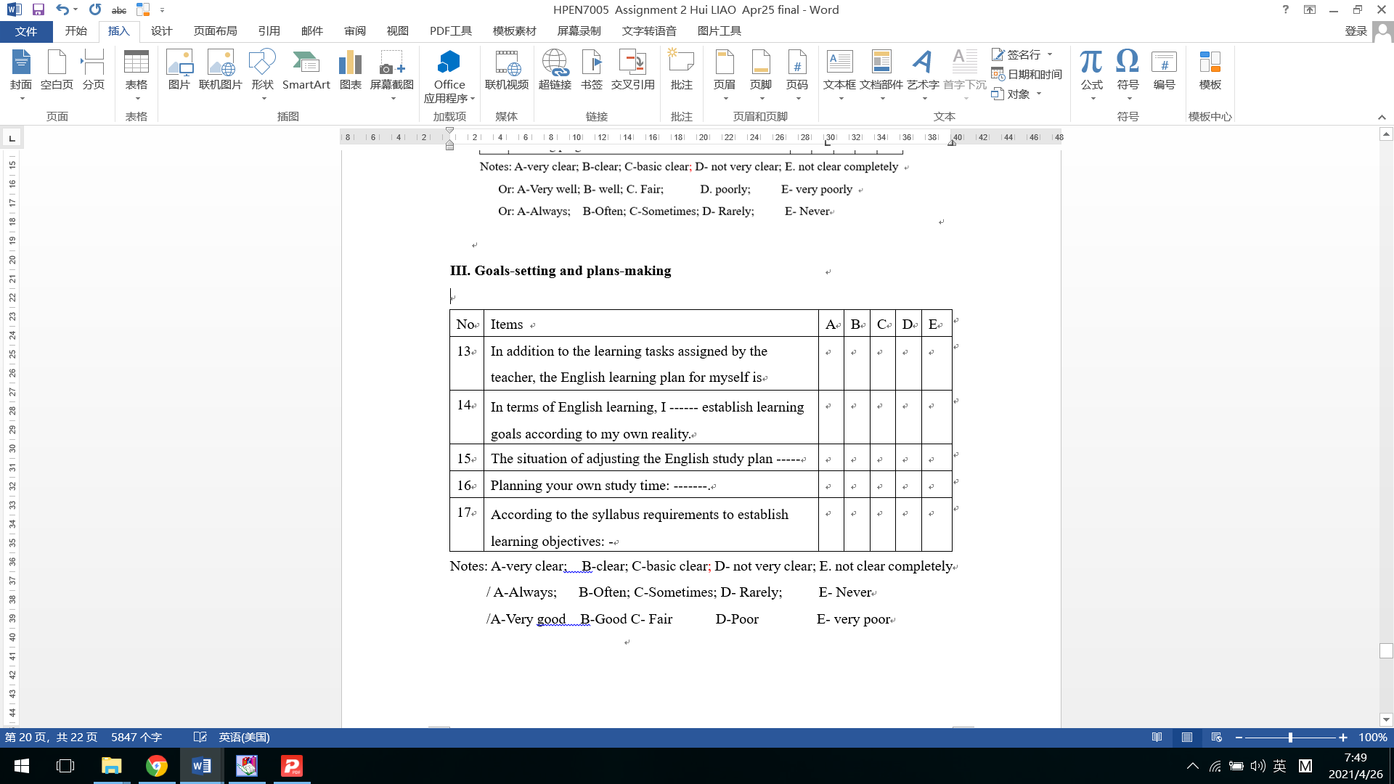

IV. Strategy-using
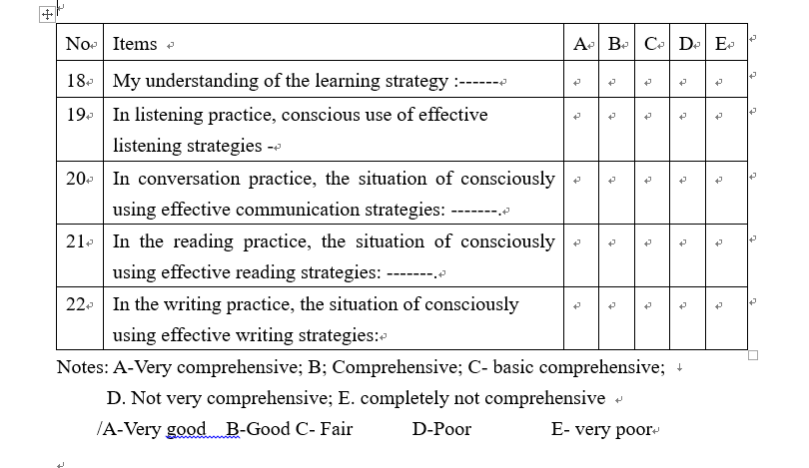

V. Strategy-monitoring
No | Items | A | B | C | D | E
23 | In listening practice, the extent to which the use of listening strategies is consciously monitored:
24 | In conversation practice, the extent to which the use of communication strategies is consciously monitored:
25 | In reading practice, the extent to which the use of reading strategies is consciously monitored:
26 | In the writing practice, the extent to which the use of writing strategies is consciously monitored
27 | I ___ evaluate my own learning methods to find out existing problems and solutions.
28 | I ___realize whether my learning method is practical.
29 | If I find that my own learning method is unrealistic, I ____.switch to other more appropriate learning methods in time.
Notes: A-Very good; B-Good ; C- Fair; D-Poor ; E- very poor
A-always; B-often; C-sometimes; D-rarely; E- never

VI. Learning evaluating
No | Items | A | B | C | D | E
30 | Outside class, I __ actively seek various opportunities to practice English.
31 | In English learning, I _ take the initiative to overcome emotional factors that are not conducive to English learning (such as anxiety, low self-esteem, depression, shyness, etc.).
32 | I __ make use of existing learning resources (such as: library, Internet, reference books, English radio, dictionary, etc.).
33 | The degree I consciously apply newly learned knowledge to language practice:-
34 | I __ take the initiative to study cooperatively with others (such as looking for oral communication partners, sharing learning experiences with other students, reviewing with other students, etc.)
35 | In the process of language learning, I __ can be aware of their own mistakes.
36 | While being aware of the error, I __ can find the cause of the error (such as mother tongue interference, unfamiliar grammar knowledge, etc.) and take corresponding measures to correct the error.
37 | In choosing effective information channels to make myself a better language learner, I do it ____.
38 | In the process of completing a certain language task, I ___ can simultaneously detect the completion of their own pre-designed plan: ---
39 | In the process of completing a certain language task, I ___ check and update your own understanding of the previous knowledge.
A-always B-often C-sometimes D-rarely E- never

