

Student name: | Rajesh Chaudhary
Student ID number: | 2433823
Programme: | Master of Business Administration
Module: | International Business Concepts
Module code: | LCMB7034
Lecturer: | Akshay Narayanan
Assignment Title: | Report
Word count: | 5,169

Table of Contents
Introduction 4
Section 1: 4
Industry and Country Overview 4
Introduction to the industry in the chosen country 4
Size and scope of the US manufacturing industry 4
Economic importance 5
Major domestic and multinational firms 5
Relative positioning of key companies 6
Critical evaluation of competitive positioning 7
Porter’s Diamond Analysis of US Manufacturing 8
Factor conditions 8
Demand conditions 9
Related and supporting industries 10
Firm strategy, structure and rivalry 11
Foreign MNC/TNC Evaluation: Toyota in the United States Manufacturing Context 12
Company profile and US manufacturing presence 13
Framework for evaluation 14
Political factors affecting Toyota’s success 14
Economic factors affecting Toyota’s success 15
Legal and regulatory factors affecting Toyota’s success 16
Cultural factors affecting Toyota’s success 16
Overall assessment of US market attractiveness for Toyota 18
Conclusion 19
Section 2: Reflective account 19
Reflective account using Kolb’s Learning Cycle 19
Concrete Experience 19
Reflective Observation 20
Abstract Conceptualisation 21
Active Experimentation 21
References 23

Introduction
This report examines the manufacturing sector in the United States within an international business environment in terms of its competitiveness, and structural features and international positioning. The United States and the manufacturing sector are the selected country-industry pair. Section 1 critically analyses the industry based on the Diamond Model of Porter and analyses the position of the Toyota Motor Corporation in the analysis of market attractiveness and strategic adjustment. Section 2 is a reflective report based on the learning cycle by Kolb and a reflection on the research and preparation process. Overall, the report assesses the impact of economic, political, legal and cultural forces on manufacturing performance and the international business strategy.

Section 1:

Industry and Country Overview

Introduction to the industry in the chosen country
The manufacturing industry is one of the most powerful industrial sectors of the world economy since it integrates mass production, high technology, capital availability and extensive integration in the global supply chains. In this report, manufacturing involves processes that change raw materials or components into finished or semi-finished products in subsectors of manufacturing, including automotive, aerospace, machinery, electronics, chemicals, food and pharmaceuticals. This renders the US a significant destination to both local manufacturers as well as multinational companies that would like to gain accessibility to a big market, elaborate demand and industrial potential (Castellani et al., 2022).

Size and scope of the US manufacturing industry
The sector is economically viable in terms of scale, although the US economy has long-term trends of moving towards services. The National Association of Manufacturers, on the basis of BEA data, reported that the US manufacturing value added increased to $2.951 trillion in Q3 2025, which constituted 9.5% of the total US value added output. Employment is also high: manufacturing had approximately $12.6 million in January 2026, which indicates that the sector continues to have a role to play in terms of jobs, incomes and industrial growth of the region (Manufacturers, 2026c). BLS indicated that manufacturing productivity grew 2.0% in 2025, which means that the industry is still helping the output grow by using efficiency and technology, but not labour expansion (BLS, 2026).
The US manufacturing is both traditional mass production and high-value advanced manufacturing in terms of scope. The industry comprises transport equipment, semiconductors, heavy machinery, chemicals, aerospace systems and medical or pharmaceutical products. It is not that a shrinking or limited industrial foundation but a diversified production system, which sustains domestic consumption, export, innovation and industrial resilience. This broad base makes the United States a target market as well as a business centre in terms of production.

Economic importance
Economic significance of manufacturing is not only on the output and employment, but also on the trade, productivity and industrial connections. Recent trade statistics demonstrate that the United States still exports a huge amount of goods and services, and that manufacturing output itself increased 0.6% in January 2026 and was 2.4% higher than it was a year ago, which shows that the industrial activity is still being affected by the greater economic pressures (Manufacturers, 2026d). The production of manufacturing also promotes logistics, supplier industry, engineering services and research investment, that is, its impact is far beyond factory production. Thus, its significance is perceived in multiplier terms, rather than as an independent sector.

Major domestic and multinational firms
The US manufacturing market is characterised by the combination of big domestic companies and giant multinational manufacturers. Key US-based companies are Ford, Tesla, Boeing and Caterpillar, which are the representatives of various manufacturing industries and competitive patterns. There are multinational corporations like Toyota that also have major manufacturing plants in North America and the United States, which proves that the country is not only appealing as a sales location, but also as a production one (Gibrilla, 2023). The official data provided by Toyota facilities proves that the company has a significant presence in manufacturing in North America, with several production locations in the US. This combination of local and foreign companies emphasises the power of the US as a global manufacturing hub.

Relative positioning of key companies
The US manufacturing is not uniformly strategic, with the leading companies holding various competitive positions.
Tesla is the most innovative company, and is going beyond electric cars into energy systems and AI-enabled technologies (Mishra et al., 2025). This strengthens its differentiation and expansion capabilities, but makes it vulnerable to technological uncertainty, high R&D expenses, and unstable demand, making its competitive stance dynamic and risk-sensitive compared to the traditional manufacturers.
Ford is in a more mass-market position, and scale allows it to have legacy production and record 2025 revenues of $187.3 billion, but it is less premium and more margin-pressured than Tesla (Ford, 2025).
Boeing holds a premium aerospace location on the basis of technological complexity and high barriers to entry. Its revenue of $89.5 billion and backlog of $682 billion show that it is in high demand, but this positioning is very reliant on the confidence of the regulatory bodies and the reliability of its operations (Boeing, 2026).
Caterpillar is again in a different position competing in the B2B industrial machinery by engineering reliability, dealer networks and service strength. Its $67.6 billion revenue and 16.5% operating profit margin indicate greater profitability resilience compared to companies that are exposed to consumer-market volatility (Caterpillar, 2026).
Overall, Tesla is the most innovative, Ford the most scaled, Boeing the most complex and Caterpillar the most industrially reliable.
Positioning Map
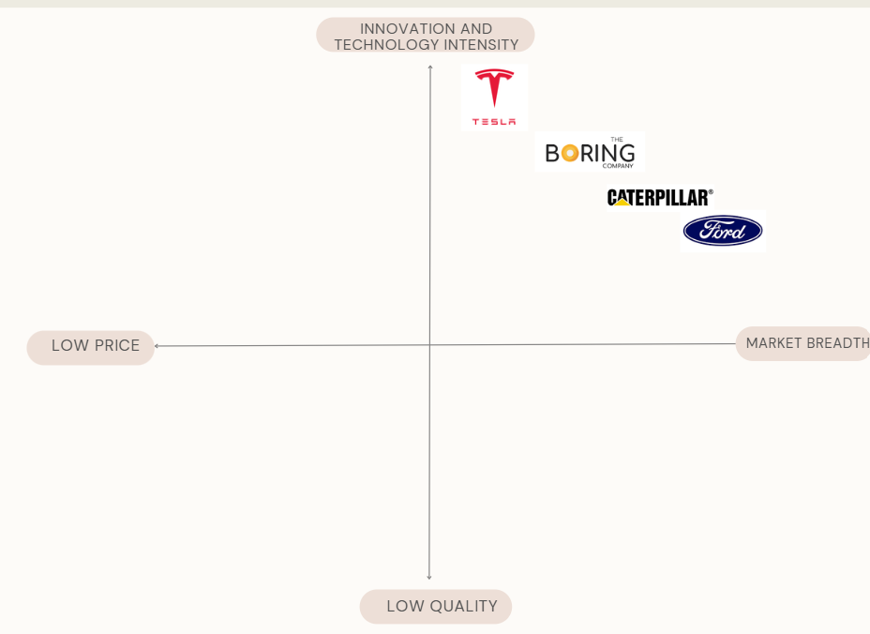
Figure 1: Positioning Map
Source: Self-made

Interpretation
The positioning map indicates that Tesla and Boeing are ranked higher in terms of intensity in innovation, whereas Ford is competing in a wider market. Caterpillar ranks between mid- and high-end, which indicates a high level of industrial penetration and moderate-high innovation. This implies that the US manufacturing is not in favour of a single competitive strategy, but of a variety of competitive strategies.

Critical evaluation of competitive positioning
Critically, these companies are competing based on various strategic logics. The primary competition that Tesla engages in is innovation and differentiation in the future. Ford is more dependent on volume, scope and mainstream market penetration. The Boeing relies on high barriers to entry and high engineering capability, whereas Caterpillar competes based on durability, industrial service support and good distribution channels.
This comparison indicates that competitive advantage in the US manufacturing environment is in a position to support various types of competitive advantage simultaneously (Skordoulis et al., 2022). Nevertheless, it also demonstrates that the high revenue does not necessarily imply better strategic resilience. Even big companies could experience a problem with profitability, regulatory risk, technology risk or supply-chain risk. Thus, the US manufacturing is not only powerful in its size, but in its capacity to maintain multiple competitive business models in the world markets.

Porter’s Diamond Analysis of US Manufacturing
The Diamond Model of Michael Porter is a model of national competitive advantage that has four major determinants, which include factor conditions, demand conditions, related and supporting industries, and firm strategy, structure and rivalry, with government and chance being the forces (Lehene et al., 2024). Applied to the US manufacturing, it emphasises strong levels of innovation and capital advantage, but also disproportionate competitiveness because of high labour costs, skills gaps and policy uncertainty.

Factor conditions
The United States possesses extremely developed factor conditions that are strongly helpful in promoting its competitiveness in manufacturing. It has the benefits of having deep capital markets, international research centres, good infrastructure, protection of intellectual property and a qualified labour force. Despite the importance of the industrial base, the number of 0.73% in Q3 2025 should be interpreted carefully since it seems to represent some growth or change measure instead of the total manufacturing value added (UNIDO, 2025).
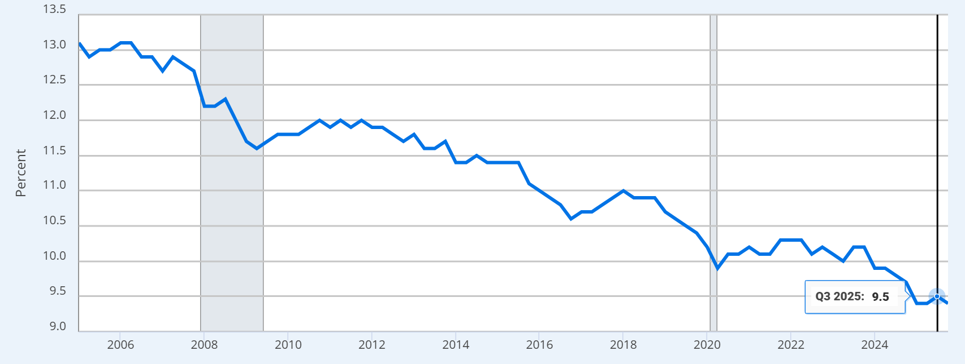
Figure 2: Value Added by Industry: Manufacturing as a Percentage of GDP (2026)
(Source: FRED, 2026)
More evidently, manufacturing contributed 9.5% of the US value-added output and validating its persistent structural significance (FRED, 2026).
There is also a high level of innovation in the US. According to NSF data, total US R&D in 2023 amounts to $722 billion, of which manufacturing firms have performed $394 billion, or 55% of domestic business R&D (NSF, 2025). This places the nation in a very strong position in aerospace, semiconductors, machinery and advanced chemicals. This strength is more applicable in high-value production than cost-based manufacturing.
Critically, the advanced factors do not necessarily ensure competitiveness in all manufacturing segments. The manufacturing jobs amount to approximately 12.6 million in January 2026, which is substantial, yet the industry still experiences labour shortages and high wage rates in comparison to cheaper manufacturing destinations (Manufacturers, 2026a). OECD data indicate that the productivity of US manufacturing has been weaker than anticipated, even with extended economic strength (OECD, 2026). Thus, the US factor base generates great competitiveness in innovation-intensive production, and it also solidifies a strategic reliance on automation, skills modernisation and capital investment instead of labour-cost competitiveness.

Demand conditions
Another strength is the demand conditions in the United States. Porter claims that advanced and challenging domestic customers compel companies to develop more quickly, enhance quality and foresee future market trends. This is the kind of market that can be found in the United States.
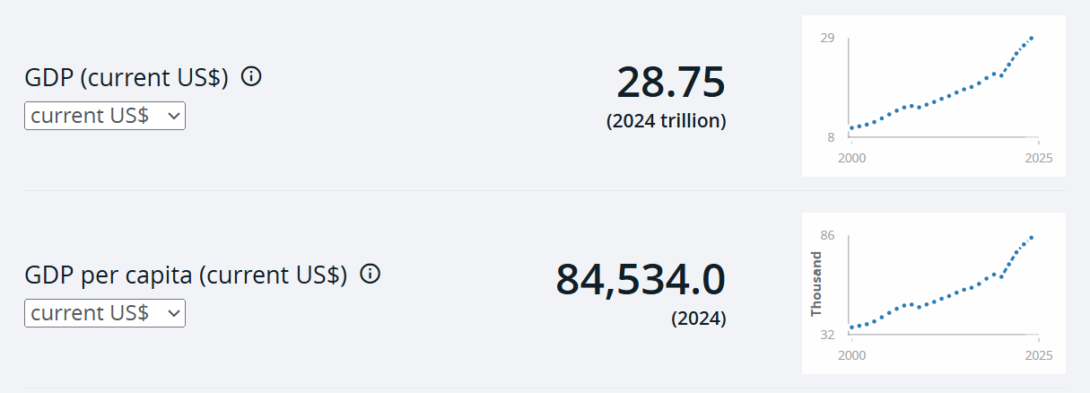
Figure 3: United States (2026)
(Source: World Bank Group, 2026)
According to World Bank data, the US economy has hit $28.75 trillion in 2024, and GDP per capita is 84,534.0, which indicates both large scale and high purchasing power (World Bank Group, 2026). This generates high domestic demand for technologically advanced vehicles, industrial equipment, aerospace equipment, medical technologies and smart electronics.
US manufacturers tend to dominate the high-specification, high-end segments as opposed to low-cost manufacturing. Strong domestic demand helps companies such as Tesla and Boeing to compete based on innovation and quality. The dependence on local markets, however, can decrease the sensitivity to international cost competition, restricting the competitiveness of exports in certain subsectors.
There is a limitation, the model by Porter does not emphasise the role of global supply chains in creating responsiveness in demand since manufacturers in the US can tailor their products to local demand and still use foreign inputs, suppliers and foreign market conditions.

Related and supporting industries
The United States also enjoys good related and supporting industries. which is core to Diamond-based competitiveness. Manufacturing firms operate in the dense networks of suppliers and logistics companies, technology companies, financial institutions, higher education institutions and consulting services. These industrial ecosystems are strong, which contributes to innovation, scale and speed. This richness is reflected in the export performance of the country: the US manufactured goods exports were a record $1.7 trillion in 2025, with $1,169.6 billion in durable goods exports (Manufacturers, 2026a). This demonstrates that US production is supported by supply chains that can produce high-value and global trade production.
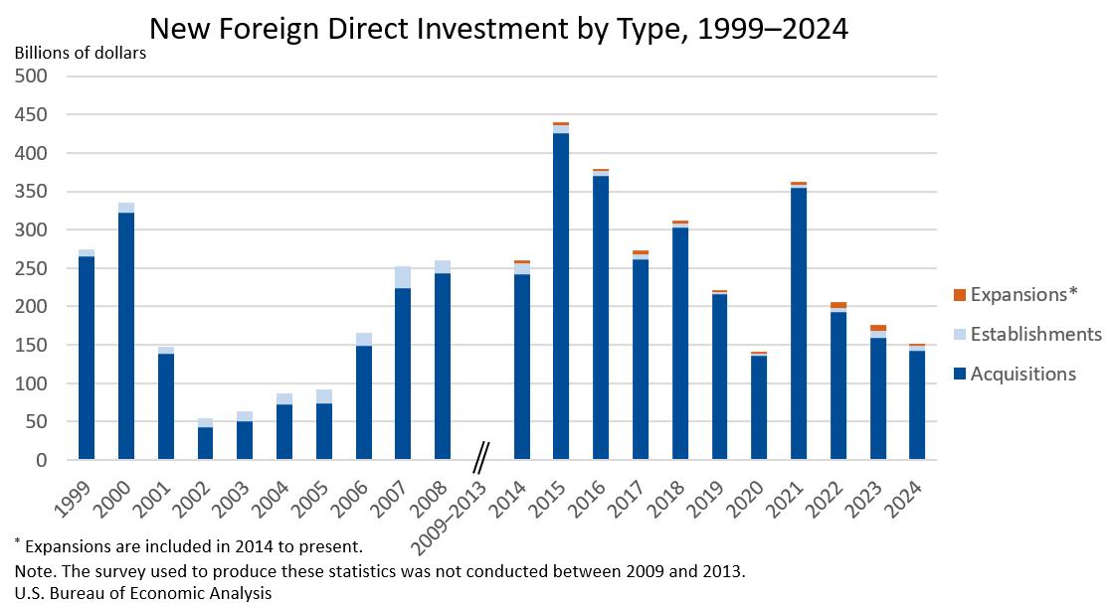
Figure 4: New Foreign Direct Investment in the United States, 2024 (2025)
(Source: BEA, 2025)
This ecosystem is also strengthened by foreign investors. According to BEA data, in 2024, new foreign direct investment in the United States is expected to amount to $151.0 billion, and manufacturing will receive the greatest amount, at $67.7 billion, or 44.9% of the total (BEA, 2025). This indicates that the US is not just a market, but a platform of production with a good industrial network for the multinational firms. But the disruptions of supply chains in recent years have also demonstrated that US manufacturing is still reliant on inputs that are distributed all over the world. This diminishes the explanatory capacity of the original national framework created by Porter, since most of the supporting industries are currently located partly across national boundaries.

Firm strategy, structure and rivalry
Porter believes that stiff domestic competition drives companies to efficiency and innovation. This is very apparent in manufacturing in the US. The models of competition between firms like Tesla, Ford, Boeing and Caterpillar are very different: innovation leadership, scale efficiency, engineering complexity and industrial reliability. This variety demonstrates that the US environment favors several strategic positions, as opposed to a single formula. Competition is stiff and this usually leads to investment in automation, digital production and product development. By early 2026, three-quarters of manufacturers 75.3% expressed optimism about their own company, indicating that a large number of companies continue to see an opportunity to grow despite the cost and trade pressures (Manufacturers, 2026b).
However, rivalry is not always a guarantee of sustainable gain. Factors such as trade policy, reshoring incentives, tariffs and geopolitical risk are becoming a major consideration in strategic performance. The Federal Reserve stated that the manufacturing output declined by 0.1% in March 2026, although it increased by 3.0% annualised in Q1 2026, indicating that competitiveness has been vulnerable to the short-term fluctuations (Federal Reserve, 2026). Thus, the US benefits from the dynamic competition, yet companies now have to weigh between innovation and resilience and policy modification.
The Diamond of Porter indicates that US manufacturing is competitive in the world market because of the advanced factors, high demand, supporting industries and competition, particularly in high-value sectors. Nonetheless, it has a limit in low-cost production, labour and policy pressure, and dependency on global supply chains. Thus, competitiveness is considered in the context of globalisation, geopolitics and industrial policy.

Foreign MNC/TNC Evaluation: Toyota in the United States Manufacturing Context
An appropriate foreign multinational company that can be considered in the US manufacturing scenario is the Toyota Motor Corporation, a Japanese-based company that has a well-established production facility in North America and the United States (Hyun, 2025). Toyota is a suitable example as it is not just a mere exporter to the US market. It has established itself by means of local production, supplier chain, research capacity and, more recently, battery investment. This renders it a powerful case study on how a foreign manufacturer manages to excel in the US and also indicates the political, economic, legal and cultural boundaries of market appeal. The success of Toyota in the United States can be attributed to both firm-specific advantages and favourable host country factors, yet the trade policy, pressure to regulation and localisation are also playing an increasing role in determining its status.

Company profile and US manufacturing presence
The US presence of Toyota is large in size and strategy. The company has a wide presence in its production, logistics and business operations, and in November 2025, Toyota announced that its new battery plant in North Carolina was its 11th manufacturing plant in the United States. The presence of that battery site alone is a $14 billion investment and is projected to generate up to 5,100 jobs (TOYOTA, 2025a).
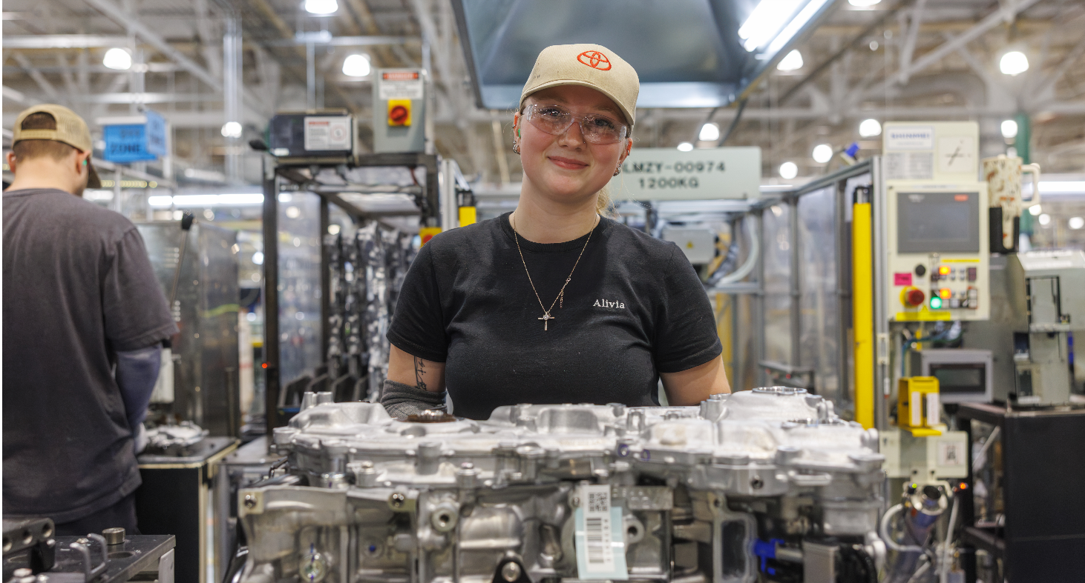
Figure 5: Toyota Boosts Hybrid Production with $912 Million Investment Creating 252 New U.S. Manufacturing Jobs (2025)
(Source: TOYOTA, 2025)
Toyota also declared another $912 million investment in US plants to facilitate the production of hybrids and it would create 252 new manufacturing jobs (TOYOTA, 2025b). These numbers indicate that Toyota is not considering the United States as a sales point. It is leveraging the nation as a main production and technology hub.
Commercially, Toyota has not been left behind in the US market. Toyota Motor North America sold 2024 US cars of 2.33 million, an increase of 3.7% (Reuters, 2025). Electrified cars of 883,426, an increase of 56.1%, or 44.5% of the total volume (TOYOTA, 2025C). This is important since it demonstrates that the success of Toyota is not just related to the presence of production but also its suitability to dynamic US demand and, in particular, the increasing acceptance of hybrid and electrified models by consumers. Strategically, Toyota has been able to achieve its performance in the US by aligning the Japanese manufacturing capacity with the American size, prices and changing energy demands.

Framework for evaluation
The performance of Toyota in the United States is assessed in terms of a PEST-C framework, including political, economic, legal and cultural factors, with the help of the OLI paradigm developed by Dunning (Luo, 2024). PEST-C framework is practical since it directly evaluates the external conditions of the host country that influence the market appeal of Toyota, such as policy stability, purchasing power, regulation and consumer behaviour.
OLI reinforces this by stating why Toyota does not export but has a deep local manufacturing.
- The ownership advantages are brand reputation, lean production capability and hybrid technology.
- The US market scale, high demand and institutional depth are its location advantages.
- Its internalisation advantages are associated with maintaining the quality of production, technology and supply-chain management within the company.
Thus, the success of Toyota in the US is evaluated through the interconnection between the external conditions of the market and the capabilities of the firm and its localisation strategy.

Political factors affecting Toyota’s success
In terms of politics, the US market is still appealing due to its size, industrial infrastructure and openness to foreign direct investment. BEA asserted that in 2024, the new foreign direct investment in the United States was $151.0 billion, with manufacturing accounting for $67.7 billion, or 44.9% of the total (BEA, 2025). This means that the United States remains a favorable place of production for foreign companies. In the case of Toyota, this political environment has traditionally favored long-term investment particularly in manufacturing states competing in terms of jobs and capital.
Nevertheless, the political climate has been more interventionist. In March 2025, the White House stated that it would impose a 25% tariff on imported automobiles, with conditions based on the value of non-US content and special treatment of USMCA-qualified content. This has a mixed effect on Toyota (The White House, 2025).
- On the one side, it strengthens the argument of local manufacturing and is beneficial to the current Toyota manufacturing presence in the US.
- On the other side, the North American operations of Toyota are still related to cross-border supply chains, which implies that tariff regulations can raise the cost of inputs, the complexity of compliance, and the cost pressure.
Critically, this implies that the political advantage enjoyed by Toyota is not absolute. Its presence in the US cushions it against a few import risks, but not policy uncertainty or content-rule exposure. Thus, the success of Toyota lies in the ability to raise the level of local content, diversify suppliers and respond to the rapidly changing US industrial policy.

Economic factors affecting Toyota’s success
The United States is still one of the most appealing automotive markets globally in terms of its size and buying capacity, economically. According to World Bank data, the US GDP is $28.75 trillion in 2024, and GDP per capita is $84,534, with broader manufacturing value added at approximately $2.961 trillion in Q4 2025 (World Bank Group, 2026). These circumstances make vehicles of various prices, including cheap sedans and high-end SUVs and hybrids, highly demanded. This has been an advantage to Toyota since its product lines suit the middle and upper-middle markets, particularly where reliability, resale value and fuel efficiency are important.
But there are also definite tensions in economic attractiveness. The US unemployment rate in March 2026 was 4.3%, indicating a rather tight labour market and annual CPI inflation increased to 3.3% in March 2026 (BLS, 2026b).
- In the case of Toyota, these numbers suggest further wage pressure, input price volatility and more conservative household expenditure. Labour costs, interest rates, energy prices and supply chain instability can squeeze profitability even in instances where demand remains large. This is the reason why the success of Toyota in the US cannot be attributed to the size of the market. Its success will be determined by the efficiency of its operations and a product mix that can absorb increased costs without killing demand.
- The strong growth of Toyota's electrified sales implies that it has done this more effectively than companies that have over-depended on either conventional petrol cars or the shift to pure EVs.

Legal and regulatory factors affecting Toyota’s success
The legal environment in the US is a strength and a weakness. On the good side, the United States has good property rights, institutional frameworks of contract enforcement and clear institutional frameworks. This is important to a multinational such as Toyota since mass production demands assurance in the safety of investments, supplier agreements and adherence mechanisms. Clear market rules are also made by safety regulations. NHTSA regulates vehicle safety and Federal Motor Vehicle Safety Standards, which provide firms with a clear legal framework in which to compete (NHTSA, 2026).
Meanwhile, the US automotive industry is costly and challenging to comply with the law. In 2024, EPA regulations established more demanding emissions requirements during the 2027-2032 model years, which put additional pressure on manufacturers to enhance the performance of their fleets in terms of emissions (Isenstadt and Slowik, 2025). To Toyota, this is partly positive since its hybrid nature provides it with a transition advantage compared to companies that have weaker low-emission portfolios. Nevertheless, the same regulations demand further investment in batteries, cleaner technologies and production redesign. Compliance thus helps firms that are technologically deep, yet it increases capital intensity and decreases strategic flexibility. In that regard, the US legal climate is favourable to such competent incumbents as Toyota, yet it can be harsh in the case of tardiness, ineffective product planning or overdependence on imported non-compliant models.

Cultural factors affecting Toyota’s success
The success of Toyota in the United States culturally demonstrates that foreign companies do not have to forget their home identity, but they have to modify it. Based on the cultural dimensions of Hofstede, the United States and Japan have a number of similarities and significant differences.
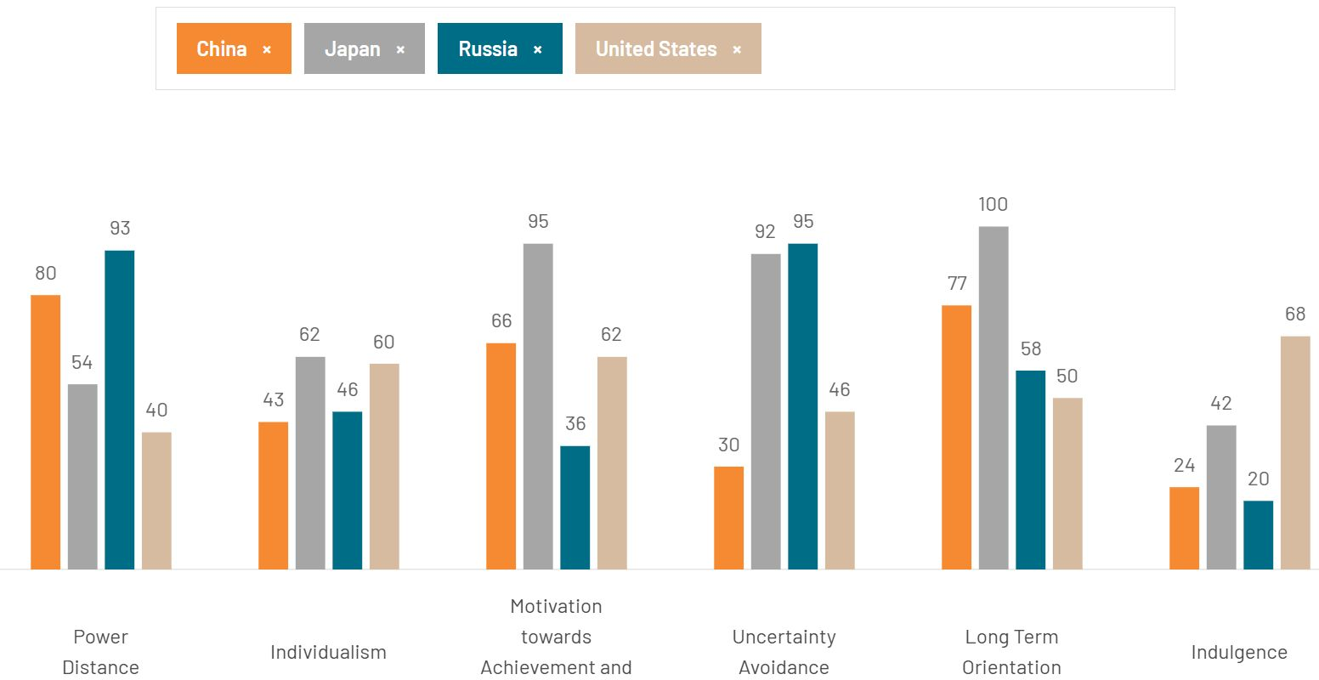
Figure 6: Launching new Hofstede culture comparison tool (2025)
(Source: Geert Hofstede, 2025)
Hofstede’s country comparison tool reports the United States at 40, 60, 62, 46, 50, 68 and Japan at 54, 62, 95, 92, 100, 42 across the six dimensions (Geert Hofstede, 2025). The most applicable contrast is that the United States is more short-term, direct and market-responsive, whereas Japan is more uncertainty-avoiding, long-term and process-driven.
This difference may have been a weakness to Toyota in the US, but in reality, Toyota has turned it into a strength by localising management products and production and maintaining the discipline of the Toyota Production System.
- American consumers cherish reliability, practicality, efficiency and are becoming more sustainability-conscious and Toyota has fitted the bill (Adhikari, 2023). Nevertheless, cultural variations remain important internally.
- Japanese decision-making may be more consensus-oriented and slower than what is expected in the US, which may slow down the pace in an extremely competitive market change. Culture is, therefore, both a strength and a point of conflict.
- Toyota has the reputation of a quality and operational discipline but it will have to strike a balance between Japanese organisational rationality and American requirements of localisation of speed and visible customer responsiveness.

Overall assessment of US market attractiveness for Toyota
Overall, the United States is a very appealing market to Toyota, but it is not an automatically appealing market.
- Politically, the market rewards those companies that localise production and invest in local capacity, which enables the embedded manufacturing model of Toyota. However, tariffs, content regulation and industrial policy also introduce uncertainty, i.e., localisation is not an opportunity but a need of defence.
- Economically, The US is a big and high purchasing power market, however, labour prices, inflation and supply-chain pressure can compromise margins. This renders operational efficiency to be the core of the success of Toyota and not the market size.
- Legally, the US offers a stable rules-based environment, which is conducive to long-term investment, but compliance expenses on safety, emissions and labour standards are still high. This is not a problem for Toyota due to its financial strength and capability of hybrid technology. The same regulatory environment may be a hindrance to weaker foreign manufacturers.
- Culturally, the US is open to quality and trusted foreign brands, but it is still up to the adjustment of the products, communication and management to the American standards to succeed.
Critically, the fit between the ownership advantages and the US market conditions is a critical Toyota advantage. Its brand name, manufacturing skills, hybrid ability and financial strength enable it to absorb compliance and localisation expenses more than less established foreign rivals. Its battery and hybrid investments also demonstrate strategic adjustment and not passive market involvement. But Toyota's position is not to be overestimated. The US market rewards companies that produce locally and upgrade their technology or have a flexible supply chain and resilience in their regulation (Johnson, 2025). The reason why Toyota is successful is that it has already acquired these capabilities when a less integrated foreign manufacturer at greater risk and less competitive.

Conclusion
The report concludes that the United States manufacturing sector is still one of the most competitive industrial sectors in the global economy. It is powerful due to its advanced technology, high domestic demand, well-developed supporting industries and intense firm rivalry, particularly in high-value production. Nevertheless, the competitiveness of the US is not limitless. Its low-cost mass production is diminished by high labour costs, regulatory pressures, policy uncertainty and reliance on global supply chains. The Toyota analysis also reveals that foreign companies can be successful when they integrate localisation, technological ability and strategic adjustment. One important critical point is that the US is appealing not due to the lowest-cost environment, but due to rewarding firms that can cope with complexity more than their competitors. Thus, the success of firms in the long-term is determined by their ability to adapt to the economic, legal, political and cultural pressures.

Section 2: Reflective account

Reflective account using Kolb’s Learning Cycle
This reflective report evaluates my experience of researching and writing Section 1 on US manufacturing, Porter's Diamond and a foreign multinational. It critically analyses my approach, challenges, learning outcomes and how this experience will improve my future academic research, analysis and overall performance using Kolb Experiential Learning Cycle.

Concrete Experience
The initial phase of the Kolb cycle relates to the real experience. When making Section 1, my primary assignment was to research the competitiveness of the US manufacturing industry and analyse Toyota as a foreign MNE in this context. This required me to balance between the industry level analysis and company level analysis but ensure that I maintained the report in line with the learning outcomes. In the beginning, the task was more challenging than it seemed at the start because it involved not only factual information but also critical judgment. I had to choose the most relevant data theoretical frameworks that would add value and how to relate industry conditions with the strategic position of a foreign firm.
The amount and complexity of US manufacturing data were a challenge, with the breadth of subsectors threatening to make the work too descriptive. The choice of Toyota Motor Corporation facilitated the analysis, but required understanding of both the industry context and the strategy of the firm (Aoki, 2026). This experience demonstrated that academic research is not all about gathering information, but making selective, rational choices on relevance, quality and analytical depth.

Reflective Observation
Looking back on the process, I can observe that organisation was one of my key strengths. I managed to divide the task into small steps, starting with industry overview and then using Porter's diamond and concluding with the assessment of Toyota based on political, economic, legal and cultural factors. This phased process has assisted me in keeping things straight, and the report was not too fragmentary. It also helped in simplifying the process of matching the content to the marking criteria and in ensuring that each section was part of the overall argument.
Nevertheless, I also found that there were some weaknesses in my first strategy. Initially, I was inclined to pay excessive attention to statistics and factual evidence.
This gave the report a strong evidence base, but sometimes jeopardized the appearance of the analysis as critical rather than descriptive. To illustrate this, early iterations focused on the scale of the US production and Toyota investments, and these numbers were not always explained as to why these numbers mattered strategically (Dupuis et al., 2026). Revision helped me realise that data presentation is not all that a higher level of academic writing demands. It entails the exposition of relationships, tension and implications.
The second important finding was that the theory implementation was not as straightforward as I had expected. The Diamond by Porter appears to be easy in books, yet in practice, the model has a few limitations, especially in the analysis of industries that are affected by the international value chain and geopolitical uncertainty. In the process, I started to wonder whether the model in itself was sufficient to explain the modern manufacturing competitiveness. It was a helpful experience since it helped me to step out of the mindset of merely applying theory in a mechanical manner and into a more critical one. I was taught that good academic work does not consider models as wholesome solutions. It employs them as instruments and also knows where they come short.

Abstract Conceptualisation
Based on this experience, I was able to formulate several more general lessons regarding research and analysis.
- First, I learned that critical analysis is not founded on information but on interpretation. Credible data is necessary, yet it will not make sense without a definite argument. The better sections in this report were those that went beyond what is happening to why it matters and what it means to international business strategy (Buckley et al., 2022). This has assisted me in realising that analytical writing involves a balance of evidence and evaluation.
- Second, I also got to know that frameworks should be adapted, rather than strictly followed. Porter's Diamond assisted in the arrangement of the analysis of the US manufacturing, yet the procedure made me realise that the modern international business could not be perceived entirely in national terms. The effect of foreign direct investment, regional supply chains and policy interventions in competitiveness are not limited to the original model proposed by Porter. This prompted me to consider theory as a guide to thinking and not something that needs to take up all of it.
- Third, I learned better the significance of case selection. Toyota proved to be a good example since it gave a tangible picture of how a foreign multinational operates in the US business environment. This made me realize that an appropriate case is a strategic academic choice. Even a strong theory would have diminished the quality of the analysis with a weak or vague case. Thus, writing skill is not the only factor in good academic work, but also making sound research design choices at the outset.

Active Experimentation
The implications of this reflection are obvious in the way I will undertake similar tasks in the future.

Figure 7: Active Experimentation
Source: Self-made
The application of the cycle of Kolb allowed a systematic assessment of the preparation of Section 1. The process enhanced my research skills in complex topics as well as my ability to critically apply theory and go beyond description. Although some initial weaknesses were revealed, it showed a definite advancement in analytical thinking and increased my confidence and awareness in my academic abilities and areas of focus.

References
Adhikari, S (2023). PERCEIVED SUSTAINABILITY KNOWLEDGE AND PROPENSITY FOR CONSCIOUS CONSUMERISM (Doctoral dissertation, Tribhuvan University). https://elibrary.tucl.edu.np/JQ99OgQIizUxyjI9nB0on9OyLkqsGIf4/api/core/bitstreams/d9348ddc-16e3-427d-a2cb-57e71e8497e0/content
Aoki, K (2026). Managerial actions using historical values for tackling hyper‐competitive environments: The case of Toyota. Strategic Management Journal.https://doi.org/10.1002/smj.70069
BEA (2025). New Foreign Direct Investment in the United States, 2024. Available at: https://www.bea.gov/news/2025/new-foreign-direct-investment-united-states-2024 [Accessed 25 February 2026].
BLS (2026a). Fourth Quarter and Annual Averages 2025, Preliminary. Available at: https://www.bls.gov/news.release/pdf/prod2.pdf [Accessed 16 February 2026].
Boeing (2026). Boeing Reports Fourth Quarter Results. Available at: https://investors.boeing.com/investors/news/press-release-details/2026/Boeing-Reports-Fourth-Quarter-Results/default.aspx [Accessed 18 February 2026].
Buckley, P.J., Enderwick, P. and Voss, H. eds (2022). International business. Oxford University Press.
BLS (2026b). Consumer Price Index Summary. Available at: https://www.bls.gov/news.release/cpi.nr0.htm [Accessed 4 March 2026].
Castellani, D., Lavoratori, K., Perri, A. and Scalera, V.G (2022). International connectivity and the location of multinational enterprises' knowledge‐intensive activities: Evidence from US metropolitan areas. Global Strategy Journal, 12(1), pp.82-107. https://doi.org/10.1002/gsj.1404
Caterpillar (2026). Caterpillar Reports Fourth-Quarter And Full-Year 2025 Results. Available at: https://www.caterpillar.com/en/news/corporate-press-releases/h/4q25-results-caterpillar-inc.html [Accessed 19 February 2026].
Dupuis, M., Greer, I. and Park, D (2026). Striking for a Just Transition? North American Auto Unions and the Electric Vehicle Transition. Industrial Relations: A Journal of Economy and Society. https://doi.org/10.1111/irel.70024Digital Object Identifier (DOI)
Federal Reserve (2026). Industrial Production and Capacity Utilization - G.17. Available at: https://www.federalreserve.gov/releases/g17/current/default.htm? [Accessed 27 February 2026].
Ford (2025). Ford Reports Fourth-Quarter, Full-Year 2025 Financial Results). Economic Data and Growth. Available at: https://s205.q4cdn.com/882619693/files/doc_financials/2025/q4/Ford-Q4-2025-Earnings-Press-Release.pdf [Accessed 22 December 2025].
FRED (2026). Value Added by Industry: Manufacturing as a Percentage of GDP. Available at: https://fred.stlouisfed.org/series/VAPGDPMA? [Accessed 20 February 2026].
Geert Hofstede (2025). Launching new Hofstede culture comparison tool. Available at: https://geerthofstede.com/launching-new-hofstede-culture-comparison-tool/ [Accessed 6 March 2026].
Gibrilla, T (2023). Peculiarities of automobile corporation’s activity in the global market (based on the company Toyota Motor Corporation) (Doctoral dissertation, Полтавський університет економіки і торгівлі). http://dspace.puet.edu.ua/bitstream/123456789/14172/1/Gibrilla_Turay_master_thesis.pdf
Hyun, J.H (2025). The Role of Transnational Strategies in Advancing Quality Management: A Case Study of Toyota Motor Corporation. Journal of Korean Society for Quality Management, 53(1), pp.93-108. https://doi.org/10.7469/JKSQM.2025.53.1.93
Isenstadt, A. and Slowik, P (2025). Hybrid vehicle technology developments and opportunities in the 2025–2035 time frame. https://theicct.org/wp-content/uploads/2025/02/ID-292-%E2%80%93-Hybrid-techology_paper_final.pdf
Johnson, H (2025). The Influence of Cultural and Structural Dynamics on Supply Chain Resilience in Multinational Corporations. https://www.preprints.org/frontend/manuscript/e8d56156c4ef50efb65f44f927b05571/download_pub
Lehene, C.F., Jaradat, M. and Nistor, R.L (2024). An interdisciplinary and multilevel analysis of local economy determinants and their impact on Firm Performance—Considering Porter’s Diamond model, clusters, and industry. Systems, 12(3), p.82.https://doi.org/10.3390/systems12030082
Luo, Y (2024). Paradigm shift and theoretical implications for the era of global disorder. Journal of international business studies, 55(2), pp.127-135. https://link.springer.com/article/10.1057/s41267-023-00659-2
Manufacturers (2026a). Facts About Manufacturing. Available at: https://nam.org/mfgdata/facts-about-manufacturing-expanded [Accessed 22 February 2026].
Manufacturers (2026b). 2026 First Quarter Manufacturers’ Outlook Survey. Available at: https://nam.org/2026-first-quarter-manufacturers-outlook-survey [Accessed 26 February 2026].
Mishra, D.P., Dash, A., Kumar, A. and Salkuti, S.R., (2025). AI-Driven Innovations in Electric Vehicle Energy Management: Challenges and Opportunities. Artificial Intelligence for Integrated Smart Energy Systems in Electric Vehicles, pp.309-334. https://link.springer.com/chapter/10.1007/978-3-031-94276-1_14
Manufacturers (2026c). Facts About Manufacturing. Available at: https://nam.org/mfgdata/facts-about-manufacturing-expanded/? [Accessed 15 February 2026].
Manufacturers (2026d). Economic Data and Growth. Available at: https://nam.org/january-industrial-production-rises-as-manufacturing-output-increases-35807/ [Accessed 17 February 2026].
NHTSA (2026). As a Federal agency, NHTSA regulates the safety of motor vehicles and related equipment. Available at: https://www.nhtsa.gov/laws-regulations [Accessed 5 March 2026].
NSF (2025). Business R&D Performance in the United States Increases to $722 Billion in 2023. Available at: https://ncses.nsf.gov/pubs/nsf25353 [Accessed 21 February 2026].
OECD (2026). United States Economic Snapshot. Available at: https://www.oecd.org/en/topics/sub-issues/economic-surveys/united-states-economic-snapshot.html#:~:text=The%20US%20economy%20has%20significantly,resolution%20of%20ongoing%20trade%20tensions. [Accessed 23 February 2026].
Reuters (2025). Toyota posts 3.7% rise in 2024 US sales. Available at: https://www.reuters.com/business/autos-transportation/toyota-posts-37-rise-2024-us-sales-2025-01-03/ [Accessed 3 March 2026].
Skordoulis, M., Kyriakopoulos, G., Ntanos, S., Galatsidas, S., Arabatzis, G., Chalikias, M. and Kalantonis, P (2022). The mediating role of firm strategy in the relationship between green entrepreneurship, green innovation, and competitive advantage: the case of medium and large-sized firms in Greece. Sustainability, 14(6), p.3286. https://doi.org/10.3390/su14063286
The White House (2025). ADJUSTING IMPORTS OF AUTOMOBILES AND AUTOMOBILE PARTS INTO THE UNITED STATES. Available at: https://www.whitehouse.gov/presidential-actions/2025/03/adjusting-imports-of-automobiles-and-autombile-parts-into-the-united-states/ [Accessed 5 March 2026].
TOYOTA (2025a). Toyota to Invest Up to $10 Billion Additional in Its U.S. Operations Over the Next Five Years. Available at: https://global.toyota/en/newsroom/corporate/43553969.html? [Accessed 28 February 2026].
TOYOTA (2025b). Toyota Boosts Hybrid Production with $912 Million Investment Creating 252 New U.S. Manufacturing Jobs. Available at: https://pressroom.toyota.com/toyota-boosts-hybrid-production-with-912-million-investment-creating-252-new-u-s-manufacturing-jobs [Accessed 2 March 2026].
TOYOTA (2025C). Toyota Motor North America Reports 2024 U.S. Sales Results. Available at: https://pressroom.toyota.com/toyota-motor-north-america-reports-2024-u-s-sales-results [Accessed 4 March 2026].
UNIDO (2025). Manufacturing Production and Trade. Available at: https://stat.unido.org/portal/storage/file/publications/qiip/World_Manufacturing_Production_2025_Q3.pdf [Accessed 19 February 2026].
World Bank Group (2026). United States . Available at: https://data.worldbank.org/country/united-states [Accessed 24 February 2026].

