

Analyzing Leadership Models: The Case of Jack Ma

11 March 2022

Ouyang Jia
2108512

A report submitted in fulfilment of the requirements for Course BMBM6012, Leading and Developing People, University of Wales Trinity Saint David.

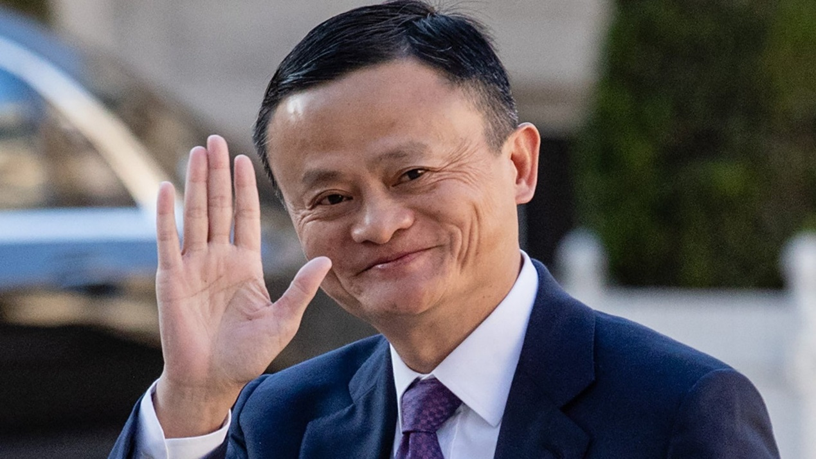
Figure 1: Jack Ma
Source: https://www.ft.com/content/4ed760ce-d38c-11e9-8367-807ebd53ab77

Jack Ma is a famous Entrepreneur in China, founder of Alibaba Group, Taobao and Alipay. On May 10, 2013, Ma stepped down as CEO of Alibaba Group, but he also held the positions of chairman of Alibaba Group, chairman of Yahoo China, dean of Alibaba Business School of Hangzhou Normal University, director of Huayi Brothers Media Group, and chairman of Cainiao Network. 2013 FT Person of the Year. This was followed by Alipay in 2003, a virtual payment platform that was the first of its kind in China. Taobao was his third major innovation, a platform that facilitated e-Commerce at no charge. In 2014 under the famous Alibaba Group IPO, Jack Ma and his team raised $21.8 billion on the New York Stock Exchange, the highest at the time (Liu and Avery, 2021). Alibaba’s success under Jack Ma has been phenomenal, not only in China, but also as the company expands to reach a global audience. In 2020, the company was worth $820.11 billion before the Chinese government halted the much-awaited IPO in the Hong Kong Stock Exchange (Macrotrends, 2021). Jack Ma’s leadership describes the possibilities that are open to individuals who believe in their power to think big and actualize those thoughts.
The VUCA environment was first described in 1987 as a response in describing the sudden change of environment and related perspectives after the fall of the USSR by the US. The acronym stands for volatility, uncertainty, complexity, and ambiguity that defines the current environment in which leaders and organizations operate (Bennet and Lemoine, 2014). Jack Ma’s journey is a clear description of changing times in China and the rest of the world with the introduction of the internet and the development of the infrastructure to compliment business and trading activity. Dynamic populations have enabled population growth through increasing birth rates and improved life expectancy in China. Growing opportunity and inequality has fostered an expansion of the global middle-class population from 6.8 billion in 2009 to 7.7 billion in 2020 (Atkinson, 2020). 66% of this population is expected to be living in Asia by 2030. Megacities have increased from 44% in 1993 to 54% in 2014 and are expected to reach 66% by 2050 (Atkinson, 2020). Increased connectedness on the internet has reduced privacy enormously, leading to the availability of big data to commercial entities (Atkinson, 2020). 21st century leadership ought to outgrow the latency of practices that are no longer viable in a complex adaptive system (CAS), where humans, objects, and technology now interact within the same system to provide complex feedback loops, thereby causing adaptation and learning (Malik and Janowska, 2018). After acknowledging Jack Ma’s leadership journey, this paper will provide a critical analysis of his leadership to establish its applicability to a VUCA environment and CAS in terms of leading innovation, sustainable outcomes, and informed decision making (Snowdon and Boone, 2007).
There are many ways in which leadership can be defined due to the complexity of the concept and its multidisciplinary application. Cyert (1990) defines leadership simply as the process through which an individual mobilizes resources ad people with the aim of achieving a set goal. Elwell and Elikofer (2015) further define leadership as the process through which an individual motivates others towards a definitive direction. So far, these two definitions acknowledge the aspects of mobilization and motivation, where one individual has the qualities required to achieve specified outcomes through others. In this case, it is necessary to differentiate between managers and leaders, noting that managers are provided with the resources (including financial, material, and human resources), which they use to work towards a specified goal while leaders are responsible for mobilizing all resources and defining the goals to be achieved. Managers are administrators, carrying out such activities as organizing, controlling, directing, and staffing, while leaders are entrusted with the visionary and entrepreneurial aspects in an organizational context.
Having defined leadership, this essay will evaluate the leadership of Jack Ma under three leadership models. The chosen models are found to be congruent with his leadership style as well as applicable to the CAS and VUCA environment in the period between 1999 and 2020, when Jack Ma officially retired from Alibaba. The first leadership model is the authentic leadership model. Authentic leaders are described on the basis of three main pillars: self-awareness, self-regulation, and ethical behaviour (Murari and Lurkherjee, 2021). Under the self-awareness pillar, authentic leaders are aware of their strengths and weaknesses, empathy levels, and how these aspects impact and influence their relationships with others. Hence, they have a high appreciation for the thoughts and language used by their subordinates. Under the self-regulation pillar, authentic leaders have a high level of resilience, emotional control, discipline, and flexibility to be patient enough to allow others express themselves constructively. This control is deliberate and active in a way (Gardner et al., 2021).
One of the strongest qualities that Jack Ma possessed as a leader in Alibaba was his self-awareness. He was aware of his background and was unashamed to retell the story even in public forums. The story about his once poor family and failure in academics has been a motivational factor to most who read about his stories online as well as those who work under him in Alibaba. Due to this background, Jack Ma is known to not despise even the simplest people as long as they can dare to dream big. In one of his famous interviews, Jack Ma narrates the story of how he gained skill and tenacity in business (Mel’s Talk, 2019). This is a story that inspires young people to embark on a self-improvement journey without anticipating that riches would be simple to access in their early stages in life.
His self-awareness acts as a guide to others under his mentorship. He shows his authentic self to his followers and is keen to acknowledge his mistakes, which indicates an acknowledgement of his strengths and weaknesses. For instance, in the World Economic Forum (2018), Jack Ma advocated for the need for people and nations in particular to learn from other people’s mistakes, which provides an aerial perspective of their situation, thereby informing on how to improve on one’s strengths. In a different interview in 2019, Jack Ma stated that it was impossible to be successful until after making 10,000 mistakes.
Ideally, the discipline in authentic leaders provides them with a keen result orientation, which allows them to place the needs of the organization above their own. For Jack Ma, leading Alibaba required a lot of sacrifice in his personal pursuits. Upon retiring, Jack Ma noted that he intended to venture into activities that were of personal interest to him such as teaching (Business Insider, 2020). Notably, before the business journey that led to founding Alibaba, Jack Ma was an English teacher, a career that he had failed thrice before qualifying as indicated in the introduction. His retirement speech meant that he had given up his teaching career for the whole period when he devoted himself to business for the benefit of the organization. This quality is proven to associate authentic leaders with committed and potent teams in the workplace (Rego et al., 2013), which alludes to executive coaching. According to Kovacs and Corrie (2017), highly unpredictable working environments require that such coaching provides support for executives to develop their capability in managing complex situations. While executives may sow a high potential for implementing change in the organization, the complexity of the changing external environment may devalue their efforts or render them inadequate to steer the organization towards success. Authentic leaders are results-oriented, which keeps them focused on the intended results for the organization. As such, executive coaching in CAS environments ought to provide executives with improved capabilities to handle cases of apparent failure and move beyond personal and external barriers (such as acknowledging the probability of failing 10,000 times and foregoing the passion for teaching) to pursue success in complex environments.

The second model of leadership is the transformational leadership model. Through charisma, charisma, intellectual stimulation and personalized care, leaders make employees realize the importance of their responsibilities and tasks, stimulate their higher needs, so that they can maximize their potential to achieve the highest level of performance. The transformational leader is articulate in their communication of a clear vision that appeals to followers. The leader has proven and reliable communication skills that enable communication of value to all within their capacities while identifying areas in which they may require empowerment in order to perform better. Managing in a CAS environment, therefore, requires that the leader provides the infrastructure, which includes organizational culture, that fosters design thinking and its implementation in the organizational context (Interaction Design Foundation, 2019; McDaniel, 2007). This is especially helpful in complex environments since employees’ morale is likely to dip occasionally due to the inability to describe change in the future and appropriate decision making to match these changes (Stacey, 2004). Their emphasis on ethical principles and standards promotes an ethical workplace in which empowerment and cooperation is made possible. Leading by example provides idealized influence, under which followers yearn to be like the leader. Intellectual stimulation is necessary to keep followers updated with the challenges that the organization is facing in the external business environment.

Jack Ma’s transformational leadership can be illustrated in his ability to articulate progressive visions for Alibaba. Using the example of the 2014 IPO, Jack Ma sought funding from an unfamiliar audience, mainly from the US, in the New York Stock Exchange. For the IPO to be successful, he needed to articulate his finance vision and communicate it in an appealing manner to the team that worked for Alibaba’s finance at the time and express his confidence in them to achieve the said vision. The target was rather high, but he remained optimistic and confident, inviting investors globally to participate in the IPO (Hu, 2020). The process of inviting investors required that he could explain his vision and ensure that the needs of all stakeholders involved were met. Another example is illustrated in the journey of the digital transformation in China from a low smartphone penetration rate in the early 2000s to the reliance on Alipay as the leading payment platform in eCommerce in the country (Hu, 2020). To secure a sustained competitive advantage, Alibaba resolved to growing into a tech conglomerate, which secured a reliable ecosystem in which the company could function profitably without the threat of unfair competition from bigger multinational companies.
The third leadership model entails adaptive leadership. Adaptive leadership focuses on the relationship between leadership and environment, that is, how leaders lead their subordinates to actively and effectively adapt to the environment around drastic changes, so as to get more efficient work. This is a new perspective for the study of leadership and is of great value to the expansion of leadership theory. For Jack Ma, this leadership is apparently lacking as indicated in his inability to link organizational change with changing stakeholder needs. For the Chinese government, Alibaba posed the threat of monopolizing eCommerce and technology through the Hong Kong IPO (Fried and Kamar, 2021). On the other hand, for Alibaba, the IPO would have opened up opportunities through which China would open up further to the rest of the world in an advantageous position in global trade. The inability of the company leadership to demonstrate the point of solution in this dilemma indicates that Jack Ma does not necessarily portray adaptive leadership. Although communication with employees is proven to be positive, his communication with external stakeholders was questionable in 2020, which led to reduced investor confidence in Alibaba, and a declining stock value since then (Macrotrends, 2021). Assessment of this failure by Alibaba and the rejection of the IPO by the Chinese government indicate the possibility of underlying assumptions that emphasize on Alibaba’s potential and contribution in the Chinese economy. Such assumptions indicate that Jack Ma possibly relied on past achievements to communicate the value of adapting to a changing business environment without counteracting negative responses, and hence poor adaptive leadership and social intelligence.

The leader acknowledged that he has made mistakes through life, realizing the impact of those mistakes on others and on his business journey. Acknowledging his mistakes in public is proof of genuineness. His acknowledgement of self-actualization as a continuous journey indicates adaptive tendencies that foster innovation and anticipation of failure along the way. The decision to operate as a tech conglomerate as in Pai and KG (2021) resulted in increased complexity in the business, hence the need for articulation in the end goal while also empowering employees through a resourceful and ethical work environment within the organization. Employee reviews at Alibaba indicate that Jack Ma was not personally involved in mentoring employees towards high performance, which would be one of the characteristics of his transformational leadership (Indeed.com, n.d.).

In conclusion, the authentic and transformational leadership models are best suited for Jack Ma in his business journey in Alibaba. His humble nature spells authenticity, which allows him to lead naturally from the heart. Sharing personal stories, for instance, is intended to inspire followers and prove that success is possible for everyone if they are willing to dream big and work towards it. His authentic leadership suits the ability to mobilize human and material resources towards a specific goal. Transformational leadership approach alludes to his ability to remain visionary and articulate this vision to the people with whom he is authentic with. In an organizational context, Jack Ma’s transformational leadership as contributed to the provision of an ethical and empowering work environment as well as working towards clear and sound goals to remain ahead of the competition, although without the required social intelligence that would convince external stakeholders that the success of the business would translate into positive outcomes for them too. Overall, his leadership approaches have enhanced success and enabled Alibaba persist and perform well through a VUCA environment while adapting CAS as a part of the company’s success.

References
Asbari, M. (2020) Is Transformational Leadership Suitable for Future Organizational Needs? International Journal of Social, Policy and Law, 1(1), pp. 51-55.
Atkinson (2020) 10 Mega Trends that are (re)shaping our world. Available a.t: https://www.ipsos.com/sites/default/files/10-Mega-Trends-That-are-Reshaping-The-World.pdf (Accessed 27 February 2022)
Bennett, N., & Lemoine, J. (2014) What VUCA really means for you. Harvard business review, 92(1/2).
Business Insider (2020) Jack Ma says goodbye to Alibaba on its 20th anniversary, as the teacher in him heads back to school. Available at: https://www.businessinsider.in/jack-ma-retires-from-alibaba-on-the-companys-20th-anniversary/articleshow/71060195.cms (Accessed 27 February 2022).
Cyert, R. M. (1990) Defining leadership and explicating the process. Nonprofit management and leadership, 1(1), pp. 29-38.
Elwell, S. M., & Elikofer, A. N. (2015) Defining leadership in a changing time. Journal of Trauma Nursing| JTN, 22(6), pp. 312-314.
Fried, J. M., & Kamar, E. (2021) Alibaba: A Case Study of Synthetic Control. Harv. Bus. L. Rev., 11, pp. 279.
Gardner, W. L., Karam, E. P., Alvesson, M., & Einola, K. (2021) Authentic leadership theory: The case for and against. The Leadership Quarterly, 32(6), pp. 101495.
Hu, L. (2020) Chinese digital and mobile platforms. In International Digital Marketing in China (pp. 31-47). Palgrave Pivot, Cham.
Indeed.com (n.d.) Alibaba Group. Available at https://www.indeed.com/cmp/Alibaba-Group/reviews?fcountry=ALL. (Accessed 27 February 2022)
Interaction Design Foundation (2019) Design Thinking. Available at: https://www.interaction-design.org/literature/topics/design-thinking (Accessed 30 January 2019).
Kovacs, L. C. & Corrie, S. (2017) Executive coaching in an era of complexity. Study 1. Does executive coaching work and if so how? A realistic evaluation. International Coaching Psychology Review. 12(2), pp. 74-89.
Liu, S., & Avery, M. (2021). Alibaba, The Inside Story Behind Jack Ma and the Creation of the World's Biggest Online Marketplace. HarperCollins Publishers Ltd.
Macrotrends (2021) Alibaba Net worth 2011 – 2021. Available at: https://www.macrotrends.net/stocks/charts/BABA/alibaba/net-worth (Accessed 27 February 2020)
Malik, R., & Janowska, A. A. (2018) Megatrends and their use in economic analyses of contemporary challenges in the world economy. Prace Naukowe Uniwersytetu Ekonomicznego we Wrocławiu, (523), pp. 209-220.
McDaniel, R. R. (2007) Management Strategies for Complex Adaptive Systems. Performance Improvement Quarterly, 20(2), pp. 21-42.
Mel’s talk. (2019) Jack Ma: You will be successful if you make mistakes. Available at https://www.youtube.com/watch?v=6lkgMmdW9Aw (Accessed 27 February 2022)
Murari, K., & Mukherjee, U. (2021) Role of authentic transformational leadership for managerial excellence and sustainability. Ilkogretim Online, 20(4), pp. 2592-2605.
Pai, Y., & KG, N. K. (2021) E-Commerce to Multinational Conglomerate: Journey of Alibaba Group–A Case Study. International Journal of Case Studies in Business, IT and Education (IJCSBE), 5(1), pp. 25-35.
Ramalingam, B., Nabarro, D., Oqubuy, A., Carnall, D., & Wild, L. (2020) Principles to guide adaptive leadership. Harvard Business Review.
Rego, A., Vitória, A., Magalhães, A., Ribeiro, N., & e Cunha, M. P. (2013) Are authentic leaders associated with more virtuous, committed and potent teams? The Leadership Quarterly, 24(1), pp. 61-79.
Snowdon, D. J. & Boone, M. J. (2007) A Leader's Framework for Decision Making. Harvard Business Review, November.
Stacey, R. D. (2004) Strategic Management and Organisational Dynamics: The Challenge of Complexity. 4 ed. Harlow: Pearson Education Limited.
World Economic Forum. (2018) Jack Ma: “Learn from the mistakes of other people.” Available at https://www.youtube.com/watch?v=6lkgMmdW9Aw (Accessed 27 February 2022)

