A REPORT ON GREEN PRACTICE IMPLEMENTATION AT THE SAVOY HOTEL

Student Name: Gheorghe Plescan
Student Number: 2234901
Module Title and Code: BMIH5006 Sustainable Hospitality & Tourism Management
Lecturer’s Name: Lisa-Marie Bassler, Giulia Chifari, Lisa Knight

Contents

1. Executive Summary 2
2. Introduction 3
3. Main Findings 4
3.1 Green Practice Initiative: Zero-Waste Operations 4
3.2 Benefits of Integrating Sustainability into Operations 5
3.3 Challenges of Implementing Zero-Waste Operations 5
3.4 Case Comparisons 6
3.5 Economic and Environmental Impact 6
3.6 Feasibility and Realism 7
3.7 Legislation Impact 7
4. Conclusion 9
5. Recommendations 9
6. References 11

Executive Summary

This report explores the implementation of a zero-waste initiative at The Savoy Hotel, a renowned luxury hotel in London, to enhance its sustainability profile. Zero-waste operations are increasingly popular in the hospitality industry as hotels seek to reduce their environmental impact while maintaining operational efficiency. The report begins with an introduction to greener practices, defining their role in sustainable hospitality, followed by a detailed examination of the potential benefits and challenges of adopting a zero-waste policy at The Savoy. Comparative analysis with similar initiatives in other luxury hotels helps demonstrate the feasibility of such a program. The report further explores the financial, environmental, and operational impact of adopting a zero-waste strategy, concluding with a set of recommendations for ensuring its successful implementation. By adopting this initiative, The Savoy can continue to lead the way in sustainable hospitality, addressing current environmental concerns while preparing for future market demands.

Introduction

As sustainability becomes a key focus in the global hospitality sector, hotels are increasingly adopting greener practices to minimise their environmental impact. These practices include strategies such as energy conservation, water management, waste reduction, and the use of sustainable materials, all aimed at reducing harm to the environment (Haski-Leventhal, 2018). The Savoy Hotel in London, part of the Fairmont Hotels & Resorts group, is renowned for its luxury services and strong commitment to corporate social responsibility (CSR). While the hotel has already made significant progress in environmental sustainability, further improvements are possible through the implementation of a comprehensive zero-waste initiative. This report explores the feasibility of such a program, considering its potential benefits, challenges, and overall impact on the hotel's operations and reputation within the industry.

Main Findings

3.1 Green Practice Initiative: Zero-Waste Operations
Zero-waste operations aim to reduce the amount of waste sent to landfills to the bare minimum, with an overall goal of recycling, reusing, or composting 90-100% of all waste generated. This initiative requires a holistic approach to waste management, addressing waste generation at every level of the hotel's operations, from food and beverage services to housekeeping and guest services (Korstanje, George, and Nedelea, 2020). The Savoy could expand its existing waste management practices by introducing more rigorous recycling processes, implementing on-site composting systems, and establishing partnerships with local suppliers to ensure that all products and materials used in the hotel are either recyclable or reusable.
Figure: Circular Economy
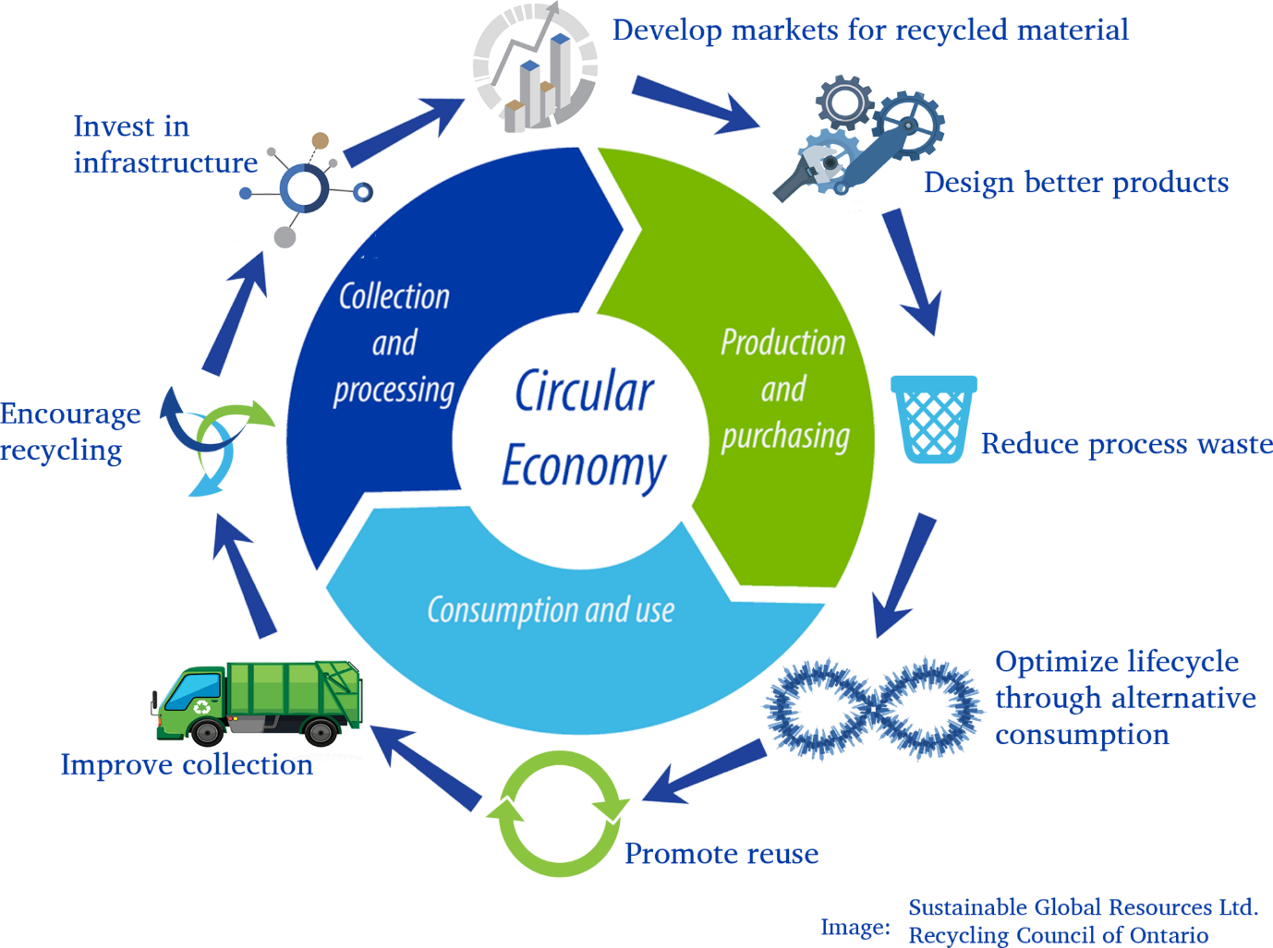
(VWRM, 2024).

Several other luxury hotels, such as the Ritz-Carlton and Hilton, have implemented zero-waste initiatives with remarkable success. The Ritz-Carlton, for example, reduced its waste output by composting organic waste, recycling all paper and plastic, and donating surplus food to local charities (Batabyal, 2018). The Savoy can draw inspiration from these case studies to design a zero-waste program that aligns with its high-end services while meeting sustainability goals.

3.2 Benefits of Integrating Sustainability into Operations
One of the key benefits of implementing a zero-waste initiative at The Savoy is the significant reduction in the hotel’s environmental footprint. Diverting waste from landfills and incineration, The Savoy would be contributing to a circular economy, where resources are reused rather than discarded. This aligns with global sustainability goals aimed at reducing greenhouse gas emissions and conserving natural resources (Costa and Costa, 2022). Additionally, the hotel could further enhance its brand image by promoting itself as a leader in sustainable hospitality, appealing to an increasingly eco-conscious customer base (Edgell, 2020).
Operational efficiency is another benefit of zero-waste operations. Streamlining waste disposal processes, The Savoy can reduce costs associated with waste management and disposal. Reusing and recycling materials can also lower procurement costs, allowing the hotel to reinvest in other sustainability initiatives, such as energy efficiency or water conservation measures (Wickham, Donnelly, and French, 2021). Over time, these cost savings can offset the initial investment required to implement the zero-waste program, making it both financially and environmentally viable.

3.3 Challenges of Implementing Zero-Waste Operations
Despite the numerous benefits, implementing a zero-waste initiative at The Savoy presents several challenges. One of the most significant barriers is the financial cost associated with upgrading waste management systems. Installing on-site composting equipment, redesigning waste disposal processes, and sourcing recyclable or biodegradable products can require substantial upfront investment (Aparcana, 2017). Moreover, the hotel will need to invest in staff training to ensure that employees understand and adhere to the new waste management protocols. Another challenge is maintaining the high standard of luxury that guests expect while transitioning to more sustainable operations. For example, sourcing eco-friendly or recyclable products that meet the quality standards of a five-star hotel may be difficult, as sustainable alternatives are often more expensive and may not always align with the hotel’s aesthetic (Das et al., 2019). Additionally, guest participation is crucial for the success of a zero-waste program. Educating guests on how to minimise waste during their stay, such as by reducing single-use plastics or opting for reusable towels, may be met with resistance, particularly among high-end clientele accustomed to convenience and luxury.

3.4 Case Comparisons
Several luxury hotels have successfully integrated zero-waste operations into their business models, providing valuable lessons for The Savoy. The Ritz-Carlton has been a pioneer in sustainability, implementing comprehensive recycling and composting programs that have dramatically reduced waste output. The hotel’s efforts to donate surplus food to local charities have also earned it widespread recognition as a socially responsible business (Gonçalves et al., 2023). Similarly, Hilton has introduced a “Green Stay” program that encourages guests to participate in the hotel’s sustainability efforts by reusing towels, minimising water consumption, and reducing waste (Bierwagen and Gonçalves-Dias, 2021). These initiatives demonstrate that zero-waste programs can be successfully implemented in the luxury hotel sector without compromising on service quality. Adopting similar practices, The Savoy could achieve comparable success. The hotel’s reputation for excellence, combined with its commitment to CSR, makes it well-positioned to implement a zero-waste initiative that meets both its operational needs and its sustainability goals.

3.5 Economic and Environmental Impact
The environmental benefits of a zero-waste initiative are extensive. Reducing the amount of waste sent to landfills, The Savoy would contribute to lowering greenhouse gas emissions, which are a significant driver of climate change (Patel et al., 2021). Additionally, the hotel would reduce its reliance on finite resources by promoting a circular economy, where materials are reused rather than discarded. This aligns with broader global efforts to reduce resource consumption and limit environmental degradation (Wang, Yang and Wang, 2022). From an economic perspective, the zero-waste initiative could lead to substantial cost savings over time. Although the initial investment in new waste management systems may be considerable, the long-term benefits, including reduced waste disposal costs and potential recycling revenue, could offset these expenses (Wickham, Donnelly, and French, 2021). Moreover, the hotel could market itself as a leader in sustainability, attracting a growing segment of eco-conscious travellers who are willing to pay a premium for environmentally responsible services (Munir, 2022).

3.6 Feasibility and Realism
Implementing a zero-waste initiative at The Savoy is both feasible and realistic, provided that the hotel adopts a phased approach. The hotel could start by focusing on reducing food waste, which accounts for a significant portion of the hospitality sector's environmental impact (Priefer, Jörissen and Bräutigam, 2016).
Investing in composting systems and partnering with local businesses to repurpose organic waste, The Savoy can make immediate progress towards its zero-waste goals. Over time, the hotel can expand its efforts to include more comprehensive recycling programs and the use of sustainable materials. The growing demand for sustainable tourism further supports the feasibility of this initiative. As more consumers prioritise sustainability in their travel decisions, hotels that adopt greener practices are likely to experience increased customer loyalty and enhanced brand reputation (Amicarelli and Bux, 2021). The Savoy’s established reputation as a luxury hotel makes it an ideal candidate for a zero-waste initiative that can attract both traditional luxury travellers and eco-conscious consumers.

3.7 Legislation Impact
In the UK, businesses are subject to strict environmental regulations that mandate responsible waste management practices. The Climate Change Act 2008 and the Waste Regulations 2011, for example, require businesses to reduce their carbon emissions and manage waste responsibly (Kasavan et al., 2022).
Adopting a zero-waste initiative, The Savoy would not only comply with these regulations but also exceed them, positioning itself as a leader in sustainable hospitality. Additionally, The Savoy could pursue certification under international sustainability schemes such as Green Key or EarthCheck, which provide third-party validation of a hotel’s environmental performance (Vizzoto, Testa and Iraldo, 2021). Achieving such certification would further enhance the hotel’s reputation and attract eco-conscious customers who seek out environmentally responsible businesses.
Figure: Green Certification

(iStock, 2024).

Conclusion

The implementation of a zero-waste initiative at The Savoy Hotel offers a valuable opportunity to enhance its sustainability efforts while preserving its status as a leader in luxury hospitality. By reducing waste, fostering a circular economy, and supporting global sustainability objectives, the hotel can substantially lower its environmental impact. Additionally, the financial advantages of long-term cost savings, alongside the rising demand for eco-friendly tourism, make this initiative both environmentally and economically beneficial. Despite challenges such as initial financial costs and engaging guests in the process, these obstacles can be addressed through a phased approach, comprehensive staff training, and guest education. Ultimately, the zero-waste initiative aligns with The Savoy's CSR goals and provides a proactive strategy for securing long-term sustainability.

Recommendations

1. Expand Recycling and Composting Programs: The Savoy should focus on increasing its recycling and composting capacity by investing in on-site composting systems and collaborating with local farms to repurpose organic waste.
2. Collaborate with Local Suppliers: The hotel can work with local businesses to source sustainable and recyclable products, ensuring that all materials used in its operations can be reused or recycled.
3. Achieve Green Certification: Pursuing certification under schemes such as Green Key or EarthCheck would provide external validation of The Savoy’s sustainability efforts and further enhance its reputation as an industry leader.
4. Invest in Staff Training and Guest Education: Comprehensive staff training and clear guest communication are essential for the success of a zero-waste initiative. The hotel should implement training programs and provide guidance to guests on how to minimise waste during their stay.
5. Monitor and Report Progress: The Savoy should regularly monitor its waste reduction efforts and report progress to stakeholders. Transparent reporting will help ensure continued success and provide valuable data for future sustainability initiatives.

References

Amicarelli, V. and Bux, C. (2021) 'Food waste measurement toward a fair, healthy, and environmental-friendly food system: a critical review', British Food Journal, 123(8), pp. 2907-2935. doi: 10.1108/BFJ-07-2020-0658.
Aparcana, S. (2017) 'Approaches to formalization of the informal waste sector into municipal solid waste management systems in low-and middle-income countries: review of barriers and success factors', Waste Management, 61, pp. 593-607. doi: 10.1016/j.wasman.2016.12.028.
Batabyal, D. (2018) Managing sustainable tourism resources. Hershey, PA, United States: IGI Global.
Bierwagen, M.Y. and Gonçalves-Dias, S.L.F. (2021) Food rescue and donation in socioenvironmental policies on tackling food loss and waste: a systematic review, doi: 10.17170/kobra-202110144896.
Cooper, C. (2021) Essentials of tourism. 3rd edn. London, United Kingdom: SAGE.
Costa, C. and Costa, C. (Eds.) (2022) Sustainability and competitiveness in the hospitality industry. Hershey, PA, United States: Business Science Reference.
Das, S., Lee, S.H., Kumar, P., Kim, K.H., Lee, S.S. and Bhattacharya, S.S. (2019) 'Solid waste management: scope and the challenge of sustainability', *Journal of Cleaner Production*, 228, pp. 658-678. doi: 10.1007/s10163-016-0509-9.
Edgell, D.L. (2020) Managing sustainable tourism: a legacy for the future. 3rd edn. New York, United States: Routledge.
Gonçalves, C., Saraiva, S., Nunes, F. and Saraiva, C. (2023) 'Food waste in public food service sector—surplus and leftovers', Resources, 12(10), p. 120. doi: 10.3390/resources12100120.
Haski-Leventhal, D. (2018) Strategic corporate social responsibility: tools & theories for responsible management. London, United Kingdom: SAGE.
Inkson, C. and Minnaert, L. (2018) Tourism management: an introduction. 2nd edn. London, United Kingdom: SAGE.
iStock (2024) Green certificate icon. Available at: https://www.istockphoto.com/illustrations/green-certificate-icon (Accessed: 15 October 2024).
Jauhari, V. (2021) Managing sustainability in the hospitality and tourism industry: paradigms and directions for the future. 9th edn. Oakville, Canada: Apple Academic Press, Inc.
Kasavan, S., Siron, R., Yusoff, S. and Fakri, M.F.R. (2022) 'Drivers of food waste generation and best practice towards sustainable food waste management in the hotel sector: a systematic review', Environmental Science and Pollution Research, 29(32), pp. 48152-48167. doi: 10.1300/J149v08n02.
Korstanje, G.B. and Nedelea, A. (2020) Strategies for promoting sustainable hospitality and tourism services. Hershey, PA, United States: IGI Global.
Munir, K. (2022) 'Sustainable food waste management strategies by applying practice theory in hospitality and food services: a systematic literature review', Journal of Cleaner Production, 331, p. 129991. doi: 10.1016/j.jclepro.2021.129991.
Patel, S., Dora, M., Hahladakis, J.N. and Iacovidou, E. (2021) 'Opportunities, challenges and trade-offs with decreasing avoidable food waste in the UK', Waste Management & Research, 39(3), pp. 473-488. doi: 10.1177/0734242X20983.
Priefer, C., Jörissen, J. and Bräutigam, K.R. (2016) 'Food waste prevention in Europe–A cause-driven approach to identify the most relevant leverage points for action', Resources, Conservation and Recycling, 109, pp. 155-165. doi: 10.1016/j.resconrec.2016.03.004.
Sloan, P., Legrand, W. and Chen, J.S. (2017) Sustainability in the hospitality industry: principles of sustainable operations. 3rd edn. London, United Kingdom: Butterworth-Heinemann.
V, F., Testa, F. and Iraldo, F. (2021) 'Strategies to reduce food waste in the foodservices sector: a systematic review', International Journal of Hospitality Management, 95, p. 102933. doi: 10.1016/j.ijhm.2021.102933.
VWRM (2024) Circular economy. Available at: https://www.vwrm.com/education-outreach/circular-economy/ (Accessed: 15 October 2024).
Wang, L., Yang, Y. and Wang, G. (2022) 'The clean your plate campaign: resisting table food waste in an unstable world', Sustainability, 14(8), p. 4699. doi: 10.3390/su14084699.
Wickham, D., Donnelly, T. and French, L. (2021) 'Strategic sustainability management in the event sector', Event Management, 25(3), pp. 279–296.

