Student name: Alexandra Elisaveta Strajeriu

Student id. : 2214913

Module Title: Management Economics

Module Code: LCBB5008
Lecturer: Riaz Bhatti

Management Economics – Study case essay

Table of Contents
Introduction 3
Main body 4
Conclusion 12
References 13

Introduction
Management economics is considered the utilisation of diverse economic theories along with the principles for making an effective decision or the allocation of resources. It helps in providing an effective mentorship in effective decision-making in contrast to organisations, customers suppliers and many more. The study will focus on the diverse problem in the context of the United Kingdom that has led to the impact on lives along with the economics of the country. The law for supply and demand along with the difference between elasticity and inelasticity in the context of fuel will be discussed in the study.

Main body
1a. Fundamental economic problems identified in the case study
The diverse fundamentals problem has disrupted the lives of the people in the United Kingdom and also hampered the economy of the country. Some of the major fundamental economic problems that have been identified in the provided case study are as follows;
The outbreak of the COVID-19 pandemic has led to an impact on the global economy and influenced diverse fundamental economic challenges and problems (World Bank Group, 2022). One of the prominent factors that has been evolved by the pandemic are rules and regulations for operating the business. It has led to stringent health along with the regulation of safety and results at the diverse businesses in the environment for adopting swiftly towards the remote working model, protocol and diverse contactless transaction. Such rapid changes in the approaches of the business environment have resulted in making huge investments in diverse technology along with infrastructure and led to the influence of financial strain towards the businesses and resulted in the reduction of revenue.
The pandemic has also led to a huge impact on the supply and demand of diverse resources. It has influenced a shortage of diverse supplies or resources due to the lack of drivers for transportation. In addition, many drivers from the European Union have left the United Kingdom for the implantation of lockdown along with diverse policies along with the exacerbation of Brexit (Gupta et al., 2023). Such factors have further resulted in a huge impact on the environment of the labour market. It has created a huge gap in the diverse logistics sectors and hampered the chain of supply. In addition, the lack of drivers for the approaches of transportation has led to the effective delivery of diverse goods such as fuels and many more in a timely manner and influenced the shortage of goods and supply in the UK.
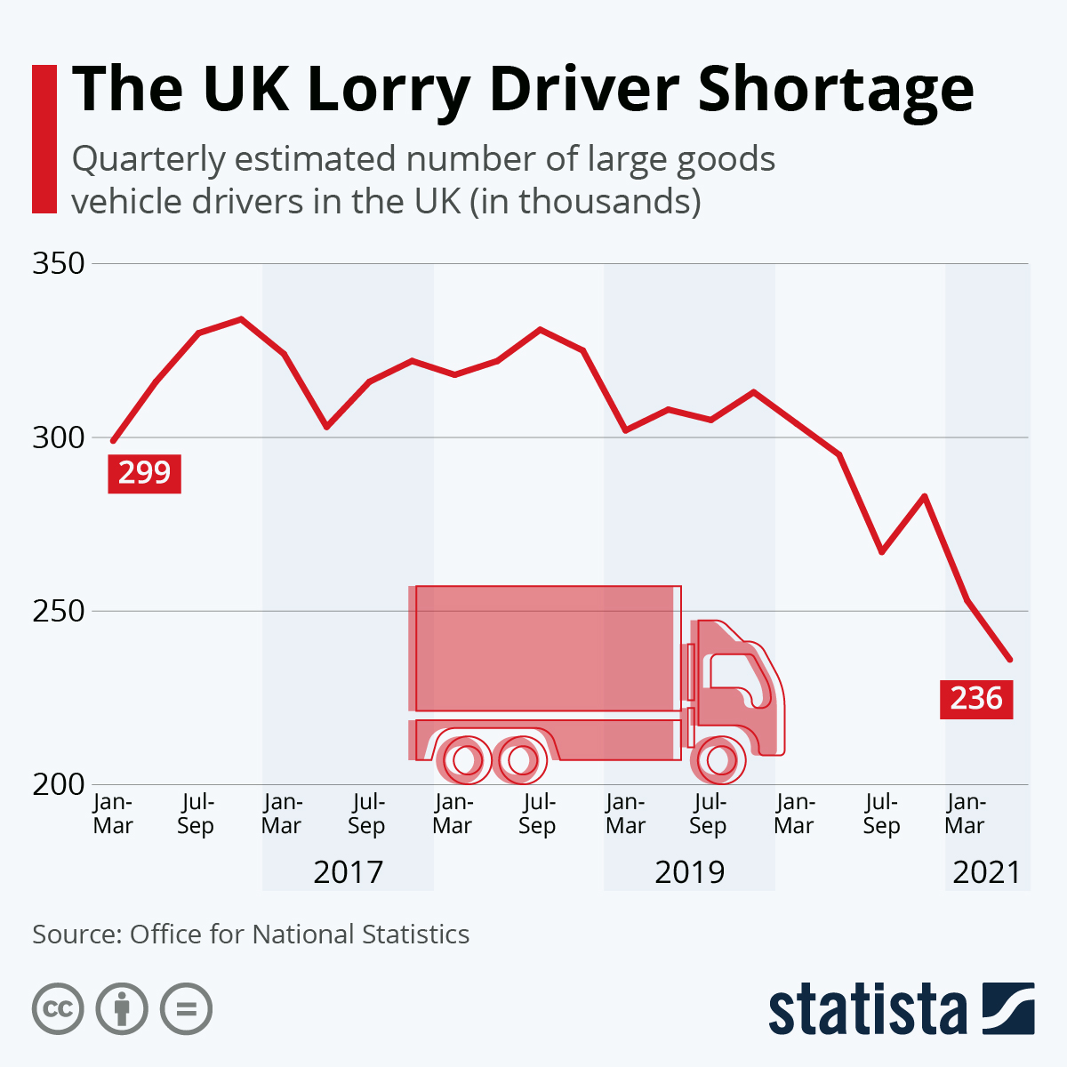
(Fig 01: Graph for the shortage of drivers in the UK)
Source: (Armstrong, 2021)
The evolution of the supply chain by Brexit has influenced the barriers to the approaches of trade and the changes in the laws and policies have made the approach for export and import of goods more costly. Such factors have created huge delays in timely delivery and even impact more on the supply chain. In addition, the impact of both Brexit along the COVID-19 pandemic has influenced the vulnerabilities in the global supply chain and resulted in uncertainty for the prolonged time frame.
Similarly, Panic buying of scarce resources, especially fuel has even exacerbated the shortage of supply (Wu et al., 2023). Furthermore, reports by diverse media on the shortage of drivers and the disruption on the hamper of the supply chain have influenced the consumer or the people to rush in purchasing and fill the tanks. Such a factor has created an artificial surge in demand. In addition, such panic buying has resulted in a huge shortage of fuels and some regions have encountered fuel reduction from 43% to 20%. Furthermore, the panic purchasing behaviours of the people have not only reduced the supply but also fostered fear among people.
In addition, the Rocketed price change in the cost of fuel has put new pressure on the economy. The lack of supply and the rise in the demand in the environment have uplifted the prices to a higher level. The hikes in the prices have resulted in a major impact on the diverse or overall cost of the services and goods and influence the business operations cost and the living cost. The increase in the cost of fuels hampers the logistics and the transportation approaches and leads to the influence of huge stress on the economy
1(b). Various ways in which these economic problems can be resolved.-
Resolving the diverse challenges and issues that are influenced by Brexit and COVID-19 pandemics requires an effective and multifaceted approach by government intervention, adjustment in the strategies along with fostering diverse supply chain management. Some of the diverse approaches that aid in effectively resolving the issues are as follows;
Government Intervention
Government Intervention acts as the major factor in fostering or stabilising the economy of the country. In addition, one of the major approaches for addressing the issues is through effective regulation along with financial support. The government of the United Kingdom can implement diverse policies along with effective aid to businesses that are facing the huge challenges caused by the increased cost of operation. Effective grants along with subsidies can aid in offsetting the cost for funds of clients and effectively help in adopting the diverse health regulations along with the rising prices for fuel. For instance, effective targeted support of finance for all SMEs aids in preventing losses of jobs and bankruptcies along with retaining the stability of economics.
In addition, the policies for immigration also have to be improved. The lack of drivers influenced by COVID-19 and Brexit has illustrated the approaches for analysing effective approaches for the entry of essential workers. Streamlining the diverse visa approaches for the drivers of foreign countries along with the other workers aids in filling the gaps. In addition, enhancing the diverse governmental agencies allows for managing the diverse policies. Government agencies have to focus on improving effective communication along with the engagement of business. The clear guidance along with the regular updates aid the business in navigating the diverse tangibility of schemes and regulations. Engaging with diverse businesses understanding all the challenges along tailoring the solution helps foster a resilient environment. In addition, adjusting the diverse policies also delivers major relief to the business. The reduction of temporary tax for the impacted business can help in fostering cash flow which will allow them to invest effectively.
Relaxing Stringent Covid-19 Rules
The influence of the rate of vaccination has led to a reduction in the threat or the challenges of COVID-19. Such factors have also reduced the stress for the business and the diverse health organisation. The diverse factors such as social distancing impact the limits of the workplace and lead the business to operate to its full potential. Such factors have to be maintained cautiously on the basis of scientific data for preventing such viruses in future.
Developing Shortage Management Strategies
Establishing an effective and dedicated management team aids in monitoring along responding to the diverse disruptions of the supply chain. Maintaining an effective strategy in anticipating the shortage along with managing the inventories helps in fostering the allocation of diverse goods effectively in a timely manner. For instance, making an effective national approach of reserves for diverse and essential goods such as medical supplies and flukes can help in buffering the issues of sudden upliftment on demand.
Influencing Supplier Collaboration Networks
By fostering the supplier collaboration network and as the major factor in maintaining an effective and robust chain of supply. In addition, businesses in the United Kingdom can focus on maintaining strong relationships with diverse suppliers leading to the influence in transparency and the corporation. Effective forecasting along with planning will aid the organisation in effectively aligning with the diverse schedule of production along with inventory management and aid in addressing the shortage of goods and services. Diversifying the basis of suppliers also acts as a core factor in mitigating the diverse risks that are associated with dependency on a single source.
Data and Case Studies
The information and data of institutions for the government highlighted how the intervention of government sources to adjust the financial support helped in maintaining the economic impact of COVID-19. For instance, the furlough scheme implemented by the government of the United Kingdom has provided effective aid for millions of people to maintain their jobs in order to prevent the risk of unemployment during the pandemic (Powell, Francis-Devine and Clark, 2024).
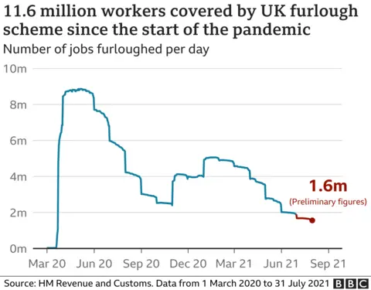
(Fig 02: Graph on the jobs saved by the Furlough scheme)
Source: (Plummer, 2020)

In the context of the importance of immigration rules for the response to the driver shortage, the government of the United Kingdom has issued diverse temporary visas to the drivers of foreign countries which will help in alleviating the issues. The intervention by the UK government has underscored the flexibility of policies for immigration in resolving issues of labour shortage
2 (a). Relevance of demand and supply in the case study
The hypothesis of the demand and supply act as the major approaches to understanding the diverse economic challenges along with the potential outcomes in the case study. The relevance of the demand and supply are multifaceted, competition, marketing, worker retention, pricing strategy and many more.
Competition and Pricing
The competition in the market is a crucial factor in driving the prices. In the context of a competitive market, all businesses and organisations are seeking to offer or provide with the best prices on the product to attract lots of customers. Effective management of the chain of supply also ensures that the organisation can retain competitive approaches to pricing in a situation of crisis. In addition, Amazon which is considered one of the largest e-commerce organisations in the world utilised an effective and sophisticated supply chain for maintaining low prices on the services and products to enhance competitive advantages (Osadiya, 2023). By aligning with the scale of economics along with the effective logistics the organisation was able to offer the prices on an effective price range for all the demand.
Pricing Strategy
The approach of demand and supply is intrinsically leveraged by the strategy of pricing. In the context of the Pandemic, the huge influence on the demand for certain goods and services has led to a supply shortage and resulted in an increase in the price of the product, especially fuel. Analysing the factors the business has to focus on establishing an effective pricing strategy for managing all the special by utilising dynamic models of pricing that help in existing the price according to the supply implementation conditions. For instance, the price of the fuel has Skyrocketed by the limited supply and huge demand. Such factors have highlighted the effective needs of the business for adopting flexible and effective rising strategies for stabilising or maintaining the market.
Marketing Strategy
The data on the demand and supply is a core factor for maintaining effective marketing approaches. Effectively analysing all the trends of the market along with tailoring with the efforts for promoting the products which are in demand on the market can lead to leverage in the effective operation of the firm. Such an approach will not only uplift the sales of the firm but also act as a major factor in optimising the spending marketing approaches. In addition, during the COVID-19 and thermic the diverse organisation that focuses on providing an effective marketing approach to the essential needs of home products along with remote work products has led to the influence on the revenue.
Worker Retention and Satisfaction
High or increase in the demand for the product and services act as a major factor in delivering an effective opportunity to provide competitive benefits and salaries towards the employees and leads to leverage in satisfaction and retention. During the Covid 19 pandemic, the diverse companies with high demand such as health care along with e-commerce have influenced the salaries along with the benefits for maintaining all their employees and operating the businesses effectively. Such approaches have led to the influence on the satisfaction of employees and also highlighted a stable workforce for meeting the demand of the market.
2(b) Difference between elasticity and inelasticity of demand with reference to price changes in the cost of fuel
The elasticity of demand is referred to as the approach to how responsive quantity demanded of the diverse products and goods changes the process (Andreyeva et al., 2010). In addition, when the demand for the product is elastic the fraction of changes in prices leads to major changes in the quantity of demand. For instance, if the prices for the fuel increase the consumer focuses on diminishing the consumption or going towards the other alternative sources. Such factors or the demand for the fuel is defined as elastic.
Advantages of Elastic Demand
If the demand for the product is elastic and reduces the price of the products the people or the customers focus on reducing the sending or purchasing to save money.
Disadvantages of Elastic Demand
The Fuel suppliers have to experience unstable streams of revenue and lead or hamper the sales of the fuel.
In addition, Inelasticity of demand usually happens when the quantity of demand is relatively insensitive to the changes in prices. For instance, if the prices for fuel increase the people or the customer focuses on purchasing the exact amount of fuel and keeping it for future use for the purpose of transportation and many other important approaches.
Advantages of Inelastic Demand
The supplier of the fuel takes the benefit due to the stable revenue the rise in the price does not impact the sales of the fuel
Cons of Inelastic Demand
The customers have to face the huge burden of the hamper on the prices because they have to purchase fuel for their daily activities regardless of any factors
2c. The laws of supply and demand
Increase Demand
When the consumers or the people's demand for the product and services increases and supply remains firm or constant the prices for the product increase by the influence of the competition among the diverse buyers (Taylor, 2021). Increasing the price influences the opportunity for profitability for the sealers and focuses on increasing production and supply. The law of increased demand focuses on demonstrating the response of market dynamics to the change or shift in the interest of customers.
Decrease Demand
When demand for a certain product or service decreases but the supply for the product remains unchanged the sellers have to focus on reducing the prices of the product to encourage the customers to purchase. Such a factor leads to the impact on the seller who has to face a huge reduction in profitability due the diminished production. The approach or the factor leads to the diminishment in the availability of the quantities and is referred to as the scenario towards the favour of the customers.
Increase Supply
In addition, when the supply of a certain product increases, the demand for that product remains the same. The market or the supplier has to experience the oversupply (Taylor, 2021). The sellers have to lower the price to attract and encourage the buyers for the customer to purchase the product. The change in the availability of the product results in the increase in the sale of quantity and leads to the major benefit for the consumer.
Decrease Supply
When the supply of the services decreases and the demand for those products remains constant such a factor or that shortage influences the market and leads to a huge increase in the price of those products (Taylor, 2021). The diverse customer has to compete to get the product due to the limited supply. The reduction in the supply of the product leads to a reduction in the availability of the goods and benefits the seller.

Conclusion
The study has focused on the diverse fundamentals that have led to the influence of the major challenges and issues on the economy along with the people of the United Kingdom. The approaches such as fostering the supplier collaboration network and as the major factor in maintaining an effective and robust chain of supply. In addition, businesses in the United Kingdom can focus on maintaining strong relationships with diverse suppliers leading to the influence of transparency and the corporation has been discussed in the study. In addition, the law of demand and supply has also been illustrated briefly in the study.

References
Andreyeva, T., Long, M. and Brownell, K. (2010) The Impact of Food Prices on Consumption: A Systematic Review of Research on the Price Elasticity of Demand for Food. American Journal of Public Health, 100, 2, 216-222.
‌Armstrong, M. (2021). Infographic: The UK Lorry Driver Shortage. [online] Statista Daily Data. Available at: https://www.statista.com/chart/25846/uk-lgv-hgv-lorry-truck-drivers/ [Accessed 19 Jul. 2024].
‌Gupta, R., Md. Mahadi Hasan, Syed Zahurul Islam, Yasmin, T. and Uddin, J. (2023). Evaluating the Brexit and COVID-19’s influence on the UK economy: A data analysis. PloS one, [online] 18(6), pp.e0287342–e0287342. doi:https://doi.org/10.1371/journal.pone.0287342.
Osadiya T. (2023), Introduction to Economics. Amazon
‌Plummer, R. (2020). Covid: What impact has the furlough scheme had? [online] Bbc.com. Available at: https://www.bbc.com/news/business-54601117 [Accessed 19 Jul. 2024].
Powell, A., Francis-Devine, B. and Clark, H. (2024). Coronavirus Job Retention Scheme: statistics. [online] House of Commons Library. Available at: https://commonslibrary.parliament.uk/research-briefings/cbp-9152/#:~:text=The%20Coronavirus%20Job%20Retention%20Scheme%20applied%20from%201%20March%202020,to%2080%25%20of%20their%20wages. [Accessed 19 Jul. 2024].
Taylor, R. (2021). What is Supply and Demand? - Fleximize. [online] Fleximize. Available at: https://fleximize.com/articles/002211/what-is-supply-and-demand [Accessed 19 Jul. 2024].
‌World Bank Group (2022). Chapter 1. The economic impacts of the COVID-19 crisis. [online] World Bank. Available at: https://www.worldbank.org/en/publication/wdr2022/brief/chapter-1-introduction-the-economic-impacts-of-the-covid-19-crisis#:~:text=The%20COVID%2D19%20pandemic%20sent,inequality%20within%20and%20across%20countries. [Accessed 19 Jul. 2024].
Wu, S., Shen, Y., Geng, Y. and Xi, L. (2023). Consumer Panic Buying Behavior and Supply Distribution Strategy in a Multiregional Network after a Sudden... [online] ResearchGate. Available at: https://www.researchgate.net/publication/368703606_Consumer_Panic_Buying_Behavior_and_Supply_Distribution_Strategy_in_a_Multiregional_Network_after_a_Sudden_Disaster [Accessed 19 Jul. 2024].

