Marketing Information Systems
Assignment 2
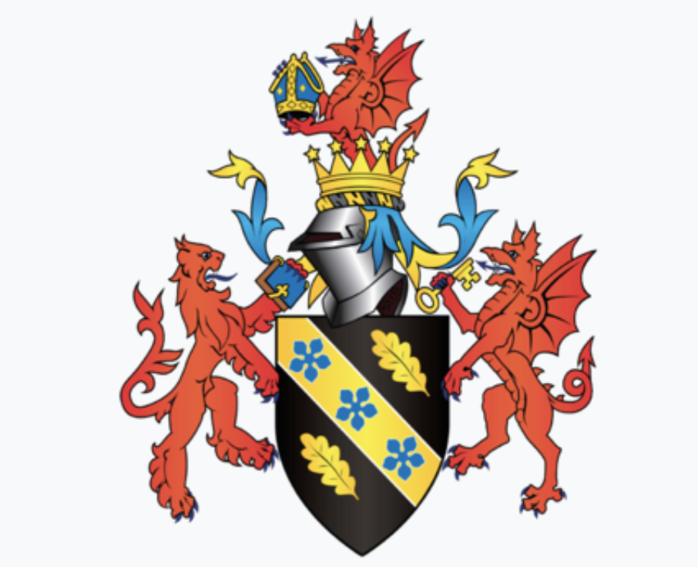January 2019
Marketing Information Systems
Nia James
1705762

Contents

- Executive summary
- Introduction
  - Report remit
  - Introduction that covers the process of how clients and agencies ensure they do relevant and appropriate marketing research.
  - Includes a section on the benefits and drawbacks of doing, and not doing, market research.
  - Includes a variety of ways in which marketing research can be undertaken for NomNom Chocolate to investigate what the agency perceives to be the issues the company require answers for in and around the marketplace.
  - Conclusion
- References

- Executive summary

The purpose of this report is to provide advice for NomNom Chocolate on whether or not they are in need of an agency to do their marketing research for them, why, how, and the benefits it will bring them or drawbacks it will do to their business.
NomNom Chocolate is a small organisation that sells different flavours of chocolate online only. They are based in Wales but sell their produce in and around the United Kingdom. They don’t have a marketing department so when a problem occurs in that sector, they have to make big decisions themselves, this is why they are considering getting in touch with an agency to do their research for them.
I am a Marketing Research Executive for a Marketing Research Agency. I have to do marketing research for NomNom Chocolate. I am approaching them because they’re not sure if they require the service of a Marketing Research Agency. In this report I inform their management team exactly what I can do for them and if they do or don’t need an agency and why.

- Introduction
This reports purpose is to be a Marketing Research Executive for a Marketing Research Agency who want to be employed by NomNom Chocolate to do their marketing research for them. NomNom Chocolate was the chosen organisation as they are a small business who are unsure of if they need the service of a marketing research agency. A Marketing Research Executive is someone who is responsible for planning, coordinating, and administrating market research projects. They are there to collect and analyse consumer information or issues (Wilson, 2012). NomNom Chocolate is an organisation set up by Liam Burges in 2011 when he was only 18 years old. His produce consists of bars of chocolate with 30 exciting flavours including local produce Welsh ingredients such as freshly grown chilli in Wales (NomNom Chocolate website, 2018). NomNom is a very small organisation so they are extremely unsure of whether they need assistance from a Marketing Research Executive or not. Therefore, this report will give NomNom all the advice they need, followed by a conclusion of whether they need this process or not.

  - Report remit
This report will begin with an introduction on the process of how clients and agencies make sure they do relevant and appropriate marketing research. It will provide a section on the benefits and drawbacks of doing and not doing marketing research. Finally, it will provide a numerous amount of ways in which marketing research can be undertaken for NomNom Chocolate to investigate what the agency believes the outstanding issues for the company are, and any answers for in and around the marketplace. This should result in the organisation receiving answers that they require from the agency.
  - The process of how clients and agencies ensure they do relevant and appropriate marketing research

Brace (2013) defines marketing research as ‘the collection and analysis of information about consumers, competitors, and the effectiveness of marketing programmes’. Marketing research is the way organisations get answers to what their targeted customers want, need, and expect. This is key because, without this, organisations will fail due to no one wanting their product or service.
Agencies follow a proposal structure given by the organisation during a briefing. The proposal structure is the contract between the agency and the client company, this is to ensure that the agency knows and fully understands exactly what their client wants from them. The structure consists of a background of the organisation, their objectives, approach and method, reporting and presentation procedures, timing, fees, personal CV’s, related experience and references, and contact details. These are all included in the process of how clients and agencies make sure they do relevant and appropriate marketing research as this is the chance for the client to share everything they want and the agency to ask as many questions as possible to make sure they are one hundred percent satisfied with that they need to do (Pfeffer, 2007).
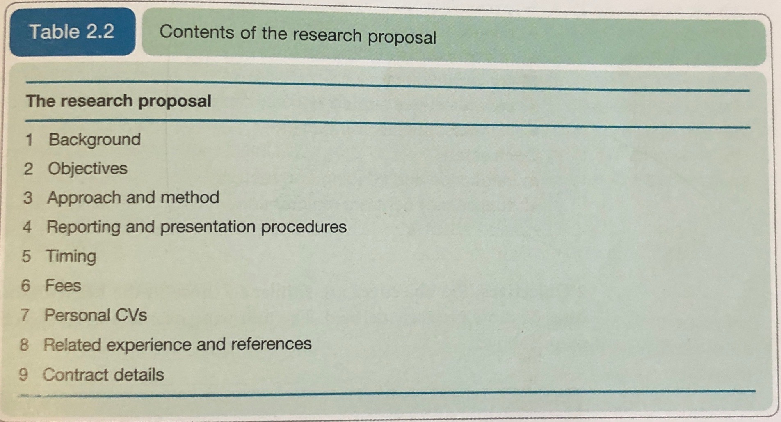
Figure 2-1 The research proposal in table form – Wilson (2012).

The background section goes first as it is the opportunity for the client to describe their organisation, it’s market and products, and the rationale for doing the research. They then move onto the objectives, this involves precisely defining them. For example, NomNom Chocolate may mention how old their machinery is and the types of machinery they currently use to make their produce. Step 3 is the approach and method which is the methodology of the research approach which then highlights the sample, the research to be used, and the method of analysis and any limitations. Step 4 highlights the structure of the report and the agency’s proposal for interim and final presentations, this includes the executive and main report (Lloria et al, 2014).
Timing is important for the clients to get across to the agencies, they must be specific to ensure that they get what they need in advance just in case they aren’t fully satisfied so that then the agency can tweak it. The fees are set up by the client to present to the agency, it’s vital they both take care when looking so that they are both satisfied. The project manager and project executive will share their CV’s to the key researchers involved. Section 8 is for the agency to sell themselves by sharing previous experience doing projects so that the client will want to go ahead. Finally, if the proposal is accepted by the client, then a contract will be signed, normally written up by the agency’s lawyer (McGivern, 2013).

  - The benefits and drawbacks of doing and not doing marketing research

Marketing research comes with many benefits and drawbacks within a small organisation such as NomNom Chocolate. NomNom are unsure as to whether they are in any need of an agency to do their research for them as they don’t know if they require it.
The obvious benefit would be that NomNom could take a back seat and not stress about their problem as they can rely on an agency to sort it out for them. This would benefit them a huge amount as they are a small organisation with a small group of staff, meaning, there is not a lot of time to do it themselves and their staff don’t have the correct training to do this themselves as there is no effective marketing department (Housden, 2008).
The main benefit for NomNom is that they will be able to understand their competition better and stay ahead of their competition. This is important because they are a very small business meaning they aren’t as safe as the bigger organisations, such as Tesco. Tesco is partnered will thousands of different brands including chocolate brands, this allows Tesco to be ahead of their competition all the time as they don’t encounter many market share problems. They are located in every city in the United Kingdom and have more than one store in each city, this is proof that they have done market research to see what criteria’s their customers use for selecting their supermarket (Hurnby et al, 2008). Although Tesco is in this situation, NomNom is different, unique, and have a USP that their flavours of chocolate are different to anywhere else in the market and still continue to sell out, so this shows that they already know and understand their targeted customers (Ghoshal et al, 1991).
A big drawback is the amount of time marketing research actually takes, especially for NomNom as they are such a small organisation they are very limited due to their resources. They don’t even have a marketing department, so they rely on their small handful of staff to do tasks. Even though this is a drawback, this is a reason as to why they could benefit from an agency to do their research for them as they can gain trust in the agency after explaining their brief as clear as possible, if they don’t do this, they will encounter many issues as it’s very important to plan and not leave till the last minute as it will affect the business and potentially lose money (Bijmolt et al, 1996).
Although NomNom would benefit from an agency as they have no time to do any research themselves, this comes with other drawbacks. It costs a lot of money to write a brief, so the question is, is it really worth NomNom paying a lot of money for research they may not need? They need to write down a list of all their company issues to then summarise it into one big question, they then need to discuss as a team whether they can resolve this problem themselves or if they are in need of an agency. Adding onto this, it’s difficult to write a comprehensive brief, so they need to decide whether or not their staff are capable and have the right skills to do this, without a strong brief, the agency may not have enough knowledge and understanding from NomNom to resolve their problem (Hart, 1987).
The drawbacks weigh up the strengths due to the fact that NomNom is such a small organisation. They are currently selling a premium product at a premium price whereby their products do sell out, a marketing research agency can do a lot to benefit them such as finding out if demographic and psychographic profiles of their customers actually affect their choice of chocolate flavouring, but this is something that they can easily tell by which flavours sell out, which saves time and money (Lin, 2002).
Not doing marketing research also comes with benefits and drawbacks for NomNom. The only benefit towards this would be the amount of money saved, as mentioned previously, NomNom are a very small organisation who haven’t yet done any research but still continue to sell out after every restock. For a small company, this is unheard of as marketing is what shows you off to the world (Martilla et al, 1977). The screenshot below is NomNom Chocolates official Instagram page, Instagram being one of the biggest social media platforms in the world (Miles, 2014), and as you can see the last time they were active was in 2013, now surely this would send a message to their consumers that they aren’t active either?
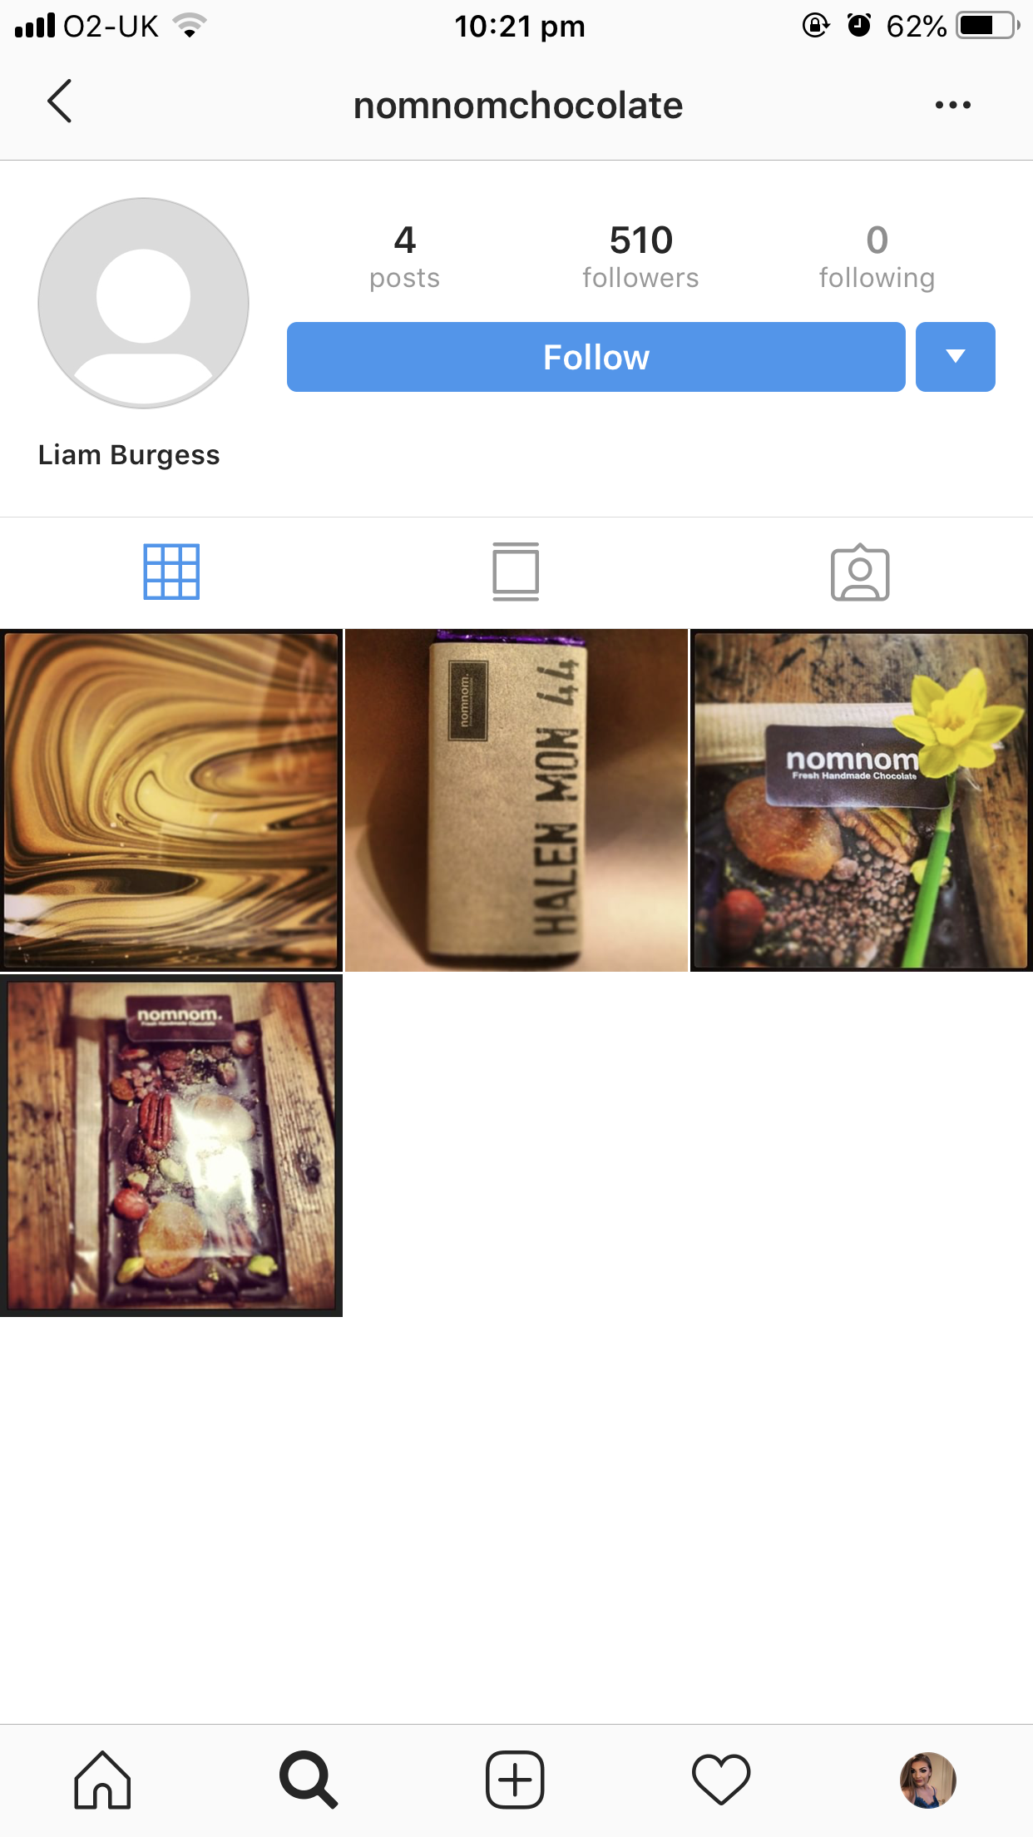
Figure 2.2 NomNom Chocolates Figure 2-3 NomNom Chocolates
Instagram page (2018) Instagram page latest image (2018)

Now, reflecting on this, I looked to see other peoples posts of NomNom Chocolate only to find that the images are very recent and up to date. This shows that their customers are continuously sharing their products through social media but why isn’t NomNom doing this also? This leads me to believe that the organisation is doing just fine without marketing research so benefit from none (Kohli et al, 1990).
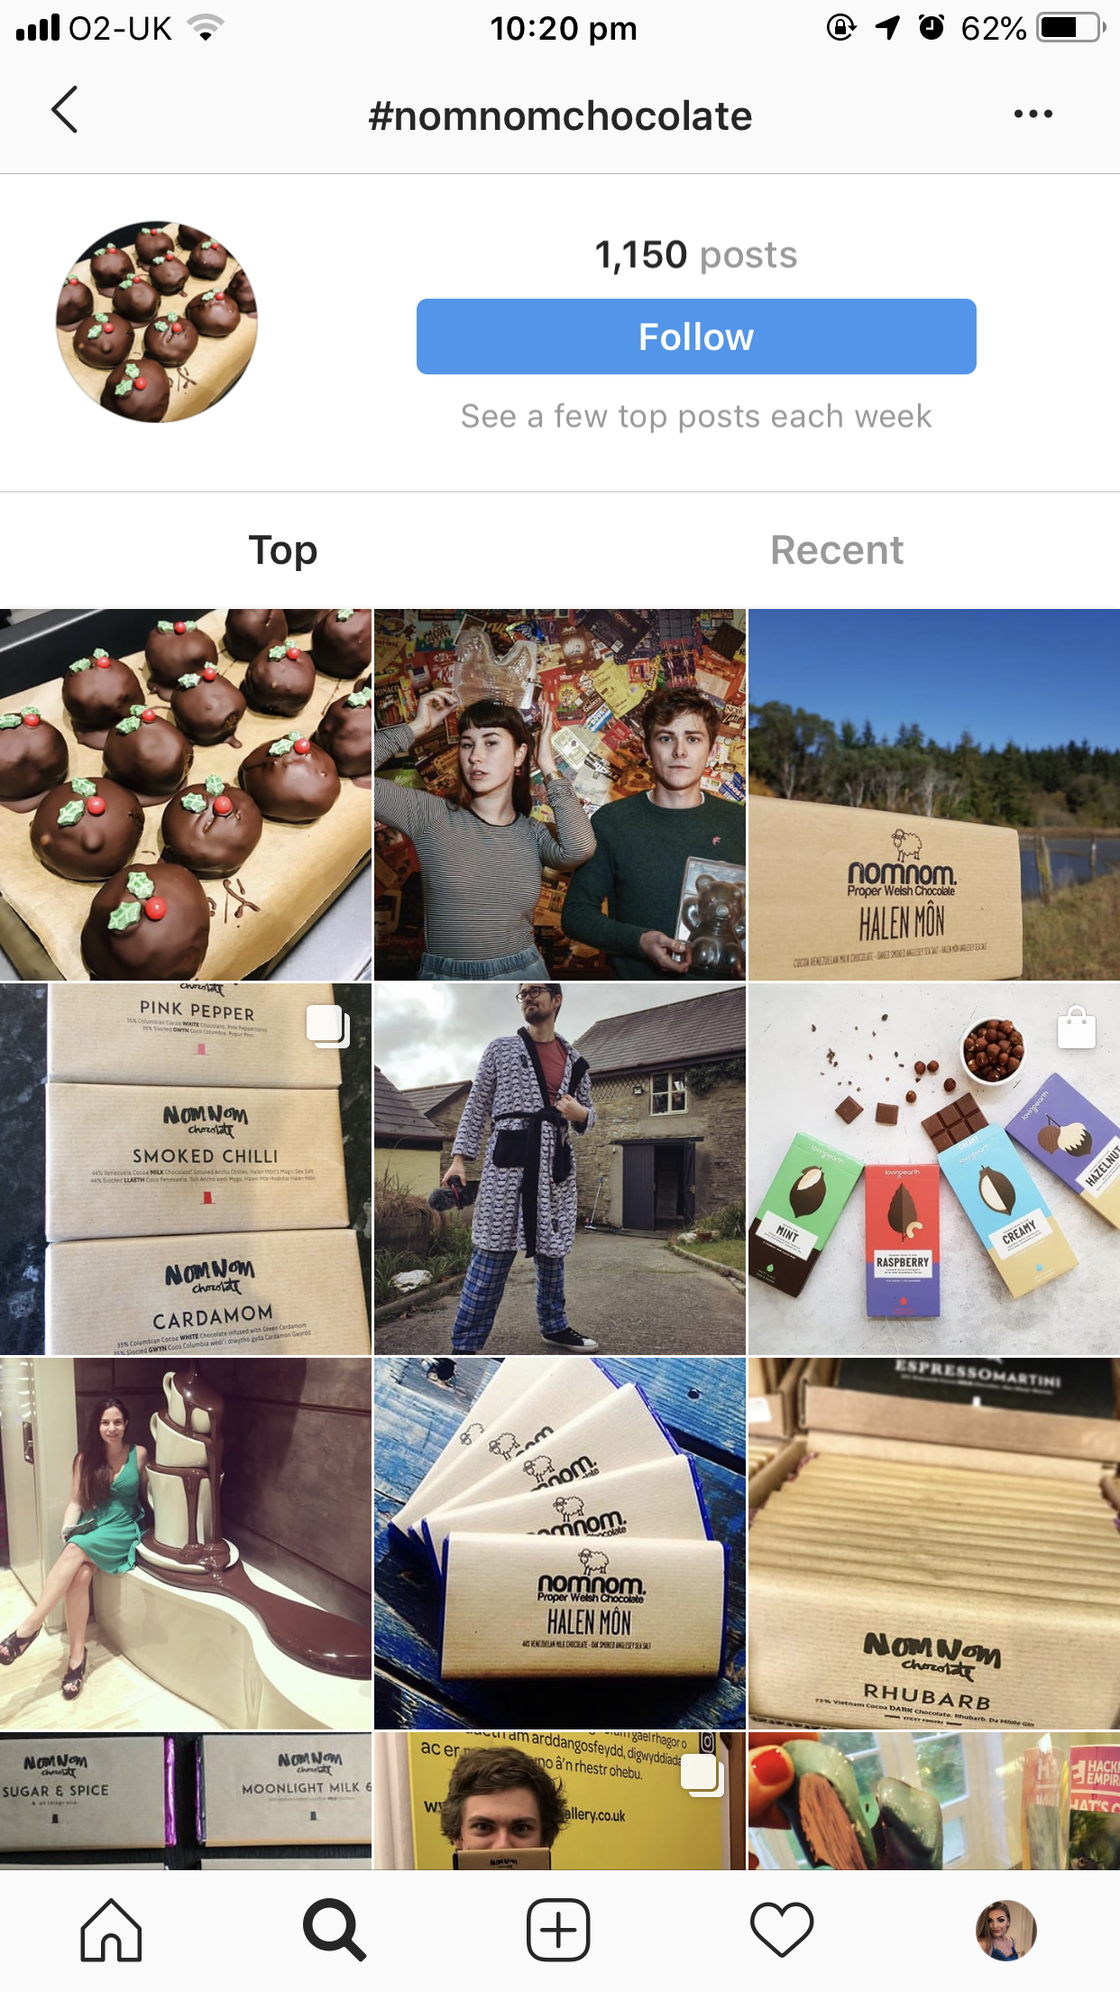
Figure 2-4 Customers images of NomNom products, Instagram (2018).

On the other hand, not doing marketing research comes with obvious drawbacks on organisations such as not knowing the correction business decisions to make to plan for the future. Their current plan is to make their factory into a modern workplace for the 21st Century (NomNom Chocolate, 2018). Now it would be a huge mistake for them to not do any research towards this planning as there are many questions they need to ask themselves, such as, how much will it cost? how much time do they need to prepare? will this hold back on production? If so, for how long? all these questions need to be figured out before any planning for the future (Carson et al, 1989).

  - Ways marketing research can be undertaken for NomNom Chocolate to investigate the issues the company have within the marketplace

Marketing research can be undertaken in a numerous amount of ways, but, finding one to fit your business is key. There are types that can work for many organisations but not all, so it is important to figure out exactly what you want to find out so that you can do your research with the appropriate method. This will then result in a strong investigation for the companies issues as the outcome will be best suited to the problem (Tapp et al, 2008).
NomNom can potentially encounter a huge amount of problems as they are a very small organisation with departments within the organisation such as a marketing department, this means, there is no hierarchy for staff to know who to talk to about anything. This is the main reason as to why they could do with an agency (Bergen et al, 1992). The image below represents the marketing research process starting from identifying a problem, now, NomNom don’t follow this structure as they have no marketing department which is an issue in itself as they may be aware of current problems but not future problems.
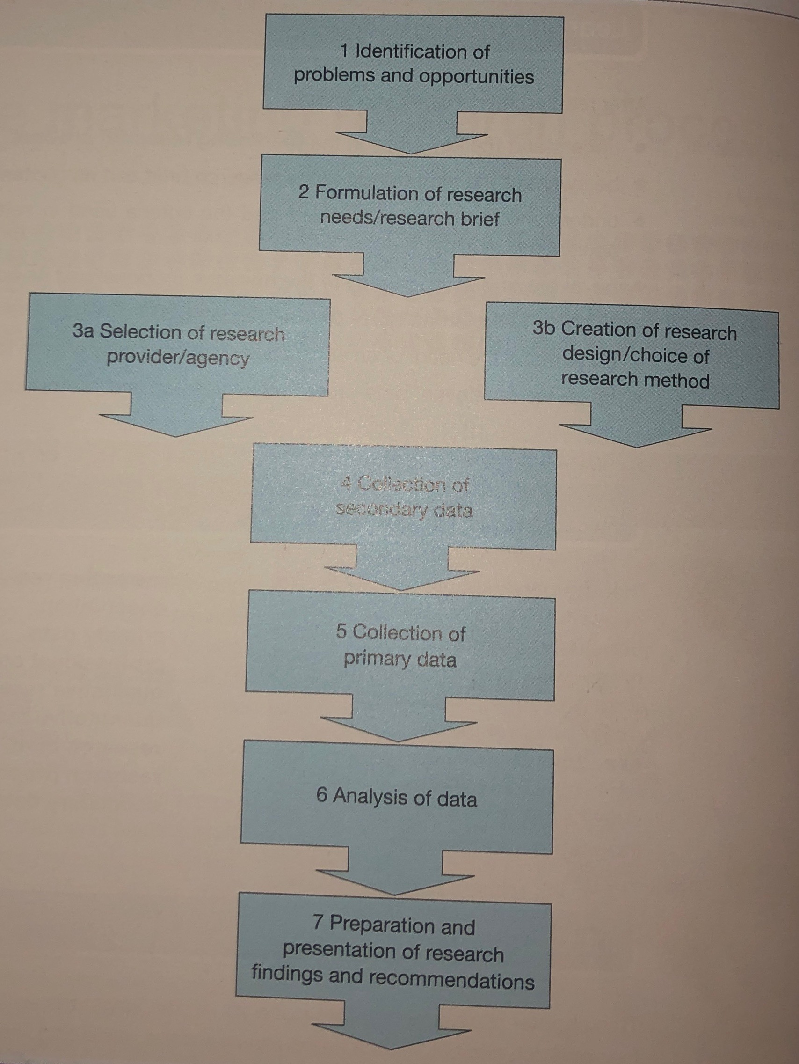
Figure 2.5 The marketing research process (Wilson, 2012)
The research design strategy will be done by the agency to identify the appropriate sources of data for the study, in other words, what’s the best way to resolve the organisations problem. There are three main categories of marketing research that can be undertaken including exploratory research, which involves qualitative and quantitative exploration, Conclusive – descriptive research which describes a specific situation and Conclusive – causal research which is cause and effect (Malhotra, 2007). The table below is the representation of the research design strategy.
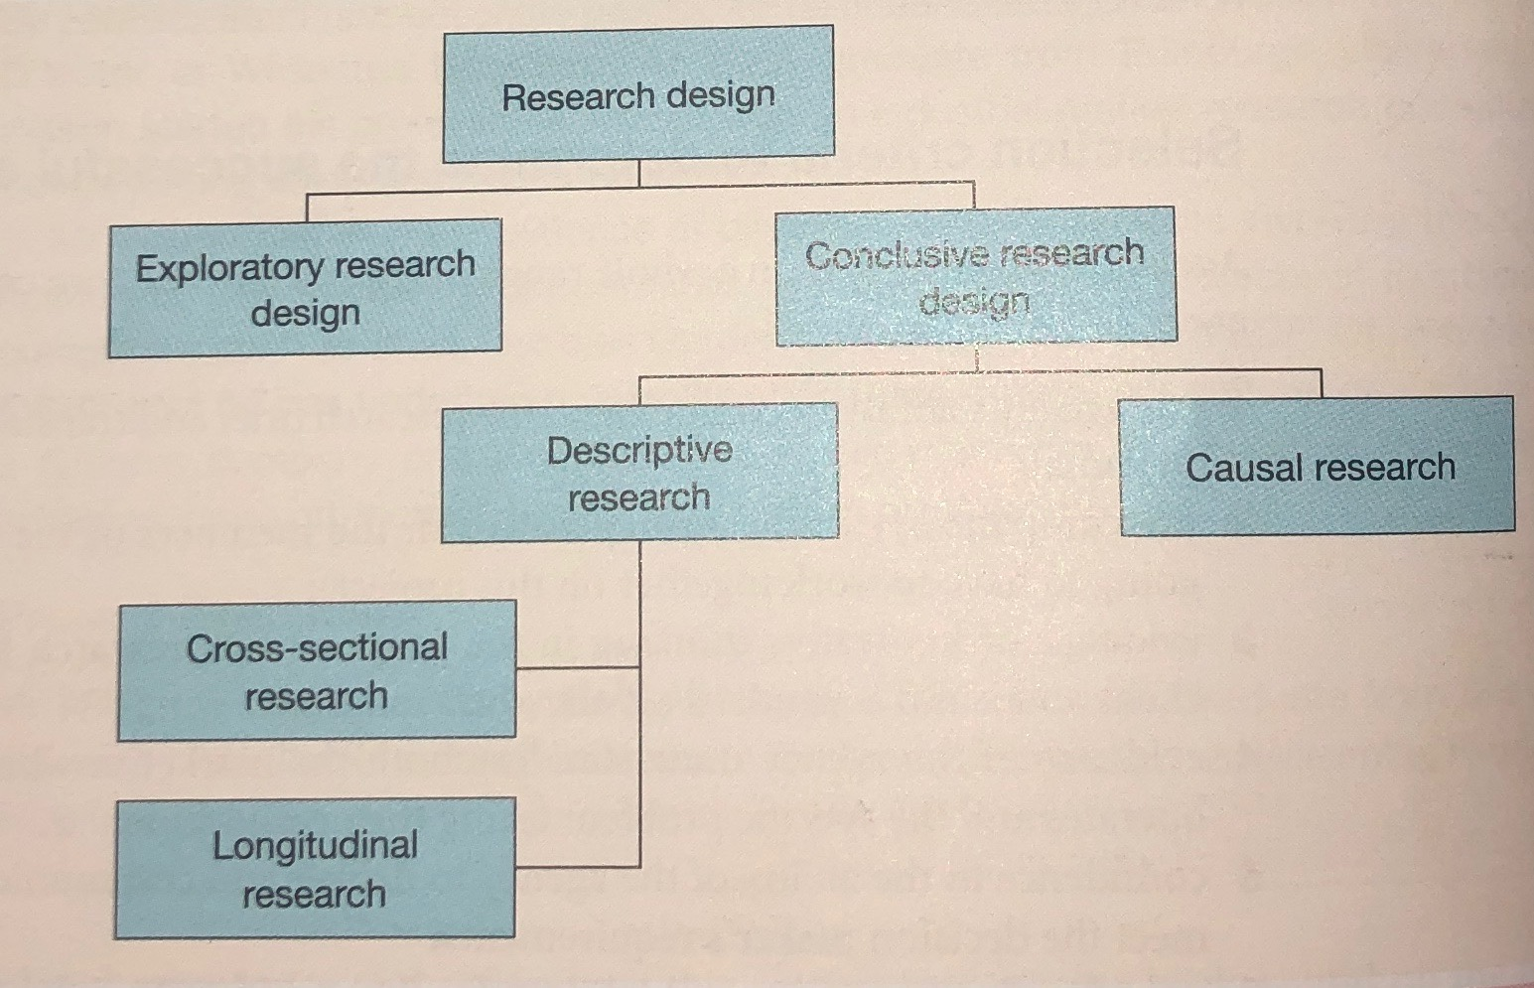
Figure 2-6 Research Design (Wilson, 2012).

Exploratory research is there to develop initial ideas or insights to then provide direction for further research, so this is the initial investigation. This is used using a minimum expenditure of cost and time which is exactly what NomNom need as this is something they lack in. It is also there to help define whether or not it is valuable to undertake further research at all which is what NomNom wants to know. The research can be aimed at exploring new products or new markets that the organisation may want to enter. Finally, it is used to prioritise practicality which NomNom need to know, therefore, they will need to use exploratory mainly as this answers what they currently need to know and because they have no marketing department to do this for them (Atuahene-Gima, 1995).
Conclusive research is trying to find or prove something, so conclusive descriptive research answers the questions who, what, where, how, and when, of marketing research. Within this comes longitudinal studies which measures trends in awareness, attitudes, and/or behaviour over time, this can be done by sending out surveys around the area the organisation is based in as there is a high chance that their customer base will be from the area. Alternatively, NomNom could do this online to their customers as they have no actual shop as they only sell their products online (Hulland et al, 1996). This research could also benefit NomNom as it is important for them to know what’s happening for them in the United Kingdom, as they can find out what city they sell their produce in the most, this can then help with future plans such as opening up a store, this is all marketing research that they vitally need for the future.
Conclusive – causal isn’t an option at all for NomNom Chocolate for a number of reasons. Causal addresses questions such what’s the relationship between advertising awareness and purchasing behaviour? But we know from section 2.3 that NomNom don’t advertise at all so this is irrelevant to them. Another example could be the weather, causal research initiates that if for example, the weather was bad then this can affect sales (Malhorta et al, 2003). Although, NomNom only sells chocolate so something like the weather won’t be a cause and effect of selling it as chocolate classed as an impulse buy as chocolate alone has it’s own global market (Restuccia et al, 2010).

  - Conclusion

Overall, due to the fact that NomNom Chocolate don’t have a massive budget, sell out for each chocolate flavour all the time with no advertisement, and have enough profit to create new flavours, I don’t think they are in need of an agency as I don’t really see any organisational problem. Although, if they wanted to do this for future reference, then I think they could benefit from it as they could research into what city buys their produce the most so that they could think about opening a store there, but I do think that they wouldn’t be able to do this themselves as they do not have enough time or resources, I think they should take the exploratory method also as this uses minimum money which would benefit them as they are a small organisation. So, if NomNom wanted to expand on the business in the future then yes they should invest in an agency but if they are happy with what they’re doing now, then no, there is no need.

- References

Atuahene-Gima, K., (1995), An exploratory analysis of the impact of market orientation on new product performance: a contingency approach, Journal of Production Innovation Management: An international publication of the product development and management association, 12, pp. 275-293.
Bergen, M., Dutta, S. and Walker Jr, O.C., (1992), Agency relationships in marketing: A review of the implications and applications of agency and related theories, The Journal of Marketing, pp. 1-24.
Bijmolt, T.H., Frambach, R.T, and Verhallen, T.M., (1996), Strategic Marketing Research, Journal of Marketing Management, 12, pp. 83-98.
Brace, I (2013), Questionnaire Design: How to plan, Structure and Write Survey Material for Effective Market Research, London: Kogan Page.
Carson, D. and Cromie, S., (1989), Marketing Planning in small enterprises: a model and some empirical evidence, Journal of Marketing Management, 5, pp. 33-49.
Ghoshal, S. and Westney, D.E., (1991), Organising competitor analysis systems, Strategic Management Journal, 12, pp. 17-31.
Hart, S., (1987), The use of the survey in industrial market research, Journal of Marketing Management, 3, pp. 25-38.
Housden, M. (2008) CIM Coursebook: Market Information & Research, Oxford, Butterworth – Heinemann.
Hulland, J., Chow, Y.H. and Lam, S., (1996), Use of causal models in marketing research: A review, International Journal of research in Marketing, 13, pp. 181-197.
Hurnby, C. Hunt, T, and Phillips, T. (2008), Scoring Points: How Tesco Continues to Win Customer Loyalty, London: Kogan Page.
Kohli, A.K. and Jaworski, B.J., (1990), Market Orientation: the construct, research propositions, and management implications, The Journal of Marketing, pp. 1-18.
Lin, C.F., (2002), Segmenting customer brand preference: demographic or psychographic, Journal of Product and Brand Management, 11, pp. 249-268.
Lloriam M.B. and Moreno-Luzon, M.D., (2014), Organisational learning: Proposal of an integrated scale and research instrument, Journal of Business Research, 67, pp.692-697.
Malhotra, N.K., (2007), Review of marketing research, In Review of Marketing Research, Emerald Group Publishing Limited.
Malhortra, N.K., Birks, D.F., Palmer, A. and Koenig-Lewis, N., (2003), Market research: an applied approach, Journal of Marketing Management, 27, pp. 1208-1213.
Martilla, J.A. and James, J.C., (1977), Importance-performance analysis, The Journal of Marketing, pp. 77-79.
McGivern, Y (2013), The Practice of Market Research: An Introduction, London: Financial Times Press.
Miles, J., (2014), Instagram power: Build your brand and reach more customers with the power of pictures, New York, McGraw-Hill Education.
NomNom Chocolate (2018), Available at: http://www.nomnom.cymru. Accessed 1st of December 2018.
NomNom Chocolate Instagram (2018), Available at: https://www.instagram.com/nomnomchocolate/?hl=en. Accessed 14th of December 2018.
Pferrer, J., (2007), A modest proposal: How we might change the process and product of managerial research, Academy of Management Journal, 50, pp.1334-1345
Restuccua D., Sprizzirri, U.G., Parisi, O.I., Cirillo, G., Curcio, M., Lemma, F., Puoci, F., Vinci, G. and Picci, N., (2010), New EU regulation aspects and global market of active and intelligent packaging for food industry applications, Food Control, 21, pp. 1425-1435.
Tapp, A. Whitten, I. and Housden, M. (2008), Principles of Direct, Database and Digital Marketing, fifth edition, Harlow: Prentice Hall.
Wilson, A (2012), Marketing Research: An Integrated Approach, Harlow: Pearson.

List of figures

2.1 – The research proposal in table form – Wilson (2012).
2.2 – NomNom Chocolates Instagram page – Instagram (2018).
2.3 – NomNom Chocolates Instagram page latest image – Instagram (2013).
2.4 - Customers images of NomNom products, Instagram (2018).
2.5 - The marketing research process Wilson (2012).
2.6 - Research Design Wilson (2012).

