Review of Professional Learning
Huw Edwards
Introduction
‘Reflective practice’ is a term I have been aware of for most of my professional career but not something I have every formally engaged in or studied. The aim of this paper is to apply the concept of ‘reflective practice’ to the three career paths of my professional career: University Lecturer, Member of Parliament and Training Consultant.
First, they will be overview of reflective practice drawing on academic studies. This is followed by a brief resume of my family background and an outline of my three career paths. This will identify issues and conflicts which merit a reflective approach and the personal learning that each career path has produced. Finally, I identify which aspects of my professional career will be developed in the major research project of the UWTSD Doctoral Programme in Professional Practice.

The study of ‘reflective practice’
Linda Finlay of the Open University outlines a wide range of concepts and issues in her paper Reflecting on ‘Reflective practice’ which is written with characteristic OU clarity.
She states:
‘In general, reflective practice is understood as the process of learning though and from experience towards gaining new insights of self and/or practice. This often involves examining assumptions of everyday practice. It also tends to involve the individual practitioner in being self-aware and critically evaluating their own experiences to practice situations.’ (Finlay p 1)
Finlay emphasises how that Donald Schon’s work in America in the late 20th century was seminal. He was a philosopher and organisational expert who applied his theories of knowledge to adult education, regional planning, urban studies, and later politics. In ‘The Reflective Practitioner’ Schon distinguished two types of reflection: reflection-on-action which is undertaking after events and reflection-in-action which is thinking while undertaking the action.
With respect to reflection-on-action, professionals at the later stages of their career like me can certainly, in Finlay’s terms, ‘review, describe, analyse and evaluate their practice’. This will be attempted with respect to my early career roles as University Lecturer and Member of Parliament.
With respect to reflection-in-action they are seen as ‘examining their experiences and responses as they occur’. This arguably should have been undertaken during those earlier careers but can certainly be done with respect to my current professional role as a Training Consultant.
Gibbs’ ‘Reflective Cycle’ offers a valuable means for assessing professional practice and is applied in nursing and other professional roles.
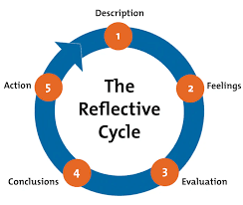

This is helpful in recognising that in evaluating what is good and bad about professional life, how to clarify our roles. But we must also be able to express feelings to make sense of these experiences and identify how to improve.
Finlay in her work on health social care professionals develops a model of reflective practice that is a ‘a synthesis of reflection, self-awareness and critical thinking.’ (Finlay p 5). She also highlights ethical concerns such as confidentiality, rights to privacy, informed consent, and professional relationships.
‘It needs to be remembered that reflection can have profound emotional impact on the person reflecting and therefore has the potential to be harmful.’ (Finlay p 109)
Reflective practice can therefore have positive and negative outcomes. My conclusion from having done this assignment is that my confidence, for example, in public speaking has been matched by a clear lack of confidence in terms of professional ambition. I was a good lecturer but not a good academic, a good MP but not a good politician and now I am a good trainer but not a good businessman.

Family Influences
Family background profoundly influences our career paths. My parents were brought up in Neath, South Wales during the inter war years when ‘unemployment crucified an entire nation’ (Morgan). They came to London in 1946 when my father became Minister of Capel Y Boro, one the many Welsh Chapels in the capital and studied at Kings College for his doctorate on the Welsh philosopher Richard Price. He had an inspiring professional life as a preacher and lecturer. I and my two sisters inherited a skill and confidence in teaching and public speaking. We had a Welsh family upbringing in London. Politically, we were a Labour supporting family but none of us were politically active.
My own education was mixed. I was an 11 + failure and didn’t get to Grammar School. That feeling of not being good enough has never left me. I went to Manchester Polytechnic for my first degree and then to the University of York to study social policy which was an inspiring and enjoyable experience.

University Lecturer
My first appointment in 1980 was Lecturer in Social Policy at Coventry (Lanchester) Polytechnic - a one-year appointment to replace a staff member who taught social policy but specialised in race relations.
Replacing staff on sabbaticals is problematic in that you may be confident to carry much of their teaching load but feel inadequate in their specialist areas. I was comfortable in the teaching I did on the Welfare State on the degree course and professional courses but struggled with the race relations option and lacked the time to prepare adequately.
One highlight of the year was to be invited by a colleague, Dr Rob Behrens, to do a first-year lecture on the work of Professor Richard Titmuss – the self-educated founder of social policy as an academic subject at LSE. Titmuss was my academic inspiration and his books ‘Essays on the Welfare State’, ‘Commitment to Welfare’ and ‘The Gift Relationship’ about blood donorship in the UK and the values of the NHS were the focus of my lecture. The lecture went well, and Rob Behrens initiated a round of applause from the students – the only round of applause I ever achieved as a lecturer!
After Coventry I was out of work for a year but completed my M.Phil. It felt that the political mood was against us in the early 1980s. Prime Minister Margert Thatcher declared there was ‘no such thing as society’ and this demoralised social scientists committed to teaching and research on poverty and social inequality. Jobs were scarce in my subject. My professor at the University of York, Kathleen Jones, said I must ‘stick it out or get out’. I decided to stick it out and stay in higher education. This was also a politically formative period but I was not politically active at the time.
By now I was developing a strong interest in devolution for Wales. The referendum for a Welsh Assembly in 1979 had produced an overwhelming NO vote from the people of Wales but I felt the public mood would eventually change and wanted to be part of the change.
Another key development was being shortlisted for a permanent lectureship in Social Policy at Cardiff University. It felt like the dream job. I would be living in Cardiff and devote myself to developing social policy as a discipline. After about ten years I would consider standing for Parliament and seek a safe seat in South Wales.
Cardiff at the time was not known as a centre for Social Policy and I saw improving this reputation as an exciting challenge. I confidently spoke in the interview about developing the subject and adapting to the new era that would surely come with devolution. The Department would need to develop a specialist area of Social Policy in Wales and conduct research into the impact of devolution in Wales.
It was all to no avail. There was clearly no interest in a ‘Welsh Social Policy’ and a researcher who had no interest in Wales, was appointed. It remains the biggest disappointment of my professional life. On reflection, I now admit that I didn’t demonstrate enough research commitment to get that job. Interestingly, the department later appointed a young social worker from Carmarthen who became Professor of Social Policy. His name was Mark Drakeford - now First Minister of Wales and he remains an inspiring friend.
In 1983 I was shortlisted and appointed as Lecturer in Social Policy at the University of Sheffield. Again, it was a one-year contract but I felt I had made it. I as a university lecturer! My job was to replace the inspirational Professor Alan Walker. I had a light teaching load and thrived on teaching social policy on the Master of Social Work course and as well as undergraduate social science courses. I would have happily stayed at Sheffield, but it was only a temporary post.
Fortunately, I applied and was appointed to another lectureship at South Bank Polytechnic where working at a multi-cultural institution was stimulating. I then secured another temporary job as Social Policy Lecturer at Manchester Polytechnic which lasted three years, each one replacing a different member of staff. While the teaching load was heavy, I widened my social policy repertoire, and it was a fulfilling three years.
I would have stayed in Manchester had a permanent job come up. I was sadly preparing to leave my new house in Chorlton when a job at Brighton Polytechnic was advertised. I applied and was successful. Unknown to me, my referee, Professor Alan Walker from Sheffield, happened to be Brighton’s external examiner at the time. The department, a mixture of social science academics and nursing and social work professionals, had a happy atmosphere with much camp Brighton humour. I could have happily settled at Brighton until retirement, but I continued to think about devolution, politics, and a potential run for Parliament.
Reflections on teaching and research
I believe I was a good lecturer, but I was not a good academic. All my appointments, apart from Sheffield, were at Polytechnics. Some lecturers gain respect for their enthusiasm and ability to inspire students to study, helping them to develop a path that would lead to a fulfilling career. Other lectures have a dismissive approach and regard teaching as an irritant and an impediment to their ‘real’ academic work.
My view of university teaching was that it should put ‘personality into our knowledge’. We should convey enthusiasm about our subject and continually show students its relevance for the professional world they hope to enter. This was the essence of the Polytechnics which had a strong vocational ethos which Steve Pile summarises perfectly:
‘Many lecturers were appointed to colleges of technology, which were subsequently amalgamated into polytechnics. For most people, expectations were geared to teaching and this has been their life and love. Still others chose polytechnic jobs because they found the traditional university indifference to students unacceptable. (Pile)
This certainly sums up my own experience of being a polytechnic lecturer. I did not strive to be a professor or head of department. I had a happy time lecturing in different institutions and learned a great deal about social policy. Hopefully this helped many students enjoy the subject and use it towards their future career and their quest to improve the human condition.

Not being reflective
Although I had never been involved in formal reflective practice, I was aware it featured heavily in the training of social workers and nurses – courses that I often taught on.
I was a lecturer in social policy and my strength was in explaining the development, implementation, and evaluation of specific policies in the field of social welfare. Take for example, the latest Mental Health Act which I might be asked to cover on a nursing or social work courses.
I would confidently outline the background, aims and provisions of the Act and any research relating to it. I did not sit on the table and ask the group ‘how do you feel about mental health’. In nearly all my lecturing, my approached proved successful and appreciated by students – precisely because it was not reflective as many of their courses were.
The one group where I recall my approach was not appreciated was Counselling students where so much of their learning was reflective. My style of coming in to give a lecture on the Mental Health Act went down badly with some. The criticism – Why do think we need to be lectured? Why do you feel the need to wear a suit and a tie…….? How do you feel about……?.
Such questions would make me feel impatient and irritated. At that stage, I was clearly not a reflective practitioner, but a more reflective approach did develop in later roles.

From higher education to politics
I knew I should be more involved in research and around 1988 started to prepare for what I saw would be a study on ‘Poverty in Wales’.
One evening, in the library at Manchester University look at data from the New Earnings Survey, I discovered that Wales had the highest incidence of low pay in the UK. This was my ‘eureka’ moment. I discovered something that had profound political implications which had not previously been highlighted and I worked with the Low Pay Unit, a small research and pressure group campaigning for a national minimum wage.
I produced research papers on low pay in Wales and briefed Welsh MPs. The Low Pay Unit was commissioned by four county councils to do a detailed study of low pay in South Wales. I undertook the research. When the report ‘South Wales: Land of Low Pay’ was published there was coverage in the Welsh news, an HTV documentary and growing political interest the national minimum wage campaign.
Although my research was not published in academic journals, it certainly had impact. The National Minimum Wage Act was passed in 1998 as one of the first measures of Tony Blair’s Labour Government. This research was my gateway to a political life.

Member of Parliament
I was elected to Parliament in 1991 – not in a General Election but in what the media called a’ by-election sensation’. Labour invested heavily in the Monmouth by election and overturned a Conservative majority of 9,200. Within a few days I went from being a contented lecturer to being the youngest MP in Wales. Fortunately, I was given a one-year unpaid sabbatical by Brighton Polytechnic.
The change from higher education to political life was dramatic. Being required to have an opinion on every topic, being required to attend endless functions seven days a week, treated as a VIP and respected by many but hated by others because of your party label are some of the immediate feelings of being a new MP.
For me understanding parliament and speaking in the Commons chamber or on a political platform was not difficult. Understanding civil society, local politics and attending endless local functions was challenging, having never been involved in local community life.
Being in the House of Commons during Prime Minister’s Questions or speaking in debates is immensely stimulating. Being involved with the media, doing TV and radio interviews, or even hearing yourself speak on Today (or Yesterday) In Parliament gives you a sense of self-importance if not arrogance. Knowing high profile politicians on first name terms and having drinks and meals with them is unforgettable.
What are the key reflections from that experience. What are the regrets?
Westminster and Constituency Duties
As an MP my constant concern was reconciling the duties of being in Westminster while also serving the constituency full time. Some MPs see their role as being in Parliament, talking and debating the national and international issues of the day. They are not there to pick up personal problems, support endless local campaigns or act as an ‘unqualified social worker’.
For others, the constituency work and helping people is the most rewarding part of the job. They are not comfortable with the ‘clubiness’ of Westminster, the procedures and style of the House or the rather tedious process of sitting in Bill committees.
On reflection, I regret not spending more time in the chamber contributing to debates of national and international importance. I also regret worrying too much about being ‘seen around’ in the constituency. In my view, serving constituency interests full time has become too strong a pressure for MPs.

Reconciling party, constituency and conscience.
MPs are elected to serve their constituents, be loyal to their parties but also to exercise their conscience. How do these loyalties conflict and what are the consequences? Let us examine two case studies.
Supporting Welsh devolution was at the centre of my political beliefs. The Labour Government was elected with a commitment to a referendum on establishing a National Assembly for Wales.
Public opposition in my Monmouth constituency was overwhelmingly opposed to devolution, though the postbag on the issue was not large. The same fears from the 1979 referendum were constantly repeated: devolution would be ‘an economic disaster’; Welsh speakers would ‘get all the jobs’ and it would ‘open the door for nationalists to break up of the UK’.
I believed strongly in devolution but decided to seek no publicity and keep a low profile. The 1997 referendum produced the narrowest YES vote after the historic Carmarthen result came through. Monmouthshire produced the highest NO vote in Wales but to my own quiet satisfaction there were more YES votes in my area than there were in the overall majority. ‘It’s Monmouth wot won it’ I proclaimed to my Welsh MP colleagues – to much derision! For me it was a fundamental matter of conscience before constituency.
Iraq became the dominant issue in run up to the 2005 General Election. The decision by the United States to attack Iraq and depose President Saddam Hussein without a mandate from the United Nations was critically supported by the Labour Government.
This caused outrage to many people in the UK. In my own constituency, opposition to the Iraq war extended far beyond traditional anti-war activists. My sense was that middle Monmouthshire could not accept Tony Blair’s unwavering support for President Bush and his disregard for the UN.
Labour opponents of the war led by Robin Cook and Jeremy Corbyn tabled a reasoned amendment which stated that the case for military action against Iraq was ‘not proven’ in view the lack of evidence of weapons of mass destruction and the failure to secure the UN mandate’. (Cook)
I was our minded to join the Labour opponents of the war and I sensed I had the support of my local party and good deal of reasonably minded constituents. But I was seen as a Blair loyalist and this was the first major issue I rebelled on. Although the Government won the vote, over 140 Labour MPs voted against Blair including myself. I was widely commended in my constituency and by my local party. For me this was a clear case of constituency and conscience before party.

Training Consultant
Facing the prospect of being defeated in the 2005 General Election, I thought long and hard about what I would do after I was no longer an MP. In my early fifties, I knew I would not go back into higher education full time and I did not want to go into commercial lobbying like many ex MPs.
My colleague from Coventry, Rob Behrens, worked at the Civil Service College in Sunningdale. I wondered if I could work training civil servants on understanding parliament. Another, friend, Paddy O’Keefe. who specialised in soft skills in management training, advised me that training was not about my knowledge but the ability to facilitate.
This was the beginning of my third career. I worked for the National School of Government (NSG) in Sunningdale on courses for fast stream civil servants on how to work and brief Ministers. I also worked at the National Assembly for Wales training Assembly staff on the new legislative processes.
My training work also took me abroad - to St Helena, the remote British Overseas Territory in the South Atlantic. I also worked in Libya on an EU project following the fall of General Gadaffi training members of the new Libyan Parliament on understanding democracy and parliamentary processes.
In 2018, I started to work for the Industry and Parliament Trust (IPT) – an educational charity based in parliament where I trained industry staff on how parliament works. I was later asked to train staff from the universities that subscribed to IPT.

Policy Engagement for University Researchers.
Training university researchers on promoting their research to parliament and policy makers has now become my main professional work.
Universities are required to demonstrate the impact of their research output. My role is to support researchers to consider what impact they want their work to have and advise and on how they could promote their work to parliament and policy makers. Courses are done through three-hour training sessions at universities, Westminster or online via Zoom.
The training courses are tailored to the expertise of different research groups - Early Career Researchers (ECRs) or Senior Researchers including professors. Courses can be offered for specific disciplines or research institutes. I have recently delivered courses to ECRs at Leicester, Hull, Essex, Lancaster and Coventry and for specialist research centres including Warwick Manufacturing Group and the Quadram Institute (Bio Science) at UEA.
My main reflection on this, my third and final career path is that this is immensely rewarding work. There are over 150 universities and tens of thousands of researchers who can benefit. I also reflect more that I am good trainer but not a good businessman. I am not good enough at promoting myself and using social media effectively and not good at discussing fees.
What is my personal learning from this work? First, that whatever a researcher’s expertise their research can have impact in the world. Second, that many university researchers are on short term contracts, face financial and academic insecurity and deserve help. Third, that universities are dependent on research funding from government and private sources and that there are major inequalities in universities’ capacity and ability to invest in policy engagement. Finally, the policy making process is not sufficiently geared up to engaging with university researchers whose research can have real impact.

Future Research and Current Position
My proposed subject for the final project of this doctoral programme is Wales and Westmintster : Reflections on Representation, Legislation and Scrutiny. This would draw on my time as MP for Monmouth from 1997 – 2005 when Parliament passed the Government of Wales Act establishing the National Assembly for Wales.
Part of the research would be documenting the reflections of as many of Welsh MPs as possible who served with me at that time. Sadly, some have died and others may not be able or willing to participate. I want to include high profile figures who may have published memoirs and ordinary backbenchers whose views and experiences also deserve to be recorded.
Overall, I feel confident to take on this major research project. My strength is working on documentary evidence, the academic literature on parliamentary studies and the memoirs of prominent political figures. I am very familiar with the extensive parliamentary website and the wealth of documentary evidence that can be used. However, I recognise the need for training on oral history and to develop more expertise in qualitative research techniques such as semi structured interviews and case studies.

Conclusion
My final reflection is that this exercise has certainly increased my appreciation of reflective practice. It had been central to much of the professional courses I worked on as a university lecturer. Reflection has also been a large part of the experience of being an MP but again not in any formal way. I am grateful for Donald Schon’s concept of reflection-on-action as it certainly applies to these two early career paths.
I can see how Gibb’s model of reflection can be applied in my case. There are feelings of confidence in the public speaking roles I have had throughout my career – in the lecturer theatre, on political stage and in the training room. That confidence only comes after the preparation has been thorough. I have certainly lacked confidence in terms of seeking promotion and advancement both in the academic and political arenas. With respect my current work with university researchers, I am confident in training young researchers and even professors when the preparation has been done but I need to be better at marketing my courses and securing more work. I appreciate the need to further develop my understanding of the theory and application of reflective practice for this work and also my research. I feel grateful that doing this Doctoral Programme means I am no longer the only person in the room not having or doing a doctorate.
My final reflection is to repeat that I believe I was good lecturer but not a good academic, a good MP but not an ambitious politician Now I find working with university researchers and doing this doctorate a highly rewarding third career.

References
Blair Tony A Journey Hutchinson London 2010

Cook Robin The Point of Departure - Diaries from the Front Bench Simon and Schuster 2004

Colomer J et al. Reflective Learning in higher education: A comparative analysis Procedia – Social and Behavioural Sciences 93 (2013) 364-370

Costley C, Elliot G and Gibbs P Doing Work Based Research Sage 2010

Finlay F. Reflecting on ‘Reflective Practice’ Practice-based Professional Learning Centre The Open University

Gibbs, G Learning by doing: a guide to teaching and learning method Oxford: Further Education Unit Oxford Polytechnic

Mogan, K.O. Wales 1880-1980 Rebirth of a Nation Oxford University Press 1982

Pile S Polytechnic, Ethos, Research. Quality Journal of Geography in Higher Education 1993 Vol 17 Issue 2

Schon D. A. The Reflective Practitioner New York: Basic Books 1983

Huw Edwards
Wyefield The Paddocks Monmouth NP25 3NP
huwedwards53@btinternet.com 07967 007701

Higher Education
1973-1976
Manchester Polytechnic: BA (Hons) Science Degree specialising in Social Policy.
Social Policy was a fascinating subject but some of the teaching and course organisation on this degree was very poor; graduated with 2:2 class degree which was disappointing and cost opportunity to do M.Sc in Social Policy at London School of Economics.
Degree course was followed by one year doing some part time adult education teaching and working for the charity Mencap which offered insight into field of learning disabilities. Applied to do MA in Social Policy at University of York.

1977-1978
University of York: MA in Social Policy
Accepted to do one-year full time MA with funding from SSRC. Department was very stimulating with strong research ethos. Dissertation subject was on new government initiative – ‘Joint Financing between Health and Social Services.’

1978-1980
University of York: M Phil in Social Policy
Offered SSRC research grant to do M.Phil. Research centred on Infant Mortality ‘one of the most sensitive indicators of social welfare we possess’ (Titmuss). Examined the empirical evidence on persistent social class gradient in infant mortality during 20th century but also ethical issues in medical decision making at which can affect neonatal mortality rates.
Research undertaken with Professor Jonathan Bradshaw and the Social Policy Research Unit at York on area variations in infant mortality published in Journal of Epidemiology and Social Medicine.
Thesis: A Study of Contemporary Infant Mortality and Social Policy
Also engaged as part time teacher on postgraduate social policy and social work courses which was a valuable opportunity to develop teaching skills and become a social policy lecturer.

University Lecturer
1980-1981
Coventry (Lanchester) Polytechnic: Lecturer in Social Policy
Temporary one year appointment responsible for delivering courses on social policy on undergraduate degree and professional courses including social work and health care. Also responsible for undergraduate option in Race Relations.

1981-1983
Completing M.Phil thesis Part time lecturer
Completed and successfully submitted M.Phil.
Undertaking part time teaching positions in social policy at: Hatfield Polytechnic, Coventry (Lanchester) Polytechnic and West London Institute of HE; also taught Ethics at the American College Richmond.

1983-1984
University of Sheffield: Lecturer in Social Policy
Temporary one year appointment in Department of Applied Social Studies responsible for delivering courses on social policy and social planning on undergraduate degree and professional courses including Master of Social Work.

1983-1984
London South Bank Polytechnic: Lecturer in Social Policy
Temporary one year appointment in a multi-cultural environment teaching social policy with a focus on health policy to a wide range of undergraduate, M.Sc and professional courses. Frist experience of supervising Masters’ level dissertations.

1984-1987
Manchester Polytechnic: Lecturer in Social Policy
Appointed to a one-year post that was extended to three one-year posts. Enriching opportunity to expand my range of social policy focussing on social services, health and policy and ideologies of welfare.
Engaged in research on problems of low pay and earnings inequality in Wales working with Low Pay Unit.
1987-1991
Brighton Polytechnic: Lecturer in Social Policy
First permanent position in HE teaching social policy and housing policy. Stimulating experience in a friendly and supporting department.
Continued with research on low pay in Wales - briefing MPs, liaising with Shadow Minister Tony Blair and featuring in HTV documentary.
In October 1990, selected as Labour Party Parliamentary Candidate for Monmouth constituency.

Member of Parliament
1991-1992
Member of Parliament – Labour Monmouth
Elected in high profile by election in May 1991 overturning 9,300 majority to win by 2,400 votes..
Represented largely rural constituency of Monmouth. Served on Welsh Affairs Select Committee.
Developed skills in campaigning and working with the media.
Defeated in 1992 General Election.

1992-1997
University of Brighton: Senior Lecturer in Social Policy
Tutor for Open University
Returned to Brighton after one year sabbatical as Senior Lecturer to continue to be responsible for social policy across degree and professional courses.
Overall, an enjoyable and stimulating experience but mindful of seeking to stand again in next General Election so maintained links in Monmouth.
Also worked as part time tutor for OU. Learned new skills in distance learning and interactive teaching.

1997-2005
Member of Parliament: Labour Monmouth
Returned to Westminster following 1997 General Election with 4,000 majority and sat on government benchers following Labour victory under Tony Blair.
Served on Committee for National Minimum Wage Bill; member of Welsh Affairs Select Committee and joint-founder of All Party Groups on Learning Disability and Carers. Introduced 10 Minute Rule Bill on carers rights to respite care later incorporated into the Carers and Disabled Children Act 2000.
Interest in constitutional affairs and devolution in Wales.
Defeated in 2005 General Election.

Training Consultant
2005 – 2018
Following General Election defeat, decided not to go into full time lobbying role but interested in ‘returning to the classroom’ as a Training Consultant specialising in parliament, government, and devolution. Appreciated the need for skills in facilitation not simply knowledge of subject.
Instrumental in developing training courses with private training providers on devolution with special interest in Wales. Recruited to National School of Government Sunningdale training fast stream civil servants on working with Ministers.
Worked with training providers in the development field, training MPs, parliamentary officials and civil servants from Commonwealth countries.
Appointed by Industry and Parliament Trust (IPT) to provide training sessions on parliamentary process to groups from major private companies visiting Parliament.
Diversified to provide training to groups from universities that subscribe to IPT focusing on Policy Engagement for University Researchers.

2008 – present
Training Consultant: Policy Engagement for University Researchers
Engaged to work with groups of university researchers in promoting their research to parliament and policy makers. Courses are designed to meet the needs of Early Career Researchers, Senior Researchers and tailored for groups across disciplines or specific research institutes. This training contributes to the submissions of universities to Ref 2027.
Skills – designing and delivering high quality presentations and encouraging researchers to give their work a policy focus and identify and articulate the impact they would like their work to have.
Expanded to provide same training as an independent contractor to universities under the brand ‘Research Impact - Policy Engagement – Huw Edwards.’

Personal Interests
Sport – playing football, rugby, cricket in past - still skiing. Currently cycling walking and running.
Music – member and past Chairman of Monmouth Male Voice Choir.
Research – Registered Practitioner Researcher on D Prof programme at UWTSD
Family – Married to Tess - an artist and calligrapher. Two stepchildren Tommy aged 37 and Chrissie 32 and wonderful granddaughter aged 7 – Georgia.

Job Description - Training Needs Analysis
Huw Edwards
Introduction
This Training Needs Analysis relates to my current career path as a Training Consultant specialising in Policy Engagement for universities. It will present a Job Description and overview of the organisations that I am currently engaged with, and an assessment of the skills required. It will then examine my aspirations to develop this role by being engaged directly by universities and the skills needed.

Training Consultant Job Description
A Trainer specialising in understanding government, parliament, devolution and policy influence. From 2006 to 2017 training was mainly provided to professional groups from the public, private and third sectors. Specific focus was also given to training elected members of parliament and parliamentary officials in Commonwealth countries. Since 2017 the focus has moved to training university researchers on how to promote their research to parliament and policy makers under the requirements of UKRI to demonstrate research impact.
Huw Edwards Training Ltd was incorporated in 2015 with Huw Edwards as sole director.

Freelance Work
The role of the freelance Training Consultant has the following characteristics. It involves being engaged on an ad hoc freelance basis and being engaged by several organisations but not being formally employed by any. The freelance role also has none of the normal requirements of being employed by an organisation. There are no annual job reviews, appraisals, or evaluations. Freelancers are not involved in the organisation’s strategic plans but their engagement may be determined by them. They are ‘only as good as their last job’ and can be dispensed with without explanation. Finally, there is no current professional body that supports freelance training consultants or sets standards.
However, freelance trainers need to develop their skills, widen their ‘market’ and improve their performance, to secure future work. As a freelance training consultant working with universities, this will be the focus of this paper. I am currently engaged by two main organisations. I am also developing my contacts to work directly for universities as an independent contractor.

Training Consultant - University Policy Engagement

I have been working with the Industry and Parliament Trust (IPT) for around 6 years. Initially, this was training groups of staff from major private companies that subscribe to the IPT. My training sessions would focus on understanding how parliament works – especially in terms of legislation, scrutiny and the role of MPs.
In 2018, I was approached to take over the training for the smaller number of universities that subscribe to IPT. This has proved to be very stimulating work and is the main focus of my current work. The aims of this training are:
- IPT University Training is designed for academics and other University staff to increase their understanding of UK Parliament. The sessions look at the functions and process of Parliament, with a specific focus on how Parliament uses academic research.
- Seminars can be tailored for specific group’s needs, including those from both a science and social science background, as well as delegates with a limited understanding of UK Parliament.
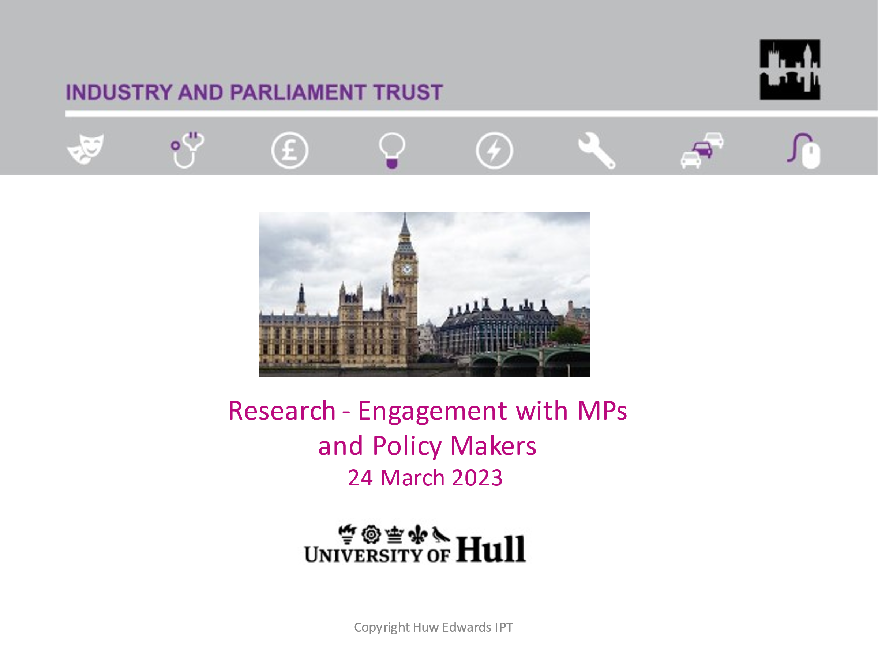

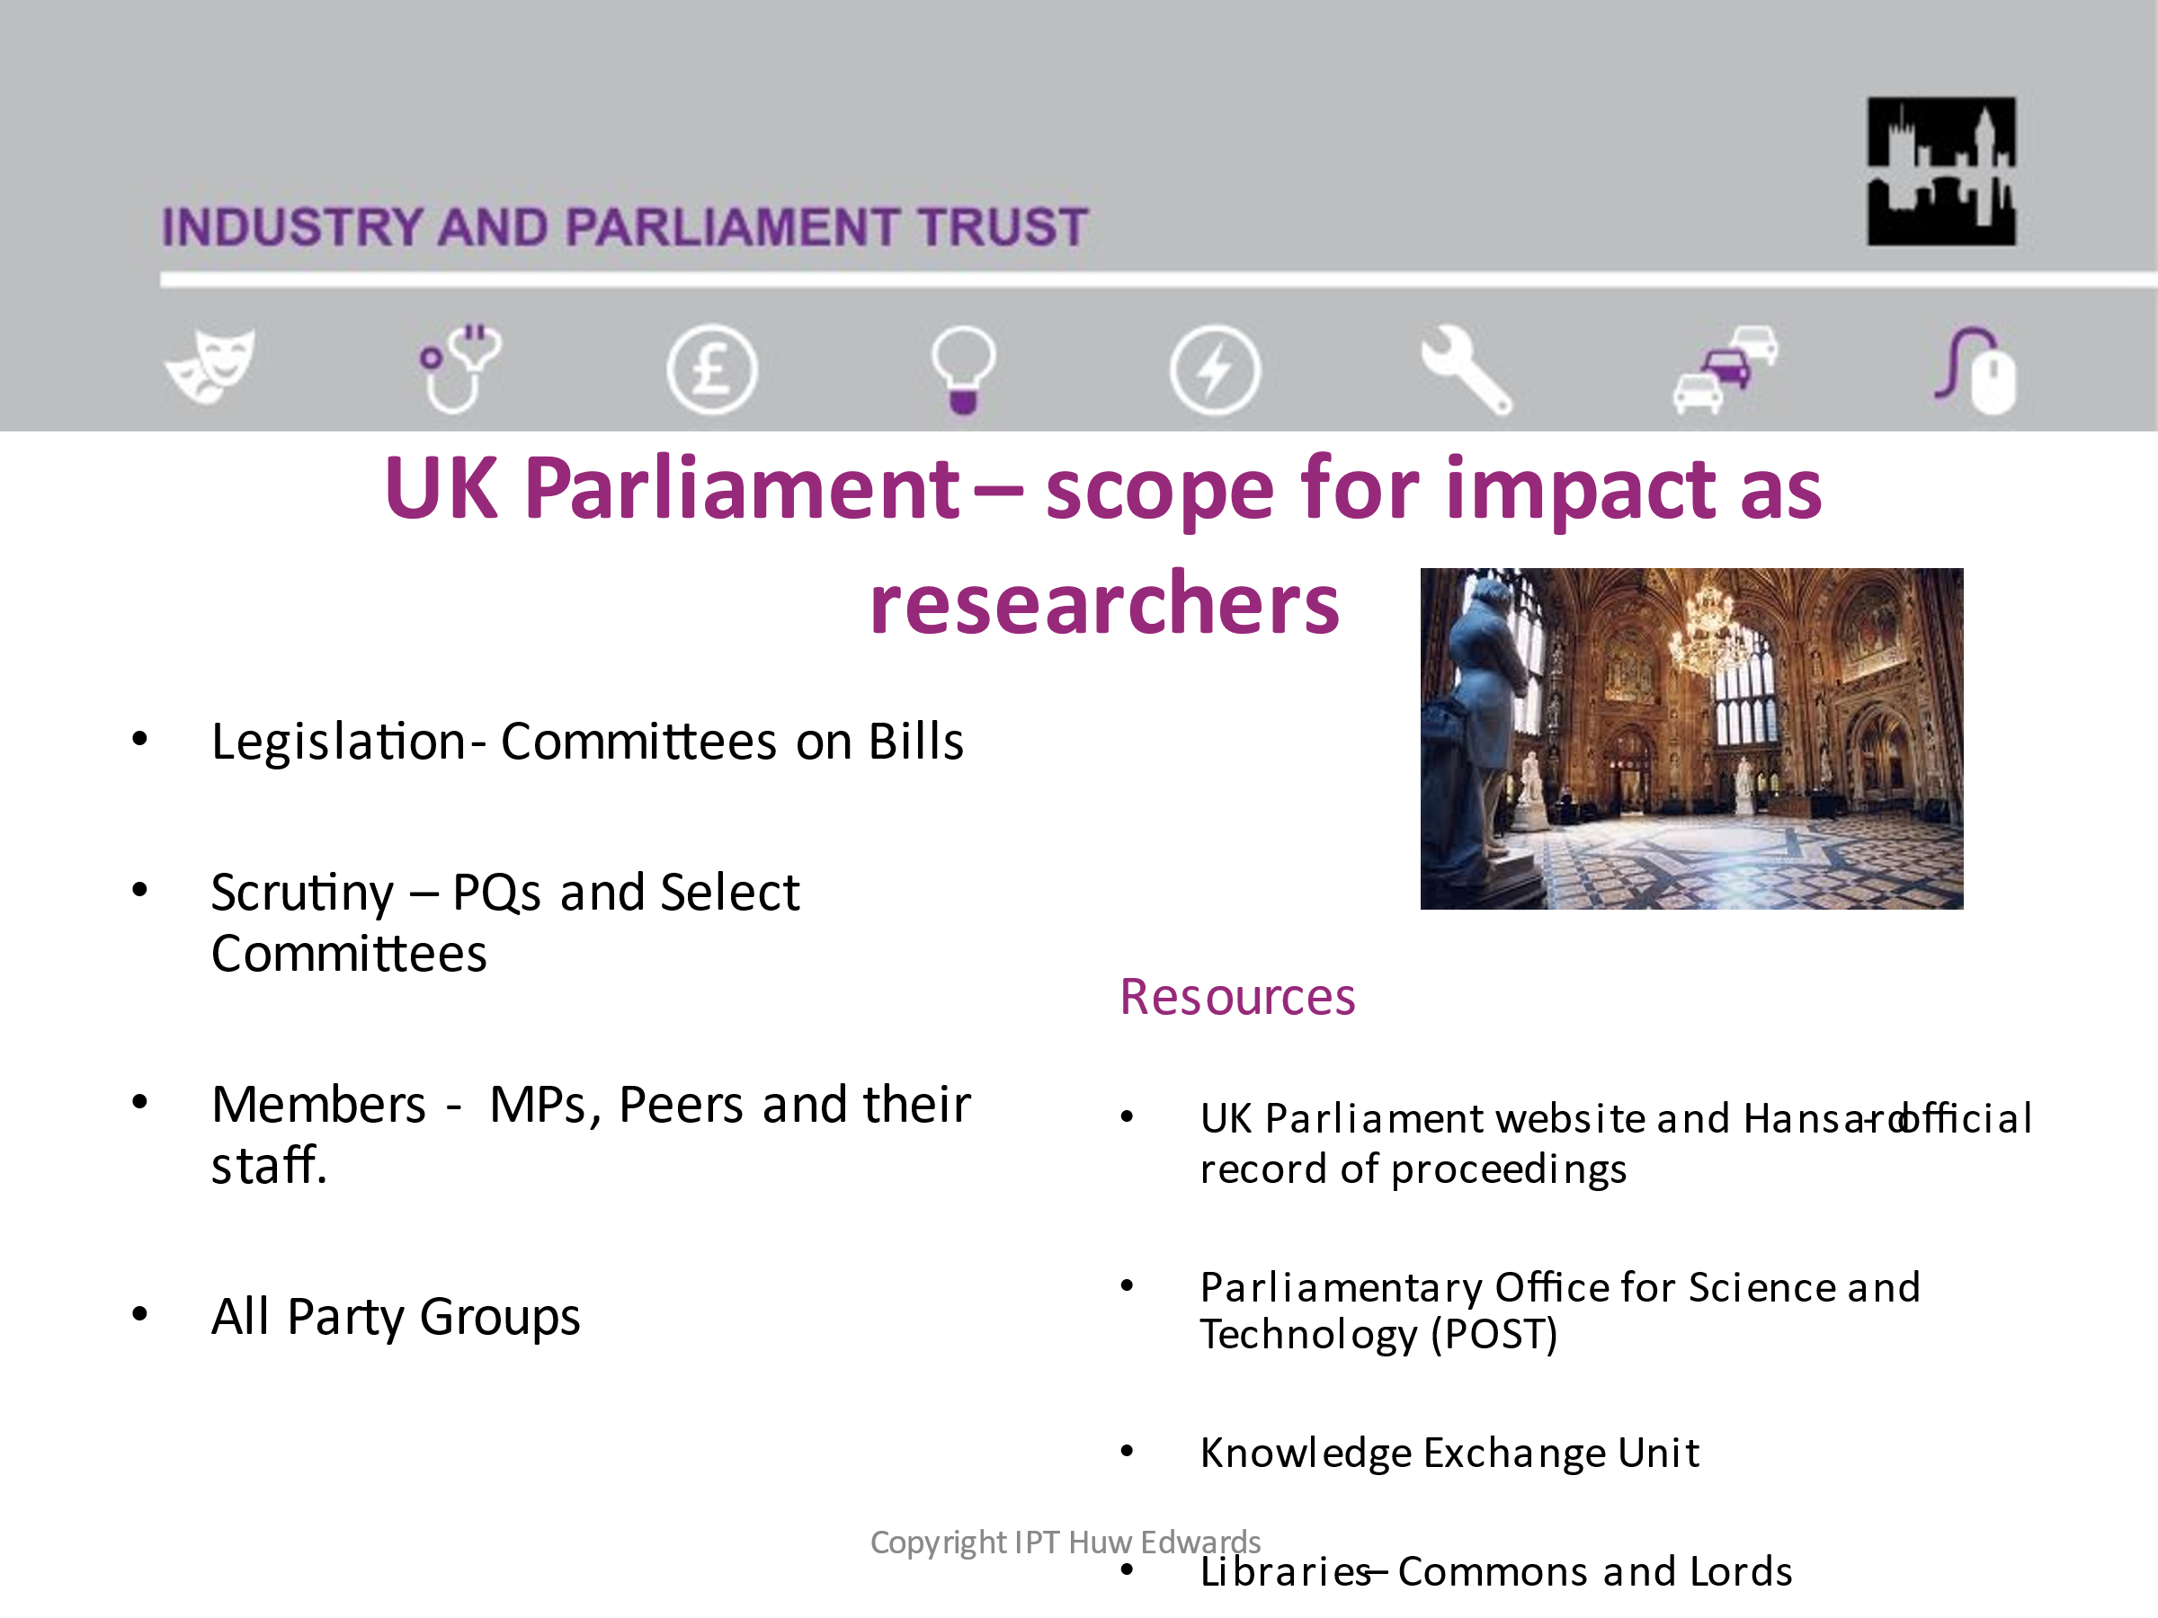
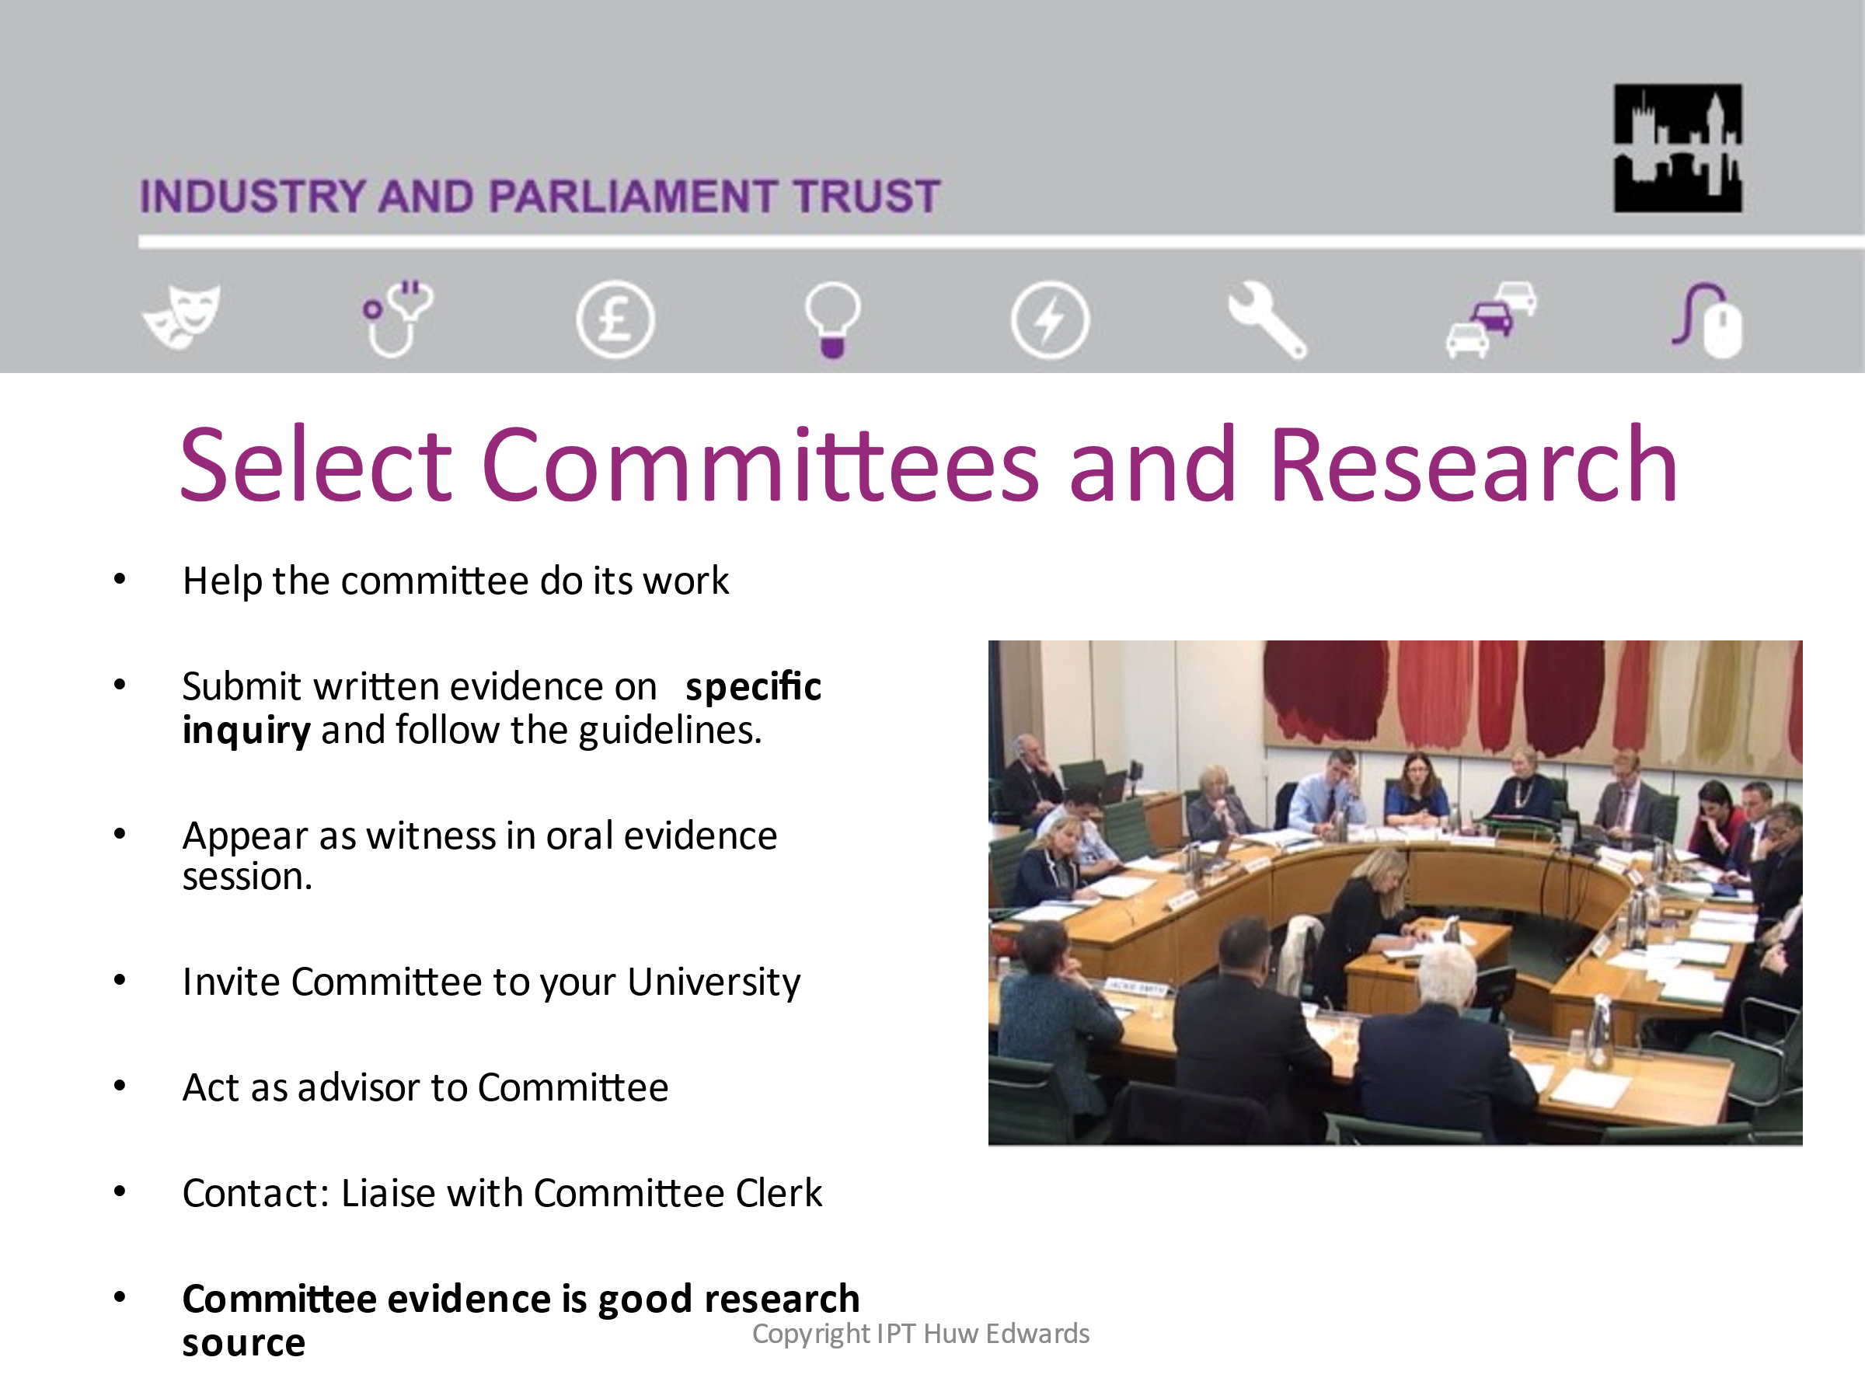

The half day sessions are held at Westminster, via Zoom and increasingly at universities. They may be for groups of Early Career Researchers, Senior Researchers or for staff from a specific research institute.
The aims of the sessions are to:
  - Identify what impact each researcher wants to achieve in their work.

  - Consider how to promote their research to UK Parliament and UK Government.

  - Support researchers to developing impact case studies for their university’s submission to the Ref 2027
My most recent was with Warwick University. There is no formal evaluation of the sessions but some participants post comments on Linked In.
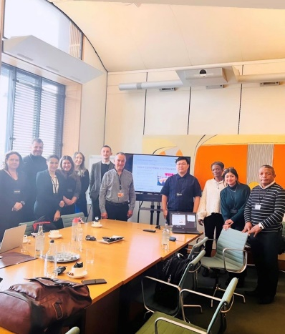
‘What a wonderful seminar at the UK Parliament organised by WMG, University of Warwick on policy training. Thank you so much Rachael Kirwan and Huw Edwards for making this so insightful’.
Shravani Sharma – PhD Researcher in Engineering


More recently, I have been approached by The Conversation, a not-for-profit organisation that supports academic researchers promote their work to the media. Most universities subscribe to The Conversation and many of the significant media stories relating to research arise through this collaboration.
The Conversation has recently established a subsidiary that focusses on training academics to write for the media and my own area of policy engagement training. Their mission is as follows:
- Universal Impact is part of a global network with an expert understanding of research and communication. For 10 years, The Conversation media organisation has worked with its university partners to take their research, knowledge and expertise and transform it into a subsidiary of The Conversation, Universal Impact now applies these skills to help universities and research institutions address a wide range of other challenges.

I contribute to The Conversation-Universal Impact training for universities on policy engagement. My courses focus on how researchers give their work impact, how they can promote their research to parliament and policy makers and give their subjects a policy focus. Again, this aims to support each university requirements under UKRI and the Ref 2027.

Independent Training Consultant for Universities
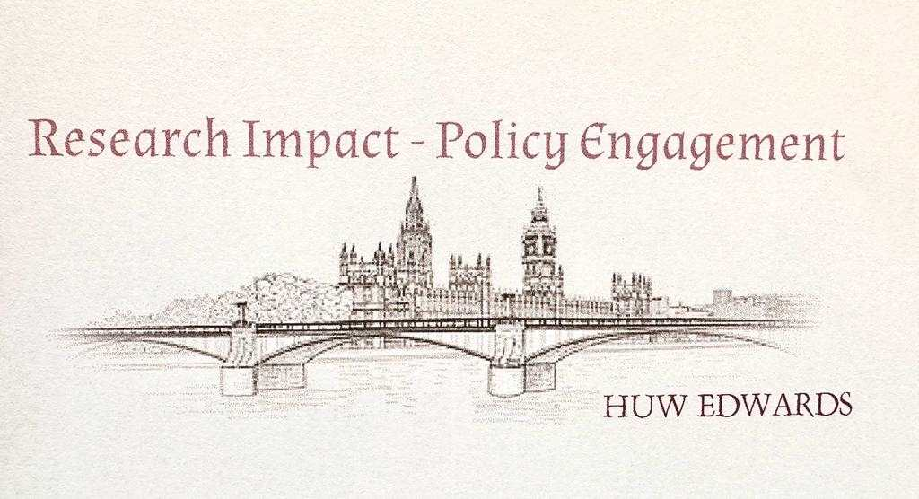
In 2023 I have been delivering policy engagement training to universities directly without the need for them to subscribe to other organisations to approach me. There are around 150 universities in the UK - large potential market.
To date, direct requests from universities have come from my social media profile on Linked In, personal recommendations and from contacts I have initiated.
The nature and standard of the of the training delivered remains the same as through other organisations. The main differences are that I must make the contacts with the universities and market myself. From the universities’ perspective, the costs of engaging me to deliver training is considerably less than going through an intermediate organisation.
Picture: Recent courses delivered at Cardiff and Lincoln.

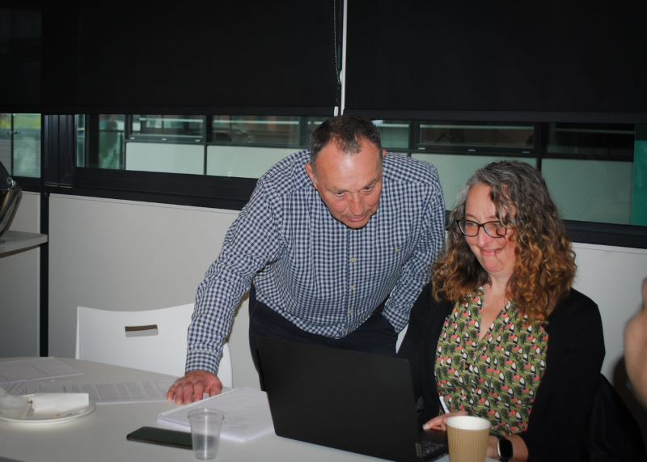
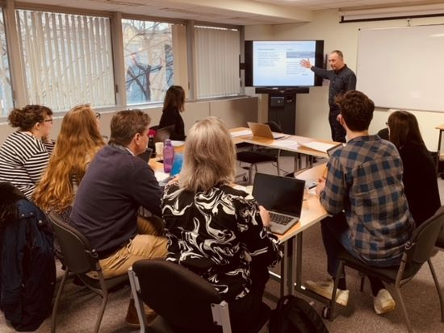

Training Evaluation – Key Skills
What are the main skills required for a training consultant working with university researchers?
- Ability to identify the level of understanding participants have and how the training session can fill any gaps in their understanding.

- Identify the current role and area of expertise of each participant using their university website profile and ‘know something relevant to the training course when they walk into the room’.

- Present a well informed and clearly designed presentation which increases understanding and is tailored to the researchers’ expertise.

- Facilitate understanding through breakout discussion, exercises, role play etc. and to make that experience relevant and enjoyable.

- To encourage participants to give their work a policy focus by guiding them through the UK Parliament and Government websites and identifying how their research subject comes up in parliamentary debate, questions, motions etc.

- Help researchers to identify how their subjects come up in select committee inquiries, encourage them to submit written evidence with policy recommendations and also coach them to give oral evidence if invited.

- Encourage them to contribute to the policy making process, to respond to government consultants and be able to brief civil servants and ministers.

- Offer to follow up after the session to support researchers in promoting their work to Parliament and Government.

Aspirations
I believe I have established a niche expertise in providing policy engagement training for university researchers. Other providers may offer expertise on government policy making and influencing skills but my own specialism, combining promotion research to the UK Parliament and UK Government may be distinct.
My main aspirations are therefore to:
- Widen the range of universities I provide training for – from a current figure of around 15 to many more.

- Develop a deeper focus on devolution, especially Wales, to increase the number of Welsh universities I could work for.

- Incorporate a deeper focus on devolution within England in recognition of the increasing number of Metro Mayors etc with decision making powers that universities are likely to be engaged with.

- Liaise with other training consultants to work in collaboration on such areas as devolution and political influence.

Further Skills
- Improve the marketing of my courses by investing in a new website and promoting it though social media.

- Enhance my social media presence by subscribing fully to platforms such as LinkedIn, develop contacts and make direct approaches to universities.

- Design a ‘feedback’ form to allow participants to comment on the relevance, content, delivery and value of each training course and to constantly improve the materials and delivery of the presentation.

- Widen the range of training to incorporate the perspectives and requirements of UKRI and coach researchers in compiling impact caser studies.

- Improve my financial management with respect to charging fees, chasing up unpaid invoices and preparing more detailed accounts.

Conclusion
This Training Needs Analysis has provided a valuable opportunity to helped to identify the role of being a Training Consultant on policy engagement for university researchers. It has an honest assessment of the strengths and weakness in my work and how to develop further skills to maintain this work for the next five years.

Personal Development Plan
D Prof Research
Huw Edwards

Introduction
This Plan will outline the necessary personal development required for the Doctoral Programme in Professional Development.
My aspirations are essentially determined by the current stage of my career. At age of 70, I believe it is realistic to plan for a five-year term during which I intend to a continue to work as a Training Consultant and to complete the Doctoral Programme. By the age of 75 it could be that my health and mental capabilities will necessitate my retirement!

D Prof Research
The current title of the final research project:
‘Wales and Westminster – Reflections on Representation, Legislation and Scrutiny’
This subject arose from my experience of being a Member of Parliament during the period of the Labour Government from 1997 to 2005 when the Government of Wales Act 1998 was passed which established the National Assembly for Wales.
As MP for Monmouth, I fully supported the devolution programme but represented a constituency that recorded the highest NO vote in the 1997 Referendum. This raised significant questions about representation and the conflicts in reconciling competing political demands – constituency, party and conscience.
Other Welsh MPs faced similar or different conflicts of representation based on many factors – political beliefs, cultural background, location and profile of their constituencies. For some, devolution for Wales may not have been as significant an issue as, for example, as the Iraq War. In either case MPs face conflicts of representation, party and personal belief and that deserve to be investigated.

Research Question
What influenced Welsh MPs in legislating on devolution for Wales and in the scrutiny of Welsh affairs in the period 1997 to 2005 and what conflicts arose in reconciling their constituencies, party loyalty and personal conscience?

This research project would be a contribution to two academic fields: political and parliamentary studies and recent Welsh history. It would aim to result in academic publications and deposit research evidence in the National Library of Wales and British Museum.

Review of Professional Learning
The research would draw on the knowledge and experience outlined in my Review of Personal Learning:
- Successful completion of higher degree research thesis for M Phil degree.

- Capacity to develop political and policy case studies.

- Study of political commentaries and biographies.

- Experience of being a Welsh MP for 8 years during passage of the devolution legislation.

- Knowledge of UK Parliament and Government and devolved institutions in Wales.

- Good understanding of parliamentary and Hansard records, select committee evidence and reports and spoken and published contributions of MPs.

- Personally known to all the Welsh MPs in the period 1997 – 2005

Further Skills
The key skills that are required to commence the research are:
- Improve use of online library resources and citations.

- Develop the skill and competence to undertake major review of academic literature and research sources from the parliamentary record and archives of the National Library of Wales.

- Improve qualitative research skills such as semi structured interviews.

- Develop skills on Oral History interviewing and transcribing.

Methods - Semi Structured and Oral History Interviews
Part of the research will involve interviewing as many as possible of the 40 MPs who were my contemporaries in the period 1997-2005. Sadly around 6 have died but around 30 from different political parties could be available for interview. It is also intended to interview former Chairs and Members of the Welsh Affairs Select Committee about the changing role of the Committee after devolution. Another part of the research will focus intergovernmental relations following devolution and this will involve interviewing Secretaries of State for Wales, key civil servants and academic experts.
I have been advised that I could also interview as many of these former MPs as part of the current Parliamentary Oral History Project. This project by the History of Parliament Trust and British Library has been running since 2011 and has so far recorded the life stories of over 200 post war MPs. Main contact Oral Historian Dr Emma Peplow.
I have applied to be a volunteer interviewer for the project and would be the first former MP to do this. I have undertaken initial training through the Oral History Society and will shortly be interviewed to be a contributor to the Parliamentary Oral History Project.

Conclusion
The D Prof programme offers an excellent opportunity to turn the experience and knowledge gained in my own three career paths - University Lecturer, Member of Parliament and Training Consultant – into a worthwhile research project.
The priority now is to embark on a major study of the academic literature and other sources and develop the skills outlined above before undertaking fieldwork and initial drafting.
Finally, can I acknowledge my gratitude to the staff and fellow researchers at UWTSD for their support in this programme and also the personal support of my lovely wife Tessie.

