In
Internet Technology & Security
University of Wales Trinity St David
Kaylie Shoulder (1800042)

Contents
Abstract 2
Introduction 3
Data-Flow Diagram 4
Mobile Device Management 5
Advantages/Disadvantages of BYOD 5
Network Explanation 6
Conclusion & Key Points 8
Bibliography 9

Abstract
Bring your own device (BYOD) ideals have become increasingly popular over previous years and will continue to grow for years to come – this report and demonstration aims to provide you with a complete, fully-functional, simulation of a BYOD network; it will also provide you with information regarding its security measures, how the network functions, and the advantages and disadvantages of a BOYD system.
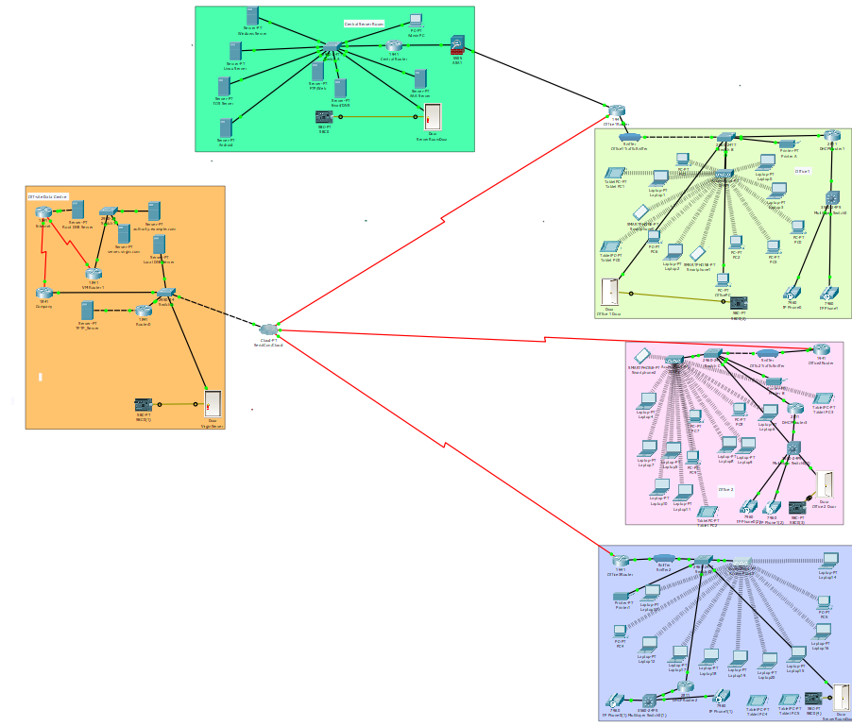
This network simulation was created using Cisco Packet Tracer version 7.2.

Introduction
Over the last few years businesses have taken leaps and bounds in regard to their advancements in technology, and this is why ‘Bring Your Own Device’ companies are becoming increasingly popular – this type of system is essentially enabling employees to bring their own personal devices from home, to work… to use for professional matters within the work-place, it is said to increase employee productivity.
Hyper-Fort’s network requires a comprehensive policy that ensures that the network is used in the correct manner, thus below is the framework which should be used:
User Policy- Acceptable Use:
This user policy covers both the use and the security of all devices on Hyper-Fort’s network – which also includes e-mails, internets, and all technological equipment. Each employee should take heed whilst using company resources, ensuring that the property is used for professional use only. Whilst using company products (including the internet) employees should refrain from using such resources to access/send/receive explicit, defamatory, discriminatory, copyrighted, or libellous material, this includes gambling and downloading software unauthorised by company policy. Employees should ensure to only used authorised software during work hours and personal devices should NOT be used for personal use during the work-place. [1]
Security Policy:
This policy covers all aspects of the networks security, which includes both physical and online security. Each member of staff should be provided with a unique username and password which will be required each time upon log-in; members of staff should refrain from releasing this password to anyone and staff should ensure to not store password in unsecure places. Each user should be sorted into a hierarchy, with each employee having their own set of individual privileges based on their role within the company. Should someone leave the company then it is the responsibility of the IT department to revoke the employees’ access and terminate the account immediately, joined with this, changes of role within the company should be accommodated for accordingly. Every password should be required to be changed after every 90 days, and each password should be at least 8 digits long, including capital letters and numbers. To ensure the network is as secure as possible, a penetration test should be completed on a monthly basis to identify any holes within the network security and should be patched promptly. Any planned changes to network hardware/software should be trialled before a permanent change and should be assessed for their effect on the system. Repeated failed log-ons should also be recorded. The rooms in which servers are stored should be secured with locked doors, and those authorised should be equip with a key. Each employee should also have in-depth training regarding online threats. The network should also be secured with a firewall, and each device should be provided with an anti-virus software.

Device Management:
Upon the installation of a network, each device should be set up in the most logical, beneficial format. Each device which includes, but is not limited to: drives, servers, switches, and peripherals [2] should be monitored constantly to ensure no malfunction has occurred- should a malfunction occur then it is the responsibility of those who recognise it, to report it, and the IT department to diagnose and rectify the issue. Severs should be backed-up at a minimum of once a week but a maximum of 7 times, to an external, off-site location which prevents mass amounts of data loss should an incident occur. Each technological device should be PAT tested annually (which includes every electrical device) to ensure safety. The network should be regularly maintained to ensure full-functionality is maintained throughout.

Data-Flow Diagram
The dataflow diagram below highlights the process of a user attempting to log into the Hyper-Fort portal, in includes the following scenarios: a user with the correct credentials, a user with incorrect credentials, an idle user, and manual user log-out.
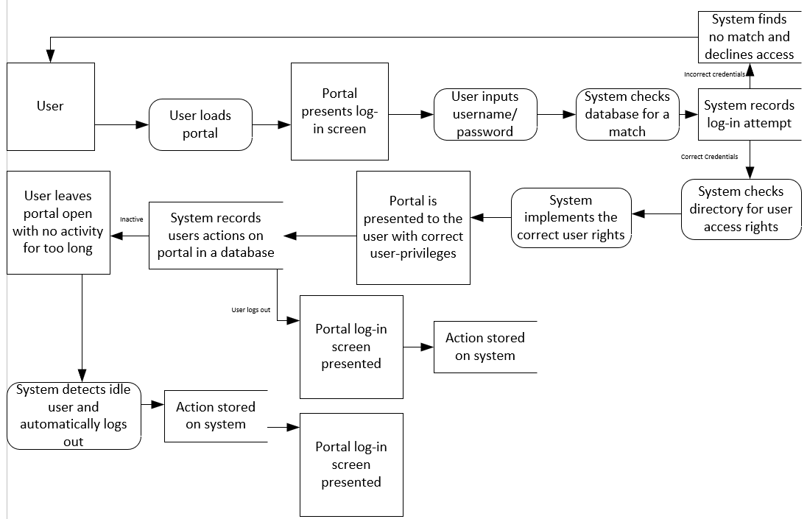

Mobile Device Management software is essential for the network as it aids with the strengthening of the network security, as Hyper-Fort is such a large company it is vital that they use only the strongest of systems, and thus it appears as though VMware’s ‘AirWatch’ is the most appropriate software for the company. This is the chosen management software because of its flexibility- firstly, AirWatch allows the admin to ‘configure MDM policies for devices based on a range of things, from layouts, restrictions, and even settings access’ [3], and can be assigned based on whether the device is corporate-owned or a personal device. Joined with this, AirWatch is highly compatible with enterprise e-mails, wireless connection, and intranet sites; Hyper-Fort is heavily reliant upon all three of these resources and its compatibility adds a back-bone to the system, which allows each device to be managed and secured correctly even whilst using such technology. Using AirWatch you can also track the GPS location of connected devices, so should an employee lose the device or leave the company then AirWatch can be used to track it, and because of AirWatch’ capabilities the admin can also wipe the device clean of all data. AirWatch can also track the activity of its users which is good for Hyper-Fort because it can detect if the device is being used wrongly. detected to have broken the contract, then the appropriate actions can be taken against the employee. AirWatch can also be used to send out broadcasts to its users, so if admin need to shut down aspects of their portal or software then they can inform the employees of the actions beforehand to allow employees to prepare for this [4]. AirWatch can also be used to generate a ‘black-list’ of all dangerous or unauthorised that employees should not be using whilst connecting to their system, preventing access to these apps whilst in the work-place. AirWatch can also act as an Anti-Malware system and can scan connected devices for any malicious code within the system. AirWatch is also easily set up, either through a batch file or through an URL and a provided activation code. Data storage will also be less of an issue for the company as AirWatch secures all data that is stored on the device – it essentially provides you with a data-backup system, and you are able to lock specific aspects of the devices whilst under the provision of the system, even things such as their browsers. [5]

Advantages/Disadvantages of BYOD
There are of course, both positive and negative aspects to using a BYOD system in the work-place and it is important that all aspects are investigated before fully implemented as a working system.
First and foremost, the way in which employees work will change drastically – if this system is implanted then it is almost guaranteed that employee productivity will boost by leaps and bounds- the primary reason as to why is rather simple, but highly effective, and that reason is that people are more comfortable with using their own devices; they’re much more familiar with them, they know how to use their own devices. Because of employees efficiency with their own devices then there is less time for them to ‘learn’ how to access specific aspects of their technology - new technology requires employees to be trained, but as they are using their own device they will already be aware of how to navigate around their own devices which means they can make full use of a range of software and applications that they may not have before, thus generating a higher-quality level of work at a much faster pace. Joined with this, employees are much more likely to complete work outside of work hours as they’re able to access their work wherever they are, regardless of the time, which means that even if an employee can’t get in to work one day because of weather conditions, they’re still able to work from home. The company also won’t have any liability upon the devices, as it is the employee’s own device, should it break, or an issue occur then it is the responsibility of the employee to ensure that the device is fixed – so the company will be at a financial benefit as they won’t have to spend on training or fixing broken products. [6]
However, there are downsides to a BYOD system in the workplace and one of the main issues is security – because employees are using their own devices to access the workplace portal, it login wherever they are, and this could pose a security threat to the company as their information can be viewed anywhere at any time; even if the employee does not disclose or intentionally hand-out workplace information, someone may be able to view their screen from behind their shoulder and take pictures of it, or write the information down, which means that company will have private information disclosed. Also, as the devices are being brought to and from the work place, there is a lot of room for loss or theft which will grant hackers easier access to the device’s information- this can be counter-measured using AirWatch and wiping the device, however. Joined with this, as the devices are employees personal devices, they could have malware embedded within their files, or malicious apps/software that could seep through onto the company network if it is connected, which could infect the machines of many, if not all devices that are connected to the same network – meaning that the company would experience down-time, and thus lose money. [7] You would also need to strictly monitor employees as it is possible that they could be using their own device for their own personal use as they have access to all of their own files – so this could result in poor quality of work, and lesser amounts if the circumstance is extreme.

Network Explanation
As Hyper-Fort rely heavily upon wireless connection, the mobile devices connected to the network will retain information about the company network after connecting to it. Firstly, the device will remember the password of the company network even if it is not exposed to the user, along with the security type that’s used so: WPA, WPA2 PSK, etc. Joined with this, it is likely the router IP & MAC address will be viewable to the users. The potential for data leakage when an employee leaves the company is always a possibility regardless of how tight the security is - however, within Hyper-Fort’s network, upon an employee’s departure it is stated within the framework that the account should be terminated immediately, which means that should the employee attempt to ‘sign in’ to the work-place portal after leaving, their account will have been revoked and they can no longer gain access. However, in some instance’s employees may have saved work-related information to their personal device itself, rather than the work-place network – in this instance, the mobile device management software can be used to wipe the device of all work-related information. After the employee departure, the IT department should also block the MAC address on the networks firewall, thus preventing the ex-employee from being able to connect wirelessly. There is always a small chance of data-leakage occurring regardless of how well the company follows procedure, however ample steps have been put in place to reduce the chances of this occurring drastically. However, should a device be lost or stolen, AirWatch should be used to wipe the device as soon as it has come to attention. If an employee’s device is broken during the office, at fault of the company or another employee, it is the company’s responsibility to provide the employee with a replacement or the funds to buy one. If it is the fault of the employee it is the employee’s responsibility to replace the device, and the broken device should be wiped.
As employee’s are using their own personal devices, it is important that the system can decipher when an employee is using their device for personal use, and when it is being used for business use. In order to decipher this, packet sniffers have been implemented on each of the separate office networks, each time an employee attempts to do something on their device, the sniffer will report it – the sniffer should have pre-determined ‘banned’ words such as ‘Facebook’, and the attempt to access this should be highlighted within the sniffer logs. An application such as ‘TeamViewer’ should also be installed on each of the devices when connected to the company network which admin can use to check on devices usages as this application allows the admin to view the screens of the users connected to it, and it also allows for remote control of the devices, along with sending messages. If an employee is caught using the device for personal use, the admin can either send a message, or lock the employee’s computer until the issue is dealt with. Joined with this, TeamViewer can block specific things from being searched, adding key words into the log (such as ‘social media’) will prevent the users from accessing such websites, and this should be implemented on the network as well as the application. When an employee attempts to search for specific things, it will be blocked, and a notification will be sent to the admin.
Employees using their own devices means that there will be many different types of devices and operating systems – it has been ensured that Hyper-Fort’s network is resilient enough to support this. The network has its own dedicated server room (which has connection to the internet service provider (ISP)) and within this server room are 4 separate servers which are: Windows server, Linux server, IOS server, and an Android server. The system should detect which OS the devices are using, and thus should be connected separately. As different OS’ require different applications/software due to compatibility differences each server will have dedicated, related software for each device to use – this includes smart phone applications. Thereon, it is assumed that the network is durable and resilient enough to withhold a large number of devices with multiple different operating systems as it has separate servers and separate comparable applications for each device.
The network designed for Hyper-Fort was carefully constructed LAN with security being the prime focus, along with functionality. Each and every single switch and router on the network has been thoroughly secured- each device has it’s own banner set, reminding those who attempt to access it that any unlawful/unauthorised access will be tried under law, and then requires a password to log in- these passwords are encrypted, which means that they cannot be read even whilst in cli. The routers are directly connected to switches, which are then connected to wireless access points- these access points have WPA2 -PSK authentication, which is the best form of password security that is offered, with a password that includes a mixed range of uppercase and lowercase letters, along with numbers – it is also 13 digits/letters long. It is also secured with an AES type of encryption which is considered practically unbreakable. To add to this, each room has been secured with a locked door that has been connected to an SBC-PT which its micro-controller, and the door can only be unlocked when those who try to access it have the correct cards to scan in. However, the server room key-fob should be separate to the office fobs, and these fobs should only be provided to the network administrators. The network also has a firewall that has been implanted at the base of the network to protect the network from malware.

Conclusion & Key Points
To conclude, Hyper-Fort’s network is a highly-secured LAN which allows for large amounts of people to connect to the network; there are a total of 3 wireless access points which devices can connect to – there are three offices that have been carefully planned out with secured routers and access points to protect the company network. Hyper-Fort have their own E-Mail system which has been secured on a separate IP and each employee shall be provided with their own personal username and password. The network is also incredibly versatile with 4 different servers being implemented to ensure regardless of the device, connection to the network can always be established. It is also secured with packet sniffers and a mobile management software which can act as a malware detection service as well as a good way to analyse traffic. It is clear that a BYOD service has both its advantages and disadvantages, and this requires extra security and a more in-depth check on the network traffic to ensure employees are on track, however it does push people to have more motivation whilst doing their work as they’re much more likely to use their own devices.

Bibliography

[1] | "Acceptable Use," [Online]. Available: https://www.getsafeonline.org/themes/site_themes/getsafeonline/download_centre/sample_acceptable_usage_policy.pdf. [Accessed 13 12 2018].
[2] | D. T. G. -. L. a. D. I. o. Technology, "Operating Systems: Device Management," Slideshare, 17 03 2017. [Online]. Available: https://www.slideshare.net/DamianGordon1/operating-systems-device-management.
[3] | vmware, "Begin with the Basics: Manage the Complete Device Lifecycle," vmware, [Online]. Available: https://www.air-watch.com/capabilities/mobile-device-management.
[4] | G. W. Stuart, "VDestination," AirWatch: What it Can and Can't Do, [ Online Report]. Available: http://vdestination.com/airwatch-what-it-can-and-cant-do/.
[5] | R. Hein, "7 Reasons to Use AirWatch for Mobile Device Management," CIO, [Online]. Available: https://www.cio.com/article/2394249/mobile/7-reasons-to-use-airwatch-for-mobile-device-management.html.
[6] | I. Riverside Technologies, "The Advantages & Disadvantages of BYOD," Riverside Technologies, Inc., [Online]. Available: https://www.1rti.com/the-advantages-disadvantages-of-byod/.
[7] | "THE PROS & CONS OF BYOD IN THE WORKPLACE," EZComputer Solutions, [Online]. Available: https://www.ezcomputersolutions.com/blog/the-pros-cons-of-byod/.

