Personal Development Plan
Study Skills

Student Number: 2206005

I confirm that I have not used any AI tools to generate any part of this presentation.
I confirm that I have not presented any AI generated text as my own work.
I confirm I have copies of my drafts, notes, and any other resources I used before and after the use of AI tools, which I may be asked to provide in evidence.

Link to Video: PDP Study Skills Presentation.mp4
Slide 1
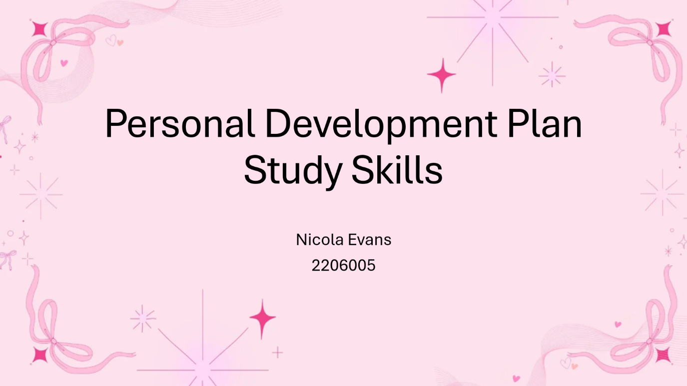
Hi, my name is Nicola Evans, and this video is my Personal Development Plan for Study Skills. I’ll be talking through my long-term goals, the areas I want to develop, and the SMART targets i have

Set to help me progress through my degree.

Slide 2
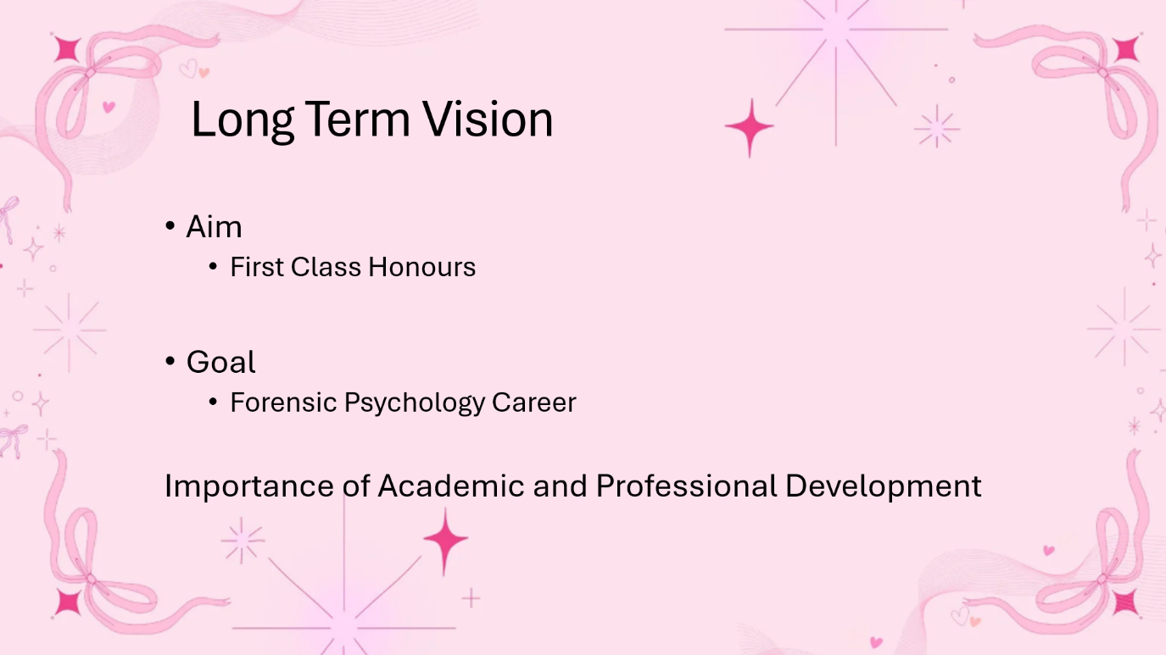
My long-term vision is to complete my degree with First Class Honours and progress towards a career in Forensic Psychology. To achieve this, I need strong academic ability and confident communication skills, so personal development is essential for building the foundation required for Postgraduate Forensic Training.

Slide 3
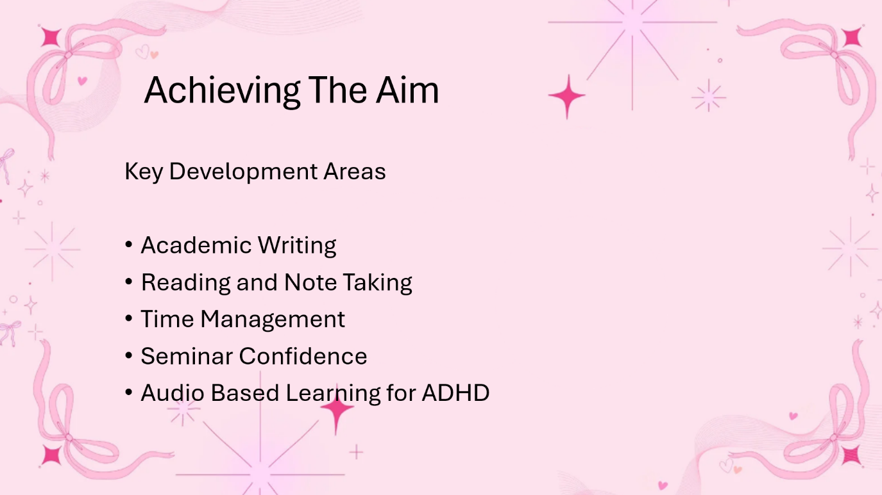
To work towards this aim, I have identified several key development areas. These include academic writing, effective reading and note-taking, stronger time management, and improving my seminar and presentation confidence. I have also included audio-based learning strategies to support my ADHD and help me learn in a way that works best for me.

Slide 4
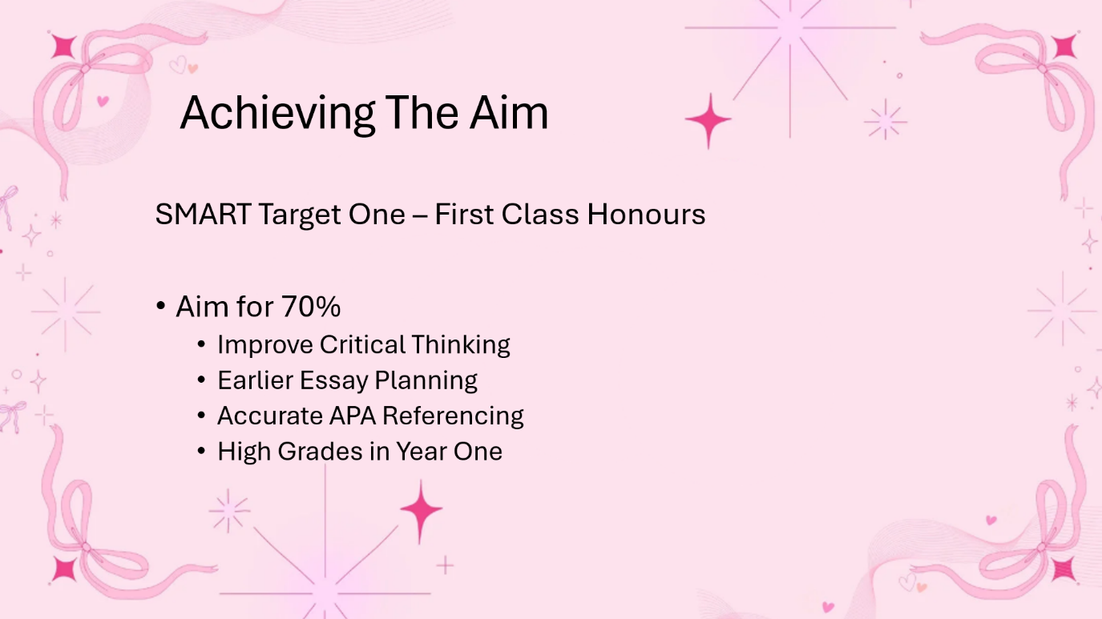
My first SMART target focuses on achieving First Class grades. To work towards this, I plan to improve my critical thinking, plan essays earlier, and use accurate APA referencing consistently. Building these habits in year one will help me work at the level required for First Class Honours.

Slide 5
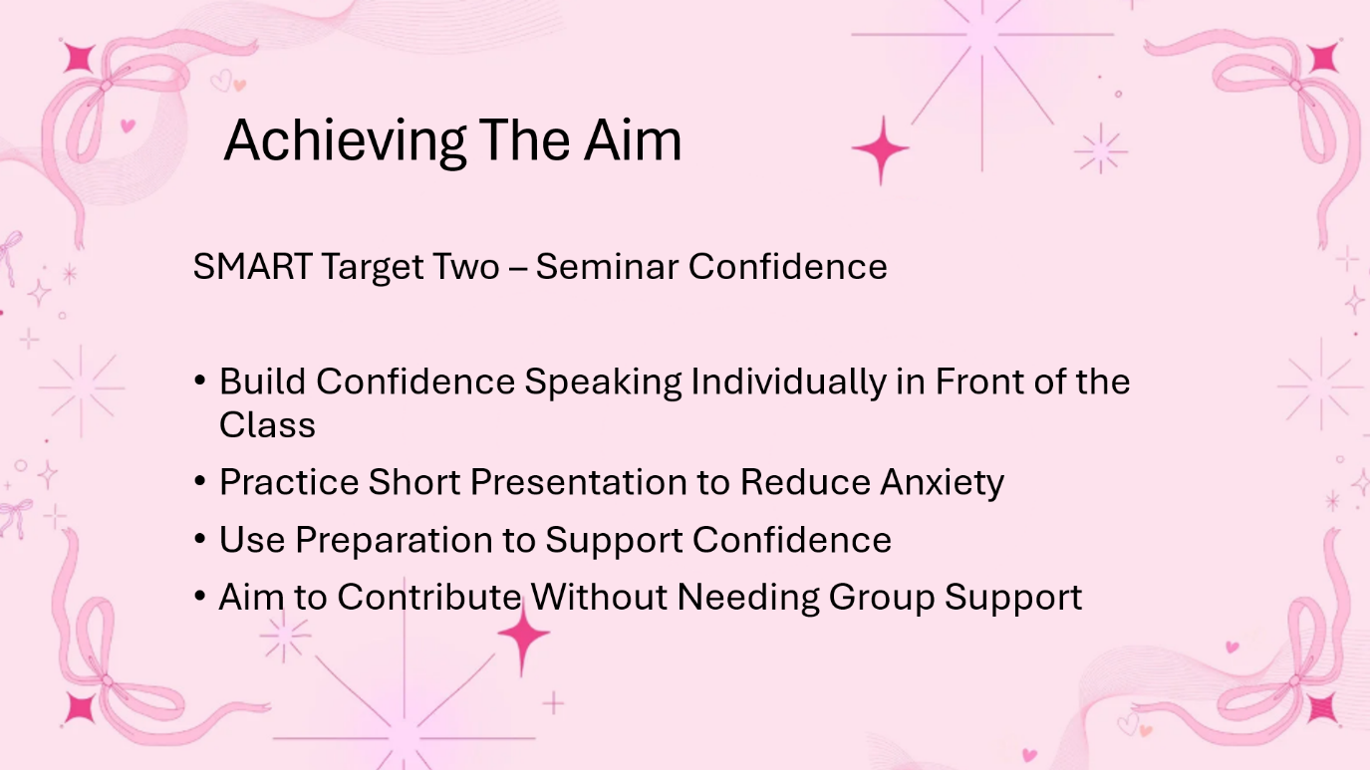
My second SMART targets focuses on developing confidence when speaking individually in front of the class. I want to become more comfortable presenting on my own, so I plan to practise short presentations, use preparation and cue cards, and gradually contribute without relying on group support. This will help me feel more confident in assessed presentations later in the course.

Slide 6
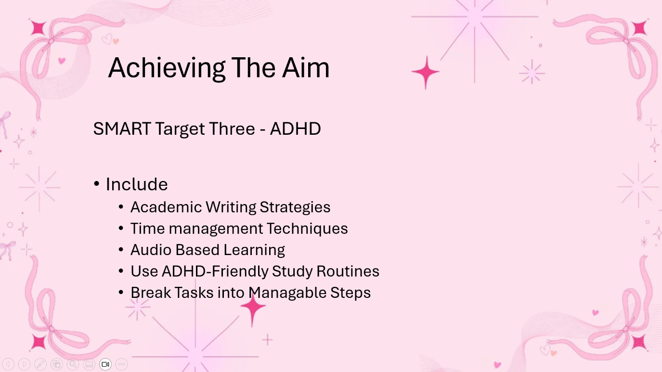
My third SMART target is based on managing my ADHD in a way that supports my learning. This includes using academic writing strategies, better time-management techniques, and audio-based learning. I also plan to stick to ADHD-Friendly study routines and break tasks into smaller steps so I can stay focused and organised.

Slide 7
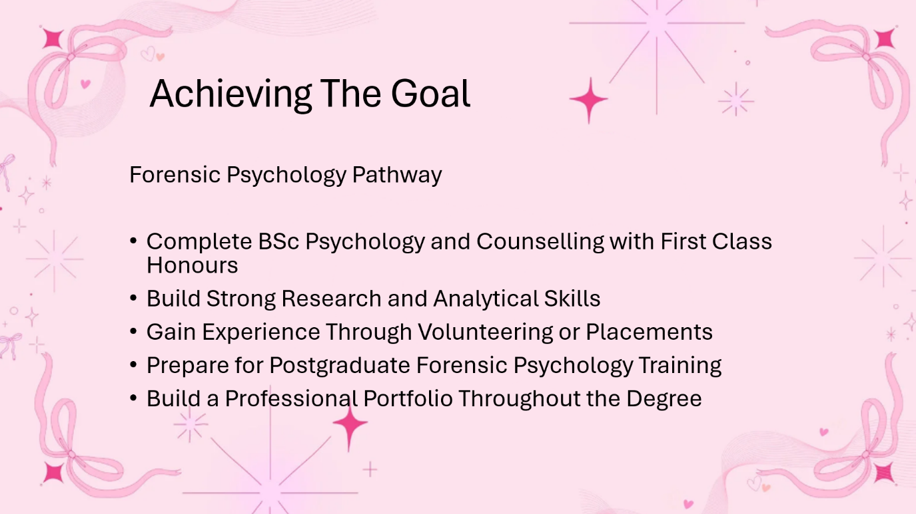
All of these targets link to my long-term goal of working in Forensic Psychology. To follow this pathway, I aim to complete my degree with strong grades, develop good research and analytical skills, and gain experience through volunteering or placements. I will also build a professional portfolio throughout my degree to prepare for Postgraduate Forensic Psychology training.

Slide 8
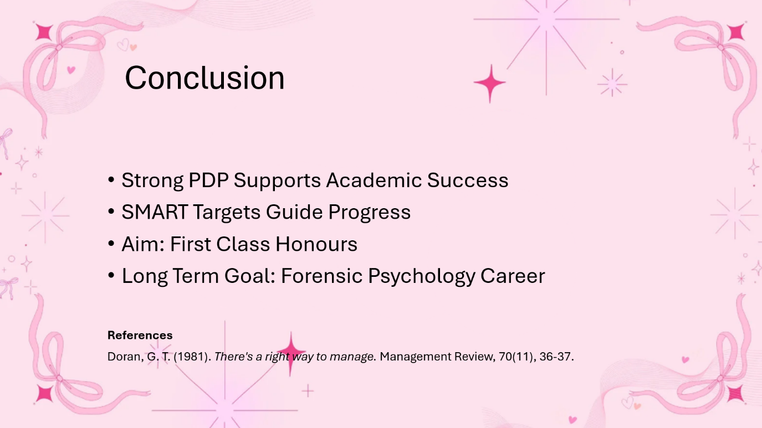
In conclusion, my Personal Development Plan gives me clear structure for improving my Study Skills and achieving my aims. My SMART targets guide my progress, and all of them support my long-term goal of gaining First Class Honours and working towards a Forensic Psychology career, Thank you.

References
Doran, G. T. (1981). There's a right way to manage. Management Review, 70(11), 36-37.

