Vehicle Tech 2 – Vehicle Structure and Aero

Seth Jones
1701717

Q1. Choose two of the following body/chassis structure types & discuss the pros and cons:

- Steel Monocoque

The steel monocoque chassis is one of the most widely used chassis today. There are many pros and cons of the chassis which will be discussed in this essay. The first pro of the steel monocoque is that it has a really low production cost. This is thanks to a hugely robotised production, meaning a more accurate production of the chassis as a robot is able to repeat the same production technique over and over again without fatigue. Also, because robots are able to work 24/7 they can produce far more chassis in a day than a person as the person will be working a 9-5 job for example, whereas a robot can be working all night and all day.
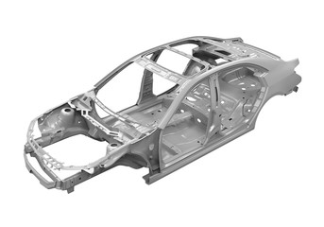

Another pro of the steel monocoque chassis is that is has inherently good crash protection. This is because the monocoque chassis is already incorporated with the body in a single piece. The monocoque chassis is actually made by welding several pieces together. The floor, which is the largest piece, and other pieces are press-made by big stamping machines. They are spot welded together by robot arms in a stream production line. The whole process just takes minutes. After that, some accessories like doors, bonnet, boot lid, side panels and roof are added. Because of the chassis being made like this, there is a lot of room for crumple zone to be added to aid crash protection.

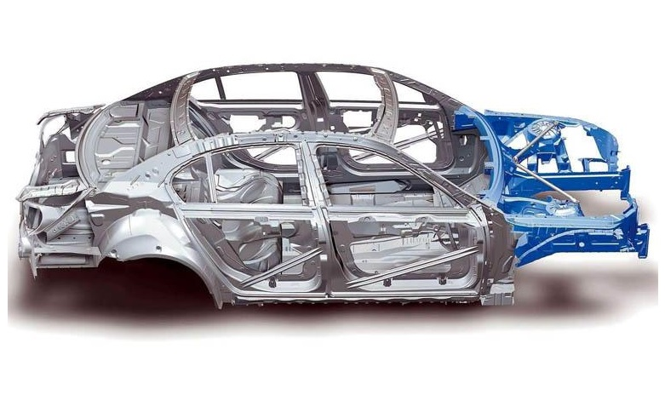
As you can see in the above photo, the area in blue is the front crash protection. As you can see, because the way that the monocoque chassis is manufactured the crash protection is built into the chassis so is stronger. Also, from this picture you are able to see the space available on both the inside and the outside of the vehicle.

Furthermore, another pro of a steel monocoque chassis is that space efficiency is pretty good. Because the way that the chassis is put together, unlike other chassis there are no large transmission tunnels or high door sills that get in the way. This is good for space efficiency within the car.

On the other hand there are a lot of disadvantages to a monocoque chassis. The first of these being that they are very heavy in comparison to other chassis types. This is because so much metal is used to make up the chassis to make it have as much rigidity within the frame as possible and to also be able to add a good size crumple zone into the chassis.

Also, because the shell is shaped to help with space efficiency rather than to strengthen, and because the pressed sheet metal is nowhere near as strong as metal tubes or extruded metal, the weight to rigidity ratio is also the lowest.

To finish, the final disadvantage of the production of the monocoque chassis is that there is no financial way to create them in a small scale volume because the setup cost of all of the tooling is too expensive, for example the stamping machines and the machines that create the mouldings.

Generative Design

Generative design mimics natures evolutionary approach to design. Designers or engineers input some design goals into generative design software, along with parameters such as materials, manufacturing methods, and cost constraints. The software explores all the possible permutations of a solution, quickly generating design alternatives. It tests and learns from each slight change what works and what does not work.

The first pro of generative design is that because there is a huge involvement with the use of a computer, the opportunities of design are absolutely endless as the computer will be able to think of new creations and designs far quicker than a human and also the computer will be able to create designs that a human wouldn’t be able to think of, meaning it will produce a wider range of designs.
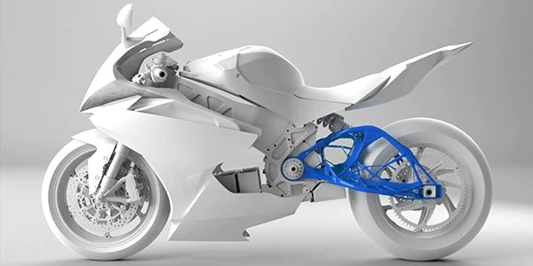

Another pro of generative design is that it will be able to produce designs that are impossible and be able to find the solutions that will make those designs possible. That is because there will be some human interaction with the generative design programme to set the parameters for the design for example the size of the product that it is designing. This will allow the programme to make alterations over and over again to make the design eventually work properly as it should to make it possible to be manufactured.

Furthermore, another pro of generative design is that there is reduced material waste. Because there are constraints available that a person can set, this will help with the reduction of waste as a constraint could be for the machine to only use the material absolutely needed and nothing more. This factor of less wastage will also mean that the outlay for materials will be cheaper as you will know how much exactly you need rather than buying too much.

On the other hand, one major negative to generative design is that there is an initial investment needed. This is because it is new software and that you need a machine to create the framework that the computer has created. This could be a big problem for people as the equipment can be very expensive.

Another negative of generative design is that because the design creations take a natural form, when it comes to creating a chassis for example or the body work of a car, it is almost exoskeletal in its appearance. Therefore if a design team was to use generative design to create a cars bodywork, they would have to put panels over the generative design skeleton to allow the vehicle to have windows, doors, and outside panels. This is a disadvantage because you will be covering up the main reason for using generative design, as you will lose the design characteristics.

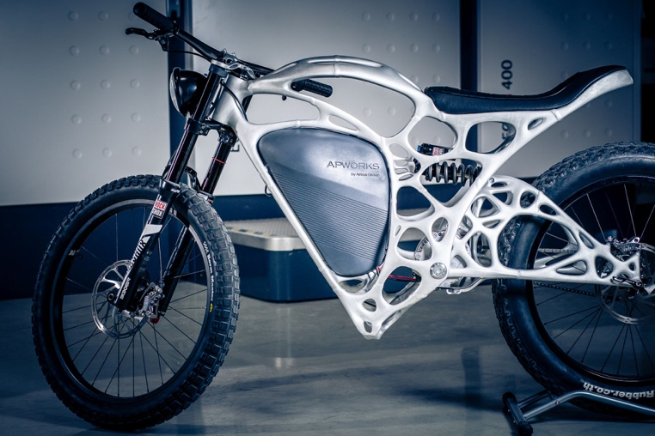

Q2 An understanding of aerodynamics as it relates to automobiles is considered to be important in order to improve which major areas of performance and explain the criteria that effects drag or wind resistance of a vehicle?

When it comes to automobiles, aerodynamics is an important part of automotive design. Aerodynamics wasn’t always very important. As time has gone on it’s become clear that when a car is designed in a way that reduces drag and promotes air to flow more easily around the vehicle, you increase performance and efficiency. A car with a low drag coefficient will generally be more efficient and have better performance than a car with a high drag coefficient.

There are six forces that are acting on a car whilst it is driving down the road, these are;

- Drag
- Lift
- Side Force
- Rolling Motion
- Yawing Moment
- Pitching Moment

The first reason why improving aerodynamics on a car is good is for the cars fuel economy. When the car has really good aerodynamic flow over the body, when it is cutting through the air, the whole car has less drag resistance meaning that the air it is hitting is clean air.

Another reason is that you can use rear wings to assist with how the car moves through the air. A rear wing is helpful because it uses the airflow coming over the car to make the rear wheels planted onto the tarmac. A good example of this is the McLaren Senna. This car has a really large rear wing which provides around 800kg of downforce on its own.

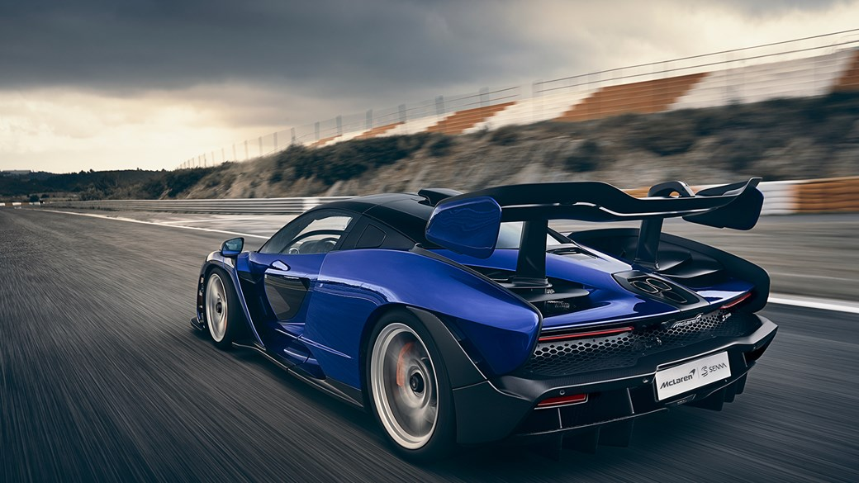

Because of this extra downforce that rear wings generate, the handling of the cars is greatly improved. This is a large factor in the handling of the vehicle, using natural downforce produced by the air flow coming over the car.

Another factor that can be added to help with downforce of the vehicle to increase the handling of the vehicle is active aero. You can add active aero to the vehicle that can open and close when the car feels it is needed or when you reach a specific speed. You can have some active aero on the floor of the car, which can move some fins on the under carriage of the car to direct the flow of the air around the car.

Good aerodynamics on a car can also improve and help with the cooling of the car. When designing a car with good aero dynamics you can design the body in a way that there are vents and openings in places which will aid the car using air to cool important components. A good example of this is McLaren, which have designed their cars to have cooling integrated into the body of the vehicle.

Some factors that affect the drag resistance of a vehicle are the shape of the vehicle. If the vehicle has a streamlined body, then it will be producing a very low amount of drag, however if you had a flat surface, or something with a very large surface area will produce a lot of drag as it has a lot of surface where the wind will be making contact and hitting it.

Tires also play a huge part in how a car moves through the air as if the tires on the car aren’t good then there will be a lot more rolling resistance than if you put a really good set of tires on your car. When you press down on the accelerator in your vehicle, you are essentially transferring energy—in the form of gas or electricity, depending on your automobile, through the engine and other systems in your vehicle. That results in your tires turning and enough momentum being built up to move your automobile. To accomplish this, though, your vehicle must overcome a lot of different factors that can make it resistant to forward movement. One of those factors is the tires’ rolling resistance. Tire rolling resistance is the energy that your vehicle needs to send to your tires to maintain movement at a consistent speed over a surface. In other words, it is the effort required to keep a tire rolling.

Tire resistance can’t be avoided seeing as through your tires, your only contact to the road underneath is through the rubber. Rolling resistance can only be minimalised. For drivers who are interested in optimizing their vehicle’s fuel efficiency, the answer is yes. Low rolling resistance tires can be much more fuel-efficient tire than conventional tires.

The aerodynamics of a car can be measured in the modelling stage. The modelers will use some white smoke in a wind tunnel to check the airflow going over the model and then if there is a section where the airflow is not how it should be or not up to scratch then they can make the change and then complete another smoke test to see if the change they made had made a change or not.

In conclusion, the main factor in my opinion which will help the most with aerodynamics and help the most with drag and wind resistance is active aero. I think this because if you have good active aero on the front of your car that will channel air around the front or take the air in through the body or underneath then this will help massively.

References

Chassis image
https://www.google.com/search?safe=strict&tbm=isch&sa=1&ei=yDWhXISwDYmhUNPjqMgE&q=+monocoque+chassis&oq=+monocoque+chassis&gs_l=img.3..0i67j0l9.1226345.1226345..1226947...0.0..0.63.63.1......1....1..gws-wiz-img.iX1nppuySnw#imgdii=CDJuStiz9S1K5M:&imgrc=slnPCZfvOyvQlM:

https://www.google.com/search?q=monocoque+chassis+crash+protection&safe=active&tbm=isch&source=iu&ictx=1&fir=oSySxes_tK1teM%253A%252CKJ_dJg-kRJu_hM%252C_&vet=1&usg=AI4_-kSy0IDrUspW2k__h1w3w9OL-B-hmQ&sa=X&ved=2ahUKEwjg3qP2_67hAhWZUxUIHeGLB-AQ9QEwAXoECAkQBg#imgdii=Nxha83gp34fLRM:&imgrc=oSySxes_tK1teM:&vet=1

Generative Design Pros

http://www.manufacturinglounge.com/11-quick-fire-benefits-of-generative-design-for-manufacturing/

Generative Design chassis

https://www.google.com/search?q=generative+design&safe=strict&source=lnms&tbm=isch&sa=X&ved=0ahUKEwiI77Sv-7HhAhVaQxUIHa5rBAEQ_AUIDigB&biw=1280&bih=632#imgrc=bo_5DPXVjoXt0M:

