Timothy Lee

Motorcycle Technology

The data I collected was for the BMW S1000RR and the Honda CRF 450R. The BMW is a Racing orientated design whereas the Honda is a motocross design. Gthe data collected included Trail, Rake angle, Wheelbase and frame dimensions. All of these data points contribute and relate to the handling and characteristics of the bikes respectively.

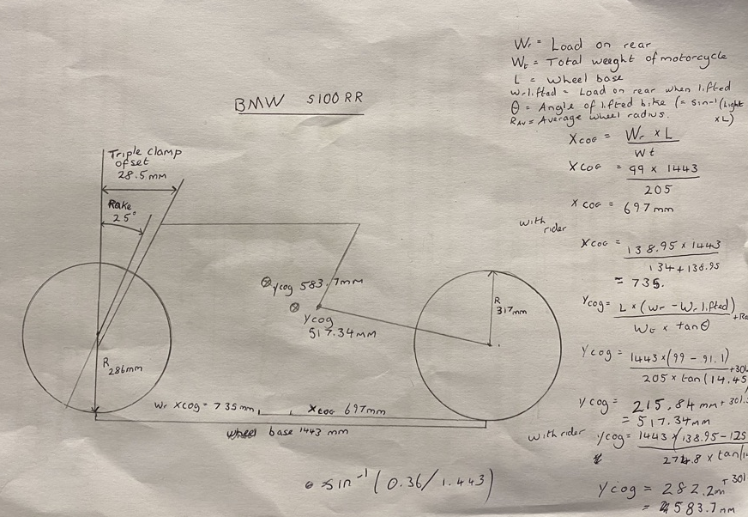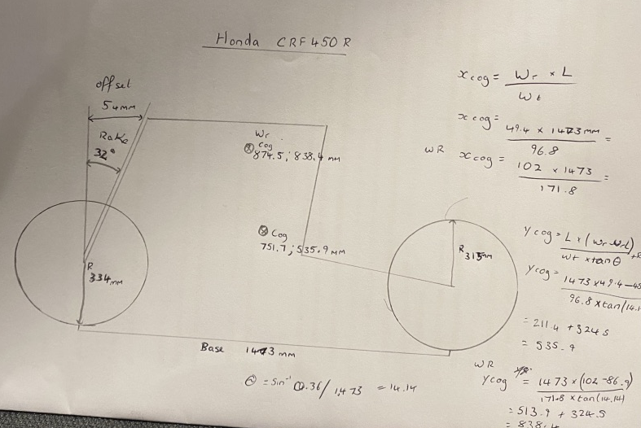
Using the information gathered personally about the BMW S100RR and further information [1]

Calculated the theoretical top speed from the gear ratio, Max RPM and the circumference of the wheel. This gave a theoretical value of 394.67 kmph. Using Air resistance and Rolling resistance formulas to give an estimated power output required for this speed. When calculating air resistance, I used a value of 0.5 for the drag coefficient because I was unable to get the actual value. 0.5 is comparable to other motorcycles in the style and range. I used the weight including rider I had collected from centre of gravity calculations to more accurately calculate the resistance forces the bike would overcome.
From my calculations the motorcycle would be unable to reach the theoretical top speed of it gearing. The bike produces 143.9kw [1], however, at a theoretical top speed of 394.67kmph it would require more than twice that at 390kw. The bike does not produce enough power for this speed. The BMW has a stated top speed of 299kmph [1] so the difference of 80kmph especially at high speed leads to the massive required power increase. When calculating air resistance, the velocity of any objected is squared in the equation. This means that small increases in velocity can increase resistance greatly.

The BMW S1000RR and the Honda CRF450R are very different motorcycles not just in styling. Despite similar wheel bases the Honda has a higher centre of gravity which allows the rider to act of the wheel base easier. The higher the Cog the more unstable the bike is at greater speed, however, at low speeds found in motocross this isn’t an issue. The easier the rider can act outside the wheel base (like an upside-down pendulum) the easier the bike will respond to the actions of the rider. this means the bike can be nimble and change directions far easier. In addition, having lower weight reduces the inertia the bike has requiring less force to move in opposing directions. This makes this bike feel light and agile to the rider.

These characteristics are useful in racing (BMW S100RR), however, it reduces the straight-line stability and high-speed stability. So, the BMW compromises with a lower Cog which is not so low that the bike become unable to lean or turn but not high where at high speeds or acceleration of the bike becomes unstable. Furthermore, the use of a smaller rake angle and offset reduces the input force required by the rider to change the steering angle. So even at the highest speeds of motorcycle racing the rider still has the ability to affect tot motorcycle. In addition, the smaller rack angle allows the suspension the react easier to the sprung weights movement and reduces the energy lost in the suspension.

The Yamaha YZR-M1 is the MotoGP bike used between 2004-2019[1]. It has been prototyping version of the Yamaha R1 and R6 which is sold as a mass manufactured motorcycle. This means both models share very similar characterises and features. However, the M1 is specialised and tailor made to both rider and MotoGP. For example, Valentino Rossi has the bike modifies to his dimensions a preference.
The geometry information I acquired is for the Yamaha R6, but they are comparable in many ways. Using similar chassis designs
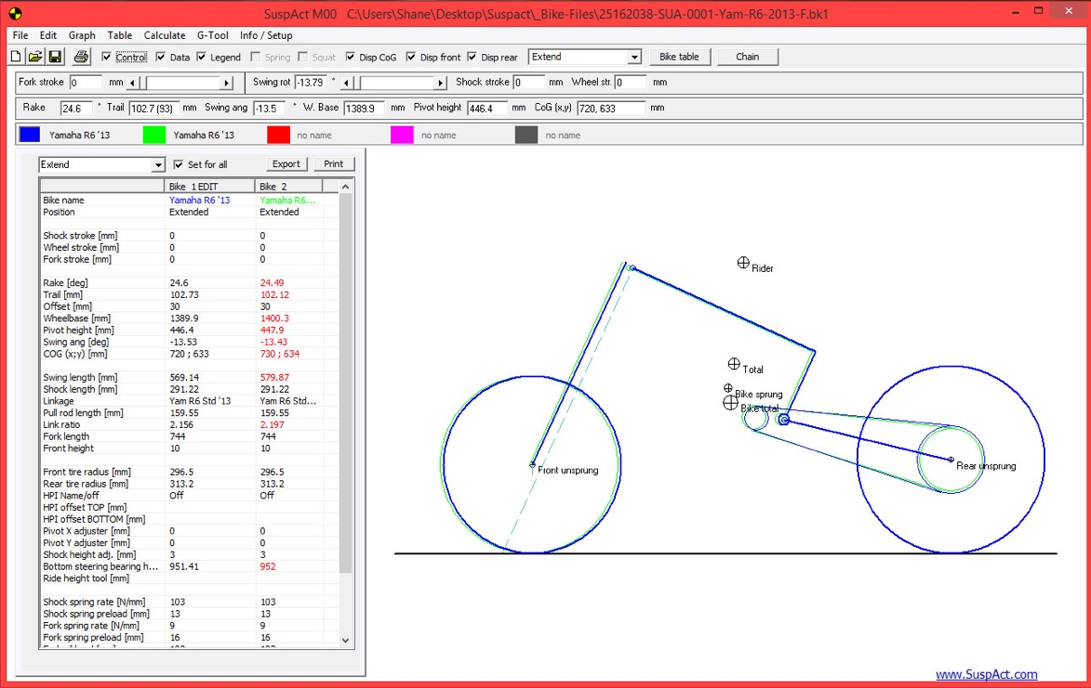 [3]
The R6 geometry or setup is tailored to its function. Every change to a motorcycle’s geometry is a trade-off between to desirable characteristic
For example, Rake angle of 24.6 degrees is low, this allows the motorcycles cycle to turn in to a steer easier, however, it also decreases the stability because reducing the force requires to steer also reduces the external force required to destabilise the bike. Extremely low fork angles lead to speed wobbles which often end in the rider high siding the bike in a crash.
The Cog is 633mm in the y axis, which similar to the BMW S1000RR, increases stability of the motorcycles but reduces the reactiveness to change in angle/ motions involved in turning and steering, requiring more force from, the rider.

The second motorcycle Is researched into is 2006 XV1900 Midnight Star which a cruiser style the rake and wheel base are far larger than any other motorcycle I have the data for. This gives it very good stability and comfort; however, they are goliaths to lean or turn. This is only compacted by their larger mass.

References
[1] BMW S1000RR, Motorcycle Specs, https://www.motorcyclespecs.co.za/model/bmw/bmw_s1000r%2013.htm
(accessed 11 January 2020)

[2]Yamaha YZF-M1, Yamaha Racing
https://www.yamaha-racing.com/motogp/bike/
(accessed 7 January 2020)

[3] Yamaha R1 Geometry, Suspact
http://www.suspact-na.com/images/D/6-6.jpg

[4] Yamaha Parts
https://www.yamahapart.com/part1chassisgeometry

