  EMPLOYABILITY SKILLS | Maria Ernila (1816792)  E MPLOYABILYT SKILLS

MARIA ANCA ERNILA

Student number 181672



RESIT/REWORK C1:

ACADEMIC AND EMPLOYABILITY SKILLS

1.
ACADEMIC AND EMPLOYEBIITLY SKILS



A lack of people with the right ‘attitude’ has been a major barrier to success

2.

INTRODUCTION

Executive summary………… ………………………………………………...1

Terms of reference…………………………………………………………….1

Procedure…………………………………….………………………………….1

3.

What are the skills?........................................2

Changes to employees’ skills…………………………………………….2

Important skills for employers……………………………………………..2

Time Management………………………………………………………………..2

Negotiation ………………………………………………………………………….2

Inter -Personal communication…………………………………………….2

What skills does the researcher /you/ have?..........................2

4.

Recommendation………………………………………………………………..3

Appendices……………………………… ……………………………………….....3

Acknowledgements……………………………………………………………….3

References…………………………………………………………………………….3


5.

Terms of reference
The report was requested in the module by CHRISTIAN FELICES on 18 of June 2019.Answering at the question. WHAT ARE THE EMPLOYBILITY SKILLS? it is the main propose this report. The researcher will analyse which are and how skills changed during employability last years.

, Employability skills can therefore be defined as the skills knowledge and attributes required to gain employment and then to be able to adapt program and learn successfully in that employment to the benefit of the individual, the employees and the company.,

Employability skills can be defined as the transferable skills needed by 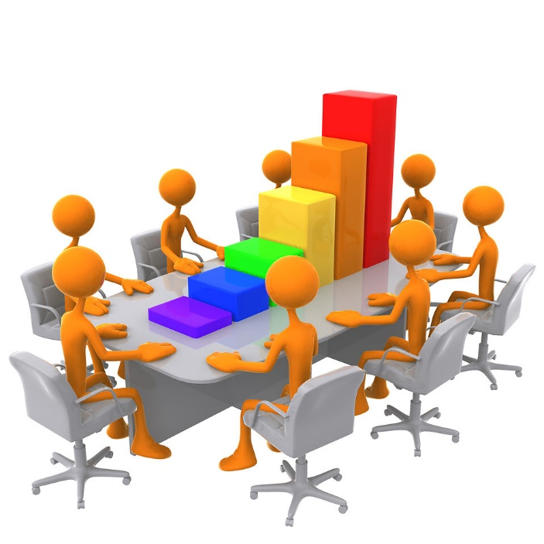
This Photo by Unknown Author is licensed under CC BY-SA

An individual to make them ,employable,.

6.
In the 21’st century the demands of the employers but also of the employees changed a lot they became a little more sophisticated so that they placed a special emphasis on the abilities under the name of soft skills.

If in the past it was enough to have minimum experience and certain qualification for a particular job today already much more emphasis is placed on skills that could bring profit to the company.

If we were to make a top with the most required skills, I would like to put one the top specific for 2019

A] SENSE OF HUMOR. A new relative requirement from last 5 years but increasingly common because employs spend a lot of time together share the same space and time and the atmosphere in the work environment is given special attention.

B] THE ENERGY represents other secret point which is valued by the interviewer. The position of the candidate in the armchair says a lot as a result of the candidates position in armchair. Every employer looks more and more at the energy level they transmit and show candidates. The low voice without propyl position in the chair are very likely not be admitted to the company.

C ] ABILITYY THE LIDERSHIP employers search for people who know their team.

D] ORGANISATION AND PRIORITATION SKILLS we live in a century of speed where things are happening fast and customers of companies want everything ready as soon as possible.

7.
The permanent need for change to resist the competition requires people in the company’s frame has greater flexibility but also openness to new.

Today among many qualities and skills most jobs involve working in the team not only with colleagues from the same department but with those from other teams and departments an individual person will never manage to communicate clearly with others and often not with herself.

Why the speciality of human resource looking after personal abilities? Personal abilities are those abilities that interact with those around you that help you expose yourself are the skills that cannot be measured or quantified . The ability to work efficiently under pressure under stressful situation that you can gain in a limit situation specially with deadline set.

Even today the workforce suffers a lot because of emigration time the employer of the usefully company will still be looking after the creativity energetic and positive person which is ready to be dedicate for a while at the company.

Teamwork, social adaptability spirit of leader, the ability to sort out the conflicts.

Why the employer looking after the competency organizational? Whit a lot of chances from the century 21’st.we need to be ready every day to answer at each of chance of change our lives .Optimal communication means you can express verbal and written . Companies will be hired to understand and come work together. Power of ability to the new environment is more important than any other experience.

8.
To be successful in a company be ready to always learn something new. All
employers look for job candidates with strong communication skills. Also to be good listener it’s another point forte.

ATTENTIVE, ACTIVE LISTING, INTERPERSONAL SKILLS, ORAL COMMUNICATION, WRITTEN COMMUNICATION can represent employability skills ,using the technology solving the problems using the initiative learning for file . Teamwork is very important any work setting.

Critical thinking refers to one’s ability to analyse and interpret the information also to understand the information.

Creativity, analytical skills conflict management represent part of the employability skills. One good leader or manager will help the team to rise working together like one strong team.

Employability skills can be representing by the computer skills. Field of technology such as software developers or IT specialist. Needs extensive programming knowledge most jobs simply require basic experience with computers. Another type of employability skill can be email management digital calendar mobile device word processing social media. More employability skills can be flexibility, ability to learn new skills, motivation put together can show us one person want to learn and grow up professional.

9.

TIME MANAGEMENT .WHAT IT IS THIS ? and WHAT IT IS IMPORTANT .
Time management play one important role in our daily life and also one daily business activity. What mean and what include? PLAN, GOOLS, DEADLINE, DELEGATION FOR RESPONSIBILITY, PRIORITIZING ACTIVTIES.
PLAN
To have a plan is good. Important activities need to have a plan. Complete pending task one by one .Tick which and has been done .Something very important do not being finish work unless you have finished your previous task.
GOALS and OBJECTIVES
To work without goals and objectives it is similar to a situation when Capitan lose the control of his sheep .
DEADLINES
Using a plan to mark each of tasks will help to know exactly where are with the project.
DELEGANTION and RESPONSIBILITY.
The role and responsibility must be as per interest.
PRIORITIZING, other really important step from management time. Because we suppose to know the difference between IMPORTANT and URGENT.
SPENDING ON THE RIGHT TIME work done at the wrong time is not of much use. The resources that a manager has at their disposal are only the time talent financial resources and human. According to a modern definition the term managements means the art of doing something alongside a team. As a manager maximising employee potential should be one of your top priorities. Each employee you hire should be considered an investment in the company. A good team manager should know how to push the employees to the maximum potential.
10.
The key of success it is representing by people who are recruiting the staff.
Hire the right people. Get to know the employees their past experience and also the expectation from future from the life and from the company. I will back at idea about the TEAMWORK because without real strong and powerful team you can’t develop any project or skills to care on the business or to play around with the competitors in the market. Teamwork it is about team building is a process which require a lot of attention and care. A good team doesn’t come over the night. To build to lead or participate in a team require an understanding of the steps of team development.ONE best way to improving people ‘s performance is by providing information to team members about their individual performance.

Successful induction increases the chance to improve the team and the performance. Understanding development needs plus training needs assessment provide potential types for identification areas that needs improvement. No matter what tasks or role you pick up on your team always you need empty room, space, time for personal development, personal improvement. Like manager you must build and foster the skills in the individuals that are congruent with the needs of team. One real and strong team will go in the same direction when is about the goals. Members of successful team all goes in the same direction and work for same idea. One united team it means more than one bunch of people thrown together.

Now I will write about Managing conflict. None like this capitol but we are different, and we have also different vision, and different ideas, for this reason sometimes like managers we need to know how supposed to deal with this type of pressure without to broke and divide the members of team. At the end of the day must remain the same team which still work on the same project.

11.
Managing conflict with theory X or with theory A, doesn’t work to much because the people and different.

Each of member and leaders should understand the basic of conflict management and to be ready learn more about the different style and always of thinking and working.

Over the day one conflict can develop anytime, sudden, without any preparation, can be inevitable consequences of working with other people and this can happen because of the opinions values styles, from here at the disagreement it is only one step. Main time like manager you suppose to have vision about immediately solution and peaceful term for everyone .To be manager to work with the people, to solve the conflict, to have good feedback ,to play with the competitors in the markets mean many days dedicate from your life on this job.

Back now at the employability skills I found few of keys points really important when it is about how to develop in the future like individual person , successful manager .
Positive attitude
Communication
Teamwork
Self-management
Willingness to learn
About some of them we have been discussing during the assessment.

12.

COMUNICATION SKILLS in proportion 90procent in the requirements section of each job are required communication skills written and spoken in the pattern language .Another statistic shows us that specialist from the humane resource seek candidates with good skills.
A good candidate with skills and personal competence works very well with suppliers and clients also they can transmit with great ease personal ideas are responsible respect the deadlines also are motivated persons.

Training and education show us you take the life professional very seriously. And for future potential to be hire. Learn teamwork skills, improve the communication, get organised all this will lead you to improve your employability skills by getting a degree or certification continuing education.
Volunteering helps to enrich the experience. And to be confident in your power mind.
Became self-motivated regular performance reviews.
Take the initiative on project and try to meet the deadline without fail. Professional and integrity represent the important key on evolution. Improving your employability skills are more likely to be the best candidate for a job.

NEGOTIATION.
Represent another capitol which can be explored with pleasure by the researcher. To write like one definition represent the processor discussing something with someone in order to reach an agreement of the discussion themselves.

, KNOWLEDGE IS POWER AND POWER IS BEING INFORMED,

13.
Most of the time when we complete a CV we want to make it obvious our best abilities can be hard to evaluate our competency’s and choose the words needed to describe us.

Negotiation doesn’t start when both parties meet in order to negotiate. The first step to negotiation consists in understanding the personality of the other person and knowing, HOW TO PUT ONSELF IN THEIR SHOES, It necessary to be prepared. Being prepared also means built your network of influence before the meeting. In order to understand the needs. Here are few steps and tips to develop; Be aware of your body language as well of that other individual
Project empathy.
Be at ease in moment of silences.
Make you self-available and let the other express themselves without interruption.

I will present 7 negotiation skills to have on your arsenal.
Being prepared and understanding the other party.
Knowing how to listen.
Controlling emotions /Emotional intelligent
Knowing how to express yourself and navigating the negotiation.
Seeking out collaboration
Negation skills knowing the scope of your influence developing trust.
Developing trust.
Why it s important to be good negotiator? To make right decision.

14.

REFERENCE; https// dictionary.combridge.org/dictionary/English. /negotiation.
; https//www.dictionary.com. /browse/negation.2014.
;; www.thefreedictionary.com./negociate.
; www.researchgate.netpublication.

INTER- PERSONAL COMMUNICATION.
What is it?
Why is t important?
How to improve?
To answer at first question Interpersonal communication is the process by which people exchange information feelings and meaning.
Interpersonal skills build on basic communication skills and often reflect the HUMANISTIC, q qualification. Like definition is the process by which people exchange information; fillings and meaning through verbal and nonverbal message. Basic inter-personal communication skills mean
Smiling and being cheerful and ready to help always.
Using simple clear language or local
Dressing appropriately and respecting the local culture.
Not being rude or showing a bad attitude.

What are the interpersonal skills? We all use interpersonal skills everyday. Without interpersonal skills everyday business would be very difficult since almost all aspect of work involve communication.
15.

COLABORATION means interaction with different types of people. The right level of confidence in the workplace can open the doors and help to achieve and gain recognition and respectful
REFERENCE=www.leaf.tv. /articles
WHAT IS GOOD INTERPERSONAL. ?
Be interested, Smile and keep eyes contact. Using simple clear language using non tektology.
What the skill does the researcher have? Good question. I don’t like to talk about this. The researcher has good skills when supposed to help anybody else but own person. Self-confident it is big challenge. To be confident means a lot of doors open for one bright future. To be here, to be part of the University Trinity Saint David LIKE A STUDENT make feel proud and also for my children IM the HERO, represent good opportunity to let them to see the advantage to be student. AT ANY AGE. Barrier language will be the first obstacle

Thank you CHRISTIAN because you have been so nice, polite, kind and you provide for us a lot material, emotional, professional support special for me which IM the for gain citizen for this city .Also I would like to say thank you for all my colleges and friends which provide enough support for people like me which have been started with lo w confident about this new capital from my life.
At the end of this first term the researcher it is much better and will try to fit with all obstacles, problems.

16.
CONCLUSION.
‘Understanding the soft skills demands of employers is important and needs to inform policy discussion of employability in the UK and elsewhere .This need for more nuanced understating is particularly pronounced because as CROUCH 2004 point out skill formation system may not operate effectively during per of change such as the current growth of the service economy generally or now specifically during the economic downturn ‘

There are very few cases today when someone keeps the same job for many years or at least for 10 years today. People qualify and retrain in different files and if they are not happy or satisfied, they leave the country in search of the perfect job.

Being given the new context employers are always put in the situation of recruiting new people.

IN the event of on interview no one has to see what kind of man you are or what abilities you have if you do not know to ‘sell’ the imagine through words in front of others before you demonstrating the practically what kind of employee are you.

To be student on University of Wales Trinity saint David. I have learned something very important,

, KNOWLEDGE IS POWER AND POWER IS BEING INFORMED,

17.
REFERENCE;
1 . www.wikijob.co.uk./[5aug 2019]
2 . www.thefreedictionary.com/negociate.[7aug 2019]
3. https//www.dictionary.com. /browser/negation.2014[12 august 2019]
4. https//dictionary.combridge.org. dictionary/English/negotiation/ [15august2019]
5. www.researchgate.net publication.[15aug2019]
6.CROUCH C[2004] Skill formation system .In; Batt R ,Ackroyd S, Thompson P et al.[eds] The Oxford Handbook of Work and Organization .Oxford; Oxford University Press. [18 aug 2019]

7. American Institute of Certified Public Accountants.1999 vision project. Retrieved October 2006,from http//www.aicpa.org/vision/ index.htm
8.Certificate in Higher Education ..Skills for the Workplace Student yearbook .with Andrew Maund, Michaela Schriek Paul k. Tinker.[18august2019].

18.

