Mobile Application Development Using Xamarin
Name : Kieran Hawkins | P Number : P145441
Module Title : Advanced Mobile Application Development
Assignment Title : Mobile Application Development using
Xamarin
Lecturer : Kemi Ademoye
Deadline Date : Tuesday 8th May 2018

Table of Contents

1.0 Table of Contents 2
Table of Figures 3
1.1 Introduction 4

2.0 Design 4
2.1 Description and Subject Matter 4
2.2 Target Audience 4
2.3 Requirements and Features 5

3.0 Implementation 6
3.1 Discussion of Practices 6
3.2 Backend and Database Design 8
3.3 Core Functionalities 9
3.4 Testing 13

4.0 Evaluation 15
4.1 Future Improvements 15
4.2 The Use of Xamarin as a Cross-Platform Tool 16

5.0 Conclusions and Recommendations 17
5.1 Conclusions and Recommendations 17

6.0 Appendices 18
6.1 Reference List 18
6.2 Screenshots 19

Table of Figures

1.0 Requirements & Features 5
2.0 Portable Class Libraries 6
3.0 Model, View, ViewModel (MVVM) Pattern 7
4.0 Database Design 8
5.0 Login/Register Activity (Left : Android, Right : IOS) 9
6.0 My Notes Activity (Left : Android, Right : IOS) 10
7.0 View Note Activity (Left : Android, Right : IOS) 11
8.0 Friend Request Activity (Left : Android, Right : IOS) 12
9.0 Black Box Tests 13
10.0 Black Box Tests Continued 14
11.0 My Account Activity (Left : Android, Right : IOS) 19
12.0 Add Friend Activity (Left : Android, Right : IOS) 20
13.0 Change Password Activity (Android) 20
14.0 Shared Notes Activity (IOS) 21

1.1 Introduction

The following project is aimed at investigating the use of Xamarin as an effective solution to cross-platform application development. Xamarin is a popular mobile development platform which allows developers to create native applications using common development environments, languages and codebases [1].

In order to effectively understand how Xamarin works, a mobile application of choice will be developed from requirements, to a working prototype. This application will target both the Android and IOS systems.

Once completed, the application and the use of Xamarin in general will be critically assessed to provide a justified assumption of its effectiveness and usefulness within a mobile development environment.

2.1 Description and
Subject Matter

The application being developed is called NoteTaker and will essentially store a user’s notes for safe keeping and later retrieval. A note will be textural, consisting of both a title and content. The application will also allow the user to share notes with friends that they have connected with within the app. This means that there would be three integral components to the application’s architecture; user authentication, user friends, and note creation/storage.

2.2 Target Audience

The target audience for NoteTaker would be relatively broad as a variety of users are now benefiting from data storage within mobile applications. A key group of target users would be families wishing to share pin up notes within their close social circles.

2.3 Requirements
And Features

The design process began by identifying a range of potential requirements and features that could potentially be implemented within NoteTaker. In order to do this, it was necessary to visualise how a potential user may use the application, taking into account their needs, goals, tasks and responses.

After some time, a number of initial requirements and features were clearly identified as shown in the following figure. These requirements were initially listed randomly but were later categorised into functional and non-functional and ranked using the MoSCoW approach [2].

Requirements & Features
Functional | Non-functional
- User storage (Login/Registration)  - Persistent note storage  - Friend request system  - Note sharing between friends  - Native Android codebase  - Native IOS codebase | - Smooth transitional UI  - Responsive networking with services and backend.
MoSCoW Rankings

Must Have

- Native Android codebase

- Native IOS codebase

- User storage (Login/Registration)

- Persistent note storage

Should Have

- Friend request system

- Note sharing between friends

- Smooth transitional UI

- Responsive networking with services and backend.

Could Have

- Specified friend sharing

- Note boards (much like Trello)

Won’t Have

- User groups and group sharing

Figure 1: Requirements and Features
3.1 Discussion of
Practices

When implementing the core architecture for NoteTaker, a number of key principles and practices were identified, providing a range of added benefits in terms of portability and improved maintenance. The first of which was the use of Portable Class Libraries (PCL).

A Portable Class Library (PCL) is essentially a .NET based project which can be referenced from a range of other projects under the .NET framework. This means that a PCL can be used to hold a range of common business logic (models, services etc.), which can be shared across projects which target a number of different platforms [3], [4].

During the development of NoteTaker, a PCL was used to hold much of the logic that would be duplicated between both the Android and IOS platforms. Classes such as models, interfaces and services were encapsulated within the PCL and accessed by both Android and IOS when required.

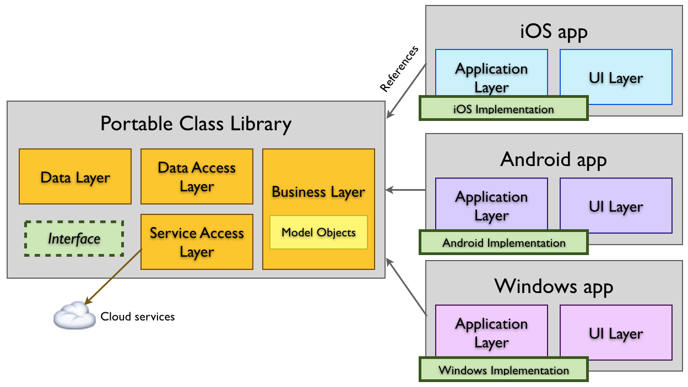

Figure 2 – Portable Class Libraries (PCL) [4].

Apart from reducing code duplication, the use of a PCL also improved the maintainability of the application as there is now a better definition between the core aspects of the system (Business logic, application logic, view logic etc.). The encapsulation also allows for key components to be worked on more efficiently within a team environment.
The second practice to be discussed was the use of an architectural design pattern known as Model, View, View Model (MVVM). The Model, View, View Model (MVVM) pattern is concerned with providing greater encapsulation between views and business logic [5]. The view model acts as a controller, in charge of manipulating the data flowing between the two elements.

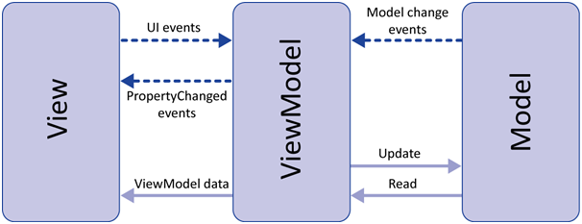

Figure 3 – Model, View, View Model (MVVM) Pattern [5].

The real benefits of MVVM can be seen when using it within cross-platform environment. View models can be used to interact with a range of native graphical interface views. This means that fully native views from both Android and IOS, can essentially bind with data that is under a single view model’s control. This again reduces common functionalities between the platforms and also speeds up maintenance and testing phases.

3.2 Backend and
Database Design

NoteTaker integrates a cloud based backend, which allows it to provide much of its core functionality. The service chosen for NoteTaker is known as Azure and is provided by Microsoft. Azure is a cloud based platform used to deploy, test and manage applications through outsourced data servers [6]. Azure is just one of many products, which are increasingly adopting a Software as a Service (SaaS) business model [7].

Azure provides a multitude of services; however, NoteTaker only required a basic data management and storage solution, which was provided using Azure’s mobile development tools. The data infrastructure was easily created within Azure using a simple tool known as Easy Tables [8]. The overall database design required to provide NoteTaker’s core features was very simple. The entities consisted of Users, Friends, Notes and Friend Requests.

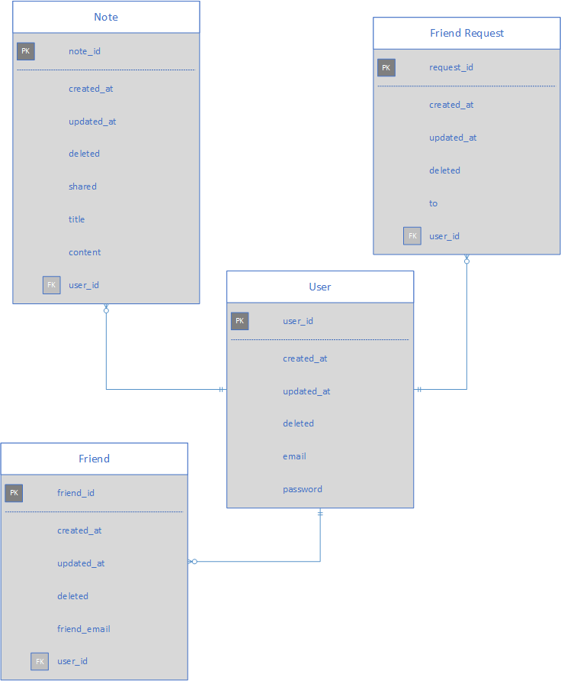

Figure 4 – Database Design
The data structure revolves around the ‘User’ entity, where the key information being stored included an email address and password. From there, a user can create any number notes, which consisted of a title and content. A user also has a number of friends, which are gathered by sending a corresponding friend request to the elected user. These requests are then removed when a request has been accepted or rejected by the corresponding user.

3.3 Core Functionalities

The main goal of the application is to allow users to store text notes and provide the ability to share these notes with their friends. To do this, a number of features and functionalities were developed, the first of which being a simple login and registration process. Upon entering an email address and password, the user must decide whether to login or register a new account. Logging in connects to the Azure backend and checks the data store to ensure a valid login. Registering a new account uses the details provided to store the new user in the database and sign them into the application.

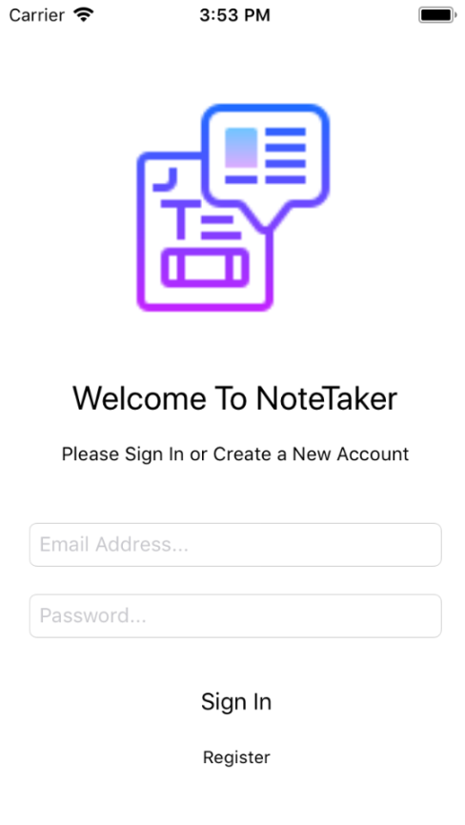
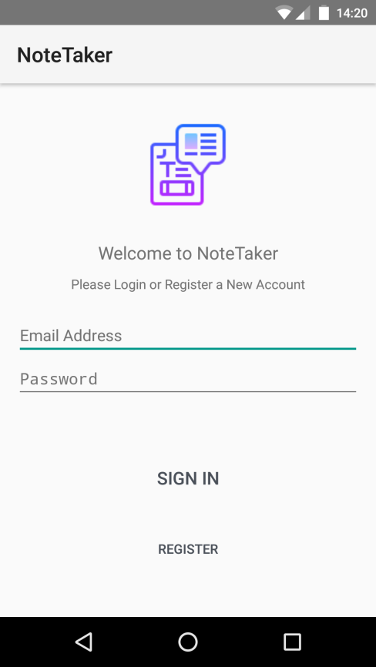

Figure 5 – Login/Register Activity (Left : Android, Right : IOS)

The next major functionality is the note storage. Upon creating a new note item, it is stored within the cloud data storage and inserted into list views within the application. The list view items show the note’s title, its content, the date and time it was created and an icon to signify whether it is currently being shared with friends. Within the following image, the note item has this sharing icon meaning it is being shared by the user and their friends can also see that note. Shared notes are stored in another list view that is much the same as this one (see appendix).

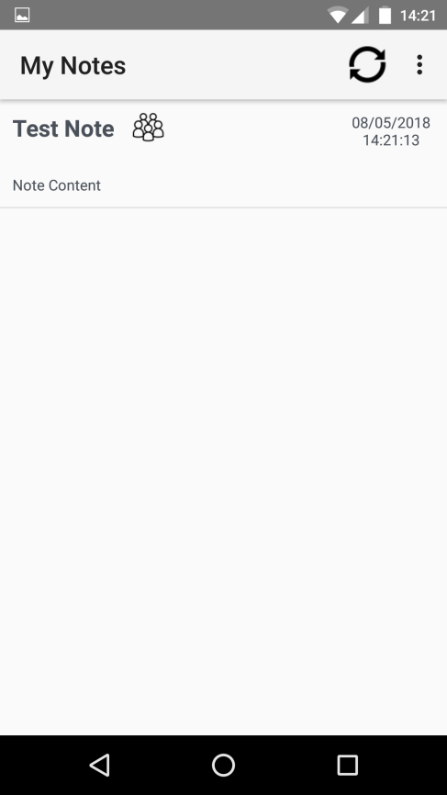
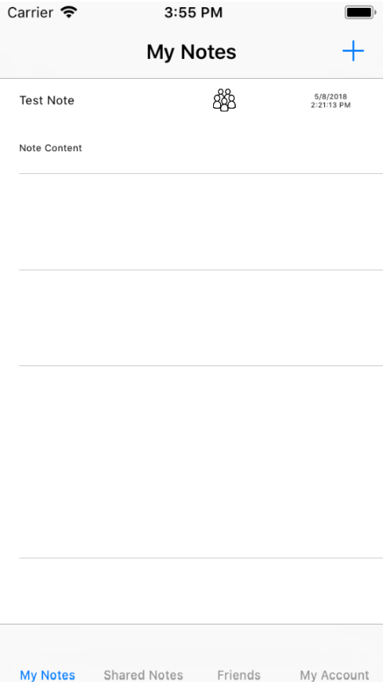

Figure 6 – My Notes Activity (Left : Android, Right : IOS)

Upon selecting a note from the list, a new activity is triggered which allows the user to view, edit, share, unshare and delete a saved note. The view consists of two text inputs, enabling the user to view and edit the note details; as well as a set of buttons to trigger the required tasks. Upon electing to edit the details, a function is called which locates and edits the correct details within the database. Sharing and unsharing is much the same process, although only the ‘shared’ attribute was amended as required. Deleting the note works by amending the ‘deleted’ attribute within the database. This means that nothing is ever actually deleted unless it is done from the backend. This also meant that the ‘deleted’ attribute had to constantly be checked within many of the CRUD functions and procedures.
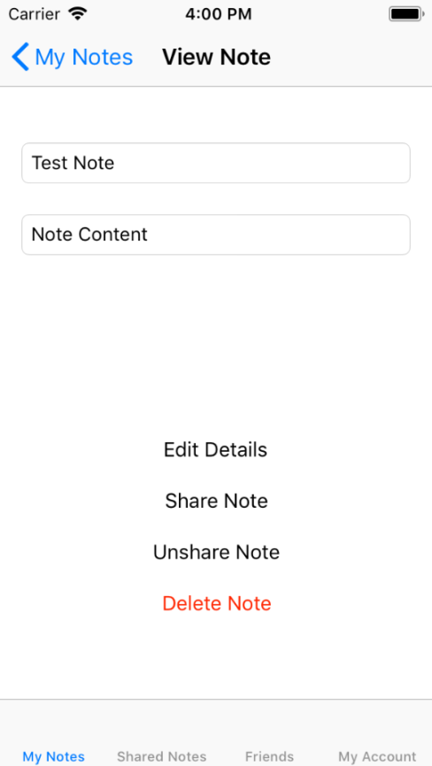
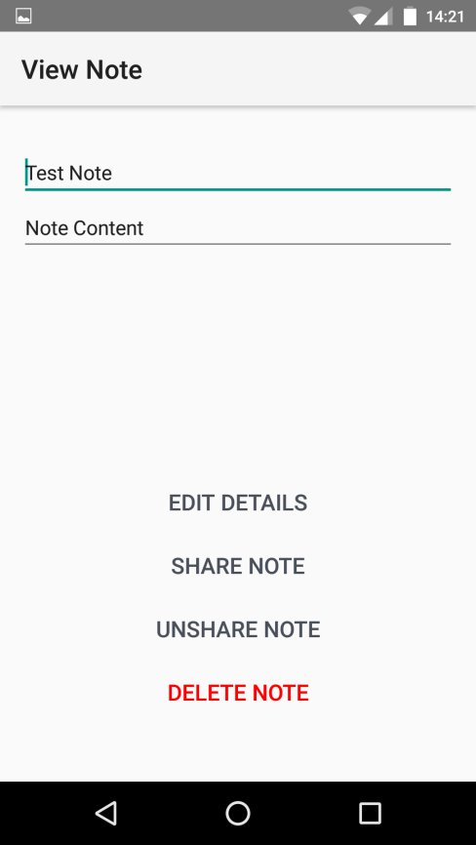

Figure 7 – View Note Activity (Left : Android, Right : IOS)

The final major feature was the inclusion of friends, which can be seen in the following figure. The process of adding a new friend involves sending the user a friend request (see appendix), which is then either accepted or rejected by the user on their end. These requests are again shown within an ordered list view on both platforms.

Once a friend request has been accepted, the new friend is then added to the friends table in the database and is also added to the friends list within the application. The request is then removed by amending its ‘deleted’ attribute.

A user’s friends are able to see any shared notes that have been created by the user and vice versa. This means that the shared notes activity (see appendix), may contain a variety of notes, created by both the user and any number of their current friends who may also be sharing notes.

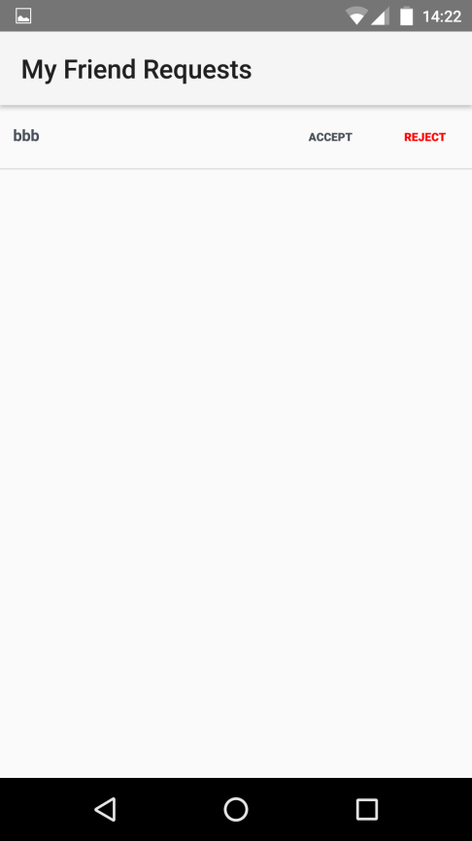
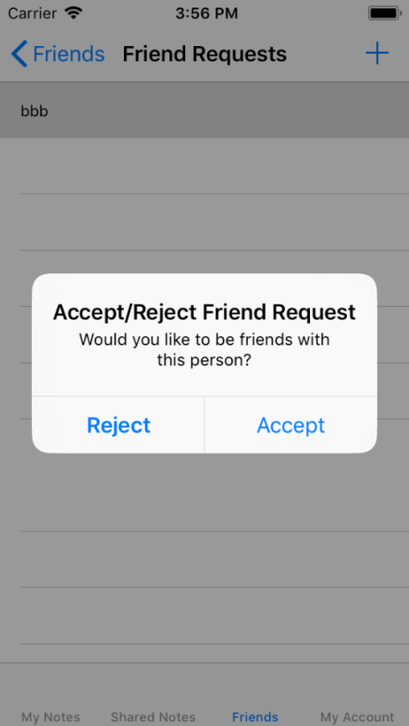

Figure 8 – Friend Requests Activity (Left : Android, Right : IOS)

3.4 Testing

The testing phase consisted of identifying and performing a range of black box tests, which could be used to quickly highlight any errors and anomalies within the application’s code base. The initial tests shown below will eventually be developed further as the application grows larger. They will also likely become a vital tool for any maintenance that may be carried out in the future.

Activity | State | Input | Expected Output | Pass/Fail
Login/Register Activity | Valid Details Entered | Register User | New Activity is triggered displaying user notes | Pass
Login/Register Activity | Valid Details Entered | Login User | New Activity is triggered displaying user notes | Pass
Login/Register Activity | Invalid Details Entered | Register User | User is told to enter valid details | Fail
Login/Register Activity | Invalid Details Entered | Login User | User is told to enter valid details | Pass
User Notes Activity | No Saved Notes | N/A | Clear list is displayed (text label for Android) | Pass
User Notes Activity | Saved Notes | N/A | Notes are displayed in list View | Pass
User Notes Activity | Saved Notes | Note Selection | New Activity is triggered to edit, share and remove note | Pass
View Note Activity | Idle | N/A | Note details are shown | Pass
View Note Activity | Idle | Edit Details | New note details are saved | Pass
View Note Activity | Idle | Share Note | Note is shared and placed in the sharing list | Pass
View Note Activity | Idle | Unshare Note | Note sharing is revoked and removed from list | Pass
View Note Activity | Idle | Delete Note | Note is removed from all lists | Pass
Add Note Activity | Idle | Add New Note | Note is added to note list | Pass
View Shared Notes Activity | Shared Notes | N/A | All shared notes from the user and friends are shown | Pass

Date of Last Test: 01/05/2018

Figure 9 - Black Box Tests

Activity | State | Input | Expected Output | Pass/Fail
View Shared Notes Activity | No Shared Notes | N/A | Empty list is shown | Pass
View Friends Activity | No Friends | N/A | Empty list is shown | Pass
View Friends Activity | Saved Friends | N/A | Friends are shown in the list | Pass
Add New Friend Activity | N/A | N/A | Friend request dialog is shown | Pass
Add New Friend Activity | Friend request dialog is shown | Valid User | Request is sent | Pass
Add New Friend Activity | Friend request dialog is shown | Invalid User | Relevant information given to user | Pass
Friend Requests Activity | No requests | N/A | Empty List is shown | Pass
Friend Requests Activity | Requests Saved | N/A | Requests are shown in the list | Pass
Friend Requests Activity | Requests Saved | Accept Request | New friend is added to list and request is removed | Pass
Friend Requests Activity | Requests Saved | Reject Request | Request is removed | Pass
My Account Activity | Idle | N/A | User details are shown | Pass
My Account Activity | Idle | Edit Details | New user details are saved | Pass
My Account Activity | Idle | Change Password | Password dialog is shown. New activity for IOS | Pass
My Account Activity | Idle | Delete Account | Account is removed and user is returned to login activity | Pass
Change Password Activity | Idle | Incorrect password | Relevant dialog shown | Pass
Change Password Activity | Idle | Mismatched new password | Relevant dialog shown | Pass

Date of Last Test: 01/05/2018

Figure 10 - Black Box Tests Continued

The failed test is due to the absence of input validation within the client side applications. This aspect of the application was completely forgotten about during the design process and should rate highly on the list of jobs that would need to be undertaken before the application can go live.
4.1 Future
Improvements

There are a number of improvements that would likely have to be made before the application can be effectively used by a range of users. The first of which has already been identified by means of the testing phase. All of the inputs will need some validation to ensure the data entering the cloud server is valid, correct and not malicious in anyway. Checking for valid email addresses will also improve the validity and credibility of the users which use the application.

Another improvement to be made is within the graphical user interfaces. As of this moment, all the user interface views are exclusively developed for mobile devices in a portrait orientation. Extending the views to be responsive and adapt to a variety of screen sizes and orientations would be hugely beneficial and will enhance the applications user experience.

The final improvement which will have to be made, relates to the security of the server side services such as the database storage. The application’s database is currently open and has no rules in place to limit and restrict its access. This is a potential security flaw and could cause damage if the connection strings were to get into the wrong hands. Before the application can become live, strict rules will need to be placed upon the database, as well as integrating server side validation to process any requests that are made to it. This would likely be one of the first and most important tasks to be undertaken within the next iteration.

4.2 The Use of Xamarin as
A Cross-Platform Tool

Upon completing much of NoteTaker’s core features and functionalities, an overall perspective on the use of Xamarin as a cross-platform development tool was established and well received.

The Xamarin platform enables developers to design applications closer to their targeted native systems. This means that individual native projects can be developed to make use of as much native functionality as possible. Then, using selected code sharing strategies (as previously discussed), these native projects can call upon the same common functionalities, which in turn significantly reduces the overall size of the application. The individual components can also be worked upon more effectively within larger teams.

Many previously used alternatives, such as Apache Cordova [9] or AngularJS [10], [11], were simpler to learn, implement and deploy applications being developed within a new team environment. However, many of the frameworks and libraries used can be rather limited and standardised across platforms.

A disadvantage when deciding whether to use Xamarin, is the fact that developers require core knowledge of the native platforms. Xamarin uses a common language (C#), which is used because it can be easily ported to a variety of native languages [1], [4]. This also means that there is also a transitional period where developers must learn to write native applications using another language.

A common problem that has been experienced when using a variety of cross-platform solutions is the integration and maintenance of many of the packages, libraries and frameworks that developers may add to improve their applications functionality and usability. Many packages and libraries can prove to be harder to integrate than others, meaning the process of learning to use the solutions can be quite rocky. Unfortunately, this cannot really be helped and should only improve with more practice in implementing and troubleshooting such components.

Overall, it can be said that Xamarin would now be a contender when a multi platform application is to be developed. However, when a project is relatively simple and will need to be developed quickly, Angular2 Typescript is one of the simplest and quickest cross-platform solutions used to date.

5.1 Conclusions and
Recommendations

Upon completing the project, a better understanding of cross-platform development and Xamarin has definitely been achieved through practice and perseverance. When beginning to learn Xamarin, it was hard to grasp the platform because of the amount of new material, which needed to be learnt in order to get a good working implementation built. However, a good understanding of development aspects such as code sharing and MVVM, has now been achieved along with new knowledge of developing for Android and IOS using a new common language (C#).

Taking the final product into consideration, it can be said a good sharing architecture has been achieved within the application. This design can be built upon and tested further and can be used to share a variety of objects within a multitude of future applications. The content within the current application was rather limited, although this was not important at this stage. What was important was the fact that the application shared common functionalities and was able to run on both Android and IOS.

The look, feel and usability of the application was relatively good compared to recent projects. However, there is always room for improvement with a variety of future tasks being documented for coming iterations.

Overall, this project turned out to be more enjoyable than anticipated and has likely drawn attention to the fact the cross-platform tools can be useful within a mobile application environment. A key recommendation when exploring new tools in future would be to give the solution a chance, along with a respectful amount of practice time to acquire a better understanding of the benefits and drawbacks it may entail.

6.1 Reference List

[1] Xamarin - Microsoft, “Mobile App Development &amp; App Creation Software - Xamarin.” [Online]. Available: https://www.xamarin.com/. [Accessed: 08-May-2018].

[2] Agile Business Consortium, “The DSDM Agile Project Framework (2014 Onwards) : MoSCoW Prioritisation.” [Online]. Available: https://www.agilebusiness.org/content/moscow-prioritisation. [Accessed: 08-May-2018].

[3] Microsoft, “Portable Class Libraries,” 2010. [Online]. Available: https://msdn.microsoft.com/en-us/library/gg597391(v=vs.100).aspx. [Accessed: 08-May-2018].

[4] Microsoft, “Sharing Code Options - Xamarin | Microsoft Docs,” 2017. [Online]. Available: https://docs.microsoft.com/en-us/xamarin/cross-platform/app-fundamentals/code-sharing. [Accessed: 08-May-2018].

[5] Microsoft, “The MVVM Pattern,” 2012. [Online]. Available: https://msdn.microsoft.com/en-gb/library/hh848246.aspx. [Accessed: 08-May-2018].

[6] Microsoft, “What is Azure – Microsoft cloud service | Microsoft Azure.” [Online]. Available: https://azure.microsoft.com/en-gb/overview/what-is-azure/. [Accessed: 08-May-2018].

[7] H. Cheang, “The Arguments for Software-as-a-Service (SaaS),” 2014. [Online]. Available: http://blog.cimpl.com/bid/205831/The-Arguments-for-Software-as-a-Service-SaaS. [Accessed: 08-May-2018].

[8] J. Sanders, “Easy tables – How can I manipulate and See My Data Efficiently,” 2017. [Online]. Available: https://blogs.msdn.microsoft.com/jpsanders/2017/12/15/easy-tables-how-can-i-manipulate-and-see-my-data-efficiently/. [Accessed: 08-May-2018].

[9] “Documentation - Apache Cordova.” [Online]. Available: https://cordova.apache.org/docs/en/latest/. [Accessed: 08-May-2018].

[10] “Angular - Architecture overview.” [Online]. Available: https://angular.io/guide/architecture. [Accessed: 22-Mar-2018].

[11] “Angular - QuickStart.” [Online]. Available: https://angular.io/guide/quickstart. [Accessed: 08-May-2018].

6.1 Other Screenshots

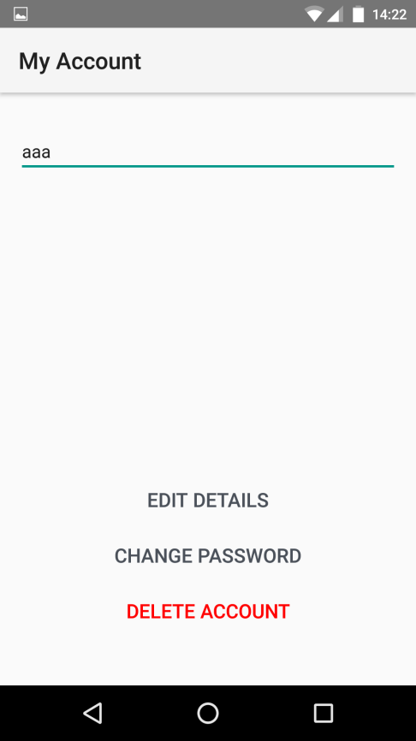
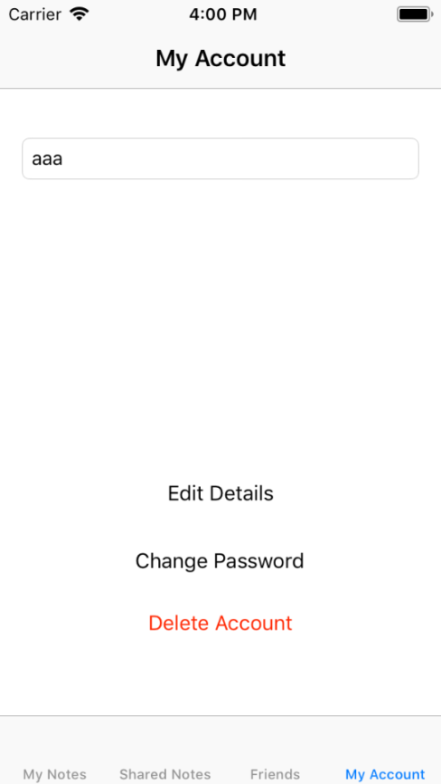

Figure 11 – My Account Activity (Left : Android, Right : IOS)

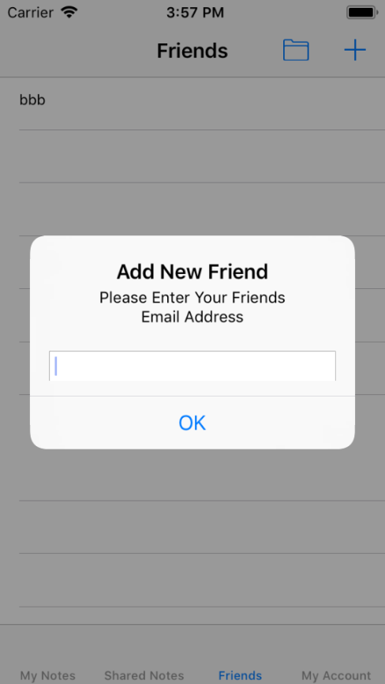
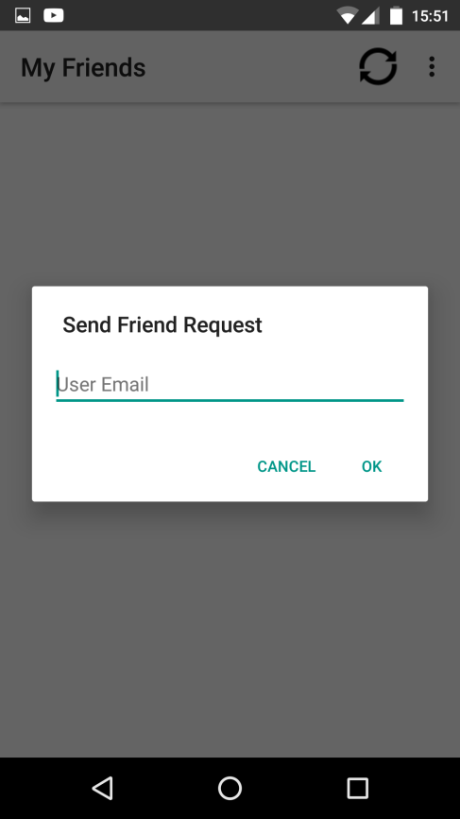

Figure 12 – Add Friend Activity (Left : Android, Right : IOS)

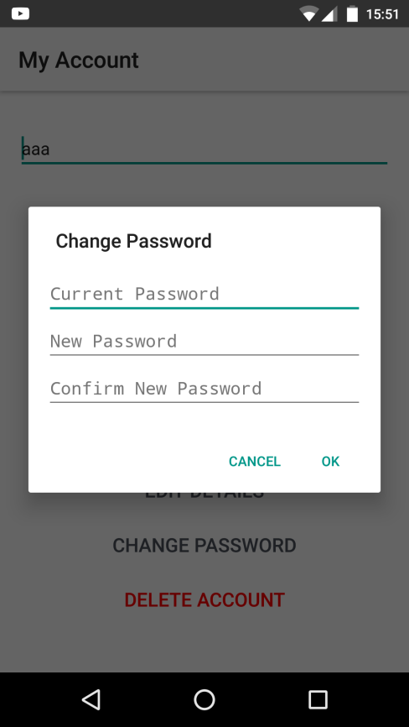

Figure 13 – Change Password Activity (Android)
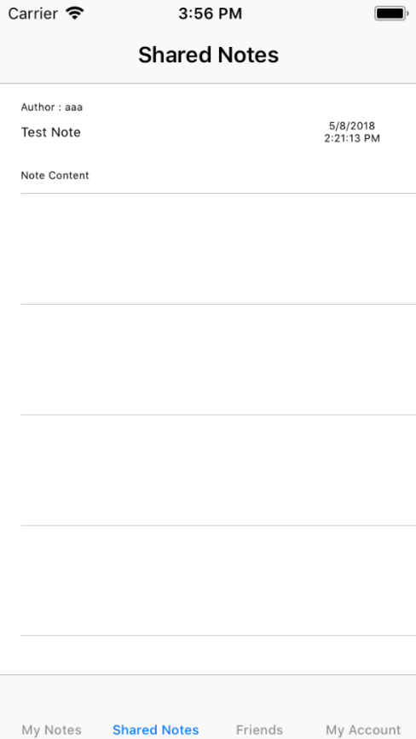

Figure 14 – Shared Notes Activity (IOS)

marking criteria and Student FEEDBACK

This section details the assessment criteria. The extent to which these are demonstrated by you determines your mark. The marks available for each criterion are shown. Lecturers will use the space provided to comment on the achievement of the task(s), including those areas in which you have performed well and areas that would benefit from development/improvement.

Common Assessment Criteria Applied (Assignment 2) | Marks available | Marks  awarded
1. Research-informed Literature
Extent of research and/or own reading, selection of credible sources, application of appropriate referencing conventions.
Demonstrates excellent evidence of research. (Grade mark: 80.00%) | 5 | 4
2. Knowledge and Understanding of Subject
Extent of knowledge and understanding of concepts and underlying principles associated with the discipline.
Demonstrates very good knowledge of the technologies and practices for developing a cross-platform mobile app with Xamarin. Very good use of the MVVM architectural design pattern. (Grade mark: 80.00%) | 20 | 16
3. Analysis
Analysis, evaluation and synthesis; logic, argument and judgement; analytical reflection; organisation of ideas and evidence
An overall, excellent evaluation of the implemented app and Xamarin development platform. Evidence of extensive testing on the implemented app has been provided and its current functionality has been critically reviewed. (Grade mark: 85.00%) | 20 | 17
4. Practical Application and Deployment
Deployment of methods, materials, tools and techniques; application of concepts; formulation of innovative and creative solutions to solve problems.
A very good attempt featuring a simple, but well-thought-out application. (Grade mark: 75.00%) | 50 | 37.5
5. Skills for Professional Practice
Attributes in professional practice: individual and collaborative working; deployment of appropriate media; presentation and organisation.
The report is well-written and presented. (Grade mark: 90.00%) | 5 | 4.5

Assignment Mark (Assessment marks are subject to ratification at the Exam Board. These comments and marks are to give feedback on module work and are for guidance only until they are confirmed. ) | Late Submission Penalties (tick if appropriate) |  | 79%
 | Up to one week late |  | 79%
 | 1st/2nd/3rd attempt? |  | 79%

