LCBB4005 Assessment 1

The Global Business Environment

Student name: Dan Viorel Joita
Student ID: 2124449
Lecturer: Alfred Mensah
University of Wales Trinity Saint David London Campus

Table of Contents
Introduction 3
Overview of the company 3
Significant External Business Environment Challenges for Jaguar Motor 4
PESTEL Analysis 4
PESTEL Analysis 5
PESTEL Analysis 6
Porter’s Five Forces Model 6
Porter’s Five Forces Model 7
Porter’s Five Forces Model 8
SWOT Analysis 8
SWOT Analysis 9
SWOT Analysis 10
Value Chain 10
Value Chain 11
Significant Internal Business Environment Challenges at Jaguar Motor 11
VRIO 11
VRIO 12
VRIO 13
Recommendations 13
Conclusion 14
References 15

Introduction
Global commerce is incredibly tough to do in the current atmosphere of the global market (Andersen, 2013). Additionally, global competitors are very skilled at capturing market share. Entrepreneurs must understand their foreign market environment in order to compete successfully on a global stage. Additionally, entrepreneurs should seize opportunities within the global market setting in order to provide value to organizations. Global market conditions are becoming more crucial and pervasive to global businesspeople for a variety of reasons. Additionally, this paper addresses the global environment, including a brief study of the foreign market environment in which Jaguar Motor Company Ltd operates.

Overview of the company
Whitley, Coventry, England is the headquarters of the British multinational automobile manufacturer Jaguar.

Until 1 January 2013, Jaguar automobiles were manufactured by Jaguar Cars, which amalgamated with Land Rover's activities to become Jaguar Land Rover. The Swallow Sidecar Company, the forerunner of Jaguar's current body design, was established in 1922 as a manufacturer of motorcycle sidecars. Many of these Jaguar-badged vehicles were manufactured as part of the Standard Motor Co. joint venture under the management of Samir Cars Limited. In 1945, the name of the firm was switched form S. S. Automobiles to Automobiles.

Significant External Business Environment Challenges for Jaguar Motor
When that comes to finding the perfect choices for a company's future, it seems that external factors are quite important to take into consideration (Brinkman, 2014). In order to see the larger picture, they use PESTEL analysis, which is combined with SWOT analysis to identify opportunities and threats.

PESTEL Analysis
Political factors
The politics of a nation have such a significant influence on the companies that are positioned around its borders (Elearn, 2008). Authorities in a number of different countries have established regulations controlling the production of automobile parts and components. The license of a company that does not conform to these criteria will most likely be withdrawn. Additionally, the car industry is reliant on decisions made by the federal government on exporters and importers.
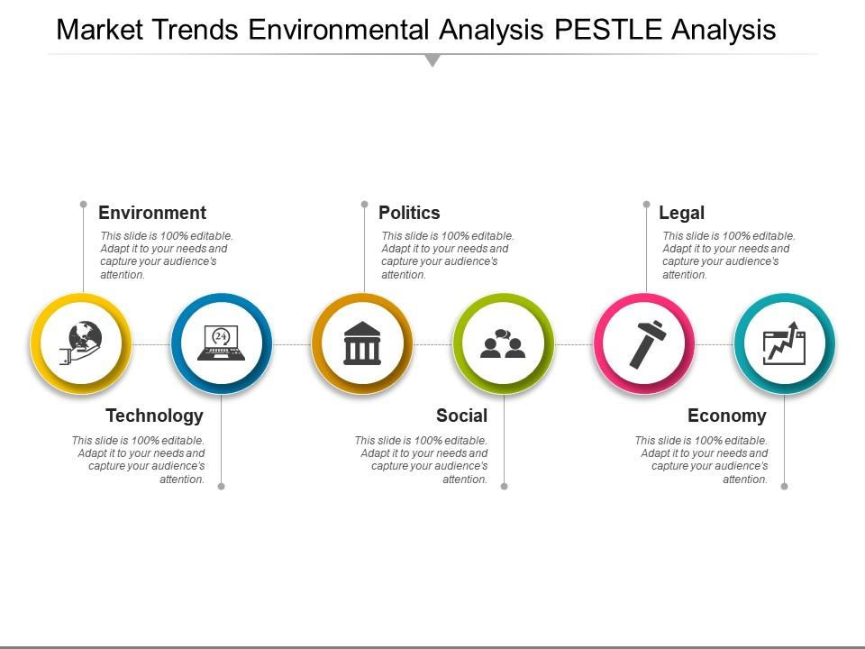
Figure 1 PESTLE (Gitman, 2018)

Economic factors
Everyone's way of life is dictated by the economy of a certain state (Gitman, 2018). Because of this, it is possible that it will have an impact on the vehicle sector. State governments have increased the cost on luxury goods by levying taxes on them. It is possible that this may lead to a decrease in demand for high-end autos. However, if a big number of enterprises offer automobiles that are comparable in price to one another, this may attract extra buyers.
Social factors
The socio-cultural factors of a place have an impact on the businesses of that area (Elearn, 2008). With such a dense population and large number of families, a nation with a highly populated frequently has a big market for heavier cars such as SUVs. Auto ownership may drop in states with excellent public transportation networks, according to some estimates. Aside from that, people in developed countries have a predisposition to buy one or even many vehicles.
Technological factors
The automotive industry is heavily dependent on current technology to ensure the safety and security of its vehicles. Companies must make significant investments in new technologies in order to guarantee that their automobiles are as safe as possible. Pollution reduction must be a top priority for businesses. Businesses may be able to do this via the use of current technologies.
Environmental factors
Environmental challenges have the potential to have a big influence on the automobile industry. As the general public gets more informed of pollution, the general public's perception of their company may deteriorate. The PESTEL analysis of the automobile industry reveals possible environmental risks in the industry. The study reveals how firms may reduce their greenhouse gases while also contributing to a slowing down of the rate at which emissions are being produced.
Legal factors
The laws of different countries may have an impact on the operations of vehicle companies alone. There are strict laws in place in many countries that limit the number of vehicles allowed on the road, which may help to lower pollution levels in the environment. The manufacturer of a car that want to participate in the global market must comply with all relevant tax and sustainability regulations.

Porter’s Five Forces Model
When it comes to identifying and assessing the five competitive variables that effect every industry, Porter's Five Forces Model is a useful tool to use (Godfrey, 2015). It can also be used to determine a company's weaknesses and strengths.

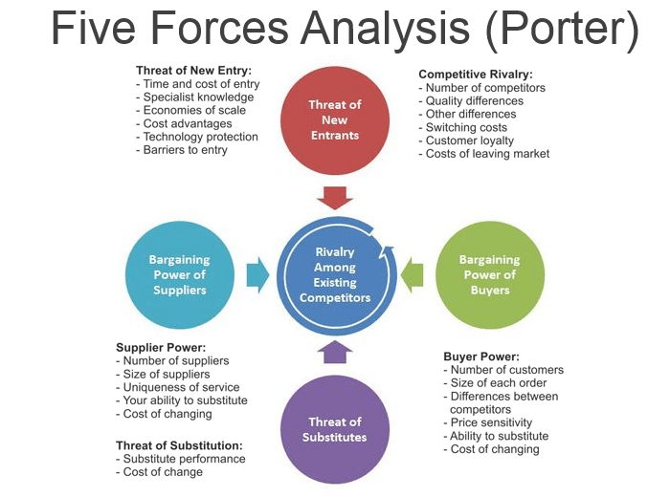
Figure 2 PORTER’S FIVE FORCES MODEL (Godfrey, 2015)
Threat of new entrants: Many vehicle manufacturers' client bases have been eroded by foreign corporations that have access to finance, technical know-how, and effective process management (Godfrey, 2015). Globalization, often known as the globalisation of finance and industry, has had a considerable influence on the car industry in recent years.
Threats of substitute: The high cost of gasoline does seem to have a substantial influence on consumers' decisions about which automobiles to purchase. The greater the cost of owning and operating a vehicle, the more likely it is that people will choose for other modes of transportation. Despite the fact that pickup trucks and utility vehicles earn higher revenues, they use much more gas than cars or commercial vehicles.
Degree of rivalry: Competition-heavy industries produce low returns as a result of the growing cost of competing. Generally speaking, the vehicle business is considered to be oligopolistic. Automobile manufacturers realize that cost competition does not always result in increased market share. Modifications may cause major interruptions and challenges, which may result in increased costs as a consequence.
The Purchasing Power of Suppliers: Automobile production is a decentralized business with a large number of independent companies. A large number of people are likely to stick by one or two automotive manufacturers in order to acquire a range of items. If a vehicle manufacturer chooses to switch suppliers, the ramifications for the old provider's business might be catastrophic. The longer a vehicle continues to operate, the greater the number of replacement parts it will need.
Bargaining power of the buyers: The bargaining power of automobile makers is unrivaled in the industry. Buyers may become dissatisfied with a majority of the products offered by a certain manufacturer and look for alternatives, particularly in the case of foreign autos. Customers on the other side, despite the fact that they are still price sensitive, lack buying power due to the fact that people seldom purchase huge numbers of autos.

SWOT Analysis
In order to improve their company's competitive advantage or plan a particular project, both individuals and companies utilize the SWOT analysis to identify and analyze their strengths, weakness, opportunities, and threats (Hill, 2011).
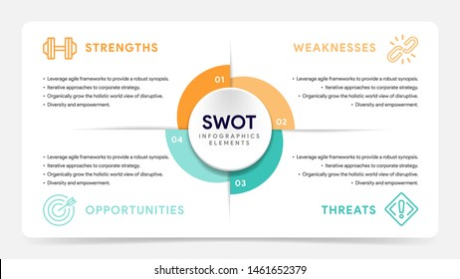
Figure 3 SWOT (Godfrey, 2015)
Strengths
Jaguar is expanding its operations into developing countries such As china, India, and other Asian countries as their economic production grows (Godfrey, 2015). International commerce has become more important for automakers as a means of competing in well-established markets. VFM products would have included gasoline and higher automobiles since the great majority of customers in these countries like to travel by car. In sophisticated countries, automobiles for long-distance transportation, as well as high vehicles that can travel long distances utilizing centrifugal compressors, are necessary.
Weaknesses
This moves from demand to supply has resulted in an abundance of models, fierce rivalry among producers and an extensive range of alternatives for consumers to select from. A rising number of people argue that vehicles should be taken off the market because of technological flaws or because they fail to meet government-mandated safety standards. The application of legislation such as income taxes, the ban of the entry of foreign automobiles into in the state, the decrease of the registry term legitimacy, and the fluctuation of the fuel price allow the government to manage the growth rate of its vehicle business.
Opportunities
For the foreseeable future, gasoline-powered automobiles will remain the norm in international markets. Companies in the automotive industry may benefit from forming strategic alliances. A growth in demand for automobiles is projected in response to overseas markets including in Southeast and the BRIC countries. OEMs may have to alter their business plans in order to achieve this goal.
Threats
Automobile manufacturers must contend with fierce competition from a slew of manufacturers as well as volatile gas prices. For the foreseeable future, the automotive sector is likely to remain preoccupied with macroeconomic, recessionary, and other economic worries. Thus, companies are shifting their focus to developing countries, where they are building infrastructure and R&D facilities. Just how much will be spent as a consequence of this is yet unknown.

Value Chain
Basic Tasks: The design, capacity development, manufacture, sales and marketing, and finally customer service are the primary activities of Jaguar Motor Company (Hunger, 2011). Design work has quickly established itself as one of the industry's distinguishing traits. As cars have become more identical in latest days, Jaguar vehicles, when outfitted with the necessary equipment, may give an image of strength and physicality. The company Jaguar is now aiming to produce autos that are not only powerful, but extremely efficient of fuel usage as well.
Acquisition of Resources: In Jaguar Motor Company, the selection of the suitable material is crucial; as shown by Porter's 5 model, suppliers have very little impact on the organization; in other words, the organization may almost always pick its preferred price over the pricing of a provider.
Productions: Jaguar Motor Company is among Europe's leading automotive manufacturers, with production (Morrison, 2020). But their methods have proved inadequate, since they have routinely generated significantly more than is necessary for the job. It has been difficult for Jaguar to catch the attention of the general public with his Branding and Sales endeavors thus far. Automobile dealerships may do this via displaying vehicles, making public remarks, and other means in order to attain cars. Jaguar transports items to and from merchants using trucks and trains.
Customer Service and Assistance: Support functions provide assistance to the Jaguar Motor Company's day-to-day operations, although they are not actively engaged in the manufacturing process. Jaguar provides a toll-free 500 number that consumers may call if they want support or have a general inquiry about the company (Taylor, 2021). This involves the shutdown of the Heathrow facility as well as the migration of production to more cost-effective sites in the United Kingdom and elsewhere. It reduced its workforce by 20% in order to boost performance and save $billion in expenses, according to Jaguar. Economic concerns such as the exchange rate, the inflation, and other similar variables are completely out of its control.

Significant Internal Business Environment Challenges at Jaguar Motor
Availability and Efficiency of Resources
- Capital ability, intangible capital, and human resources are all examples of physical resources. If Jaguar can't attract and keep the resources and talents it needs to exist and thrive, you're doomed to fail (Craig, 2012).
- Money on hand, collections, and the ability to borrow money from a variety of lenders are examples of financial resources.
- During the business cycle, the human capital appears to be the resource that coordinates all other resource variables.
- Employees' skills, manufacturing procedures, and technology are all considered "intellectual resources."
- Natural resources, manufacturing facilities, and finished goods are all included in this category.

VRIO
Incorporated within a company‘s strategy plan, VRIO is an economic analysis approach that helps it make better business decisions.
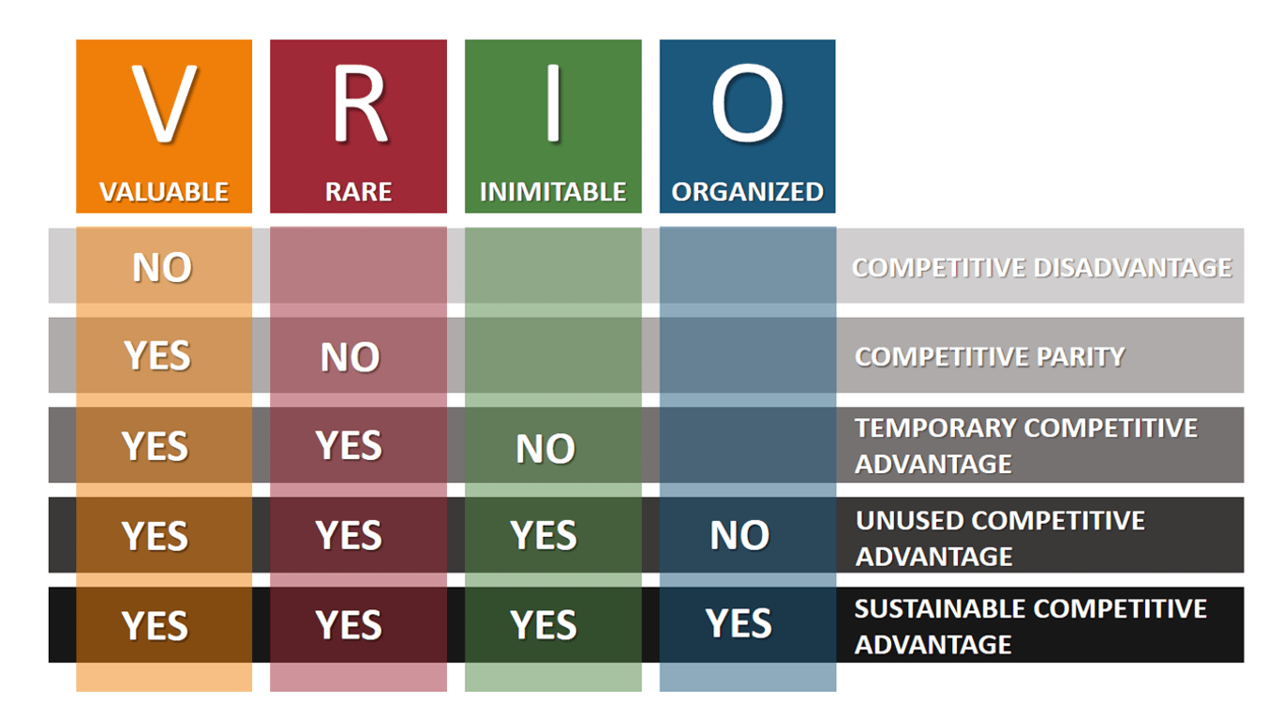
Figure 4 Vario (Tonder, 2013)

Value
Essentially, this refers to the ability of a company's resources to improve the overall customer experience (Taylor, 2021). To feel that he is receiving good value for the money he spent for the automobile, the customer wants the vehicle to function smoothly and efficiently. Customers who believe they are getting the best value for their money may become loyal.
Rare
This is a hyperlink to a material that has been created by the organization. The fact that the Jaguar automobile made its premiere earlier of all other competitors is an excellent demonstration. As the first differentiation approach in that segment of the new car market, the corporation will reap the benefits of this.
Inimitable
That the firm is capable of producing resources that are tough to reproduce is implied by this. By patenting all of the innovations created by the firm, it may protect them from being copied and pasted: Although this was tough in the case of Straits, it was necessary due to the fact that all of the company's choices were subject to scrutiny and examination by your competitors.
Organisation
This expression refers to the interaction of all organizations in order to achieve the goals and objectives of the organization, as well as the confluence of all organizations in order to achieve the goals and objectives of the organization According to the Straits Times, this sector did nothing to convince employees to stay in this field rather than go to another. Because there is no room for error in the real world, the sector may have difficulty retaining top-tier professionals.

Recommendations
The following are some basic thoughts on how Jaguar Motor Corporation Limited should improve its European effectiveness, as expressed by the company:
Jaguar has the ability to begin altering the management side of the league. They can choose to concentrate their energy on the lucrative European market sector, for example. Jaguar should refrain from making new investments inside the EU until the economy improves. Transform the way that EU conduct business by developing tiny cars that are currently commonplace. These individuals should consider incorporating additional features into their autos.

Conclusion
In today's world, the phrase "internationalism" is used to denote a wide range of things, including physical universe (Morrison, 2020). Globalization has made it simpler than ever before to break into a new international market. The business sector, on either hand, has experienced a number of challenges as a consequence of the situation. Trade restrictions, cultural barriers, political unrest, financial instability, and other reasons have made it very tough and complicated to do business in China. The Jaguar Motor Company's business has grown at a dizzying pace in recent years. Once it comes to financial problems, on the other hand, they've received a great deal of attention. To put this another way, it requires a huge amount of skill to run a successful multinational corporate enterprise. For the reason that this firm has a positive brand image and has shown its ability to compete well in the international market when certain strategies are implemented.

References
Andersen, T. J., 2013. Short Introduction to Strategic Management. s.l.:Cambridge University Press.
Brinkman, J., 2014. Unlocking the Business Environment. s.l.:Taylor & Francis.
Craig, T., 2012. Organisations and the Business Environment. s.l.:Taylor & Francis.
Elearn, 2008. Business Environment. s.l.:Taylor & Francis.
Gitman, L. J., 2018. Introduction to Business. s.l.:OpenStax College, Rice University.
Godfrey, R., 2015. Strategic Management: A Critical Introduction. s.l.: Routledge.
Hill, C. W. L., 2011. Essentials of Strategic Management. s.l.:Cengage Learning.
Hunger, J. D., 2011. Essentials of Strategic Management. s.l.:Prentice Hall.
Kapoor, M., 2019 . Global Business Environment. s.l.:SAGE Publications.
Morrison, J., 2011. The Global Business Environment. s.l.:Palgrave Macmillan.
Morrison, J., 2020. The Global Business Environment. s.l.:Bloomsbury Publishing.
Paperback, 2009. Global Business Environment. s.l.:GRIN Verlag.
Taylor, S., 2021. Work and Employment in a Changing Business Environment. s.l.:Kogan Page.
Tonder, E. v., 2013. A Theoretical Framework For Managing CSR Plans And Related Initiatives In The Modern Business Environment. A Theoretical Framework For Managing CSR Plans And Related Initiatives In The Modern Business Environment, Volume 11, p. 12.
Wetherly, P., 2018. The Business Environment: Themes and Issues in a Globalizing World. s.l.:Oxford University Press.

