
Title: Exploring the Impact of Covid-19 on Exercise Barriers and Motivation among Football Players
Name: Reon King

Student id: 2114408
Programme: Bsc health nutrition and lifestyle
Word Count: 7891

Undergraduate Dissertation Certificate



Name of the Programme of Study: BSc Health Nutrition and Lifestyle

Name of Student (Capital Letters): REON KING

DECLARATION

I certify that the whole of this work is the result of my individual effort, and that all sources have been acknowledged.

Signed ..............Reon King................................................. (Student)

Date .......................19/04/2024........................................

DECLARATION

I am satisfied that this work is the result of the Student’s effort.

Signed .............................................................. (Lecturer)

Date ..............................................................

Content Page

Abstract………………………………………. Page 3

Introduction…………………………………. Page 4

Literature review……………………………. Page 7

Method ………………………………………Page 11

Results………………………………………. Page 14

Discussion……………………………………Page 24

Summary……………………………………. Page 30

References……………………………………. Page 31

Appendices……………………………………Page 37

Abstract
The purpose of this study was to identify the impact of the COVID-19 pandemic on barriers and motivation among football players. The COVID-19 pandemic created an unprecedented disruption to daily life, including the world of sports and physical activity. As lockdowns and restrictions were implemented globally, athletes faced significant challenges in maintaining their training routines, participating in competitions, and sustaining their motivation levels (Paludo et al., 2022). Participants were 13 male football players (mean age=24±6) recruited from University of Wales Trinity Saint David's student teams and the local community through purposeful sampling. Prior to March 2020, they averaged 13.5±7.3 years of football experience, training level of 7±2.6, and 2.4±1.5 weekly sessions. The 29-item questionnaire and 26-question follow-up survey with 4 participants covered barriers, motivations, and experiences before, during, and after the pandemic relating to football training and participation. The mixed-methods approach combined quantitative and qualitative data for a comprehensive understanding. The COVID-19 pandemic substantially impacted football training and competitions, with all players reporting difficulties owing to limitations. This resulted in a decrease in weekly exercise frequency for the majority (62%), following March 2020. Strict lockdowns, cancelled games, facility closures, a shortage of equipment, and low enthusiasm were among the obstacles. Players adapted with home workouts, outdoor sessions, and individual routines, but some had to discontinue training entirely. The epidemic had an influence on 62% of football players' motivation owing to limited social contact, rigorous guidelines, and alternative activities that replaced football. Some remained motivated by planning for future competitions, improving fitness, having fun, and avoiding quitting.

Introduction
The COVID-19 epidemic has had a significant impact on many areas of life, including sports. The epidemic has caused various concerns for professional football players, including physical performance, mental health, and injury incidence (Wagemans et al., 2021; Souter et al., 2022). The basis for doing this research stems from the need to fill knowledge gaps about how the COVID-19 pandemic has affected football players' challenges and motivation levels. Exploring these qualities can provide valuable insights into the challenges that athletes face and the strategies they employ to remain motivated and enthusiastic in their sport in the face of pandemic-induced disruptions. Participants in this study include both student and community football players, reflecting a wide range of people active in the sport at various levels. By recruiting individuals from these two diverse groups, the study hopes to provide a thorough knowledge of how the pandemic has affected football players in a variety of contexts and demographics.
This study uses questionnaires and follow-up surveys as crucial instruments for data collecting and analysis. These devices allow researchers to collect thorough information from football players on their training limits, emotional affects, problems, motivational techniques, and suggestions for help. The follow-up surveys connect the players' previous experiences to their present activities, to gain deeper insights into their thoughts and experiences regarding on COVID-19 impacted allowing for a longitudinal investigation of the impact of COVID-19 on barriers and motivation in football. The research intends to provide a controlled yet comprehensive approach to investigating the impacts of the pandemic on football players using questionnaires and follow-up surveys.
The epidemic has also had an impact on football players' strength and performance because of house confinement and training modifications (Moreno-Pérez et al., 2020; Pedersen et al., 2021). Furthermore, throughout the pandemic, the mental health of both amateur and professional football players has been studied (Akgün et al., 2021). Because of the impact of COVID-19 on football, infection control techniques and policies have been developed to maintain a safe game environment (Chamari et al., 2022; Schumacher et al., 2021). The comeback of football during the pandemic has piqued the curiosity of researchers, with studies examining the medical perspective and successful return to professional football competitions (Meyer et al., 2021).
Furthermore, the prevalence and characteristics of COVID-19 infection among football players have been investigated (Papagiannis et al., 2022). Research has focused on the risk of SARS-CoV-2 transmission during football games, particularly in college football (Coffey et al., 2021; Schreiber et al., 2022). Because of the pandemic, preventive measures and infection control methods have been created to ensure the safety of athletes, personnel, and spectators at football games (Chamari et al., 2022). However, there have been critical perspectives on the revival of football during the epidemic, highlighting the importance of caution and correct protocols (Corsini et al., 2020). The Royal Spanish Football Federation has also issued a statement on the return of football activities following the COVID-19 pandemic, highlighting the importance of therapeutic measures to prevent infection among players and staff (Herrero-Gonzalez et al., 2020).
The findings from this study can guide sports organizations, coaches, and mental health professionals in developing targeted interventions and support programs to address the specific challenges athletes face during pandemics or other disruptive events. This includes strategies to maintain motivation, manage stress, and adapt to alternative training methods. By understanding the impact of pandemic restrictions on athletes' physical activity engagement, public health authorities can develop policies that consider the unique needs and challenges of this population. This can lead to more inclusive and effective measures that promote overall health and well-being among athletes during crises.
The study emphasises the importance of mental health support services for athletes experiencing low motivation, social isolation, and uncertainty during pandemics. Sports psychologists and counsellors can give athletes with coping skills and emotional support to help them manage stress and preserve their well-being. Understanding the constraints associated with facility closures and a lack of equipment can help establish contingency plans, such as temporary outdoor training facilities or equipment lending programmes, to ensure athletes have access to the resources they need during pandemics.
Create detailed preparedness strategies for anticipated disruptions to training, competitions, and athlete well-being during pandemics or other crises. These plans should contain contingency measures, communication techniques, and support networks to reduce the impact on athletes.
Aim
This study looks backward at how the COVID-19 pandemic affected football access and participation. It looks at the things that drove football players and the challenges they encountered, as well as the major alterations brought about by lockdowns and constraints. Players had to adapt to solitary or remote training schedules since lockdowns interfered with their regular practise and competition schedules.
This study examines the sport and fitness practises of football players three years after the pandemic’s peak. It examines how they exercise and how much they play football and other sports. The study assesses the obstacles they encounter in addition to their present reasons for being active. Additionally, it looks at whether football players think the pandemic has affected their current fitness and sports participation in a long-term way, including if they have changed their preferences for group or solo training, motivation, and facility access. It is imperative for the football community and other sports contexts to comprehend the enduring effects of the pandemic on exercise routines. Potential hypotheses include examining during the pandemic has resulted in increased exercise barriers among football players, such as limited access to training facilities and reduced group training sessions, leading to a decrease in motivation to engage in physical exercise.

Lit Review
The literature review on the impact of the COVID-19 epidemic on barriers and motivation for football players will be structured into several sections. Firstly, it will provide background information on football in the UK, including its popularity and the number of people playing at different levels. Secondly, it will explore the benefits of football, encompassing physical, psychological, and social aspects. Thirdly, it will delve into research on the motivation to play football. Finally, it will transition to the impact of the pandemic on football, followed by an examination of the barriers to playing football during and after the pandemic.
Football, also known as soccer, is immensely popular in the UK, with a significant number of people engaging in the sport at various levels. The sport has a profound impact on individuals' physical, psychological, and social well-being. Research has shown that regular football participation offers numerous health benefits, including improved cardiovascular fitness, muscle strength, and endurance (Reddy et al., 2017). According to Mutz et al., (2020), a representative survey collected during the period of Covid-19-related lockdowns and enforced regulations for social distancing and self-quarantine revealed that leisure time sport and exercise (LTSE) activity levels decreased sharply and significantly in Germany. During the COVID-19 pandemic, a study indicated that physically passive behaviour increased while physically active/very physically active behaviour decreased. Nonetheless, characteristics such as physical activity practice with a buddy or being supervised by a professional online were linked to physical active behaviour during social distance suggestions (Marques et al., 2020). Moreover, it has been found to have positive effects on mental health, promoting well-being and reducing the risk of depression and anxiety (Reddy et al., 2017). Additionally, football plays a crucial role in fostering social connections and community cohesion, providing individuals with a sense of belonging and camaraderie (Burns & Jollands, 2024). Motivation to play football is a complex area that has been investigated extensively. Studies have explored various factors influencing individuals' motivation to engage in football, including intrinsic factors such as enjoyment, skill development, and social interaction, as well as extrinsic factors like rewards and recognition (Coelho et al., 2018).
Understanding these motivational factors is essential for comprehending the appeal of football and sustaining participation in the sport. The COVID-19 pandemic has significantly impacted football, leading to various barriers to playing the sport. These barriers include restrictions on gatherings and social distancing measures, which have limited access to football facilities and disrupted regular training and competition schedules (Coffey et al., 2018). Furthermore, concerns about the risk of infection have deterred many individuals from participating in football activities, particularly during the height of the pandemic (Coffey et al., 2018). As a result, the pandemic has posed significant challenges to the continuity of football participation and has necessitated adaptations to ensure the safety and well-being of players and the broader football community.
COVID-19 impact on football players has been extensively researched, with studies concentrating on numerous elements such as physical performance, mental health, injury incidence, and infection control (Wagemans et al., 2021). A retrospective case series was conducted to investigate the impact of COVID-19 on physical performance and mental health in professional football athletes over the 2020-2021 season. The study evaluated thirty-three professional athletes from a Belgian first division football club and raised concerns about the impact of COVID-19 on performance and mental health (Wagemans et al., 2021; Maestro et al., 2022). Studied the rise in injury occurrence following COVID-19 infection among male professional football players, emphasising the necessity to understand the true effect of COVID-19 on professional football (Maestro et al., 2022; Souter et al., 2022). Furthermore, the focused on the impact of COVID-19 on the mental health of professional footballers, particularly those from marginalised communities, underlining the broader consequences of the pandemic on footballers' livelihoods and security (Souter et al., 2022).
The study by Pedersen et al., (2021) examined the maintenance of maximal strength, sprint, and jump performance in high-level female football players during the COVID-19 lockdown, emphasizing the need for customized training programs to mitigate the impact of the pandemic on strength and performance (Pedersen et al., 2021; Gouttebarge et al., 2022). During the COVID-19 emergency period, a comparative cross-sectional study was done to examine anxiety and depressed symptoms, emphasising the ubiquitous social isolation and psychosocial impact on professional football players (Gouttebarge et al., 2022; Clarkson et al., 2022). Given the views on the threat and uncertainty for the future of elite women's football in England, emphasising the importance of addressing the COVID-19 consequences on the game (Clarkson et al., 2022). Chuatrakoon et al. (2023) studied the symptoms and impact of COVID-19 disease on pulmonary function and metabolic power during matches, revealing the persistence of general and muscle tiredness symptoms in professional football players. Moreno-Pérez et al., (2020) investigated the effects of home confinement due to the COVID-19 pandemic on eccentric hamstring muscular strength in football players, emphasising the pandemic's impact on physical health and performance.
Meyer et al., (2021) discussed the debate over the resumption of professional sports, particularly football, during the COVID-19 pandemic, whereas Schumacher et al., (2021) conducted a prospective cohort study to assess the risk of viral transmission associated with contact sports such as football during the pandemic. Furthermore, as stated by Wagemans et al., (2021), the influence of COVID-19 on performance and mental health was a big worry for football players. COVID-19 has an impact on physical performance and mental health in people other than professional football players. Peña-González et al., (2022) assessed the effect of a guided self-training program on international CP football players’ physical fitness during the COVID-19 mandatory lockdown, emphasizing the broader impact of the pandemic on football players across different levels of the sport. Furthermore, the impact of COVID-19 on women's football was explored by Lozano et al., (2021), shedding light on the diverse experiences and challenges faced by football players during the pandemic. In addition to the physical and performance-related impacts, the pandemic also raised concerns about the transmission of SARS-CoV-2 among football players.
The pandemic has significantly impacted participation in recreational activities such as football, with various barriers and motives identified. A study from Petersen et al., (2021) stated that association between socioeconomic position and participation in recreational activities, indicating that individuals from lower socioeconomic backgrounds may face barriers to engaging in such activities. Additionally, Ball & Bice (2015) found that past participation in high school sport and recreation is linked to adult BMI and physical activity levels, suggesting that disruptions in such participation during the pandemic may have long-term effects on physical activity (Ball & Bice, 2015). Furthermore, the study by Zubair (2022) stated that loneliness and participation in recreational activities during the COVID-19 lockdown emphasizes the importance of maintaining routines that lessen loneliness, indicating a potential motive for individuals to engage in recreational activities such as football (Zubair, 2022). These studies collectively suggest that socioeconomic factors, past participation in recreational activities, and the impact of the pandemic on mental well-being and loneliness are crucial considerations when examining the barriers and motives to playing football during and after the pandemic for recreational level participants. Understanding these factors can inform strategies to address barriers and promote participation in football and other recreational activities.
The study by Gouttebarge et al., (2022) highlighted the impact of the COVID-19 emergency period on professional footballers, shedding light on the psychological challenges faced during the pandemic. Additionally, Schumacher et al., (2021) provided insights into the resumption of professional football during the pandemic, emphasizing the need for infection control strategies to ensure a safe game environment. Khan et al., (2022) also discussed the successful recommencement of football competitions with spectators during the active phase of the COVID-19 pandemic, emphasizing the importance of preventive measures. Furthermore, Chamari et al., (2022) provided a recapitulation of infection control policies aimed at ensuring a safe game environment for football during the pandemic. These studies collectively underscore the significance of understanding the barriers and motives to playing football during and after the pandemic for recreational level participants. The psychological impact, infection control measures, and successful resumption of football competitions with spectators during the pandemic are crucial aspects that need to be considered in assessing the challenges and motivations for football participation. However, there is a lack of specific research focusing on recreational level participants, highlighting the need for a dedicated study to address this gap. Therefore, the rationale for conducting a study on the barriers and motives to playing football during and after the pandemic for recreational level participants is justified by the existing literature's emphasis on professional footballers and the need for tailored insights into the experiences of recreational players.
The study by Schumacher et al., (2021) provides insights into the infective and immune status of professional football players during the Covid-19 pandemic. This study utilized a prospective cohort design, which aligns with the use of questionnaires and follow-up surveys to gather data over time. Additionally, the study by Wagemans et al., (2021) highlights the concerns of football players and their entourage regarding the impact of Covid-19 on physical performance and mental health. This emphasizes the need for longitudinal data collection through surveys to understand the evolving challenges faced by players. The study by Farah et al., (2021) identifies barriers to physical activity during the Covid-19 pandemic in adults, indicating the relevance of using surveys to capture detailed information on challenges faced by individuals. Moreover, the research by Khan et al., (2022) provides insights into the recommencement of football competition during the active phase of the pandemic, emphasizing the importance of understanding the experiences and perspectives of players and spectators, which can be effectively achieved through questionnaires and follow-up surveys.

Method
To understand the impact of the Covid-19 pandemic on football players, it is essential to gather comprehensive data on the barriers and motivations experienced by players. This study will use a qualitative design, including a questionnaire and a follow-up survey. The questionnaire will collect standardised data from a larger sample, while the follow-up survey will provide more detailed insights into athletes' experiences.
Participants
Participants was recruited by contacting University of Wales trinity Saint Davids student football teams and surrounding community in south Wales aged 18 and older (mean = 24 ± SD = 6). Because this is a unique niche community, purposeful sampling will be used to target football players directly. The sample size of the questionnaire is 13 all males’ footballs to allow for statistical analysis, and considerable recruitment was conducted to assure adequate replies. The follow-up survey includes 4 samples that will serve as a link between footballers' pandemic experiences and their current activity. Prior to March 2020, participants had an average of 13.5±7.3 years of football experience, a 7±2.6 level of training, and a 2.4±1.5 frequency of participation in football training and competition. The questionnaire distributed covered all aspects of prior, during, and after the pandemic experiences, as well as barriers and motivations.
Measures
The measures included a questionnaire consisting of 29 items (see appendices 2) and a follow-up survey with 26 questions (see appendices 1). The questionnaire and survey covered a range of topics including the impact of COVID-19 on exercise habits, exercise habits before and during the pandemic, exercise motivation, barriers to exercise, current exercise habits, and future outlook. The questions in the measures were designed to elicit specific information from the participants. For example, questions related to exercise habits before and during COVID-19 may have included items such as frequency of exercise, types of activities engaged in, and changes in exercise routines. Exercise motivation may have been assessed through questions about factors that influenced the participants to engage in physical activity. Barriers to exercise could have been explored through inquiries about challenges faced by the participants in maintaining their exercise routines during the pandemic. Responses to the questions were structured in a way that allowed for both open-ended and closed-ended formats. Open-ended questions may have required participants to provide detailed explanations or descriptions of their experiences, while closed-ended questions may have involved selecting from predefined response options such as yes/no or Likert scale ratings.

Procedures
The questionnaire was distributed online to football players in the University of Wales Trinity Saint and surrounding community aged 18 and up who were still playing before, during, and after the outbreak, with the sample obtained at random from any individual on any team who was willing to take part, though all participants were given a consent form (see appendices 3). Over a four-week period (January 14 to February 16, 2024). The University Research Ethics Committee has accepted this study in accordance with the Ethical Permission Form's guidelines and was approved. It will involve quantitative assessments of exercise frequency, duration, type, and perceived barriers and motivators during COVID-19 restrictions. The study will include open-ended questions to assess people's reasons for participating in the outbreak. The study will also investigate whether the outbreak has had an impact on their continued participation in football, such as their current playing status and level of involvement. The questionnaire will collect descriptive information on how exercise habits have evolved, and which specific factors are most influential. To eliminate participant bias, the surveys were blended into a single survey with no indication of which study the questions came from.
The choice of questionnaire employed in the study was critical to assuring validity. By using a validated measure of motivation, the researcher can improve the accuracy of the data collected. This entails employing recognised and dependable instruments that have been tested and proved to accurately measure the target constructs. Furthermore, using qualitative research methodologies that adhere to the principles established by Golafshani (2003) can improve the study's internal validity. By following criteria like as credibility, transferability, dependability, and confirmability, the researcher can assure that the findings are trustworthy. If the study were to be repeated with the same participants, obtaining comparable results is critical for dependability. This can be accomplished by ensuring consistency among the researcher, testing settings, and methodologies used. Furthermore, using several techniques of data collecting and analysis might improve the trustworthiness of the research results. Clear and precise descriptions of research methodologies was also required to ensure the study's dependability. Other researchers should be able to reproduce the study and achieve comparable results if full information on how the data was obtained, evaluated, and interpreted is provided. The instrument used to gather and organise data was a questionnaire and survey created in Microsoft Form and distributed to participants via a link. Statistical tools, such as Excel, were utilised to investigate the demographic information and quantitative measures contained in the questionnaire.
Data analysis
In the context of this study, a two-pronged method to data analysis is used, consisting of questionnaire data analysis and subsequent survey data analysis. The questionnaire data was analysed quantitatively, beginning with a full descriptive statistical analysis. This entails summarising and explaining significant elements of the quantitative dataset, such as measures of central tendency and variability. Common trends, frequencies, and patterns in standardised replies was carefully identified. Statistical tools, such as Excel was used to delve into the demographic information and quantitative metrics contained in the questionnaire, providing a quantitative summary of participants' characteristics and trends.
Concurrently, the follow-up survey data were being analysed qualitatively using thematic analysis. This strategy comprises a methodical evaluation of open-ended responses to identify repeating themes, patterns, and significant insights offered by football players. Responses was carefully coded to categorise and organise data into categories pertaining to various factors, such as training limits, emotional affects, encountered problems, motivational techniques, and ideas for aid. To achieve a systematic and thorough study, qualitative analysis software or manual coding methods was used, which allow for the understanding of the subtle and subjective components of the participants' experiences.
The data obtained from the questionnaire and follow-up survey provided a rich source of information for the study. Statistical packages like Excel were instrumental in analysing the quantitative data, while qualitative analysis software methods facilitated the in-depth exploration of the qualitative responses. By employing a two-pronged approach to data analysis, the study was able to gain a holistic understanding of the impact of COVID-19 on barriers and motivation among football players, capturing both quantitative trends and qualitative insights from the participants' perspectives.

Result
This study investigated the impact of the COVID-19 pandemic on barriers and motivation among 13 male football players aged 18 and older (mean = 23.70 ± SD = 5.98) from the University of Wales Trinity Saint David's student teams and the local South Wales community. A mixed-methods approach was utilized, combining quantitative data from a 29-item questionnaire and qualitative data from follow-up with 26-open-ended questions. The quantitative results provided statistically valid, quantifiable data points, while the qualitative insights allowed participants to express their thoughts and experiences in their own words. This holistic perspective examined how the pandemic disrupted football training and competitions, requiring adaptations and strategies to overcome challenges. The impact on motivation for football activities was assessed quantitatively and qualitatively. Quantitative measures captured motivators, barriers to regular exercise after March 2020, exercise habits, frequency, and types before, during, and after the pandemic. Qualitative data explored adaptations to exercise routines and approaches to football. The mixed-methods design enabled a comprehensive understanding of how the pandemic affected these football players, combining quantitative statistics with rich qualitative insights into their lived experiences, motivations, barriers, and adaptations during this unprecedented time.
Pre Covid before March 2020
The study asked participants about their weekly frequency of football training and competition before March 2020 (see appendices 4). The responses ranged from 0 to 5 times per week with the mean frequency was (2.46 ± 1.51) times per week, suggesting participants averaged around 2-3 football sessions weekly prior to March 2020. The study asked participants about their engagement in forms of exercise other than football training before March 2020 (see appendices 5). The mean number of participants who engaged in additional exercise was 6.5, with a standard deviation of 0.7. Out of the total 13 participants, 6 individuals (46%) responded affirmatively, indicating that they partook in additional physical activities beyond football training before March 2020. Conversely, the remaining 7 participants (54%) reported that they did not engage in any other forms of exercise apart from football training during the specified period.

During Covid 19 (National lockdowns (late March 2020 - June 2020, January 2021 – July 2021) and local lockdowns (tiers) (September 2020 – November 2020) UK
Table 1: Disruption to Training and Competitions
 | Yes | No | Maybe | Mean±SD
Disruption of football training and competitions | 100% | N/A | N/A | 13±N/A
Restrictions or guidelines that prevented you from training | 84% N=11 | 8% N=1 | 8% N=1 | 4.33±5.77
Any changes in the frequency or intensity of your training sessions | 62% N=8 | 15% N=2 | 23% N=3 | 4.33±3.2

Table 1 shows the disruption to football training and competitions. All responders said "yes," indicating that they had suffered disruptions in their football training and competition. The mean value is 13, but no standard deviation is provided. Restrictions or guidelines that prevented you from training 84% (11 respondents) said "Yes", 8% (1 respondent) said "No", and 8% (1 respondent) said "Maybe". The mean value is 4.33 and the standard deviation is 5.77. Any variations in the frequency or intensity of your training sessions: 62% (8 respondents) said "Yes", 15% (2 respondents) said "No", and 23% (3 respondents) said "Maybe". The mean value is 4.33, and the standard deviation is 3.2.
The study questioned individuals how their weekly exercise frequency had changed compared to before (see appendices 6). The majority, 62%, or 8 out of 13 people, reported a decline in their weekly exercise frequency after March 2020. In contrast, 23%, or three people, increased their weekly exercise frequency throughout the same period. The remaining 15%, consisting of two people, reported that their weekly exercise routines remained unaltered. The average value for the group was 4.3, with a standard deviation of 3.2.

Table 2: Adaption to the challenges posed and caused by the pandemic on exercise.

Did you have to modify your training routine to adapt to the challenges posed by the pandemic? If, so how? | How did you generally adapt to the disruptions caused by the pandemic in terms of your football training and exercise routines?
Virtual online team (N=1) | Home workout (N=2)
Adaptation (N=3) | Outdoor workout (N=3)
Home exercise (N=1) | Time Management (N=1)
No, Stay the Same (N=5) | Covid Restriction (N=3)
Individual training (N=1) | Training Stop (N=2)
 | Individual workout (N=2)
 | Follow Guidelines (N=2)

Table 2 summarises participants' reactions to how they changed their training routines and exercise habits during the COVID-19 epidemic. Regarding alterations to their training routines, five respondents answered that they didn’t need to make any changes and could continue as before. One respondent noted transitioning to individual training, and three said they had to change their routines in some way. One respondent noted adding home exercises, while another mentioned participating in virtual online team training sessions. Two respondents described conducting home workouts to cope with the pandemic's disturbances. Three respondents mentioned doing outdoor workouts as an option. Three respondents identified COVID-19 limits as a factor impacting their training, while two indicated they had to halt training entirely for a period. One respondent emphasised the importance of better time management during the pandemic, while two others suggested completing solo workouts. Additionally, two respondents said that they followed pandemic-related instructions for their training routines.

Table 3: Barriers made it harder for you to exercise regularly after March 2020
Which factors below made it harder for you to exercise regularly after March 2020 | Respondents
Facility closures: | 6
Lack of equipment: | 6
Cancellation of competitions/games: | 7
Isolation from teammates: | 5
Fear of infection transmission: | 2
Strict lockdown rules: | 8
Injury or illness: | 1
Lack of motivation: | 6
Mental health impacts: | 5

Table 3 summarises participants to a questionnaire question asking participants about the issues that made it difficult for them to exercise frequently after March 2020. Among the barriers mentioned, severe lockdown requirements were the most frequently stated problem, with 8 respondents reporting that it affected their ability to exercise consistently. The cancellation of competitions or games provided a considerable issue, with seven respondents citing it as a barrier. Facility closures and a shortage of equipment were both highlighted by six respondents, indicating that access to exercise facilities and gear was critical in maintaining regular exercise habits. Interestingly, six respondents cited a lack of motivation as a barrier to regular exercise during this time. The impact of social isolation was clear, with five respondents citing difficulty exercising on a regular basis. Five respondents cited mental health concerns as a barrier to regular exercise.

Table 4: Pandemic affect motivation and the impacted towards it.

Did the pandemic affect your motivation to engage in football-related activities? | If yes, please describe how it impacted your motivation. | If you continued during the pandemic, what motivated you to participating in football during the pandemic, despite the challenges?
Yes (8 Respondent 62%) | Challenging (N=1) | Outdoors workout (N=1)
No (5 Respondent 38%) | No affected (N=5) | No challenges encounter (N=4)
Mean= 6.5  SD= 2.1 | Training level increase (N=1) | Preparing for future competitions (N=3)
 | Limited contact of friends (N=1) | Enjoyment (N=3)
 | Follow Guidelines (N=2) | Afraid of Quitting (N=1)
 | New Activities (N=1) | Increasing fitness (N=3)
 | Competitive (N=1)
 | Lack of motivation (N=1)

Table 4 summarises participants out of the total respondents, 8 (62%) stated that the COVID-19 pandemic affected their motivation to engage in football-related activities, while 5 respondents (38%) said it did not impact their motivation, with a mean score of 6.5 and a standard deviation of 2.1. Among those who reported that the pandemic affected their motivation, one respondent found it challenging, and another mentioned an increase in their training level. Interestingly, 5 respondents said it did not affect them, despite stating that the pandemic impacted their motivation. Additionally, one respondent cited limited contact with friends, another engaged in new activities, and one became more competitive. Two respondents followed guidelines, while one experienced a lack of motivation. For the respondents who continued participating in football during the pandemic, their motivations varied. One individual sought an outdoor workout, while 4 respondents did not encounter any challenges. Three respondents were preparing for future competitions, and another was afraid of quitting. Increasing fitness was a motivating factor for 3 respondents, and an equal number cited enjoyment as their reason for continuing football-related activities during the pandemic.

After Covid (19/07/2021 lifting all lockdown restrictions) UK
The study questioned individuals about the pandemic's impact on their workout routines and football engagement (see appendices 7). In terms of long-term changes brought about by the pandemic, 31% said "Yes" and 69% stated "No". Those who replied "Yes" added further information, such as playing every day to improve, feeling more fit, intending to go to the gym more frequently than previously, and having an extra day to practise football with friends. When asked if they expected the pandemic to have any long-term impacts on their future participation in football and exercise, 23% indicated "yes," while 76% said "no." There were no details offered in the data for individuals who replied "Yes" to anticipated long-term potential repercussions.
The study included a follow-up qualitative survey with 4 participants from the initial sample (N=13). The participant was selected randomly with the initial sample which were recruited from the University of Wales Trinity Saint David's student football teams and the surrounding community in South Wales, aged 18 and older. The survey aimed to gain deeper insights into their thoughts and experiences regarding how COVID-19 impacted exercise barriers and motivation for football players. Participants discussed their motivations for initially playing football and factors keeping them engaged pre-pandemic. They then described their experiences during the pandemic restrictions, including barriers faced. Finally, they shared how their football motivation and engagement was impacted post-pandemic, whether it returned to previous levels, increased, or decreased.

Table 5: Shows how the participants first got involved in playing football, Training Routine Preferences and Motivation in football.
Theme | Participant | Quote
Introduction to Football | Case 1 | "Well first I learning the basic about the game like the rules, using the ball with my foot, etc.\ When I was growing up saw my older brother playing the sport so I wanted to and my first experience was great."
 | Case 2 | "I first got involved through watching friends play as a child."
 | Case 3 | "My cousin introduced me to football and I joined the team she was on."
 | Case 4 | "Got involved around 4 years old, training and playing non-competitive on a local astro every week. From around 9 years I joined the Urdd football team and played there until I was about 15. I played for another few years with a couple of teams until 2019 then stopped. I joined back into playing with my uni after COVID, and joined my local team Lampeter, who I currently play with."
Training Routine Preferences | Case 1 | "I love doing drills."
 | Case 2 | "Cardio workout."
 | Case 3 | "Training was every day from 4pm to 6pm."
 | Case 4 | "Playing simulated games and passing drills with movement."
Motivation in Football | Case 1 | "The challenge of competition and reaching new personal levels, skill improvement, potential, etc."
 | Case 2 | "Personal improvement."
 | Case 3 | "Personal improvement."
 | Case 4 | "Community involvement with Ceredigion at the moment."

Table 5 presents quotes from participants in a survey about their experiences with playing football, organized into three themes. Regarding their introduction to football (see appendices 8), the quotes highlight various pathways that led the participants to initially get involved in the sport. Cases 1 and 3 were inspired by family members, with Case 1 seeing their older brother play and Case 3 being introduced by their cousin and joining the same team. Case 2 was influenced by watching friends play as a child. Case 4 provides a more detailed account, starting to train and play non-competitively on a local field around the age of 4, joining an organized team (Urdd football team) at 9 years old and continuing to play for various teams until taking a break in 2019 before rejoining after COVID. On the theme of motivation in football (see appendices 9), the quotes reveal that personal improvement, such as reaching new skill levels and realizing their potential, was a significant motivator for Cases 1, 2, and 3. Case 1 also cited the challenge of competition as a motivating factor. In contrast, Case 4's current motivation stemmed from community involvement with the Ceredigion team. Regarding training routine preferences (see appendices 10), the participants enjoyed various aspects. Case 1 loved doing drills, Case 2 mentioned cardio workouts, Case 3 had an intensive routine lasting from 4 pm to 6 pm every day, and Case 4 enjoyed simulated games and passing drills with movement.
Table 6: Exploring pre-pandemic routines and Anticipation and preparation.
Theme | Participant | Quote
Exploring Pre-pandemic routines | Case 1 | "Well I try to exercise 2-3 hours everyday indoors."
 | Case 2 | "Exercising 4 times per week."
 | Case 3 | "Consistent"
 | Case 4 | "Casual and non directed,"
Anticipation and preparation | Case 1 | "reach maximum efficiency in abilities connected to a certain sports discipline," "mastering physical condition, affiliation, psychological condition, appearance, others' expectations, enjoyment, and competition/ego."
Anticipation and preparation | Case 2 | "good," "Keeping fit"
Anticipation and preparation | Case 3 | "Low," "It was fun"
Anticipation and preparation | Case 4 | "Basic drills and fitness, sometimes indoors in the winter. Shooting drills often," "General joy of football and exercise"

In table 6, The participants' perspectives on pre-pandemic routines and anticipation/preparation for physical activity vary significantly (see appendices 11 and 12). In terms of pre-pandemic routines, one participant (Case 1) exhibits a highly structured approach, dedicating 2-3 hours daily to indoor exercise. Another participant (Case 2) maintains a regular routine, exercising four times per week. In contrast, Case 4 describes their approach as more casual and non-directed. Regarding anticipation and preparation, Case 1 emphasizes maximizing efficiency across various aspects of sports, including physical, psychological, and social factors. Case 2 preparation is simply described as "good," with a focus on fitness maintenance. Conversely, Case 3 anticipation is low, but they still find the activity enjoyable. Finally, Case 4 engages in basic drills and fitness exercises, particularly emphasizing football-related activities, while expressing a general joy for both football and exercise. These diverse perspectives highlight the multifaceted nature of individuals' approaches to physical activity and their levels of commitment and enjoyment.

Table 7: Exploring the Adaptation to disruption and motivation to engage in football-related activities changed during the COVID-19 pandemic.
Theme | Participant | Quote
Adaptation to disruption | Case 1 | "reaction by avoiding exercise, which reduces the fitness level. As a result, breathing becomes hard."
 | Case 2 | "Training had to stop."
 | Case 3 | "Not much can be done in doors."
 | Case 4 | "weren't playing much as usual in the 2 years because of covid impact."
Adaptation to disruption (continued) | Case 1 | "lack of energy, fear of injury, lack of skill, lack of resources."
 | Case 2 | "Everybody had to get rapid test and well as vaccines."
 | Case 3 | "Couldn't manage Work, school and football."
 | Case 4 | "Being allowed to meet in groups."
Motivation | Case 1 | "hard to maintain fitness and very difficult to play with team members."
 | Case 2 | "hard to focus on football."
 | Case 3 | "Curfews affected this participant's training time."
 | Case 4 | "Dropped completely."

The "Adaptation to disruption" section explores how the disruptions caused by the pandemic impacted the participants' football training and exercise routines (see appendices 13). The quotes reveal various challenges faced by the participants. For Case 1, the disruptions led to avoiding exercise, which reduced their fitness level, making it hard for them to breathe. Case 2 had to stop training completely due to the pandemic. Case 3 expressed the limited options for indoor activities during this period, stating, "Not much can be done indoors." Interestingly, Case 4 mentioned that they "weren't playing much as usual in the 2 years because of the COVID-19 impact," suggesting a direct impact on their football activities. The section further delves into the specific challenges or barriers the participants faced in maintaining their football activities during the pandemic period (see appendices 14). Case 1 faced multiple challenges, including lack of energy, fear of injury, lack of skill, and lack of resources. For Case 2, the requirement for rapid testing and vaccination posed a barrier. Case 3 struggled to balance different responsibilities, finding it difficult to manage work, school, and football. Case 4 highlighted the restriction on meeting in groups as the main challenge. The "Motivation" section explores how the participants' motivation to engage in football-related activities changed during the COVID-19 pandemic (see appendices 15). The quotes suggest a negative impact on motivation across the cases. Case 1 found it hard to maintain fitness and very difficult to play with team members. Case 2 expressed that it was hard to focus on football during the pandemic situation. For Case 3, curfews affected their training time, likely impacting their motivation. Case 4's motivation dropped completely, as stated in their succinct response.

Table 8: Exploring the Current exercise habit and perceive any lasting effects of the pandemic on their participation in football.
Theme | Participant | Quote
Current exercise habits | Case 1 | "No."
 | Case 2 | "get fit and prepare for future games."
 | Case 3 | -
 | Case 4 | "yes regularly typically twice a week (weather permitting)."
Long-term impact assessment | Case 1 | "No not to my knowledge."
 | Case 2 | "Not really hope everything get back to normal."
 | Case 3 | "kinda but for the better I need to get back my motivation."
 | Case 4 | "I was on and off playing football during COVID so after being in lockdown, I enjoyed starting up once again after COVID."

In table 8, shows the current exercise habits section exploring whether the participants are still actively playing football after the COVID-19 pandemic (see appendices 16). Case 1 is no longer actively engaged in playing football, while Case 2 is actively playing and recognizes the need to "get fit and prepare for future games." Similarly, Case 3 is not actively playing football after the pandemic period. In contrast, Case 4 is regularly playing football, typically twice a week, weather permitting. The "Long-term impact assessment" section assesses whether the participants perceive any lasting effects of the pandemic on their participation in football and exercise in the current period (see appendices 17). Case 1 and Case 2 do not perceive any lasting effects, with Case 2 hoping that "everything will get back to normal." On the other hand, Case 3 acknowledges some lasting effects but sees them as positive, expressing the need to "get back my motivation." Interestingly, Case 4 mentions enjoying starting up again after COVID since they were hardly playing football during the pandemic, stating, "I was on and off playing football during COVID so after being in lockdown, I enjoyed starting up once again after COVID."

Discussion
The COVID-19 pandemic disrupted football training and competitions for participants in this study, with all reporting significant disruptions due to implemented restrictions and guidelines. This led to a decline in weekly exercise frequency for 62% of players, citing various barriers such as strict lockdown rules and lack of motivation. Strategies to adapt included home workouts and outdoor training, though some stopped training altogether during lockdowns. Motivation was affected for 62%, attributed to limited social contact and new activities replacing football. However, some remained motivated by preparing for future competitions and enjoyment of the sport. Post-pandemic, 31% reported positive changes like increased play frequency and improved fitness, while 23% expected lasting impacts on their participation. Follow-up surveys revealed mixed engagement post-pandemic, with some remaining active due to enjoyment, while others discontinued. Positive impacts included increased motivation and appreciation for team sports, alongside adopting individual training routines.
In line with prior research with other groups such as Canadians, Germans, and various profiles such as athletes and the elderly, the participants in this study reduced their levels of physical activity during the COVID-19 epidemic (Meyer et al., 2021). The study found contrasting results compared to Marques et al., (2020) national study, where 40% practiced some physical activity during the pandemic. In the current football player study, the majority (62%) reported a decline in weekly exercise frequency after March 2020, notably different from the national study's higher percentage (40%) maintaining activity. Interestingly, 23% of football players increased exercise, while Marques et al., (2020) did not distinguish increases or decreases. 15% of football players maintained consistent routines, suggesting a smaller portion could continue exercising compared to the general population. The study under evaluation closely aligns with Lima et al., (2021) findings on the impact of COVID-19 restrictions on athletes, particularly football players. Both employed questionnaires to investigate the pandemic's effects on training routines and exercise habits. Lima et al., (2021) focused on elite athletes across sports, including football, revealing significant impacts on training due to COVID-19 restrictions. Facility closures and limitations on group activities led to decreased frequency and intensity of training sessions for many athletes. The current study corroborates these findings, with 84% responding "Yes" to restrictions preventing training, and 62% reporting variations in frequency or intensity (15% "No," 23% "Maybe"). These results are consistent with Lima et al.'s observation of decreased training among elite athletes due to COVID-19 restrictions, potentially impacting physical conditioning, performance, and well-being. The alignment between the studies reinforces the significant impact of the pandemic and associated restrictions on athletes' training routines and exercise habits across levels. By corroborating findings, these studies provide a comprehensive understanding of the challenges athletes faced during the pandemic, highlighting the need for adaptive strategies and support systems to mitigate potential negative impacts on their physical and mental well-being. The findings from the study conducted on football players during the COVID-19 pandemic, which indicated a significant disruption in their training and exercise routines due to restrictions and guidelines, align with previous research by (Wagemans et al., 2021).
Highlighted concerns regarding the impact of COVID-19 on the physical performance and mental health of professional football athletes. This retrospective study sheds light on the challenges faced by affected football players and emphasizes the importance of considering the overall well-being of athletes during such unprecedented times. The study by Schumacher et al., (2021) further supports these findings by revealing the profound impact of the COVID-19 pandemic on football players' exercise routines. The disruptions caused by restrictions and guidelines implemented during the pandemic period led to a notable decrease in the weekly exercise frequency of most players post-March 2020 compared to pre-pandemic levels. This decline in exercise frequency highlights the challenges faced by athletes in maintaining their physical fitness and training regimens during times of crisis. These findings are consistent with the current study, which highlighted the pandemic's dramatic impact on football players' workout routines and the difficulty associated with maintaining physical fitness and training regimens. Both findings highlight how the COVID-19 pandemic has drastically altered football players' usual training and exercise habits. The limits, facility closures, and rules imposed during the epidemic made it impossible for players to continue their normal training routines while being physically prepared.
Several previous studies, including Ammar et al., (2020) and Maestro et al., (2022), have explored the effects of the COVID-19 pandemic on athletes, aligning closely with the findings of the current study on football players. Ammar et al.'s research revealed similar barriers such as strict lockdown rules, competition cancellations, and limited access to training facilities. They also identified coping strategies like home workouts, echoing adaptations reported by football players in the present research. Maestro et al., (2022) focused on elite adolescent soccer players, finding disruptions in training routines, decreased motivation, and increased injuries due to lockdown restrictions. These findings reinforce the challenges identified in the current study. Football players faced barriers to regular exercise including lockdown rules, competition cancellations, facility closures, and lack of equipment access, leading to varied coping strategies like home workouts and outdoor training. Some participants ceased training entirely during lockdowns. These findings underscore the widespread impact of the pandemic on athletes and highlight the need for targeted support systems and coping strategies to promote athlete well-being and performance during such unprecedented times.
Furthermore, Bas et al., (2020) investigation into the broader impact of COVID-19 on sport and physical activity underscored the challenges faced by athletes amidst lockdown measures and competition cancellations. Although not specifically targeting football players, their findings emphasize the importance of adapting physical activity routines during periods of restricted movement, which resonates with the experiences shared in the current study. By referencing these studies, a comprehensive understanding of COVID-19's impact on athletes' training routines and well-being emerges, demonstrating consistency in the challenges faced and the strategies employed to overcome them.
The findings from the study investigating the effects of the COVID-19 pandemic on football players' exercise routines and motivation resonate with existing research on the impact of lockdowns and restrictions on athletes' behaviour and mental well-being. For example, Clemente-Suárez et al., (2020) examined the psychological consequences of COVID-19 lockdowns on professional South African athletes, revealing decreased motivation, heightened stress, and disrupted training regimens. Similarly, Schinke et al., (2021) explored the pandemic's psychological impact on athletes across various sports and countries, identifying stressors like uncertainty about competitions, facility closures, and virus-related concerns. These studies parallel the findings regarding the challenges faced by football players during the pandemic, including limited social interaction, cancelled competitions, and decreased motivation. Such barriers reflect broader societal issues and underscore the intricate relationship between external stressors, individual motivations, and health behaviours. Moreover, the adaptive strategies adopted by football players, such as home workouts and individual training routines, highlight resilience in the face of adversity. These findings contribute to understanding how global crises like the COVID-19 pandemic can influence individuals' thoughts, feelings, and behaviours, particularly concerning physical activity engagement.

The adaptive strategies adopted by football players, like engaging in home workouts and individual training routines, demonstrate resilience in the face of adversity. This resilience is crucial for athletes to maintain their physical and mental well-being during challenging times. Understanding how crises like the pandemic can influence individuals' thoughts, feelings, and behaviours, especially regarding physical activity engagement, is essential for developing targeted interventions and support systems for athletes. Practical implications of these findings extend to sports medicine physicians, coaches, sports psychologists, and policymakers involved in athlete well-being. Sports medicine physicians can use insights from studies like Wilson et al., (2020) to guide the return-to-play process for athletes recovering from COVID-19, considering cardiac evaluations and potential risks of cardiac complications. Coaches and sports psychologists can tailor training programs and mental health support to address athletes' decreased motivation and heightened stress during uncertain times. Policymakers can use this information to implement strategies that support athletes' well-being and performance during and after global crises.
Sports organizations and clubs can utilize research findings to tailor support programs for athletes facing disruptions during the pandemic, focusing on maintaining physical and mental well-being by addressing challenges like decreased motivation and limited training opportunities (Wagemans et al., 2021). Athlete support services, including coaches and sports psychologists, can design targeted interventions based on insights from studies to enhance motivation, manage stress, and facilitate adaptation to alternative training methods such as home workouts (Schumacher et al., 2021). Public health authorities can benefit from understanding the effects of COVID-19 restrictions on athletes' physical activity engagement to develop policies that consider athletes' unique challenges and promote overall health and well-being within the population (Meyer et al., 2021). Furthermore, the research contributes to the growing body of knowledge on the psychological and behavioural effects of the pandemic on athletes, allowing the research community to delve deeper into understanding athletes' responses to crisis situations and develop evidence-based interventions to support their resilience and performance during challenging times (Pedersen et al., 2021). By applying these insights, stakeholders can better address the unique needs and challenges faced by football players, supporting their physical and mental health, enhancing resilience, and promoting continued engagement in physical activity despite external disruptions (Richlan et al., 2023).

The study under evaluation employed a mixed-methods approach, incorporating both quantitative and qualitative data collection techniques to investigate the impact of the COVID-19 pandemic on football players' barriers and motivations. This methodological choice allowed for a comprehensive and nuanced exploration of the subject matter, providing a deeper understanding of how the pandemic influenced the training routines and motivations of the participants. By combining numerical data with non-numerical insights, the researchers were able to capture a more holistic view of the effects of the pandemic on football players. Furthermore, the research topic itself is noted for its novelty within the field, as it delves into the specific repercussions of the COVID-19 pandemic on football players' behaviours and attitudes towards training. This unique focus contributes to the existing body of knowledge by shedding light on an underexplored area, thereby adding value to the literature on sports psychology and athlete performance during times of crisis.
The study has several notable limitations. First, the small sample size of only 13 participants raises concerns about the statistical power and generalizability of the findings. A larger sample size would have provided a more robust basis for drawing conclusions. Additionally, the lack of transparency in the participant selection process and criteria raises questions about the representativeness of the sample and the potential for biases. Another limitation is the absence of a control group in the research design. A control group would have facilitated comparisons and helped account for extraneous variables that could have influenced the outcomes. Furthermore, the study's focus on a specific geographic location, South Wales, limits the generalizability of the findings to other regions or populations. The limited scope of the study, in terms of both sample size and geographical representation, may restrict the applicability of the results to a broader context. While the inclusion of individuals from both university football teams and the local community adds diversity, a more extensive and representative participant pool would have strengthened the study's validity and generalizability. Overall, these limitations highlight the need for caution when extrapolating the findings and underscore the importance of replicating the study with a more rigorous research design.
The study focused on the immediate impacts of COVID-19 on football players' barriers and motivation. Suggesting a longitudinal study to explore enduring effects, it could reveal insights into players' well-being, performance, and engagement over time. Such research could aid in developing strategies to assist athletes in recovering and building resilience. Future studies could conduct comparative analyses across sports, uncovering unique challenges and coping mechanisms. Tailored support programs could then address athletes' specific needs. Further research could evaluate the effectiveness of coping strategies like virtual training and mental health support services, guiding best practices for athlete support during disruptions. Investigating social support networks' role in mitigating adverse effects on motivation and well-being could be crucial. Understanding these networks could inform strategies for fostering stronger connections and providing emotional support. Additional research could address potential gender disparities in athletes' experiences and needs. Overall, these efforts could lead to more comprehensive support systems tailored to athletes' needs, equipping them to navigate future obstacles while safeguarding their physical and emotional well-being.

Summary
In conclusion, the study examined the profound impact of the COVID-19 pandemic on football players' exercise routines, barriers, and motivation levels. The findings shed light on the significant disruptions experienced by participants, with all reporting interruptions to their training and competitions due to restrictions and guidelines implemented during the pandemic. This disruption had far-reaching consequences, leading to a decline in weekly exercise frequency for most players compared to pre-pandemic levels. The follow-up survey provided further insights into the varied experiences of participants, with some remaining actively involved in football, citing enjoyment and consistency as motivating factors, while others had discontinued their participation. Positive impacts reported included feeling more motivated and appreciative of team sports, as well as adopting individual training routines. These findings can inform the development of targeted interventions and support systems to address athletes' decreased motivation, heightened stress, and disrupted training regimens during global crises. Additionally, the research highlights the need for sports organizations and clubs to tailor support programs that promote physical and mental well-being, enhance resilience, and facilitate continued engagement in physical activity despite external disruptions. In the future, more study is necessary to investigate the pandemic's long-term impacts on athletes, compare different sports and competition levels, and assess the effectiveness of various coping mechanisms and interventions. By expanding our understanding of these areas, we can better support athletes in navigating and overcoming future obstacles while safeguarding their physical and emotional health.

References

Akgün, H., Biçer, M. and Vural, M., (2021). INVESTIGATION OF MENTAL HEALTH OF AMATEUR AND PROFESSIONAL FOOTBALL PLAYERS IN THE COVID–19 PANDEMIC PERIOD. European Journal of Physical Education and Sport Science, 7(2).
Ammar, A., Brach, M., Trabelsi, K., Chtourou, H., Boukhris, O., Masmoudi, L., Bouaziz, B., Bentlage, E., How, D., Ahmed, M. and Müller, P., (2020). Effects of COVID-19 home confinement on eating behaviour and physical activity: results of the ECLB-COVID19 international online survey. Nutrients, 12(6), p.1583.
Ball, J.W. and Bice, M.R., (2015). Adult BMI and physical activity: Retrospective evaluation of high school sport and recreation participation. Recreational Sports Journal, 39(2), pp.144-156.
Bas, D., Martin, M., Pollack, C. and Venne, R., (2020). The impact of COVID-19 on sport, physical activity and well-being and its effects on social development.
Burns, J.E. and Jollands, S., (2024). Review Papers Examining accountability in relation to local football communities. Accounting, Auditing & Accountability Journal, 37(2), pp.627-637.
Chamari, K., Dergaa, I., Mujika, I., Schumacher, Y.O., Tabben, M. and Saad, H.B., (2022). Football in times of COVID-19: A recapitulation of preventive measures and infection control policies aiming at a safe game environment. International Journal of Sports Physiology and Performance, 17(9), pp.1448-1451.
Chuatrakoon, B., Konghakote, S., Sa-Nguanmoo, P. and Nantakool, S., (2023). Long-term impact of SARS-CoV-2 infection on cardiorespiratory fitness: a meta-analysis. Frontiers in Public Health, 11, p.1215486.
CİDDİ, P.K. and YAZGAN, E.A., (2020). Investigation of the continuity of training and mental health of athletes during social isolation in the Covid-19 outbreak. International Journal of Disabilities Sports and Health Sciences, 3(2), pp.111-120.
Clarkson, B.G., Culvin, A., Pope, S. and Parry, K.D., (2022). Covid-19: Reflections on threat and uncertainty for the future of elite women’s football in England. Managing sport and leisure, 27(1-2), pp.50-61.
Clemente-Suárez, V.J., Fuentes-García, J.P., de la Vega Marcos, R. and Martínez Patiño, M.J., (2020). Modulators of the personal and professional threat perception of Olympic athletes in the actual COVID-19 crisis. Frontiers in psychology, 11, p.564947.
Coelho, D.B., Pimenta, E.M., Rosse, I.C., de Castro, B.M., Becker, L.K., de Oliveira, E.C., Carvalho, M.R.S. and Garcia, E.S., (2018). Evidence for a role of ACTN3 R577X polymorphism in football player’s career progression. International journal of sports medicine, 39(14), pp.1088-1093.
Coffey, K.C., Malani, P. and Morgan, D.J., (2021). Preventing transmission of SARS-CoV-2 during college football games. JAMA Network Open, 4(10), pp.e2135592-e2135592.
Coffey, N., Lawless, M., Kelly, S. and Buggy, C., (2018). Frequency of self-reported concussion amongst professional and semi-professional footballers in Ireland during the 2014 season: a cross-sectional study. Sports Medicine-Open, 4, pp.1-8.
Corsini, A., Bisciotti, G.N., Eirale, C. and Volpi, P., (2020). Football cannot restart soon during the COVID-19 emergency! A critical perspective from the Italian experience and a call for action. British Journal of Sports Medicine, 54(20), pp.1186-1187.
Dixon, B.C., Fischer, R.S., Zhao, H., O’Neal, C.S., Clugston, J.R. and Gibbs, S.G., (2021). Contact and SARS-CoV-2 infections among college football athletes in the Southeastern conference during the COVID-19 pandemic. JAMA Network Open, 4(10), pp.e2135566-e2135566.
Facer-Childs, E.R., Hoffman, D., Tran, J.N., Drummond, S.P. and Rajaratnam, S.M., (2021). Sleep and mental health in athletes during COVID-19 lockdown. Sleep, 44(5), p.zsaa261.
Farah, B.Q., do Prado, W.L., Malik, N., Lofrano-Prado, M.C., de Melo, P.H., Botero, J.P., Cucato, G.G., de Almeida Correia, M. and Ritti-Dias, R.M., (2021). Barriers to physical activity during the COVID-19 pandemic in adults: a cross-sectional study. Sport sciences for health, 17, pp.441-447.
Finch, C.F., White, P., Twomey, D. and Ullah, S., (2011). Implementing an exercise-training programme to prevent lower-limb injuries: considerations for the development of a randomised controlled trial intervention delivery plan. British journal of sports medicine, 45(10), pp.791-796.
Gattoni, C., Conti, E., Casolo, A., Nuccio, S., Baglieri, C., Capelli, C. and Girardi, M., (2022). COVID‐19 disease in professional football players: symptoms and impact on pulmonary function and metabolic power during matches. Physiological Reports, 10(11), p.e15337.
Girardi, M., Casolo, A., Nuccio, S., Gattoni, C. and Capelli, C., (2020). Detraining effects prevention: a new rising challenge for athletes. Frontiers in Physiology, 11, p.588784.
Golafshani, N., (2003). Understanding reliability and validity in qualitative research. The qualitative report, 8(4), pp.597-607.
Gouttebarge, V., Ahmad, I., Mountjoy, M., Rice, S. and Kerkhoffs, G., (2022). Anxiety and depressive symptoms during the COVID-19 emergency period: a comparative cross-sectional study in professional football. Clinical Journal of Sport Medicine, 32(1), pp.21-27.
Harøy, J., Wiger, E.G., Bahr, R. and Andersen, T.E., (2019). Implementation of the Adductor Strengthening Programme: Players primed for adoption but reluctant to maintain—A cross‐sectional study. Scandinavian journal of medicine & science in sports, 29(8), pp.1092-1100.
Herrero-Gonzalez, H., Martín-Acero, R., Del Coso, J., Lalín-Novoa, C., Pol, R., Martín-Escudero, P., De la Torre, A.I., Hughes, C., Mohr, M., Biosca, F. and Ramos, R., (2020). Position statement of the Royal Spanish Football Federation for the resumption of football activities after the COVID-19 pandemic (June 2020). British journal of sports medicine, 54(19), pp.1133-1134.
Khan, N.A., Al Musleh, A.A., Abdurahiman, S., Asim, M., El-Menyar, A. and Al-Thani, H., (2022). Recommencement of football competition with spectators during the active phase of the COVID-19 pandemic in a Middle Eastern country. BMC Sports Science, Medicine and Rehabilitation, 14(1), p.112.
Kiliç, Ö., Aoki, H., Goedhart, E., Hägglund, M., Kerkhoffs, G.M.M.J., Kuijer, P.P.F.M., Waldén, M. and Gouttebarge, V., (2018). Severe musculoskeletal time-loss injuries and symptoms of common mental disorders in professional soccer: a longitudinal analysis of 12-month follow-up data. Knee surgery, sports traumatology, arthroscopy, 26, pp.946-954.
Laporte, N., Soenens, B., Brenning, K. and Vansteenkiste, M., (2021). Adolescents as active managers of their own psychological needs: The role of psychological need crafting in adolescents’ mental health. Journal of Adolescence, 88, pp.67-83.
Lima, Y., Denerel, N., Öz, N.D. and Senisik, S., (2021). The psychological impact of COVID-19 infection on athletes: example of professional male football players. Science and Medicine in Football, 5(sup1), pp.53-61.
Lozano, J.R., Santino, M. and Wood, D., (2021). The Impact of Covid-19 on Women's Experiences of and Through Football in Buenos Aires. Frontiers in Sports and Active Living, 2, p.624055.
Maestro, A., Varillas-Delgado, D., Morencos, E., Gutiérrez-Hellín, J., Aguilar-Navarro, M., Revuelta, G. and Del Coso, J., (2022). Injury incidence increases after COVID-19 infection: a case study with a male professional football team. International journal of environmental research and public health, 19(16), p.10267.
Marques, M., Gheller, R., Henrique, N., Menezes, E.C., Streit, I., Franchini, E. and Autran, R., (2020). Physical activity during the COVID-19 pandemic: a survey with adults in Northern Brazil. Revista Brasileira de Atividade Física & Saúde, 25, pp.1-8.
McFalls, T., Maggio, P. and DeBeliso, M., (2022). ASSESSING EXERCISE HABITS OF RETIRED DIVISION I NCAA FOOTBALL PLAYERS. European Journal of Physical Education and Sport Science, 9(4).
Meyer, T., Mack, D., Donde, K., Harzer, O., Krutsch, W., Rössler, A., Kimpel, J., Von Laer, D. and Gärtner, B.C., (2021). Successful return to professional men’s football (soccer) competition after the COVID-19 shutdown: a cohort study in the German Bundesliga. British journal of sports medicine, 55(1), pp.62-66.
Mon-López, D., García-Aliaga, A., Bartolomé, A.G. and Solana, D.M., (2020). How has COVID-19 modified training and mood in professional and non-professional football players?. Physiology & behavior, 227, p.113148.
Moreno‐Pérez, V., Del Coso, J., Romero‐Rodríguez, D., Marcé‐Hernández, L., Peñaranda, M. and Madruga‐Parera, M., (2020). Effects of home confinement due to COVID‐19 pandemic on eccentric hamstring muscle strength in football players. Scandinavian journal of medicine & science in sports, 30(10), pp.2010-2012.
Mutz, M. and Gerke, M., (2021). Sport and exercise in times of self-quarantine: How Germans changed their behaviour at the beginning of the Covid-19 pandemic. International review for the sociology of sport, 56(3), pp.305-316.
Paludo, A., Karpinski, K., Silva, S., Kumstát, M., Sajdlová, Z. and Milanovic, Z., (2022). Effect of home training during the COVID-19 lockdown on physical performance and perceptual responses of team-sport athletes: A mini-review. Biology of Sport, 39(4), pp.1095-1102.
Papagiannis, D., Laios, T., Tryposkiadis, K., Kouriotis, K., Roussis, X., Basdekis, G., Boudouris, P., Cholevas, C., Karakitsios, S., Kakavas, P. and Kiriakidis, T., (2022). COVID-19 infection among elite football players: a Nationwide prospective cohort study. Vaccines, 10(5), p.634.
Pedersen, S., Johansen, D., Casolo, A., Randers, M.B., Sagelv, E.H., Welde, B., Winther, A.K. and Pettersen, S.A., (2021). Maximal strength, sprint, and jump performance in high-level female football players are maintained with a customized training program during the COVID-19 lockdown. Frontiers in Physiology, 12, p.623885.
Peña-González, I., Sarabia, J.M., Manresa-Rocamora, A. and Moya-Ramón, M., (2022). International football players with cerebral palsy maintained their physical fitness after a self-training program during the COVID-19 lockdown. PeerJ, 10, p.e13059.
Petersen, C.B., Bekker-Jeppesen, M., Aadahl, M. and Lau, C.J., (2021). Participation in recreational activities varies with socioeconomic position and is associated with self-rated health and well-being. Preventive medicine reports, 24, p.101610.
Pillay, L., van Rensburg, D.C.C.J., van Rensburg, A.J., Ramagole, D.A., Holtzhausen, L., Dijkstra, H.P. and Cronje, T., (2020). Nowhere to hide: The significant impact of coronavirus disease 2019 (COVID-19) measures on elite and semi-elite South African athletes. Journal of science and medicine in sport, 23(7), pp.670-679.
Quchan, A.H.S.K. and Kordi, M.R., (2020). Strategies and Solutions to Return to Training for Teams and Elite Athletes After Lifting COVID-19 Restrictions. Asian Journal of Sports Medicine, 11(3).
Reddy, P., Dias, I., Holland, C., Campbell, N., Nagar, I., Connolly, L., Krustrup, P. and Hubball, H., (2017). Walking football as sustainable exercise for older adults–A pilot investigation. European journal of sport science, 17(5), pp.638-645.
Richlan, F., Thürmer, J.L., Braid, J., Kastner, P. and Leitner, M.C., 2023. Subjective experience, self-efficacy, and motivation of professional football referees during the COVID-19 pandemic. Humanities and Social Sciences Communications, 10(1), pp.1-15.
Romo, L.K. and Abetz, J., (2023). How US college athletes manage COVID-19 related uncertainty. Qualitative Research in Sport, Exercise and Health, 15(4), pp.547-565.
Rubio-Tomás, T., Skouroliakou, M. and Ntountaniotis, D., (2022). Lockdown due to COVID-19 and its consequences on diet, physical activity, lifestyle, and other aspects of daily life worldwide: a narrative review. International Journal of Environmental Research and Public Health, 19(11), p.6832.
Schinke, R., Papaioannou, A., Henriksen, K., Si, G., Zhang, L. and Haberl, P., (2020). Sport psychology services to high performance athletes during COVID-19. International journal of sport and exercise psychology, 18(3), pp.269-272.
Schreiber, S., Faude, O., Gärtner, B., Meyer, T. and Egger, F., (2022). Risk of SARS-CoV-2 transmission from on-field player contacts in amateur, youth and professional football (soccer). British Journal of Sports Medicine, 56(3), pp.158-164.
Schumacher, Y.O., Tabben, M., Hassoun, K., Al Marwani, A., Al Hussein, I., Coyle, P., Abbassi, A.K., Ballan, H.T., Al-Kuwari, A., Chamari, K. and Bahr, R., (2021). Resuming professional football (soccer) during the COVID-19 pandemic in a country with high infection rates: a prospective cohort study. British journal of sports medicine, 55(19), pp.1092-1098.
Shepherd, H.A., Evans, T., Gupta, S., McDonough, M.H., Doyle-Baker, P., Belton, K.L., Karmali, S., Pawer, S., Hadly, G., Pike, I. and Adams, S.A., (2021). The impact of COVID-19 on high school student-athlete experiences with physical activity, mental health, and social connection. International Journal of Environmental Research and Public Health, 18(7), p.3515.
Smith, D.C.V., (2022). Footballers’ citizenship during COVID-19: A case study of Premier League players’ community support. International Review for the Sociology of Sport, 57(6), pp.980-997.
Souter, G., Tonge, A. and Culvin, A., (2022). The impact of Covid-19 on the mental health of professional footballers. Managing Sport and Leisure, 27(1-2), pp.168-171.
Wagemans, J., Catteeuw, P., Vandenhouten, J., Jansen, J., De Corte, X., Ceusters, C. and Vissers, D., (2021). The impact of COVID-19 on physical performance and mental health—a retrospective case series of Belgian male professional football players. Frontiers in sports and active living, 3, p.803130.
Washif, J.A., Mohd Kassim, S.F.A., Lew, P.C.F., Chong, C.S.M. and James, C., (2021). Athlete's perceptions of a “quarantine” training camp during the COVID-19 lockdown. Frontiers in sports and active living, 2, p.622858.
Wilson, M.G., Hull, J.H., Rogers, J., Pollock, N., Dodd, M., Haines, J., Harris, S., Loosemore, M., Malhotra, A., Pieles, G. and Shah, A., (2020). Cardiorespiratory considerations for return-to-play in elite athletes after COVID-19 infection: a practical guide for sport and exercise medicine physicians. British journal of sports medicine, 54(19), pp.1157-1161.
Zubair, M. (2022). Analysis of loneliness and participation in recreational activities, spirituality, work, and school in east king county, washington during the covid-19 lockdown. PBRJ, 2(1), 49-59.

Appendices 1
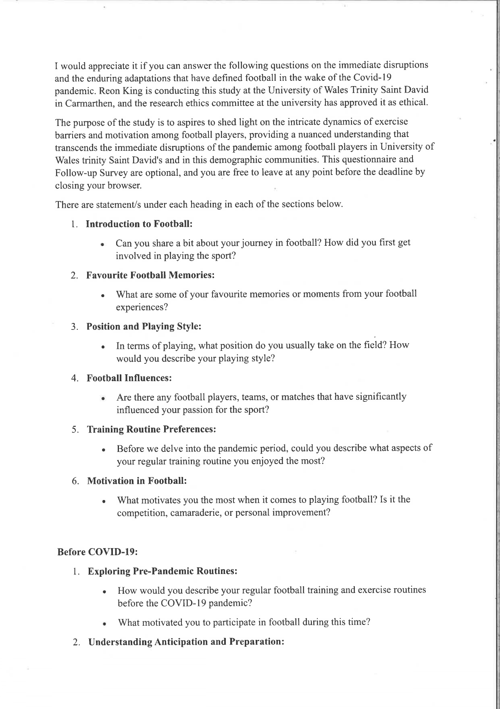

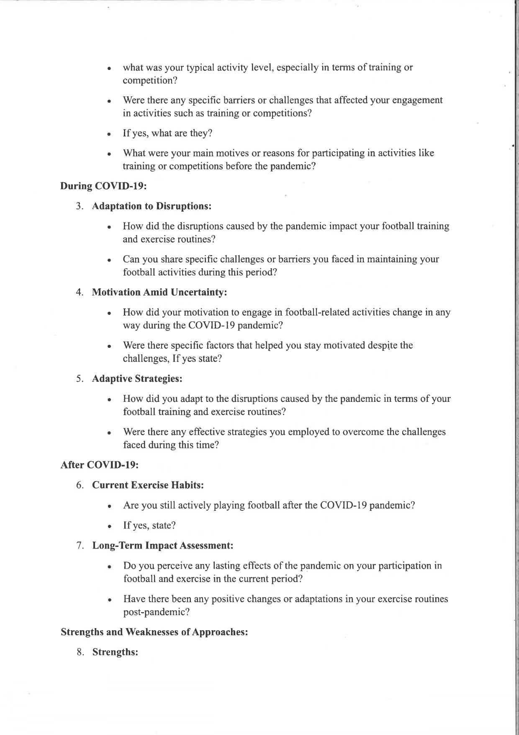

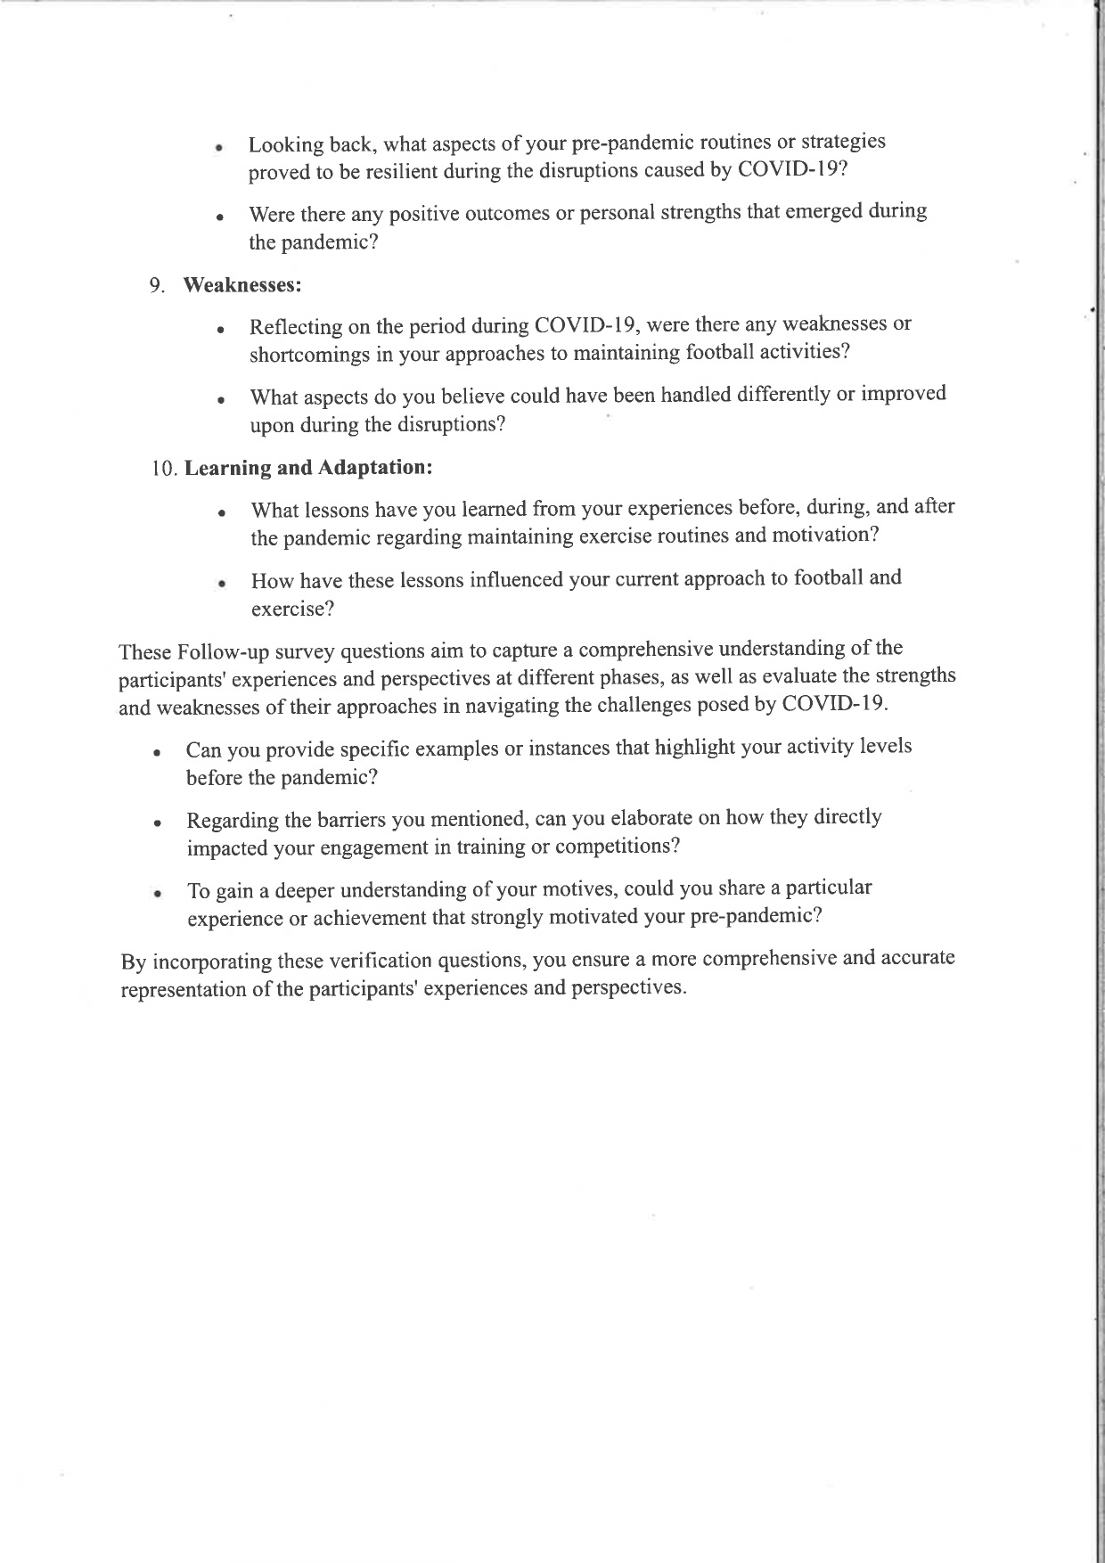

Appendices 2

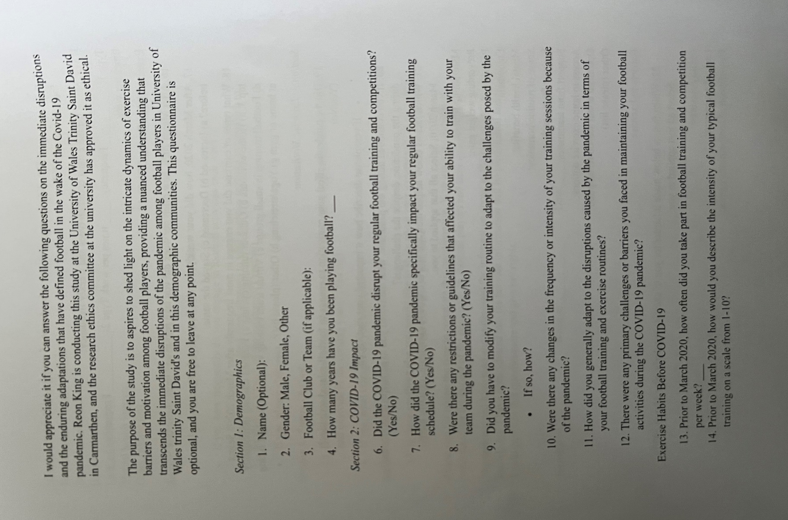

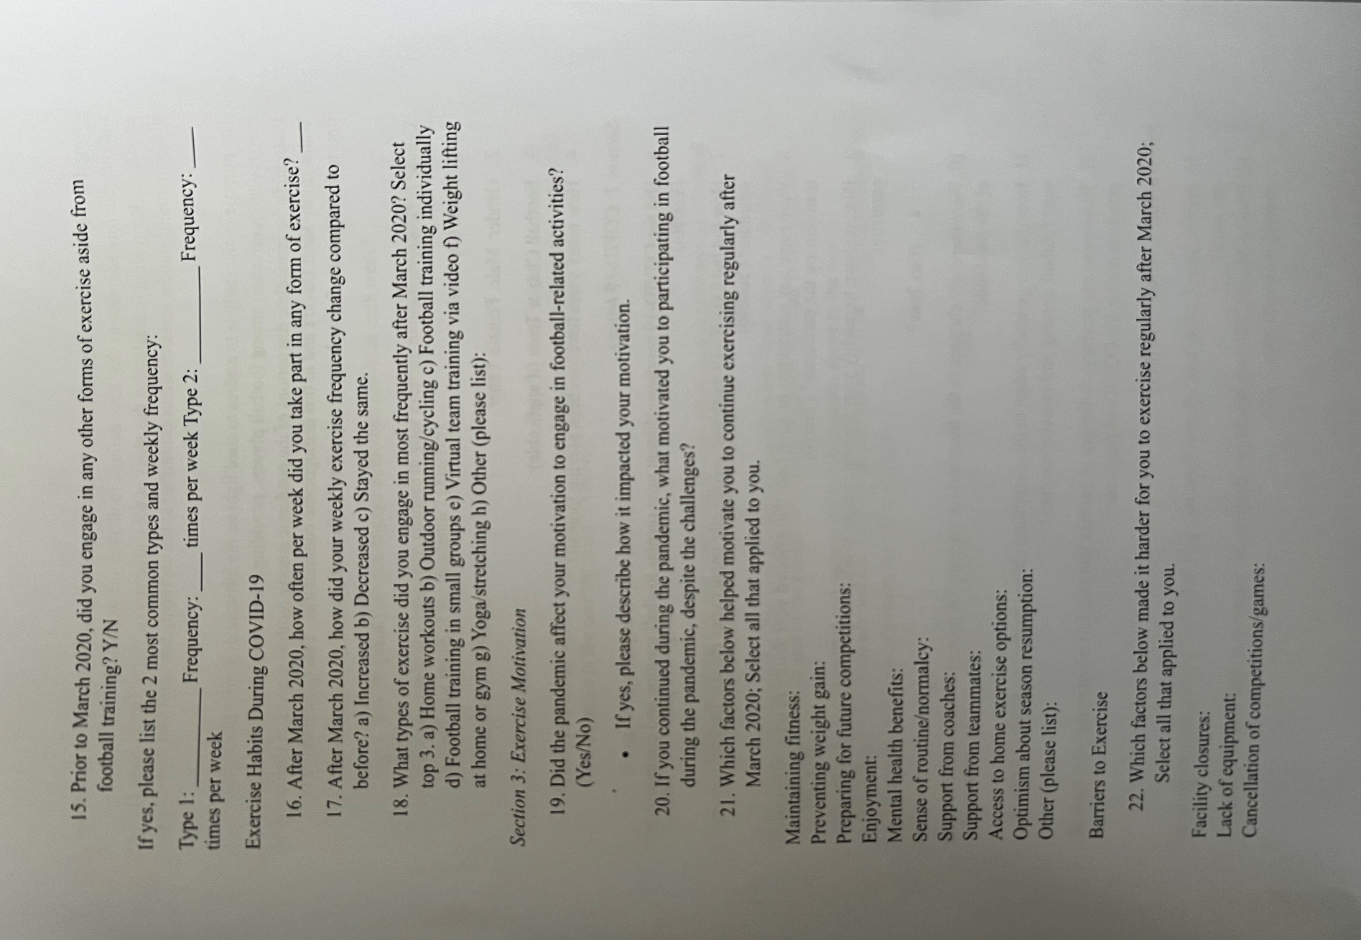

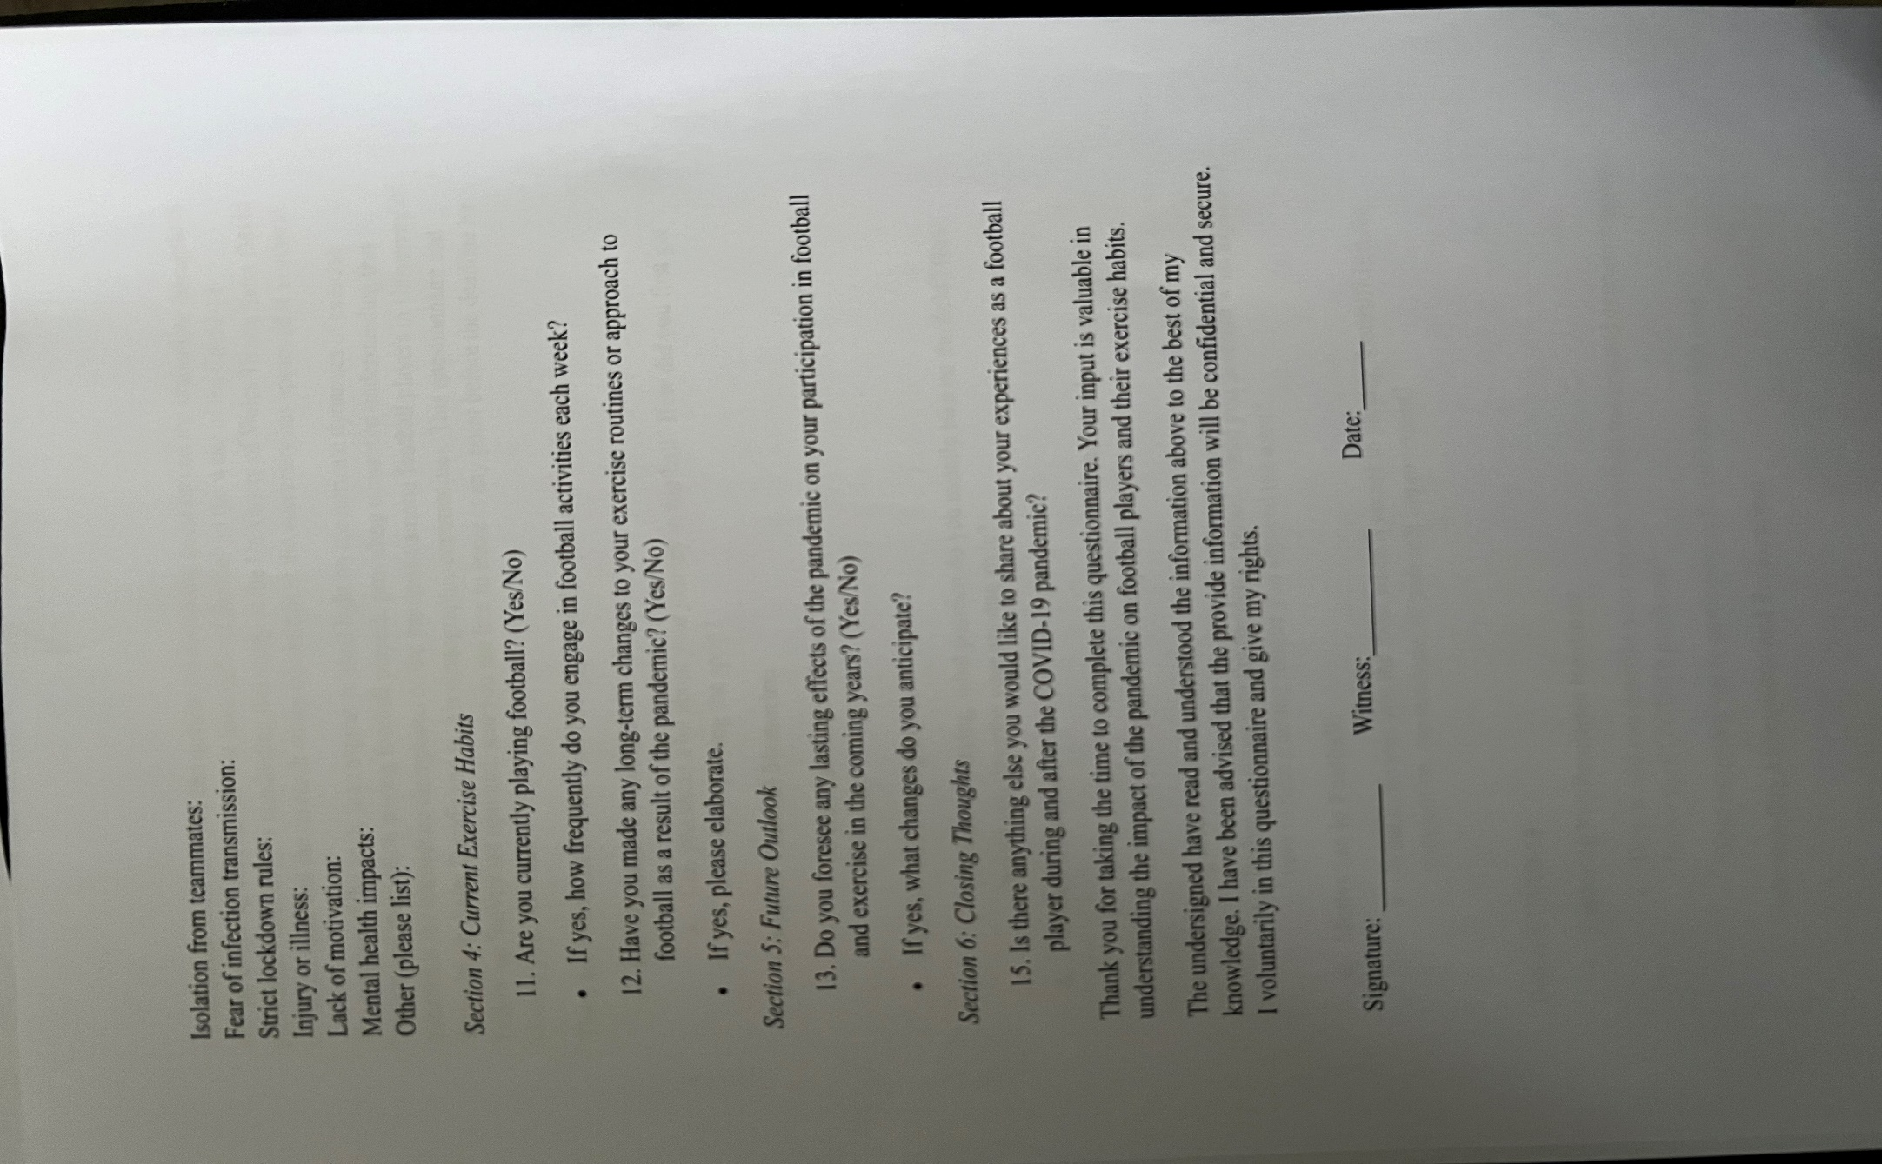

Appendices 3

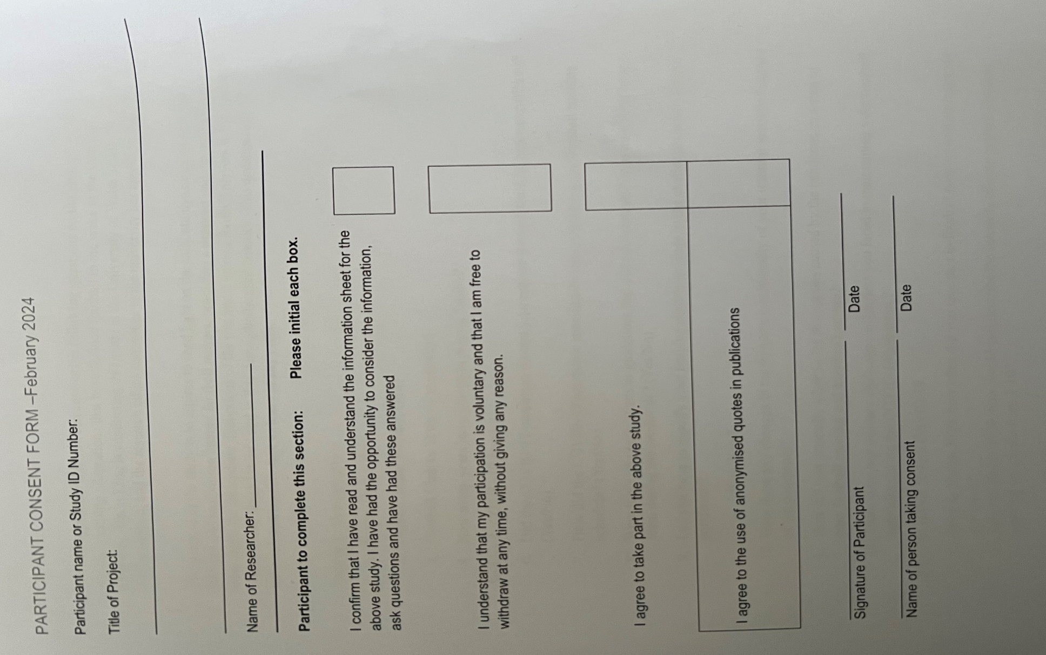

Appendices 4
Prior to March 2020, how often did you take part in football training and competition per week?
3
4
4
2
1
2
0
3
5
3
3
2
0
2.461538462
1.506396618

Appendices 5
Prior to March 2020, did you engage in any other forms of exercise aside from football training?
Yes running | Yes
no | No
Running twice a week  Cycling everyday | Yes
no | No
No | No
no | No
No | NO
Push ups 3 times per week  Squats 3 times per week | Yes
Golf 2-3 times a week | Yes
no | No
Prior to march 2020 I would train and play rugby every week | Yes
No | No
1: Weights lifting Frequency: 5-6 times per week | Yes
 | Yes= 46% (6) | No= 54%(7) | Mean=6.5  SD=0.7

Appendices 6
After March 2020, how did your weekly exercise frequency change compared to before?
Decrease
Decrease
Stayed the same
Decrease
Stayed the same
Increase
Increase
Decrease
Decrease
Decrease
Decrease
Decrease
Increase
Increase=23% (3) | Decrease= 62%(8) | Stayed the same= 15 (2) | Mean= 4.3  SD= 3.2

Appendices 7
Have you made any long-term changes to your exercise routines or approach to football as a result of the pandemic?
No
No
Yes
No
No
No
No
Yes
Yes
No
Yes
No
No
Yes= 31%(4) | No= 69% (9) | Mean=6.5  SD= 3.5

If yes, please elaborate.
Play everyday to improve
Feeling more fit
Going to start going to the gym more often then before
I now have an extra day to play football with my mates to practice as regularly as possible

Appendices 8
Introduction to Football
Well first I learning the basic about the game like the rules, using the ball with my foot, etc.
When I was growing up saw my older brother playing the sport so I wanted to and my first experience was great
I first got involved through watching friends play as a child
My cousin introduced me to football and i joined the team she was on
Got involved around 4 years old, training and playing non competitive on a local astro every week. From around 9 years I joined the Urdd football team and played there until I was about 15. I played for another few years with a couple of teams until 2019 then stopped . I joined back into playing with my uni after COVID, and joined my local team Lampeter, who I currently play with .

Appendices 9
Training Routine Preferences
I love doing drills
Cardio workout
Training was every day from 4pm to 6pm
Playing simulated games and passing drills with movement.

Appendices 10
Motivation in Football
The challenge of competition and reaching new personal levels, skill improvement, potential, etc
Personal improvement
Personal improvement
Community involvement with Ceredigion at the moment.

Appendices 11
Exploring Pre-Pandemic Routines:
Well I try to exercise 2-3 hours everyday indoors
Exercising 4 times per week
Consistent
Casual and non directed.

Appendices 12
Understanding Anticipation and Preparation: | Understanding Anticipation and Preparation: | Understanding Anticipation and Preparation:2
reaching maximum efficiency in abilities connected to a certain sports discipline. | No | mastering physical condition, affiliation, psychological condition, appearance, others' expectations, enjoyment and competition/ego.
Activity level was good | Transportation and work | Keeping fit
Low | Time, there's no time now to train | It was fun
Basic drills and fitness, sometimes indoors in the winter. Shooting drills often. | Nothing stopping me. | General joy of football and exercise

Appendices 13
Adaptation to Disruptions:
reaction by avoiding exercise, which reduces the fitness level. As a result, breathing becomes hard
Training had to stop
Not much can be done in doors
I wasn't playing in the 2 years before COVID

Appendices 14
Adaptation to Disruption
lack of energy, fear of injury,lack of skill,lack of resources
Everybody had to get rapid test and well as vaccines
Couldn't manage Work, school and football
Being allowed to meet in groups.

Appendices 15
Motivation Amid Uncertainty
due to the circumtance of covid it was hard to maintaine fitness and very diffcuilt to play with team memebers
Because of everything happening it was hard to focus on football
Curfews affected training time
Dropped completely

Appendices 16
Current Exercise Habits
No
Yes, i need to get fit and prepare for future games
No
Yes regularly, typically twice a week (weather permitting).

Appendices 17
Long-Term Impact Assessment
No not to my knowledge
not really hope everything get back to normal
kinda but for the better I need to get back my motivation
I was not playing football during COVID so after being in lockdown, I enjoyed starting up once again after COVID.

