

Assignment Title: Group Report

Module Name: Introduction to Modern Workplace

Module Code: LCBB 4003

Program of Study: BA Business Management

Student Name: Hamdan Ahmad, Deljana Mance ,Martin Kehayov, Rajwinder kaur

Student ID #: 2208436 ,9132439, 2209792, 2214604

Lecturer Name: Dr Uju Ugochukwu

Table of Contents
Introduction 3
Intrinsic motivation 3
Extrinsic motivation 3
Intrinsic motivators used by Google 4
• 20% time policy 4
• Voice and Value 4
• Freedom of work 5
• Flexibility 5
• Opportunities for personal growth 5
Extrinsic motivators used by Google 5
• Financial benefits 5
• Onsite services 5
How intrinsic and extrinsic motivation can be used to enhance employee performance 6
References 7

Introduction
Motivation comes from the word motive which denotes a person's needs, desire, wants and urges. Motivation is the force that drives you towards a specific goal. These forces can be biological, emotional, social and cognitive.

Motivation is to persuade other to use the best of their abilities to reach a goal. Now how to motivate an individual is a question. We don’t know what a person desires are and what we can do to motivate them. However, there are some theories which we can follow to read human behavior and plan accordingly out of which one is Behavioral approach.

Motivation is of two kinds

- Intrinsic motivation
- Extrinsic motivation

Intrinsic motivation
As the name suggest intrinsic is something internal. This deals with the internal satisfaction of an individual. For example; Mr. X has a very busy schedule but still he manages time to read his favorite comic book. He does this because he gets internal satisfaction by doing so.

Similarly, what managers/leaders can do to satisfy their employees internally is known as internal satisfaction. We know that how much motivation is necessary to drive your employees. Every leader wants to see their employees growing and performing the best. Also, on a selfish note organization want to recognized by how well they are treating their employees.

In the recent times, it has become quite a mantra to keep your employees as happy as you keep your customers. To do that companies are now taking steps to motivate employees on intrinsic levels as well.

Extrinsic motivation
Extrinsic means external. These are the external goals that are designed to motivate employees to reach their targets. The easiest example is of a sales agent. A sales agent has a commission based job and he is paid commission on every sale that he makes. Commission act as an external motivator here. Employees than work hard and try to make as many sales as possible to get the maximum commission.
This is influenced by rewards and incentives and also punishment. For example; in a school, it is must to participate in a sport otherwise you will get a minus five deduction mark. This is again an extrinsic motivator which is influenced by punishment.

Companies now understand how valuable their human resources are and are finding ways to motivate them on the both levels. Here we have taken an example of Google. In the today’s world google is an organization that invests heavily on his staff. From the office layout to providing financial incentives Google has covered it all.

Let’s have a look at a few motivation tactics that Google is using for its employees.

Intrinsic motivators used by Google

20%-time policy
Google has introduced 20%-time policy where employees are allowed to spend 20% of their work time doing anything they would like. They can spend it on working on a project of their choice or they can spend it by sleeping. It’s up to them how they want to utilize their 20% time.
Gmail is an outcome of 20%-time policy. Paul Buchheit is the developer who has developed Gmail in his 20% time.

Voice and Value
For employees to remain motivated it is important for them to know that they are valued. Google has a flat hierarchical structure which means that employees can directly reach out to top management. Today many organizations do not pay attention to their employee voices and decision comes from the top. However, google practices democratic culture where every individual has the freedom to participate in discussions.
One example of this is, every Friday Google hosts a meeting where 20 most asked questions are discussed and every employee is allowed to participate. They can participate through different channels including Google+, Fixits (24 hour sprints wholly dedicated to fixing a specific problem), surveys, TGIF and even direct emails to any of the Google leaders.
By following this practice employee feel motivated and engaged and it also strengthens the connection between employees and management. According to Schimidt (2013),
This is one of the reasons for Google’s success.

Freedom of work
Google employees are empowered to take their own decisions about a problem or they have a freedom to pursue work on their own terms. There is no standardized procedure but, employees are encouraged to come up with their own creative solutions.

Flexibility
Google management does not have a strict dress code. Employees are allowed to wear whatever they like. They can wear a pajama or even a suit to work. Whatever suits them the best.
Google also gives employee the flexibility to choose their own work schedule.

Opportunities for personal growth
The millennial generation seeks personal growth. They prefer organizations that gives them the opportunities to gain more knowledge and attain more skills. Google understand this and provide different training and development programs to advance their careers As Smith (2014) explains, this is also one of the ways google motivates its employees.

Extrinsic motivators used by Google

Financial benefits
Financial benefits are the strongest motivators. Google offers flex spending accounts, no-cost health and dental benefits, insurance, vacation packages and tuition reimbursements. It also offers maternity benefits of up to 18 weeks, 100% paid. The parents of new born are given $500 for take-out meals in initial 3 months along with free lunch and dinner.

Onsite services
Google employees have the access to gym, car wash, dry cleaner, massage, bike repair, hair stylist. Google has furnished all the facilities under one roof. It’s not just a workplace but Google has striven to create a home-family like environment.
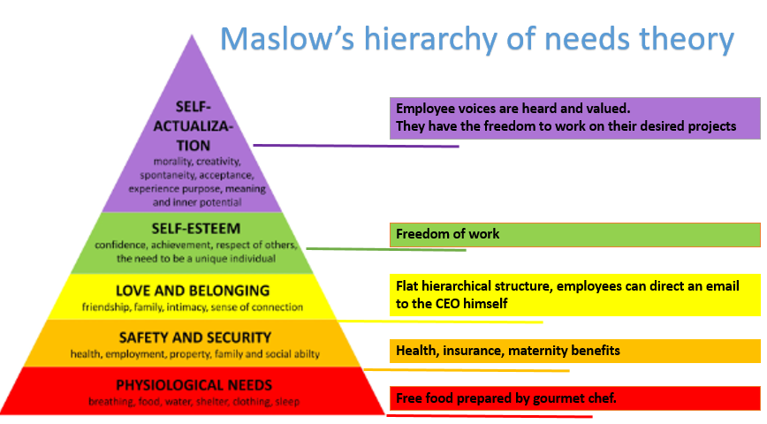
This chart explains how Google is using Maslow’s hierarchy of needs theory to motivate and satisfy employees at each level.

How intrinsic and extrinsic motivation can be used to enhance employee performance
Employee performance is directly related with how motivated, engaged and how passionate a person is about his job. It is extremely crucial to design work place in such a manner that employee remain motivated and committed with the organization. If a company takes care of its employees and offer different types of perks the employees will stay loyal with the organization and will try his best to perform with the best of his abilities.

References
Ryan, R.M. and Deci, E.L., (2000) ‘Intrinsic and extrinsic motivations: Classic definitions and new directions’. Contemporary educational psychology. 25(1), pp.54-67.
Mosley, A.L., (1998) ‘A behavioral approach to leadership: Implications for diversity in today's organizations’. Journal of Leadership Studies. 5(1), pp.38-50.
Smith, J., (2014) Inside Google Culture Of Success And Employee Motivation. Available at: https://www.forbes.com/sites/jacquelynsmith/2014/03/20/inside-googles-culture-of-success-and-employee-motivation/?sh=1b384aaf4c4e (Accessed19-03-2023)
Schimidt, E., (2013) The Surprising Secret to Google’s Success. Harvard Business Review. Available at: https://hbr.org/2013/04/the-surprising-secret-to-googles-success (Accessed19-03-2023)

