Harley Harris
(2419715)

Week 1 30/09/2024:

- Completed Autodesk Interactive Maya [1] Tutorial in class I have learned the basic functions of moving objects and moving the camera around the object/space coming from Blender [2] this is entirely new as a lot of changed with different keys/buttons doing different functions on Maya than Blender.

- Secondly, I went on the Introduction to Modelling Maya Tutorial and I learnt the basic resize, move and rotate tools that Maya [1] uses then made a simple statue that Maya Bot introduced me to.

Week 2 07/10/2024:

In class, we were diving into Maya[1] 2024 for 3D modelling. This screenshot captures my exploration of the extrude, resize, and rotate tools.
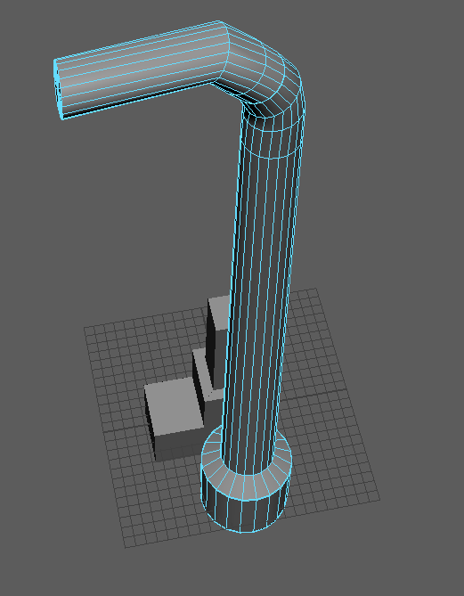
I made a simple block and extruded the top face and side face making this 3-block shape I found this easy to do with shortcuts CTRL+E for extruding, R for Scale Tool and then E for rotating tool. I then went on to experiment with other tools and other shapes including the cylinder.
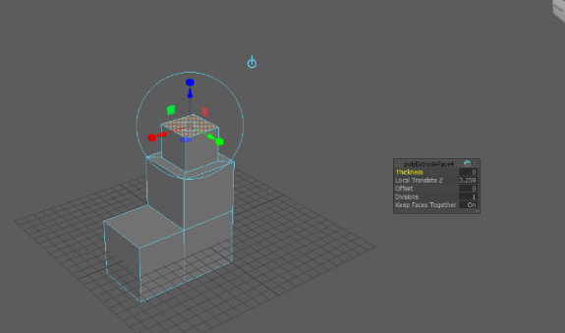

After getting used to the tools of Maya I have started a rough shape of a Lamp post using extrude, scale and rotate tool to get the shape of the bottom of the lamp post and the stand of where the light would be.

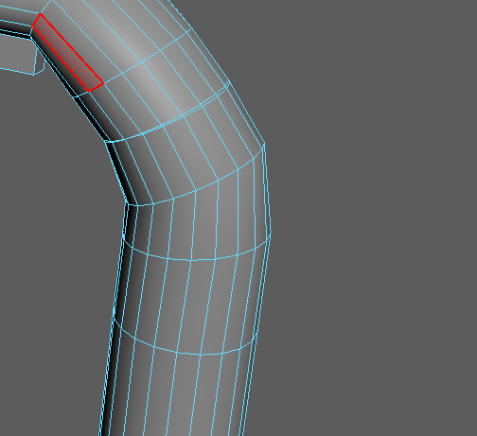
I have encountered some building errors of my own
doing. I acknowledged this and to fix the mistake I
learnt to add another cylinder by doing extrude and
not to rotate as early as I did in this screenshot. As I
looked closer at the base of the lamp post I found that
the start of the lamp post has expanded a tiny bit over
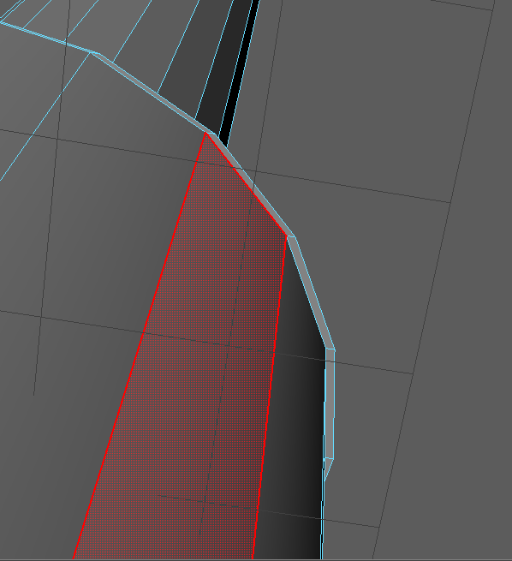
the circular base. I do not know exactly what caused
but it does look like a scaling problem next time I have
to make sure by looking closely at the model to double
check if these issues arise again.

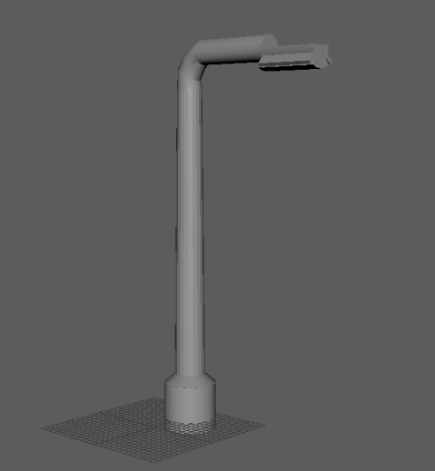
The theme I was going for in this rough model of a
Lamp post was a cyberpunk/futuristic style. I didn’t
really like the first model of where the light should
be so I rescaled to make it more flushed to the
pole of the model I stayed with the
cyberpunk/futuristic style of a streetlamp post.
I am happy at the end rough model that I produced.
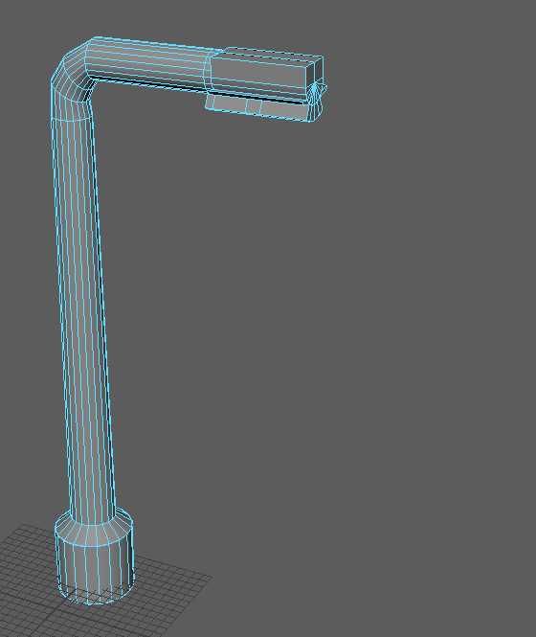

Week 3 21/10/2024
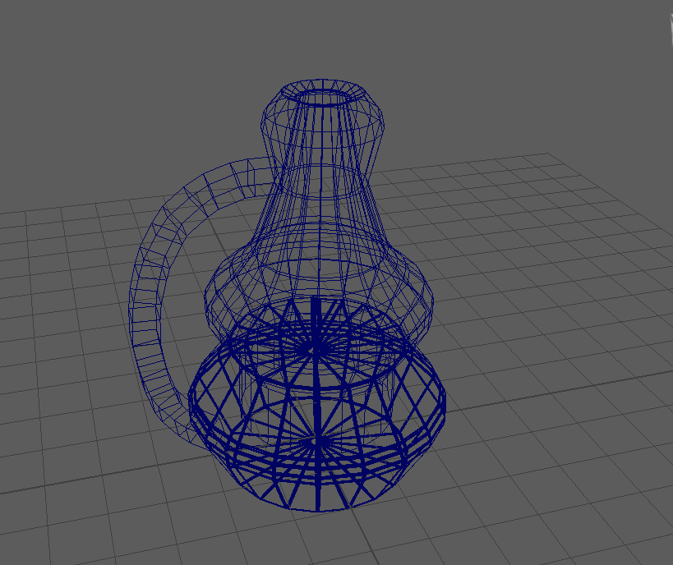
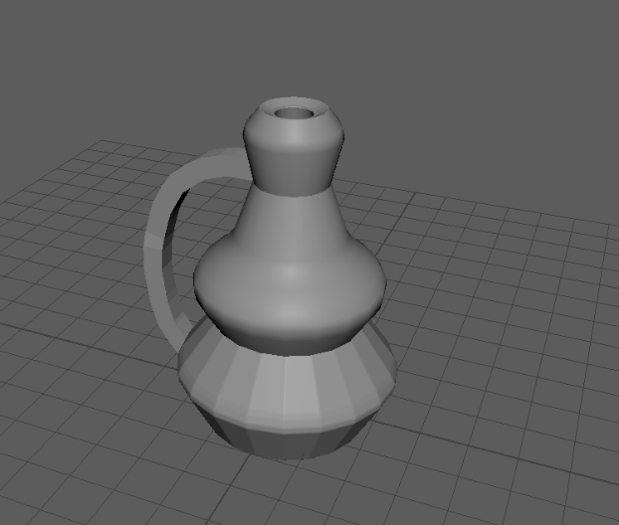
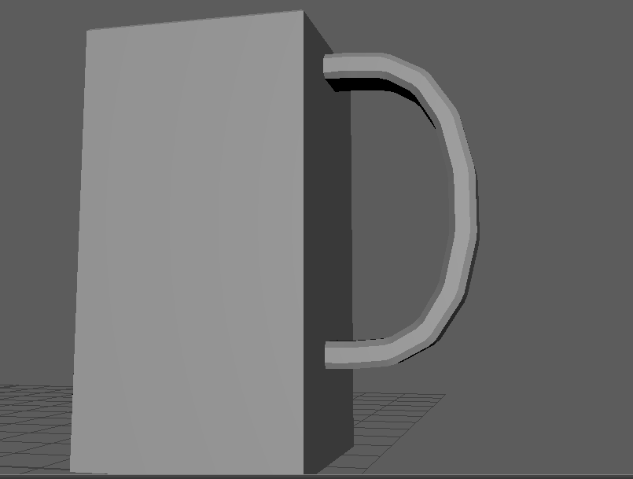
- Started to learn Bridge Tool as an example we made a coffee cup and then using the Bridge tool for the handle by creating a square model then duplicating putting one square on top of the cup then one at the bottom of the cup then by using the bridge tool it created a handle which had to be fine-tuned to around 6 blocks per curve. I then experimented with a more sophisticated model of a cup by also modelling the inside and bevelling with curves with some mistakes by bevelling
Too much on the bottom part of the cup and bridging went
slightly wrong by curving midway through. Which I think I
misaligned the bottom square from the top by a few
centimetres next time I should double check that the
square

This week we also learned Quad Drawing by using the top of a coke can as an example when I did this, I encountered some errors when connecting the polygons together this was my own mistake as I mis-aligned the vertex corners which made slight gaps in the model as this is the first time I’ve used Quad Drawing this is a rough model which I wasn’t happy with the final result as the full model has some mistakes as the top gap is much smaller on the model than the picture I then modelled the can portion which went well
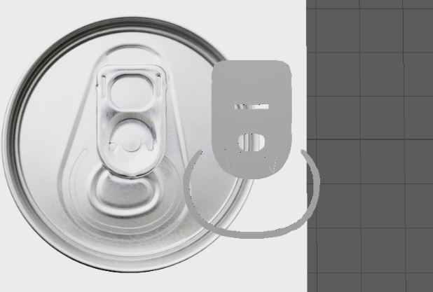
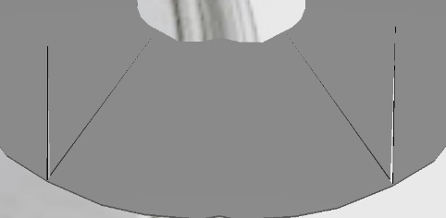

Then I moved the top of the coke can model on top of the can model which I made although I wasn’t happy with the top of coke can model. I am happy with the result of moving it to the whole can model making it a proper coke or whatever brand can it is.
I used the extrude tool to create an inward curvature on both the top and bottom of the can, giving it a more realistic shape. Additionally, I applied beveling to smooth the edges and enhance the overall curvature, resulting in a more lifelike appearance.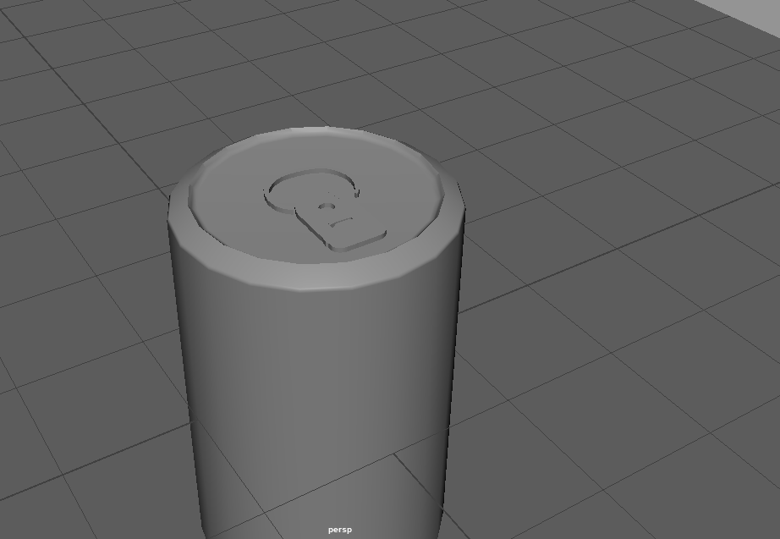 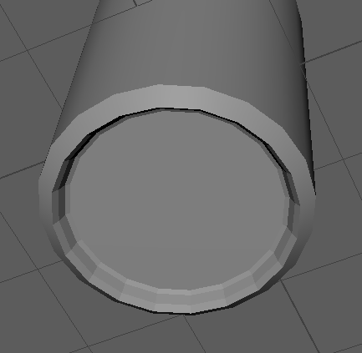

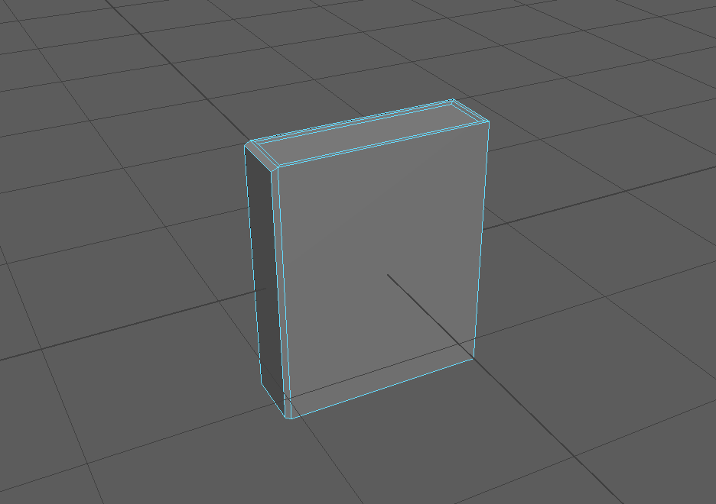
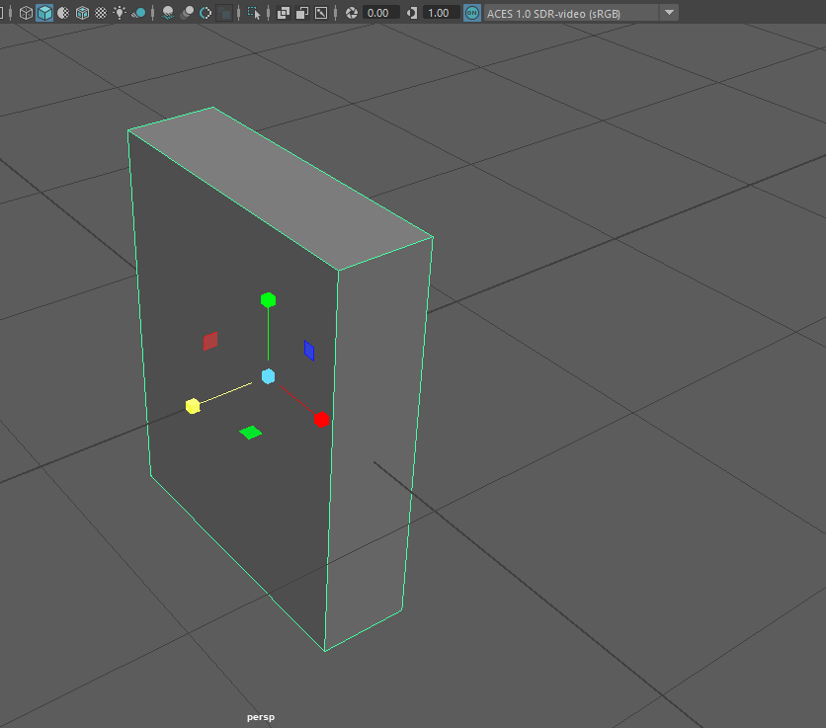
Week 4 11/11/2024

- Using a YouTube tutorial [2], I found to create a simple book in Maya using multiple tools (Extruding, Resizing and cutting tool to make new faces)
- Next time I should learn on how to add paper/pages to the book in closed and open positions for an overall better-looking model. Also to use bevelling (CTRL+B) to curve the books edges and spine of the book. Could also use bevelling for the pages.

Week 5 18/11/2024

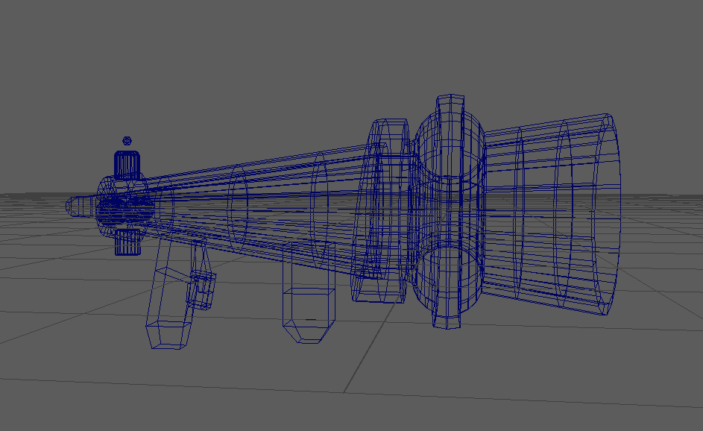

- Made a model of a futuristic gun made with multiple objects extruding, bevelling rotating and more.
- Happy with end result of this could add more detail to the gun grips and the magazine
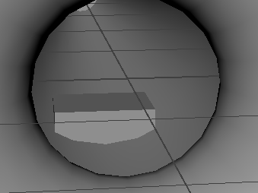
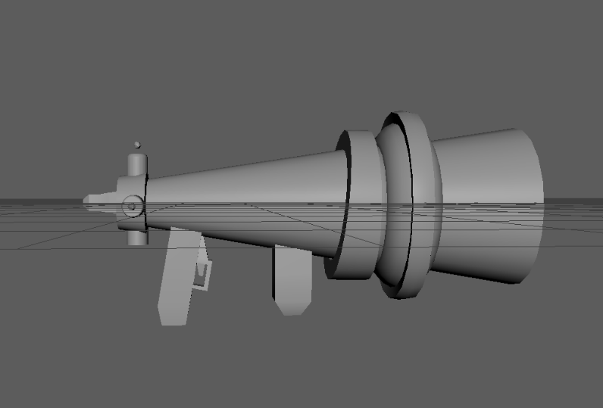

- Although happy with end result the magazine has clipped through to the gun

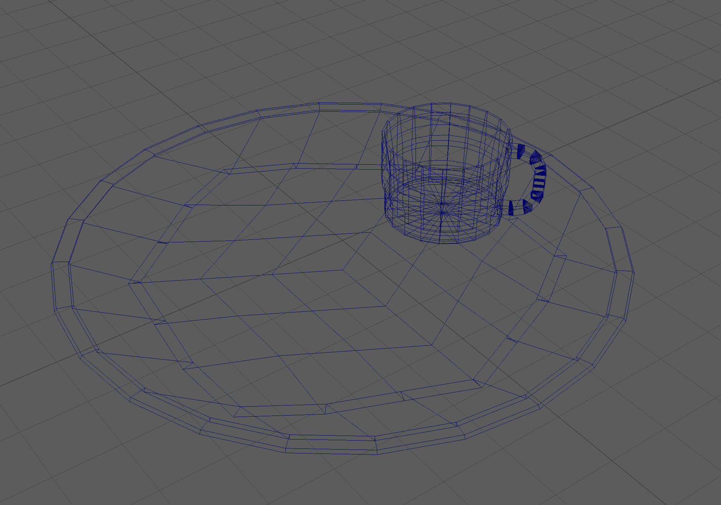
This is an initial model of a teacup and plate that requires further refinement. The teacup needs adjustments to better capture its true shape and design, and I plan to consult additional references for improved accuracy. The plate also requires more intricate detailing to enhance its overall appearance.
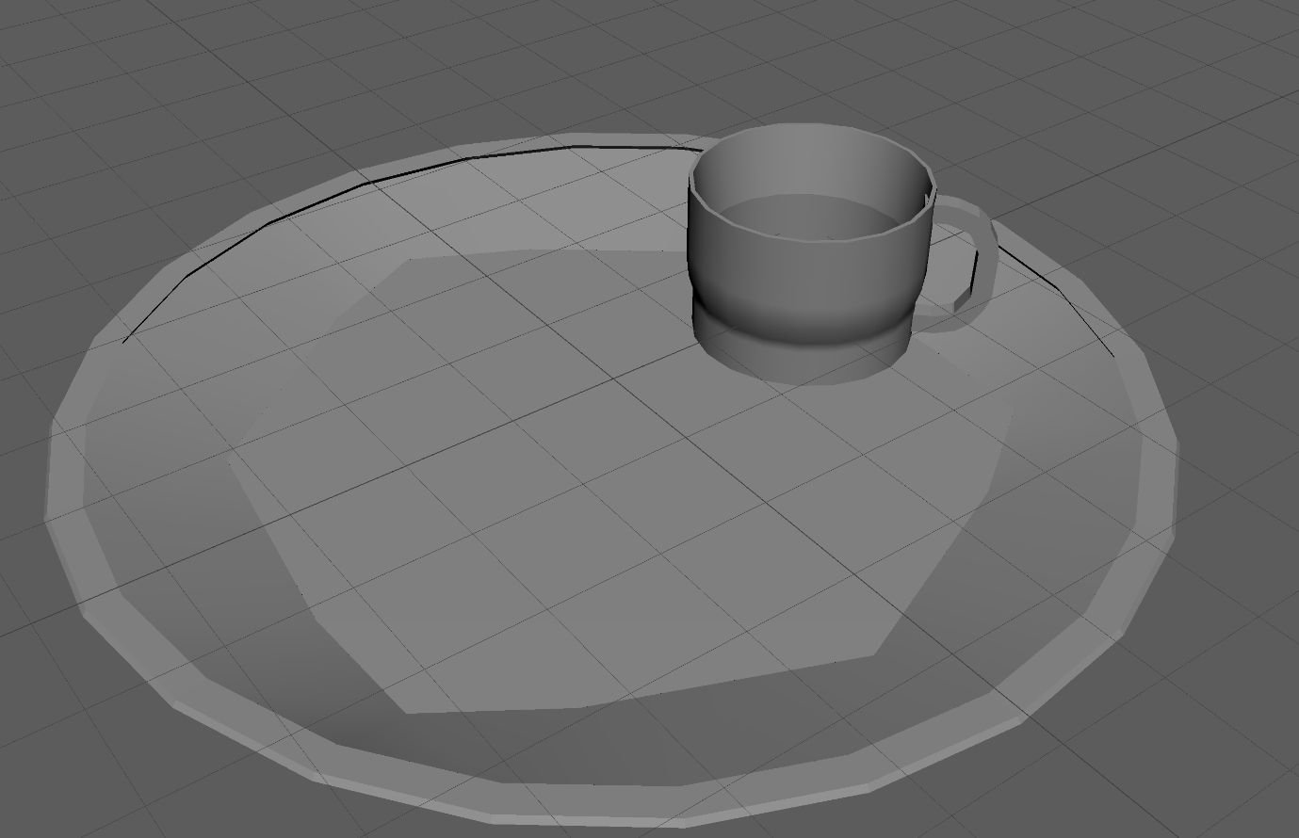
This is an initial model of a teacup and plate that requires further refinement. The teacup needs adjustments to better capture its true shape and design, and I plan to consult additional references for improved accuracy. The plate also requires more intricate detailing to enhance its overall appearance.

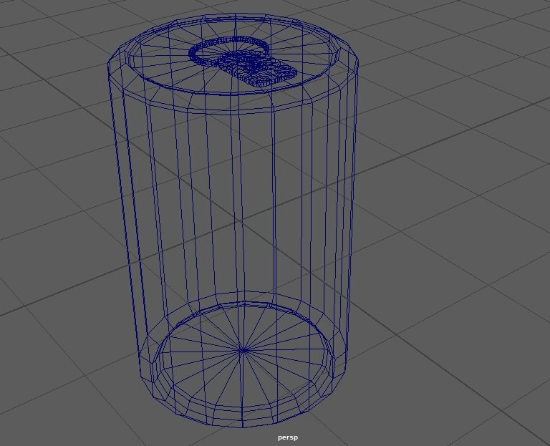

I modeled this Coke can using extrude, quad draw, and resizing tools. I'm quite pleased with the final result, as it closely resembles a real can with impressive accuracy.

Week 6 25/11/2024.
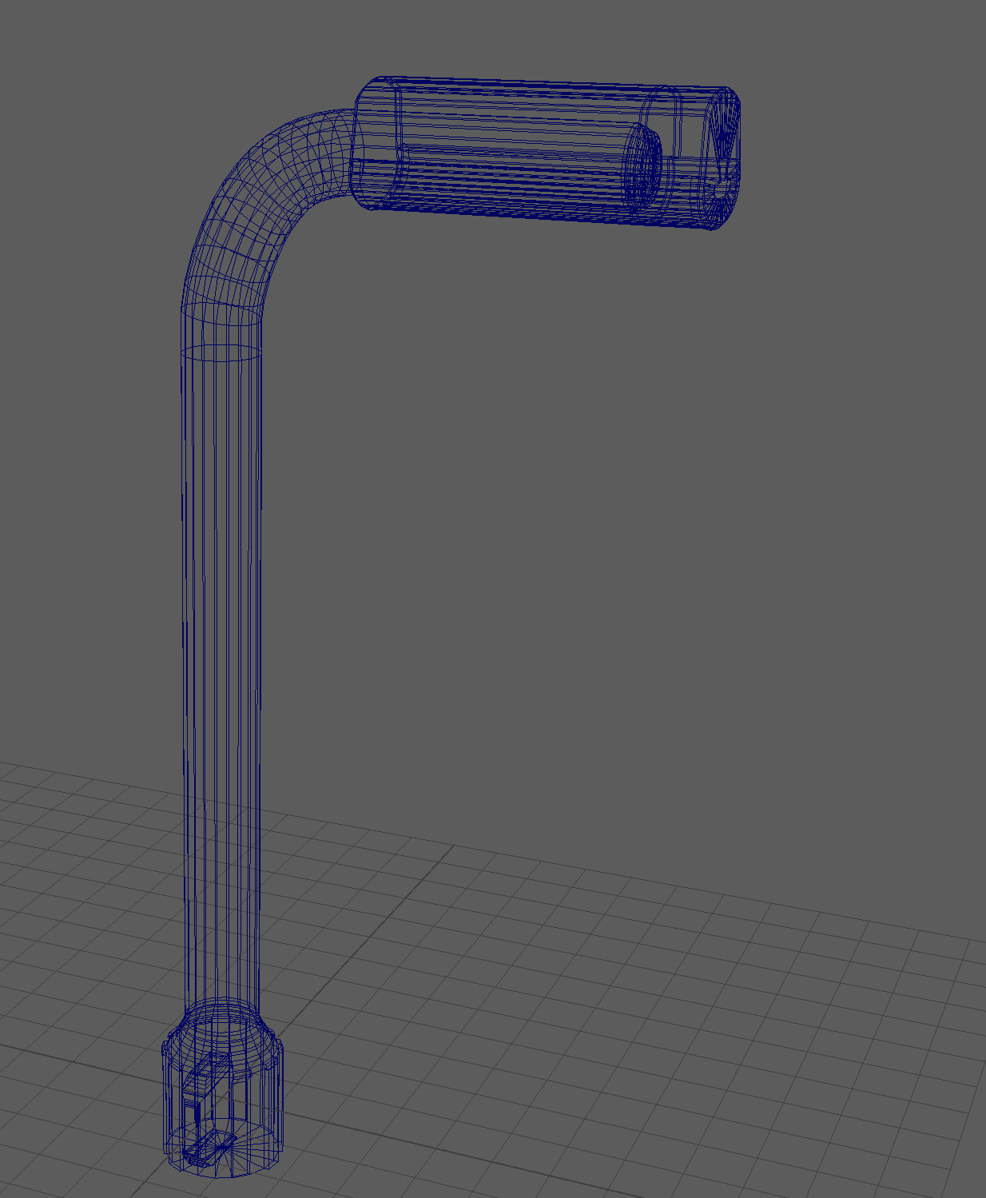
I created this cyberpunk-style lamp post as my final design, and I am absolutely thrilled with how it turned out. I used a combination of extrude, draw, and resize tools to bring this vision to life.

Bibliography

[1] Maya 2025, [Software], San Francisco,
[2] “3d Modelling Tutorial - How to Model A Book in Autodesk Maya 2023,” www.youtube.com. https://www.youtube.com/shorts/0b0PSaNjtlQ (accessed Nov. 7, 2024).
‌

