
Costa Coffee
Mihaela Cristina Teleanu (1919245)
Lecturer- Zainab Atta
LCBB5004
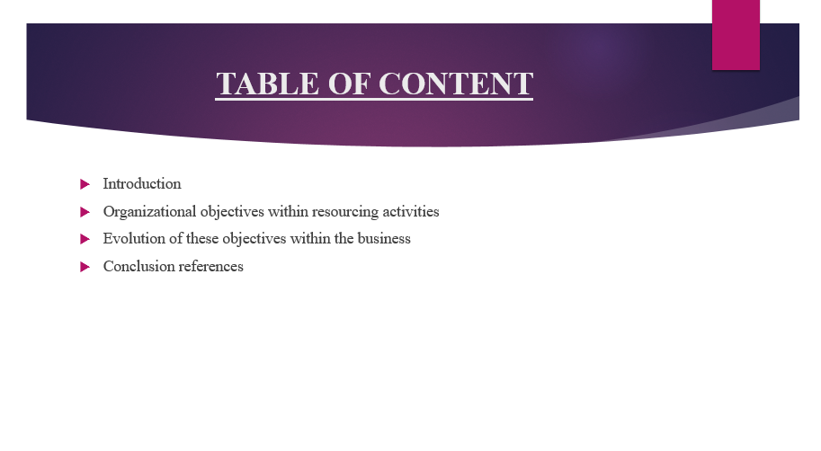
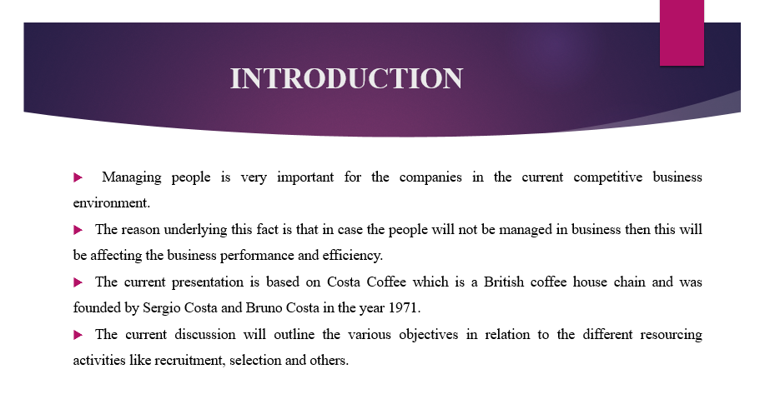

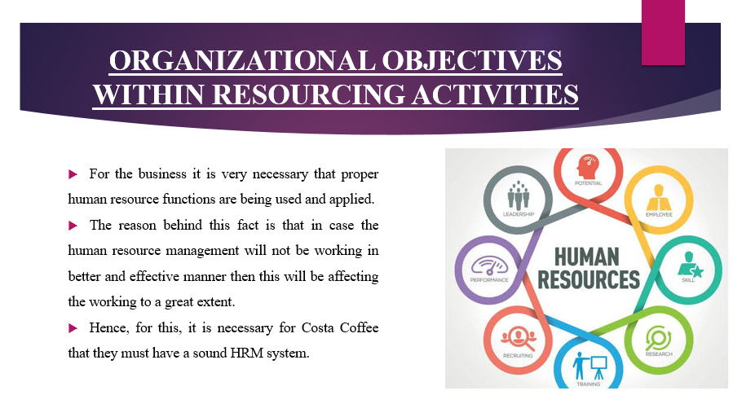
This is necessary because in case HRM will be good and effective then this will lead to success of the company.

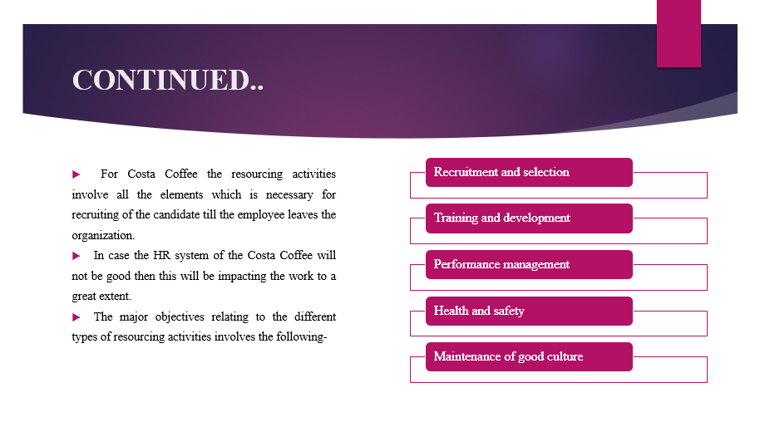
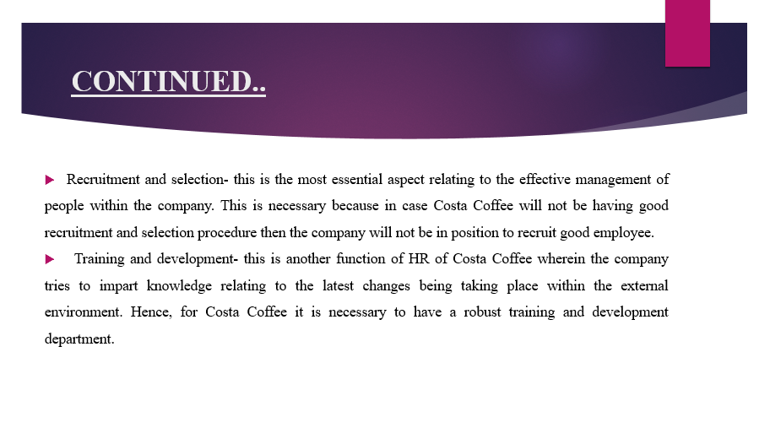
Recruitment and selection- The reason pertaining to the fact is that in case the recruitment and selection process will not be good then this will be affecting the quality of people working within the company. Thus, the objective of recruitment and selection of Costa Coffee is to recruit and select highly skilled employees so that the objectives of the business can be attained.
Training and development- This is necessary in order to analyse and enhance the operational efficiency of the people. Thus, the objective of Costa Coffee relating to the training and development is to continuously research within the market to analyse that what trends are being changing and whether these are related with the company and its operations or not. In case these are related with the company and its operations then this need to be implemented in proper manner.

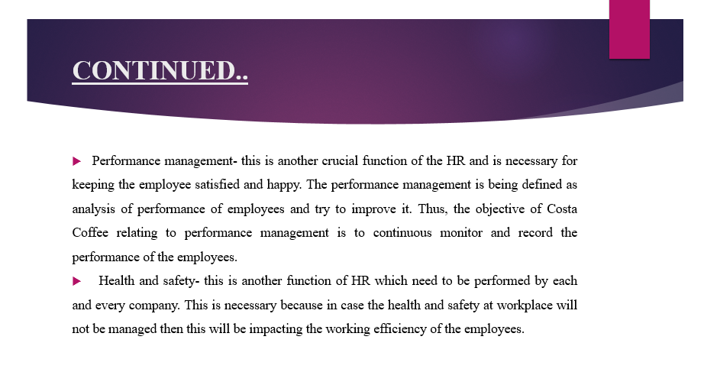
Performance management- This is necessary in case the employees will not be performing in good and better manner then this will affect the working efficiency in negative manner. This is necessary because of the reason that in case the working of the employees need to be improved then this will increase the working efficiency of the business. Hence, Costa Coffee sets the objective of increasing the performance of employees by using some of KPI that is key performance indicator against which the performance of the employees will be measured. These different KPI will assist Costa Coffee in analysing the performance of the employees and decide that how well the employees are performing.
Health and safety- this is another function of HR which need to be performed by each and every company. This is necessary because in case the health and safety at workplace will not be managed then this will be impacting the working efficiency of the employees.
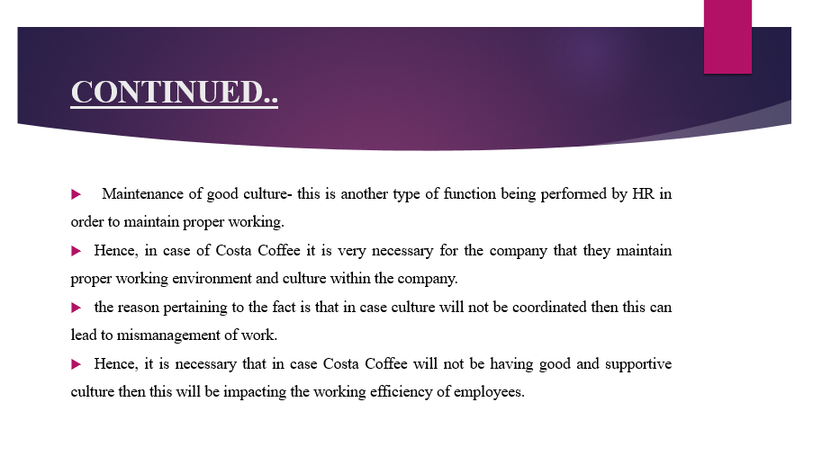
- Thus, with respect to current pandemic it is very crucial for Costa Coffee to manage good culture within company so that they can effectively work within the organisation. Due to COVID 19 people were fearful for coming to workplace but Costa Coffee motivated the employees to come to the place and work. The objective of health and safety aspect of Costa Coffee is to maintain and healthy environment and to follow all the guidelines with respect to the current pandemic.

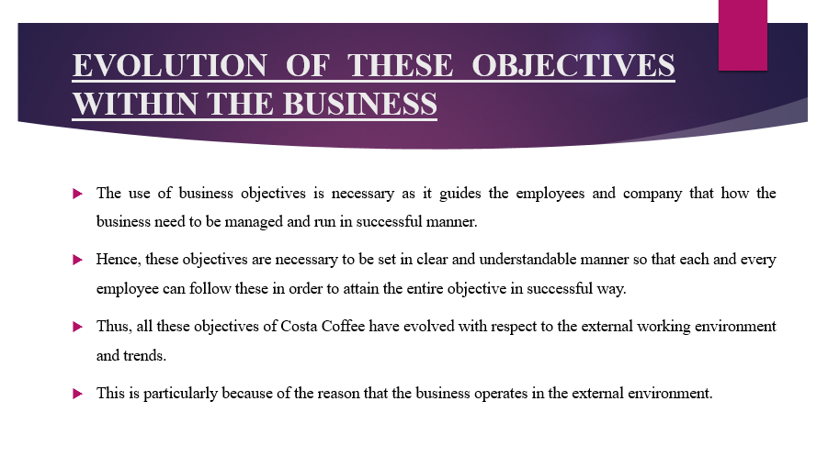
In case the changes of external environment will not be managed and implemented within the company then this may lead to decrease in efficiency of the company. The reason pertaining to the fact is that in case the objectives are not being set as per the external environment then this will be impacting the working efficiency of business. Hence, the evolution of each and every business objective is based on both internal and external working only. The reason beneath this fact is that in case the objectives will be made as per the internal and external working then this will make the working better and effective.
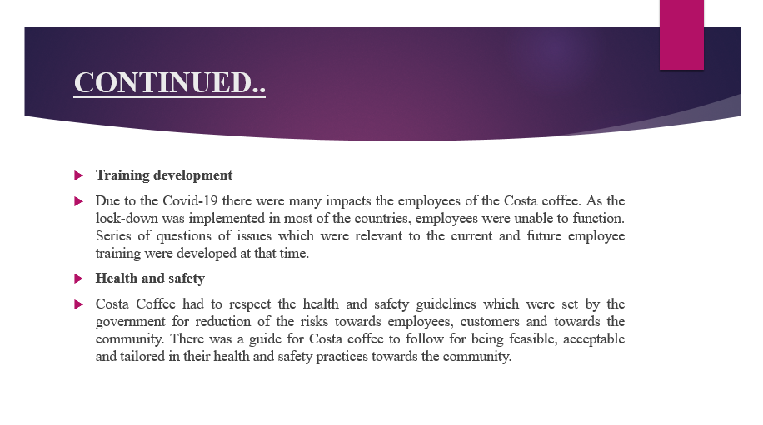
Training development
Post pandemic practices required the employees of the organization to adapt to the strategies which were regarding the effects created by Covid-19. The work from home practices also restricted the training and development programs which the employees otherwise would have been a part of.
Health and safety
There was a guide for Costa coffee to follow for being feasible, acceptable and tailored in their health and safety practices towards the community. Most rules, standards and regulations were force to towards the employees in which, Masks became mandatory for serving, preparing coffee or any sorts of interaction at the work (John and Curran, 2021). Hand washing etiquettes were implemented as the part of the organizational culture for better hygiene and restriction of the spread of the virus.
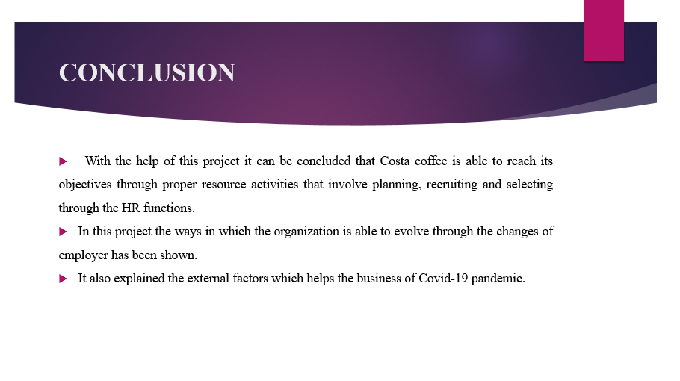
The above presentation focused on the analysis of people management in company as without this the working cannot be managed and company cannot get successful. Hence, in addition to this, the discussion also evaluated that there are different function of HR like recruitment, selection, performance management and other which are necessary to be used by the company. Hence, as a result of this, the working of the company is improved. Also, it was analysed that the use of these objective was assistive in analysing and implementing all the internal and external working in better and effective manner.


