Module Title: Foreign Languages and Cultural Awareness
Module Code: M5X01923
Student Name:Sgambati Arianna
Student ID:1816097

Executive Summary
This document has provided a list of international countries and identified some key cultural, customs and behavioural differences among them. Based on the identified differences, this document has produced an Aide Memoire for the hotel staffs of Park International Hotel and this Aide Memoire will help the staffs of the hotel in managing guest service experiences for international visitors. A table of “Do’s and Don’ts” for staffs have also been included to help avoid mistakes in behaviour toward the guests.

Table of Contents
Executive Summary ii
Introduction 1
Hotel Management of The Park International Hotel 2
Differences in Cultures, Customs and Behaviors among Different Countries 4
An Aide Memoire for Hotel Staffs That Will Help Them Manage Guest Service Experiences for International Visitors 7
Guidelines for Managing Guests from China 7
Guidelines for Managing Guests from Indonesia 8
Guidelines for Managing Guests from Germany 9
Guidelines for Managing Guests from France 9
Do’s and Don’ts for Hotel Staffs 10
Conclusion 11
References 12

Figure 1: Hotel Management of The Park International Hotel Source: (Singh and Dewan, 2018) 2

Introduction
International hotels serve customers from various countries who differ in their cultures, customs and behaviours; and these differences call for a well-prepared guideline for the hotel staffs to manage guest service experiences (O'Fallon and Rutherford, 2015). The Park International Hotel is a UK based 4-star international hotel which serves hundreds of international customers daily with its 171 fully furnished modern rooms and well-trained hotel staffs. This hotel is best for the accommodation of visitors with group or family although it also provides accommodation for couples and leisure or business solo travellers and its Checkmate Bar & Restaurant serves authentic British and Thai cuisine to the customers. Again, the Orchid Room of the hotel offers enough space for weddings, private dining and also for conferences and meetings which increase international business visitors’ convenience.

Hotel Management of The Park International Hotel
Hotel management refers to the management of different operational aspects of a hotel such as staff management, revenue management, strategy, public relations, marketing, change management etc.
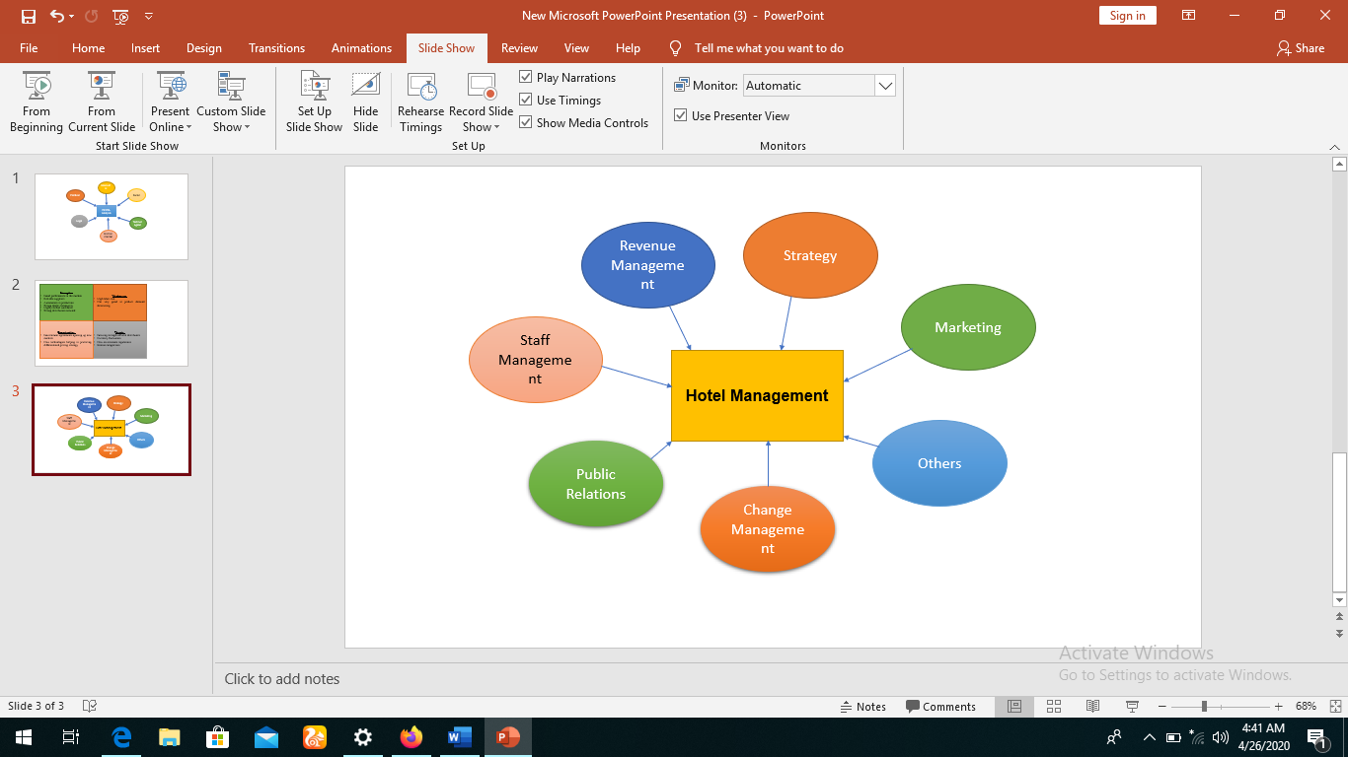
Figure 1: Hotel Management of The Park International Hotel
Source: (Singh and Dewan, 2018)
Among all of these operational aspects, staff management is most important as the staffs directly provide services to the customers and customer satisfaction and retention mostly depend on the staffs’ services and behaviours. The staffs of Park International Hotel work in five different positions such as hospitality staff, security staff, housekeeping staff, culinary staff and management and these staffs have to daily manage hundreds of international visitors and these international visitors are tourists from outside the UK and have differences in cultures, customs and behaviours from those of the UK and other countries (Pokhilko, 2016). Culture refers to the knowledge, norms, values and characteristics shared among a certain set of people which encompass around religion, language, cuisine, arts, music and social habits.

The staffs of Park International Hotel first need to identify their guests' country which helps them in recognizing the guests' native culture and this helps them in communicating with the guests in their languages and in providing all other services according to their culture (Gonçalves, 2014). Custom refers to the way of behaving, activities, events or practices which are traditional or usual in a society and these customs and behaviours all are influenced by the cultures. Therefore, the management of Park International Hotel needs to address all of these cultures, customs and behaviours of the guests and shape their hotel services according to them.

Differences in Cultures, Customs and Behaviors among Different Countries
Every country has its own culture and custom and these two things eventually shape the behavioural pattern of the people of that country and these differences can be identified from different dimensions. Some countries from Asia such as China and Indonesia; and some countries from Europe such as Germany and France can be observed to understand cultural, customs and behavioural differences among international countries.
Key Differences | Description | China | Indonesia | Germany | France
High Context vs Low Context | In high context culture, the communicator thinks that the listener needless description and they know the thing and therefore, communication occurs indirectly keeping it implicit (Hall and Hall, 2014). In low context culture, all the things are spelt out with full description making the communication explicit and the listeners only depend on what is said to them. | High context culture | High Context Culture | Low Context Culture | High Context Culture
Future vs Present vs Past Orientation | Future-oriented countries are optimism and believe that their actions can change the future; present-oriented countries think that the past has already gone and future is also not certain and that's why, they focus on the present; and finally, past-oriented countries focus on the traditional values and are tend to be conservative and slow in changing traditional things (Minkov, 2017). | Past Oriented | Past Oriented | Future-Oriented | Past Oriented
Monochronic vs Polychronic | In monochronic culture, people like to do one work at a single time but in polychronic culture, people do multiple works at a time. | Polychronic Culture | Polychronic Culture | Monochronic Culture | Polychronic Culture
Power Distance | The extent of people’s acceptance regarding power differences and their allowance to shape their aspects of life according to the difference (Freeland, 2014). | High Power Distance | High Power Distance | Low Power Distance | High Power Distance
Time Consciousness | Some cultures see time as plentiful and some see as a limited resource which cannot be replaced and they value time. | Highly Time Conscious | Less Time Conscious | Highly Time Conscious | Less Time Conscious
Individualism vs Collectivism | People only take care of themselves and their family in an individualist society. In a collectivist society, people believe that they live in a group and they should look after each other. | Collectivist Society | Collectivist Society | Individualist Society | Individualistic Society
Native Language | The language that is spoken by the people of the country | Mandarin | Indonesian | German | French
Religion | Religion is a faith or belief which influences people's behaviour. | Mostly Buddhists or followers of Chinese Folk Religion | Mostly Muslims | Mostly Christian | Mostly Christians

Table 1: Key Differences in Cultures, Customs and Behaviors of Some International Countries
Source: (Redding, 2019)

An Aide Memoire for Hotel Staffs That Will Help Them Manage Guest Service Experiences for International Visitors
An Aide Memoire will help the hotel staffs maintain appropriate behaviour toward guests from different countries and here, Aide Memoire for China, Indonesia, Germany and France have been demonstrated.

Guidelines for Managing Guests from China
- Way of Providing Instructions: Staffs do not need to explain every instruction in detail to the Chinese guests as they belong to high context culture and this way of communication may be perceived as insulting to them (Chen and Min, 2018).
- Room Decorations: Rooms of Chinese guests should be decorated with traditional things as they are past-oriented and are very attached to their tradition. So, the traditional designs and decorations will be admired by them and this will increase their good experience with the hotel.
- Reception: The staffs in reception get flexibility with Chinese guests as the staffs can do other works or can take phone calls and also talk to the guests but the Chinese guests will not find this disrespectful as they belong to the polychronic culture.
- Time Maintenance: Everything the Chinese guests ordered should be on time and not even one minute late as the Chinese are highly time conscious and even one minute late may create a negative image of the hotel service to them.
- Room Offering: As Chinese are from a collectivist society, they will come mostly with their family and so the family rooms should be available for them.
- Translation Service: The hotel must have Google translator or any other good quality technology to translate Mandarin into English and English into Mandarin for removing the inconvenience of communication (Davies, 2018).
- Food Service: Chinese cuisine must be added to the menu of Park International Hotel's Checkmate Bar & Restaurant.

Guidelines for Managing Guests from Indonesia
- Way of Providing Instructions: Like Chinese people, the Indonesians also find it disrespectful to get a description of simple things and that's why the staffs have to provide instructions implicitly.
- Room Decorations: Indonesian people also like and admire traditional designs and therefore, their rooms must be decorated with traditional things.
- Reception: The Indonesian people are also okay with the receptionist's multitasking and talking to them at a time and therefore, reception staffs will get flexibility here (Clarke and Chen, 2018).
- Time Maintenance: The Indonesian people are not much conscious about time and five or ten minutes late will not be seen as of late to them. Therefore, though the staffs should be on time in delivering the ordered things to the guests, they can get the flexibility of time from Indonesian guests.
- Room Offering: Like Chinese people, Indonesians also live in collectivist society and therefore, family rooms have to be kept available for them.
- Translation Service: Translation service must be kept available for the Indonesian language for the customers and staffs’ convenient communication.
- Food Service: As Indonesians are mostly Muslims, they have an issue of haram and halal food and therefore, halal food must be available in the food menu of Checkmate Bar & Restaurant.

Guidelines for Managing Guests from Germany
- Way of Providing Instructions: German people belong to low context culture and therefore, the staffs have to communicate explicitly with them and describe every instruction in details.
- Room Decorations: German People like modern designs and decorations and thus their rooms must be decorated with modern things (Jones, 2017).
- Reception: Reception staffs should not do multitasks and also talk to the German guests because the guests will find this behaviour as disturbing and will have a negative impression on staff behaviour.
- Time Maintenance: Like Chinese people, German people are also very conscious about time and therefore, their ordered things should be delivered on time.
- Room Offering: As the German people belong to individualist society, solo and couple rooms will be mostly required by them and thus, these rooms must be available.
- Translation Service: Though many German people can communicate in English, the translation service for translation from German to English and English to German must keep available.
- Food Service: German cuisine need to be added to the food menu of Checkmate Bar & Restaurant (Bangs, 2018).

Guidelines for Managing Guests from France
- Way of Providing Instructions: Like Chinese and Indonesian guests, the French also require less description in instructions.
- Room Decorations: The French should be provided with the rooms which have traditional designs and decorations.
- Reception: Reception staffs will get to continue multitasks along with answering the queries of French customers and they will not get annoyed with staff's this behaviour.
- Time Maintenance: French people are not time-sensitive and therefore, the staffs will get the flexibility of time in delivering the customers' orders.
- Room Offering: French generally come with their spouse or alone as they belong to individualist society and therefore, couple or solo rooms will be their requirement and these rooms should be available (Pizam, 2018).

- Translation Service: As many French people cannot speak English, French language translators must be available in the hotel.
- Food Service: French cuisine should be made available on the menu of Park International Hotel's restaurant.

Do’s and Don’ts for Hotel Staffs
Hotel staffs need to be careful about their behaviour as they are dealing with people from different countries of the world and therefore, they should maintain some manners which are commonly seen as polite in many countries and also should avoid some mistakes.
Do’s | Don’ts
- Respect your guests | - Don’t insult your guests
- Be honest with your customers | - Don’t exaggerate your hotel service
- Communicate with a smiling face | - Don’t show anger to guests
- Be friendly while answering customers’ queries | - Don’t be unfriendly or rude to customers
- Always respect customers’ feedback | - Don’t neglect customer feedback
- Be responsive to customers | - Don’t show indifference
- Admit the mistakes you have done | - Don’t blame customers for your own mistakes
- Provide instructions in a simple way to your guests | - Don’t make instructions complicated
- Always try to reduce customers’ inconvenience | - Don't be obsessed with your convenience
- Always think of the overall reputation of the hotel | - Don't only think about your good

Table 2: Do's and Don'ts of Hotel Staffs
Source: (Jones et al., 2017)

Conclusion
Cultural awareness is crucial for staffs of the Park International Hotel as they have to manage guests from many countries over the world daily. The cultures, customs and behaviours of the people of different countries also differ from each other in many aspects and that's why the staffs need to behave differently with customers from different countries according to their cultures. So, a guideline for managing different cultures and a guideline for avoiding mistakes and managing the positive behaviours can help in managing behaviours with diverse customers and create a positive reputation about the Park International Hotel for managing diversification and good staff behaviour.

References
Bangs, O., (2018). Food Service Planning. Cornell Hotel and Restaurant Administration Quarterly, 2(1), pp.8-9.
Chen, Y. and Min, B., (2018). The effects of hotel staffs' nonverbal communication on customers' behavioural intention: focusing on the mediating role of emotional attachment. Journal of Hospitality and Tourism Studies, 77, pp.72-88.
Clarke, A. and Chen, W., (2018). International Hospitality Management.
Davies, E., (2018). The practice of hospitality management. International Journal of Hospitality Management, 1(2), pp.128-129.
Freeland, A., (2014). Cultural Differences. ITNOW, 56(3), pp.24-25.
Gonçalves, A., (2014). The Journey not the Arrival Matters: Developing Intercultural Awareness and Communication Skills in Tourism Education, ENCATC Journal of Cultural and Policy, 4(1) 2014/ISSN 2224-2554.
Hall, E. and Hall, M., (2014). Understanding Cultural Differences. Boston, Mass.: Intercultural Press.
Jones, C., Taylor, G. and Nickson, D., (2017). Whatever it Takes? Managing `Empowered' Employees and the Service Encounter in an International Hotel Chain. Work, Employment & Society, 11(3), pp.541-554.
Jones, R., (2017). Managing hotels. International Journal of Hospitality Management, 3(2), p.89.
Minkov, M., (2017). Cultural Differences In A Globalizing World. Bingley, UK: Emerald.
O'Fallon, M. and Rutherford, D., (2015). Hotel Management And Operations. Hoboken, N.J.: Wiley.
Pizam, A., (2018). International Encyclopedia Of Hospitality Management.
Pokhilko, O., (2016). Cross-Cultural Awareness. SSRN Electronic Journal.
Redding, G., (2019). International Cultural Differences. Aldershot: Dartmouth.
Singh, U. and Dewan, J., (2018). Hotel Management. New Delhi: APH Pub. Corp., in association with Indian Institute of Management.

