University of Wales Trinity Saint David
Change Management Plan
Tutor: Nadeem Mirza

Gheorghe Trifoi (2030295)
BMSW6103 Leading and Implementing Workplace Change
8/23/24

Contents
Introduction 2
Main Body 2
Section 1- Critical evaluation of the adopted change management process and Identification of the suitable strategic change option 2
Section 2- Critical Evaluation of the Change Management Models 6
The Conscious Change Leadership Accountability Model 6
Kurt Lewin change model 7
Kotter’s Eight-Step Plan for Implementing Change 8
Section 3- Proposal and Implementation of Change Strategy 11
Conclusion and Recommendations 12
References 13

Introduction

No matter how big or small a company is, change affects all in all industries so the company chosen for this analysis is from an industry known to everyone, the retail industry in the UK, to be more specific the food industry. One of the biggest retailers in the UK is Tesco, a British born retailer that not only sells food but offers different services to their customers like pharmacy, opticians, coffee shops, telephone, and banking. Since 1919 Tesco has gone through many changes and lately the rise in inflation rates and the covid-19 pandemic and has survived to be a big retailer today with a market share of around 27 percent or more (Bedford, 2024). Tesco has shops in every area of the country and even internationally and it was an easy to choose company because of the everyday shopping and visits to the stores that I make, not only this but also some friends that work at Tesco have helped with some information about the retailer.
The purpose of writing this report is first to show the changes Tesco has gone through as an organisation in difficult times and how different factors influenced the company to deal and manage these changes to survive. This will be done by analysing the external factors that could have been reasons for change through a PESTEL analysis. Then will be looking at Tesco’s annual reports to see what leadership styles the company used to manage change and how these changes impacted on the culture of the organisation. Secondly areas of change must be identified and with the help of change management models a proposal of a change management plan will be outlined for future use by the company to manage other changes that may come like the pandemic or economic uncertainties.

Main Body

Section 1- Critical evaluation of the adopted change management process and Identification of the suitable strategic change option
Tesco Overview
Since the 1919 when it started as a small stall in the market, Tesco has continued to grow and adapt to different changes and from their history page it looks the company changed for the better every time. The first store opened in 1929 and over the years it expanded to over 4 thousand stores with 3 and a half thousands only in the UK; a big change Tesco had to adapt to was the second world war when the store had to ration food so everyone had something to eat, this is similar to the start of the pandemic when Tesco had to ration some essential groceries like toilet paper and paracetamol; in the past, the owner, Jack Cohen brought from America the self-service idea that change the way people shop, today Tesco is taking advantage of every piece of technology to function either offline or online; (Tescoplc, 2024) After 40 years of selling food only, Tesco started selling household items and clothing, today it sells more than that, it sells electricals, banking and own Tesco mobile network services, pharmacy and opticians, coffee shops and petrol stations; it did their bit for the community giving back starting with the computers for schools scheme that raised millions and today they are giving free food for the kids in their cafés at different times and do food collections where customers can bring food and clothing donations for charities and people in need; Their club card had over 5 million customers in the first year, today has over 16 million users (Statista Research Department, 2014); It started small, making £1 profit in the first day, today having a 27,6 percent market share, 68.2 billion pounds revenue sales and 2,8 million profit, numbers that are growing every year, Tesco has survived the pandemic and continues with their business regarding the changes of the pandemic and the economic uncertainty are bringing (Tescoplc, 2024).
External factors PESTEL
Pestel analysis it is a useful tool that helps an organisation to identify areas for growth and development and provides data that will assist the organisation in foreseeing future events and potential issues (Yuksel, 2012). According to Buye (2021) any company manager must adjust to the ever-changing and competitive environment if they hope to see their business thrive in the years to come. Since a market's environment brings both opportunities and challenges, managers must anticipate change and use it as an advantage over rivals. Thus, the reason for a PESTEL analysis in the case of Tesco, that helps in finding the actual state the company is in and could help the company in need take necessary strategic action to manage any changes that the factors bring. These are political, economic, social, technological end environmental factors, they are outside the company’s control and influences how the company operates in a positive or negative way.
Political factors: Tesco is managing a few political constraints imposed by the government, including trade restrictions and tariffs. These measures were advantageous to Tesco as they allowed the company to expand internationally through free trade. Although the war in Ukraine has not affected UK as much, there is a pressure on the price of food and energy and Tesco had to deal with growing operating costs, a competitive market, and export tariffs because of BREXIT as well. Because of the stable political environment in the UK, Tesco has been able to hold its rank among the top retailers in this country (Tescoplc, 2024)
Economic factors: Cost of living pressure remains a significant factor for the next year, because of this people are spending more in their communities and more children need help reason for Tesco to intervene and donate free school meals, founded Stronger Starts initiative that includes projects for children, around health, nutrition and physical activity. In addition, during the UK’s economic crisis, which implies financial instability as people cut back on spending and prioritise simply meeting their most necessities Tesco’s profitability as a company was affected (Tescoplc, 2024).
Environmental factors: Tesco's core principle is sustainability, which drives the company to reduce its impact on the environment and encourage healthier living across its supply chain and internal operations. Tesco has included six initiatives in their plan to fulfil their mission of improving the lives of their customers, communities, and the planet every day; Improving their products by lowering the environmental impact of the goods they sell; Decarbonising transportation by cutting down on emissions produced during the transportation of products; Minimise the emissions from their stores and centres in order to reduce store emissions; Encourage sustainable consumption by assisting consumers in making the transition to a more sustainable, healthier diet; Reduce food waste and packaging from the point of production to the homes of their customers in order to eliminate waste and Protect the environment by collaborating with it to restore ecosystems and boost biodiversity (Tescoplc, 2024).
Social factors: Social beliefs, values and lifestyles influence customers on how they shop for products or services. Tesco monitors societal shifts as well as the opinions and actions of its customers to ensure that it is providing them with products that satisfy their needs. Being conscious of the growing vegan trend and the enormous demand for plant-based products, Tesco is the leading plant-based retailer in the UK, offering a wide range of plant-based products, it also supports and offers opportunities for employment to individuals from diverse backgrounds and cultures. Its mission is to assist young people in enhancing their employable skills through graduate programs, work placements, permanent career opportunities, apprenticeships, and other programs.
Technological factors: Tesco increased their sales throughout the crisis of the pandemic, by using e-commerce as a means of adapting to technology. With 1,424 stores now using Tesco's Whoosh speedy delivery service, 74% of deliveries arrive within 30 minutes. Additionally, it increased online accessibility to 98.1% and introduced new tills in certain locations that let customers check out without having to scan their items... These developments are in response to consumers' continued expectations for better, faster, more integrated digital retail to make shopping easier (Tescoplc, 2024).
Legal factors: The factors influencing Tesco are the legal laws and regulations like those related data and consumer protection, health and safety, discrimination, or employment law. Organisational activities can be impacted either positively or negatively by the legal environment. Tesco places a high priority on staff welfare and health and safety. To support employees' physical and mental well-being both within and outside of stores, the company has implemented wellness programs, have raised salaries and paid time off, believes in diversity and inclusion by "treating people how they want to be treated," and has invested in technology to teach staff members and further develop their professional skills (Tescoplc, 2024).
.
Leadership styles Tesco Used to manage change.
Firstly, what was the most important was that as a leader, Tesco admits to the challenges they faced, it acknowledges and states in their annual report for 2023 that "there is still a high degree of economic uncertainty surrounding wage and cost inflation, as well as problems with the supply of energy, which is causing prices to rise and continues to affect their customers' finances” (Tescoplc, 2023). The conflict in Ukraine has an additional impact on them as well with raising operating costs for the business and its suppliers. This helped Tesco to act in the face of change, they handled the cost-of-living issue even in the face of ongoing economic uncertainty but only together with their colleagues, they were able to follow their "mission of serving their customers, communities, and planet a little better every day”. Tesco has increased sales every year because of the company's ability to handle the crisis with resilience. Has demonstrated an adaptable leadership style by changing their tactics to deal with the economic crisis that brought higher prices to food and bills. Their top executive has acknowledged that they have exhibited agility and quickness in responding to shifting circumstances, demonstrating that their most valuable leadership attributes are resilience and adaptability in times of need. With their approaches to equity, diversity and inclusion, climate change, and the environment, Tesco's leadership puts a lot of effort into becoming a moral leader (Tescoplc, 2023).
Impact of the change on Tesco’s organisational culture
According to Mullins (2019) the productivity of an organisation is influenced by its culture, and a company’s strong culture is characterised by its capacity to identify and adjust to changes in the external environment. Tesco views its culture as a distinctive asset and is shaped by its core principles, 83% of its employees say that the company has an inclusive culture. The company's vision, goal, and values, together with its rules and procedures, have all contributed to the development and maintenance of its culture (Tescoplc, 2024).

Section 2- Critical Evaluation of the Change Management Models
This part will look at some of the change management models that an organisation can use to help implement their strategic change plan and decide how suitable one of them will be for Tesco to use in their strategic change management plan.

The Conscious Change Leadership Accountability Model
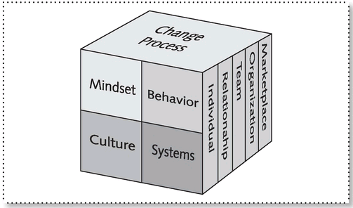
(The Conscious Change Leadership Accountability Model, (Anderson, 2010)

According to Anderson (2010) the secret to success in transformation is to approach it consciously. This necessitates an understanding of human behaviour as well as mental and emotional processes and the model above, The Conscious Change Accountability Model illustrates the four main regions and five levels in which you need to operate as a leader, demonstrates the connection of all quadrants and levels, and emphasises the fact that change happens in all dimensions. The Conscious Change Leader Accountability Model is not sufficient to guide the transformation of your organisation on its own; a change process model is required. They provide direction on how to bring about change and what steps to do first. It is necessary to have a plan that illustrates the process of the journey since transformation necessitates moving from where you are to where you want to be. So, the Change Leader’s Roadmap (pictured below) is the model that serves as an extensive plan for moving your company from its current state to its intended one, over time.

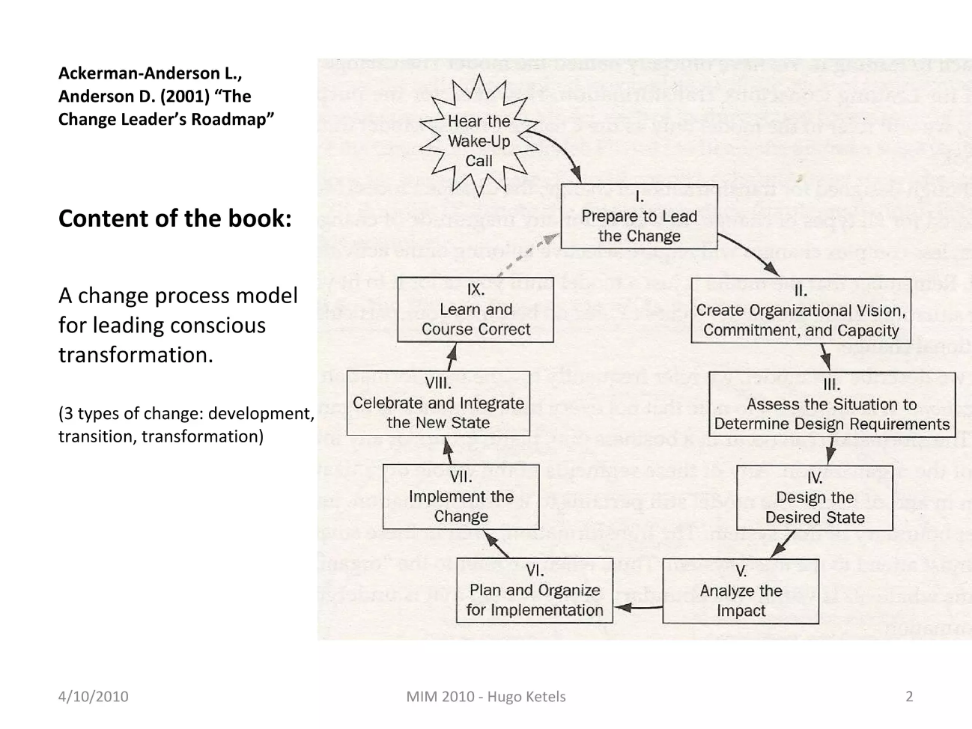
(Image taken from Anderson, (2010))

Created for transformational change, it can be used for all kinds of change. The model is a spiral that keeps moving upward. At the end of each "cycle" of change is an outcome that has been altered, enhanced, and made better than it was before.
The Change Leader’s Roadmap utilises a task-driven process model, which means that tasks and, more specifically, the work steps for each task are how the work of change is carried out. Leaders can intentionally plan and execute their change processes with the aid of this road map. The model's implementation must constantly be customised to the outcomes, scope, change leadership style, and resource limitations of your circumstance.

Kurt Lewin change model
According to Cameron and Green (2019) Lewin’s Three-Step Model was created by German American psychologist Kurt Lewin for organisations as well as communities and the public, and it has a positive impact on business operations and activities. He says that to help a corporation advance from the current state to the desired one is taking the best available route and should consider and assess all the options and possibilities from the beginning. Mirza (2024) in his Moodle lesson adds that there are two types of resistance to change: the resistance that arises from social habits and norms, and the resistance that arises from within. If management tries to change the group's values or reduce the importance the group places on something, resistance may be reduced (D’Souza, 2021).
The model is a planned approach involving three steps unfreeze-change-refreeze.
In the unfreezing step one must describe the current situation, outlining the motivating and impeding elements, and visualizing the ideal situation in which workers are now able to recognise the new work environments. Managers should use meetings, announcements, and other channels of communication to bring up the need for change with their staff at this time.
Often, unfreezing means using the evidence on the new issue to break psychological bonds to the past and prepare the organisation by challenging the beliefs and attitudes that define the current state (Mitchell, 2012).
The change step requires advancing to a new level through engagement and participation, educating the workforce about the need for change, considering all relevant factors, and identifying and periodically evaluating the potential solutions. People need to realise how this change will benefit them as well as the company since it will take some time for them to accept and adjust to it (Aguirre and Alpern, 2014).
The refreeze step comes in as soon as the changes are in pace and people have started to understand and accept the need for change. As the new circumstances settle in, staff members begin to feel assured and at ease with the new working practices. Standards, protocols, and rules are set as well (Cameron and Green, 2019).

Kotter’s Eight-Step Plan for Implementing Change
According to his book there are 8 steps that an organisation should consider when implementing change:
- Establish a sense of urgency is necessary for collaboration because, despite the use of various rewards or techniques to persuade individuals to change, everyone must share the same sense of urgency for the change to be sustained. Strong senses of urgency typically call for ambitious or even risky measures, which are traits of effective leadership.
- Create a coalition. Significant change is challenging to implement; a strong force is needed to keep the process going, and a CEO cannot do it by themselves instead building a guiding team is usually a crucial first step in any attempt to reorganise, reinvent, or modify a set of measures. Under these new conditions, teams can only function at a high level if their members have enough trust in one another and the team and have the same goal. A strong united coalition capable of working together must lead any new decision-making process, this way more information can be processed faster. To do this strong member are needed, one of them should have a position in power, another should have expertise credibility and leadership. For the leading coalition, you need both leadership and management abilities, and they must be combined in a cooperative manner as a governing coalition led by incompetent leaders will fail (Kotter, 2019).
- Develop a clear vision. A vision for the change process helps to organise the actions of many participants quickly and effectively, encourage people to take appropriate action, and clarify the direction of the change. Vision it is only one component of a bigger system that also consists of strategies, plans, and finances in successful transformations. IA a vision is easy to communicate then is an effective vision. There are five qualities that define an effective vision: Imaginable: Paints a picture of what is possible for the future. Ideal: Appealing to the long-term interests of stakeholders in the business, such as customers, employees, and investors, is feasible and consists of reachable, realistic goals. Concentrated: Is sufficiently lucid to offer direction while making decisions Flexible: Has enough generality to permit individual initiative and different approaches in response to evolving circumstances. Communicable: Easily understood and able to be explained in five minutes
- Share the vision, communicate it further. Kotter (2019) states that a vision's true strength is fulfilled when most of the persons engaged in the effort or activity share a common understanding of its objectives and course. Low vision communication is frequently connected to low-level employees' intellectual limitations or to people's general aversion to change and, hence, to accepting information about change. The effective communication of vision depends on a few factors: Simplicity: Get rid of any technobabble and jargon; Examples, metaphors, and analogies: a picture painted with words is worth a thousand words; Various platforms: large and small gatherings, newspapers and memoranda, official and casual communication—all these are useful for getting the information out; Repetition: it takes repeated exposure for ideas to become fully ingrained; setting an example for others to follow: important people's actions that are at odds with the vision overshadow other channels of communication; Justification for apparent contradictions: when errors go unchecked, all communication loses credibility; Give and take: communication that is two-way is always more effective than communication that is one-way.
- Empower people to clear obstacles. Some obstacles exist for empowering people. Bosses oppose taking any action that will carry out the new vision. Workers are constrained even though they are aware of the vision and wish to see it come to pass. Action is undermined by a lack of necessary abilities and it's challenging to act due to personnel and information systems. To get beyond these obstacles, it is necessary to take down organisational barriers, provide the required training, match systems to the vision, and handle challenging supervisors.
- Secure short-term wins. A great short term-win possesses at least these three qualities: 1. It's observable; a lot of individuals can determine for themselves if the outcome is genuine or just marketing speak. 2. It's clear; there won't be much debate on the call. 3. It is obviously connected to the endeavour for change.
The role of short-term wins: Short-term victories are essential in justifying the short-term expenditures required by showing that sacrifices are worthwhile; Give change agents a pat on the back for their efforts: Positive reinforcement boosts motivation and morale after a long day of labour; Assist in refining the vision and strategies: Quick victories provide the steering coalition with hard evidence on the feasibility of their concepts; Undercut resisters who are self-serving and cynical: Clear performance gains make it harder for people to resist necessary change; Maintain boss support: gives proof that the transition is proceeding as planned to those at the top of the hierarchy; Create momentum by converting sceptics into believers, hesitant believers into willing volunteers,
- Consolidate and keep moving. This step should resemble the following in a successful change effort: a. Increased, not decreased, change: The governing coalition takes on more and more significant change initiatives by leveraging the confidence that comes with immediate successes; b. Greater assistance: More staff members are hired, advanced, and trained to assist with all the adjustments; c. Senior management leadership: Senior staff members concentrate on upholding urgency and a clear common objective for the entire endeavour; d. Leading from below and project management: Lower positions in the hierarchy oversee and manage certain initiatives as well as give them direction.
- Anchor the change or make change stick. There are three main reasons why culture is powerful: Due to the excellent selection and indoctrination of people. Because the acts of hundreds or thousands of people represent the culture and because it is difficult to dispute or even bring up because all of this occurs without much conscious intent. Cultural shifts don't happen until after you've successfully altered people's behaviour, the new behaviour has momentarily benefited the group, and people have realised how the new behaviour is related to better performance. Thus, stage 8 rather than stage 1 is when most cultural change occurs (Aguire and Alpern, 2014). Changes in behaviour and attitude usually start early in the process of transformation. These modifications then lead to practice adjustments that assist a business in producing better goods or services at a reduced cost. However, the majority of this only settles in the culture after the end of the transformation cycle (Kotter, 2019).

Section 3- Proposal and Implementation of Change Strategy
The proposition in this case is that all three change management models described above are equally suitable and important to use when managing a change even by the retailer, Tesco. Each one of them have relevant ideas that Tesco can use to implement change in the future but what they have in common is that they are based on leadership actions and skills.
So, to better manage the implementation of the three models Tesco should adopt the organisational learning approach as the first step into implementing the change strategy. A lifelong learning for the whole organisation, leadership and employees and added innovation and sustainability. The next steps can be followed to help with the implementation of the change strategy:
- Competitive drive contributed to the development of lifelong learning, which raised levels of expertise and knowledge—particularly in leadership—and ultimately resulted in a remarkable capacity to navigate an increasingly complex and rapidly evolving global economy (Kotter, 2012). In an interview Kotter said that leaders need to have political skills (Bencivenga, 2002).
- According to Percy (2019) the reason that the change initiatives that have been implemented are failing is due to a lack of communication between leaders and employees. Instead of spending money on technology or other things to try to push employees into change, companies and leaders can invest more in interacting with employees so they embrace the change projects.
- Since people are more resistant to change, leaders tend to underestimate how difficult it is to push them beyond their comfort zones, so communication is very important.
- To manage and implement changes, collaboration is required in addition to strong line leadership and a clear vision to direct decision-making (Mitchell,2012). In such volatile times, mistakes during the implementation of change are inevitable; nevertheless, they can be minimised or prevented with the right skills and awareness of the situation. However, successful change implementation will depend more on strong leadership than on good management alone. Ten to thirty percent management and seventy to ninety percent leadership are needed for a successful change. Only effective leadership can ensure that changes become deeply rooted in an organization's culture. Everyone is impacted by corporate culture, which is significant since it can profoundly influence behaviour and can be challenging to alter (Kotter, 2012).
- Sustainability (Organisational learning + innovation) -Organisational change initiatives are being implemented by businesses to reduce energy and resource consumption, minimise waste production, create more sustainable goods and services, and so forth. These initiatives are frequently undertaken with the hope of making a profit while also having a positive environmental impact. Research indicates, however, that standard process improvement programs aimed at productivity, quality, and cost often fall short (Sterman, 2015).
To improve the company's sustainability, managers and leaders must take certain actions, such as:
-For example, in order to generate unique sustainability policies and practices, one cannot just dismiss statistics on climate change; instead, one must engage with this data and explain a firm's degree of acceptance (and non-acceptance).
-A senior management needs to become more actively aware of environmental and social issues, speak about them in language that is suitable, and develop new ideas and procedures around them in order to obtain a competitive advantage.
- A senior manager must take advantage of his or her company's position in the field's infrastructure and its network connections with field members to pursue various sustainability opportunities.
-A variety of internal and external sustainability experts can assist. S/he must think about a whole portfolio of approaches to sustainability. As a result, the senior management should be able to take the company further towards sustainability, which is characterised as progress that meets present demands without affecting the ability of future generations to meet their own (Greenwood, et al., 2015).

Conclusion and Recommendations
According to their chief executive Ken Murphy Tesco focuses on what they can control, have contingency plans in place and act quickly to find solutions and keep products coming for their customers (Tescoplc, 2024).
According to this environmental analysis done at the beginning there are factors that influence Tesco to go through changes. On a political level Tesco had growing operating costs, had the cost-of-living pressure and their profitability was affected. But stand by their values into sustainability which motivated the company to work to minimise environmental effects through their supply chain and internal operations. Is very conscious of the growing trends that the customers are experiencing like veganism, social beliefs and lifestyles. And used the latest te technology advances that helped them stay afloat online and in shops.
Being adaptive and resilient means leaders must respond quickly at changing circumstances or any crisis like the COVID19 but as an organisation there is a lot to add to that by continuing to learn and make progress (Hope, 2020). Reason for the model of Conscious Accountability whereas a leader one must be aware of the changes and that they happened in all dimensions and with the use of the Leader’s Road map, can adapt different leadership styles and Tesco can move their company forward from the actual state. Also, the Kurt Lewis model will help with the resistance to change going through the unfreezing, changing and re freezing steps. In the other hand Kotter’ 8 step plan involves having a clear vision, involving people and teams, moving forward with the change and securing it in place.
All these steps require an inclination towards learning, innovation and sustainability, a learning organisation can follow through with any of the models and can take Tesco from where it is now towards better in the future.

References
Aguirre, D. and Alpern, M. (2014) 10 principles of leading change management (https://www.strategy-business.com/article/00255? gko=6c601). Strategy+Business. No 75, Summer. pp65-71.
Anderson, D. (2010) Beyond change management [electronic resource] : how to achieve breakthrough results through conscious change leadership . 2nd ed. San Francisso :, Pfeiffer.
Bencivenga, J. (2002) John Kotter on leadership, management, and change, Published in School Administrator, February 2002, Vol. 59 Issue 2, p36 5 (online august 2024).
Buye, R., (2021). Critical examination of the PESTEL Analysis Model. Project: Action Research for Development.
Cameron, E. and Green, M. (2020) Making sense of change management: a complete guide to the models, tools, and techniques of organizational change. Fifth edition. London; New York, Kogan Page.
D’Souza, D. (2021) https://moodle.uwtsd.ac.uk/mod/resource/view.php?id=341406 Change management fact sheet CIPD, (online august 2024).
Greenwood, R., Jennings, D., and Hinings, B., (2015) 'Sustainability and Organizational Change: An Institutional Perspective', in Rebecca Henderson, Ranjay Gulati, and Michael Tushman (eds), Leading Sustainable Change: An Organizational Perspective (Oxford, 2015; online edn, Oxford Academic, 23 Apr. 2015), https://doi.org/10.1093/acprof:oso/9780198704072.003.0013, accessed 20 Aug. 2024.
Hope, V. (2020) Responsible business through crisis: senior leaders on trust and resilience during COVID-19 https://moodle.uwtsd.ac.uk/mod/resource/view.php?id=341986 (online august 2024).
Kotter, J. P., (2012), Leading Change, with a New Preface by the Author, Harvard Business Review Press, La Vergne. Available from: ProQuest Ebook Central. [20 August 2024].
Mayne, J. (2015) Useful Theory of Change Models. Class article week 5. (Accessed 20/08/2024)
Mitchell, G. (2012) https://moodle.uwtsd.ac.uk/mod/resource/view.php?id=341416 Selecting the best theory to implement planned change (online august 2024).
Percy, S. (2019) Why Do Change Programs Fail? (Online accessed from Moodle week 9 at https://moodle.uwtsd.ac.uk/mod/resource/view.php?id=344884
Peters, R. (2020) What lessons can COVID-19 teach us about organisational change (https://peopleprofession.cipd.org/insights/articles/lessons-covid-19-organisational-change) ? CIPD People Profession Insight. 20 august.
Statista Research Department (2014), Tesco club card key data Available from: Tesco Clubcard no of members 2024 | Statista
Sterman, J. (2015), 'Stumbling Towards Sustainability: Why Organizational Learning and Radical Innovation are Necessary to Build a More Sustainable World—But Not Sufficient', in Rebecca Henderson, Ranjay Gulati, and Michael Tushman (eds), Leading Sustainable Change: An Organizational Perspective. online edn, Oxford Academic.
Yüksel, I., (2012). Developing a multi-criteria decision-making model for PESTEL analysis. International Journal of Business and Management, 7(24), p.52.

