ACCA4035 Benjamin Mason-Ling
2513241

BA Computer Games Design / BA Animation & VFX
Portfolio of work

Contents

Perspective Drawing………………………………………………………………………….3
Anatomy……………………..………………………………………………………………….…6
Photo Compositing/Photobashing………………………………………….…………..9
Moodboard Creation…………………………………………………………………………12
Colour Theory……………………………………………………………………………..……13
Gesture Drawing/Line of Action…………………………………………………………14
Link to portfolio…………………………………………………………………………………16
Bibliography………………………………………………………………………………..……17

Perspective Drawing

These are some examples of perspective drawings I have made, utilising 1st, 2nd, and 3rd person/points.

1st Person
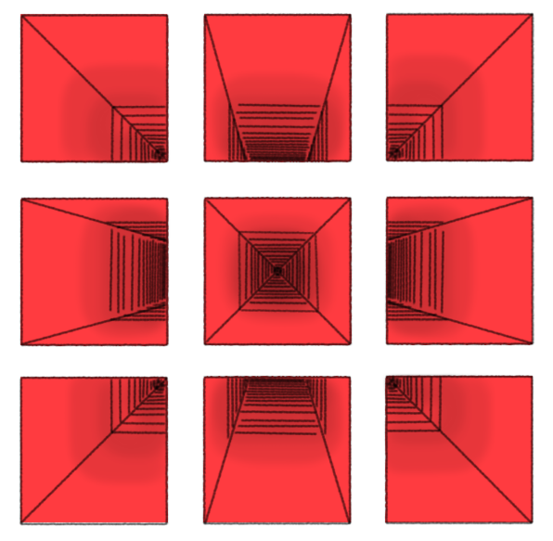
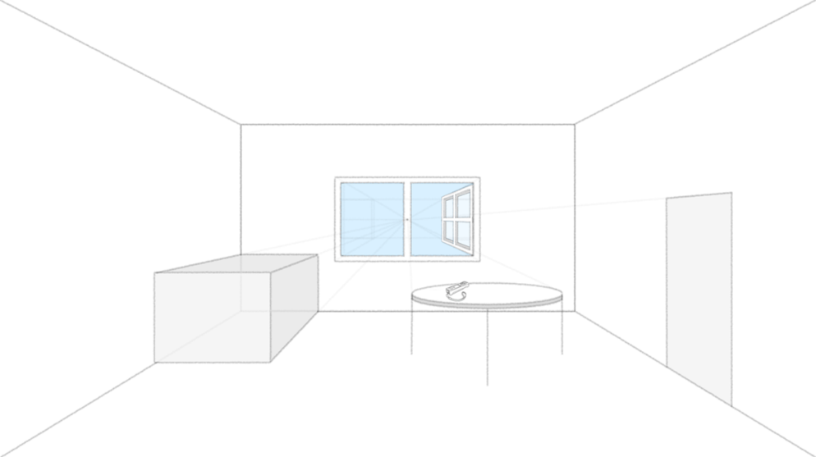

One vanishing point. Objects face you directly; depth goes straight back (like a hallway). These images show a centre dot as the main focus point. Everything is revolving around this point and is all in line, for instance a room, the walls will all be aligned so that they are pointing at the vanishing point. The first image was loosely inspired by a scene in Silent Hill 2, where the protagonist, James Sunderland, comes across 9 red squares on the wall. I had recently played the game when making this, so it came to mind [1]. The second image was also inspired, this time by the Nintendo Wii, more specifically the “Take a break” notice in Wii sports. I chose this as when I was designing the room, I added a window on the back wall and the shade of blue I chose for the outside reminded me of the notice. I went further and added a Wii remote on the round table [2].
2nd Person
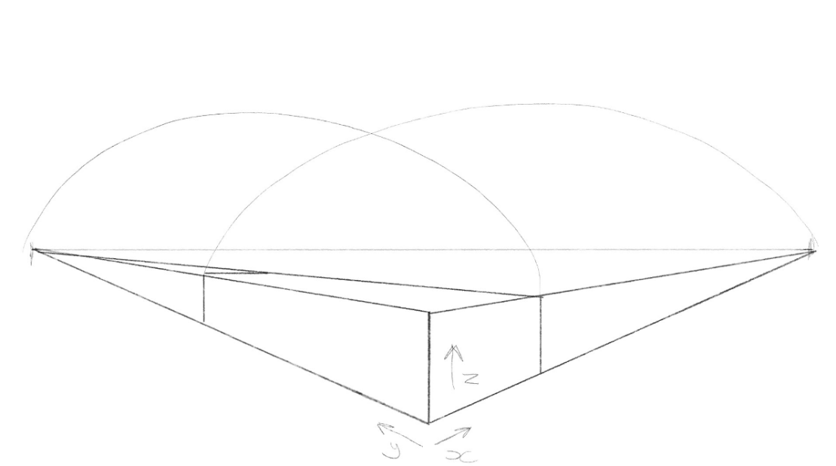
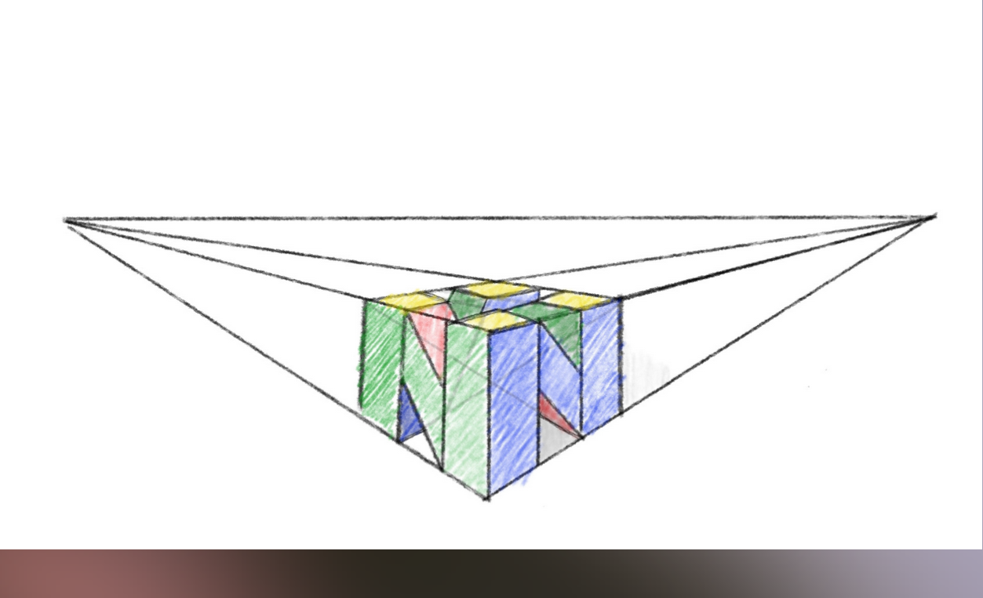
Two vanishing points. You see a corner of an object; sides recede left and right (like a box turned slightly). These images were some of the first ones I created, backed up by how rough they are. The 1st of the two show my process for drawing in 2 points, with the arks and the axis labelled. The second image is of the N64 logo, which I thought was fitting as it was already a 3d box shape [3].
3rd Person
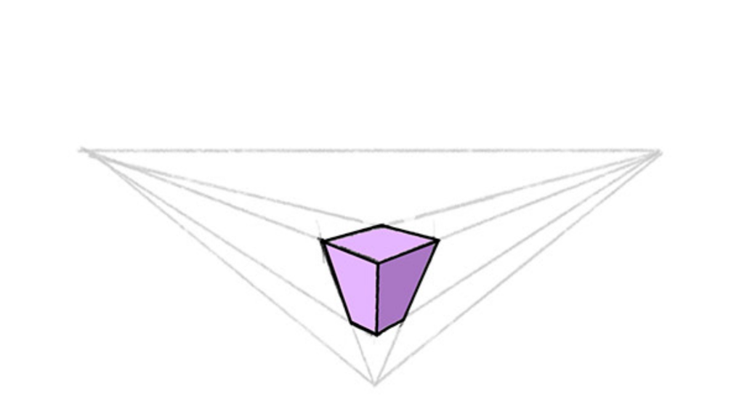
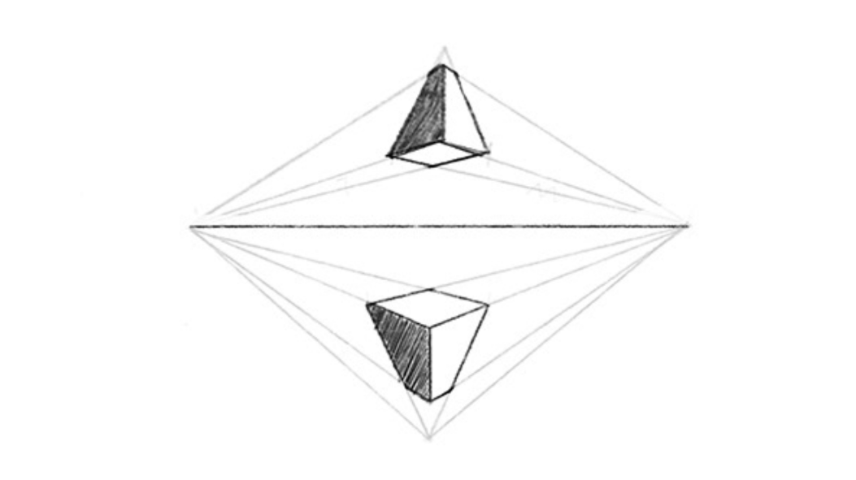
Three vanishing points. Adds height or depth dramatically - looking up or down at an object (like skyscrapers). These images show the vanishing point being at the bottom with 2 other points to the sides, marking as alignments. Both show the process lines of how everything is lined up, as well as how the bottom of the shape shrinks the further down it goes. Adding shading to these is always a good step to do as it adds some more depth.

Anatomy

These are some examples of anatomy drawings that I have done, including, hands, humanoid, muscles, faces, and eyes.

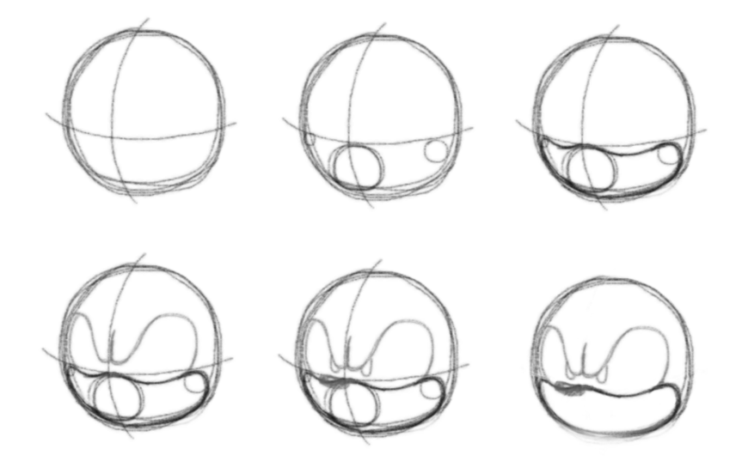
This example of a face shows the character of Sonic The Hedgehog. First you start with a circle with a cross through it, indicating the middle of the face, then you add more details, outlining the mouth, then the eyes, the nose, and lastly adding pupils and erasing the cross.

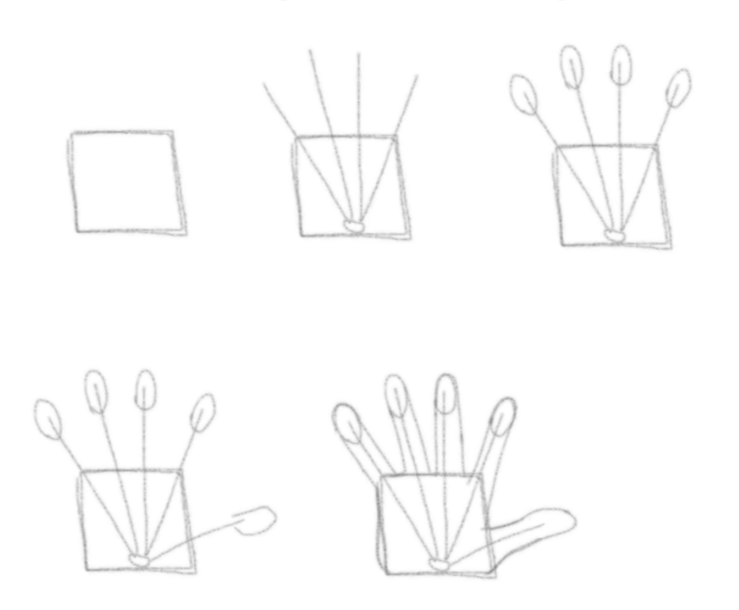
This image, similarly to the previous drawing, is a step by step, this time of a hand. First starting with a box, then tapering out 4 lines from the bottom centre, adding ovals to the ends of the lines, next add another line and oval lower down on the side of the box, the finally add the outlines for the fingers [4].
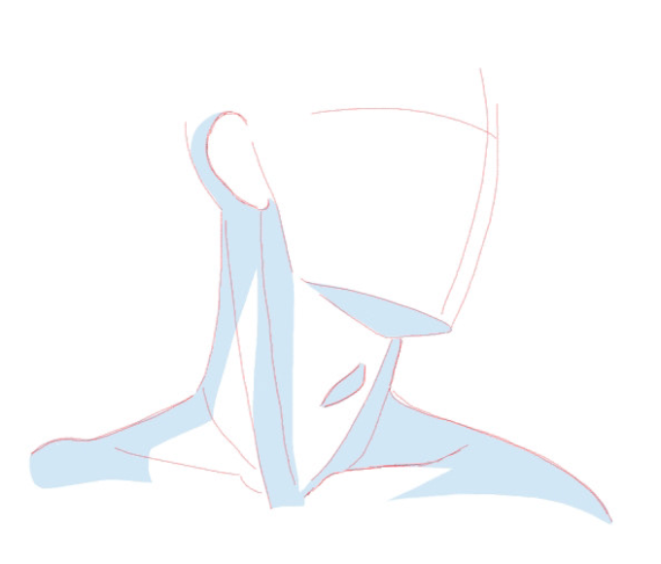
This drawing focuses on the lighting aspect, showing how shadows can add more depth to a person. It is important to understand your lighting scenario and stick to it, otherwise you will have shadows in the wrong place [5].

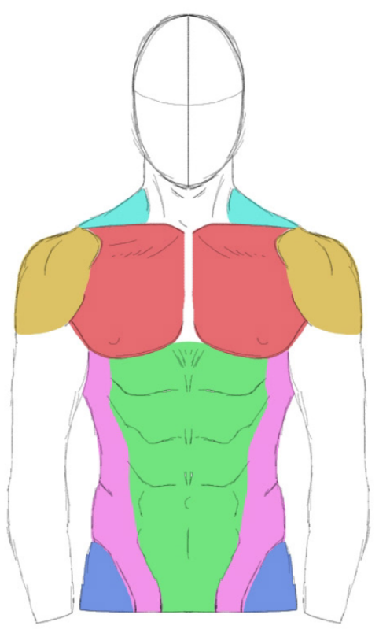
This drawing depicts different muscle groups on a body, indicated by their colour. Green being the core, yellow being the shoulders, etc. It’s handy to understand muscles in a drawing so that if and when you draw a humanoid, you’re able to pose them in a realistic manner.
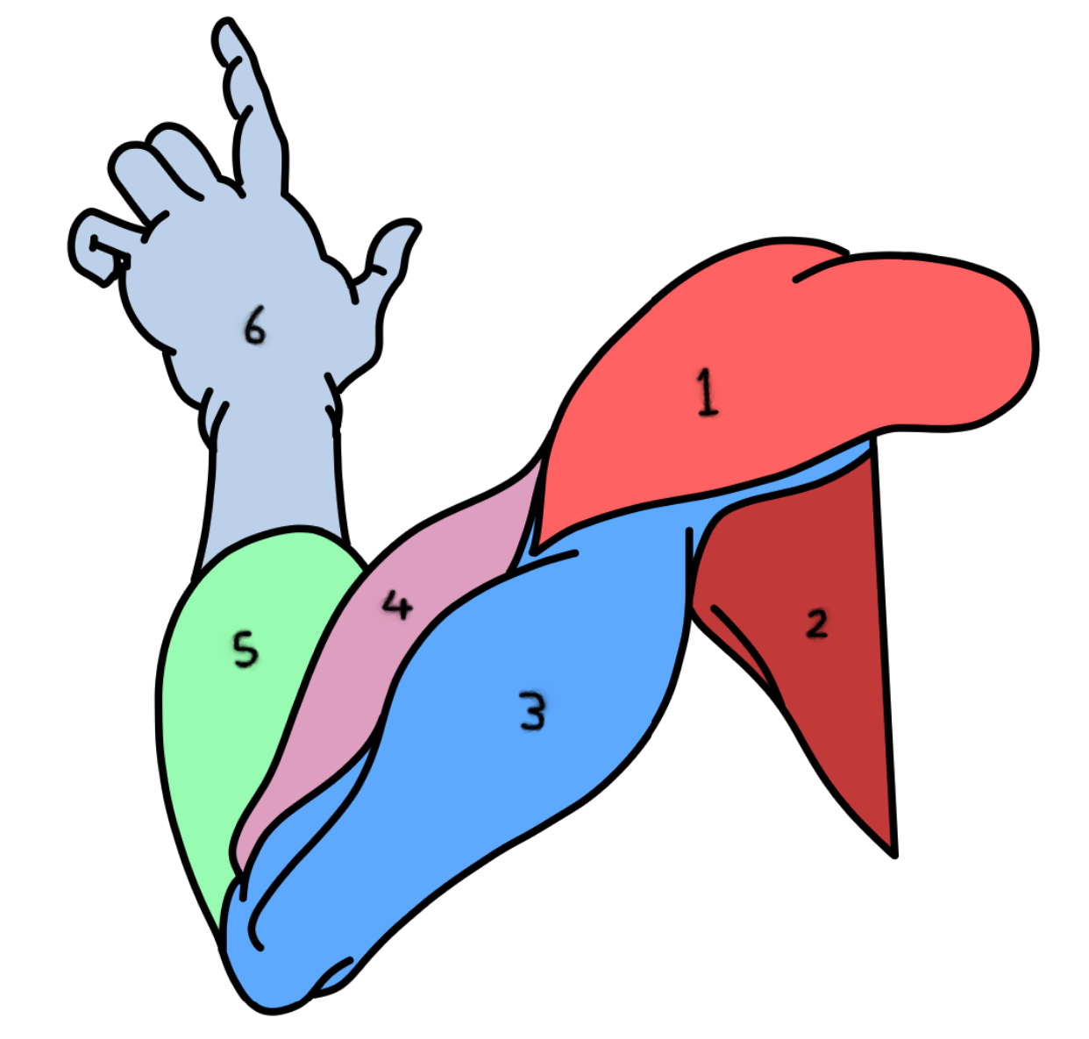
This is another example of muscles groups, separated by colours, this time they are also numbered [6].

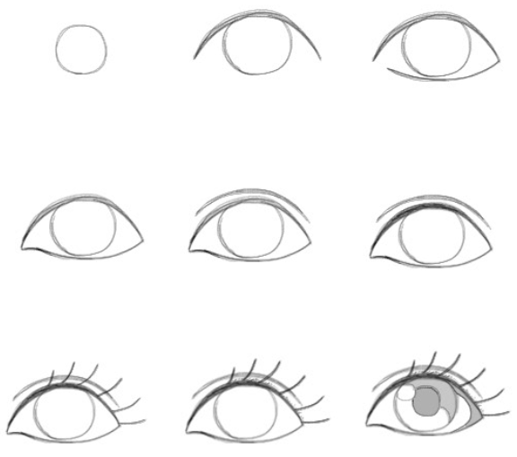
Lastly, this is another step by step, this time for an eye. Starting with a simple circle, then adding an arch on top, bringing the arch back on itself on the bottom of the circle, and then by adding more details such as eye lashes, and shine to the pupil, you will have a fairly detailed eye [7].

Photo Compositing/Photobashing

Here are some examples of work that I have created using adobe photoshop. Some images were given a prompt of around 3 words, and I was tasked to create an image with those words. Some other images were made with creative freedom.

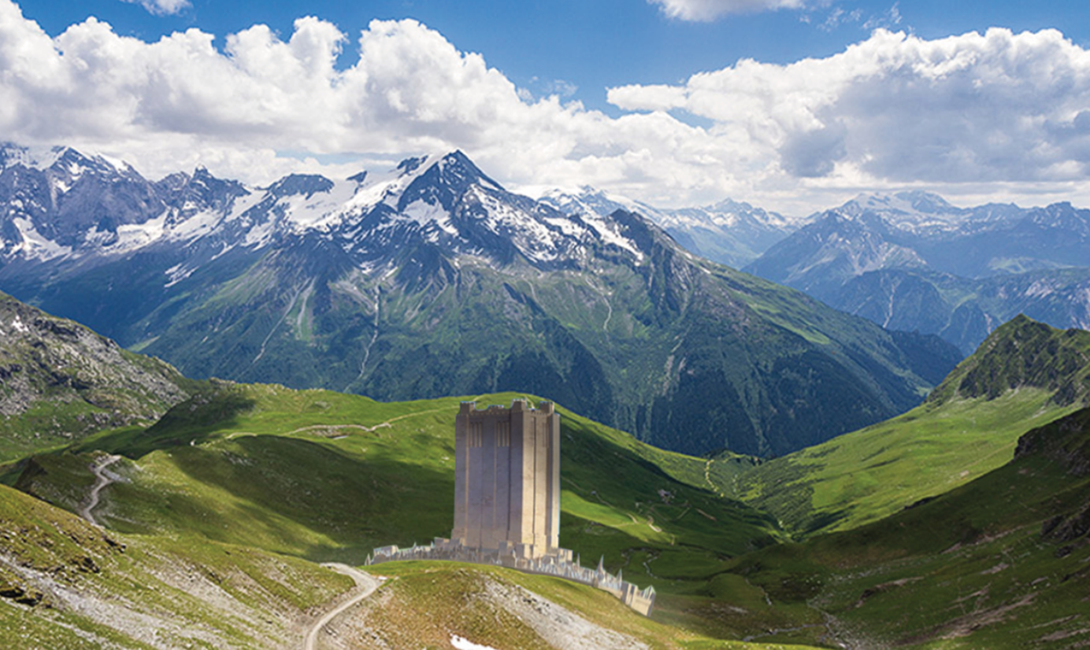

This was the first image I created in Photoshop. Unlike the others it didn’t have a 3 word prompt. It was a test to get familiar with the program and its different tools. It depicts the castle town from the movie Shrek, Duloc, in a mountainous environment.

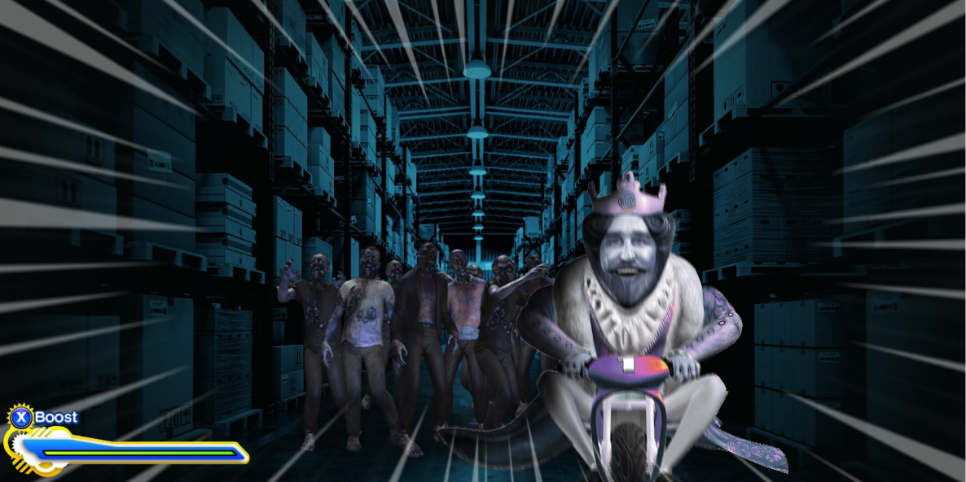
This was the first image I created with the 3 worded prompt, that being: Zombie, Warehouse, Burger King. The idea I had was the Burger King mascot fleeing from a group of zombies in a dark warehouse. The image I found of the burger king already had him on the bike, so from that I simply found a group of zombies and places them behind him. On top of everything, I added some speed lines, and a boost prompt, to make it look like a scene from a game.

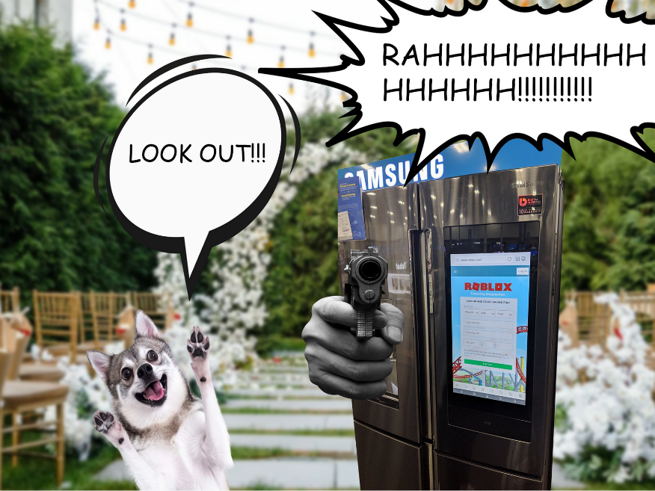
The prompt for this next image was: dog, fridge, gun, wedding. I found an image of a dog looking relatively shocked, a hand holding a gun model, placed it on top of a fridge and then lastly found a wedding back drop. The speech bubbles are just to add some drama.

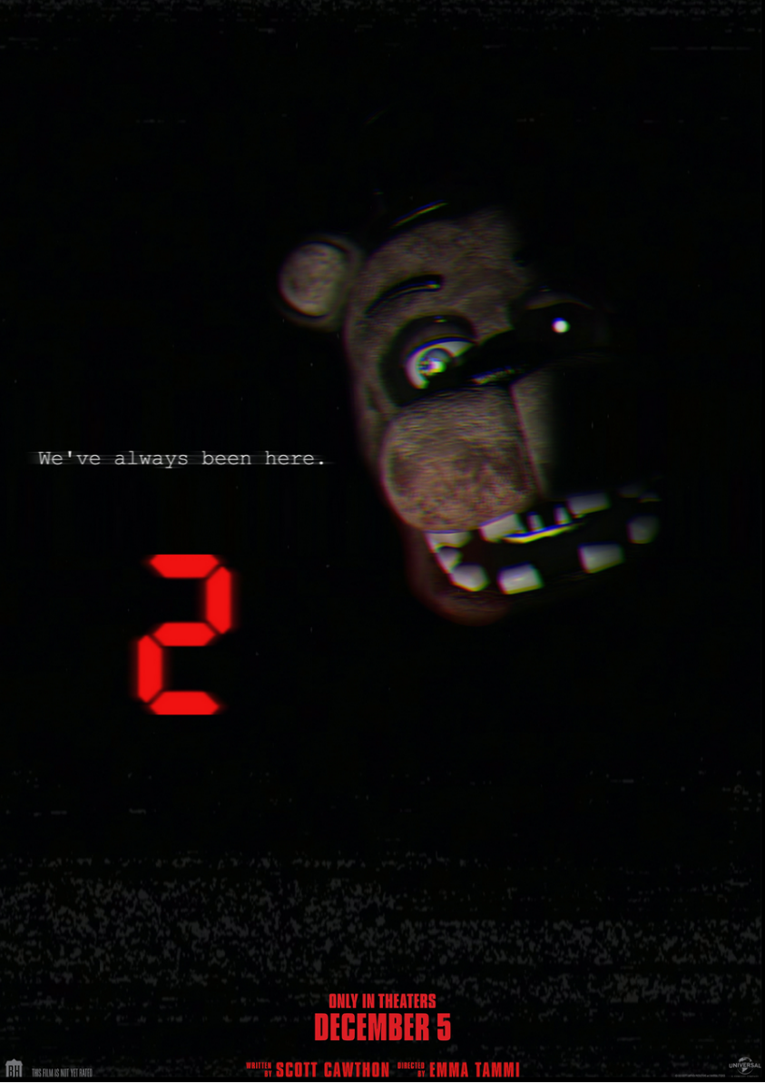
This next image is a favourite of mine just because of how simple yet affective it is. I made this when the hype for the then upcoming Five Nights at Freddy’s 2 movie was high. For inspiration I based it off of the old Scott Cawthon teasers for the FNAF games, where they were really cryptic and simple. I found an image of the Freddy character, erased one side of his face and placed it in a black background. I erased one of his eyes and placed a white dot in its place, so that it would illuminate in the dark. For the text I thought of something quite vague but impactful, which ended up being “We’ve always been here.” Which makes sense in the context of the film. Lastly, I added a big red 2, to show that it was a sequel, and some credits at the bottom, as well as the date for its release. For some final adjustments, I also added a VHS like filter to it, as well as some chromatic aberration, to make it look glitchy and slightly blurry, to mimic old cameras.
Moodboard Creation

A mouldboard is used when trying to design a character with a bunch of ideas, for inspiration purposes. The image below is an example of using 3 words gained from a random word generator. Those being, Art, Agent, Rider.

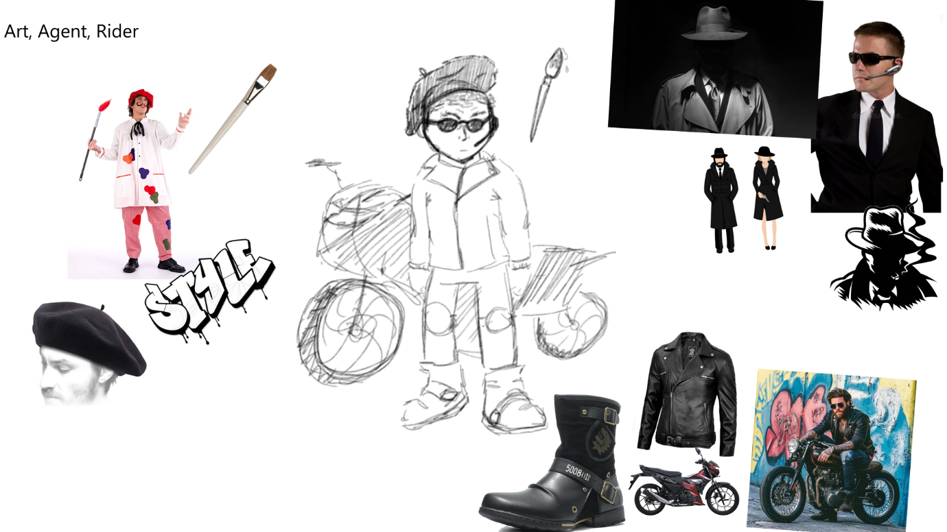
These images were sourced and brought into the moodboard, being placed around the outsides. Once I had enough images, I designed a rough sketch of a character that applied these words. He is an Agent, that rides a motor bike, but is also an artist, that uses his paint brush for combat, he paints his tag on his enemies.
Creating moodboards is a great way to create characters and lay out work in a creative way, as it helps the mind in creating new and creative things.

Colour Theory
Colour theory is the idea of contrasting or blending colours together to gain different results. For instance, a sun set backdrop would contain yellows, and blues, for warm and cold colours respectively [8]. Sticking with that idea, these 2 images demonstrate how changing the colour overlay on an image can change its feel.

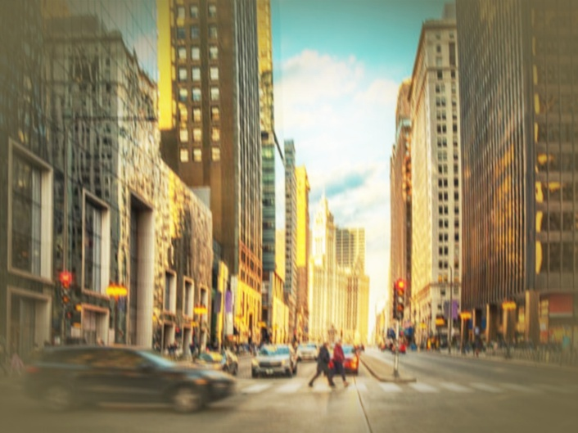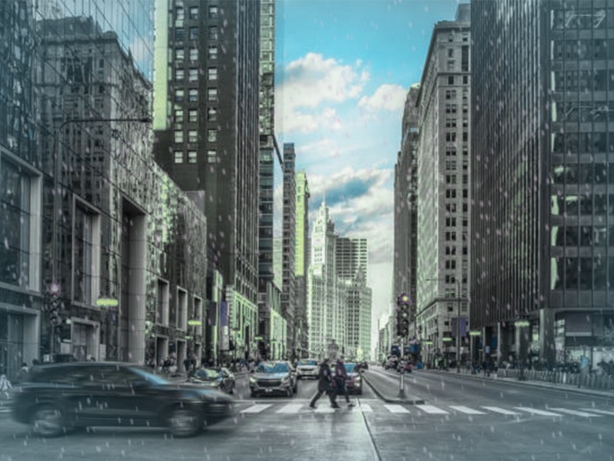
These images are the same [9], however the one on the left was given a warm colour, orange, over the top of it, as well as some vignette around the edges. This is meant to convey the idea that the city is warm. The image on the right was given a cool colour, blue, to represent cold. Adding vignette to the cold image helped a lot, however I feel like I may have made it too dark in the warm image, I should’ve made it a brighter yellow.

Gesture Drawing/Line of Action work
Gesture Drawing/Line of Action refers to a character pose, as well as their core stance, for example, the image below shows a blue line going through the centre of the character, this is the Line of action, and is used when drawing poses to help the artist understand what pose they want that character to be in.

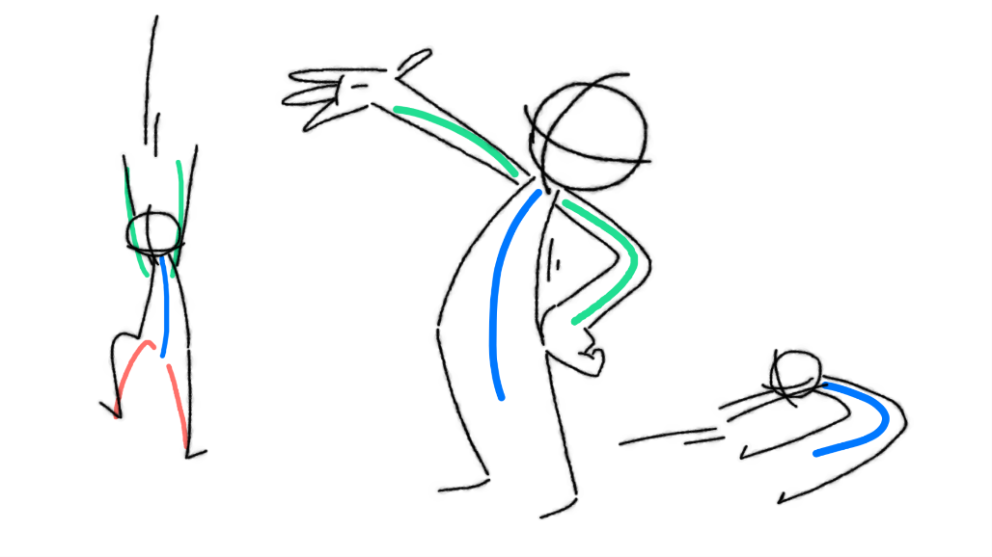
This image shows a simple example of line of action, the 3 characters are posed in different ways, all with the central blue line, however they also have other coloured lines representing other parts of the characters, like the hands and legs. Line of actions is very important, especially when posing a cartoon character.
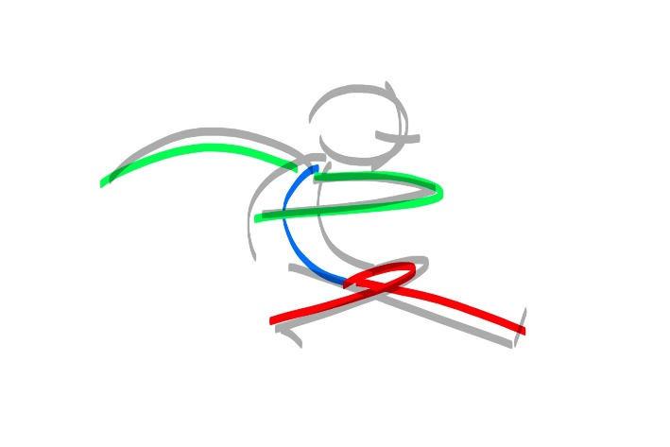
This is another example of line of action, in a different pose.
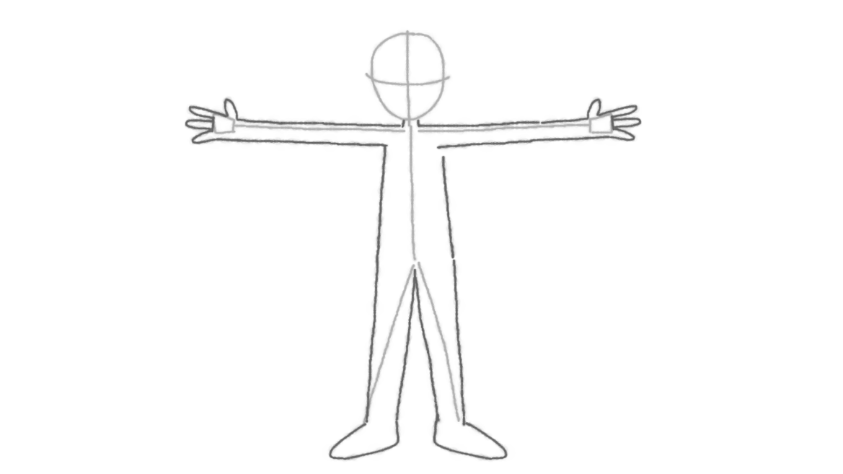
This is a reference of the default pose that animators use when working with models, it is called the T-Pose and is used by basically everyone when working with animation, this is also handy for when you are working on a character design sheet and need them to be in a simple pose.

Link to portfolio

Here: https://a25132413e8e.myportfolio.com/

Bibliography

[1]C. to, “Red square,” Silent Hill Wiki, 2022. https://silenthill.fandom.com/wiki/Red_square?file=SH2sp.jpg (accessed Jan. 19, 2026).
[2]reactjpg, X (formerly Twitter), 2026. https://x.com/reactjpg/status/1553706610526040064/photo/1 (accessed Jan. 19, 2026).
[3]Wikipedia Contributors, “Nintendo 64,” Wikipedia, Jan. 08, 2026. https://en.wikipedia.org/wiki/Nintendo_64#/media/File:Nintendo_64_(logo).svg
[4]Rhea, “How To Draw Hands - Step by Step Guide | 21 Draw,” 21-draw, Jul. 18, 2022. https://www.21-draw.com/how-to-draw-hands/
[5]Clip Studio Paint, “Learn from Anatomy to Improve Your Poses,” Art Rocket. https://www.clipstudio.net/how-to-draw/archives/161109
[6]M. Woodie, “Top 5 Dos and Don’ts of Drawing Anatomy,” Artists Network, May 28, 2018. https://www.artistsnetwork.com/art-techniques/beginner-artist/drawing-anatomy-for-beginners/
[7]N. Madrigal, “How To Draw An EYE - 40 Amazing Tutorials And Examples,” Pinterest, Feb. 02, 2016. https://www.pinterest.com/pin/831477149923836871/ (accessed Jan. 19, 2026).
[8]Yaroslav Piatkivskyi, “Stunning sunset view from modern apartment overlooking city skyline,” Dreamstime, Apr. 12, 2025. https://www.dreamstime.com/golden-hues-sunset-fill-large-window-contemporary-apartment-city-skyline-visible-showcasing-tall-buildings-image374065762 (accessed Jan. 19, 2026).
[9]A. Zlatopolsky, “Culture, food and history make Chicago a prime choice for business meetings,” Crain’s Chicago Business, Jan. 18, 2024. https://www.chicagobusiness.com/crains-content-studio/culture-food-and-history-make-chicago-prime-choice-business-meetings (accessed Jan. 19, 2026).

