Financial Management for the Hotel industry
Business Report- Comparison of two Hospitality Organizations
BMIH5007
Student Name: Tanya Gue Ferreira Amaro
Student ID Number: 2209539

Table of Contents
Introduction: 2
Shangri-La Hotels: 2
Travelodge Hotels: 2
1. Total Revenue 3
2. Market Position 6
4. Growth Potential 8
4. Financial Obligation for CSR 11
Recommendations 11
Conclusion 12
References: 13

Introduction:
In todays’ modern era, hotels have become the comprehensive social service organization. Unlike past century when hotels were supposed to provide accommodation services only, today hotels have become essential part of people’s lives. They not only contribute to the economic development of a country but also enhance the tourism industry there. Hotels now, serve as common place for business negotiations, fitness sessions, and wedding or birthday celebrations and have become common place with demand of high quality services (Ma, 2021). Therefore, managing finances for hotels is also important to meet the competence of this emerging industry. It includes managing statistics, performing analysis of the financial outcomes, managing fixed assets, material supply and monitoring currency and capital exchange in terms of hotel’s operating activities. Hotel’s financial management is directly related to its potential to long-term operations and sustainability (Anđelković, 2020). This report will conduct a comprehensive analysis of two prominent hotel groups Shangri-La Hotels and Travelodge Hotels. It will cover various factors related to financial management, which include total revenue, market position, growth potential, and CSR (corporate social responsibilities) of both the industry giants. Report will also provide details on the financial strategies and practices of both organizations, and recommendations for their future prosperity.

Shangri-La Hotels:
The Shangri-La Hotel is a luxury hotel chain that operates 50 hotels around South East Asia, Europe, North America, and Bridle. The company is known for its quick expansion, with plans to open more locations throughout China (Ahmad, 2024).
Shangri-La Group has a significant mark in Asia and doorway cities across the globe. The first hotel under Shangri-La was opened in Singapore in 1971, that continued to grow and currently it is serving in 76 destinations with 104 hotels and resorts, more than 500 Restaurants and Bars employing over 44000 workforce around the world (Shangri-La Group, 2024/a). Its consolidated revenue for the year 2022 was estimated to be as USD 1, 462, 1 million. While Recovering 95% of FY2019, the Group's effective share of revenue was USD 2.8 billion (Shangri-La Group, 2024/b).

Travelodge Hotels:
Travelodge was founded in 1984 as the first budget friendly hotel chain, currently it is the largest budget hotel chain in the UK with nearly 600 hotels across UK, Ireland and Spain. It employ more than 13000 workforce, and host around 22 million guests annually (Travelodge, 2024/a). Its revenue for the FY 2023 reached to a record performance with revenue exceeding £1 billion. While adjusted EBITDA increased 14.6% to £243.9m, compared to £212.9m in 2022. Total revenue increased by 13.7% to £1,035.2m from £910.8m in a year (Travelodge, 2024/b).
Financial Comparison of Shangri-La Hotels and Travelodge Hotels:
1. Total Revenue
Shangri-La Hotels:
Shangri-La Hotels has proven its resilience in providing stable financial performance, as the company continuously records an increase in revenue over the years. The major sources of income are derived from room rentals, food and beverage services and additional services including a spa and event hosting. Revenue growth can be attributed to the entry into new markets, strategic partnerships, and the provision of high-quality services to the elite or upper class of clients (Shangri-La Group, 2024/b).
Figure-1: Growth in revenue of Shangri-La Groups for 2022

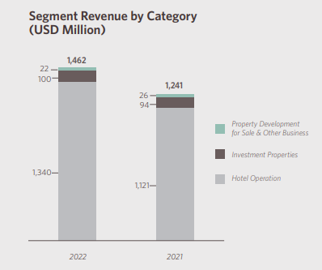
(Source: Shangri-La Group, 2022).
According to He, (2024); after three years of loss due to Covid-19 restrictions, Shangri-La Group announced attributable net profit of $184.1 million for 2023. The luxury hotel operator and owner profited from the relaxation of travel restrictions related to the pandemic in mainland China and Hong Kong, which are its two largest revenue-generating areas. While its revenue increased by 46.5% to US$2.1 billion in FY2023 from US$1.5 billion in the previous year (Oh, 2024).

Figure-2: Increased Revenue of Shangri-La for 2023.
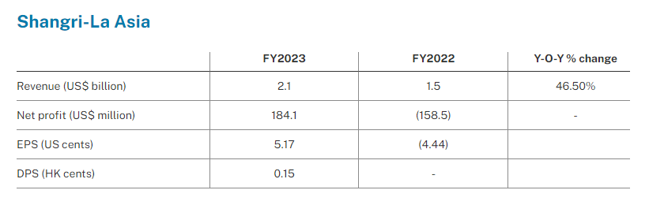
(Source: Oh, 2024).
Due to cost savings at hotel management services in addition to general business recovery, the effective share of EBITDA for the year ended December 31, 2023, was USD873.6 million, up 97.8% from USD441.6 million for the year ended December 31, 2022 (Shangri-La Group, 2024/c).
Travelodge Hotels:
Travelodge Hotels’ are also known for a considerable increase in revenue, which is mostly focused on room bookings within its expansive portfolio of budget hotels (Travelodge, 2024/a). According to Seo, (2024); the low-cost hotel chain reported earnings before interest, taxes, depreciation, and amortization (EBITDA) increased by 14.6% to £243.9 million for the year that ended on December 31, 2023.
While the company has performed towards growth in past with Strong cost control measures, that are not immune to increasing inflationary pressures. As per the financial results for the year 2022, its revenue increased by 25% as compared to the revenue from 2019 (Travelodge, 2023).
Figure-3: Growth in revenue of Travelodge for 2022 from 2019
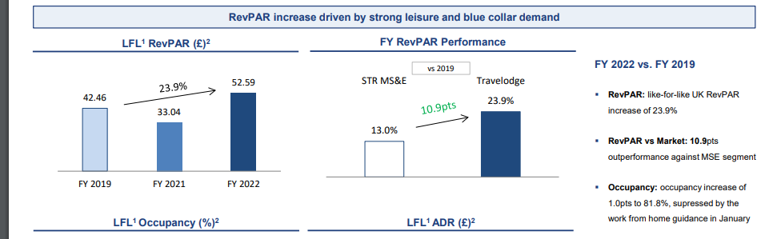
(Source: Travelodge, 2023).
Although, it is observed that he coronavirus (COVID-19) pandemic's unprecedented effects on the hotel business worldwide are responsible for the decline in income in 2020. While it managed to bring in 560 million British pounds in income in 2021, a rise over the 284 million earned in the year prior.
Figure-4: impact of covid-19 pandemic on Travelodge revenue

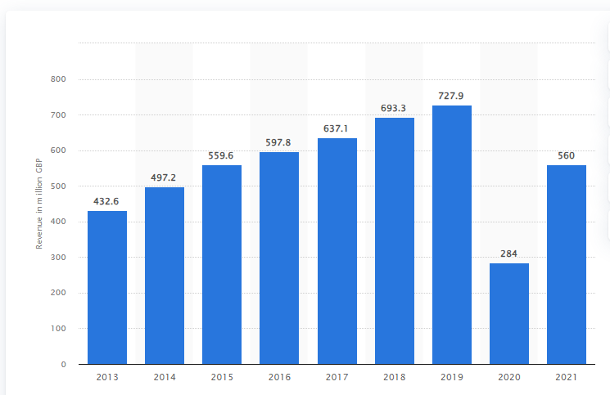
(Source: Statista, 2023).
Contrary to Travelodge, the revenue growth of Shangri-La may be slightly resistant to economic fluctuations owing to its positioning as a mid-range to budget type of hospitality. However, marketing innovations as well as competitive pricing have still enabled the company to maintain the growth of its revenues.
2. Market Position
Shangri-La Hotels:
Market Share: Shangri-La Hotels serves the wealthy travelers who are in search of luxury experiences. The hotel brand Shangri-La boasts of an outstanding reputation for service excellence and top-of-the-line facilities, which have led to achieve a position of industry leader in the world of hospitality (Bhasin, 2024). In the luxury hotel industry, Shangri-La Hotel Group has a substantial market share, especially in important markets in Asia, the Middle East, Europe, and North America. With a portfolio of upmarket hotels that appeal to sophisticated guests, it may not have the biggest market share when compared to some other international hotel chains, but it nevertheless has a sizable position in the premium hospitality industry (KHAING, 2016)

Customer Demographics: Shangri-La Hotels appeals mostly to wealthy vacationers, business leaders, and high-end leisure visitors who are looking for outstanding lodging, professional service, and lavish accessories. High net worth individuals, business clients, and luxury travellers who seek exclusivity, elegance, and extraordinary experiences represent the majority of its clientele (Bhasin, 2024).

Brand Perception: The Shangri-La Hotel Group is well-known for its exquisite rooms, and unique Asian-inspired hospitality, making it one of the top luxury hotel brands in the world. The brand is well-known for its exclusivity, refinement, and elegance, making it appealing to tourists looking for exquisite experiences with meticulous attention to detail (Shangri-La Group, 2024/a). Its brand engages with affluent travellers who value quality, comfort, and authenticity in their hotel experiences because of its dedication to providing great service, cultural authenticity, and environmental sustainability (Bhasin, 2024).
Travelodge Hotels:

Market Share: On the other hand, Travelodge Hotels build its brand around the value-driven accommodation concept. Travelodge has secured a significant market share in the mid-range hotel segment (Travelodge, 2024/a). It holds a significant portion of the market, especially in countries like the US, Canada, and the UK. Though its market share may not be as large as that of other expensive or luxury hotel chains, Travelodge has made a good name for itself in the low-cost lodging industry by emphasising accessibility and affordability (Travelodge, 2024/b).
Customer Demographics: It mostly serve travellers on a limited budget, including families, business travellers, students, and vacationers seeking affordable lodging without sacrificing essential facilities. Its clientele frequently consists of people looking for affordable, easy, and straightforward hotel stays (Travelodge, 2024/a).
Brand Perception: Travelodge is regarded as a reliable and reasonably priced hotel brand that provides neat, comfortable lodging at reasonable prices. Travelodge is a well-liked option for low-cost travellers due to its constancy, dependability, and accessibility. The brand resonates with travellers who value accessibility and affordability when choosing accommodations because of its emphasis on price, convenience, and practicality (Wu, 2021). Travelodge has a good reputation for providing reasonable lodging at competitive rates, while opinions may differ based on personal experiences and preferences (Travelodge, 2024/b).

4. Growth Potential
Shangri-La Hotels:
Luxury hotel sector may have high competition, and economic uncertainties could hinder travel trends (Shangri-La Group, 2024/d).
Expansion Strategies:
1. Global Expansion: Shangri-La Hotels is extending its footprint throughout the world by going after new countries where there is a rising need for upscale hospitality services. This can include well-established markets in North America and Europe as well as developing economies in Asia, Africa, and Latin America (Shangri-La Group, 2024/d).
2. Brand Diversification: Shangri-La is considering branching out into other areas of the hospitality business, such as boutique hotels, resorts, serviced apartments, and opulent homes, in addition to conventional luxury hotels. This can assist in reaching a wider audience and satisfying various client preferences (Burgos, 2022).
Market Opportunities:
1. Increasing Middle-Class in Emerging Markets: As the middle class in emerging markets grows, so does their disposable income, which raises demand for upscale hotel services. By increasing its footprint in these markets, Shangri-La can profit from this trend.
2. Trends in Luxury Travel: Rich tourists are increasingly looking for unique and genuine experiences. Shangri-La can serve this market by providing customised experiences, carefully chosen trips, and collaborations with regional specialists and craftspeople (Sharma, 2016)
3. Business Travel: In spite of the growing trend of remote work, business travel is still crucial to the hospitality sector. By providing cutting edge meeting spaces, business centres, and corporate loyalty programmes, Shangri-La may appeal to business clientele (Sharma, 2016).
Potential barriers to Growth:
1. Intense Competition: There are many local and international businesses fighting for market share in the hotel sector, which is extremely competitive. Established luxury hotel chains, as well as newly opened boutique hotels and other lodging options, can pose a serious threat to Shangri-La.
2. Regulatory Obstacles: Licence requirements, zoning laws, and tax laws are a few examples of the regulatory barriers that may prevent a company from expanding into new markets. In order to effectively enter and function in multiple nations, Shangri-La needs to successfully manage these legal obstacles (Burda 2023).
3. Economic Volatility: Shifts in the economy can have an effect on how much customers spend on upscale hospitality services. The growth potential of Shangri-La could be impacted by events like recessions, changes in exchange rates, and geopolitical unrest in important markets (Burda, 2023).
Growth Potential for Travelodge Hotels:
Expansion Strategies:
Travelodge Hotels is still looking for growth opportunities by extending its presence in both the domestic and the international market. Travelodge with emphasis on the improvement of the performance of operations and the optimization of distribution channels intends to gain market share from competitors and increase its position in the mid-range hotels segment. While this may imply an increase in operating expenses and a shift in consumer demands, it could pose a threat to long-term growth (Travelodge, 2023).
Market Opportunities:
1.Rise in Domestic Travel: As domestic travel becomes more important, particularly in the aftermath of the epidemic, there is a growing need for reasonably priced lodging choices. Travelodge may serve this market niche by providing reasonably priced lodging in well-known tourist locations and corporate centres.
2. Demand for Business Travel: Although remote work is becoming more common, business travel is still a vital part of the hospitality sector. Travelodge may appeal to cost-conscious business travellers by providing attractive packages, practical locations, and basic amenities like breakfast and free Wi-Fi.
3. Extended Stay Market: By providing long-term lodging alternatives with flexible rates and amenities appropriate for lengthy stays, Travelodge can take advantage of this market.
Possible obstacles to expansion include:
- Competition from Alternative Lodging: Low-cost hostels, vacation rentals, and Airbnb are a few of Travelodge's rivals. These replacements give unusual experiences and can entice travellers looking for unconventional dwelling choices.
2. Economic Uncertainty: Travel demand and discretionary lodging expenditures may be impacted by recessions and swings in consumer spending. There are several factors that could affect Travelodge's capacity for growth, including as inflation, unemployment rates, and recessions.
3. Difficulties with Regulations: Regulations that could make business challenging to grow into new locations include those pertaining to zoning, construction rules, and licence requirements, to name just a few. Travelodge must navigate numerous legal complexities in order to secure permissions and maintain compliance for new hotel constructions (The business Street, 2023).
4. Financial Obligation for CSR
Shangri-La Hotels: Shangri-La Hotels demonstrates a great concern for CSR projects, spending a lot of money on environmental sustainability, community development, and staff welfare. Shangri-La supports different initiatives and partnerships that are in line with its corporate values of responsible business conduct and ethical governance by engaging in social and environment causes (Baxter and Srisaeng, 2020).
Travelodge Hotels: Travelodge Hotels may not have the same CSR measures as Shangri-La, but the company is still committed to a socially responsible business by adopting eco-friendly practices, supporting local communities, and promoting diversity and inclusion among its employees. Travelodge aims at the integration of CSR into its business operations with the intention of achieving positive social impact whilst ensuring the sustainability of the firm (Travelodge, 2022).
Recommendations
Shangri-La Hotels: Shangri-La can proceed in its expansion into emerging markets keeping its focus on guest experience of high quality. Besides that, other expenditures in green techniques and corporate social responsibility may increase brand reputation and attract green-minded customers (Ahmed, 2024).
Travelodge Hotels: The growing demand for cheap lodging is the opportunity that Travelodge can take advantage of through entering into strategic partnership or franchise agreements to speed up its expansion. In addition, spending on a renovation and other improvements will attract more guests and ensure their return. Besides, the more visible display of a strong CSR engagement will improve Travelodge’s brand image and attract more socially-oriented travelers (Wu, 2021).

Conclusion
To summarize, Shangri-La Hotels and Travelodge Hotels each have their own financial management strategies and practices that are consistent with the kind of market positioning and growth they are aiming for. Through the utilization of their strengths and the tackling of the possible issues, both companies will be able to maintain a competitive advantage and succeed in the dynamic nature of the hospitality industry.

References:
Ahmad, A.A., 2024. Corporate Governance and Its Determinants: A Study on Shangri-La Hotel (Malaysia) Berhad. Available at SSRN 4694743.
Anđelković, D., 2020, September. THE SIGNIFICANCE OF FINANCIAL STATEMENTS FOR FINANCIAL MANAGEMET OF HOTEL COMPANIES. In Tourism International Scientific Conference Vrnjačka Banja-TISC (Vol. 5, No. 1, pp. 43-58).
Baxter, G. and Srisaeng, P., 2020. Environmentally sustainable hotel operations: The case of the Shangri-La Group. วารสาร เพื่อ การ พัฒนาการ ท่องเที่ยว สู่ ความ ยั่งยืน, 2(2), pp.1-26.
Bhasin, H. 1st March, 2024. Marketing mix of Shangri-La Hotels and Resorts - Shangri-La Marketing. Marketing91. Viewed on 1st May, 2024 Available at: https://www.marketing91.com/marketing-mix-of-shangri-la-hotels-and-resorts/.
Burda, K. 8th March, 2023. The Barriers to Next-Level Revenue Growth for Hotels. CoStar. Accessed 1 May 2024 Available at: https://www.costar.com/article/1640486351/the-barriers-to-next-level-revenue-growth-for-hotels.
Burgos, 18th April, 2022. Hotel Chains From Hilton To Shangri-La Are Expanding Across Asia On Post-Pandemic Recovery Hopes. Forbes. Accessed 1 May 2024]. Available at: https://www.forbes.com/sites/jonathanburgos/2022/04/18/hotel-chains-from-hilton-to-shangri-la-are-expanding-across-asia-on-post-pandemic-recovery-hopes/?sh=45f59e4d6c40
He, K. (2024). Shangri-La Returned to Profit in 2023 with 47% Revenue Jump. Mingtiandi. Accessed 1 May 2024. Available at: https://www.mingtiandi.com/real-estate/finance/shangri-la-returned-to-profit-in-2023-as-revenue-jumped-47-on-travel-recovery/
KHAING, M.I., 2016. A STUDY OF CUSTOMERS SATISFACTION AND CUSTOMERS LOYALTY OF SULE SHANGRI-LA, YANGON (Doctoral dissertation, SIAM UNIVERSITY BANGKOK, THAILAND).
‌Ma, H., 2021. Optimization of hotel financial management information system based on computational intelligence. Wireless Communications and Mobile Computing, 2021, pp.1-11.
Oh, T. 2024. Shangri-La Asia returns to black in FY2023 with US$184.1 million net profit. The Business Times. Viewed on 1st May, 2024. Available at: https://www.businesstimes.com.sg/companies-markets/shangri-la-asia-returns-black-fy2023-us-184.1-million-net-profit.
Seo, J. 28th March, 2024. Travelodge revenue exceeds £1b for the first time. The Caterer. Viewed on 1st May, 2024. Available at: https://www.thecaterer.com/news/travelodge-2023-full-year-results.
Shangri-La Group, 2024/a. Our Presence. Viewed on 1st May, 2024. From Shangri-la.com. Available at: https://www.shangri-la.com/group/.
Shangri-La Group, 2024/c. 2023 FINAL RESULTS ANNOUNCEMENT. Shangri-La Asia Limited. Viewed on 1st May, 2024. From https://www1.hkexnews.hk/listedco/listconews/sehk/2024/0322/2024032200585.pdf
Shangri-La Group, 2024/d. Strong Global Portfolio of Diverse Businesses. Viewed on 1st May, 2024. Available at: https://www.shangri-la.com/group/our-businesses/
Shangri-La Group. 2022. Annual Report 2022. ‌Shangri-La Asia limited. Viewed on 1st May, 2024. From https://sitecore-cd.shangri-la.com/-/media/Project/Shangri-La-Group/Investor/Files/Public-Disclosures/Latest-Top-Publications/e0069_230418_AR.pdf
Shangri-La Group.22nd March, 2024/b. Shangri-La Group Releases 2023 Full Year Results. Viewed on 1st May, 2024. Available at: https://www.shangri-la.com/group/media/media_post?post=Shangri-La%20Group%20Releases%202023%20Full%20Year%20Results.
Sharma, S., 2016. A study on the trend of luxury hotels. International Journal of Advanced Research and Development, 1(5), pp.118-121.
Statista. 7th September, 2023. Travelodge UK revenue 2020. Viewed on 1st May, 2024 Available at: https://www.statista.com/statistics/429089/travelodge-total-revenue-united-kingdom-uk/.
The business Street. 3rd November, 2023. Budget Hotel Market: Growth Trends and Future Demand in 2031. [Accessed 1 May 2024]. LinkedIn. Available at: https://www.linkedin.com/pulse/budget-hotel-market-growth-trends-future-demand-2031-ktodf
Travelodge, 2022. Better Future; Our Sustainability Plan 2022. Accessed 1 May 2024. Available at: https://www.travelodgesustainability.co.uk/wp-content/uploads/sites/2/2022/05/Better-Future-Report-2022.pdf
Travelodge, 2024/a. Company Overview. Viewed on 1st May, 2024. Available at: https://www.travelodge.co.uk/our-business/about-us/company-overview/.
Travelodge, 2024/b. Record full year performance with Travelodge well positioned for long-term growth. Accessed 1 May 2024. Available at: https://travelodge.co.uk/our-business/blog/press_release/record-full-year-performance-with-travelodge-well-positioned-for-long-term-growth/#:~:text=Jo%20Boydell%2C%20Travelodge%20Chief%20Executive
Travelodge, 30th March, 2023. Trading Update Presentation. Viewed on 1st May, 2024. Available at:https://www.travelodge.co.uk/sites/default/files/2022_Q4_Financial_Results_Presentation_FINAL.pdf
Wu, S.Y., 2021. A Study on Promotion Strategies and Purchase Intention during the epidemic situation-In the Travelodge Industry.

