

Student name: Ionut Ungureanu
Student ID: 2323114
Module: Digital Skills for Personal and Professional Growth
Module code: BMSW4008
Lecturer: Philippa Fitzgerald
Assignment title: Evidence of Learning
Submission deadline: 6th December 2024 at 23:59

Table of Contents
1 Task 1: Questionnaire Analysis 3
1.1 Analysis of Questions 7
2 Task 2: Website and Marketing Materials 11
2.1 Segmentation 11
2.2 Targeting 13
2.3 SEO 13
2.4 Webpages Designed 15
2.5 Marketing Materials Created 17
3 Task 3: Microsoft Excel 19
4 Task 4: Advertising the Brand 22
5 References 26
6 Appendix 29
6.1 Questionnaire 29

Task 1: Questionnaire Analysis

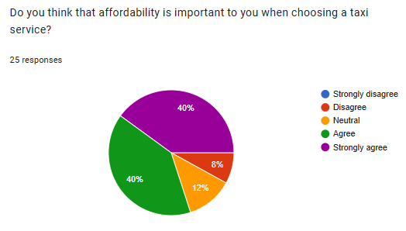
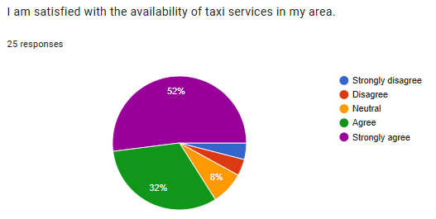
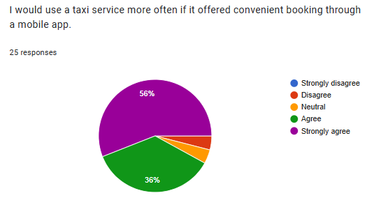

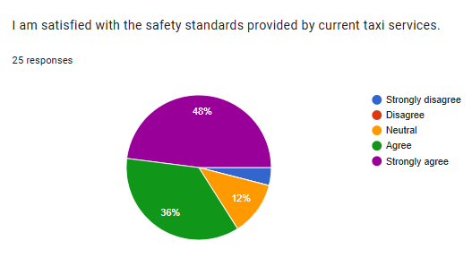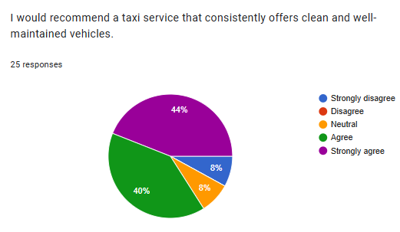

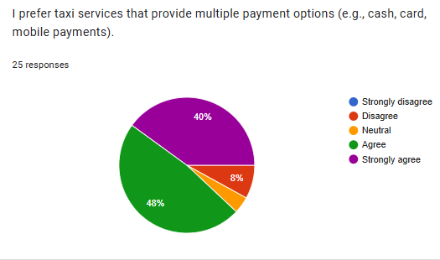
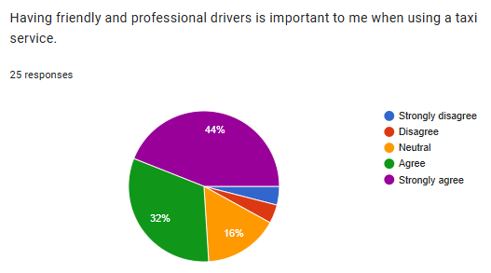
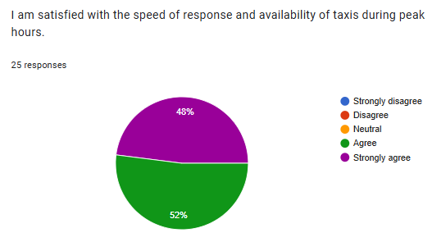
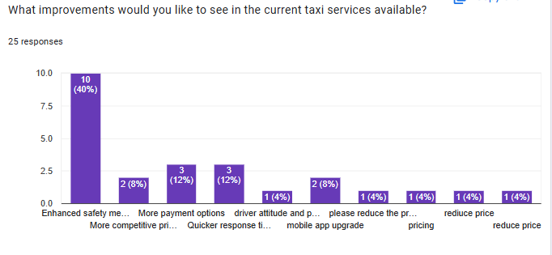

Analysis of Questions

The survey outcome shows that there is high concern by the respondents for the affordability of the taxi service while choosing which of the taxi services to choose. As 40% agreed and the other 40% were strongly agreed, it raises the conclusion that 80% of the respondent rate value for money as part of their selection criteria. Consequently, this gives an insight that price is one among the criteria that determine loyalty and preference of consumers in such a competitive taxi business. Those that stayed neutral at 12% may suggest some mixed reaction to pricing, wherein although affordability is important, the quality of service offered or convenience is equally so. The 8 percent that do not agree in that such attribute is important may show how such groups would rather pay for superior services or comfort.
Therefore, such outcomes will be essential for the Swift Ride Company to implement competitive pricing policies to capture the attention of the market and sustained customer stakeholders. By providing price affordability, the business would be in a good position in this market by offering tiered options or limited-time promotions and discounts in their marketing to appeal primarily to these common concerns in the target population (Kienzler and Kowalkowski, 2017; Anderson and Fox, 2019).
The survey findings focused on the friendliness and professionalism of the drivers as some of the necessary factors, demonstrate a customers’ desire for quality service in the taxis business. While 44% of respondents strongly agreed, and 32% agreed, 76% of participants select a taxi service based on the courtesy and professionalism of drivers. This trend suggests that the experiences of customers largely depend on the engagements that passengers have with drivers (Wu et al. 2024). The fact that 90% of the respondents emphasised friendliness and professionalism of the staff and services as important factors approving the importance of these qualities for customer engagement. Other passengers will also be relieved and safe when drivers who exhibit friendly attitudes welcome them. This can lead to word of mouth recommendation and repeat purchase which are key drivers for the success of a taxi service (Boninsegni et al 2020).
On the contrary 16% of the respondents showed their neutral tendency by agreeing to the part that there are interactions occurring between drivers and they still do not see and other facets like cost or accessibility having an influence in their choice they are making. Thus, the small percentage of those who disagreed might mean that there is another target audience, which is indifferent to driver quality, but values other factors, such as speed or the state of the vehicle. Therefore, the study recommends that more resources be channeled to training the drivers to provide better customer service and professionalism for the passengers.
Based on an analysis of the results from the surveys on areas to be improved in the current taxi services, some key areas that need a priority focus for customer satisfaction and quality of service are that there is a need to improve safety, which took the top spot at 40%. Such a high demand for safety is an indication of public awareness and concern over security while traveling, especially following recent events in the world. It means that their safety needs to be secured as a customer before even hiring taxi service companies. In the secondary preferred change, 8% named competitive pricing as essential, showing that while price must be right for so many consumers, it stands on second position after concern in relation to safety matters. This knowledge gives the feeling that competitive pricing could attract more customers and should be weighed against strong safety protocols (Nagle and Müller, 2017).
Moreover, 12% were interested in faster response times too, which indicates that they need efficiency in delivering the service. In a fast-moving environment, customers need quick service and less wait time. An 8% interest rate in mobile app updates indicates a trend toward digital solutions, and this would require easier booking and payment. Other responses, which concentrate on the attitude of the driver and lower prices, tend to agree that customer service and value for money are important factors in retention. Collectively, these findings indicate that the taxi company should work on improving safety, making services more efficient, and possibly investing in digital platforms to ensure it meets customer expectations and raises the overall quality of the service.

Task 2: Website and Marketing Materials

Segmentation
Segmentation | Evaluation
Demographic | • The primary demographic identified includes individuals aged 18-45, primarily working professionals, students, and budget-conscious travelers.  • 80% of respondents value affordability, indicating the need for competitive pricing options to retain and attract customers. Offering tiered options, promotions, and discounts could appeal to this segment.
Psychographic | • Respondents show a strong preference for friendly and professional drivers, with 76% prioritizing driver courtesy. This suggests that service quality, including driver attitude and professionalism, is critical in building customer loyalty and driving positive word-of-mouth.  • Additionally, there is an interest in environmentally friendly practices, which aligns with opportunities to market eco-friendly or hybrid vehicle options (Justitia et al., 2019).
Behavioral | • There is a clear demand for fast, reliable service, with many customers valuing rapid response times.  • Loyalty programs and discounts for frequent users appeal to respondents, indicating a desire for incentives that reward regular usage, such as student or commuter packages.
Geographic | • The data suggests targeting densely populated urban and suburban areas, especially near business hubs, universities, and transit centers, where the demand for convenient and affordable transportation is high.  • Marketing efforts could also focus on areas with a high concentration of young professionals and students, who prioritize value for money.
Safety and Digital Features | • 40% of respondents prioritize safety, highlighting the need to showcase strong safety protocols and driver training in marketing materials.  • Additionally, an 8% interest in mobile app features indicates a trend toward digital solutions, suggesting the need for a user-friendly app with streamlined booking, tracking, and payment options to enhance customer convenience and satisfaction (Iamtrakul and Wongbumru, 2019).

Swift Ride Taxi Company can create specific marketing strategies to successfully interact with each recognized customer segment by using these segmentation insights. Marketing strategies may involve targeted advertising on social media platforms that reach out to colleges. It also offers special deals designed for students as well as travelers on a budget.
Swift Ride could provide varied pricing options such as seasonal deals that cater to budget-conscious customers looking for worth (Arbatani et al., 2020).

Targeting
Swift Ride can design specific marketing strategies that reach all the targeted group of customers. Cost effectiveness remains an essential criterion for most targeted customers in choosing a low-cost taxi service. Company can use strategic advertisement on various social media platforms for efficient reach of such target market. Such strategies assist the company to reach colleges to offer special advertisements (Chandratreya and Kulkarni, 2024). Various pricing strategy such as season passes for commuters can attract those customers who are always on the lookout for discount. Customer experience has to be improved through a customer-centric mobile application that should enable booking and payment processes easy (Gu et al., 2024). Surveys show that if the taxi service mobile application facilitates booking then the services would be used more. Implementing a customer reward system with perks for frequent use may enhance customer loyalty even more. Swift Ride can craft a strong brand narrative to being cost effective that highlights dependability, environmentally-friendly choices and safety (Iamtrakul and Wongbumru, 2019). It is important to create a blog that discusses the company's dedication to safety measures and driver professionalism. It also helps in highlighting eco-friendly efforts and attract individuals who focused on sustainable practices. Swift Ride can increase its attractiveness by presenting eco-friendly vehicles to customers who care about the environment. The main focus market includes people between the ages of 18 and 45 (Justitia et al., 2019). This age group incorporate professionals, students as well as environmentally aware shoppers. This group of people looks for affordable solutions which favors online availability. The company can establish a brand that strongly connects with these ideals by matching Swift Ride's services with the priorities outlined in the survey (Kim et al., 2020).

SEO
Swift Ride Taxi Company can improve online presence through optimizing SEO. It also help the company in order to appeal to the appropriate audience. This can be done by prioritizing primary keywords along with secondary keywords during integration process. Furthermore, it is important to integrate long-tail keywords strategically on the website. Such keywords can be added in headings, Meta descriptions, Meta title and image captions in order to optimize SEO (Liquori et al., 2020). It is essential to add keywords in Meta description and heading of blogs which can help to attract the desired audience. It also guarantees that each page features have a concise as well as informative title.
Moreover, it is crucial to optimize Google business profile of Swift Ride's for local SEO. Along with this, it is crucial to incorporate precise business details and high quality images (Papagiannis, 2020). Customer feedback can also be included to enhance visibility in local search outcomes. By including location-specific keywords guarantees that prospective clients can be able to discover their taxi services when looking for nearby transportation options. It is also important to ensure uniformity in name, contact number and address on the website and other local directories. This thing helps in establishing credibility with search engines as well as users (Psaraftis et al., 2024). Meta description for each page should briefly explain the content which include several keywords which shows that the company is providing budget-friendly with skilled drivers. This approach help the business in order to enhance search rankings (Siyal et al., 2021).
More than that, it is essential to link important pages such as service, about us and contact information that can helps in enhancing the user-friendly navigation on the website. It is crucial to use content strategy for Swift Ride to draw in potential customers by creating blog posts about relevant subjects. The website content should be created to showcase the various locations served by Swift Ride (Chandratreya and Kulkarni, 2024). It also has a separate sections for key features that can assist in enhancing SEO efforts. In addition, SEO efforts can also be improved by interacting customers by displaying positive feedback social media platforms. Swift Ride Taxi Company can also be promoted by utilizing various social media platforms.
Along with this, visibility can be increased by incorporating multiple hashtags to draw in a wider range of viewers. The company can track its operations using Google analytical tools. Swift Ride can refine its SEO strategy based on website traffic, user behaviour and keyword performance. This can result in better search rankings that facilitate customer engagement (Kim et al., 2020). The company should technically optimize the website for mobile because most of the customers use their cell phones to book drives. It is also crucial that the website has a responsive design and fast loading speed because these factors are important for enhancing user experience. With the implementation of structured data, search engines may better help present Swift Ride's business information correctly in the results of searches (Siyal et al., 2021).

Webpages Designed
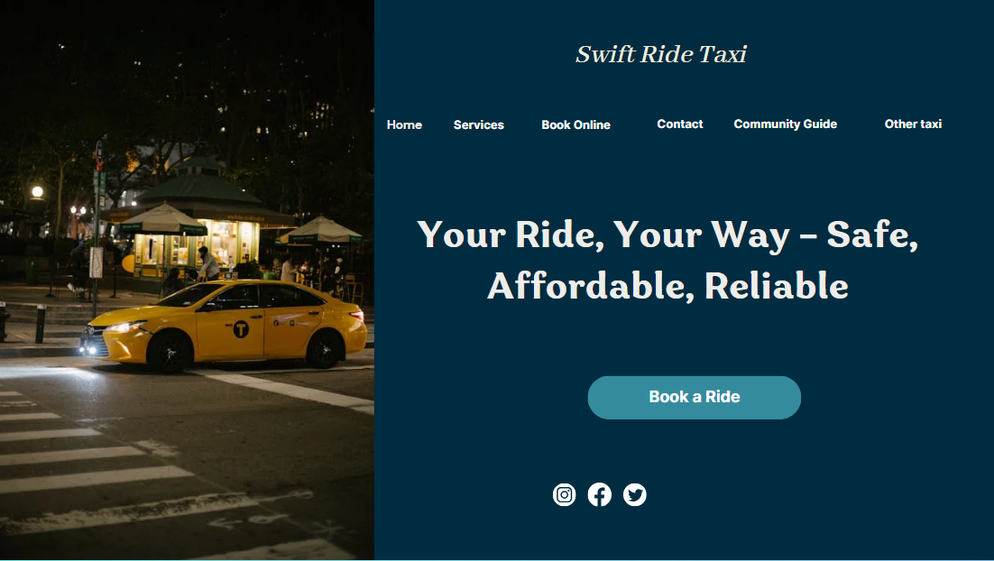
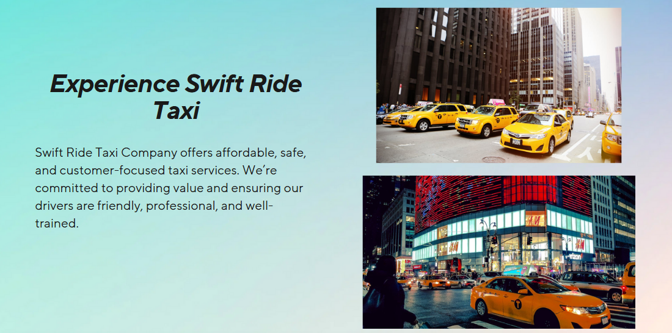


Marketing Materials Created
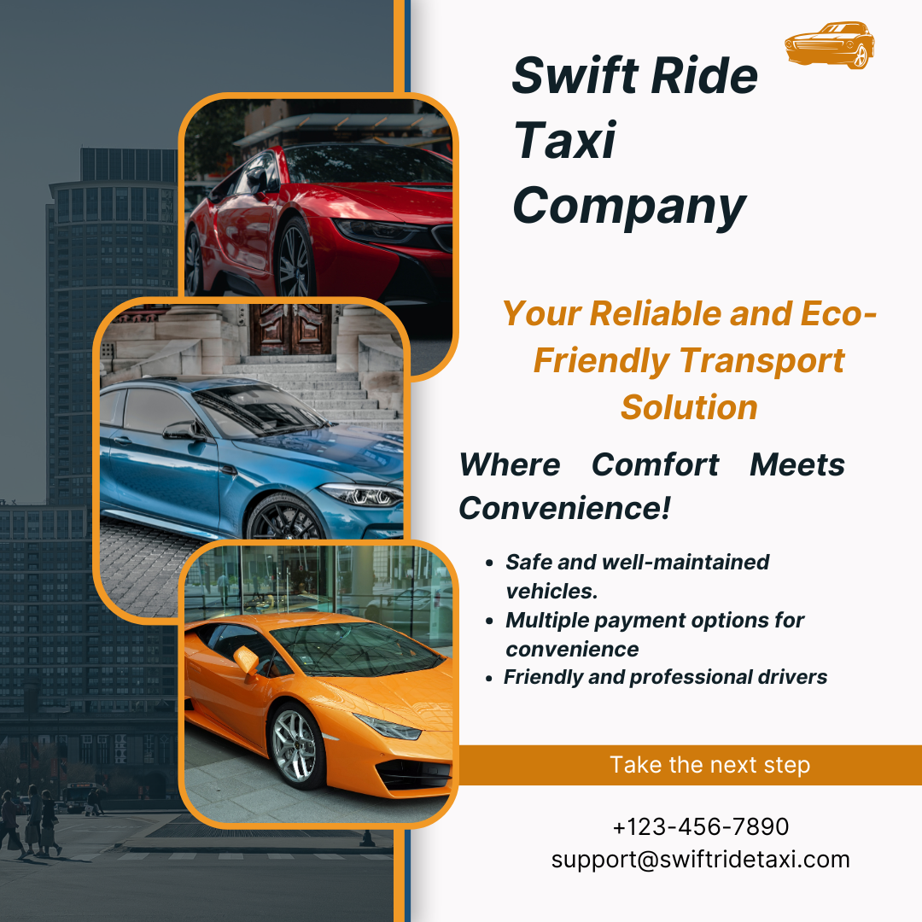

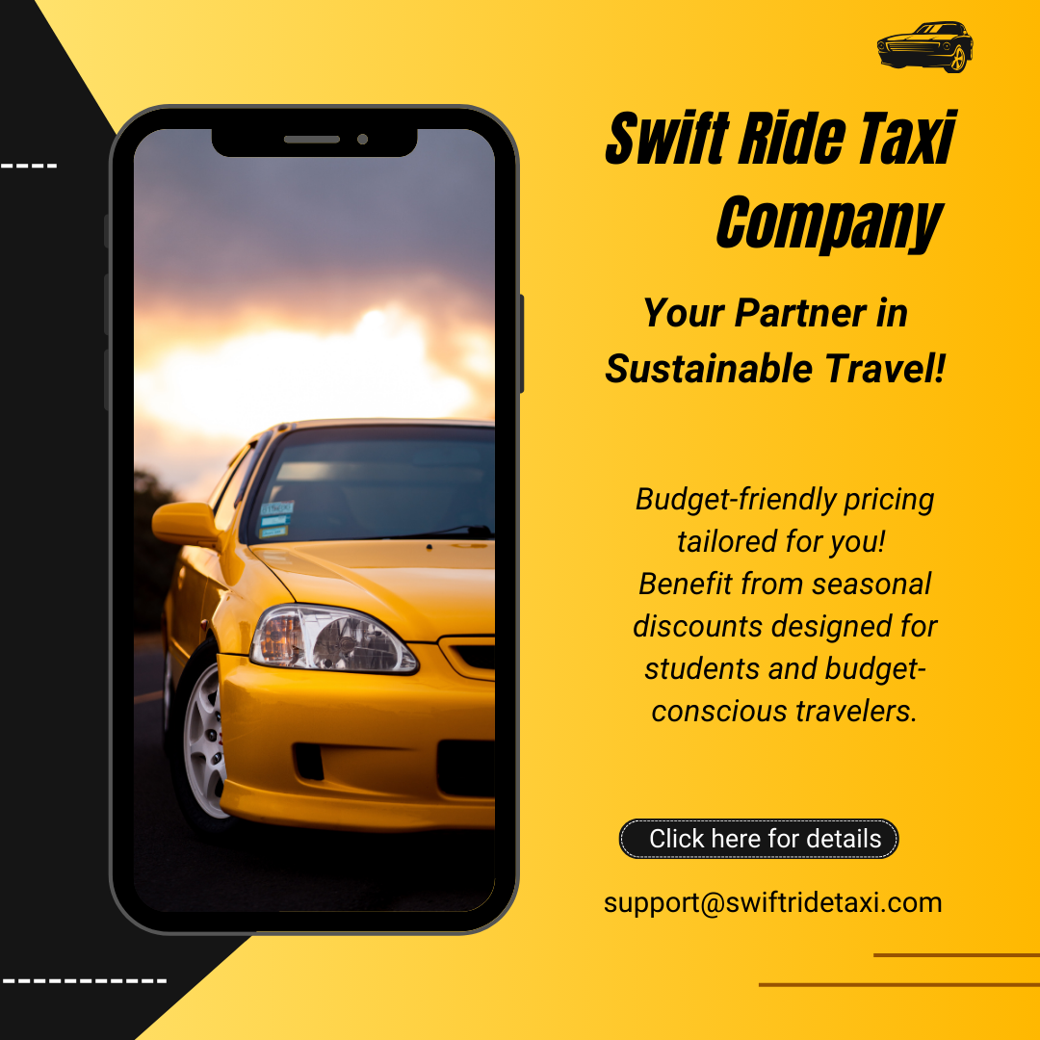
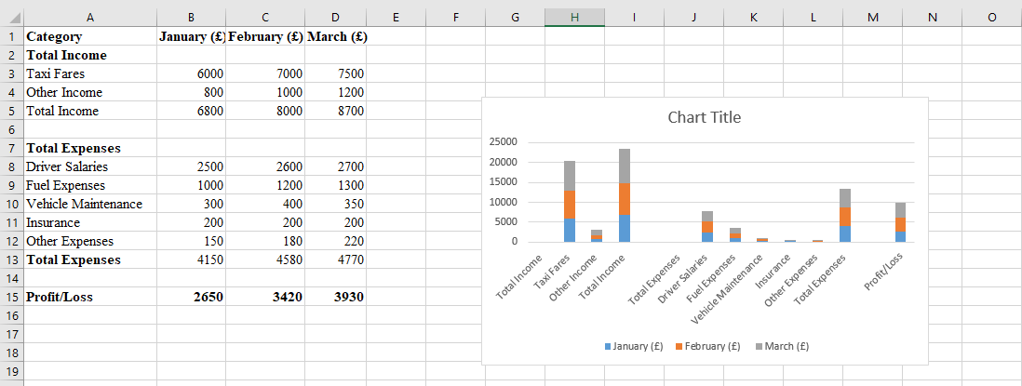

Task 3: Microsoft Excel
Microsoft Excel has become one of the most important tools in the current world that is full of a large quantity of information. Therefore, its importance is not just restricted to modern calculations or simple data storage; today it is core part of data management, analysis and reporting solution. Excel enables users to analyze data, automate activities, improve efficiency, and hence become an essential tool in today’s technologically advanced society (Akpan, 2024).
Data Management and Organization
Another big plus of Excel is the possibility to sort and analyze the data quickly and easily. When information is deemed as the new gold, then processing data efficiently is incredibly pivotal. This makes it possible for users of Excel to regulate large frameworks of data that can fit into the structured excel spreadsheets. The program has a grid format which combined with the sorting and filtering functions that allow the user to sort and find the data quickly and effectively (Sharma and Barua, 2023). This organization is essential for organizations that require records of stocks, sales, customers and virtually everything.
Data Analysis and Insights
Excel is well endowed with tools and functions that make it easier to analyze data in ways that are hard to come by with some other software. It is possible to use regulations and procedures like formulas & functions in the analysis of large or small amounts of data, trends, and patterns. Tools such as VLOOKUP or pivot tables and charts help people analyze large sets of data to reach specific conclusions (Aqlan et al. 2020). For example, in doing business it is easier to measure and track the trends in sales over a certain period or to determine customer habits, or to study the business results, in other words to make decisions based on the available materials. In such situation, in complex and competitive environments, the ability to make rapid analyses and conclusions may add great competitive advantage to the organization. In addition, the fact that Excel is compatible with other data sources improves its analytics (Alshehhi et al. 2018).
Reporting and Visualization
Analysis of data is a critical process as much as the presentation of data in reports. Reporting and visualization are of Excel; where users are able to generate good looking reports and dashboard. In charts, graphs, and conditional formatting tools aid users in how they present the findings where apparently large amounts of information may not be easily understandable by the users. Specifically it is stated that, in the information age, more important than ever is the commutation of data (Lohani, 2023). Business firms when preparing reports to be presented to their stakeholders in a unique and effective ways can use these forms of visual aids. In addition, organizations in Excel have been in a position to create templates to customize their reporting techniques for standard setting.
Collaboration and Sharing
The trend in the digital age is that anyone who wants to succeed needs to collaborate. Excel offers numerous features that makes it possible to apply in teams and collaboration. With cloud facilities like Microsoft 365, people can share Excel files, and many can have access to and edit documents at the same time. This capability facilitates communication and makes it easy to align the members of the team (Rosener, 2024). Further, version control is another aspect that enables you track change thus making it easier for teamwork. Its collaboration function is also enriched by the possibility to protect spreadsheets by a password and permissions.
Versatility across Industries
Another reason that makes Excel so critical in the modern world and business is its flexibility. This method of project delivery lies across finance, marketing, education, health, and logistics industries. In finance, people apply Excel for calculations, planning, and modeling on the financial indicators. Excel is used mainly for data analysis for campaign and customers. In education, both teachers and students solve grade calculations and perform data analysis using Excel (Damjanovic and Katanic, 2023). This versatility is reassuring and makes sure that Excel will always be applicable, across any business field, thus cementing its role as one of the core tools of the modern digital businessperson.
Conclusion
Furthermore, Microsoft Excel has become an established essential tool in the modern digital age. This is why it is important for organisation competing to contest in the contemporary and fast growing data oriented world. With the increase of the use of technology in businesses, the skills of performing operations in excel not only improve the efficiency of the individual but also increase the effectiveness of organizations.

Task 4: Video

https://youtu.be/4PkIWjrA45g?si=Sy1WGdfgd0xPwchx

Slide 1: Title
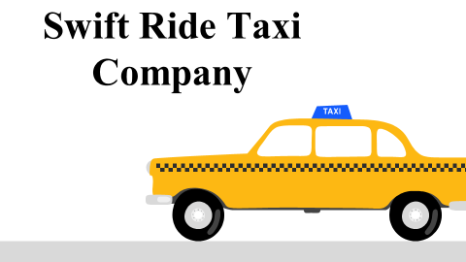
Slide 2: Introduction
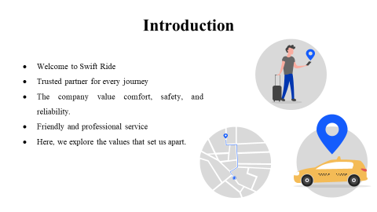
In this presentation, we shall introduce Swift Ride Company as a leading taxi service devoted to delivering topnotch travel experiences. Here we will talk about how our commitment to comfort, safety, and reliability through professional service by drivers gives a reason to feel you have chosen the best.
Slide 3: About the Brand
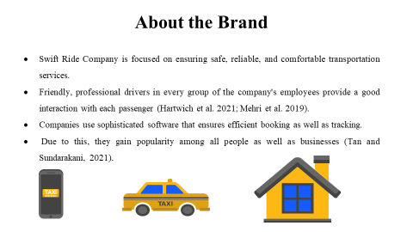
Swift Ride is different from the rest of the taxi companies as it strives hard to satisfy the customers. They are very keen on safety and comfort while selecting professional drivers who are well-trained to provide better services. They make sure every ride is smooth with their easy-to-use app and quick response.
Slide 4: Customer-Centric Approach
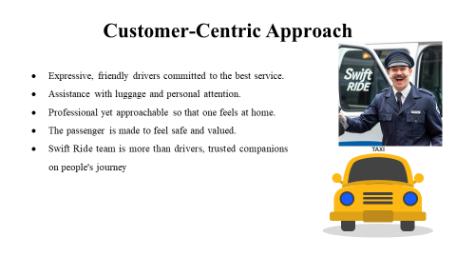
Swift Ride is a customer-centric company; its drivers are the hearts. Here is the professional service with warm personal treatment-from the handling of luggage to the pleasant conversations. And hence, every passenger feels just fine and valued, and therefore, every ride is not only positive but also a good memory.
Slide 5: Call to Action
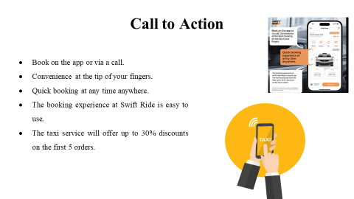
Swift Ride allows booking of a ride with absolute ease and speed. Customers can book a taxi at Swift Ride in seconds and even call them directly to book a ride. Convenience is the core of designing their platform, and any ride begins with ease in their platform. Download this app or contact Swift Ride right now to feel the change.

Slide 6: References
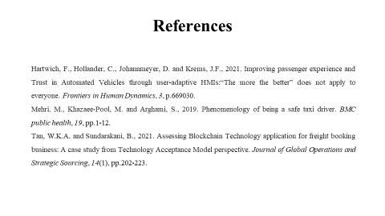
Hartwich, F., Hollander, C., Johannmeyer, D. and Krems, J.F., 2021. Improving passenger experience and Trust in Automated Vehicles through user-adaptive HMIs:“The more the better” does not apply to everyone. Frontiers in Human Dynamics, 3, p.669030.
Mehri, M., Khazaee-Pool, M. and Arghami, S., 2019. Phenomenology of being a safe taxi driver. BMC public health, 19, pp.1-12.
Tan, W.K.A. and Sundarakani, B., 2021. Assessing Blockchain Technology application for freight booking business: A case study from Technology Acceptance Model perspective. Journal of Global Operations and Strategic Sourcing, 14(1), pp.202-223.

References

Akpan, D.M., 2024. Excel: VLOOKUP, Pivot Tables and SQL. In Future-Proof Accounting: Data and Technology Strategies (pp. 95-127). Emerald Publishing Limited.
Alshehhi, A., Nobanee, H. and Khare, N., 2018. The impact of sustainability practices on corporate financial performance: Literature trends and future research potential. Sustainability, 10(2), p.494.
Anderson, E.T. and Fox, E.J., 2019. How price promotions work: A review of practice and theory. Handbook of the Economics of Marketing, 1, pp.497-552.
Angus, A. and Westbrook, G., 2019. Top 10 global consumer trends. Euromonitor International: London, UK.
Appah, E., 2018. Strategies taxicab owners use to sustain their operations in a competitive environment (Doctoral dissertation, Walden University).
Aqlan, F., Nwokeji, J.C. and Shamsan, A., 2020, October. Teaching an introductory data analytics course using microsoft access® and excel®. In 2020 IEEE Frontiers in Education Conference (FIE) (pp. 1-10). IEEE.
Arbatani, T.R., Norouzi, E., Omidi, A. and Valero-Pastor, J.M., 2021. Competitive strategies of mobile applications in online taxi services: The cases of Snapp and Tap30 in Iran. International Journal of Emerging Markets, 16(1), pp.113-130.
Boninsegni, M.F., Furrer, O. and Mattila, A.S., 2020. Dimensionality of frontline employee friendliness in service encounters. Journal of Service Management, 32(3), pp.346-382.
Chandratreya, A. and Kulkarni, M.P., 2024. Innovations and Challenges in Managing Cab Aggregators.
Damjanovic, S. and Katanic, P., 2023. Employing microsoft excel for enhanced mathematical and statistical online pedagogy in economics amidst a pandemic. Education Science and Management, 1(2), pp.58-72.
Gu, T., Xu, W., Shi, P., Wang, R. and Kim, I., 2024. Taxi in competition with online car-hailing drivers: Policy implication to operating strategies. Multimodal Transportation, 3(2), p.100129.
Hartwich, F., Hollander, C., Johannmeyer, D. and Krems, J.F., 2021. Improving passenger experience and Trust in Automated Vehicles through user-adaptive HMIs:“The more the better” does not apply to everyone. Frontiers in Human Dynamics, 3, p.669030.
Iamtrakul, P. and Wongbumru, T., 2019, December. Exploring eco-friendly travel towards sustainable water transport in Bangkok. In IOP Conference Series: Earth and Environmental Science (Vol. 398, No. 1, p. 012014). IOP Publishing.
Justitia, A., Semiati, R. and Ayuvinda, N.R., 2019. Customer satisfaction analysis of online taxi mobile apps. Journal of information systems engineering and business intelligence, 5(1), pp.85-92.
Kienzler, M. and Kowalkowski, C., 2017. Pricing strategy: A review of 22 years of marketing research. Journal of Business Research, 78, pp.101-110.
Kim, S., Chang, J.J.E., Park, H.H., Song, S.U., Cha, C.B., Kim, J.W. and Kang, N., 2020. Autonomous taxi service design and user experience. International Journal of Human–Computer Interaction, 36(5), pp.429-448.
Liquori, S.S.M.A., 2020. Strategies in dealing with online taxi invasion to the local companies’ offline minibus taxi: a case study of local offline taxi companies in Yogyakarta, Indonesia. Russian Journal of Agricultural and Socio-Economic Sciences, 98(2), pp.76-84.
Lohani, S.K., 2023. Excel for Finance and Accounting: Learn how to optimize Excel formulas and functions for financial analysis (English Edition). BPB Publications.
Mehri, M., Khazaee-Pool, M. and Arghami, S., 2019. Phenomenology of being a safe taxi driver. BMC public health, 19, pp.1-12.
Nagle, T.T. and Müller, G., 2017. The strategy and tactics of pricing: A guide to growing more profitably. Routledge.
Papagiannis, N., 2020. Effective SEO and content marketing: the ultimate guide for maximizing free web traffic. John Wiley & Sons.
Psaraftis, K., Ntalianis, K. and Mastorakis, N.E., 2024. Quality of experience oriented eco-friendly taxi-ride sharing recommendation framework. IEEE Access.
Rosener, W.J., 2024. Comparative Analysis of Google Sheets and Microsoft Excel: A Discussion Case in Spreadsheet Software. Journal of Cases on Information Technology (JCIT), 26(1), pp.1-21.
Sharma, P. and Barua, S., 2023. From data breach to data shield: the crucial role of big data analytics in modern cybersecurity strategies. International Journal of Information and Cybersecurity, 7(9), pp.31-59.
Siyal, A.W., Chen, H., Chen, G., Memon, M.M. and Binte, Z., 2021. Structural equation modeling and artificial neural networks approach to predict continued use of mobile taxi booking apps: the mediating role of hedonic motivation. Data Technologies and Applications, 55(3), pp.372-399.
Siyal, A.W., Hongzhuan, C. and Gang, C., 2021. From consumer satisfaction to recommendation of mobile app–based services: An overview of mobile taxi booking apps. Sage Open, 11(1), p.21582440211004179.
Tan, W.K.A. and Sundarakani, B., 2021. Assessing Blockchain Technology application for freight booking business: A case study from Technology Acceptance Model perspective. Journal of Global Operations and Strategic Sourcing, 14(1), pp.202-223.
Wu, H.C., Chen, S.X. and Wu, T.P., 2024. Exploring the drivers of experiential outcome intentions among driverless bus passengers. Research in Transportation Business & Management, 56, p.101165.

Appendix

Questionnaire

Do you think that affordability is important to you when choosing a taxi service?
- Strongly disagree
- Disagree
- Neutral
- Agree
- Strongly agree
I am satisfied with the availability of taxi services in my area.
- Strongly disagree
- Disagree
- Neutral
- Agree
- Strongly agree
I would use a taxi service more often if it offered convenient booking through a mobile app.
- Strongly disagree
- Disagree
- Neutral
- Agree
- Strongly agree
Having friendly and professional drivers is important to me when using a taxi service.
- Strongly disagree
- Disagree
- Neutral
- Agree
- Strongly agree
I am satisfied with the safety standards provided by current taxi services.
- Strongly disagree
- Disagree
- Neutral
- Agree
- Strongly agree
I would recommend a taxi service that consistently offers clean and well-maintained vehicles.
- Strongly disagree
- Disagree
- Neutral
- Agree
- Strongly agree
I prefer taxi services that provide multiple payment options (e.g., cash, card, mobile payments).
- Strongly disagree
- Disagree
- Neutral
- Agree
- Strongly agree
I am satisfied with the speed of response and availability of taxis during peak hours.
- Strongly disagree
- Disagree
- Neutral
- Agree
- Strongly agree
What improvements would you like to see in the current taxi services available?

