

Student name: | Leticia Reyes De Leon | Student ID number: | 2424430041
Programme: | Certificate of Higher Education in Business Skills for the Workplace
Module: | Problem Solving and Decision Making
Module code: | LCLM4004 | Contribution to  Overall Module Assessment (%): | 100%
Lecture Name: | Ferry Circus Charless Oham | Assessment Type | Presentation

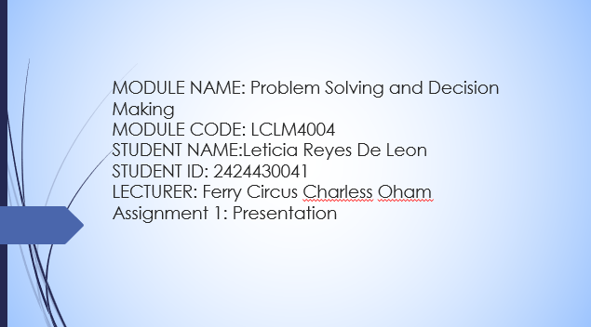

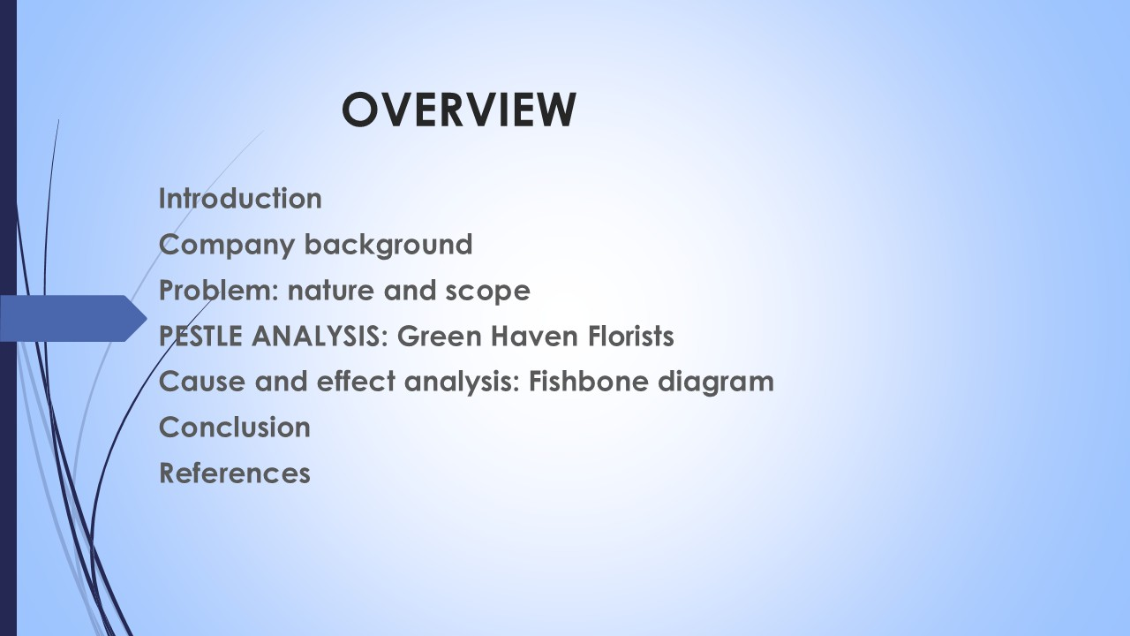
Table of Contents
Introduction 5
Company Background 6
Nature and Scope of the Problem. 7
PESTLE Analysis: Economic, Social. 9
PESTLE Analysis: Environmental, Legal, Technological. 11
Cause and Effect Analysis (Fishbone Diagram). 13
Conclusion. 15
References 16

Introduction
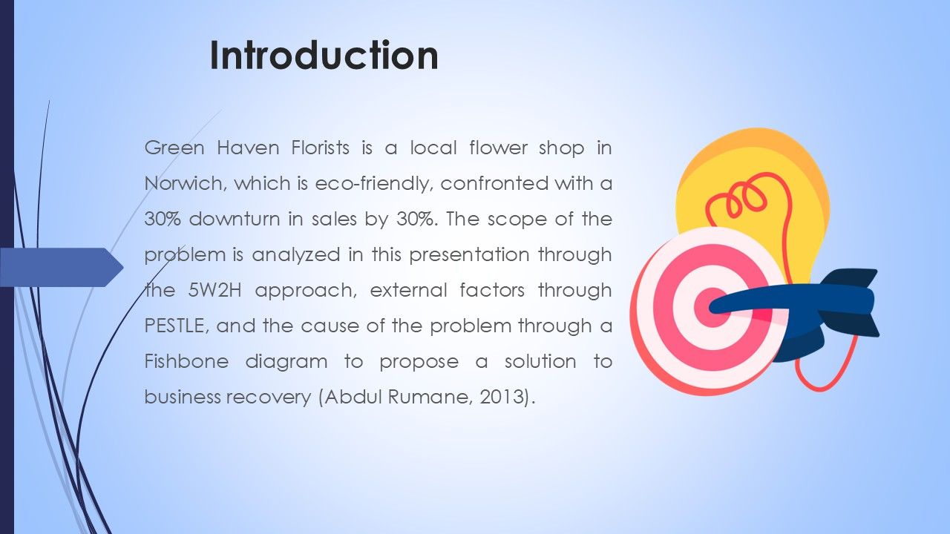
Green Haven Florists was established in 2016 by Liam and Priya Patel, and its brand was based on sustainability, creativity, and close ties to the community. The company gained momentum with local and corporate customers to create customized, eco-friendly floral arrangements (Abdul Razzak Rumane, 2013). Nevertheless, in the last year, the shop has seen the in-store sales reduce by a factor of 30. This has been occasioned by various factors such as heightened competition in the online arena, supply chain hiccup, inflation, and modified consumer behaviour in favour of online convenience. This presentation is going to discuss the nature, extent, and causes of this problem. I will apply three analytical tools, which include the 5W2H tool to state the issue of concern, a PESTLE analysis that will look at the external factors, and a Fishbone diagram that will look at the root causes of the problem. The objective is to come up with a detailed analysis of the problems Green Haven has and to propose knowledgeable and practical solutions of sustainable solutions.

Company Background
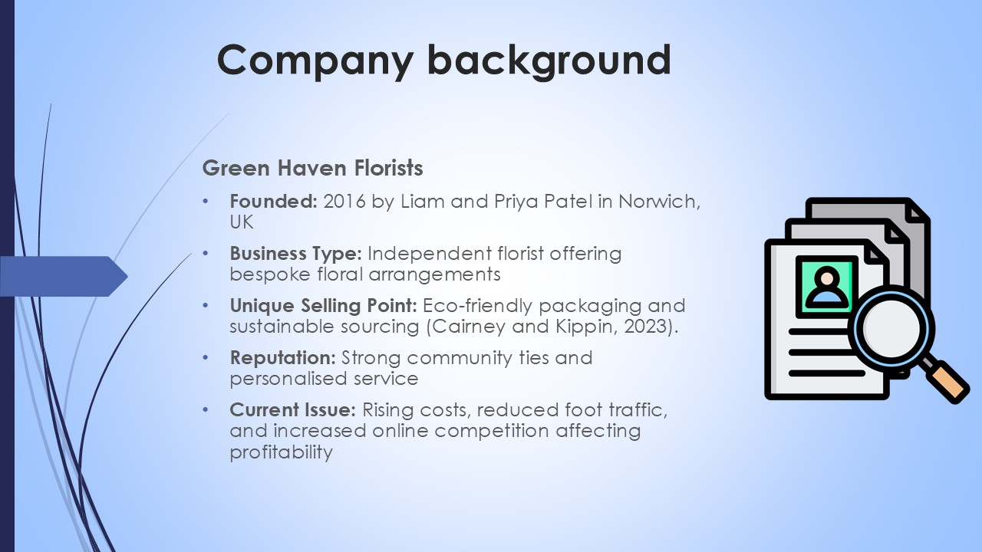
Green Haven Florists is a community-owned floral store that has the mission to provide the local community with the best sustainable floral products. It used to be a leader in the Norwich community due to its dedication to the use of biodegradable wrapping and the use of locally sourced flowers (Cairney and Kippin, 2023). At first, the store was prospering on word of mouth and returning clients due to weddings, parties, and company contracts. But the business environment has evolved at a very fast pace. The number of stores around it being shut down, rising inflation, and the prevalence of online delivery platforms have greatly decreased foot traffic. This has not compensated for the in-store revenue, although online orders have slightly increased. Moreover, the owners have been late in embracing digital marketing trends, where they predominantly use conventional techniques. Consequently, Green Haven Florists are now in dire need of modernizing their business model to survive in the digital age without losing their ethical and community-focused image.

Nature and Scope of the Problem.
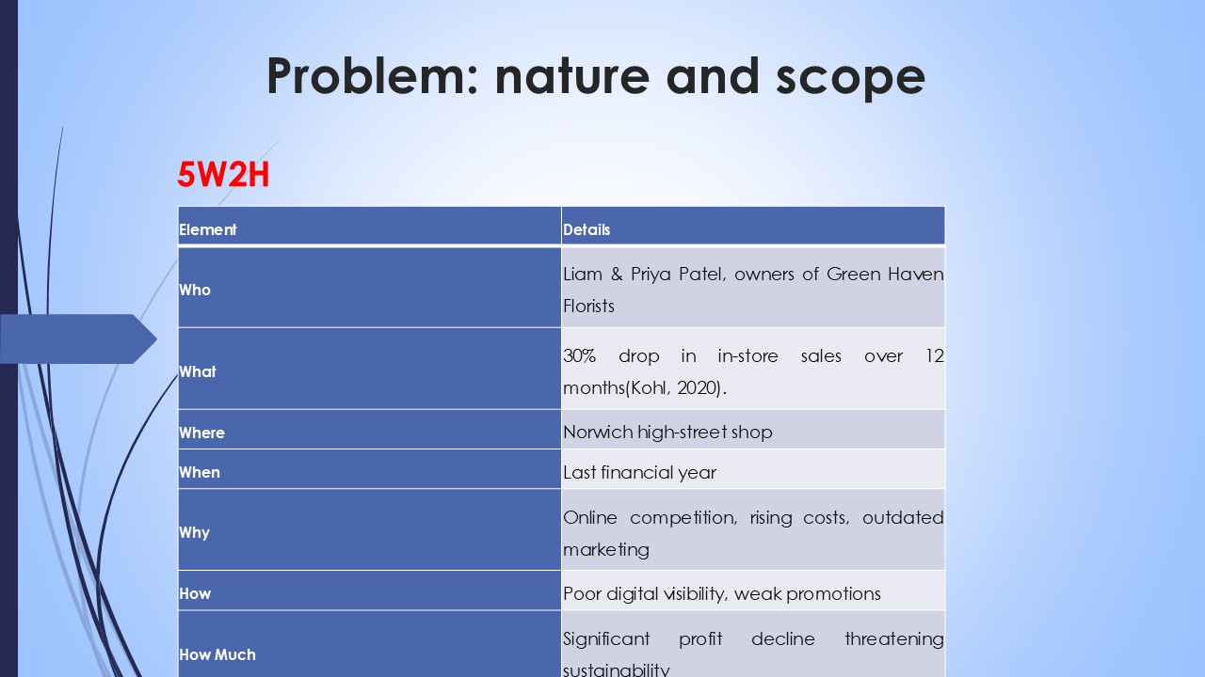
Green Haven Florists has experienced a decline of nearly a third of sales in the last year, which is a major operational and strategic issue. The essence of the problem is the decrease in in-store purchases related to the altered consumer preferences and the decrease in local activity. The area of the issue reaches financial, operational, and marketing levels. Lost revenues impact the cash flow, restrict reinvestment, and decrease the capacity of the owners to sustain sourcing. The physical location of the shop, which was originally beneficial, is no longer effective as the high street is in decline (Kohl, 2020). Discounts and same-day delivery by online rivals have pulled the legs of loyal customers. In addition, its internal capabilities, including a lack of digital marketing skills and the use of an old-fashioned site, have also minimized growth opportunities. This problem is not only about profitability, but it also affects brand reputation and long-term sustainability. To clearly see the complexity of this situation, the 5W2H tool is used next to make every element of the problem understandable on a systematic basis.
5W2H Analysis of the Problem.
Using the 5W2H approach, the Green Haven crisis can be explained clearly:
Who: The owners, Liam and Priya, along with the small team, are directly involved.
What: Sales will reduce by 30 percent, a threat to sustainability.
Where: The Norwich High Street location is currently showing low traffic of customers.
When: The decrease has been experienced in the last 12 months.
Why: A mix of digital rivalry, evolving customer behaviors, as well as financial pressures.
How: The shop has not been able to win new customers over the internet because it has a poor online presence and does not do a lot of advertising.
How much: Profits have declined dramatically, and the operational stability has been impacted.
Such a framework will affirm the fact that the problem is not only strategic but also operational; it is not merely a temporary loss of revenue, but rather an overall problem in the way the technology, marketing, and outside forces interact. This would need to be approached on the one hand through an internal digital upgrade and, on the other hand, by responding to the external market forces, which are discussed below in terms of PESTLE.

PESTLE Analysis: Economic, Social.
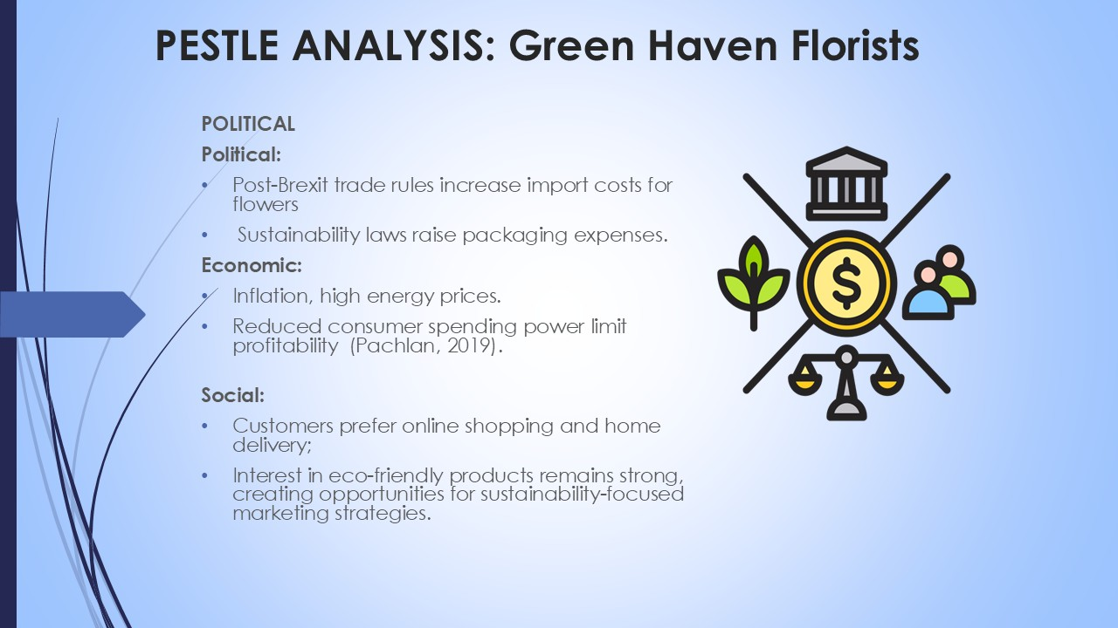
PESTLE analysis starts with Political, Economic, and Social forces that influence the environment of Green Haven:
- Political: The post-Brexit policies have added duties on imported flowers between the EU and highly exotic varieties, such as tulips. This increases the cost of procurement as well as constraining prices. The environmental laws also necessitate that sustainable packaging laws be adhered to, which raises the cost of operations.
- Economic: The inflation rate in the UK has decreased consumer spending capacity, and customers are price sensitive (Pachlan, 2019). The increase in rent, energy, and supplier prices has decreased profit margins. The local sourcing method used by the shop, although morally right, puts an additional strain on the finances.\
- Social: There is a change in the social behaviours of consumers moving to the digital concept of convenience- customers like to order their flowers online and enjoy the delivery and payment of the order. Nevertheless, sustainability is also becoming more popular, and this aspect fits well with the values of Green Haven, but should be communicated better via online platforms. These three aspects show that the retail floral business is being redefined by external forces that require innovation and online adjustments to be competitive.

PESTLE Analysis: Environmental, Legal, Technological.
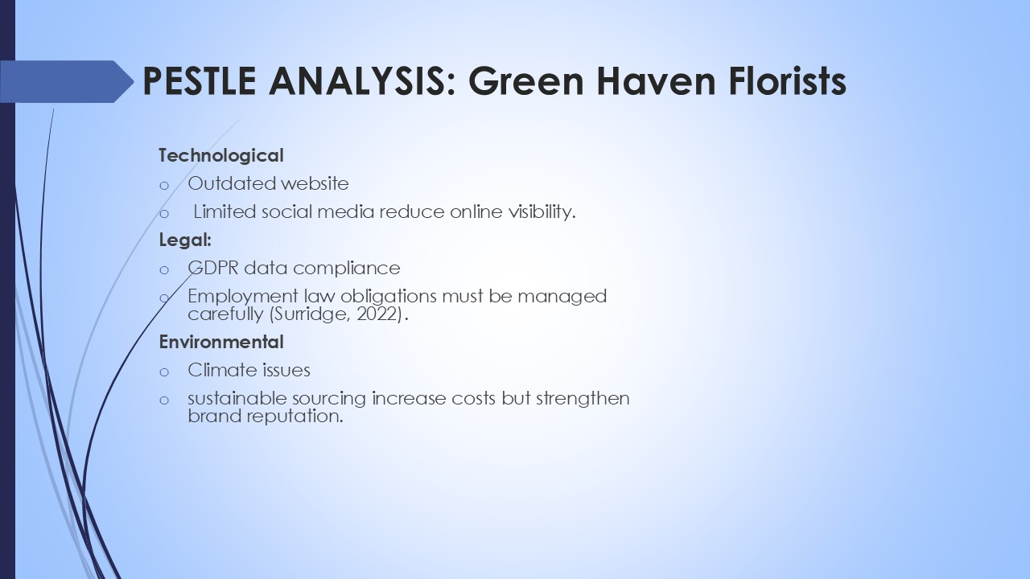
The other PESTLE forces also indicate the challenges of Green Haven Florists:
- Technological: The store has an old-fashioned webpage and does not have any contemporary e-commerce service, including Web-based payment portals, monitoring of order delivery, and mobile accessibility. This restrains customer convenience and online conversion. Rival companies, in their turn, leverage SEO, Instagram advertising, and subscriptions.
- Legal: The business should abide by the UK employment laws, which cover equal remuneration and safety in the workplace (Surridge, 2022). It also has to deal with GDPR requirements of customer data in extending online services. Any failure to do that might damage the reputation and result in financial fines.
- Environmental: The application of biodegradable wrapping and local sourcing in Green Haven is sustainable, but it is more expensive than the alternatives based on polymers. In addition, climate patterns are erratic changes that influence the availability and quality of the flowers.

Cause and Effect Analysis (Fishbone Diagram).
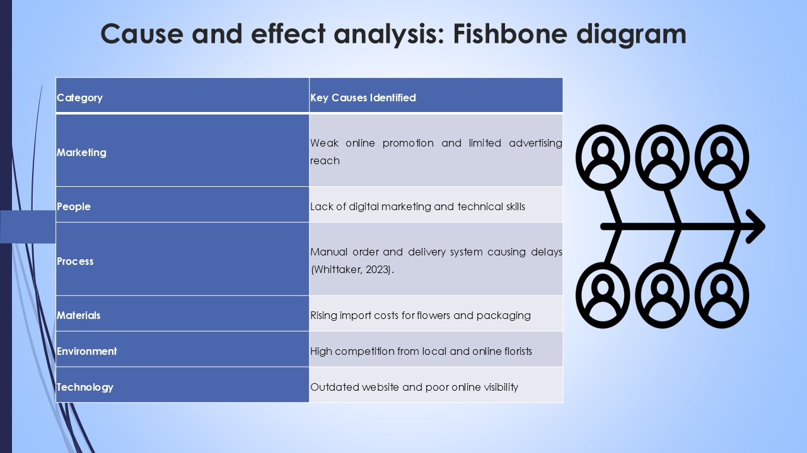
The Fishbone (Ishikawa) Diagram cites the root causes of dwindling sales in under six categories:
- Marketing: Green Haven has poor access to customers, which is caused by the use of traditional marketing and a low frequency of use of social media.
- People: They do not have sophisticated digital skills among the owners and staff, and they can manage fewer online systems or analytics (Whittaker, 2023).
- Process: Order and delivery management are a manual process, which limits efficiency and scale.
- Resources: The increasing prices of exotic flowers due to the rising import prices have put off repeat customers.
- Environment: The market pressure is high because there are two new entrants, one of which has a good social media presence, and another has low prices.
- Technology: The obsolete site compromises the ease of navigation and online shopping.
This discussion explains that the issue is multifaceted as it involves a concerted enhancement strategy in the marketing, e-capacity, and supply chain theatres. All of these factors should be considered together to regain growth and competitiveness
There is a decline in sales and increase in costs leading to very minimal profitability in the company. It does not have much money to reinvest in the business or even advertise. This renders it hazardous in the future since the company requires cash flow to maintain adequate stocks and also to handle peak seasons. Green Haven is also not seen as well by customers due to inefficiencies of the site. Customers who are loyal are shifting to other competitors that are more convenient and less expensive. Employees within the company can be demotivated when the jobs are threatened. The environmental-friendly image of the company is at risk too as the high cost gives the company an illusion of lack of competitiveness, although, sustainability measures are more pronounced. The combined issue demonstrates that Green Haven requires a digital upgrade that causes values and financial wellbeing to be balanced. The business may provide such changes or the brand might be depersonalized.

Conclusion.
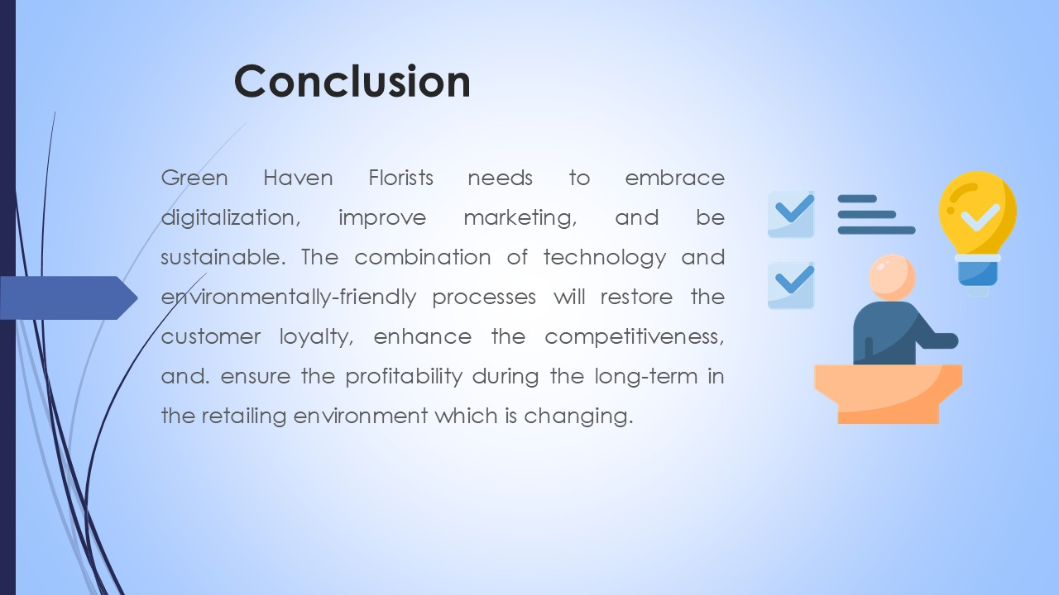
Green Haven Florists has numerous internal and external issues. The company that used to perform well has been harmed by inflation, the alterations of the desires of customers, and increased competition. Nevertheless, this research indicate that the issues can be solved through clever alterations. The firm is now able to proceed with an actual digital refurbishment, improved advertising, new collaborations, and employee development. It must always work towards purchasing in a sustainable manner and acting ethically, as this will make Green Haven stand out amidst the market saturation. It has allowed us to visualize the size of the problem and the reasons of its occurrence with the help of 5W2H, PESTLE, and Fishbone tools. The company will need to continue monitoring online performance and feedback to continue improvement in the future. The solution to clients of Green Haven Florists to be profitable once again and stronger in a shifting retail environment is aligning improved operations with its values of sustainability.

References

Abdul Razzak Rumane (2013). Quality Tools for Managing Construction Projects. CRC Press.
Cairney, P. and Kippin, S. (2023). Politics and Policy Making in the UK. Policy Press.
Coccia, M. (2020). Fishbone Diagram for Technological Analysis and Foresight. SSRN Electronic Journal, 14. doi:https://doi.org/10.2139/ssrn.3719084.
Kohl, H. (2020). Standards for management systems: a comprehensive guide to content, implementation tools, and certification schemes. Cham: Springer.
Pachlan, P.P. (2019). STRATEGY IMPROVES THE NUMBER OF NEW STUDENTS IN SEKOLAH MENENGAH ATAS NEGERI 1 GETASAN THROUGH ISHIKAWA DIAGRAM APPROACH (FISHBONE). Jurnal Pencerahan, 12(2), pp.56–64. Doi:https://doi.org/10.58762/jupen.v12i2.31.
Surridge, M. (2022). The business environment. 4th ed. London: Collins Educational.
Whittaker, N. (2023). Geopolitics and Identity in British Foreign Policy Discourse. Taylor & Francis.
Worthington, I. and Britton, C. (2023). Business Environment: a Global perspective. 9th ed. Pearson Education.



