

LOCATION: Swansea | LLEOLIAD: abertawe
LEVEL 4 | LEFEL 4
EXAMINATION PERIOD | CYFNOD ARHOLIADAU
MOCK 2 | MOCK 2

MODULE CODE: ACDA4013
Embedded C

TIME: 2 HOURS
ANSWER ALL QUESTIONS

Total Marks: 100

This exam does not allow the use of reference materials, scraps of paper, online resources, or observing any practice sessions.

- Equipment or materials required – PC running CAD software or Pencil/Ruler/Paper
- Use the Answer Sheet to respond to theoretical questions, including topics like working principles, operation, circuit diagrams, purpose, etc. Screenshots of schematic circuits, code, and simulation results should be included in a separate MS Word document.
- Save the name of the word Document in this pattern ‘Exam_studentname_studentid’ and upload the file in Moodle.
- Please note that only submissions uploaded during the official exam window, with an additional 10 minutes provided if needed, will be accepted.

QUESTION 1
Design a circuit using the PIC16F877A microcontroller where each pin of PORTD is connected to an LED with a 100Ω current-limiting resistor. Additionally, connect a push button to the second pin of PORTC. The circuit should perform the following functions:
- When the switch is pressed, all LEDs on PORTB should be turned ON.
- When the switch is released, all LEDs should turn OFF.
The project should include the following components:
- Design the circuit using simulation software. [10 Marks]
- Write a C program to accomplish the specified counting task. [10 Marks]
- Execute the simulation to verify the operation of the circuit and program. [5 Marks]
QUESTION 2
Demonstrate an up-down counter using 7- Segment Display by considering the following conditions.
- When a push button is connected to port pin RC0 is pressed once, the 7 segments should count up from 1 to 9 within a delay of 100ms.
- When a push button is connected to port pin RC7 is pressed once, the 7 segments should count down from 9 to 1 within a delay of 100ms.
- The counter should stop counting when the button is released.

Consider Common Anode 7- Segment display using the hex values given below.
0 | 1 | 2 | 3 | 4 | 5 | 6 | 7 | 8 | 9
0XC0 | 0XF9 | 0XA4 | 0XB0 | 0X99 | 0X92 | 0X82 | 0XF8 | 0X80 | 0X90

The project should include the following components:
- Design the circuit using simulation software. [10 Marks]
- Write a C program to accomplish the specified counting task. [10 Marks]
- Execute the simulation to verify the operation of the circuit and program. [5 Marks]
QUESTION 3
- The circuit shown below has been made available to you on Moodle, named ‘Question 3’,
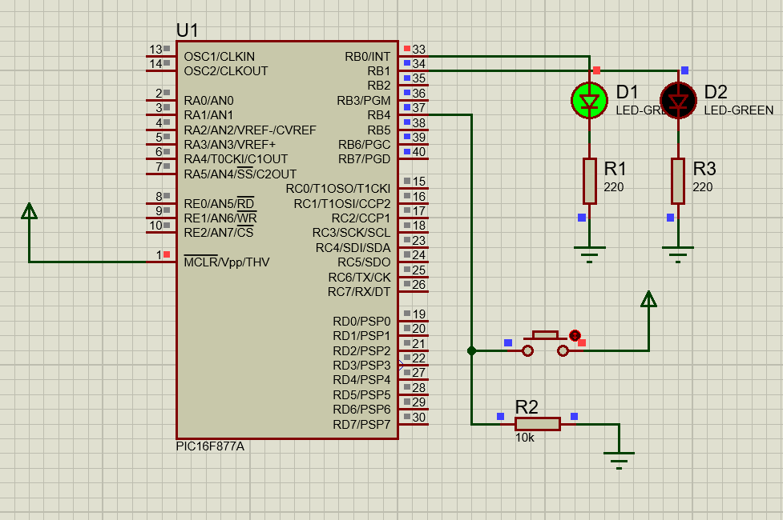
Simulate the provided Proteus circuit file on Moodle. Observe its behaviour when the push button is pressed. Identify the sequence and logic of operation of the LEDs. Then, Answer the following questions.
Then, Answer the following questions.
- Based on your understanding from the simulation:
- Write a CCS C program that exactly replicates the working of the circuit. [13 Marks]
- Briefly explain:
- What happens when the button is pressed? [4 Marks]
- How are the LEDs controlled using PORTB and the button using PORTD? [4 Marks]
- What is the role of RD0 in input detection and logic control? [4 Marks]
QUESTION 4
Below is the given Program
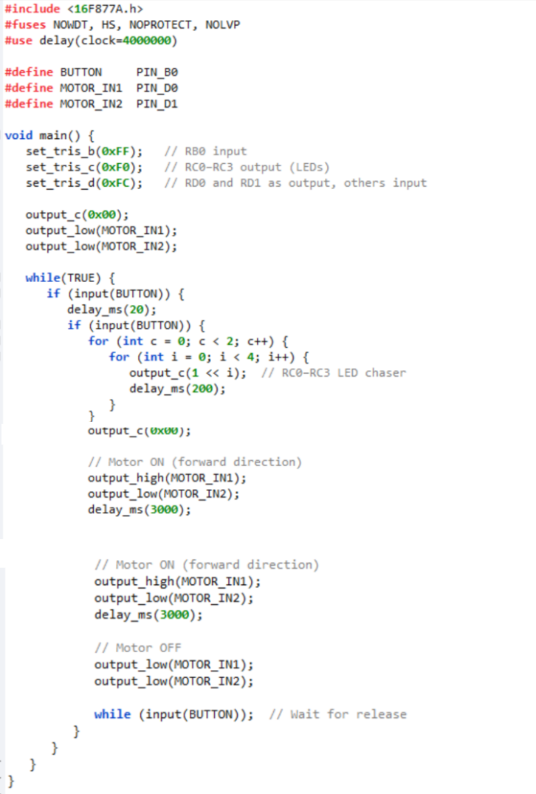
Answer the Following
      - Identify and describe the operation performed by the program when executed.
[5 Marks]
      - Based on your understanding of the program, design a circuit schematic that would support its functionality. [5 Marks]
      - Write and run the program in a simulation environment. Submit the program and provide a screenshot of the simulated circuit. [5 Marks]
      - What does the set_tris_c(0xF0) instruction indicate regarding PORTC configuration? [5 Marks]
      - Explain how the LED chaser effect is achieved using PORTC in the program. [2 Marks]
      - What issues may arise if the button input is connected without an appropriate pull-down resistor? [3 Marks]

Diwedd/End

