

Applied Leadership and Management in the Workplace

Module Assignment Submission

Student Name | Hayley James
Student number | 2420251
Module No: | BMSK4011
Module Title: | Continuous Professional Development

Statement of Authenticity

I have used permitted AI sanctions for this assignment; please see appendices.

Contents
Applied Leadership and Management in the Workplace 1
Module Assignment Submission 1
Statement of Authenticity 1
I have used permitted AI sanctions for this assignment; please see appendices. 2
Contents 2
1. Introduction 3
2. Learning Styles and Approaches to Learning 4
3. Identifying Development Needs 6
4. Barriers to Learning and Overcoming Them 7
5. Learning and Development Opportunities 9
6. Support Mechanisms for Development 10
7. Development Plans 11
8. Employability Tools (CV & CPD) 12
9. Conclusion 13
10. References 14
11. Appendices 16
Professional Profile 29
Key Skills 29
Employment History 29
Volunteering 30
Education & Professional Qualifications 30
Professional Development 31
Achievements 31
Additional Information 31
References 31

1. Introduction

The objective of this assignment is to investigate and assess the abilities, knowledge, and techniques needed to promote professional and personal growth, with an emphasis on employability and workplace performance. People must not only recognise their areas of strength and growth in the competitive job sector of today, but also exhibit resilience, adaptability, and the ability to learn new things throughout their lives. As a result, this report will look at key aspects of development and learning, such as learning styles, identifying developmental needs, learning challenges, and methods for overcoming them.
Using established frameworks like the VARK and Honey and Mumford models, the subject of discussion will start by evaluating each team member's unique learning preferences and contrasting them with their own. The contribution of both formal and informal learning to professional development will also be explored. Following on this, the assignment will use techniques like skills audits and SWOT analysis to pinpoint areas that need improvement before assessing potential obstacles and possible solutions to guarantee ongoing progression.
After discussing the various learning opportunities and support systems that are accessible, such as training, mentorship, and workplace resources, I will share two Personal Development Plans (PDPs) which a team member and I created. To show suitability for work and future professional advancement, employability resources, including a customised CV and continuing professional development (CPD) record will be supplied.
By focussing on these themes, the assignment directly addresses the learning objectives of the module by raising knowledge about efficient working procedures, identifying individual strengths and areas for improvement, and setting career goals backed by a workable professional development plan.
By identifying learning styles, which improve comprehension of individual and team skills; evaluating development needs, which promotes personal growth; and offering employability tools and Personal Development Plans (PDPs), which set clear career goals and prepare for future advancement, this report meets the module objectives. Every section helps build the abilities, experience, and tactics required to function well and progress in one's career.

2. Learning Styles and Approaches to Learning
Individuals can improve their ability to learn, solve problems, and advance their careers by being aware of their own learning preferences. Despite the widespread usage of models such as VAK and Honey and Mumford's Learning Styles Questionnaire (1992), research cautions against strict use. According to Atlassian (2024), there is little proof that teaching only in a favoured manner enhances student performance. However, these resources continue to be helpful for introspection, assisting people in adjusting their education to the demands of the industry. Self-awareness in learning helps rent officers manage cases, evaluate policies, and communicate with tenants.
I used the VAK and Honey and Mumford models to evaluate my preferred methods of learning. According to my Honey and Mumford results, I strongly preferred being a Reflector (18 points), while Theorist (14) and Pragmatist (12) had intermediate scores (Appendix 1). This implies that I learn best by watching, considering different viewpoints, and thinking things through before acting—a process that is consistent with going over housing laws and tenant case notes before making decisions. My Pragmatist and Theorist scores demonstrate a preference for organised, evidence-based methods, which are especially helpful when interpreting laws, as well as a willingness to apply theory when necessary. According to the VAK evaluation (Appendix 2), I am a visual learner who retains and analyses complicated housing data best when presented with written material, charts, and diagrams. This enhances my Reflector inclinations by allowing me to carefully consider my options before taking action.
A Pragmatist inclination for instant application and practical exploration was seen in a colleague's Honey and Mumford results. Although this differs from my Reflector approach, both approaches have merit: I guarantee careful planning and evaluation, while my colleague encourages quick testing and implementation. Diverse methods to workplace learning promote resilience, adaptability, and productive teamwork, according to CIPD (2021).
Even though there is disagreement on learning styles, understanding preferences might increase productivity at work. According to Fergusson and van der Laan (2021), workers pick up knowledge via doing, observing, and working together. Training that caters to a variety of tastes, including textual materials for Reflectors and role-playing workshops for Pragmatists, encourages participation and retention. Additionally, it's critical to distinguish between official learning—such as compliance training and CIH qualifications—and informal learning—such as peer talks, shadowing, and reflection. The fall in informal learning during COVID-19 is noted by the OECD (2021), highlighting its significance for professional resilience. While informal learning fosters problem-solving, communication, and negotiation abilities, formal schooling guarantees policy compliance for rent officers.
I methodically examined my learning experiences using Gibbs' Reflective Cycle (1988), considering what transpired, my feelings and thoughts, assessment, and action planning. According to Gibbs (1988), this insight assisted me in recognising circumstances that call for adaptation, such as urgent tenant instances that necessitate prompt action rather than thoughtful planning. I momentarily switch from visual/reflective to pragmatic and auditory approaches in these situations,
In conclusion, although there is no evidence to support prescriptive learning styles, using frameworks such as VAK and Honey and Mumford in conjunction with Gibbs' Cycle for organised reflection improves self-awareness and productivity at work. Understanding my own preferences as well as those of my coworkers enables the integration of formal and informal learning opportunities, fostering employability, flexibility, and preparedness for professional progression.

3. Identifying Development Needs

Improving awareness of themselves helps people recognise their strengths and areas for improvement, which is crucial for employability and job effectiveness. It is commonly acknowledged that tools like SWOT analysis, skills audits, and reflective frameworks like Go MAD Thinking facilitate focused development and organised assessment. Professionals can evaluate present performance, investigate opportunities, and convert findings into attainable objectives by using these strategies. Finding growth requirements is essential for Rent Officers to enhance service delivery and facilitate professional advancement, as strong communication, policy knowledge, and problem-solving skills are essential.

To determine my personal and my colleague's growth needs, SWOT analysis (appendix 3 & 4) and Go MAD Thinking (appendix 5) were chosen as easy-to-use and useful methods. While Go MAD divides more ambitious objectives into manageable chunks, which facilitates progress monitoring and the application of learning in the workplace, these approaches enable the clear mapping of strengths, weaknesses, opportunities, and threats.
The Go MAD Thinking methodology (Green & Humphrey, 2021) places a strong emphasis on setting clear objectives, coming up with ideas, organising tasks, and assessing results. My long term objective is to become an effective manager who motivates and supports colleagues, while ensuring compliance with housing policies.
A thorough approach to development is offered by combining SWOT and Go MAD Thinking. While Go MAD promotes progress by dividing lofty goals into manageable, quantifiable milestones, SWOT emphasises the existing situation. For me, developing leadership skills now, like decision making, persuasion, and mentoring is essential to my goal of becoming a manager. My colleague's future career advancement and case management will both benefit from improved written communication. Both routes demonstrate how employability and advancement readiness are enhanced by structured tools.

4. Barriers to Learning and Overcoming Them

Even though assessing development needs is crucial, many professionals run into obstacles that keep them from reaching their maximum potential. These obstacles might be environmental, organisational, or personal, and they have an impact on both teamwork and individual development. For learning and development to continue, these obstacles must be identified and removed
The main barriers to my aim of being a competent manager are as follows:
- Time management: There is frequently little time for leadership development while juggling a large caseload of rent arrears with extra development initiatives. Time pressure is one of the most common obstacles to workplace learning, especially in positions with high operational demands, according to CIPD (2021).
- Strategy: Set aside certain time each week for learning by using organised planning tools like scheduling. Progress is ensured without requiring significant amounts of extra time by integrating learning into routine tasks (e.g. computer entries following tenant meetings).

- Confidence in Leadership: Moving from an administrative position to a leadership post demands having confidence in one's ability to make decisions and influence people, which can be difficult at first. Affective hurdles, including a lack of confidence, can limit participation in educational opportunities (Illeris 2018).
- Strategy: Before moving into official management positions, gradually assume informal leadership tasks (such as coaching or overseeing minor projects) to gain confidence. Managers' regular comments will also offer guidance and assurance.

- Organisational Change: Rent laws and housing policies are subject to frequent changes, which can lead to uncertainty and make it more difficult to concentrate on long-term development objectives.
- Strategy: To be flexible, use both formal education (like CIH leadership courses) and informal education (like peer talks and shadowing).

My colleague who needs to improve their written communication skills faces the following challenges:
- Preference for immediate action: Based on their pragmatic learning approach, individuals find textual assignments to be slow or uninteresting.
- Strategy: To guarantee relevance and engagement, include hands on activities in the learning process. For example, create actual case reports rather than made up ones.

- Limited Confidence in Written Expression: Practice may be discouraged by a fear of generating work of poor quality. According to Bandura's (1997) self-efficacy hypothesis, a lack of confidence might make it harder to stay motivated to complete learning tasks.
- Strategy: To progressively boost confidence, give frequent, helpful criticism via a peer review procedure, emphasising both strengths and areas for growth.

- Workload Pressures: A large volume of tenant interactions can restrict the amount of time available for meticulous report writing, just like my personal barrier.
- Strategy: Make time during business hours for documentation, backed by management's understanding that case notes and reports are essential to service quality and compliance.

These sets of challenges demonstrate that learning is not separate from the realities of the job. Common challenges include organisational expectations, time constraints, and confidence issues, but these can be handled with planned tactics. For me personally, getting past these obstacles is crucial to reaching my objective of being a competent manager. Resolving my colleague's obstacles will enhance both their individual proficiency and the team's overall efficacy.

5. Learning and Development Opportunities

Opportunities for learning and growth can come in a variety of forms, from formal education to unofficial job experiences. For rent officers looking to improve their employability and get ready for future career advancement, both strategies are crucial. While informal learning enables workers to build abilities more freely in their daily work, formal learning offers structured, validated information.
There are numerous potential prospects for my personal growth, with the aim of becoming a competent manager. Formal choices include enrolling in the Level 5 Diploma in Housing program offered by the Chartered Institute of Housing (CIH), which is well-known in the industry and provides advanced knowledge of housing legislation, policy, and leadership. I could also observe leadership in action by shadowing senior managers, for example, and get advice and criticism on my own leadership style from mentorship connections.
I could practise and improve my management skills by taking on small leadership tasks like project management, meeting chairing, or mentoring new employees. The theoretical foundation and legitimacy for career progression would come from formal training, but informal opportunities would enhance this by allowing me to immediately use what I've learnt in my current position.
According to Eraut (2022), one of the most important sources of professional development in the workplace is informal learning, which is frequently disregarded.

6. Support Mechanisms for Development

Support from both individuals and organisational structures will be crucial as I work towards my goal of becoming a manager. In addition to delivering chances for feedback and reflection, mentoring from an experienced manager would offer direction on how to manage team leadership, make assured decisions, and inspire others. Structured assistance is also given by line managers and HR departments, who guarantee training access, keep an eye on development plans, and assist me in coordinating learning objectives with organisational priorities. Another useful tool is peer support, where coworkers may encourage one another and exchange best practices, especially when assuming new leadership roles.
Family support is important outside of the office as well, since juggling personal obligations and professional growth calls for understanding and support from people outside of the workplace. When combined, these strategies aid in establishing the framework that allows me to concentrate on developing the abilities and self-assurance needed for future managing roles.

7. Development Plans
Building the information, abilities, and behaviours necessary to advance to a managerial position while continuing to perform effectively in my existing function is the major goal of my personal development plan, or PDP (Appendix 4). The main goal is to hone management and leadership abilities to advance into a Senior Rent Officer position in the future. Between February 2025 and February 2026, I will finish a Certificate of Higher Education in Applied Leadership and Management to do this. In addition to my coursework, I will put what I've learnt into practice by mentoring new employees. My line manager's feedback and my track record of effectively managing small projects will assist this.
To continue to better assist vulnerable tenants, I will supplement these objectives by gaining more understanding about safeguarding through specialised training and voluntary work with Swansea Women's Aid. In addition, I'll use digital planning tools regularly to enhance time management. My progress will be evaluated by how many deadlines I miss and how well I balance work, school, and volunteer activities.
Increasing accuracy, professionalism, and confidence while creating reports, emails, and case notes, my colleague's Personal Development Plan (PDP) (appendix 5) places a strong emphasis on developing written communication skills. Strong written communication skills are essential for rent officers to keep correct records, communicate with tenants in an efficient manner, and ensure housing laws are followed.
The initial goal is to finish a professional writing workshop to acquire organised and concise writing methods. The second is putting what they've learnt into practice by creating weekly tenant reports and asking their line manager for input. Building confidence through peer review sessions, where feedback is exchanged to encourage ongoing growth, is the goal.
Colleague cooperation, managerial direction, and internal training all support these initiatives. Every month, progress will be evaluated, and success will be determined by how well reports are written and how few modifications are required.

8. Employability Tools (CV & CPD)
Demonstrating readiness for career growth and lifelong learning requires employability tools like a Curriculum Vitae (CV) and a Continuing Professional Development (CPD) record. A CPD record demonstrates continuous learning and reflection, demonstrating competence and a dedication to professional development, whereas a CV summarises accomplishments, experience, and skills.
With an emphasis on management advancement, my CV (appendix 6) is customised for a career path as a rent officer. It is organised in reverse chronological order to highlight recent and pertinent accomplishments. A professional profile, fundamental competencies, work history, and education are important aspects. My desire for leadership is highlighted in the profile, and my communication, problem-solving, and data-analysis capabilities are displayed in the skills section. This focused strategy guarantees that my resume reflects the skills needed for a Senior Rent Officer position. According to Indeed (2023), to improve employability, a CV should be tailored to each role, feature quantifiable accomplishments, and contain keywords pertinent to the role.
By offering proof of both official and informal learning activities, such as finishing a Certificate in Applied Leadership and Management, going to courses on housing, and mentoring new employees, the CPD (appendix 7) enhances the CV. Keeping a CPD journal shows ongoing learning, promotes career conversations, and promotes self-reflection. Recording CPD activities, including learning objectives, techniques, and outcomes, promotes career development and guarantees professional competence, according to CPD UK (2023).
Continuous training is essential in a changing work environment. CPD guarantees current knowledge and ongoing professional performance for rent officers in an environment where housing policies and tenant needs change frequently. Employability, professional preparedness, and the module learning objectives are supported by the CV and CPD record, which together show accomplishment and continuous improvement.

9. Conclusion
The key elements of both professional and personal growth have been examined in this assignment, with particular attention paid to employability tools, learning styles, development demands, and learning obstacles. My preferred learning style was determined by self-assessment utilising Honey and Mumford and VARK to be a reflector with a visual propensity. This highlighted the significance of structured reflection and observation in my professional development. Knowing my own and a colleague's preferred methods of learning has shown how various strategies may enhance one another in the workplace, promoting cooperation and team effectiveness.
Through self-analysis and skills evaluation, development requirements were determined, resulting in specific objectives including enhancing time management, data analysis, leadership, and knowledge protection. Workload and juggling professional and academic obligations were among the potential obstacles that were examined, along with solutions including systematic planning, support systems, and mentoring. After analysing both formal and informal learning opportunities, Personal Development Plans (PDPs) were developed to offer a methodical, SMART-based strategy for accomplishing goals.
Lastly, employability tools, such as a customised CV and CPD record, were assessed, showing how career advancement is supported by evidence of abilities and ongoing learning. All things considered, this method has strengthened my comprehension of my own advantages, shortcomings, and the useful tactics needed for career progression, all of which are in line with the module's learning objectives.
I examined my learning preferences, employment experiences, and growth needs using Gibbs' Reflective Cycle. I was able to methodically think about what transpired, why, how I felt, and what I would do differently thanks to this paradigm. By using this reflection, I have improved my employability and effectiveness as a Rent Officer by guiding my personal development, informing my PDP, and understanding how to modify my learning style for real-world situations.

10. References
Atlassian. (2024, May 1). Why learning styles don’t work – and proven ways to learn more effectively. Atlassian. https://www.atlassian.com/blog/productivity/learning-styles
CIPD. (2021, May 25). Learning and skills at work 2021. CIPD. https://www.cipd.org/uk/knowledge/reports/learning-skills-work
CPD UK. (2023). Simple advice on recording your CPD activities. CPD UK. https://www.cpduk.co.uk/news/simple-advice-on-recording-your-cpd-activities
Eraut, M. (2022). Informal learning in the workplace: Evidence, mechanisms and implications. International Journal of Training and Development, 26(2), 123– 140. https://doi.org/10.1111/ijtd.12260
Fergusson, M., & van der Laan, L. (2021). Learning by … Knowledge and skills acquisition through work-based learning and research. Journal of Work- Applied Management, 13(1), 59–71. https://doi.org/10.1108/JWAM-12-2021- 0065
Gibbs, G. (1988). Learning by doing: A guide to teaching and learning methods. Oxford Polytechnic.
Green, R., & Humphrey, S. (2021). Go MAD thinking: Coaching for results (2nd ed.). Go MAD Thinking Ltd.
Honey, P., & Mumford, A. (1992). The manual of learning styles (3rd ed.). Peter Honey Publications.
Indeed. (2023). 10 resume writing tips. Indeed Career Guide. https://www.indeed.com/career-advice/resumes-cover-letters/10-resume- writing-tips
OECD. (2021, March 25). Adult learning and COVID-19: How much informal and non-formal learning are workers missing? OECD Publishing. https://doi.org/10.1787/56a96569-en

11. Appendices
Appendix 1 Honey and Mumford – Learning Styles Questionnaire
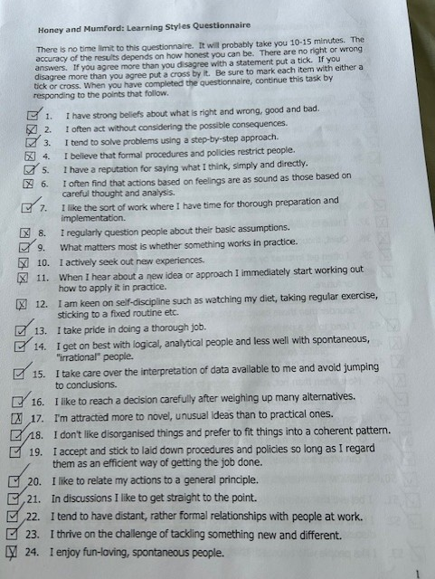

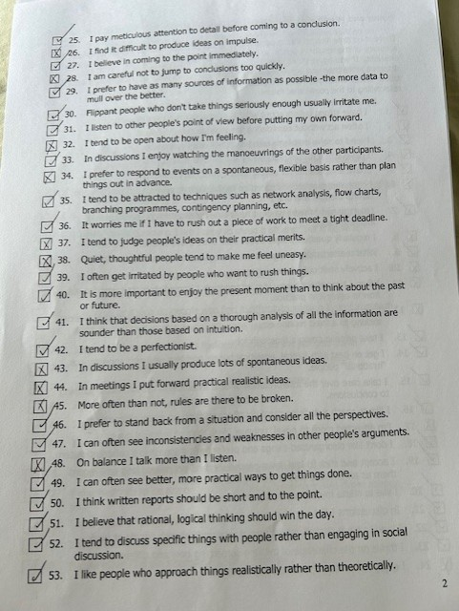

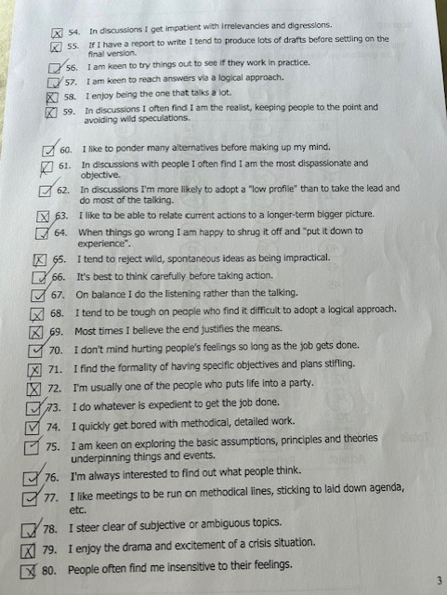

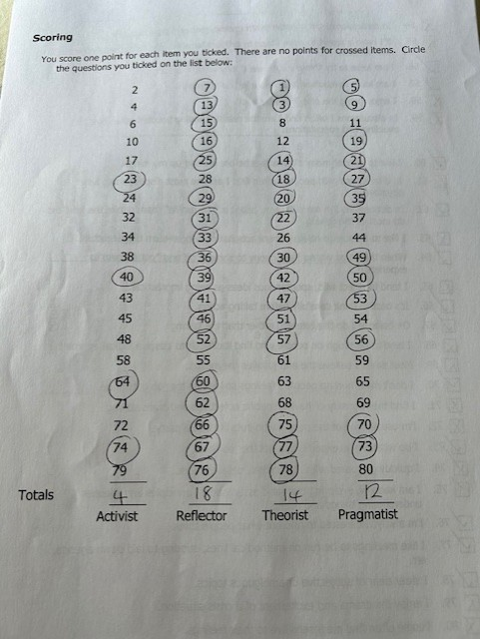

Appendix 2 – VAK learning styles self-assessment questionnaire




Appendix 3 - SWOT analysis of myself
Strengths:
- Reflector learning style: the capacity to listen, watch, and weigh choices before making decisions.
- Excellent organisational abilities, such as maintaining thorough case notes on arrears.
- Competent in deciphering visual data, such as tenancy flowcharts and dashboards.

Weaknesses:
- Little experience in leadership; rarely in charge of overseeing others directly.
- Overly contemplative at times, which causes decision making to be delayed.
- Confidence in motivating and impacting colleagues must be developed.

Opportunities:
- Access to management and leadership development programs via CIH and the Council.
- Chances to observe seasoned managers in action.
- Possibility of taking on coaching duties or acting out roles.

Threats:
- Risk of getting passed over for a promotion if you don't have managerial experience.
- Time for leadership development is limited by heavy caseload requirements.
- Organisational transformation necessitates that managers promptly adjust to new regulations.

Appendix 4 - SWOT analysis of a Team Member
Strengths:
- A pragmatic learner is one who is comfortable experimenting with new methods fast.
- Excellent verbal communication, especially when interacting with tenants.
- Making decisions quickly under pressure.

Weaknesses:
- At times takes actions without fully weighing the hazards or long-term effects.
- Less assured when writing reports and casework.
- More organised planning abilities are required.

Opportunities:
- Mentorship or coaching to improve writing communication.
- Instruction on following housing laws.
- Prospects for development through project management of modest initiatives.

Threats:
- May be errors brought on by moving too fast.
- Without improved report-writing abilities, there is a chance that career advancement would stall.
- Burnout brought on by handling too many demanding cases at once.

Appendix 5 – GO MAD
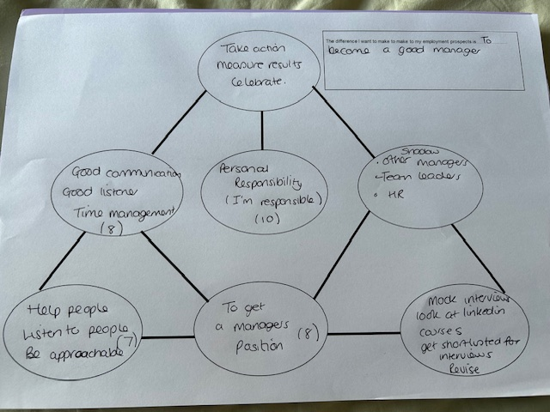

Appendix 6 – Personal Development Plan – Hayley James
Learning Objective | SMART Action Steps | Support / Resources Needed | Timeframe | Review / Success Measure
1. Improve knowledge of housing legislation for better case management | - Attend council housing law training  - Shadow senior colleagues in legal case preparation | Internal training resources, mentoring from senior officers | June 2025 – Dec 2025 | Completion of training; improved accuracy in legal documentation
2.Develop confidence in customer service when dealing with difficult tenants | - Attend conflict resolution workshop  - Role-play scenarios with colleagues  - Reflect on challenging cases in supervision | Training course, supervisor support, peer feedback | Apr 2025 – Nov 2025 | Feedback from tenants and manager; reduced complaints logged
3. Build long-term career development pathway | - Complete a personal SWOT analysis  - Draft a career plan with manager input  - Set development goals for next appraisal | Line manager meeting, HR support | Apr 2025 – Jan 2026 | Documented career plan discussed at appraisal

Appendix 7 – Personal Development Plan – Colleague
Learning Objective | SMART Action Steps | Support / Resources Needed | Timeframe | Review / Success Measure
1. Improve written communication skills for professional reporting | Complete professional writing workshop focused on report and correspondence writing | Internal/external writing workshop, training materials, manager support | Feb 2025 – Jan 2026 | Completion certificate; improved structure and tone in written work
2. Apply writing skills in daily casework to enhance report clarity | Produce weekly tenancy reports and seek feedback from line manager | Supervisory feedback, report templates, time for reflective practice | Apr 2025 – Dec 2025 | Positive feedback from manager; reduced revisions needed
3. Develop confidence through peer collaboration and feedback | Participate in monthly peer review sessions to share and critique written reports | Peer group collaboration, feedback sessions, mentoring | May 2025 – Dec 2025 | Peer feedback indicating improved confidence and quality of written communication

Appendix 8 – CV
Curriculum Vitae – Hayley James
Contact Details
23 Zouch Street, Swansea, SA5 9PJ
📱 07960 142208
📧 hayleyjames15@icloud.com | hayley.james@swansea.gov.uk

Professional Profile
Dedicated Rent Officer with 24 years’ experience at Swansea Council in social housing, rent collection, and tenancy management. Strong track record in reducing arrears, supporting vulnerable tenants, and ensuring compliance with housing legislation. Experienced in inter-agency working, welfare benefits, and data reporting. Currently enhancing leadership capabilities through higher education study and contributing to the community as a volunteer with Swansea Women’s Aid.

Key Skills
- Rent Collection & Arrears Management
- Tenancy Law & Case Preparation for Court
- Customer Service & Complaint Resolution
- Welfare Benefits & Universal Credit Support
- Data Analysis & Reporting (Power BI)
- IT Proficiency: Orchard Housing, MS Office, Windows 365
- Stakeholder & Inter-agency Collaboration
- Strong Written & Verbal Communication
- Leadership & Team Development

Employment History
Rent Officer – Swansea Council (Rents Team), Morriston
Oct 2019 – Present
- Manage a caseload of over 690 arrears accounts, ensuring income maximisation.
- Provide tenant support with Housing Benefit, Universal Credit, and Council Tax Reduction claims.
- Prepare legal documentation for court proceedings and attend hearings.
- Carry out home visits and interviews, offering advice and support to tenants.
- Liaise with prisons, probation services, and support agencies.
- Produce detailed reports and secure financial aid to prevent evictions.
Neighbourhood Officer – Swansea Council
Oct 2004 – Oct 2019
- Managed neighbourhood issues and anti-social behaviour cases.
- Supported tenancy sustainment through engagement and enforcement.
- Liaised with tenants, Councillors, and contractors on estate improvement projects.
Administrative Roles – Swansea Council
2000 – 2004
- Provided administrative and clerical support across housing services.
- Managed record keeping, repair logs, and customer enquiries.
Weekend Supervisor – Brantano/Shoe City
1997 – 2000
- Supervised weekend operations and managed staff rotas.

Volunteering
Volunteer – Swansea Women’s Aid
March 2025 – Present
- Provide support to women accessing advice and safeguarding services.
- Assist with community outreach and awareness activities.
- Contribute to a supportive environment for vulnerable service users.

Education & Professional Qualifications
- Certificate of Higher Education in Applied Leadership and Management in the Workplace (Feb 2025 – ongoing)
- NVQ Level 2 – Customer Services (2007)
- Digital Skills for Business (Level 2), Gower College
- City & Guilds Level 3 – Flower Arranging (2010)
- Foundation Year – Applied Science (1999)
- Year 1 Degree – Maths & Business Studies (2000)
- GCSEs including English, Maths, Science, and IT (1996)

Professional Development
- Ongoing in-house training in tenancy law, estate inspections, and working with vulnerable tenants.
- Experienced in Power BI reporting, Orchard Housing System, and Microsoft Office.
- Regular attendance at PACT meetings, stakeholder events, and court proceedings.

Achievements
- Secured Homeless Prevention Fund support to prevent evictions.
- Drafted successful Housing Benefit reconsideration submissions.
- Deputised as Senior Supervisor within NSU, managing staff rotas.
- Delivered accurate reports for performance tracking and audits.

Additional Information
- Full UK Driving Licence (clean)
- Enhanced DBS Clearance
- Flexible with working hours (evenings/weekends)
- Strong IT, administrative, and communication skills

References
Available upon request.

Appendix 9 – Continuing Professional Development Record (CPD) - Hayley James
Date | Learning / Development Activity | Type of Learning | Skills / Knowledge Gained | Evidence / Outcome
Feb 2025 – ongoing | Certificate of Higher Education in Applied Leadership & Management in the Workplace | Formal | Leadership theory, strategic decision-making, managing people, workplace problem-solving | Ongoing study; university transcripts and assignments
Mar 2025 – ongoing | Volunteering with Swansea Women’s Aid | Informal / Experiential | Communication with vulnerable service users, safeguarding awareness, community engagement | Feedback from supervisors; volunteer hours log
2019 – 2024 | In-house training – tenancy law, estate inspections, supporting vulnerable tenants (Swansea Council) | Formal / Informal | Housing legislation, tenancy management, tenant safeguarding | Attendance certificates; internal council training records
2010 | City & Guilds Level 3 – Flower Arranging | Formal | Creative design, planning, project organisation | Award certificate; completed floral design projects
2007 | NVQ Level 2 – Customer Services | Formal | Customer service principles, complaint handling, communication | Qualification certificate
2000 – present | Attendance at PACT meetings, stakeholder events, and housing court hearings | Informal / Experiential | Networking, partnership working, real-world application of tenancy law | Meeting minutes; participation notes
Ongoing | Reflective practice and self-directed learning | Informal | Critical reflection, self-assessment of strengths/weaknesses, PDP development | Personal development journals and PDP updates

I acknowledge the use of Chatgpt (https://chatgpt.com) on 12th September 2025 to create a structure for my assignment.
create a structure for a 3000 word assignment which follows this brief Module Learning Outcomes (from module syllabus) Upon the successful completion of this module, the student should be able to: • Understand the skills and knowledge needed for working effectively • Demonstrate readiness for employability and personal advancement through an understanding of personal strengths and areas for further development • Establish employment goals and develop a personal action plan TASK DESCRIPTION Indicative Content What You Should Focus Upon • Identify your own learning styles and the learning styles of another member of the team • Consider Formal and Informal learning • Use a simple technique for identifying own development needs and the development needs of another member of the team • Identify potential barriers to learning • Explain how barriers to learning can be overcome Use a recognised technique to identify the learning styles of yourself and another member of the team Consider the difference between Formal and Informal learning and the benefits of it. Provide examples. What tool/technique will you use to identify your own development needs and the development needs of one other person and provide a discussion of your results? Identify any barriers to your learning (and another person) that might occur and explain how these can be overcome. • Briefly analyse learning/development opportunities to meet needs of self and another member of the team • Identify support mechanisms for the development of self and another member of the team • Prepare a development plan to achieve a learning objective for self and another team member • Describe a method that could be used to monitor the development of self and another member of the team You need to demonstrate your awareness and understanding of potential learning and development options for yourself and one other person and provide a discussion. Briefly analyse learning/development options for yourself and the other member. Identify support mechanisms, such as family, spouses, peers, training resources, job rotation or coaching, for the development of yourself and the other team member. Produce development plans using SMART objectives and provide an appropriate discussion. Prepare a personal development plan (PDP) to achieve the learning objectives for yourself and the other team member Demonstrate your awareness of an appropriate method that could be used to monitor the development of self and another member of the team. Describe how a method such as a PDP, could be used to monitor development • Create a CV focused for the specific industry / role you have chosen • Create a CPD record for yourself Demonstrate your understanding of an effective CV that includes all relevant sections and has an appropriate layout by creating and including a CV. Include a personalised CPD for yourself detailing any and all formal and informal learning and development events. • Organise the knowledge and learning through use of a range of information resources. The layout, structure and grammar are presented at the appropriate level and include APA style references. Your work should be checked for grammar errors, follow a report structure, include in-text citations and have a separate Reference section populated with full references of all your information sources – and follow APA V7 style of referencing.

