
UNIVERSITY OF WALES TRINITY ST. DAVID

BA LEADERSHIP AND MANAGEMENT SKILLS FOR THE WORKPLACE

STRATEGIC MANAGEMENT FOR SMEs (BMSW6104_LON)

Task 1: Report 4500 words

Lecturer: Toyin Adisa
Student: Andrea Pisanti 2111539

Table of Contents
Executive summary 3
Introduction 3
Current Strategic Direction 4
Strategic Analysis 7
Strategic Growth Choices 9
Stakeholder Analysis 11
Strategic Recommendations 14
Conclusion 15
References 16

Executive summary
This report delves into the strategic analysis of Hone Foods, a coffee roastery in Cambridgeshire, where I hold the position of Roastery Manager. It examines the company's internal strengths, such as skilled staff and premium sourcing, as well as external opportunities like growing demand for ethically sourced products. Furthermore, it identifies challenges such as economic fluctuations and competition within the coffee industry. With my firsthand experience at Hone Foods, I provide insights into how the company can leverage its strengths and address challenges to achieve sustainable growth and maintain a competitive edge.

Introduction
At Hone Foods, our journey is one fuelled by passion, precision, and a deep love for all things coffee. Nestled amidst the tranquil landscapes of Cambridgeshire, our humble roastery is more than just a place where beans are roasted – it's a sanctuary where the artistry of coffee-making thrives. In this comprehensive report, we embark on an exploration of Hone Foods' strategic landscape, seeking to unravel the intricacies of our mission, vision, and values, and uncovering the strategic pathways that will guide us towards future success. (Hone, 2023)
As we delve into the heart of Hone Foods, it becomes abundantly clear that our mission extends far beyond simply brewing exceptional coffee. It's about creating moments of joy and connection, one cup at a time. Our vision is bold yet simple: to be the premier destination for coffee lovers seeking unparalleled quality and a truly authentic experience. At the core of everything we do are our values – integrity, excellence, and sustainability – which serve as the guiding principles that shape our decisions and actions.
But understanding our strategic direction requires more than just a look inward – we must also turn our gaze outward, examining the ever-changing landscape of the coffee industry and identifying the opportunities and challenges that lie ahead. Through the lens of strategic analysis tools such as PESTEL and SWOT, we gain valuable insights into the external factors shaping our environment and the internal resources and capabilities that set us apart. From the macro-level forces of economic trends and regulatory changes to the micro-level nuances of our operational strengths and weaknesses, every aspect of Hone Foods is scrutinized with precision and care.
Armed with a deeper understanding of our strategic landscape, we turn our attention to the future, exploring the myriad of growth opportunities that await us. Whether it's expanding our product offerings, entering new markets, or enhancing our operational efficiency, the possibilities are endless. By leveraging frameworks such as Porter's Generic Strategies and Ansoff's Matrix, we can identify the most promising avenues for growth and chart a course that aligns with our long-term vision for success.
Of course, no strategic analysis would be complete without considering the perspectives of our stakeholders – the customers, suppliers, employees, and communities that make up the fabric of Hone Foods. By conducting a thorough stakeholder analysis, we gain valuable insights into their expectations and concerns, allowing us to tailor our strategic initiatives to meet their needs and preferences.
In conclusion, the journey of strategic analysis for Hone Foods is one of discovery, reflection, and forward-thinking. As we navigate the complexities of the coffee industry, guided by our mission, vision, and values, we are confident that the insights gained from this report will serve as a roadmap for success. With passion as our fuel and excellence as our destination, the future of Hone Foods is indeed bright.

Current Strategic Direction
Strategic management is the process of formulating and implementing initiatives and actions that guide an organization towards achieving its long-term goals and objectives in a dynamic and competitive environment. At Hone Foods, strategic management serves as the compass that directs our efforts and shapes our journey towards sustainable growth and success. As the Roastery Manager of Hone Foods, I have had the privilege of witnessing firsthand the transformative power of strategic management in driving our company forward. In this section, we delve into the core elements of Hone Foods' current strategic direction, exploring its mission, vision, values, goals, and objectives, and evaluating how this shape our day-to-day operations and long-term aspirations. (Jasper, 2012)
Mission and Vision
At the heart of Hone Foods' strategic direction lie its mission and vision, serving as the guiding stars that illuminate our path forward. Our mission is simple yet profound: to craft exceptional coffee experiences that delight our customers and contribute to a more sustainable world. With every batch of coffee we roast, we strive to uphold our commitment to quality, integrity, and excellence, ensuring that each cup tells a story of craftsmanship and care. Our vision, on the other hand, paints a picture of the future we aspire to create – one where Hone Foods is recognized as the premier destination for coffee lovers seeking unparalleled quality, authenticity, and innovation. As we journey towards this vision, we remain steadfast in our dedication to delivering exceptional products and experiences that exceed expectations and foster lasting connections with our customers. (Hone, 2023)
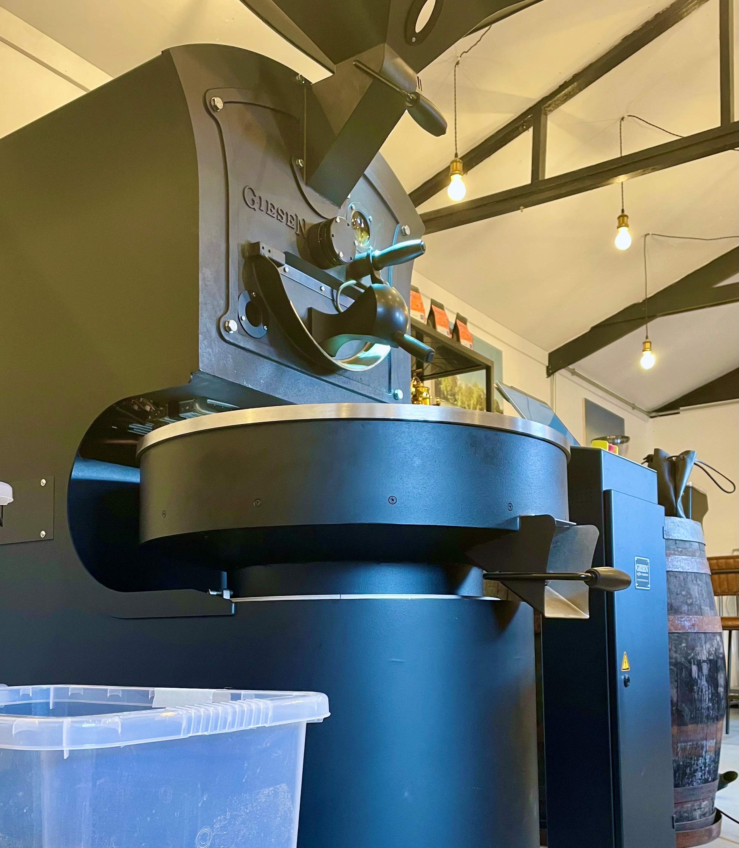
Picture taken by the author in the workplace.

Values
Integral to Hone Foods' strategic direction are its core values, which serve as the bedrock upon which our company culture is built. Integrity, excellence, and sustainability are not just words on a page – they are the guiding principles that inform every decision we make and every action we take. Integrity is the cornerstone of our relationships with customers, suppliers, and partners, as we uphold the highest standards of honesty, transparency, and ethics in all our dealings. Excellence is our constant pursuit, driving us to continuously innovate, improve, and exceed customer expectations at every touchpoint. Sustainability is our commitment to responsible stewardship of the environment and the communities in which we operate, ensuring that our actions today leave a positive legacy for future generations. (Sithanen, 2022)
Goals and objectives
To bring our mission, vision, and values to life, Hone Foods has identified clear and actionable goals and objectives that guide our strategic initiatives and operational priorities. These goals encompass both short-term targets and long-term aspirations, providing a roadmap for success across all areas of our business. From expanding our product offerings and market reach to enhancing operational efficiency and sustainability practices, our objectives are designed to propel Hone Foods towards continued growth, profitability, and impact.
Customer Focus
Central to Hone Foods' strategic direction is a relentless focus on our customers – their needs, preferences, and aspirations. We recognize that our success hinges on our ability to deliver exceptional value and experiences that resonate with our target audience. As such, we are committed to listening, learning, and adapting to evolving customer expectations, ensuring that our products and services remain relevant, compelling, and differentiated in the marketplace. Through ongoing engagement, feedback mechanisms, and customer-centric initiatives, we strive to deepen our relationships with customers, building loyalty and advocacy that sustains our growth and competitive advantage.
Innovation and Differentiation
In a crowded and competitive marketplace, innovation and differentiation are essential drivers of success for Hone Foods. We understand that standing out requires more than just offering great products, it requires a commitment to continuous improvement, creativity, and innovation in everything we do. Whether it's developing new coffee blends, exploring sustainable packaging solutions, or enhancing our customer experience, innovation is woven into the fabric of our strategic direction. By staying ahead of trends, anticipating customer needs, and pushing the boundaries of what's possible, we aim to carve out a distinctive position in the market that sets us apart from competitors. (Maspul, 2023)
Sustainability and Responsibility
As stewards of the environment and members of the community, Hone Foods takes its responsibility to sustainability and social responsibility seriously. Our strategic direction is anchored in a commitment to minimizing our environmental footprint, promoting ethical sourcing practices, and contributing positively to the communities in which we operate. From investing in eco-friendly packaging and energy, efficient roasting technologies to supporting local farmers and charitable initiatives, sustainability is not just a goal, it's a fundamental principle that shapes our decisions and actions every day. (Daniele Giovannucci, 2005)
Hone Foods' current strategic direction is defined by its mission to craft exceptional coffee experiences, its vision to become the premier destination for coffee lovers, and its values of integrity, excellence, and sustainability. Guided by clear goals and objectives, a customer-centric focus, a commitment to innovation and differentiation, and a dedication to sustainability and responsibility, Hone Foods is poised for continued growth, success, and impact in the dynamic landscape of the coffee industry. As we chart our course forward, we remain steadfast in our belief that great coffee has the power to inspire, connect, and transform lives – and at Hone Foods, that's exactly what we aim to do.

Strategic Analysis
Strategic analysis serves as the foundation upon which organizations like Hone Foods build their roadmap for success. It involves a comprehensive examination of both internal and external factors that influence the company's performance and competitive positioning. At its core, strategic analysis seeks to identify strengths, weaknesses, opportunities, and threats (SWOT) facing the organization, while also exploring broader environmental factors through tools like PESTEL (Political, Economic, Social, Technological, Environmental, and Legal) analysis. In this section, we embark on a journey of strategic analysis for Hone Foods, leveraging these powerful frameworks to gain insights into the company's current position and prospects. By conducting a strategic analysis, companies like Hone Foods can gain valuable insights that inform decision-making, resource allocation, and strategic planning efforts. (Jasper, 2012)
PESTEL Analysis
PESTEL analysis is a widely used framework for understanding the external macro-environmental factors that impact an organization's strategic decision-making. (Jurevicius, 2023)
Let's break down each component of PESTEL analysis and examine its relevance to Hone Foods:
Political Factors: In the coffee industry, political factors such as government regulations, trade policies, and taxation can significantly impact operations. For Hone Foods, staying abreast of regulatory changes related to food safety standards, import/export regulations, and sustainability initiatives is crucial for maintaining compliance and minimizing risk.
Economic Factors: Economic conditions, including GDP growth, inflation rates, and consumer spending patterns, influence consumer behaviour and purchasing power. For Hone Foods, economic factors may impact demand for premium coffee products, pricing strategies, and overall market stability. (BUSH, 2024)
Social Factors: Sociocultural trends, lifestyle preferences, and demographic shifts shape consumer preferences and market demand. As consumer awareness of ethical sourcing practices and sustainability grows, Hone Foods may need to adapt its marketing strategies and product offerings to align with evolving societal values.
Technological Factors: Rapid advancements in technology, such as automation, e-commerce platforms, and data analytics, present both opportunities and challenges for Hone Foods. Embracing technological innovations can enhance operational efficiency, customer engagement, and product innovation, but failing to keep pace with technological trends may lead to competitive disadvantage.
Environmental Factors: Environmental concerns, including climate change, resource scarcity, and environmental regulations, have a significant impact on the coffee industry. As a coffee roastery, Hone Foods must consider its environmental footprint, sustainable sourcing practices, and initiatives to reduce waste and promote environmental stewardship.
Legal Factors: Legal factors encompass regulations, laws, and industry standards that govern business operations. For Hone Foods, compliance with food safety regulations, labor laws, and intellectual property rights is essential to mitigate legal risks and maintain ethical business practices. (RAHMAN, 2024)
By conducting a PESTEL analysis, Hone Foods can gain a holistic understanding of the external forces shaping the coffee industry and identify strategic opportunities and threats that may influence its future direction.
SWOT Analysis
SWOT analysis is a strategic planning tool that evaluates an organization's strengths, weaknesses, opportunities, and threats to inform strategic decision-making. Let's explore how SWOT analysis applies to Hone Foods:
Strengths: Hone Foods' strengths lie in its commitment to quality, craftsmanship, and customer satisfaction. With a dedicated team of experienced roasters, a loyal customer base, and a reputation for excellence, Hone Foods has a competitive advantage in the market. Additionally, its focus on sustainability and ethical sourcing practices enhances its brand reputation and customer loyalty.
Weaknesses: Despite its strengths, Hone Foods faces certain weaknesses that may hinder its growth and competitiveness. These may include limited market reach, reliance on a single source of coffee beans, and operational inefficiencies. Addressing these weaknesses through strategic initiatives such as market expansion, diversification of suppliers, and process optimization is critical for long-term success.
Opportunities: Hone Foods has numerous opportunities for growth and innovation in the dynamic coffee market. These opportunities may include expanding product lines to include specialty blends or flavoured coffees, leveraging digital marketing channels to reach new customers, and exploring partnerships with local cafes or retailers. By capitalizing on these opportunities, Hone Foods can strengthen its market position and drive revenue growth.
Threats: Like any business, Hone Foods faces threats that pose risks to its success. These threats may include increasing competition from larger coffee chains, fluctuations in coffee bean prices, and changing consumer preferences. By proactively addressing these threats through strategic planning and risk management measures, Hone Foods can mitigate potential challenges and maintain its competitive edge.
By conducting a SWOT analysis, Hone Foods can identify strategic priorities, capitalize on its strengths, address its weaknesses, and navigate external opportunities and threats more effectively. (Fadli, 2022)
In conclusion, strategic analysis plays a pivotal role in shaping the future direction of Hone Foods. Through frameworks like PESTEL and SWOT analysis, the company can gain valuable insights into its internal capabilities, external environment, and strategic positioning within the coffee industry. By leveraging these insights, Hone Foods can make informed decisions, identify strategic priorities, and chart a course for sustainable growth and success in the dynamic and competitive market landscape.

Strategic Growth Choices
In the dynamic and competitive landscape of the coffee industry, strategic growth is imperative for organizations like Hone Foods to thrive and remain relevant. As the Roastery Manager of Hone Foods, I am tasked with identifying and implementing strategic growth choices that align with our mission, vision, and values while capitalizing on market opportunities. In this section, we will explore various strategic frameworks and models to determine the most viable growth strategies for Hone Foods.
Strategic growth choices encompass a range of options that organizations can pursue to expand their market presence, increase revenue, and enhance their competitive advantage. These choices may include market penetration, product development, market development, and diversification strategies. Each strategy offers unique opportunities and challenges, requiring careful consideration and analysis to determine the most suitable approach for Hone Foods' growth objectives. (Danilo Brozović, 2023)
Ansoff Matrix
The Ansoff Matrix provides a structured framework for assessing growth opportunities based on market and product dimensions. (Clarissia, 2020) Let's examine how each quadrant of the Ansoff Matrix applies to Hone Foods:
Market Penetration: Hone Foods can focus on increasing sales of existing products in current markets through market penetration strategies. This may involve expanding our distribution channels, launching targeted marketing campaigns, or enhancing customer loyalty programs to attract and retain customers. (Isibor, 2020)
Product Development: Product development strategies involve introducing new products or variations to existing product lines. For Hone Foods, this could entail creating new coffee blends, exploring flavored or specialty coffees, or introducing complementary products such as coffee accessories or merchandise to appeal to a broader customer base.
Market Development: Market development strategies involve entering new markets with existing products. Hone Foods could explore geographic expansion into new regions or demographic segments where demand for specialty coffee is growing, thereby expanding our customer base and revenue opportunities. (Ginevičius, 2001)
Diversification: Diversification strategies involve entering new markets with new products. While inherently riskier, diversification allows Hone Foods to leverage its brand reputation and expertise into adjacent industries or product categories, such as coffee-related beverages or gourmet food offerings, to diversify revenue streams and mitigate market risks. (Nur Rahmawatini, 2023)

Porter's Generic Strategies
Porter's Generic Strategies framework offers insights into how organizations can achieve competitive advantage through cost leadership, differentiation, or focus strategies. (Bruin, 2021) We will now explore how Hone Foods can put these strategies into practice:
Cost Leadership: While Hone Foods may not compete solely on price, efforts to optimize operational efficiency, streamline supply chain processes, and reduce production costs can help maintain competitive pricing while preserving product quality and profitability.
Differentiation: Hone Foods can differentiate itself from competitors by offering unique products or services that provide superior value to customers. By emphasizing factors such as product quality, flavour profiles, sustainable sourcing practices, and customer experience, we can create a distinct brand identity that resonates with target customers.
Focus: Focus strategies involve targeting a specific market segment or niche where Hone Foods can excel. Whether it's catering to coffee connoisseurs seeking premium single-origin beans or meeting the needs of environmentally conscious consumers with sustainable and ethically sourced products, a focused approach allows us to tailor our offerings and marketing efforts to specific customer segments and drive customer loyalty and retention. (Ali, 2021)
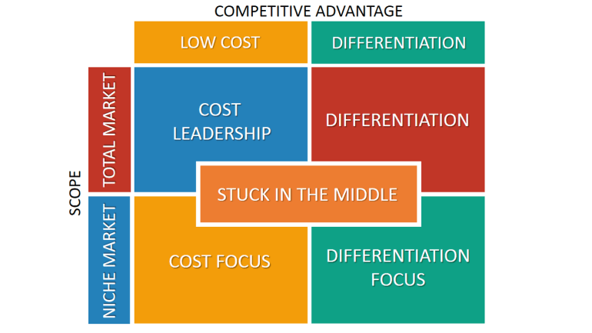
Image source

Stakeholder Analysis
Stakeholder analysis is a crucial component of strategic management, providing insights into the interests, expectations, and influence of key stakeholders on the organization's objectives and operations. As the Roastery Manager of Hone Foods, it is essential to identify and understand the diverse range of stakeholders that impact our business and to develop strategies for engaging and managing these relationships effectively.
Stakeholder analysis is a systematic process of identifying, assessing, and prioritizing stakeholders based on their interests, influence, and involvement in the organization. By understanding the needs, expectations, and concerns of stakeholders, organizations like Hone Foods can anticipate challenges, mitigate risks, and build mutually beneficial relationships that contribute to long-term success. (Johanna Kujala, 2022)
Identifying Key Stakeholders
At Hone Foods, our stakeholders encompass a broad spectrum of individuals, groups, and organizations that have a vested interest in our business and its outcomes. These stakeholders may include:
Customers: Our customers are central to our business success, driving demand for our products and services and providing valuable feedback that informs product development and marketing strategies.
Suppliers: Our suppliers play a critical role in our supply chain, providing the raw materials and resources necessary for coffee production. Maintaining strong relationships with suppliers is essential to ensure quality, reliability, and cost-effectiveness.
Employees: Our employees are the backbone of our operations, contributing their skills, expertise, and dedication to the success of our business. Ensuring employee satisfaction, engagement, and development is essential for organizational performance and retention.
Investors: Investors provide financial capital and resources to support our business growth and expansion initiatives. Building trust and transparency with investors is crucial for securing funding and maintaining long-term partnerships.
Community: The local community where Hone Foods operates plays a significant role as stakeholders, influencing public perception, regulatory environment, and community relations. Engaging with the community through corporate social responsibility initiatives, partnerships, and outreach programs is essential for building trust and goodwill.
Regulators and Government Agencies: Regulators and government agencies oversee compliance with laws, regulations, and industry standards that impact our business operations. Maintaining compliance and positive relationships with regulators is critical for avoiding legal issues and reputational damage.
Competitors: Competitors in the coffee industry represent both challenges and opportunities for Hone Foods. Understanding competitor strategies, market dynamics, and customer preferences is essential for developing competitive advantages and positioning our brand effectively. (Laura Roche, 2020)

Analysing Stakeholder Interests and Influence
Once stakeholders have been identified, it is essential to assess their interests, influence, and level of involvement in Hone Foods' activities. This analysis helps prioritize stakeholder engagement efforts and tailor communication strategies to address their specific needs and concerns. (Simon L. Bager, 2020)
Customers: Customers are primarily interested in high-quality products, excellent customer service, and value for money. Their influence lies in their purchasing decisions and brand loyalty, making it crucial to deliver exceptional products and experiences that meet their expectations.
Suppliers: Suppliers are interested in stable, long-term relationships with reliable buyers and fair compensation for their products and services. Their influence stems from their ability to supply critical inputs and resources, making it essential to maintain open communication and fair dealings.
Employees: Employees are interested in fair compensation, opportunities for growth and development, and a positive work environment. Their influence lies in their productivity, morale, and commitment to organizational goals, making it vital to prioritize their well-being and engagement.
Investors: Investors are interested in financial returns, growth prospects, and risk management strategies. Their influence stems from their financial investment and decision-making authority, making it essential to provide transparent reporting, clear strategic direction, and a compelling business case for investment.
Community: The local community is interested in environmental sustainability, social responsibility, and economic development. Their influence lies in their support, advocacy, and potential impact on public opinion and regulatory decisions, making it crucial to engage with community stakeholders and address their concerns.
Regulators and Government Agencies: Regulators are interested in compliance with laws, regulations, and industry standards that govern business operations. Their influence stems from their authority to enforce regulations and impose penalties for non-compliance, making it essential to maintain proactive engagement and adherence to regulatory requirements.
Competitors: Competitors are interested in gaining market share, outperforming rivals, and protecting their competitive position. Their influence lies in their ability to innovate, disrupt markets, and respond to changing customer needs and preferences, making it important to monitor competitor strategies and trends.

Developing Stakeholder Engagement Strategies
Based on the stakeholder analysis, Hone Foods can develop tailored engagement strategies to build positive relationships, address stakeholder concerns, and leverage opportunities for collaboration and mutual benefit. These strategies may include:
Customer Engagement: Implementing customer feedback mechanisms, loyalty programs, and personalized marketing initiatives to enhance customer satisfaction and loyalty.
Supplier Relationships: Establishing clear communication channels, fair pricing agreements, and supplier development programs to foster long-term partnerships and ensure a reliable supply chain.
Employee Development: Investing in training and development programs, performance incentives, and employee wellness initiatives to attract, retain, and motivate top talent.
Investor Relations: Providing regular updates, financial transparency, and strategic insights to investors to build trust and confidence in Hone Foods' growth prospects and financial performance.
Community Outreach: Engaging with local communities through corporate social responsibility initiatives, sponsorships, and community events to demonstrate commitment to environmental stewardship and social impact.
Regulatory Compliance: Establishing robust compliance processes, monitoring regulatory developments, and maintaining open dialogue with regulators to ensure adherence to legal requirements and industry standards.
Competitive Intelligence: Conducting market research, benchmarking competitor strategies, and identifying opportunities for differentiation and innovation to stay ahead of competitors and capture market share.
By implementing effective stakeholder engagement strategies, Hone Foods can build strong, mutually beneficial relationships with key stakeholders, enhance organizational resilience, and create value for all parties involved. (Fabricio Stocker, 2020)
Stakeholder analysis is a vital tool for strategic management, providing insights into the diverse interests, expectations, and influence of key stakeholders on Hone Foods' business operations and outcomes. By identifying and understanding the needs and concerns of stakeholders, Hone Foods can develop tailored engagement strategies that foster trust, collaboration, and shared value creation. Through effective stakeholder engagement, Hone Foods can navigate complex relationships, mitigate risks, and capitalize on opportunities for sustainable growth and success in the competitive coffee industry landscape.

Strategic Recommendations

As Hone Foods continues to operate in the competitive coffee industry, it is essential to develop and implement strategic initiatives that drive sustainable growth and success. Based on the findings of our strategic analysis and stakeholder engagement efforts, the following recommendations are proposed to enhance organizational performance and capitalize on emerging opportunities:
Diversify Product Offerings: While Hone Foods has established itself as a reputable coffee roastery, there is an opportunity to diversify our product offerings to cater to evolving consumer preferences. Introducing complementary products such as specialty teas, artisanal pastries, and branded merchandise can enhance our revenue streams and attract a broader customer base.
Enhance Customer Experience: Investing in customer experience initiatives is critical for fostering brand loyalty and differentiation. Implementing loyalty programs, enhancing online ordering platforms, and offering personalized recommendations based on customer preferences can elevate the overall customer experience and drive repeat business.
Sustainable Sourcing Practices: Given the increasing emphasis on sustainability and ethical sourcing within the coffee industry, Hone Foods should prioritize sustainable sourcing practices. Partnering with certified coffee growers, implementing environmentally friendly packaging solutions, and promoting fair trade practices can enhance our brand reputation and appeal to socially conscious consumers.
Expansion into New Markets: While Hone Foods has established a strong presence in our current market, there is potential for expansion into new geographic markets. Conducting market research to identify untapped opportunities, establishing strategic partnerships with local businesses, and leveraging digital marketing channels can facilitate geographic expansion and drive revenue growth.
Invest in Technology: Embracing technology is essential for optimizing operational efficiency and enhancing customer engagement. Implementing advanced roasting equipment, leveraging data analytics for inventory management and demand forecasting, and enhancing our online presence through e-commerce platforms can streamline operations and drive business growth.
Employee Training and Development: Our employees are valuable assets to the organization, and investing in their training and development is essential for driving performance and innovation. Providing ongoing training programs, leadership development initiatives, and opportunities for career advancement can enhance employee morale, productivity, and retention.
Community Engagement: Strengthening our ties with the local community is crucial for building brand loyalty and goodwill. Engaging in community outreach initiatives, sponsoring local events, and supporting charitable causes aligned with our brand values can demonstrate our commitment to corporate social responsibility and foster positive relationships with stakeholders.
Continuous Improvement: Adopting a culture of continuous improvement is essential for staying ahead of competitors and adapting to changing market dynamics. Implementing regular performance reviews, soliciting feedback from customers and employees, and benchmarking against industry best practices can drive operational excellence and innovation.
By focusing on diversification, customer experience, sustainability, expansion, technology, employee development, community engagement, and continuous improvement, Hone Foods can strengthen its competitive position and achieve its strategic objectives in the years to come.

Conclusion
In conclusion, the strategic analysis conducted, and the subsequent recommendations put forth serve as a guiding framework for Hone Foods, enabling it to effectively navigate the complexities of the coffee industry. By recognizing the internal strengths and weaknesses alongside external opportunities and threats, Hone Foods can strategically position itself for sustained growth and success.
The delineation of key strategic growth choices, combined with stakeholder analysis, underscores the importance of aligning organizational goals with stakeholder expectations. Through fostering positive relationships with stakeholders and addressing their concerns, Hone Foods can cultivate a supportive environment conducive to its long-term prosperity.
Furthermore, the strategic recommendations outlined encompass various facets, including product diversification, customer experience enhancement, adoption of sustainable practices, expansion into new markets, technology investment, employee development, community engagement, and continuous improvement. Embracing these recommendations will empower Hone Foods to stay ahead of the curve, adapt to market shifts, and capitalize on emerging trends.
Ultimately, by diligently implementing these strategic initiatives and remaining agile in response to market dynamics, Hone Foods can solidify its competitive standing and achieve sustainable growth in the ever-evolving coffee industry. With a commitment to excellence and a strategic vision guiding its endeavours, Hone Foods is well-positioned to realize its full potential and emerge as a leader in the coffee roastery sector.

References
Ali, B. J. &. A. G., 2021. Porter’s Generic Competitive Strategies and its influence on the Competitive Advantage.. International Journal of Advanced Engineering, Management and Science, 7(6), p. 42–51.
Bruin, L. d., 2021. Business-2-You. [Online]
Available at: https://www.business-to-you.com/porter-generic-strategies-differentiation-cost-leadership-focus/
[Accessed 25 april 2024].
BUSH, T., 2024. PESTEL Analysis. [Online]
Available at: https://pestleanalysis.com/coffee-industry-pestel-analysis/
[Accessed 20 april 2024].
Clarissia, M. S., 2020. A Study on Ansoff Matrix Technique: As A Growth Strategy and an Adaptive Learning Technique Adopted in the Leading Brand of Products. BIMS Journal of Management , 5(1), pp. 18-21.
Daniele Giovannucci, S. P., 2005. Standards as a new form of social contract? Sustainability initiatives in the coffee industry. Food Policy, 30(3), pp. 284-301.
Danilo Brozović, C. J. B. B., 2023. Strategic flexibility and growth of small and medium-sized enterprises: a study of enablers and barriers. Management Decision.
Day, G. S., 1981. Strategic market analysis and definition: An integrated approach. Strategic Management Journal, 2(3), pp. 281-299.
Fabricio Stocker, M. P. d. A. K. M. C. d. M. J. M. G. B., 2020. Stakeholder engagement in sustainability reporting: A classification model. Corporate Social Responsibility and Environmental Management, 27(5), pp. 1989-2400.
Fadli, E. T. K., 2022. ARABICA COFFEE PROCESSED PRODUCT DEVELOPMENT. International Journal of Economic, Business, Accounting, Agriculture Management and Sharia Administration, 2(6), pp. 1300-1314.
Ginevičius, R. a. A. R., 2001. THE EVALUATION OF A COMPANY’S STRATEGY BY THE ANSOFF’S PRODUCT MARKET MATRIX. Statyba, 7(2), p. 158–165.
Hone, 2023. Hone Foods. [Online]
Available at: https://honefoods.co.uk/
[Accessed 20 april 2024].
Isibor, O. &. G., 2020. Strategizing for growth within a Niche: Market penetration as a viable alternative in the Hospitality Sector. Uniport Journal of Management, 5(1), pp. 1-12.
Jasper, M., 2012. What is strategic management?. Journal of Nursing Management, 20(7), pp. 838-846.
Johanna Kujala, S. S. a. D. L., 2022. Stakeholder Engagement: Past, Present, and Future. Sage Journals, 61(5).
Jurevicius, O., 2023. Strategic Management Insight. [Online]
Available at: https://strategicmanagementinsight.com/tools/pest-pestel-analysis/
[Accessed 19 april 2024].
Kaniawati, K., 2021. Coffee Business Development Model. REVIEW OF INTERNATIONAL GEOGRAPHICAL EDUCATION, 11(6), pp. 434-438.
Laura Roche, D. A. M. C., 2020. Research priorities of the autism community: A systematic review of key stakeholder perspectives. Sage Journal, 25(2).
Luis F. Samper, X. F. Q.-R., 2017. Towards a Balanced Sustainability Vision for the Coffee Industry. Sustainable Supply Chain Management), 6(2).
Maspul, K. A., 2023. Digital Innovation in the Specialty Coffee Market: Revolutionizing Business and Competitive Advantage. Journal Nusantara, 3(1).
Nicholas, J., 2023. businessanalystmentor. [Online]
Available at: https://businessanalystmentor.com/vrin-framework-vrio-analysis/
[Accessed 19 april 2024].
Nur Rahmawatini, D. I. R. M. M., 2023. Proposed Business Strategy for Lanora Florist to Compete and Grow Successfully in the Future. International Research Journal of Economics and Management Studies, 2(4), pp. 692-697.
RAHMAN, M., 2024. howandwhat. [Online]
Available at: https://www.howandwhat.net/pestel-analysis-coffee-industry/
[Accessed 20 april 2024].
Simon L. Bager, E. F. L., 2020. Sustainability strategies by companies in the global coffee sector. Business Strategy and the Environment, 29(8), pp. 3555-3570.
Sithanen, N., 2022. mtpakcoffee. [Online]
Available at: https://mtpak.coffee/2022/08/what-values-should-a-coffee-roaster-have/
[Accessed 19 april 2024].
Togar M. Simatupang, P. P. a. S. J. W., 2017. The emergence of value chain thinking. International Journal of Value Chain Management, 8(1), pp. 40-57.

