Production Dairy
Neo Drive/ Neo Tokyo
Nathan Chaplin – 1705172

Week 1 – Jan 28th
Week 2 – Feb 4th
Week 3 – Feb 11th
Week 4 – Feb 18th
Week 5 – Feb 25th
Week 6 – Mar 4th
Week 7 – Mar 11th
Week 8 – Mar 18th
Week 9 – Mar 25th
Week 10 – Apr 1st
Week 11 – Apr 8th
Week 12 – Apr 15th
Week 13 – Apr 22nd
Week 14 – Apr 29th
Week 15 – May 6^{th Deadline}

Week 1 – Jan 28th

Today was the first day back. Today we got as a group to discuss the decision needed to be made in order to finish the game that we had started in the last semester (Neo Drive). Firstly, we discussed about multiplier and if we wanted it. This then made us think about the problems that we may run into and then time. We decided that if we were done early then we will add it in. Then we split up to our level groups for me that was neo Tokyo and then we made huge improvement to what the outcome will be and what we should remove and add into the game. We also set up a Trello which will allow us to share images easily and make checklists to find out what had been done and what hasn’t. This page will allow me to understand Jordan and Mitch’s ideas and help me modelling them using this page.

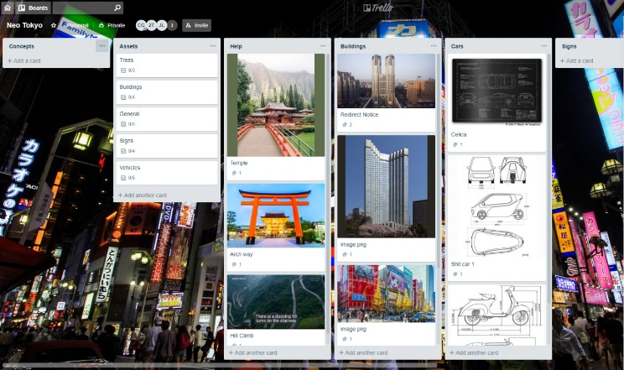
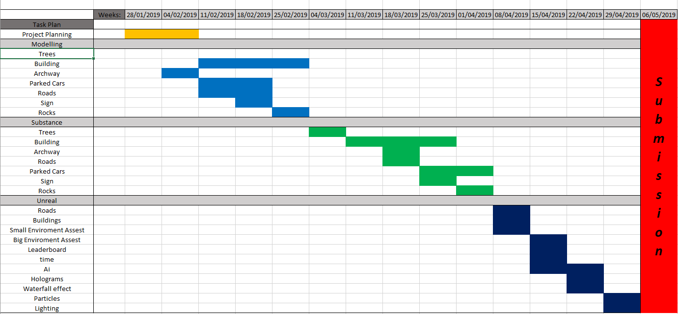

Week 2 – Feb 4th

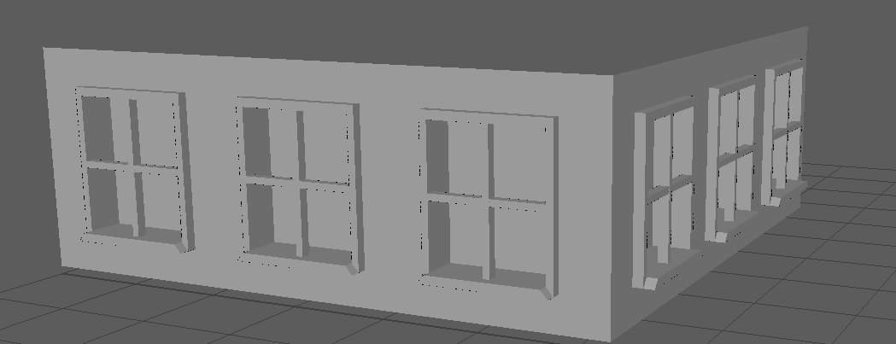
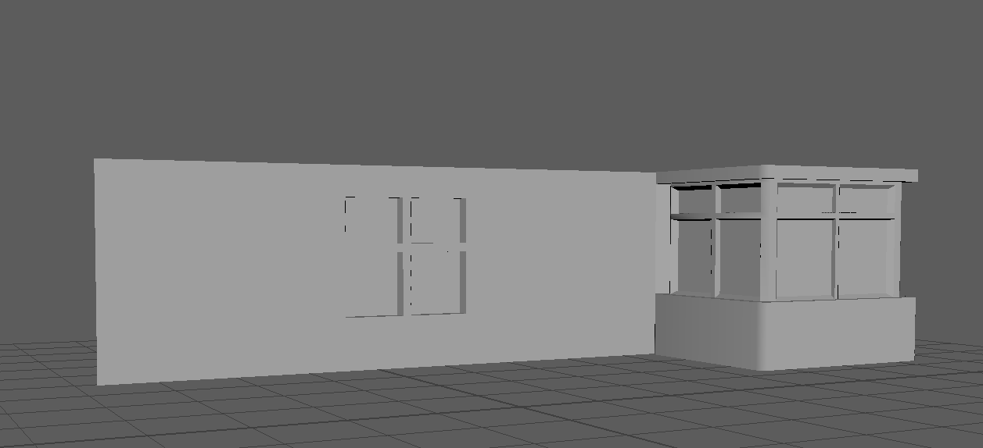
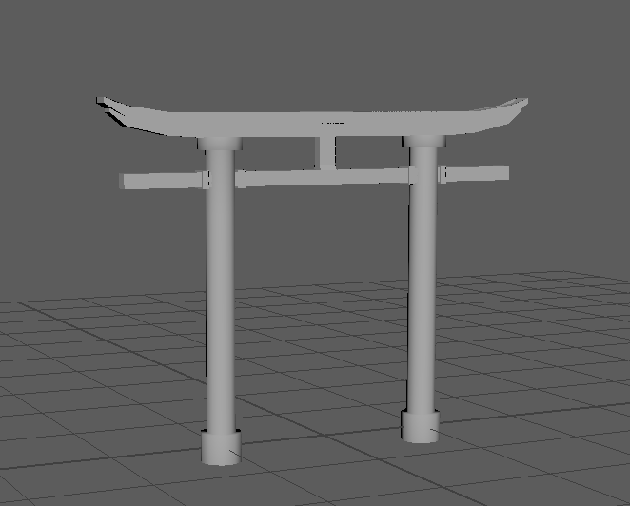
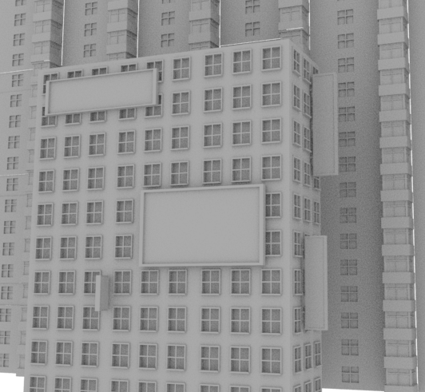
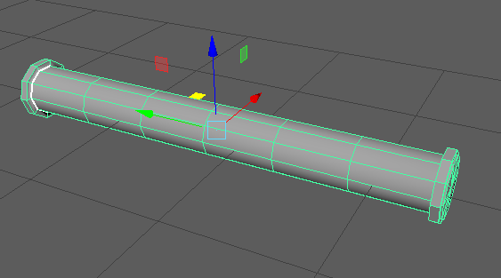
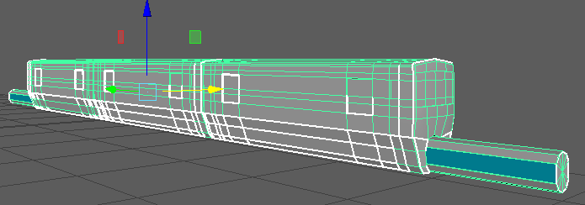
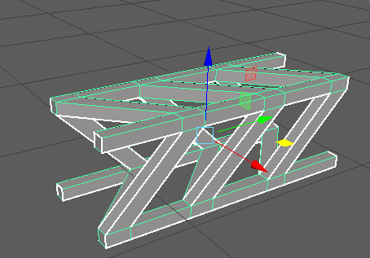
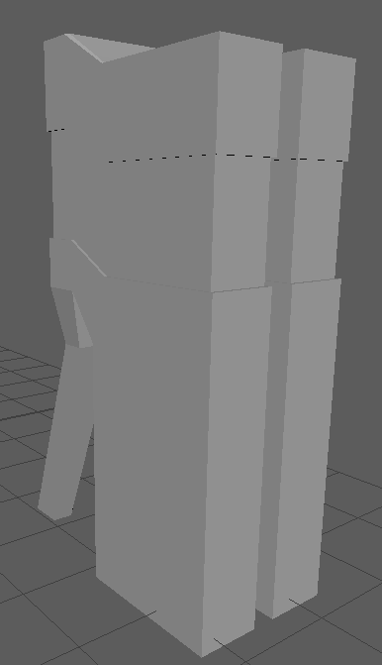
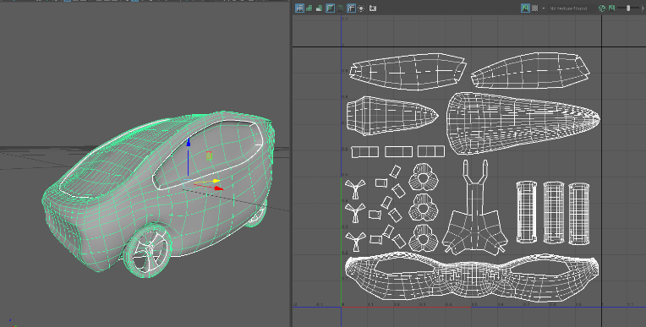
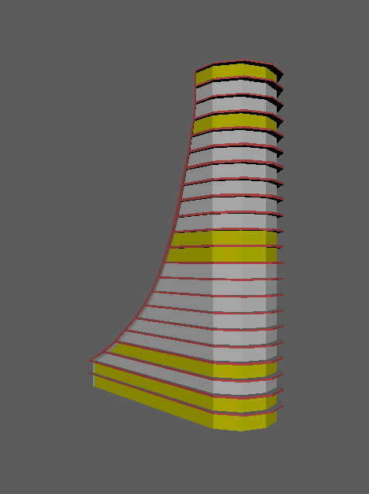

This week I started to make quick model in Maya for us to kind of see what types of assets we will need for the game. Above I came up with some idea which some only took 5 to 10 minutes to create which then give me and the team a good idea on the types of assets that would need to be drawn to model. Some of these asset me and the team really like and started to base the assets we needed for the game of this coming up with unique ideas in which then Jordan can build a level design around.

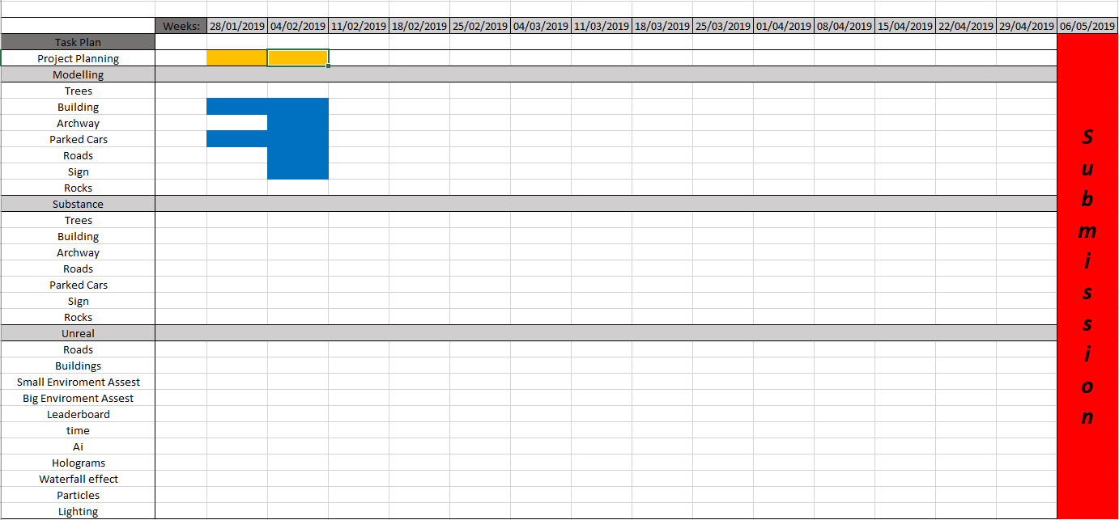
After making the Ghart chart i decided to make one for this week but has what I have done so I can see where I am falling behind and what is coming ahead that I may need to move around. This will hopefully allow me to keep my self on track ready for the week to come while making the game

Week 3 – Feb 11th

Talk
When the team was talking, I am one of the people which will me modelling a car for the game. So, I decided to do some research on car and I found a tutorial series which allowed me to learn the basic on modelling a car. The car they used was a Jaguar F type. I give my self only a short period of time to learn how to do this and what I found is that I would not be done in the time frame I had for it. So, I still carried on watching the tutorial until I had to stop and I came up with this first half of the car. Personally, I think for my first real car I think I did a good job. I would like to go further into detail and carry on with the car but for now I will make sure that I stick to the tasks at hand without giving my self too much work to do.
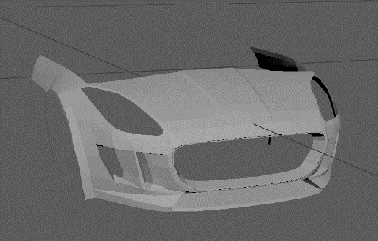

https://www.youtube.com/watch?v=-7hFlgvh3J0&list=PLyl1H9kKlS_lbtJF-E0VXGQun6kMjhe6n&index=3&t=788s

This week I also started to make the road for the game as my team we don’t want to use premade assets done by other people we wanted to push our selves and made all the assets. So, because I was the modeler and unreal, I decided to make a set of roads which were modular and try them out. When I imported them, I tried them out I quite liked them, but I knew there could be improvements done as the car was getting stuck to the curb. So, I decided for now they are just for playtesting other items that needed to be done.
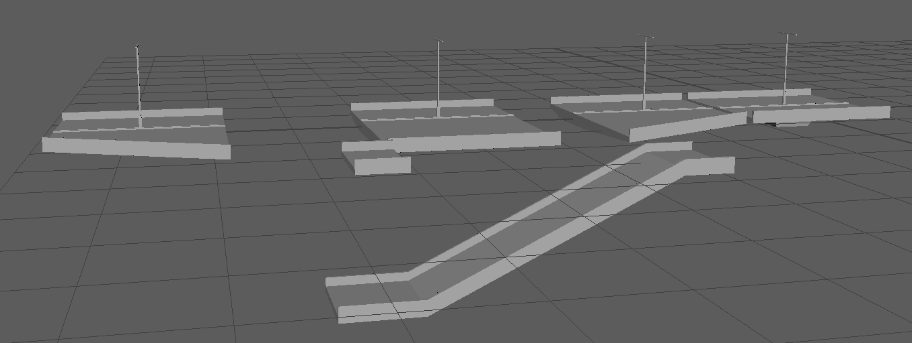

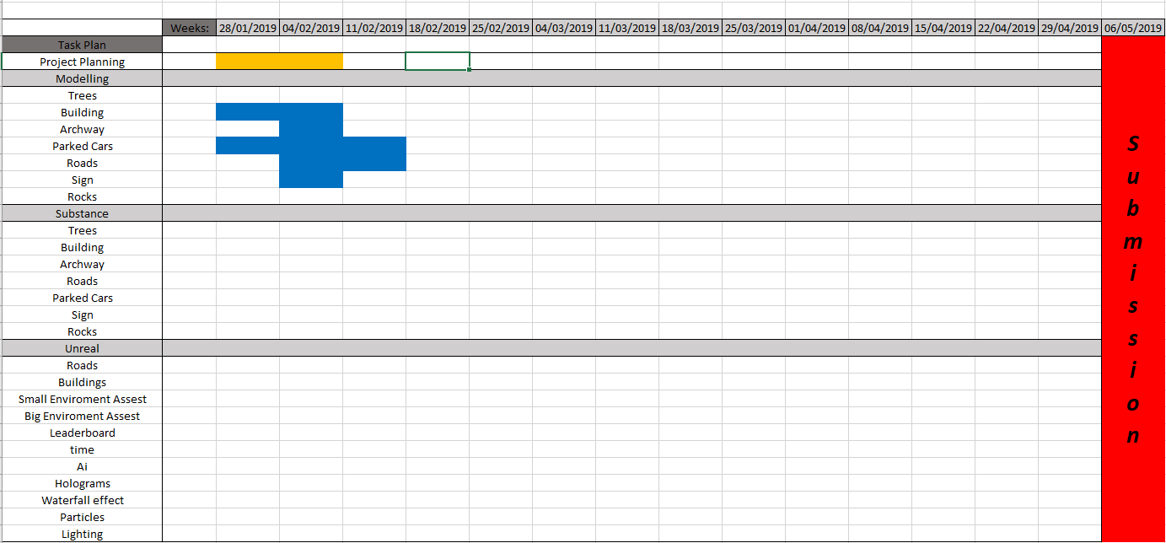
My Ghart chart now show what else I have done but it doesn’t show what practises I have done which will not be implanted. Next time I will make sure I do a practise tab which allows me to understand how much time I took to practise and do work.

Week 4 – Feb 18th

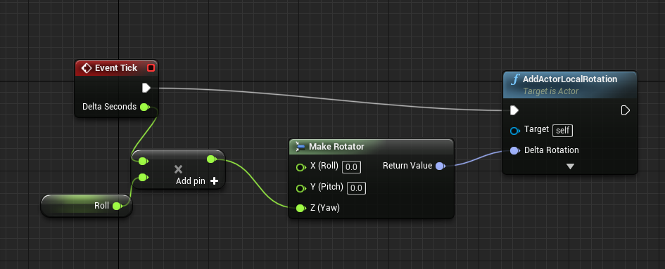

This bit of code makes the object turn on it Z Axis’s this will be used for the roundabout and any hologram that will need to rotate.
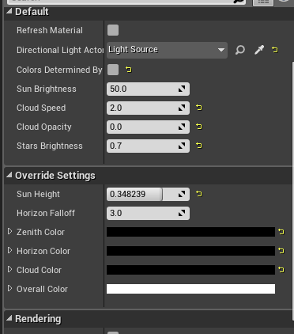
Making it night time

On the Sky Sphere I have changed the settings to the picture on the left. This will make it night time in the level.

Once I did this I noticed that in the level the more you stayed in it the brighter it got. To fix this problem I put in the post process volume. This allows me to keep it the same lighting without it getting brighter.
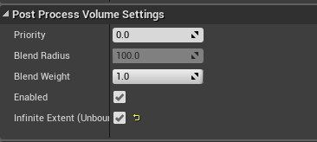
I enabled Infinite Extent.

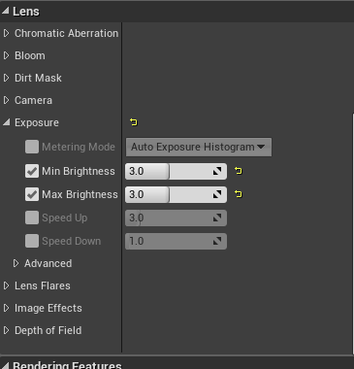
Then I Enabled Min brightness and then Max Brightness and set them to the same number. I did a bit of testing and for now. 3 is a good lighting. But I am unsure at this time if they will stay like this cause I have to experiment with different street light and neon lights.
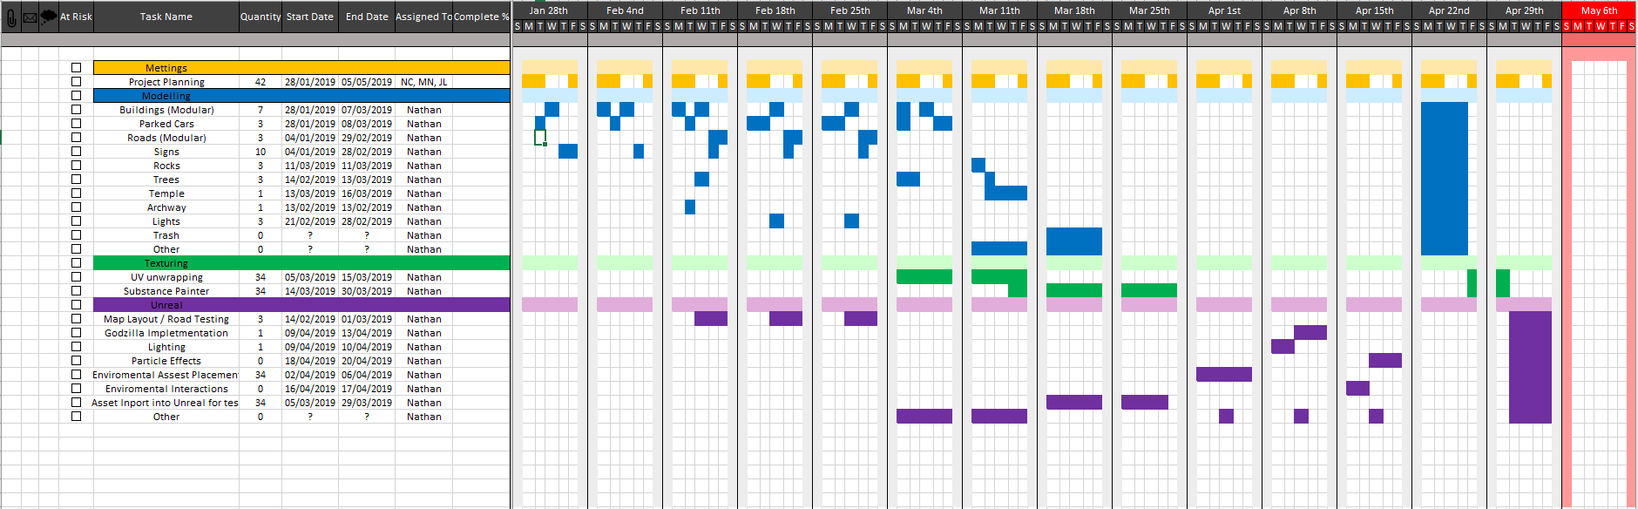

Week 5 – Feb 25th

Boost
As I was apart of the unreal team, I was set a task to make the vehicle have boost. So I set my self a week to be able to do this task. As I started it, I firstly made sure that I understood the vehicle cause I didn’t create it. So, I started changing number and removing and adding block to find out what did what in the level. I found out that there is a relative boost force. This I could see effect the speed so on Monday after about 2 hours I came up with a simple boost that worked.
On Tuesday I looked back and I could see that some setting weren’t changing and there was still bugs so because I knew what I had to do now I restarted making boost and I found that my second attempt was way better that the first. First, it was neater and it easy to understand what goes into what so it will be good for bug fixes in the future if there is any. Secondly my second attempt on boost allowed the car to use it then generate it over time. This felt nice in the game which I am happy it did. Then this car will stop generating boost when the player had gone over a boost pad.

Because of the week I had set out for this I was able to fine tune the setting to make sure that it doesn’t over generate, and the vehicle has enough boost but also not too little. Overall, I am very happy with the way this planned out. This has also gone me to understand the vehicle a little better so I can help any of the unreal team if they need it.
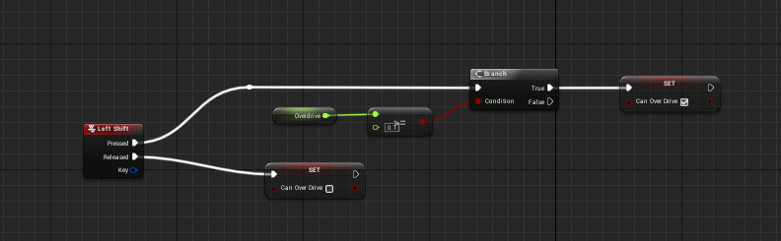
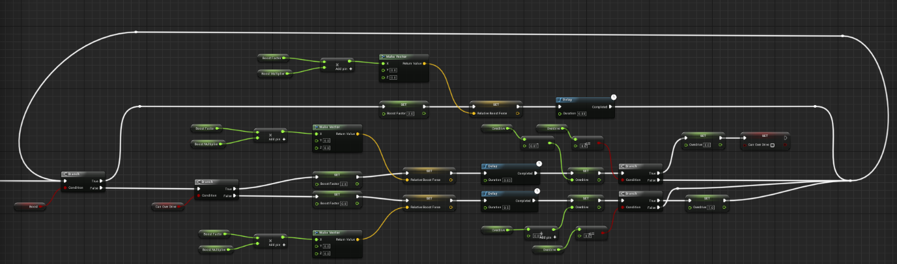

Week 6 – Mar 4th

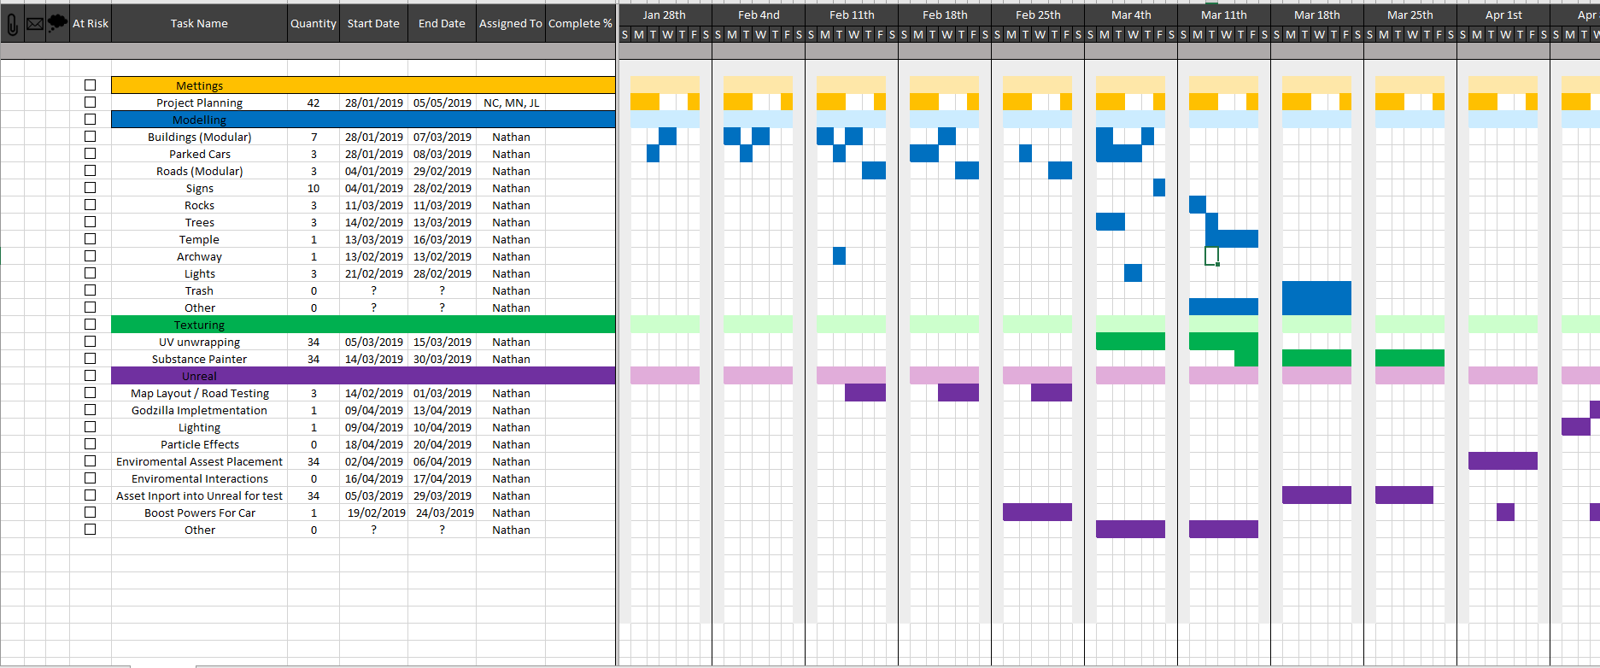
Changed The Ghart chart. Needed to update what I did in the weeks to come because I have fault behind due to other problems in family.
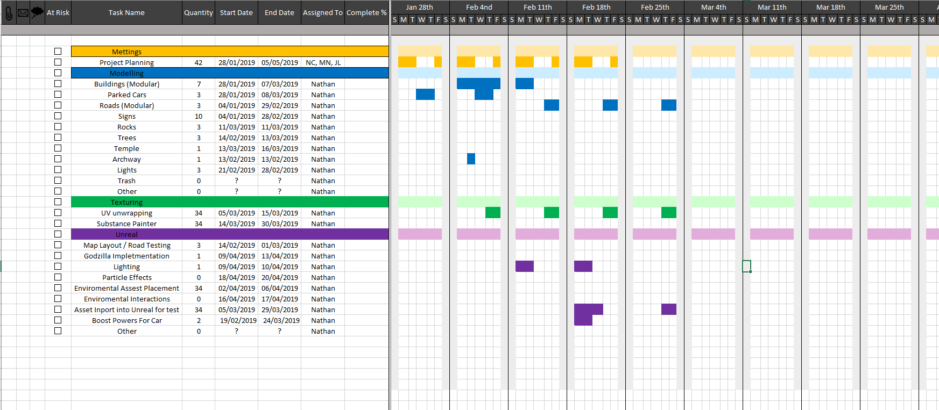
This is what I have done so far. So far I aren’t happy with how much work I have done but sadly this couldn’t be helped and in the next few weeks my work should increase in amount and quality.

Work this week
Worked on the unreal project. Origaized Files and fixed any bugs that were in there. Took the boost I made and matched it up with Matts ui which shows the cars health and boost. So now you can see how much boost you have. And the car will boost when it has got boost in the tank. 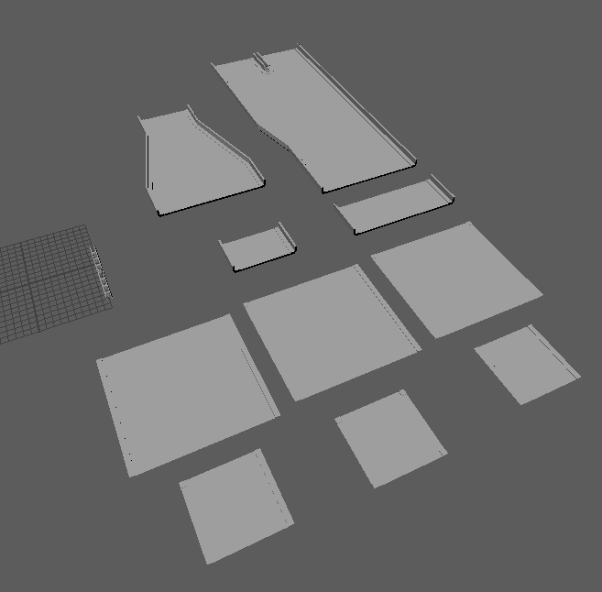

Unreal Laggin on Uni Computers
In uni I brought what I worked on in unreal and was showing the group. When I then sat down with Jordan to build the map more the blueprints for the roads started lagging and I was not able to keep working on the map out of the level because of how much lag it was causing. Now after thinking of a alternative I will go and use landscape splines in order to reduce the lag of the level and hopefully this will allow me to work on the uni computers

Week 7 – Mar 11th

Monday
Team Meeting
On Monday we had to have a team meaning about who was going to do the Retop on Mechazilla as I was very busy with my Ghart chart and mitch and Jordan didn’t plan that they were going to do the Retop on the Mechazilla model. This means that we had to come together in order to decided what or who was going to take the model and do the Retop on the model. When we came together mitch was saying how he couldn’t do it and that Jordan has too. Jordan on the underhand said he didn’t plan for it and he has too much to do. The boys kept saying how I had too much work to do and I shouldn’t do it even though I was offering. After 5 mins I noticed the talk between mitch and Jordan starting to get more aggressive. Once I noticed this, I had to do something. So, I told them both to be quite and I took charge of the situation as I knew if I left it any longer then my two mates would be very aggressive over a Retop and I couldn’t let that happen. So, When I took charge of the situation, I talk to one of them at a time and not on the topic of the Retop. So, I said to mitch that he has to give me a list by the end of the lesson on what he had to do to the MechaZilla and I told him he had to do it by Friday. Then I ask Jordan to make a list of tasks he must do by Friday by the end of the lesson and I told them both to stop thinking about the Retop until the end of the lesson.
At the end of the lesson I went to do a meeting and I had the list and told them both that it had to be done by Friday and the Retop I said that I would take it as I know If I left that between them both then it either won’t be in the game or friends would not be friends or both and I couldn’t let that happen. This meant that I would have to work in weekends and would have to work constantly with no stops for me to be able to achieve the goals that need to be hit.
In Lesson I carried on creating the level with the models of the roads I made last week.

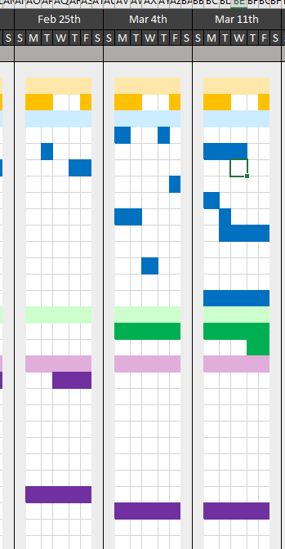

Ghart chart

I had to move my Ghart chart up to help with Things which were said in the meeting and hopefully I will be able to pull it off by the deadlines I have set my self

Celica
On Monday I started as was able to finish the base of the Celica which will be replacing the vehicle, I did last semester. I found that this model is way better because I was able to use the knowledge when I was learning to model the jaguar f type and apply it to this one.
I am happy with the results and with an hour or two more work I will be able to finish it nicely
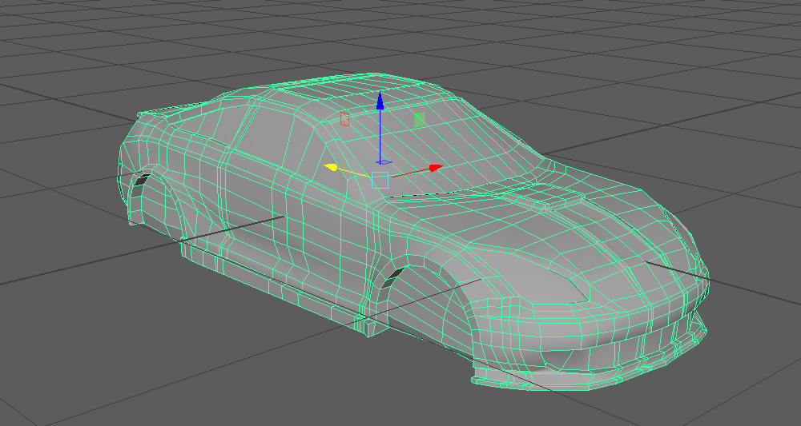
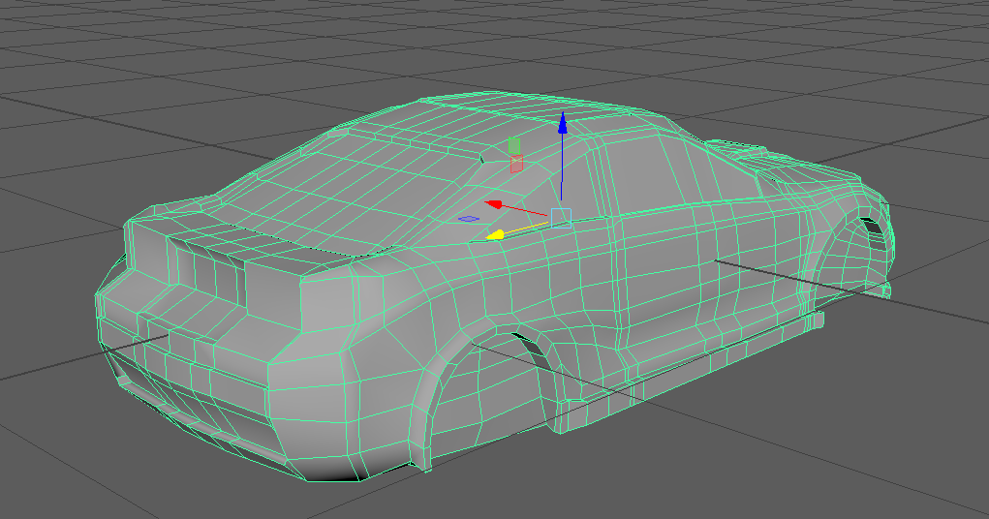
Also, I will have to wait on concept designs off harry for the wheels as he as offered to do it for us. And this will hopefully take a week as then I can get the car to mitch to texture asap.
Tuesday
Celica
On Tuesday I did some more work on the Celica and was able to add more to it and smooth it out and by the end I was happy with the result. I like the way it looks, and I am happy with the overall design of it.
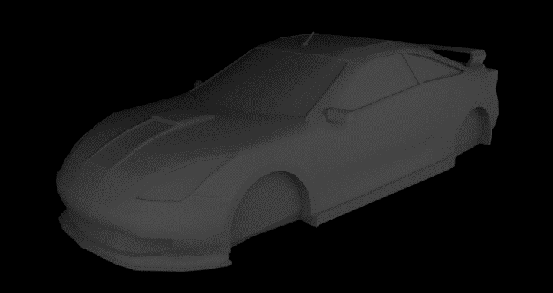
The only thing I must do is wait for the wheel designs on the car and then UV unwrap the model. This should take me a hour or two to be able to complete when I get the designs of the wheels.
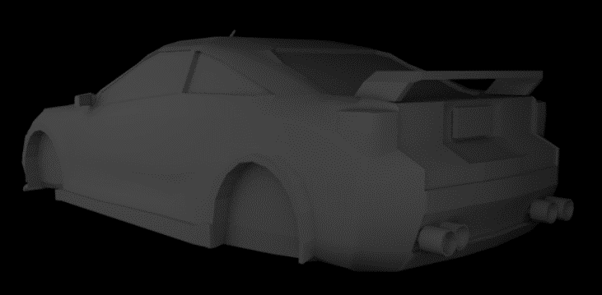

Wednesday
Road Mapping
On Wednesday I started carrying on with the road mapping and experimenting with lighting and I ran into a problem with lighting to I reverted back to the old save and planned it as I should and lighting I have planned to do in a few weeks at the end.

Thursday
Road Mapping
On Thursday I was able to finish the road layout. Once I finished it I tested the game and then I got Jordan to test the level and we both could see the problems we were running into.
Firstly, the curb on the road, this is because the was a bevel on the curb and because of the way the car react that car was sticking to the curb and then launching off the track and it didn’t feel nice.
Secondly, we found the walls were to basic on the city side of the level.
Thirdly and the poverty side you couldn’t see where the coner was and we had it without walls or barriers and we didn’t like this
These give me everything I needed to know in order to improve the road and make it feel nice.

Friday
Road Making
On Friday in lesson I remade the road and I was able to create every road and UV unwrap them in that session and was able to import them into unreal ready to be Laid out.
Once I put them in the level, I could instantly see a huge difference and me and Jordan were very happy with how much It felt better that the night before.

MechaZilla
On Friday i started work on Retoping MechaZilla and within 2 hours I was able to Retop the main body without the joints and spikes. I left this task for Saturday. So far, I am happy with the retop and on Saturday I will hopefully finish the whole thing and UV unwrap it or if not by then, then it will be done on Sunday.
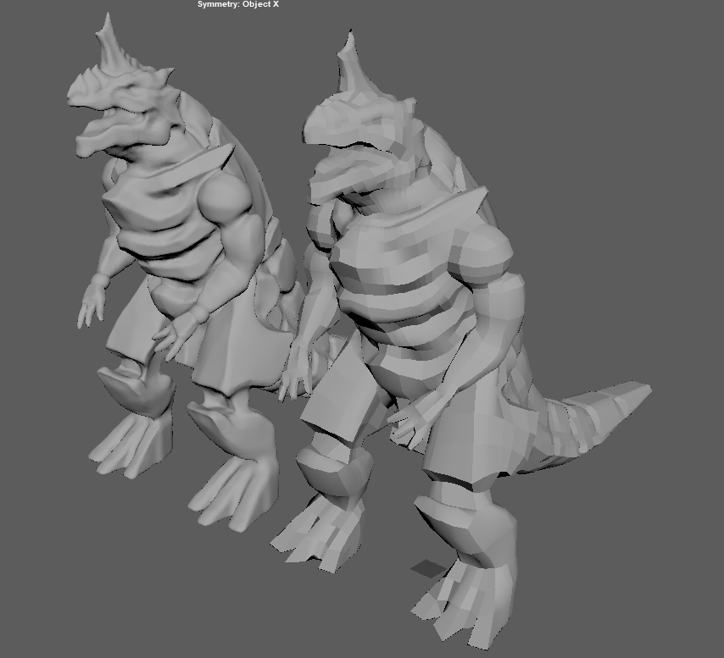

Wall
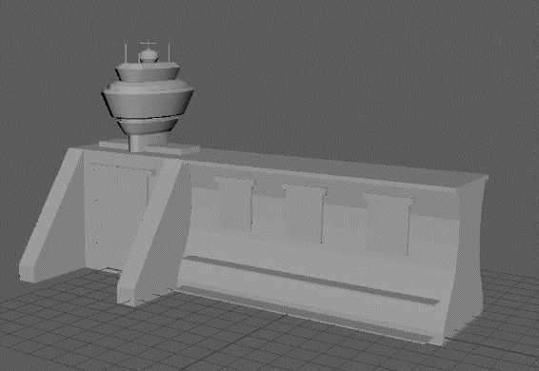
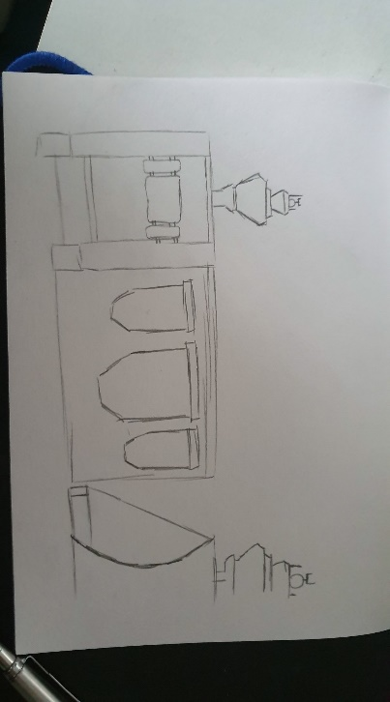
Friday I also decided to start the model of the wall. I did a concept on paper and I liked the design but I wanted to make sure so I took 30mins of time to model this wall and I was very happy with the end result. It felt nice but simple and when sending the model to a team mate he really like the wall as well and what we agreed on is we will add more different types of models to the wall to make each part of the wall more unique so it felt more natural.
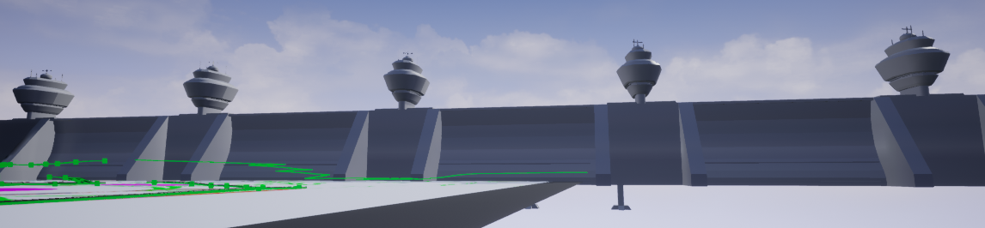

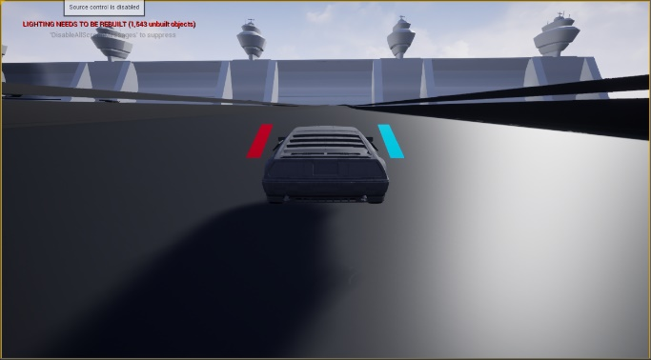

After testing the level, we talk and found what could change and I added more edges to it just to make it not feel as bland. Then after I edited the model, I was very happy with the result and I UV unwrapped it that night.
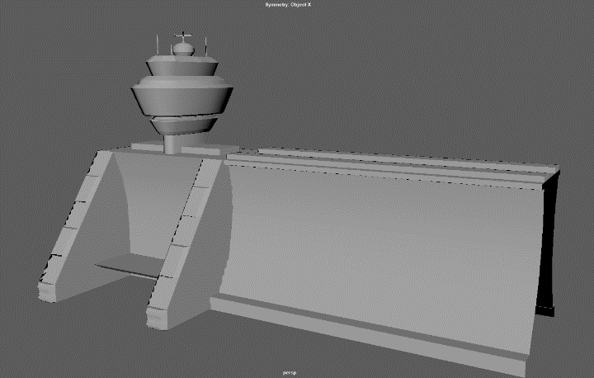
We talk about what makes the one the player going into different and my idea was that you have a big red sign which it warning people not to go in and all of the other portals and green and look fine. But this will be discussed on Monday with the team and then I will be able to go from there. I also tried a tarp on the wall to see what it looked like
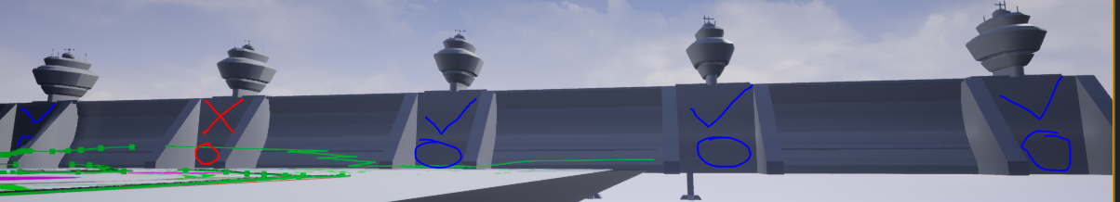

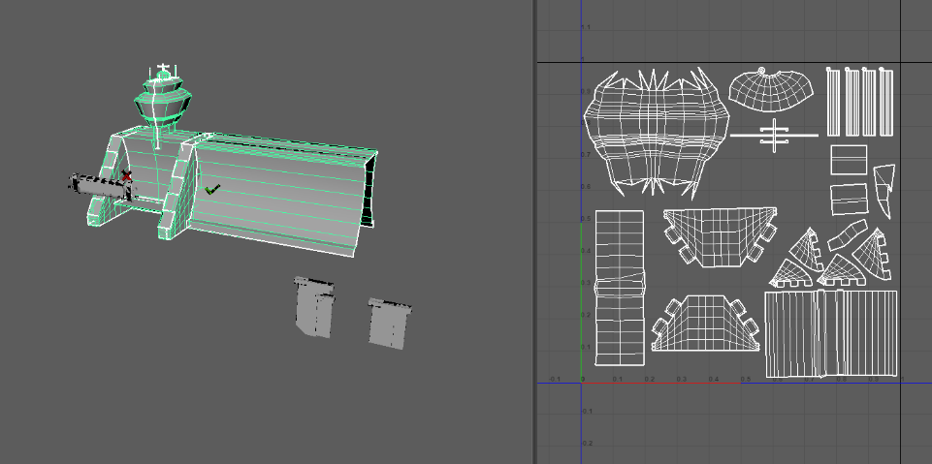

On Friday I also did some quick designs on light and traffic lights and some signs and some train rails. These ideas I will have to discus with the team to see if they like them or if something will need to change,
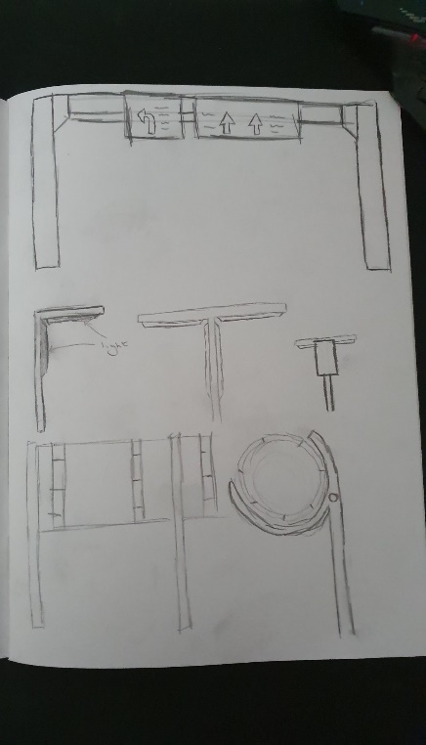
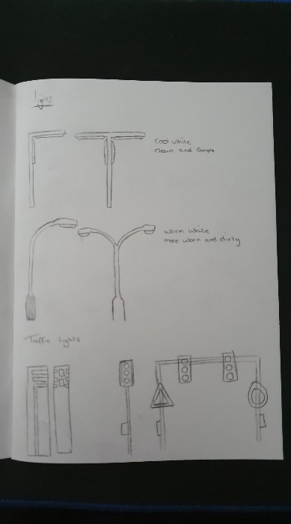

Saturday
Godzilla Stuff
When I had the Model, which was done in zbrush Off mitch, I ran into problem straight away. Firstly, I ran into the problem with the teeth. One tooth was split up into though ands of polys which were not joined and all separate. To fix this problem I took the teeth that were broken, and I remodelled them in Maya to match the set below is a picture of the teeth after I had finished.
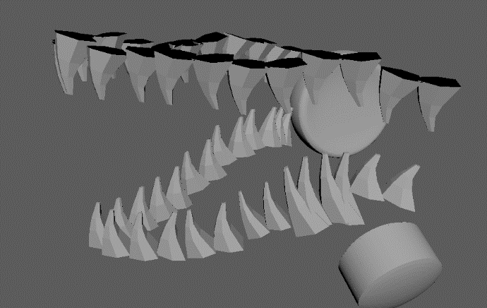

After Finishing the teeth, I noticed that it was still lagging. When I click the joints, I noticed that they were way too high poly and there were to objects inside of each other and they were not dynameshed to join them in brush so they become a new object.
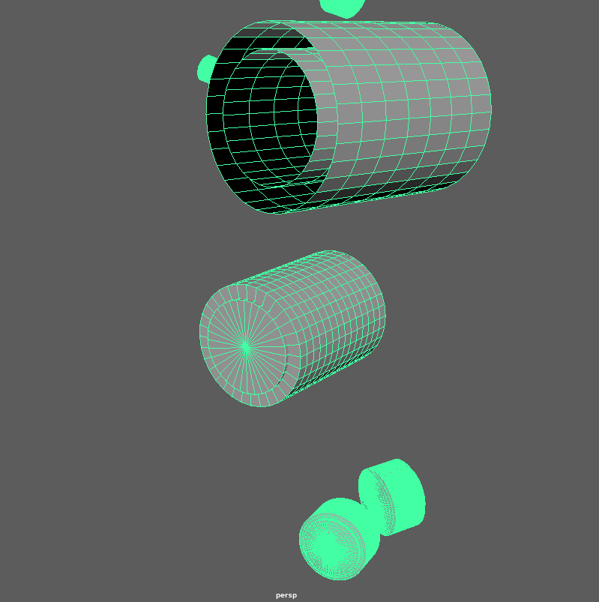

These are the problems. As you can see they were two objects inside of each other and then too high poly when there was no need too. So for the knee I created this
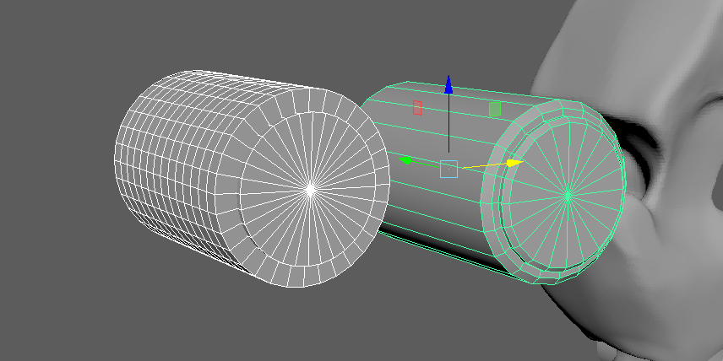
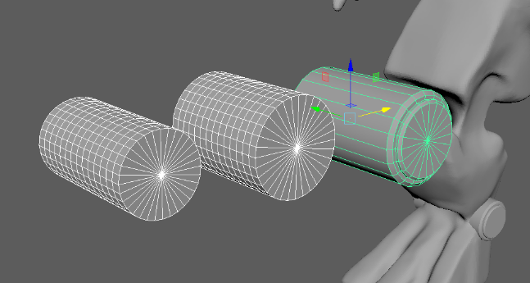

In Maya I put them beside the one that mitch give me. The one highlighted in green is the new one I did. I was pretty happy with the outcome as it looked similar and better while keeping a lower poly.
Then I ran into the shoulder pad
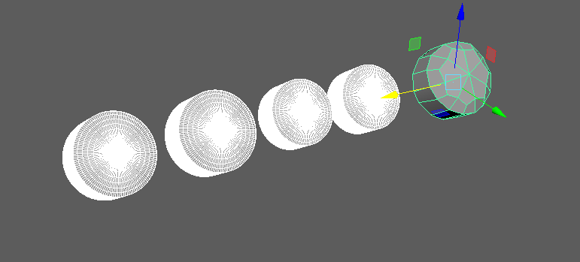
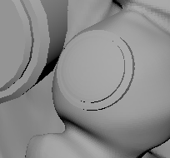
On the image on the left is what I see and when I deconstructed it, it had all of the objects including the low poly at the end which is selected in green in that one shoulder.
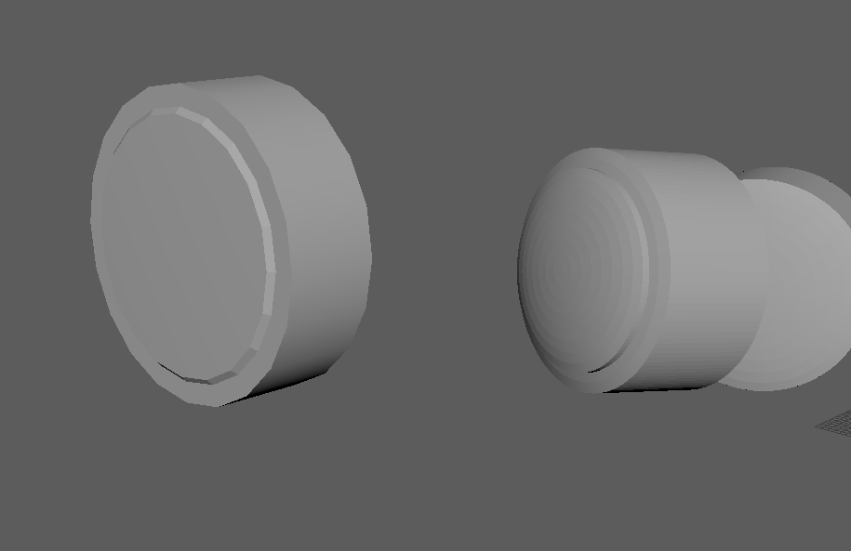
Below I recreated it again. This type It was as good as the other one in looks but it had a way low poly and fitted the same.

After completing the joints I selected the spikes and there was another problem
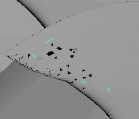
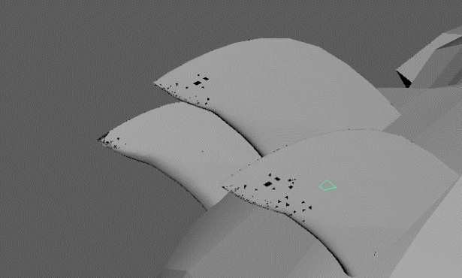
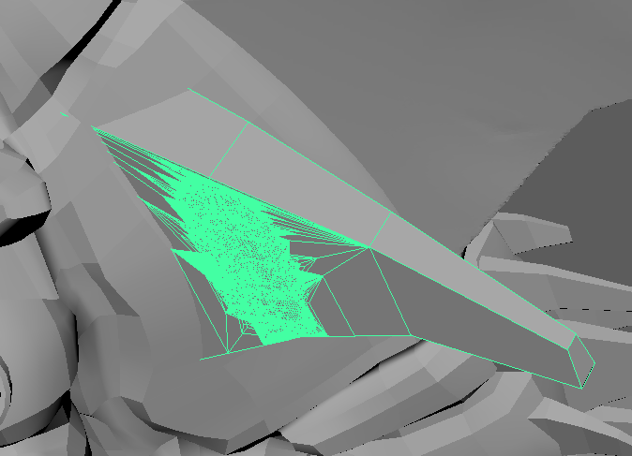

The spikes on one side had bad retopology and I tried reimporting but that didn’t work and all the spikes where like this. I also had a problem the same as the teeth with some spikes. I noticed that the spike was not that high poly and looked like they was not edited in zbrush. So I decided to re-do all the spikes in Maya and I came out with a result which I am happy with.
I was pretty happy with the results of these and I double checked the results with mitch and Jordan and these changes stayed but I made them to be the same as what mitch give me.
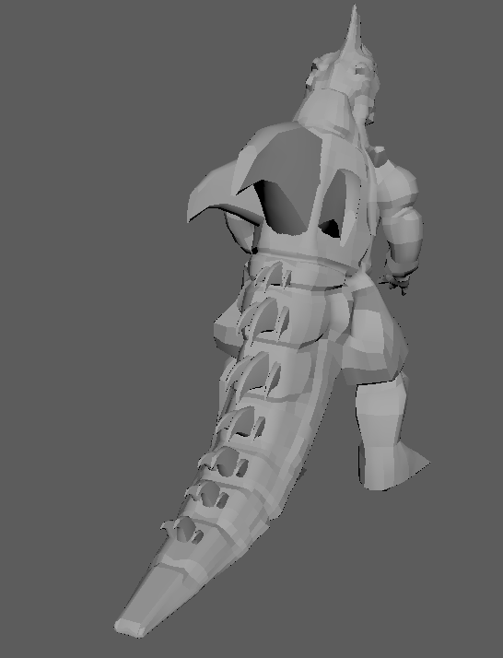
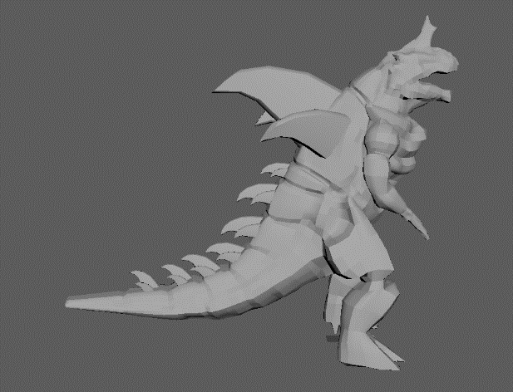

Once the model was fully done, and I couldn’t find any problems I then put it in substance painter and tried the baking to make sure it works with the low poly. I first made an error in baking but that cause I did it wrong and after 5 minutes I was able to fix it and then I upload the substance file for mitch to start painting. I also set the Maya file up to Jordan can easily see where what was.
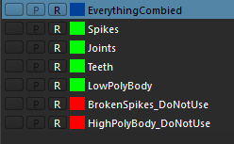
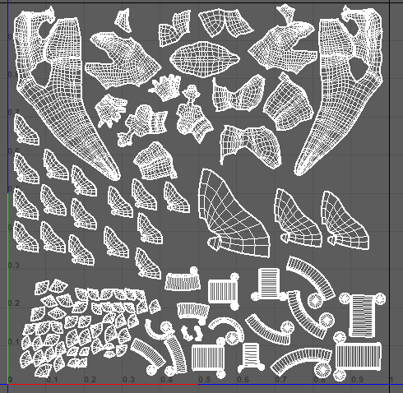
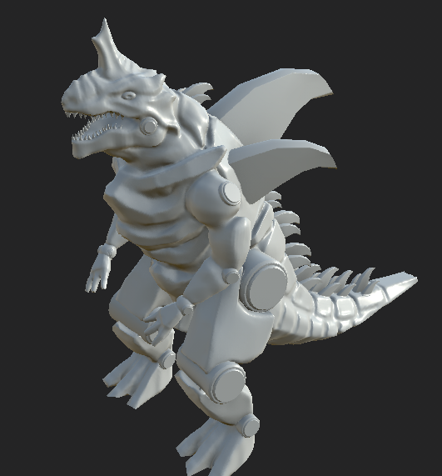

Sunday
Road Mapping
I sent 2 to 3 hours on Sunday doing one side of the levels track and mapped the main road which the player will be driving on then I mapped out all the sides roads which you’ll be able to see but can’t drive on.
After I did this I wanted to see if there were any problems with the roads, so I had Connor test them out. I didn’t block off any of the junctions cause I wanted to test the roads its self to see if there was any problem. What he found is in the circle it would launch the car and once it went through the barrier, but it never happened again. I was able to fix the Jumping of the car by smoothing the road but I am unsure about the glitching though the wall and will keep play testing in making sure that it doesn’t happen again.
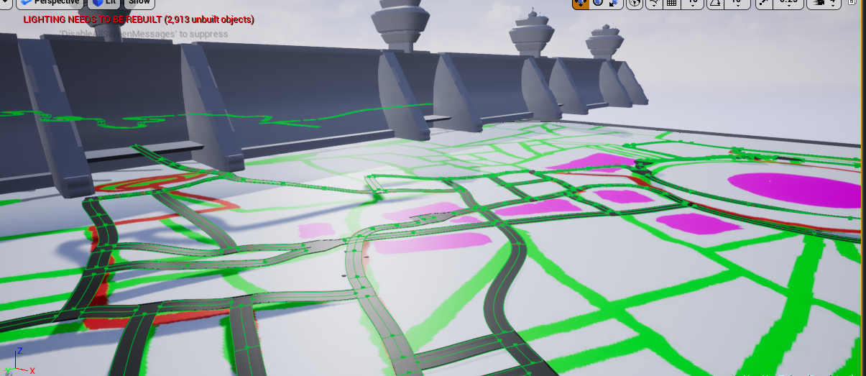
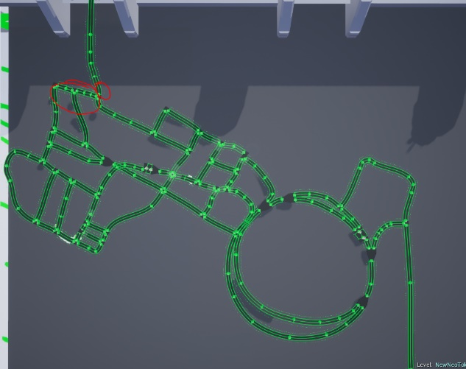

Week 8 – Mar 18th

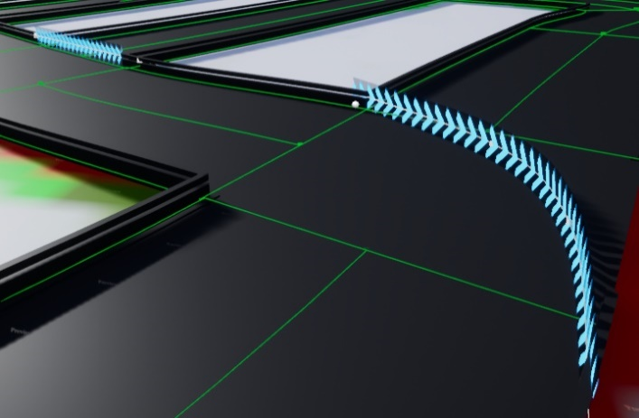

This week I added in the arrows for the level. These were made by Connor Hale, but I edited them to make them into a spline. I did this so there would be easier to place and I can make arrows which bend around corners. I am happy the way these turned out and these will be good for projects in the future.
Seamless portals
https://www.youtube.com/watch?v=F28NKqG7ce8&t=681s
Making seamless portals. I was using the YouTube videos where he talks about and making the seamless portals for the game.
Only thing I will have to change is the Plane for the portal will have to make my own for it to look nice and seamless.
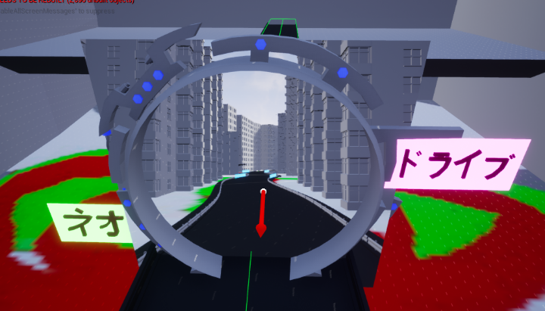

When I did complete this tutorial and get it working I found that the lag in the game was servilely increased so when looking into this problem I could find a solution to keep it while it not lagging so I disabled the camera for the portal

Game Testing
I did some game testing on the game to see if anyone can find bugs in the game and to find out their experience in the level.
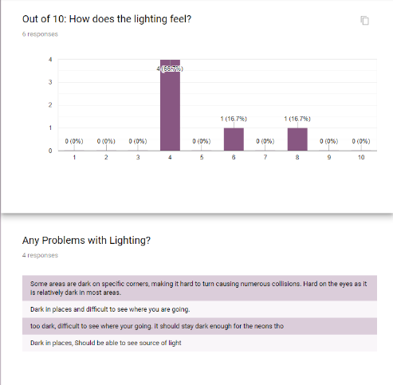

Here is one of the results of game testing. This section is on lighting. At this point in the game I only put basic lighting in just to make it night-time, but I knew I had to edit this part. The feedback shows that I needed to work on this, and lighting will be redone in one of the weeks ahead.
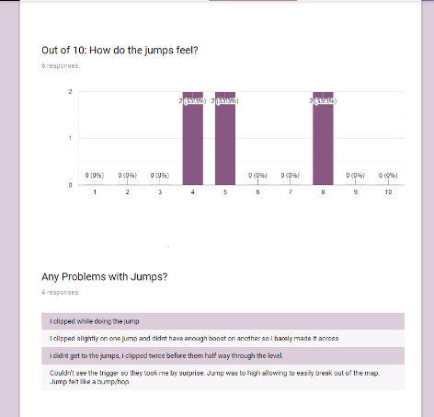
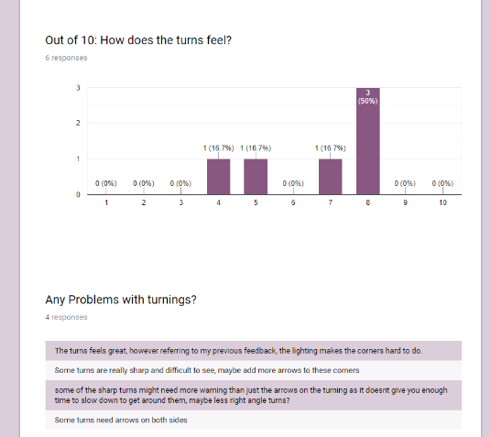

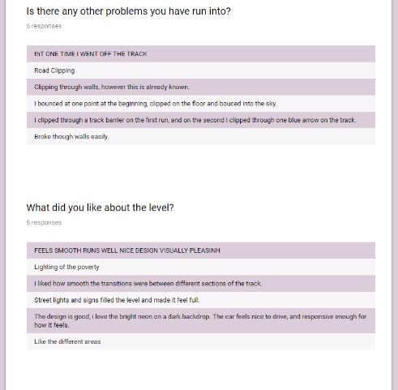
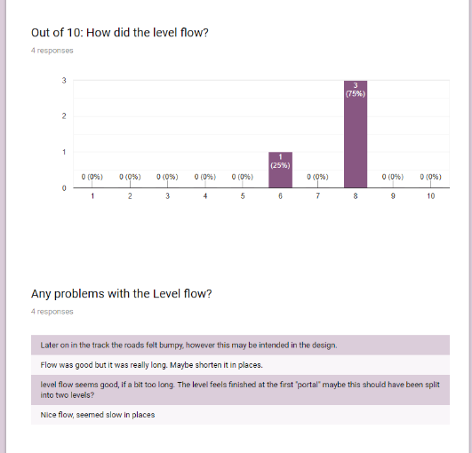

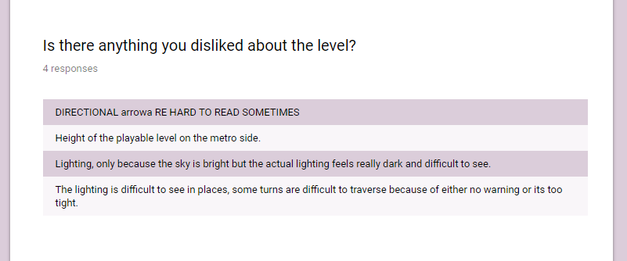

These are the information I got back from game testing after lighting. I found on that people loved having the streetlights in the game as it made them feel like they were going a lot faster. I also found out that people loved the seamless portal and it didn’t stop the flow of the game. The feel of the track was nice and turning people also liked which I am happy with.
The bad points are that some people clipped through the wall. This problem I know what the problem is, because I don’t have the new updated vehicle and the vehicle, I had didn’t have the Collison the normal vehicle has. So, I will come back to the problem when we have complied the project together and have the right vehicle in there. Another problem that people brought up is that sometime the level jumps so when your driving along the track the level will chuck the car in the air and the player can go off the map. To fix this I will put in collision boxes in where they jump as I have tried to move the track and adjust it but it doesn’t seem to fix the problem so with the Collison boxes in if the player was to run into this problem then the Collison box will keep the player on the track.
Play Testing
On the first week I did two building as concepts. When I looked back into them, I noticed that they were quite high poly compared to what I wanted. So, I re-did these two models and created two more and I was able to take these 4 models make them into splines and add them to the level.
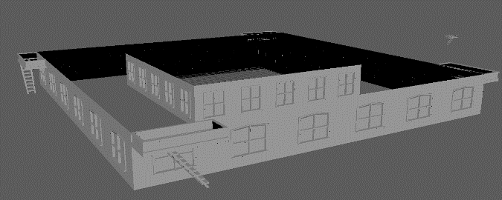

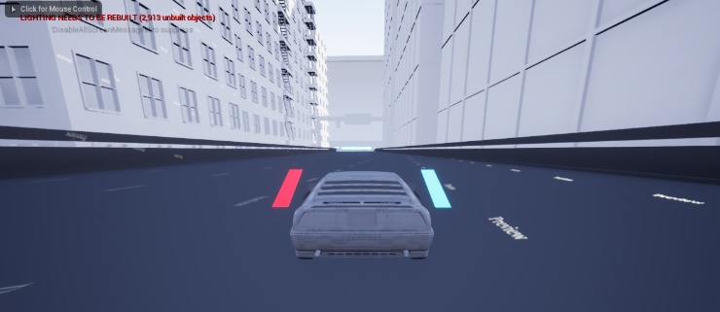

This week matt was having a problem with Noah’s models with the different textures. He wanted it so you can see the textures both sides while having collision on both sides while also having a problem with bending the track with a spline. So, I took one model to explain to matt the process which I think is the right way to fix the problems he was having. I took the model deleted half of it because there was not need cause of the spline and add different materials on the object. I asked matt to tell Noah what to do for this next model for the road.

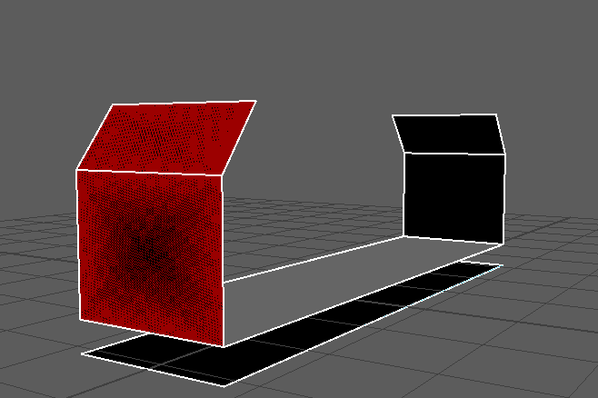
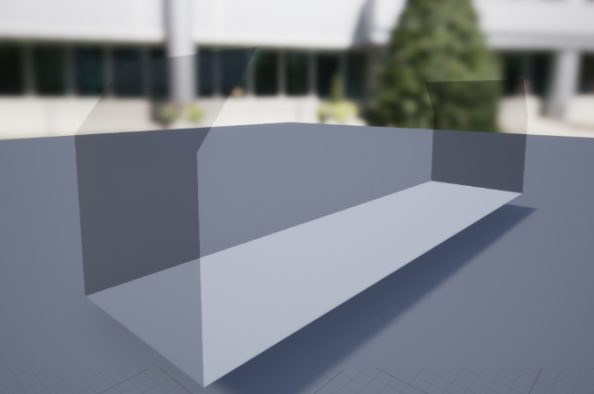

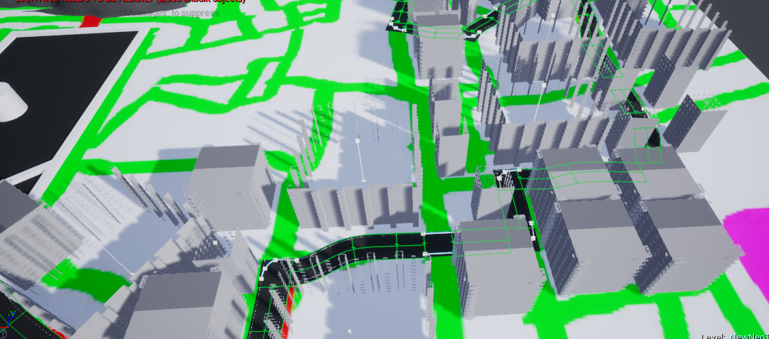

Play testing
When I started to game test my self on the pov side of the world I found a problem which I was able to fix in 5 minutes. The problem was the new roads on the pov side. Cause they had barriers which then had a gap between them the car was able to go through the gap which will then allow the player to escape the track and go where they shouldn’t. To fix this I went into Maya and took eh barrier and just made it longer so the gap between them was closer. After then reimporting it and game testing I was unable to break this and the car would just stop which was good. Put in building to build up the area around you and to test how the felt in the game while driving on the level

Week 9 – Mar 25th

Changing my Ghart chart
As I found that my Ghart chart was not helping me I decided to take time to redo it. I have split the Ghart chart up into 4 parts. Team meetings, Modelling, Texturing / UV unwrapping and unreal. I have planned until the week April 15th this is because I want to leave flex time and I hope to get most of the assets done by this time. The only think I have planned for after this week is the Game testing as this will be important to make sure the game feels smooth.
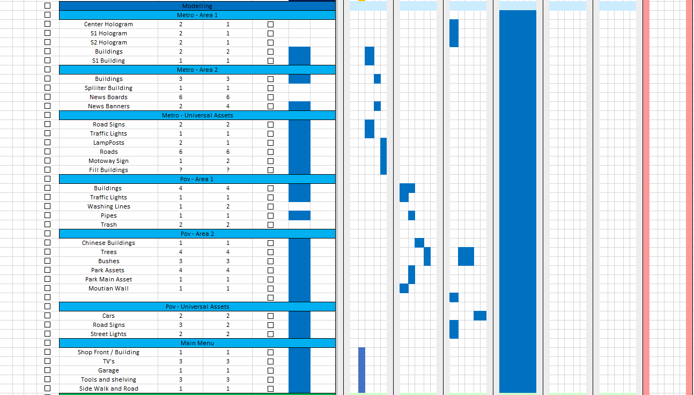
This is my new Ghart chart
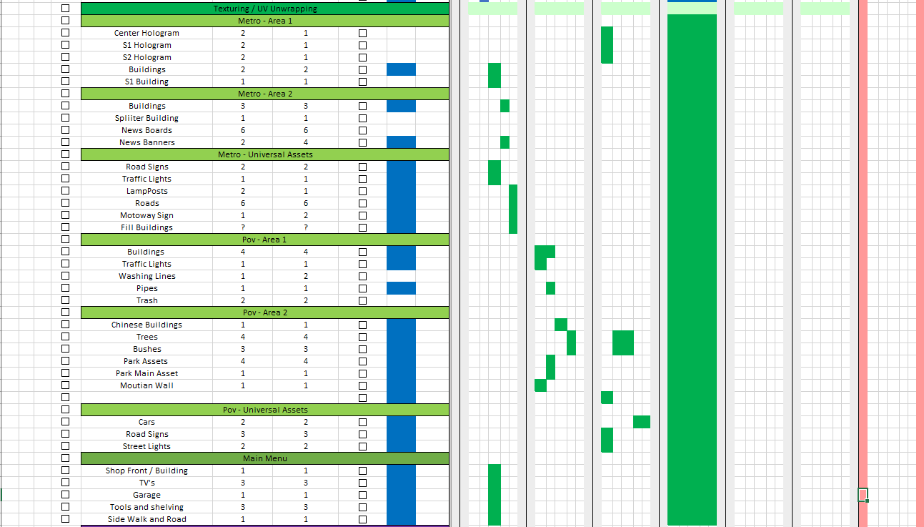

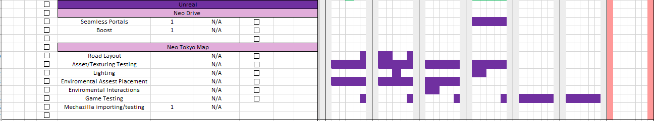
Overall, I will be filling I will be reviewing this Ghart chart every Monday making sure I check what I have done

Week 10 – Apr 1st

Trees
On Wednesday I set out a task for me to be able to make at least on tree. I give myself this much time because I have never made trees before and I wanted to know, but also knew that it was going to take longer than all the other things I do.
When I was making it and following a tutorial (https://www.youtube.com/watch?v=cPu0pBuwP9Y) it should a plug in which help make the branches and give you the tools to make the process quicker. But when I got to retoping I realised that it wasn’t working. When looking more into it I think that the problem is to do with the new software the tutorial is using a older software version compared to the one that I have. This means that the thinks I was trying to do it wasn’t working.
After I spent about 2 hours trying different thickness, settings and models I decide to make then in the new week to come because I knew that I had other plans to work on.
So, in the next week I will work on trees and give myself 2 days to make them. I will change the software and go onto Maya instead of Zbursh. This will allow me to work on a more familiar software but all I need to do is learn how to make then and the best way to make a tree in Maya.
Unreal Problem (Lag)
On Friday I did a play testing session where I got the people in the class to test out the level to find the bugs in that level. But at the start I found that the level went really lag and basically not playable. What I did notice was after a little while it would become fine and run smoothly but there were areas in which the FPS would drop.
I was able to get thought the play testing session which a few bugs. But for the Lag I will have to sort that out in the next week and see if I can find away in reducing this problem.
Playtesting Session
On Friday I ran a play testing session in which I allowed the people in the class to play the whole level to see if they can find any new bugs that I haven’t already so I will be able to make the game better

Week 11 – Apr 8th

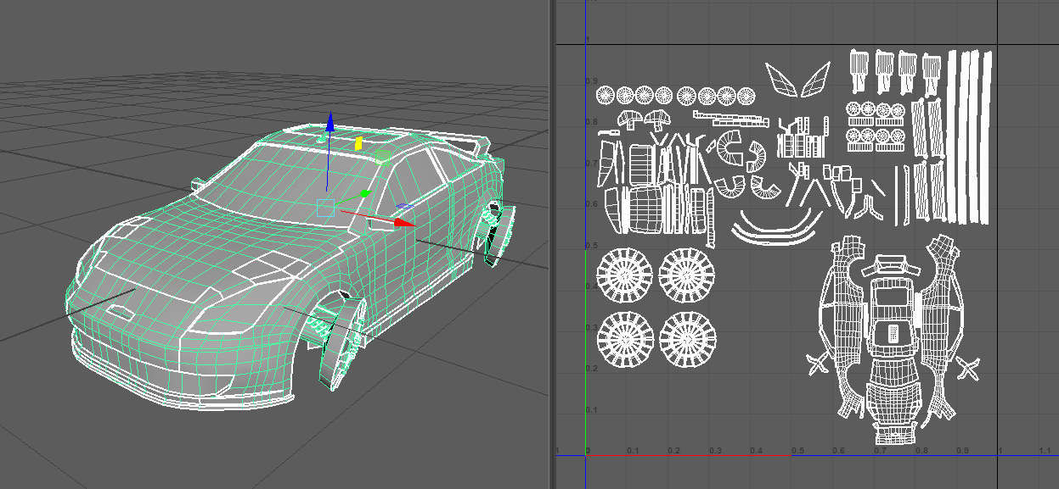
- UV Problem- with how in uni the machine was cutting everything when you would press unfold even though the auto fix was checked off
- For the time scale dealed with the problem finish the UV wasn’t best but it had to do

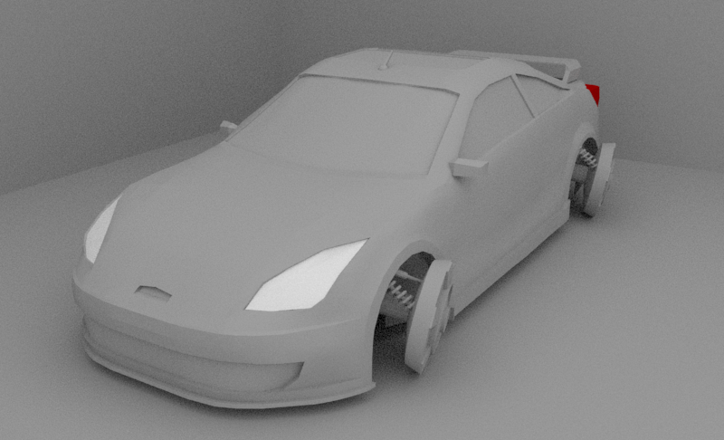
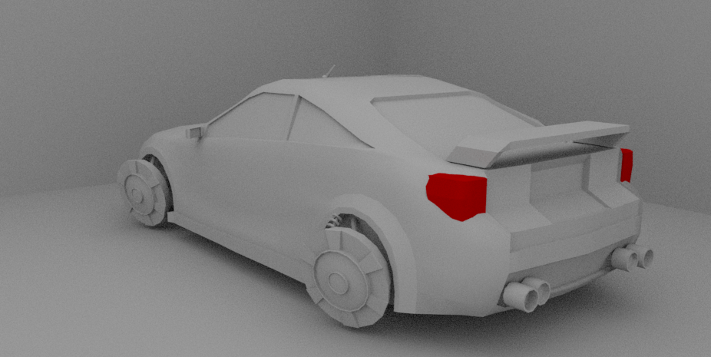
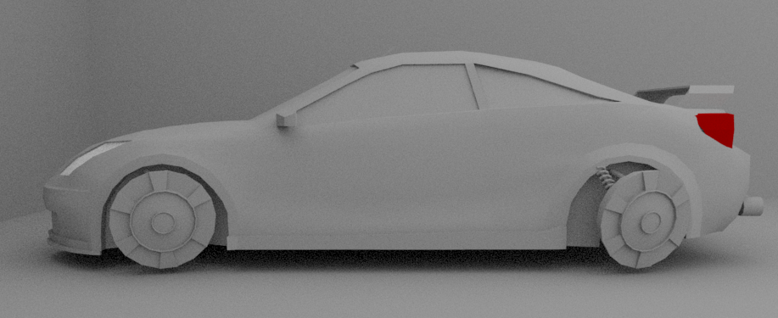

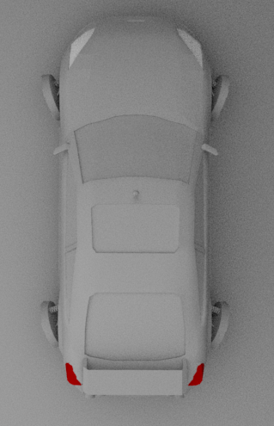
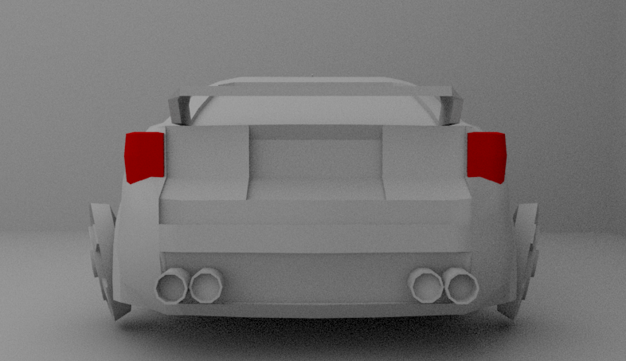

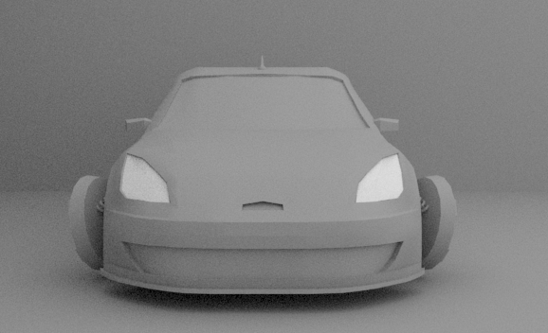

Unreal Problem
In Uni Connor told me that another group in a different here had a similar problem. They said that this was caused due to lighting in the level. The way they fixed that was making it a static. For my level I went on and I tried it what I found was it was no more lag but there was not lighting on the lights. So, I then moved on to making the light a stationary lighting. This stopped lag and produced light in the level.
Excel Following Problem
AS the more and more week go it still getting hard to keep up with the table, I have made for myself. This is because I am tasking too many tasks off teammate or helping them to do their task rather than sticking to the one, I have for myself. I am disappointed with this problem, but I know in the future where to improve on now. I think this problem accord because there was no set leader in the group and when people looked at someone, they looked at me which I was not planned for. Next time I will make sure that we have a set leader so people can ask for help off them but also if I am the leader next time then I will make sure I have planned everything and made sure that everyone is on task and if someone has never done a certain task I will make sure that they have made time for them to learn it while not giving themselves too short to long enough to do it in.

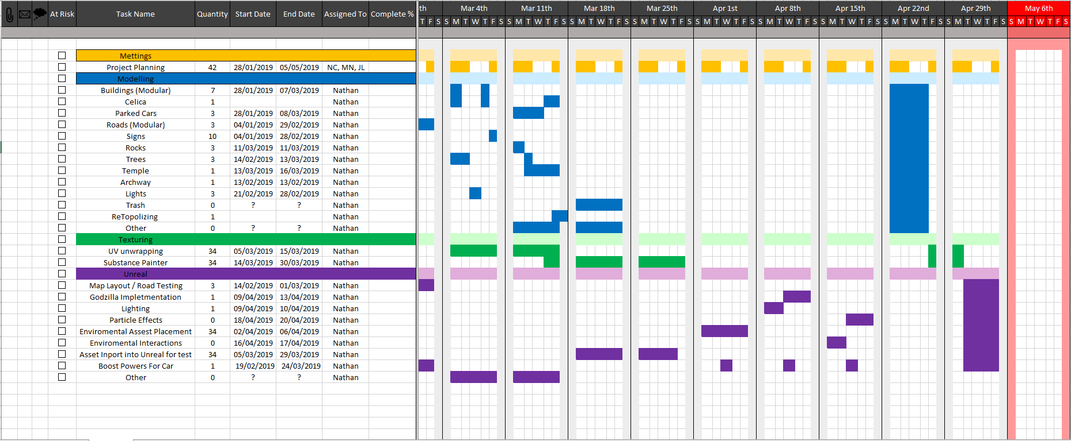
Overall even though I am not following my Ghart chart correctly it has made me realise what I must do. Without this I don’t think I could understand what to do next, so it has helped me but next time I need to make sure to stick to the Ghart chart to finish the projects for the future. Another thing I must stop doing is taking on too much work and because of this I think my production dairy and most of my other work has slacked this semester.

Week 12 – Apr 15th

Building Lighting Hologram Material Problem
The idea that the team had was having Godzilla as a hologram which allowed him to go into the metro side to showcase that there was a problem. Using Connors hologram material, I placed that onto the Godzilla mesh that we made and was able to make it look like a hologram. But when I built the lighting for the game there was a huge problem with Godzilla it made bright light everywhere throughout the side of metro. It was so bright that you couldn’t see anything. I asked Connor if he could help me understand why this wasn’t working and both of us could work it out.
The way we got around this was either applying the same material and the same colour as the hologram to Godzilla instead of it being red or we take out Godzilla hologram at the end.
Portal
In this week I was able to make the seamless portal mesh. This was the portal that was going to seamlessly take the player from one side of the map to the other.
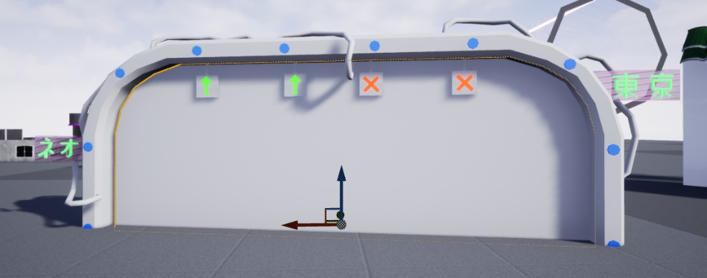

Seamless portal problems
The seamless portal problem that I had while building it was this type of portal was like portal the game. It allowed the player to see what was at the other side of the portal without going through it. This worked and the only problem which I made the decision to then get agreed on with the team to take it out was the fact that it was causing too much lag and I was under sure why this was happening and going find a solution to fix or replace it with. So, me and the team decided that we will have it as a blank plane for now which work in the same way but doesn’t show the player where they will end up.
Importing road textures
This week I started to import the textures mitch had done into the game. On first import I noticed that Godzilla was broken but after a day I was able to fix this problem as it was due to the wrong placement of a mesh. The other problems I had was the crossroad on metro side and one or two assets not fully complete. I was able to report this to mitch and he was working on the fixes.
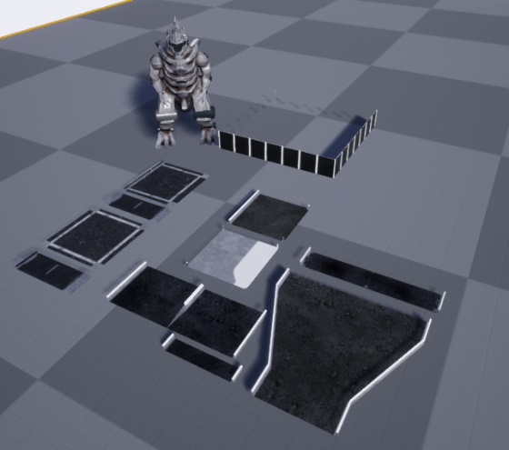

Week 13 – Apr 22nd

Trees
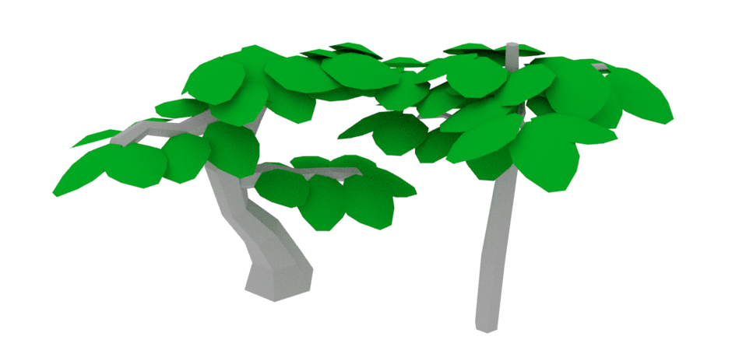
Due to timing issues looking at the plan we needed trees for the game to fill out the pov side of the map on the hill climb. Then I decided instead of going for realistic trees in the level and doing research I thought that if I made very basic low poly trees which can be a place holder if I have any spare time at the end I can focus on trees. If I decided to do the realistic trees, we wanted then the project would be late and not on time ready for compiling.

Placement of Assets
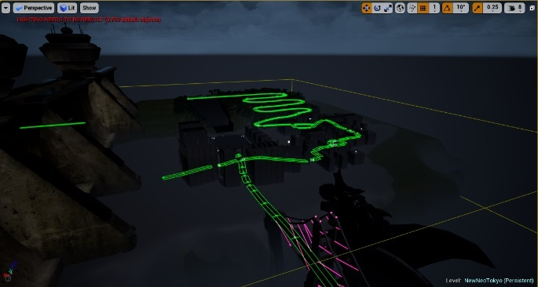
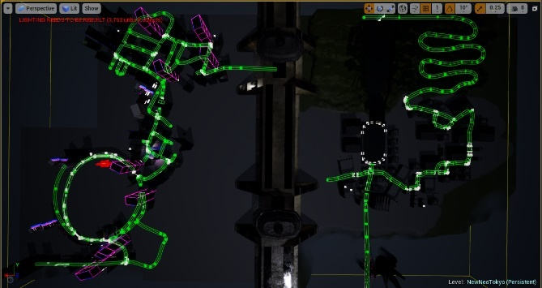
After I had made the trees, I took time in this week to place the rest of the assets which haven’t been made or done yet by myself. I started to place all the trees as foliage and placing building in certain areas which exposed a lot of the level when it didn’t need to.
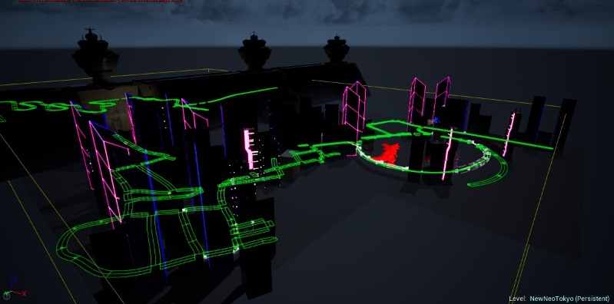

Lighting
Matt give me a link to a youtube video which gives lighting for unreal. I applied the night time and I found it was something that I needed but the only thing I changed was the brightness I made it a little lighter. This is the youtube link (https://www.youtube.com/watch?v=jlVKpQQ2J60) I think I will be using this guys tutorials again as they were very useful.

Downhill Slide
The downhill slide is a big part of the level as it breaks up the level from the roads. This week while placing down the assets I was able to make the downhill slide properly and add in blocking volumes in which stopped the player from going off course and also placing down the trees in the middle of the downhill slide to make a challenge for the player to get through.
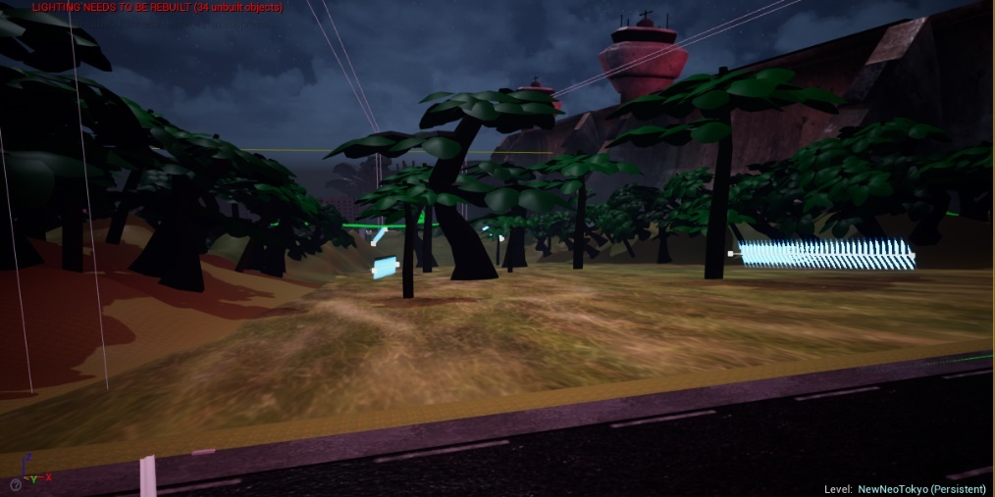

Lagging issues
In the game I was experiencing lag issues when I ran the game on the uni computers. Firstly, the reason why I didn’t see this problem before was because when playing on my own computer, my computer has higher specs compared to the uni computers. So, after seeing the lag I went into seeing which the biggest problem was I want I found was the lighting on every streetlight was turned to moveable. This means that the pc had to run every light making sure it cast shadows and if it was moving which put heavy strain on the computer. After changing these to either static or stationary depending on where the lights were. The lag issues change dramatically, and I could instantly tell the fps go up which was a good sign.
I will come back to optimizing the level next week.

Tunnel
There is an area in the map which support to have a hologram of Godzilla. But after playing it I found that it just didn’t feel full and you can hardly see Godzilla the way the player is driver. So, I decided to make a tunnel which fill an area of the roundabout where Godzilla would be after playing it in, it made the level way better in my own option and then showing it to the team they all loved the idea so this tunnel stuck in the game.
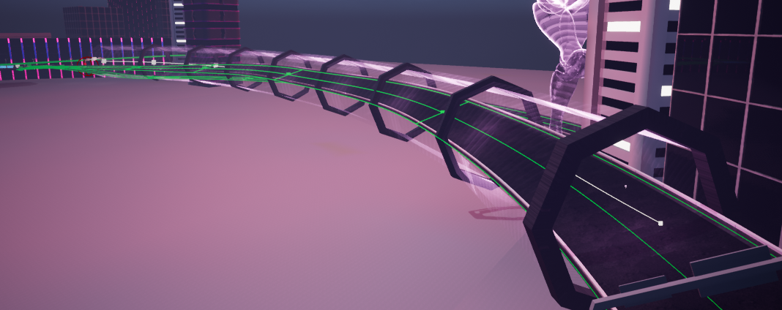

Lighting Change

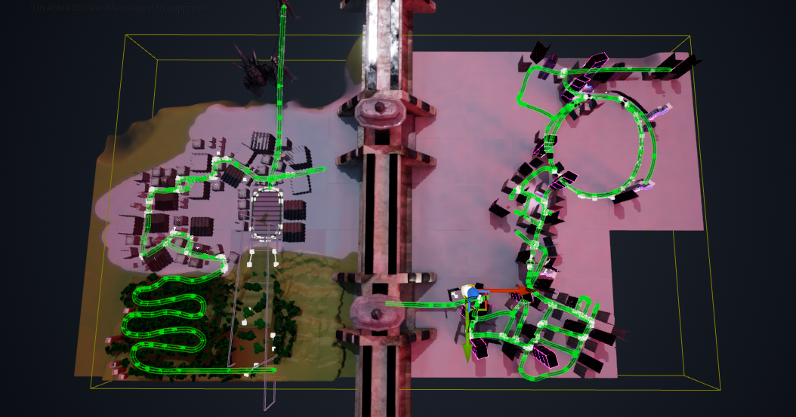

Week 14 – Apr 29th

Doing Textures
Mitched text me in this week asking for help with the texture he needs to do. Now looking back, it was the wrong decision for me to take the tasks from him. But I started to do small assets in the level like the archway and signs and little tasks like that. I even started basic texturing building which I purposely didn’t give to mitch as he kept telling me how much work he had to do. So, while my level was building lighting, I was able to texture every asset he told me, and I was able to work on the texture for the main menu which me and Connor came up with a couple of weeks back.
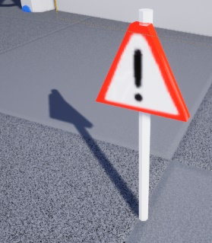
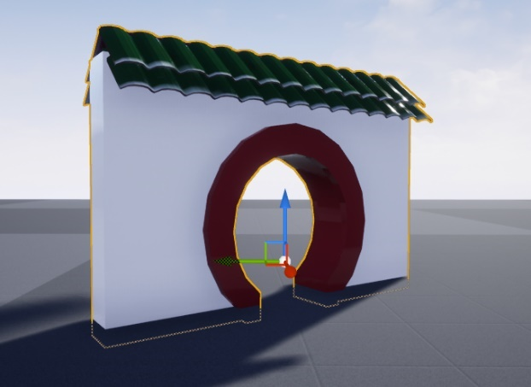

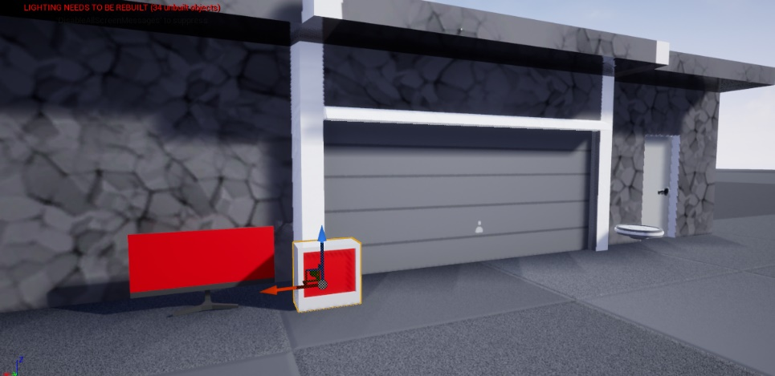

Texture Imports
This week I was able to import every texture into the game that we had. I decided to make a new level where it had 1 mesh with the texture that I imported so I can see what textures where broken or haven’t been done easily. Any other problems I had beside the road which I have said before I reported and tried to get fixed.
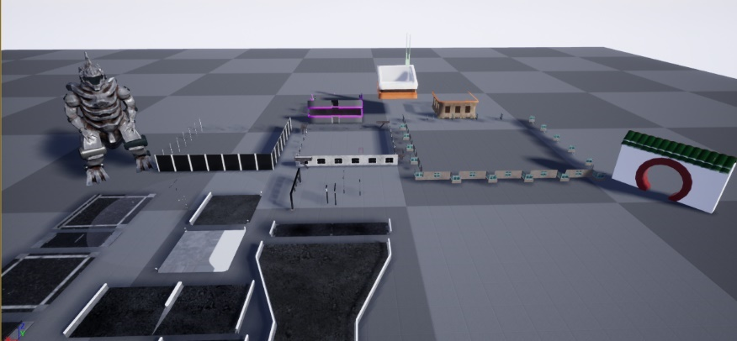

Animation Problem
In uni me and Jordan were trying to add the animations with the skinning model to our level after an hour I was unable to get it too work and when Jordan checked the animation nothing seemed to be wrong. I tired exporting the animation in different ways but me and Jordan were unable to get it working. I will come back to this at then end. I am doing it at the end otherwise the level can’t compile with the other levels.
Compiling
On Wednesday me and matt got together to compile out maps to one project. While complain we ran into a small problem which was then fixed 20 mins after where the name referencing was breaking the car. But when we reimported it, we made sure that anything to do with the vehicle was not imported from my level over to his. This worked nice and well there were only a couple of changes need which we knew about but the only problem I had left with my level was optimization but I can only do this now when matt uploads the new project on google drive and doesn’t edited more to it while I edit it.
Communication problems
Cause matt now had the new build of the level I knew that if I was to go and edit it again then we would have to compile it. I also knew that I had to optimise by changing settings to my assets. As I was trying to explain this to matt, matt went off and did it him self and started to change setting on my level. He also kept saying how bad my models and lag was in the game while compile. But every time I tried to help or give advice, he blanked me and did it himself. So, from this point on I don’t have access to the new updated one as matt keep editing his level and we don’t have the best communication.
Not much can be done now about this problem but in the next one we would need to communicate and listen more to each other and make sure everyone knows what they are doing at one given time.
Modelling fixes
Jordan came to me to talk about the model I give he. He explained how there were problems with history of the model. I found out this was because of the Neo Titan model problems the broken it saved it and I forgot to get rid of them. Jordan delete this for me but thanks to Jordan I know next time to make sure I double check all the history and make sure everything is neat and tidy.
Animation working
Jordan sent me the next version of the skinning as he found a problem with his. When I tried it firstly it didn’t work but then after downloading the file and exporting it myself with a couple of tries’ in unreal, I was able to get the animation working on neo titan. I have talked to matt who is compiling, and he will add it in with my help.

Week 15 – May 6th (Deadline)
Bibliography

https://www.youtube.com/watch?v=-7hFlgvh3J0&list=PLyl1H9kKlS_lbtJF-E0VXGQun6kMjhe6n&index=3&t=788s

https://www.youtube.com/watch?v=F28NKqG7ce8&t=681s

https://www.youtube.com/watch?v=cPu0pBuwP9Y

https://www.youtube.com/watch?v=hzkvqGCB72M

https://www.youtube.com/watch?v=JOD0lquwLe0&t=603s

https://www.youtube.com/watch?v=jlVKpQQ2J60

https://www.youtube.com/watch?v=jlVKpQQ2J60

https://www.youtube.com/results?search_query=maya

https://www.youtube.com/watch?v=xEQujyivsOg

https://www.youtube.com/watch?v=yV9_w_rA_F8&t=23s

