
BMSW4008
Evidence of Learning (E-Portfolio)
Digital Skills for Personal and Professional Growth
Petrica Filip (2024879)
7-5-2024

Table of Contents
Task 1 Essay………………………………………………………………………………….2
Task 2 Video………………………………………………………………………………….7
Task 3 Questionnaire analysis……………………………………………………………...8
Task 4 Design of the website and marketing materials………………………………….14
References………………………………………………………………………………….22

Introduction
Storytelling has evolved into a vital component of modern commercial marketing strategy. Unlike traditional advertising, which frequently focuses primarily on the utilitarian benefits of a product or service, storytelling tries to engage the audience emotionally, resulting in a stronger relationship with the brand. Reedy and Parker (2017) define storytelling in brand development as the creation and communication of storylines that reflect the brand's identity and resonate with consumers. This strategy focuses not only on promoting items but also on creating a distinctive brand identity that stands out in a congested marketplace.
This essay examines the role of storytelling in brand development, including its impact on establishing a distinct identity, cultivating consumer loyalty, and distinguishing out in a competitive market, using Coca-Cola as a case study.

Definition of Storytelling in Brand Development.
Storytelling in brand development is the deliberate creation and transmission of narratives that exemplify the company's values and objectives. According to Barker, R.T. & Gower, K. (2010), good storytelling goes beyond traditional marketing by engaging the audience with characters, stories, and emotions, making the brand more relevant and memorable. This story technique contributes to a deep emotional bond between the brand and its target audience, generating loyalty and advocacy.
The strength of narrative stems from its capacity to humanise a brand. Businesses may develop a sympathetic and compelling story by providing honest stories about their brand's journey, struggles, and accomplishments. This authenticity contributes to the development of trust and credibility, all of which are necessary for developing a strong brand identity (Denning, 2006).
Real-World Example: Coca-Cola
Coca-Cola is an excellent example of a brand that successfully utilised storytelling to establish and promote its brand identity. Coca-Cola, which was founded in 1886, has a rich history that it uses to elicit emotions and develop long-term connections with its audience through fascinating stories.
During the holiday season, Coca-Cola shares one of its most memorable storytelling moments. The yearly publication of Coca-Cola Christmas ads has become a worldwide tradition. These advertisements showcase the company's iconic red trucks adorned with glittering lights, which provide joy and happiness to communities. The "Holidays are Coming" jingle and the sight of the Coca-Cola Christmas truck has become synonymous with the holiday season, instilling excitement and nostalgia (Elliot,2014).
This seasonal narrative promotes Coca-Cola's image as a company that brings people together and spreads joy, creating an emotional connection with its target audience.
Coca-Cola's storytelling goes beyond holiday celebrations to highlight everyday moments of joy and connection. Their advertisements frequently include simple yet significant stories about people sharing a Coca-Cola, whether it's friends bonding over a meal, families getting together, or strangers connecting in unexpected ways. Coca-Cola uses these stories to position its product as more than just a drink, but also as a catalyst for memorable events. This strategy humanises the company and makes it approachable, establishing a sense of community and shared experiences among customers.
Coca-Cola has successfully constructed a story around tradition, emphasising the brand's continuity throughout the centuries. The brand generates a sense of timelessness and tradition by showcasing stories from multiple generations. Coca-Cola intentionally incorporates iconic glass bottle designs and classic red and white branding into its storytelling, strengthening a connection to the past while remaining relevant in the present (Pinto & Guarda, 2020). This narrative of tradition and heritage appeals not only to long-term clients but also to younger generations, assuring the brand's endurance.
The Power of Storytelling in Developing Brand Identity
Storytelling is critical for brands looking to develop a unique identity in a competitive market. A captivating story communicates the brand's values, objectives, and personality, making it more relevant and memorable to the target audience. According to Reedy and Parker (2017), narrative humanises a brand, allowing customers to connect with it on a deeper level.
Coca-Cola's emphasis on joy, connection, and history sets it apart from other beverage brands. Coca-Cola has created a distinct brand identity that resonates with people all over the world by regularly conveying these concepts via narrative. This distinct character not only makes the business identifiable but also promotes a sense of loyalty among its customers.
Increasing Customer Loyalty through Storytelling
One of the primary advantages of storytelling is its capacity to generate and maintain client loyalty. When consumers relate to a brand's story, they are more likely to form an emotional commitment to it. Customers experience a stronger sense of belonging and trust in the brand as a result of this emotional connection, which encourages loyalty.
According to Byrd (2021), the narrative may build anticipation and enthusiasm for a brand, driving recurrent engagement and long-term commitment. Coca-Cola's use of seasonal themes, such as its Christmas advertisements, keeps the audience excited for fresh material each year. This recurring narrative strengthens the link between the brand and its customers, increasing the likelihood that they will select Coca-Cola over competitors.
Stand out in a competitive marketplace
In a competitive market, storytelling is an essential tactic for brands seeking to stand out. A one-of-a-kind and engaging story has the potential to captivate the audience and leave an indelible impact. Sandhu (2020) observes that in an age where customers are inundated with advertising messages, a well-told tale can cut through the clutter and touch more profoundly with the audience.
Coca-Cola's deliberate use of narrative to elicit emotions and foster a feeling of tradition and community has enabled the company to maintain a strong market presence despite fierce competition. Coca-Cola has distinguished itself from rival beverage companies by focusing on storytelling that emphasises universal themes of joy and connection, cementing its position as a beloved and trusted brand

Conclusion
The ability to create captivating stories is an essential skill for businesses aiming to establish strong market presences and foster long-term emotional ties with their customers. Coca-Cola's use of storytelling to celebrate seasonal joy, share happy events, and emphasise tradition exemplifies storytelling's ability to engage audiences and forge deep bonds between brands and their customers. Businesses that embrace authenticity and true connection may create tales that genuinely resonate with their target audience, resulting in increased engagement, loyalty, and long-term success.

Task 2
Video
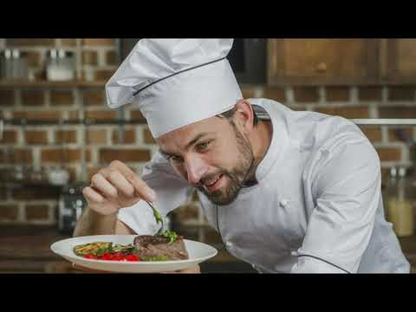

https://youtu.be/eUuB6NX6Ct4?si=8q318ov65TTTjgdJ

Task 3
Questionnaire Analysis - Introduction
This questionnaire was designed to obtain vital information about the prospective market for a new restaurant specialising in Romanian cuisine. The survey was issued to a group of respondents (University colleagues), to learn about their demographics, acquaintance with Romanian food, dining habits, and restaurant feature preferences. This analysis focuses on all of the questions in order to produce meaningful insights that will help shape the new restaurant's business plan.
Key Findings and Analysis
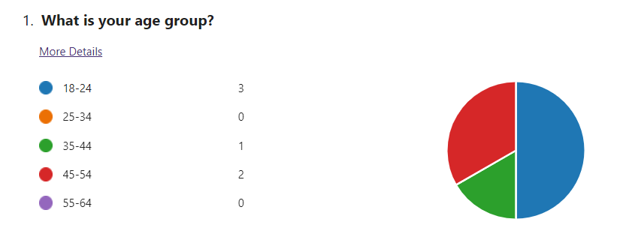
The bulk of responders are between the ages of 18 and 24, followed by those aged 45 to 54. This points to a potential dual-target demographic. According to Ostmeier and Strobel (2022), identifying a target audience's age demographics is critical for adapting marketing strategies and menu options. The restaurant should examine menu items and marketing strategies that appeal to both youthful and middle-aged clients.
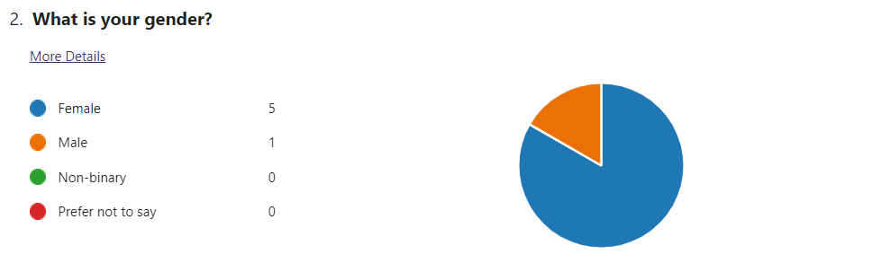
The responses are primarily female. Varenyk and Piskova (2024) emphasise the relevance of gender issues in market research, stating that it can influence dining preferences and marketing efficacy. The restaurant may concentrate on decor, menu products, and marketing that appeal to female guests, possibly integrating themes and offers that resonate with this group.
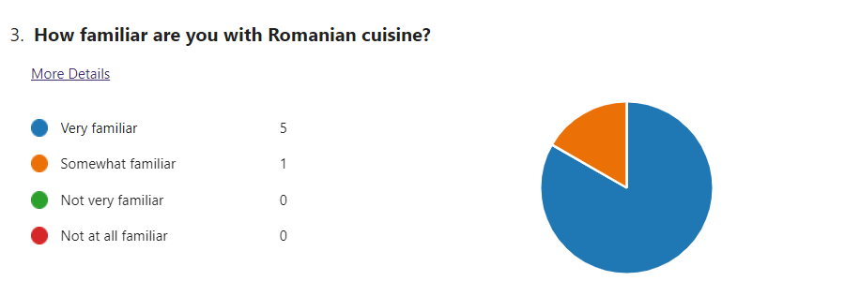

The replies show that the majority of participants are very familiar with Romanian food, with only one being slightly familiar. This high level of knowledge shows that the target audience already appreciates and knows Romanian cuisine. According to Ostmeier and Strobel (2022), understanding potential consumers' cultural and culinary backgrounds is critical for businesses since it allows them to adjust their offers to their expectations and desires.
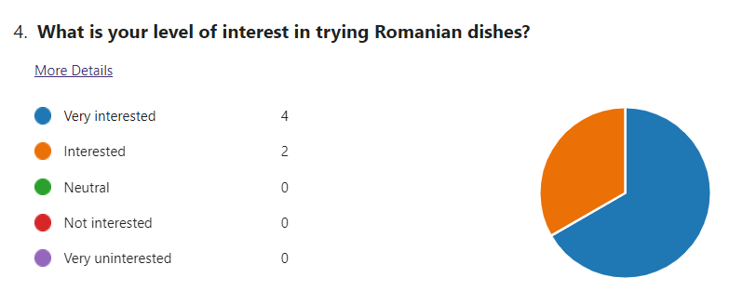
According to the research, all respondents want to taste Romanian dishes, with the majority being very interested. This means that the eatery has a strong market potential. Byrd (2021) emphasises the significance of leveraging current interests in order to efficiently recruit clients. The restaurant may capitalise on this enthusiasm by showcasing its distinct and authentic Romanian dishes.
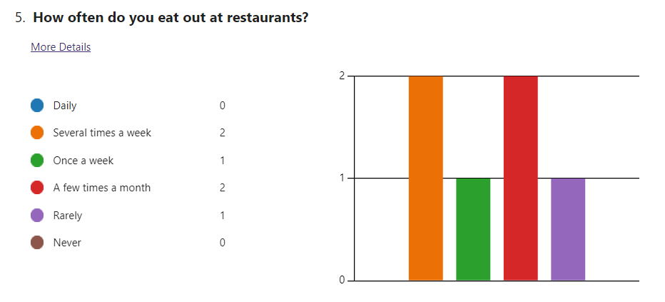The majority of respondents eat out on a weekly or monthly basis. This shows that the target population enjoys dining out on a regular basis, which bodes well for the restaurant's potential client base. According to Dadwal (2020), analysing dining habits might help with the timing of promotions and special events to attract habitual diners.
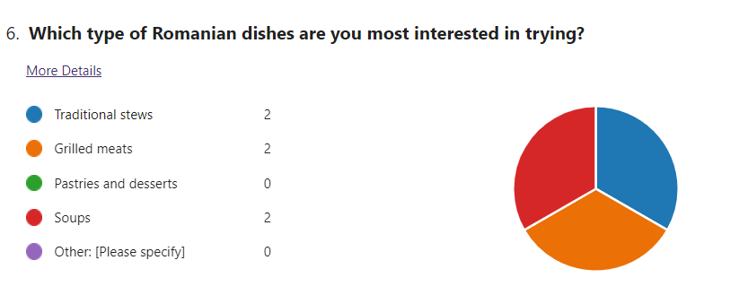
Traditional stews, grilled meats, and soups receive an equal number of responses, with no interest in pastries or desserts. This information can help guide menu planning, ensuring that the restaurant concentrates on the most enticing categories. Sandhu (2020) contends that emphasising on popular menu items can improve customer happiness and operational efficiency.

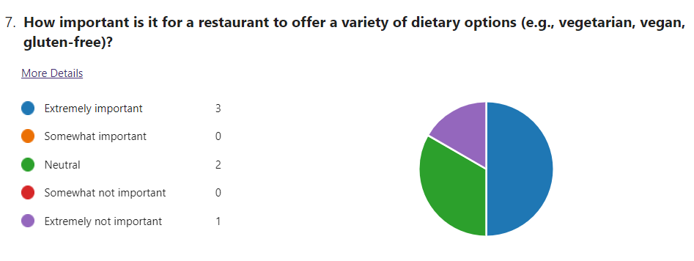
The findings suggest that half of respondents believe it is critical for a restaurant to have a choice of dietary alternatives. Varenyk and Piskova (2024) emphasise the growing demand for dietary inclusion in the food sector, which is driven by health trends and personal preferences. This conclusion emphasises the need of providing a wide menu to meet a variety of dietary demands and tastes.
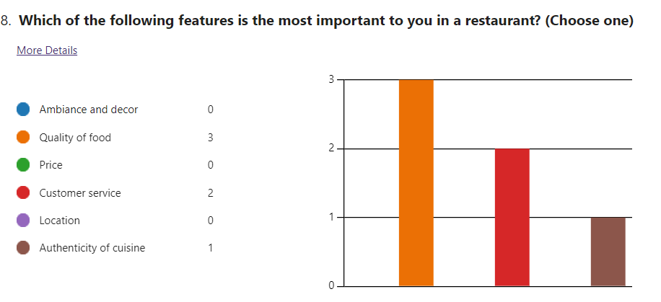
Food quality is ranked first, followed by customer service and culinary authenticity. This is consistent with Hill's (2020) argument that the main components of a dining experience should be high-quality cuisine and great service. To match client expectations and establish a solid reputation, the restaurant should prioritise these factors.
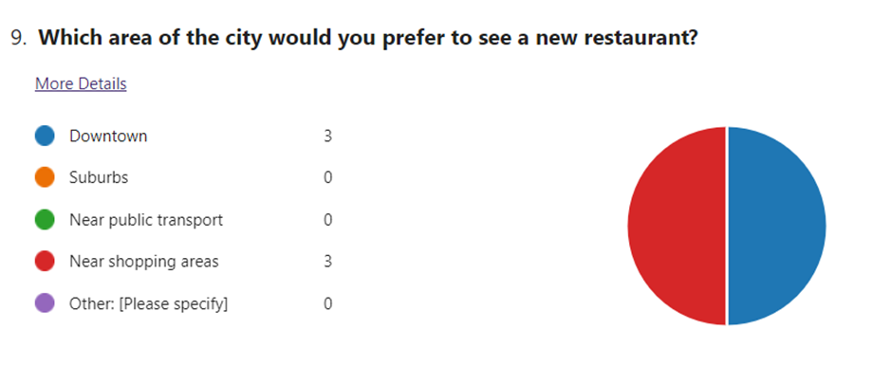
The preferences are evenly distributed between downtown and nearby retail locations. Gobble (2018) observes that location is an important aspect in restaurant business, influencing foot traffic and accessibility. The business should examine these sites to increase visibility and consumer access.
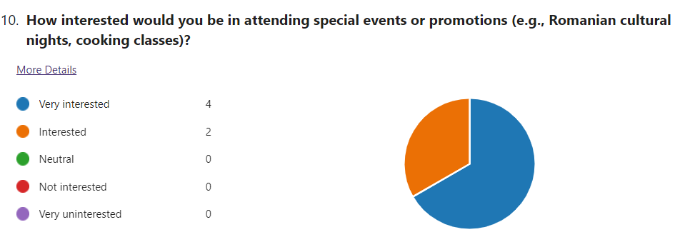
The responses indicate a strong interest in attending special events or promotions. This suggests that such events may be an important tactic for customer engagement and company uniqueness. Hill (2020) emphasises that providing customers with unique experiences can strengthen their relationship to the business and promote long-term loyalty.

Trends & Patterns
The examination of questionnaire responses reveals many trends:
- High Familiarity with Cuisine: The target audience is well-versed in Romanian cuisine, demonstrating a great interest and respect for the dish.
- Demand for Dietary Inclusivity: There is a significant demand for various dietary options, which reflects broader health and inclusivity trends in the food business.
- Interest in Cultural Engagement: There is a lot of interest in special events, which suggests that experiential offers could be important for the restaurant's success.
Implications of Business Strategy
The findings of this research provide actionable insights that may be used to develop and enhance the business strategy for the new restaurant.
- Menu Design: Emphasise real Romanian foods while providing extensive details to educate unfamiliar clients. To meet the various demands of your customers, offer a choice of dietary options.
- Event Planning: Plan frequent special events, such as cultural nights and cooking courses, to engage customers and establish a distinct corporate identity.
- Marketing and Promotion: Emphasise the menu's authenticity and inclusion in marketing initiatives. Promote special events to reach a larger audience and increase client loyalty.
Conclusion
The questionnaire offered useful information about the interests and expectations of potential customers for a new Romanian restaurant. By emphasising authenticity, dietary inclusivity, and cultural connection, the restaurant may establish a strong, loyal client base while standing out in a competitive market. These findings are consistent with broader trends in the food business, highlighting the necessity of recognising and addressing customer demands through strategic storytelling and experience offers.

Task 4
Integrating Questionnaire Insights into Website and Marketing Materials Design Introduction
The objective of creating a two-page website and marketing materials for the new Romanian restaurant is to proficiently convey the brand's personality and services, allure potential clients, and develop a devoted customer base. The information obtained from the questionnaire had a crucial role in influencing the design and content of the website and marketing materials. This review examines how the questionnaire data influenced the development of these materials, with a specific emphasis on audience segmentation, SEO optimisation, and the general content strategy.
Significant findings derived from the questionnaire data
The questionnaire yielded some crucial observations:
- Demographics: The 18-24 age group constituted the largest portion of responders, followed by the 45-54 age group. The audience was largely female.
- Acquaintance with Romanian Cuisine: The majority of participants displayed a high level of familiarity with Romanian cuisine.
- Dining Habits: The respondents routinely engaged in dining out, with many of them doing so many times per week.
- Dietary Preferences: There was a substantial request for a range of dietary choices, encompassing vegetarian, vegan, and gluten-free options.
- Event Interest: I am quite interested in attending special events and promotions, namely Romanian culture nights and cooking lessons.
- Key criteria: The primary factors considered were the food's quality, the level of customer service, and the authenticity of the cuisine.
Segmentation
Based on the data collected from the questionnaire, we have identified two main target audience groups: young adults aged 18-24 and middle-aged adults aged 45-54, with a notable representation of females. The website and marketing materials were customised to attract these categories by emphasising characteristics that align with their tastes and behaviours.
Individuals between the ages of 18 and 24.
For this particular section, the website and marketing materials place a strong emphasis on lively, captivating imagery and interactive content. The characteristics encompass:
- Event Announcements: Showcasing Romanian cultural evenings and culinary workshops to captivate the attention of this demographic and pique their interest in distinctive and exceptional activities.
- Social Media Integration: Promoting social sharing and engagement by incorporating Instagram and Facebook links, as these sites are widely used by young adults.
- User-Generated Content: Encouraging customers to contribute their eating experiences and images to foster a sense of community.
Individuals between the ages of 45 and 54.
This section emphasises authenticity, quality, and comfort.
Traditional Romanian foods are described in detail to cater to the audience's familiarity and admiration for authentic cuisine.
- Reviews and testimonials from customers: Utilising good comments and testimonials from content customers to establish trust and trustworthiness.
- Cosy Atmosphere: Focusing on creating a pleasant and inviting environment that is perfect for dining with family.
Web design
The website, consisting of two pages, was created utilising the Weebly platform, guaranteeing a user-friendly interface with easy-to-use navigation and visually appealing graphics. The webpage is dedicated to presenting the restaurant and emphasising important aspects such as the menu options, unique events, and testimonials from customers. The second page offers comprehensive information regarding the menu, encompassing dietary alternatives and elaborate descriptions of authentic Romanian cuisine.
Elements of a Homepage
The main image showcases a stunning depiction of a typical Romanian food, accompanied by the compelling phrase "Immerse Yourself in the Genuine Flavours”
- Key moments of the event: A special segment featuring forthcoming activities, such as cultural soirées and culinary workshops, designed to captivate attention and foster active participation.
- Client Feedback: Utilising testimonials and feedback from content customers to establish credibility and foster confidence.
Elements of the Menu Page
- Comprehensive Menu: The menu is organised into different parts, making it easy to navigate. It includes a variety of options such as traditional stews, grilled meats, soups, and dietary choices like vegetarian, vegan, and gluten-free.
- Meal Descriptions: Concise explanations that emphasise the cultural importance and components of each meal, aiming to inform and attract customers.
- Call to Action: Prompting visitors to book reservations or get in touch with the restaurant for further details.
Designing marketing materials
The marketing materials were produced utilising CANVA, with a specific emphasis on aesthetically pleasing and informational designs that effectively connect with the target audience segments.

Advertising materials in the form of flyers and posters
- Event Promotions: Captivating designs showcasing Romanian cultural nights and cookery lessons, with vivid colours and compelling imagery to appeal to young adults.
- Menu Highlights: Promotional materials including highly sought-after culinary offerings and diverse dietary choices, meticulously crafted to captivate the interests of both youthful and middle-aged individuals.
- Social Media Graphics Interactive Posts: Graphics designed to motivate followers to share their dining experiences, take part in contests, and interact with the company on social media.
- Event Announcements: Captivating messages promoting forthcoming events, crafted to inspire enthusiasm and expectation.
Search Engine Optimisation (SEO)
In order to enhance the website and marketing materials for search engines, a number of techniques were used, utilising insights derived from the questionnaire results.
Keyword analysis
By utilising tools such as Google Keyword Planner, we have determined pertinent keywords associated with Romanian cuisine, nutritional choices, and cultural gatherings. The website text and meta descriptions were intentionally infused with keywords such as "authentic Romanian food," "vegan Romanian dishes," and "Romanian cultural night."
On-Page SEO involves optimising title tags and meta descriptions with relevant keywords to enhance exposure on search engine results pages (SERPs).
Alt text is a descriptive text added to photographs to promote accessibility and better search engine optimisation (SEO).
- Content Marketing Blog part: Incorporating a dedicated part on the website specifically for publishing frequent articles about Romanian food, cooking techniques, and event highlights. This not only offers relevant information to visitors but also enhances search engine results.
- Backlink Strategy: Employing a proactive approach by contacting food bloggers and influential individuals within the local community to get backlinks, hence enhancing the search engine optimisation (SEO) of the website.
Conclusion
The questionnaire data provided excellent insights that greatly influenced the design and content of the website and marketing materials for the new Romanian restaurant. To effectively attract and engage potential consumers, the restaurant can focus on important target categories, including extensive menu descriptions, promote special events, and optimise for SEO. By strategically employing vivid graphics, genuine material, and interactive features, the restaurant distinguishes itself in a competitive industry, cultivating a devoted clientele and achieving long-term success.

Marketing materials created with CANVA

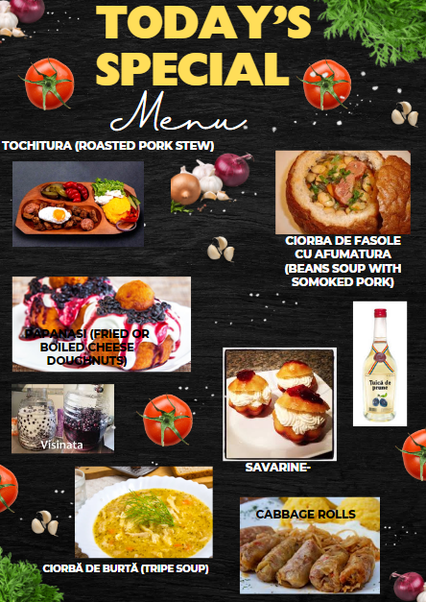

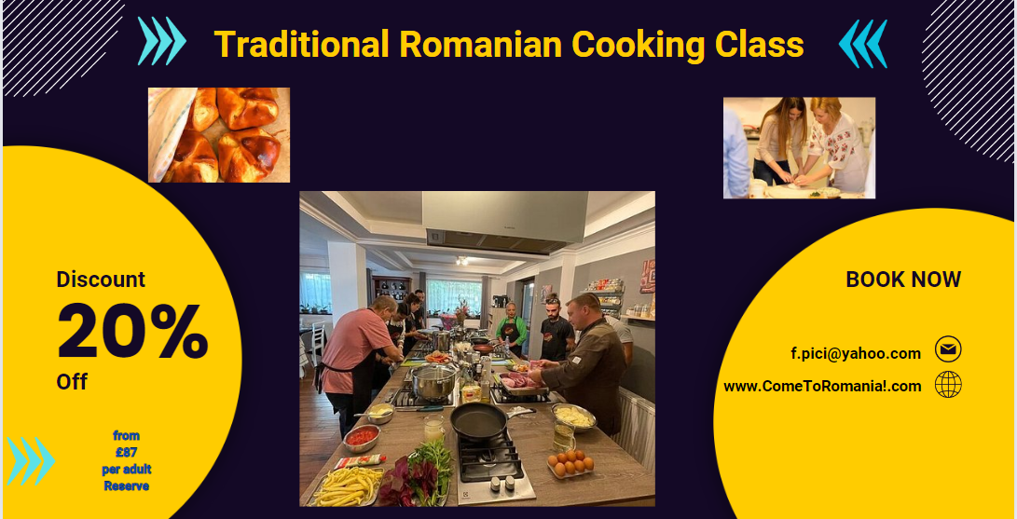

Website

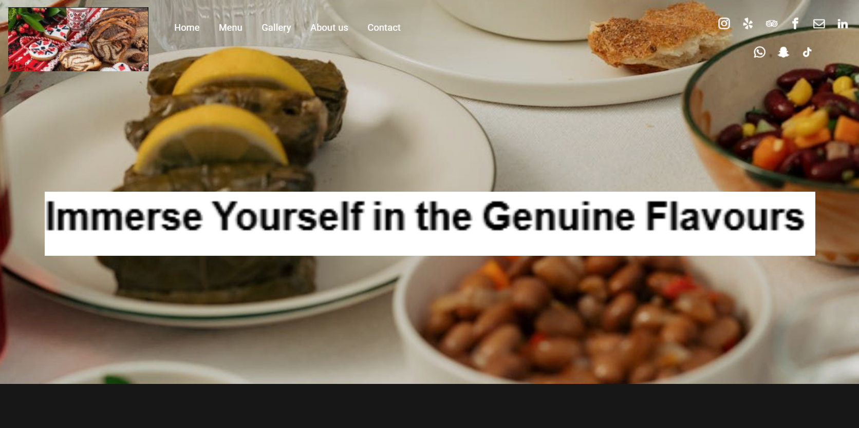

Website link
https://www.sitemodify.com/preview/cbcebb2e?device=desktop&pageId=137154315

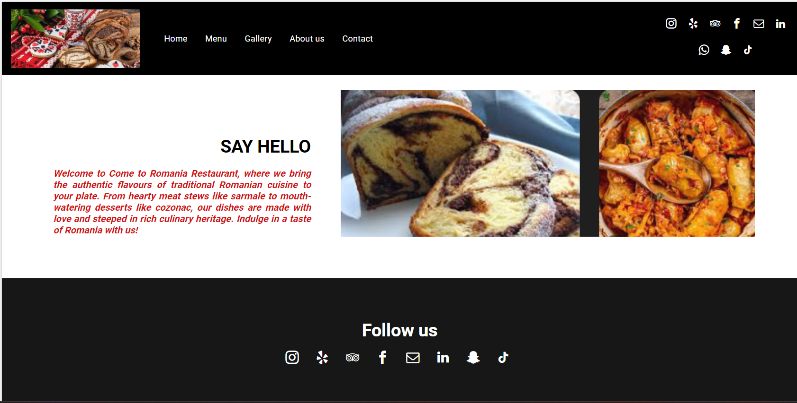

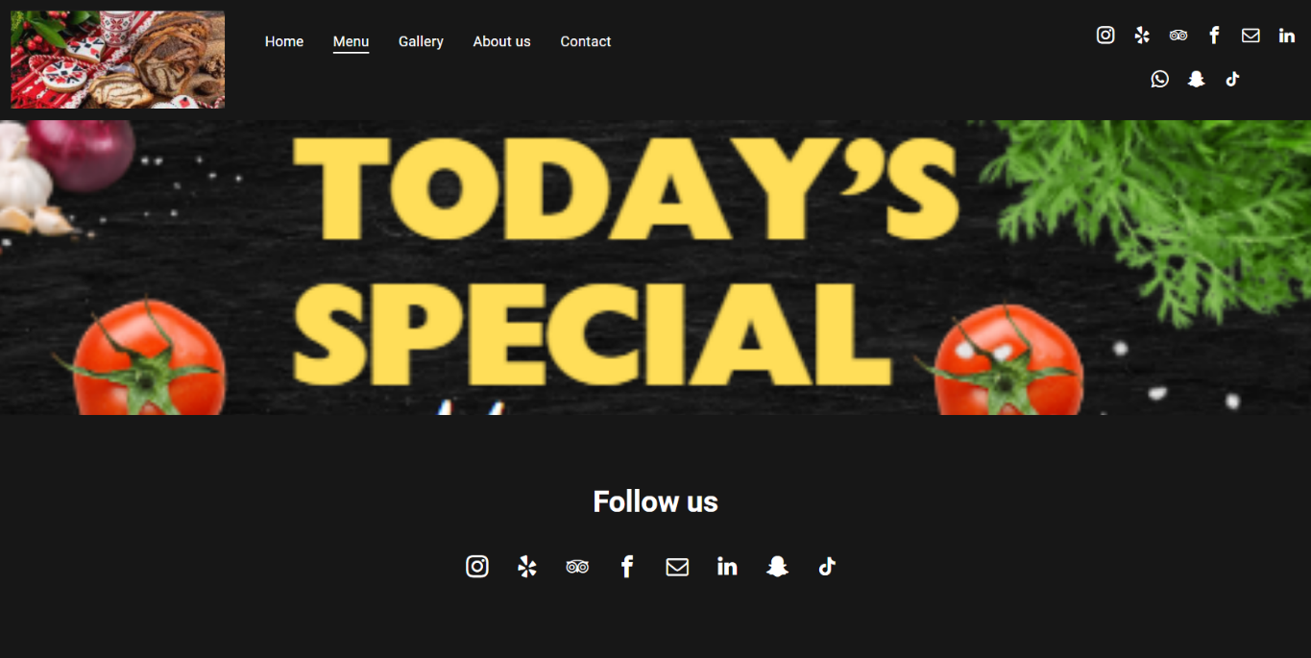

References
Armstrong, G., Kotler, P., Harker, M. & Brennan, R. (2015) Marketing: An Introduction. 13th ed. Pearson.
Aaker, J.L. (1997) Dimensions of brand personality. Journal of Marketing Research
34(3): 347-356.
Barker, R.T. & Gower, K. (2010) Strategic application of storytelling in
organizations toward effective communication in a diverse world. Journal
of Business Communication 47(3) July: 295-312.
Bartel, C.A. & Garud, R. (2009) The role of narratives in sustaining organizational
innovation. Organization Science January/February: 107-119.
Bencsik, A. (2017) Knowledge Management Initiatives and Strategies in Small and Medium Enterprises. IGI Global. Available at: http://doi:10.4018/978-1-5225-1642-2
Burgess, J., Marwick, A. and Poell, T. (2018) The SAGE Handbook of Social Media. SAGE Publications Ltd. Available at: http://www.doi.org.ezproxy.uwtsd.ac.uk/10.4135/9781473984066
Byrd, L. S. (2021) Cultivating Entrepreneurial Changemakers Through Digital Media Education. IGI Global. Available at: http://doi:10.4018/978-1-7998-5808-9
Chaffey, D. and Ellis-Chadwick, F. (2019) Digital Marketing: Strategy, Implementation and Practice. 7th ed. Pearson.
Chiu, H.C., Hsieh, Y.C. & Kuo, Y.C. (2012) How to align your brand stories with
your products. Journal of Retailing 88(2): 262-275.
Clarke, I. and Flaherty, T.B. (2020) Advances in Electronic Marketing. IGI Global.
Dadwal, S. S. (2020) Handbook of Research on Innovations in Technology and Marketing for the Connected Consumer. IGI Global. Available at: http://doi:10.4018/978-1-7998-0131-3
Denning, S. (2006) Effective storytelling: strategic business narrative techniques.
Strategy and Leadership 34(1): 42-48.
Elliot, S. (2012) Coke revamps web site to tell its story. New York Times, 11 November
Gobble, M. M. (2018) 'Digitalization, Digitization, and Innovation', Research-Technology Management, 61(4), pp. 56–59. Available at: https://doi.org/10.1080/08956308.2018.1471280
Hemann, C. and Burbary, K. (2013) Digital Marketing Analytics: Making Sense of Consumer Data in a Digital World. Que Publishing.
Hill (2020) 'Introduction to the Special Issue: Looking to the Digital: An Introduction to Digital Storytelling', Storytelling, Self, Society, 16(2), p. 153. Available at: https://doi.org/10.13110/storselfsoci.16.2.0153
Kingsnorth, S. (2019) Digital Marketing Strategy: An Integrated Approach to Online Marketing. 2nd ed. Kogan Page.
Ledford, J.L. (2009) SEO: Search Engine Optimization Bible. 2nd ed. Wiley.
Ostmeier, E. and Strobel, M. (2022) 'Building skills in the context of digital transformation: How industry digital maturity drives proactive skill development', Journal of Business Research, 139, pp. 718–730. Available at: https://doi.org/10.1016/j.jbusres
Paulus, P. and Nijstad, B. (2003) Group Creativity: Innovation through Collaboration. Oxford University Press. Available at: https://oxford-universitypressscholarshipcom.ezproxy.uwtsd.ac.uk/view/10.1093/acprof:oso/9780195147308.001.0001/acprof-9780195147308
Pinto, F. M. and Guarda, T. (2020) Digital Marketing Strategies and Models for Competitive Business. IGI Global. Available at: http://doi:10.4018/978-1-7998-2963-8
Reedy, K. and Parker, J. (2017) Essential Digital Literacy Unpacked. Facet Publishing. Available at: https://ebookcentral.proquest.com/lib/trinity/detail.action?docID=5490897
Ryan, D. and Jones, C. (2016) Understanding Digital Marketing: Marketing Strategies for Engaging the Digital Generation. 4th ed. Kogan Page.
Radicic, D. and Petković, S. (2023) 'Impact of digitalization on technological innovations in small and medium-sized enterprises (SMEs)', Technological Forecasting and Social Change, 191
Sandhu, K. (2020) Digital Transformation and Innovative Services for Business and Learning. IGI Global. Available at: http://doi:10.4018/978-1-7998-5175-2
Smith, P.R. and Zook, Z. (2016) Marketing Communications: Integrating Offline and Online with Social Media. 6th ed. Kogan Page.
Soltanifar, M., Hughes, M. and Göcke, L. (2021) Digital Entrepreneurship. Springer. Available at: http://doi:10.1007/978-3-030-53914-6
Stokes, R. (2013) eMarketing: The Essential Guide to Digital Marketing. Quirk eMarketing.
Tuten, T.L. and Solomon, M.R. (2017) Social Media Marketing. 3rd ed. Sage.
Varenyk, V. and Piskova, Z. (2024) 'Soft, hard, and digital skills for managers in the digital age: Business requirements and the need to master them', Development Management, 23(1), pp. 46–61. Available at: https://doi.org/10.57111/devt/1.2024.46
https://www.sciencedirect.com/science/article/pii/S0040162523001592
https://selar.co/blog/coca-cola-storytelling-sell-drinks/
https://econsultancy.com/coca-cola-s-storytelling-three-lessons-on-content-marketing-and-creativity/

