

NAME OF STUDENT: VANSHIKA

STUDENT ID: 2224637

NAME OF LECTURER: MOHAMED ASIM

MODULE NAME: HUMAN RESOURCE MANAGEMENT

MODULE CODE: LCMB7000

ASSIGNMENT TITLE: ASSIGNMENT 1

SUBMISSION DATE: 10 MAY, 2023

Executive Summary
Human resource is considered for its capacity to develop policies and strategies for the attainment of organisational goals. The following study is aimed at evaluating the current labour market of the UK. This study states, UK is currently facing a “tight labour market”. Additionally, the emerging changes in human resource strategies within the post Covid and Brexit situation have been assessed. These states, increase in hybrid and flexible working opportunities and evaluation of new changes in UK’s immigration laws are the new emerging changes.
Table of Contents
Introduction 3
Analysis of current state of labour market in the UK 3
Analysis of the emerging changes in human resource strategies in post Covid-19 situation 6
Analysis of the emerging changes in human resource strategies in post Brexit situation 9
Conclusion 11
References 12

Introduction
Human resource management is defined by the process of strategically approaching and nurturing employees within an organisation. Moreover, ‘human resource management (HRM)” is also considered for its capacity of motivating and encouraging employees in maintaining a positive work culture (Armstrong and Taylor, 2020). Human resource management is also characterised for its ability to recruit and retain talents within an organisation. Additionally, the HR department is also recognised for their ability to maintain communication and collaboration within the workplace. Due to this, inability to communicate properly and collaboration could lead to workplace conflicts. Occurrence of conflicts within the workplace is detrimental as it restricts the ability to effectively achieve an organisation’s goals and objectives. Subsequently HRM is also considered as a vital aspect within an organisation as it performs activities that reduce occurrence of demotivation and employee turnover. The following study focuses on the evaluation of the current situation of the labour market of the UK. Furthermore, the study will also analyse the changes within human resources strategies in the post Covid-19 and Brexit environment.

Analysis of current state of labour market in the UK
The labour market also known as the job market is defined by the supply and demand for labour. As opined by Lane and Saint-Martin (2021), the employees within the job market are considered to provide supply of labour in the job market. On the other hand, employers are considered for their capacity to provide demand for employment within the labour market. Additionally, the labour market is a crucial aspect for a region’s economy. Due to this, labour is directly linked with the aspect of “capital, goods and services” within the market.
Moreover, within the aspects of macroeconomics, supply and demand are influenced by domestic along with international market trends. Due to this, the labour market is influenced by factors like “immigration rate, age of population, and educational capacities” (Lee et al. 2020). Moreover, the measures that determine a region’s labour market are “productivity, unemployment rate, total income and gross domestic product (GDP)”. However, in the aspect of microeconomics the labour market is influenced by the internal factors within an organisation (Armstrong and Taylor, 2020). This implies, employers are considered for their ability to interact with their employees (Lauder and Mayhew, 2020). These processes include “hiring, termination, promotion and determining salaries.” The supply and demand within the labour market determines the working hours as well as salaries of an employee in an organisation.
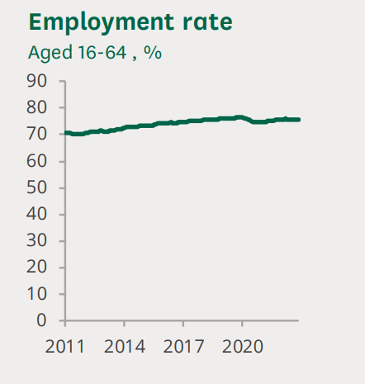
Figure 1: Employment rate in the UK
(Source: Researchbriefings.files.parliament.uk, 2023)
The labour market within the UK has been observed for its capacity to have a rise in employment rates. On the other hand, the UK's labour market has noticed a minor fall within its economic activities. This states, the UK's job market is considered to have improvement within its employment rates and reduction of activities that negatively influence the job market. In the time period of November 2022 to January 2023, citizens aged above 16 were in the labour market of the UK. The total estimate of this group has been 32.84 billion (Researchbriefings.files.parliament.uk, 2023). Additionally, the employment rate of individuals belonging to the age group of 16-64 has risen to 75.7%. This rate has been observed to have increased since the rate that was observed during the pandemic. However, the employment rate has increased prior to the occurrence of Covid-19 in the current year. Due to this, there is still a large population that is considered to be unemployed in years 2022-2023.
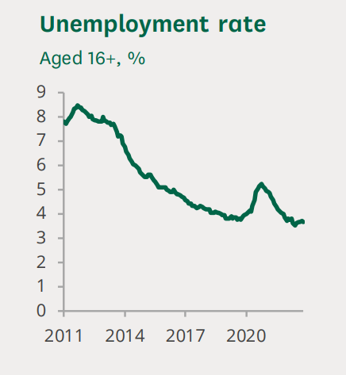
Figure 2: Unemployment rate in the UK
(Source: Researchbriefings.files.parliament.uk, 2023)
The unemployment rate within the UK has been considered to have fallen and raised within years 2022 to 2023. In 2023, the unemployment rate within the UK was estimated at 3.7%, which states 1.25 million within the age group of 16 above were unemployed (Researchbriefings.files.parliament.uk, 2023). Moreover, within the UK’s labour market it has also been observed to have a rise in “redundancies”. In the opinion of Rong et al. (2019), redundancy is defined by the process of employers' ability to terminate certain employees. This is due to situations that are not related to their performance in the organisation. This implies redundancies occur due to occurrence of circumstances that affect an organisation’s ability to sustain talents. For instance, an organisation facing bankruptcy might resort to redundancy. Due to this, they do not have the appropriate funds for sustaining talents in the workplace. Similarly, the UK was observed to have more than 94,000 redundancies in 2023, which has increased from previous years (Researchbriefings.files.parliament.uk, 2023). This could be associated with loss of profits faced by organisations due to the occurrence of Covid-19 and Brexit, that restrict them to sustain a large workforce due to lack of appropriate funds.
Low unemployment rates and high job vacancies in the UK determines it is experiencing a “tight labour market”. This means, most individuals seeking employment are already employed within an organisation. Due to this, recruitment of new talents is becoming increasingly difficult for organisations. As stated by Asali and Gurashvili (2020), a tight labour market is characterised by an economy that is close to achieving full employment. Due to this, the ability to hire new employees becomes more difficult as there is an increased pressure with the ability to offer wages. Similarly, the UK's tight labour market has occurred due to increase in economic inactivity amongst its population. Lack of economic activity within residents of the UK occurred due to the pandemic as most individuals were unemployed. This has restricted the ability to spend their funds on risky economic activities (Sumption et al. 2022). Moreover, reduction in immigration from the EU within the UK has also resulted in a drop of individuals within the UK's labour market. Subsequently, tightness within the UK's labour market has also resulted in the rise of “nominal wage.” This phenomenon has enabled the creation of upward pressure in inflation rates of the region. Thus, the overall situation of the UK's labour market is tight, which is near to achieving full employment.

Analysis of the emerging changes in human resource strategies in post Covid-19 situation
HRM has been forced to adapt to varied changes that have risen due to the occurrence of the Covid-19. Additionally, the occurrence of the pandemic was an unexpected change that was faced by HRM across organisations around the globe. This is because the changes that arose during the pandemic have not been practised on a mass scale within business environments. One of the major changes that was observed during the pandemic is “work from home”. Nations across the globe were forced to implement national lockdowns to restrict movement of individuals in public spaces (Dey et al. 2020). This was mainly done to restrict the spread of the virus from one person to another. Due to this, organisations were observed for their ability to continue their operations by operating from their homes. During the pandemic, the HRM has been responsible for the maintenance of engagement and productivity of employees working from their homes (Wang et al. 2019). This is because lack of face-to-face interaction has increased the probability of demotivation and disengagement within employees.
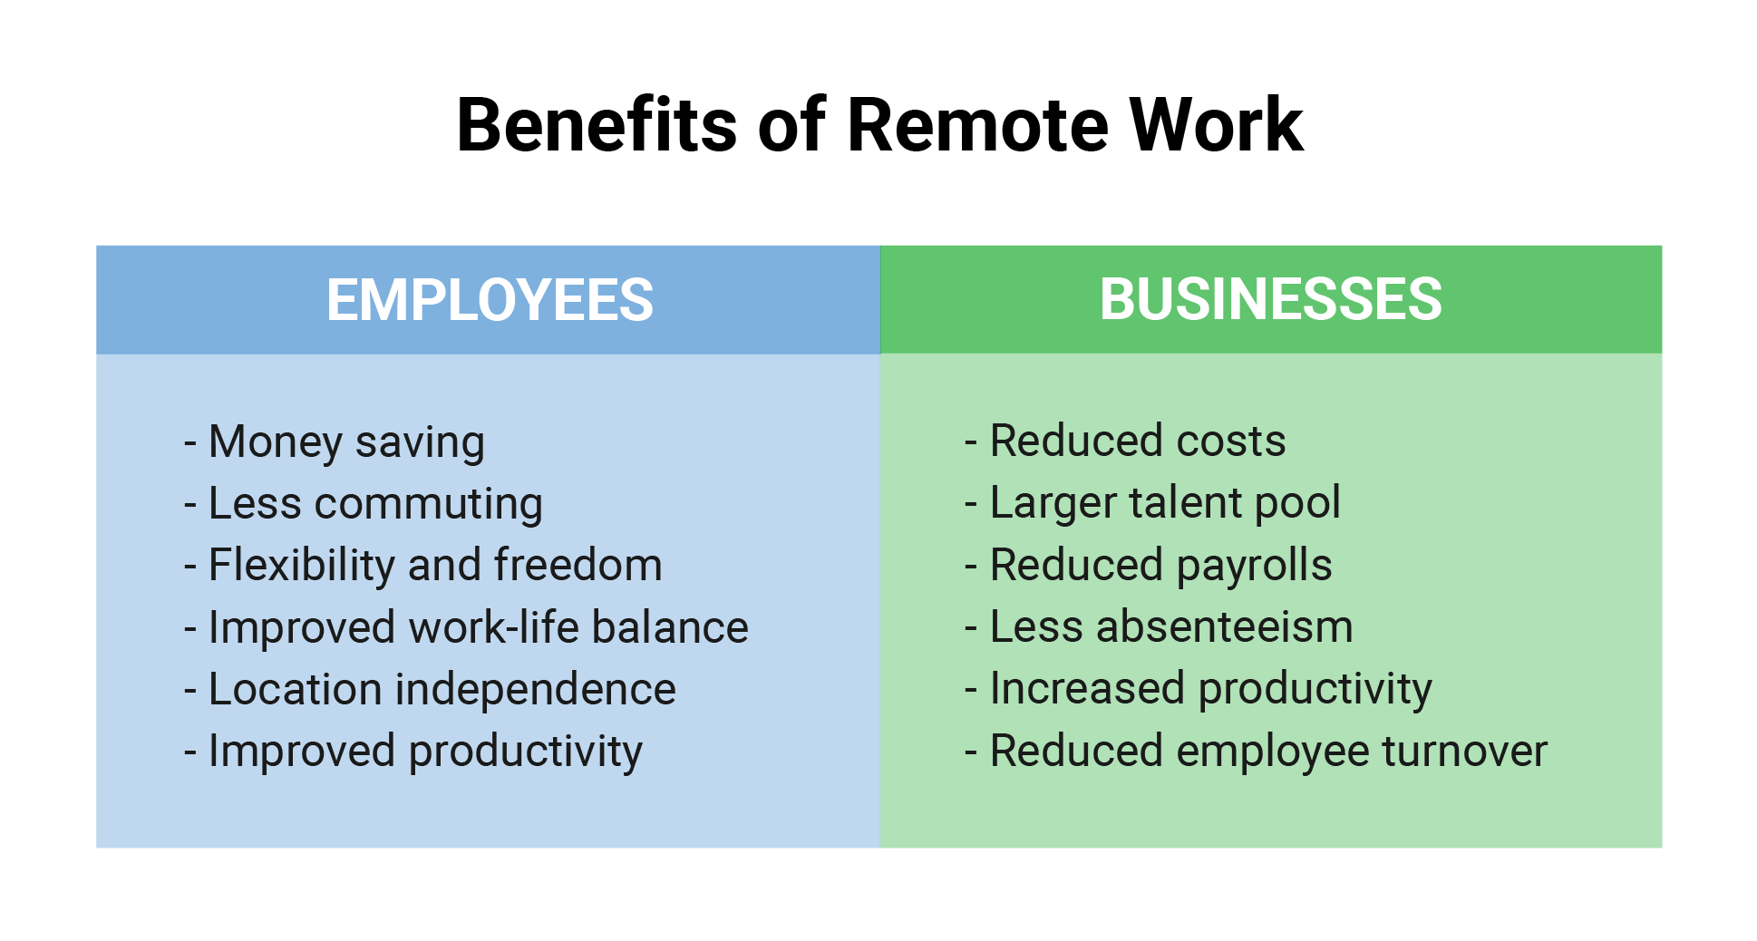
Figure 3: Benefits of remote work
(Source: Influenced by Ozimek, 2020)
This states, one of the emerging changes within human resource strategies within post Covid-19 circumstance is “rise in remote working abilities”. In the opinion of Ozimek (2020), remote working is characterised by the process of completing organisational tasks by being outside the company premises. Due to this, during the pandemic HRM’s across the nations were expected to develop “work from home policies” for maintenance of performance levels within employees. One of the benefits of remote working for employees is the ability to manage their “work-life balance.” This is because staying at home and completing organisational tasks enabled employees to have more time for their families and acquaintances. Additionally, remote working is crucial within the post Covid-19 situation as it enables in providing independence and flexibility to employees (Yang et al. 2022). Providence of flexibility at work enables employees to have more engagement and productivity due to lack of “micro managing” of employees, which is noticed within traditional workplace.
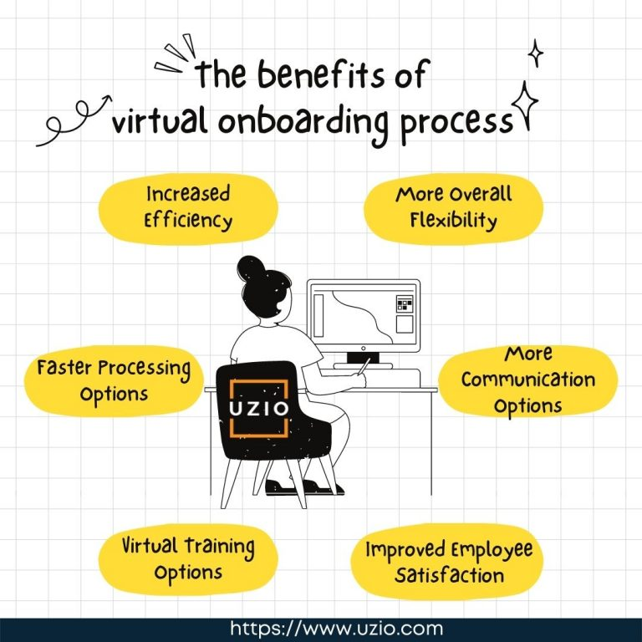
Figure 4: Benefits of online on boarding
(Source: Influenced by Baker and DiPiro, 2019)
Another emerging change within human resource strategies that has raised from the pandemic period is the “online onboarding process”. Traditionally, the onboarding process requires the candidate to be physically present within the company premises for attending the interview process and training sessions (Baker and DiPiro, 2019). On the other hand, occurrence of national lockdown resulted in HRM’s conducting the on boarding process entirely in online platforms. This states, interview and training sessions of candidates were conducted online by HRM’s within organisations. One of the advantages that is associated with online on boarding is the ability to recruit candidates from new locations (Yadav et al. 2020). Generally, before the pandemic organisations were considered to recruit talents who were residing in regions the company operates in. This is because, ability to recruit talents from the same region assisted the organisation to save cost during the on boarding process. However, popularity of remote working capacities has enabled organisations to hire talents residing in different regions (Kapusy and Lógó, 2022). This states, online on boarding strategies have enabled those who can achieve organisational objectives.
HRM strategies has also been observed to have seen a change in its ways it monitors the performance of its employees while working in remote environments. In the opinion of Jeske (2022), monitoring performance of employees during remote working hours has been a new task for HRM’s during the pandemic. This is because monitoring employees in their homes was an impossible task for organisations. Due to this, HRM’s were expected to develop strategies to effectively evaluate performance of employees while operating remotely (Armstrong and Taylor, 2020). “Pair wise working” has been an emerging trend that arose during the pandemic. As stated by Beutel et al. (2019), pair-wise working is defined by the process of collaboration with other teams and individuals for completion of an operational task. This implies, employees while working remotely resorted to collaborating with other employees in order to determine their ability to maintain effective communication and collaboration. This process acted as an indirect way of providing feedback regarding employees and their performance while operating in a remote situation. Evaluating these feedbacks would enable HR strategies post Covid determine performance levels of remote employees. Thus, these are the HR strategies that could be observed as emerging changes in the post Covid situation.

Analysis of the emerging changes in human resource strategies in post Brexit situation
The UK was observed to resign itself from the “European Union (EU)” in 2020, which resulted in the occurrence of various changes within the region's regulations and policies. Additionally, the UK's resignation from the EU stated that none of the EU regulations regarding employment and recruitment would be applicable for organisations operating within the UK. According to Sindakis and Aggarwal (2022), Brexit enabled HRM’s within organisations operating in the UK to evaluate the new employment policies for the maintenance of legality in their operational abilities. This implies, Brexit has enabled the emergence of trends that would enable HR departments to consider the immigration process of employees being recruited from regions outside the UK.
The first emerging change post Brexit is “ability to understand the UK's new immigration policies and regulations.”HRs within the UK has been vested with the responsibility of determining a candidate's home nation before the recruitment process. Due to this, candidates belonging from “European Economic Area (EEA)” would be ruled by special immigration regulation compared to candidates belonging from the UK (Croxford et al. 2020). Due to this, before the on boarding process HRM’s across the UK would have to check the immigration status of its potential candidates hired in the post Brexit situation.
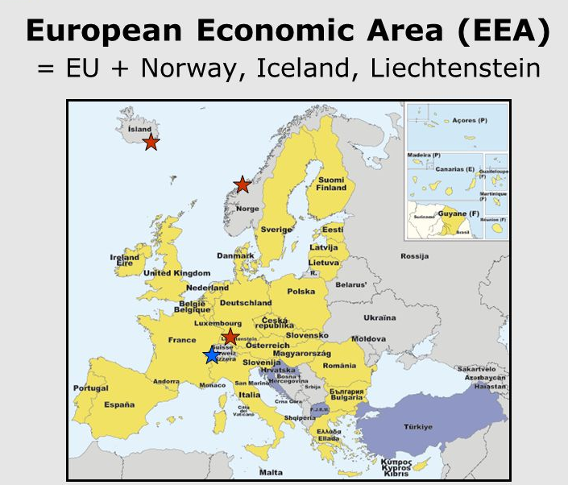
Figure 5: European Economic Area (EEA)
(Source: Influenced by Juverdeanu, 2019)
“Ability to assist employees in achieving settled status” is another emerging human resource strategy within the post Brexit situation. Candidates belonging in the “European Economic Area (EEA)” and have resided in the UK prior to 2020 have the opportunity to apply for “settled or pre-settled status” (Juverdeanu, 2019). Ability to successfully apply for this status enables employees not belonging from the UK to stay employed in organisations of the UK after the occurrence of Brexit. Due to this, HRM’s operating in the UK are expected to maintain continuous communication with their employees belonging from EEA regions to apply for “settled status” under the new immigration law of the UK. This would enable UK organisations to effectively retain talented employees who were hired from non-UK regions.
“Reviewing employment policies” is another emerging change within human resource strategy that is crucial in the post Brexit situation. Brexit has resulted in changes in employment policies regarding hiring of foreigners within the UK's workforce. Due to this, employers in the UK are expected to conduct “immigration audits” of candidates who are being hired from regions outside the UK. According to Sumption (2022), immigration audits are a crucial task for employers seeking to employ talents from foreign regions. Ability to conduct effective immigration audits allows employers to recruit candidates without any form of bias. This implies, HRM’s operating within the UK would be expected to effectively comply with regulations that restrict occurrence of discrimination against employees recruited from foreign regions. For instance, an organisation recruiting a foreign candidate would be required to reduce bias against candidates who are required to have a visa or sponsorship to attain employment in the region. Due to this, it is crucial for HRM in the UK to effectively monitor their capacity to comply with employment policies to reduce bias and discrimination against candidates hired from foreign regions.
“Maintenance of transparency” is another emerging change within human resource strategies that would be observed in the post Brexit environment. This implies, HRM’s of organisations operating in the UK would be required to effectively disseminate information regarding changes in employment and immigration policies due to Brexit to its employees. Effective dissemination of information would lead to employees residing in the UK for work purposes having less ambiguity regarding their sustenance in the UK’s labour market (Frennhoff Larsén and Khorana, 2020). This is because, occurrence of Brexit has caused ambiguity and confusion amongst EEA employees of the UK, which could lead to disengagement in the workplace. Thus, HRM’s have to play the role of motivating and assisting employees belonging from the EEA and other foreign regions to retain their employment in the post Brexit situation.

Conclusion
Human resource is considered for its capacity to develop policies and strategies for the attainment of organisational goals. From the above study it has been concluded that the UK has the presence of a “tight labour market”, which is defined by the potential of full employment leading to increases for multiplying the existent nominal wage (Armstrong and Taylor, 2020). In addition, the study has concluded the emerging trends that have emerged in the post Covid and Brexit situation. Increased ability to have remote working facilities, effective knowledge regarding changes in UK immigration policies and online on boarding are few changes.

References
Armstrong, M. and Taylor, S., (2020). Armstrong's handbook of human resource management practice. Kogan Page Publishers. (Accessed: 07 April 2023).
Asali, M. and Gurashvili, R., (2020). Labour market discrimination and the macroeconomy. Economics of Transition and Institutional Change, 28(3), pp.515-533. https://onlinelibrary.wiley.com/doi/abs/10.1111/ecot.12249 (Accessed: 07 April 2023).
Baker, B. and DiPiro, J.T., (2019). Evaluation of a structured onboarding process and tool for faculty members in a school of pharmacy. American journal of pharmaceutical education, 83(6). https://www.ajpe.org/content/83/6/7100.abstract (Accessed: 07 April 2023).
Beutel, A., Chen, J., Doshi, T., Qian, H., Wei, L., Wu, Y., Heldt, L., Zhao, Z., Hong, L., Chi, E.H. and Goodrow, C., (2019, July). Fairness in recommendation ranking through pairwise comparisons. In Proceedings of the 25th ACM SIGKDD international conference on knowledge discovery & data mining (pp. 2212-2220).https://dl.acm.org/doi/abs/10.1145/3292500.3330745 (Accessed: 07 April 2023).
Croxford, S., Tavoschi, L., Sullivan, A.K., Combs, L., Raben, D., Delpech, V., Jakobsen, S.F., Amato‐Gauci, A.J. and Desai, S., (2020). HIV testing strategies outside of health care settings in the European Union (EU)/European Economic Area (EEA): a systematic review to inform European Centre for Disease Prevention and Control guidance. HIV medicine, 21(3), pp.142-162. https://onlinelibrary.wiley.com/doi/abs/10.1111/hiv.12807 (Accessed: 07 April 2023).
Dey, M., Frazis, H., Loewenstein, M.A. and Sun, H., (2020). Ability to work from home. Monthly Labor Review, pp.1-19.https://www.jstor.org/stable/26931202 (Accessed: 07 April 2023).
Frennhoff Larsén, M. and Khorana, S., (2020). Negotiating Brexit: A clash of approaches?. Comparative European Politics, 18, pp.858-877.https://link.springer.com/article/10.1057/s41295-020-00213-6 (Accessed: 07 April 2023).
Hu, Z., Wang, Y., Peng, Q. and Li, H., (2019, May). Unbiased lambdamart: an unbiased pairwise learning-to-rank algorithm. In The World Wide Web Conference (pp. 2830-2836).https://dl.acm.org/doi/abs/10.1145/3308558.3313447 (Accessed: 07 April 2023).
Jeske, D. (2022). Remote workers' experiences with electronic monitoring during Covid-19: implications and recommendations. International Journal of Workplace Health Management. https://www.emerald.com/insight/content/doi/10.1108/IJWHM-02-2021-0042/full/html (Accessed: 07 April 2023).
Juverdeanu, C. (2019). Brexit and the European Economic Area: Semi-and quasi-EU citizenship as by-products of external differentiation. In Differentiated Integration and Disintegration in a Post-Brexit Era (pp. 74-90). Routledge. https://www.taylorfrancis.com/chapters/edit/10.4324/9780429026959-5/brexit-european-economic-area-cristina-juverdeanu (Accessed: 07 April 2023).
Kapusy, K. and Lógó, E., (2022). User experience evaluation methodology in the onboarding process: Snapchat case study. Ergonomics in Design, 30(3), pp.4-10. https://journals.sagepub.com/doi/pdf/10.1177/1064804620962270 (Accessed: 07 April 2023).
Lane, M. and Saint-Martin, A., (2021). The impact of Artificial Intelligence on the labour market: What do we know so far?. https://www.oecd-ilibrary.org/social-issues-migration-health/the-impact-of-artificial-intelligence-on-the-labour-market_7c895724-en (Accessed: 07 April 2023).
Lauder, H. and Mayhew, K., (2020). Higher education and the labour market: an introduction. Oxford Review of Education, 46(1), pp.1-9. https://www.tandfonline.com/doi/full/10.1080/03054985.2019.1699714 (Accessed: 07 April 2023).
Lee, S., Schmidt-Klau, D. and Verick, S., (2020). The labour market impacts of the COVID-19: A global perspective. The Indian Journal of Labour Economics, 63, pp.11-15. https://link.springer.com/article/10.1007/s41027-020-00249-y (Accessed: 07 April 2023).
Ozimek, A. (2020). The future of remote work. Available at SSRN 3638597.https://papers.ssrn.com/sol3/papers.cfm?abstract_id=3638597 (Accessed: 07 April 2023).
Researchbriefings.files.parliament.uk (2023). UK labour market statistics. Available at: https://researchbriefings.files.parliament.uk/documents/CBP-9366/CBP-9366.pdf (Accessed: 07 April 2023).
Rong, K., Xiao, F. and Wang, Y., (2019). Redundancy in the sharing economy. Resources, Conservation and Recycling, 151, p.104455. https://www.sciencedirect.com/science/article/pii/S0921344919303611 (Accessed: 07 April 2023).
Sindakis, S. and Aggarwal, S., (2022). The Implications of Brexit for Small Businesses in the UK. In Small Business Management and Control of the Uncertain External Environment. Emerald Publishing Limited. https://www.emerald.com/insight/content/doi/10.1108/978-1-83909-624-220211011 (Accessed: 07 April 2023).
Sumption, M. (2022). Shortages, high-demand occupations, and the post-Brexit UK immigration system. Oxford Review of Economic Policy, 38(1), 97-111. https://academic.oup.com/oxrep/article-abstract/38/1/97/6514754 (Accessed: 07 April 2023).
Sumption, M., Forde, C., Alberti, G. and Walsh, P.W., (2022). How is the end of free movement affecting the low-wage labour force in the UK?. The Economics of Brexit: What Have We Learned?.https://kclpure.kcl.ac.uk/portal/files/175707837/Economics_of_Brexit.pdf#page=91 (Accessed: 07 April 2023).
Wang, B., Liu, Y., Qian, J. and Parker, S.K., (2021). Achieving effective remote working during the COVID‐19 pandemic: A work design perspective. Applied psychology, 70(1), pp.16-59. https://iaap-journals.onlinelibrary.wiley.com/doi/abs/10.1111/apps.12290 (Accessed: 07 April 2023).
Yadav, S., Meena, N., Dalal, R. and Saindane, C., (2020). Increasing employee engagement in new recruits in COVID times: an analysis of the onboarding process. Jawaharlal Nehru University, pp.1-14.https://www.jnu.ac.in/sites/default/files/abvsme/WP-01.pdf (Accessed: 07 April 2023).
Yang, L., Holtz, D., Jaffe, S., Suri, S., Sinha, S., Weston, J., Joyce, C., Shah, N., Sherman, K., Hecht, B. and Teevan, J., (2022). The effects of remote work on collaboration among information workers. Nature human behaviour, 6(1), pp.43-54.https://www.nature.com/articles/s41562-021-01196-4 (Accessed: 07 April 2023).

