Component 2:
How a school develops one aspect of its SDP: a report that critically reflects on the actions, impact, and evidence base.

Introduction:
The aim of this assignment is to investigate how a school identifies and develops one aspect of its School Development Plan (SDP). The assignment will critically reflect on one action point from the school’s targets, how it develops its targets and how the impact is measured.
The SDP highlights four priorities, to further develop leadership skills including enhanced pupil voice opportunities, to develop staffs’ application of the twelve pedagogical principles, further implementation of the ALN bill and to adapt school assessment procedures in line with Curriculum for Wales (CfW). This assignment will focus on priority one, to further develop leadership skills including enhanced pupil voice opportunities.
In accordance with BERA guidelines, the name of school and staff members will remain anonymous throughout (BERA, 2018). The SDP has been taken from a small English Medium Primary school in Swansea, South Wales. To maintain its anonymity, the school will be known as School X throughout. School X has approximately 110 pupils, with approximately 2% eligible for free school meals (FSM) which is significantly below the average for schools in Wales and 19.5% of pupils identified as having additional learning needs (Estyn, 2015).
Literature Review:
An SDP is a document which schools use to implement a process for improvement. It is a continuous process which reflects on the school’s performance through self-evaluation and highlights priorities or targets for improvement (Welsh Government, 2014). Doud (1995) highlights the importance of each school creating an individual improvement plan by describing it as integral to a school being successful. In addition, improvement, it must be noted, is not just the development of pupils and their learning, but also by developing a school’s organisation and overall effectiveness (Smylie, 2010).
The main objective of a successful SDP is to lead to the enhancement of quality education for its pupils (Davies and Ellison, 1992). Fernandez, (2011) agrees and claims that having an SDP in place improves the quality of teaching and learning.
Burton and Brundrett (2005) suggested that subject leaders play a key role in the creation and implementation of a school development plan due to their role as middle managers and being part of the management team. The Welsh Government (2014) go further and state that whilst the governing body would be overall responsible for the SDP, in reality, for it to be successful the Headteacher would collaborate with the staff and governors to produce the SDP and will ultimately be responsible for its success. Many schools, however, are different both in their size and priorities, this highlights the importance for each school to have an SDP and for it to be individual to their needs.
Further develop leadership skills including enhanced pupil voice opportunities
Harris et al (1996) highlight the importance of leadership when discussing its’ positive effects on the quality of a school. Beare et al concur and assert that ‘outstanding leadership has invariably emerged as a key characteristic of outstanding schools’ (p. 24, 1997). Despite these claims being made over 25 years ago, the views are still relevant today, Harris and Muijs (2005) for example, highlighting the importance of how school leadership contributes to school improvement. The role of leadership in a school is not confined to just the Headteacher. It is true that the Headteacher has ultimate responsibility, however, there is a need for others to possess the necessary skills for a group to be successful (Smith, 1995). Harris et al (1996) agreed and stressed how leadership needs to be distinguished from management.
Burton and Brundrett (2005) go into further detail and explain the differences between management and leadership and why it is important. They provide an explanation that essentially managers need leaders to get things done. This is why it is important to have people with specialist knowledge in different areas so they can contribute to the overarching objective of the plan. A manager, or in this case, Headteacher may possess the management and leadership strategies to deal with a lot of the areas, however, they would need expertise from elsewhere. This is why it is paramount to develop leaders from not only the existing senior leadership team (SLT) but from across the school where they can add value. This could be in the form of a teacher, Teaching Assistant (TA) or indeed pupils. A newly qualified teacher (NQT) would possess certain skills that an experienced teacher of 25 years may not, and vice versa, whilst a TA can offer a different perspective on certain areas.
Developing leadership skills was a clear priority for school X due to its size. A lower number of teachers in the school ensured that most, if not all teachers would be part of a leadership function by default, which means that the priority to further develop its leadership skills was a necessity. This may not be the case for larger schools where there is an established leadership hierarchy with the appropriate level of skills required at that time.
Due to the size of the school, there is a close relationship between pupils and staff. There has been a pupil voice in place for some time which has also been a part of previous SDP’s, however, upon reflecting on previous actions found that further interaction between pupils and pupil voice was required. Rudduck and Flutter (2004) emphasise the importance of having an enhanced pupil voice participation by claiming it has a direct impact on pupil engagement. They add that if pupils feel that they have a voice and are respected then the engagement levels will increase, and they will be motivated to work towards the school’s purpose.

Developing an Action Plan:
This section will discuss the SDP and how school X identified developing Leadership skills including enhanced pupil voice opportunities as one if its priorities and specifically developing leadership skills as an action point. It will also explore the four stages of improvement that the Welsh Government (2014) set out, self-evaluation, strategic planning, making improvement and reviewing impact, as can be seen in Figure 1 below.
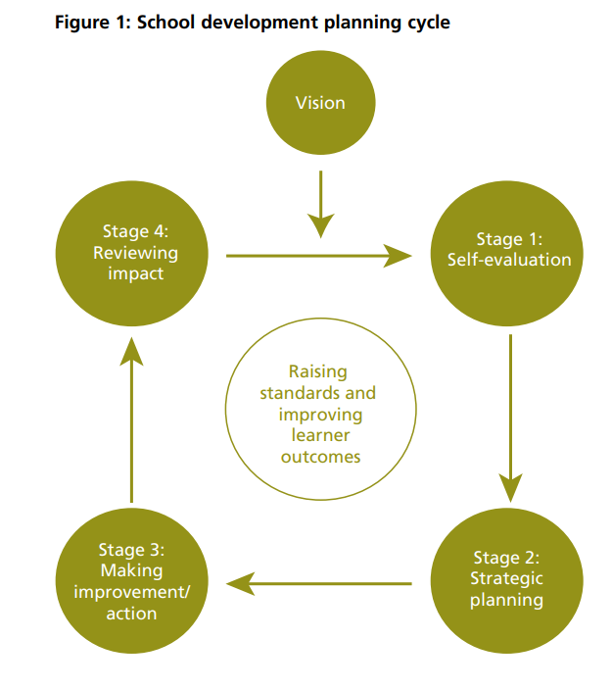

Self-evaluation:
This is an important aspect of the SDP and where the school would identify any areas that would need developing and the rationale behind it. Burton and Brundett (2005) recognise this importance and state that quality self-evaluating plays a vital role in updating a schools improvement plan as it provides the basis for an area of focus and can be used as a good measure of effective leadership.
Welsh Government (2014) provide information on the range of data available to schools which helps formulate the SDP. For example, qualitative data such as previous inspections and information on pupils’ well-being can be used as well as quantitative data which would encompass attainment results, absence information or any data that can be recorded. It is also noted that schools have access to benchmarking data which allows schools to compare with the better performing schools and those within their local cluster. There are benefits to this, of course, as it allows schools to share best practice, however, whilst acknowledging that what works well in School B may not work well in School X, the sharing of knowledge allows other strategies to be constructed.
School X’s SDP was written after consultation and input from the staff, governors, parents, and pupils. The consultation was conducted through INSET days and council meetings, whilst questionnaires were sent out to parents. A member of the SLT stated that at the time of creating the document and self-evaluating, the school was suffering from long term absences of key personnel within the school, which severely impacted the SLT and required an interim Headteacher to be appointed. This enabled a new senior leadership team to be assembled to create the SDP.

Strategic Planning:
A crucial component of the SDP is the planning, and this requires full cooperation and commitment of all stakeholders for it to be effective (Welsh Government, 2014). This supports the view held by Davies and Ellison (1992) who state that collaboration between school staff and governors should work together to ensure that effective change can be made. Whilst Smith (1995) initially acknowledges a potential limitation in greater participation is that it could increase tensions and be time consuming, he offsets this view by arguing that by involving not just staff and governors but also parents and where appropriate, pupils, the SDP will be greatly enhanced by the wider range of expertise on offer.
School X decided on four priorities, with priority number 1 focusing on developing leadership skills including enhanced pupil voice opportunities. This was due to the long-term sickness of key personnel which highlighted a risk as key dependencies were unavailable and an eagerness to embrace the smaller, community school environment to include pupils. An action was to build capacity and to develop succession planning as there was a need to build and develop and support the leadership team at all levels as the SLT was previously too narrow, even for a smaller school.

Making Improvement:
Following the self-evaluation and planning, the next part of the improvement cycle is to implement the actions and strategies that were set out in the SDP. The Welsh Government (2014) state that the school staff will have been consulted and the owners of each action point will be aware of their responsibilities. The owners of this action are the Headteacher, Senior Leaders, Middle Leaders, TA’s and learners.
School X believed having all aspects of personnel of the school as owners would engage everyone and ensure full cooperation, this supports the view held by Davies and Ellison (1992) who fully advocate the consultation of all staff on implementing the action. This is important as if staff are not involved, the success may be in question, something that was recognised by Brighouse and Woods (1999) when they stressed the danger of not including staff in the design and implementation.

Reviewing Data:
The SDP should be reviewed regularly throughout the development timeframe, at least annually, as it is thought of as a ‘live’ document. The purpose of this is to ensure that the priorities and strategies are still up to date (Welsh Government, 2014) School X have put in place check points in which to review the action, identifying mid-term performance reviews and SLT meetings as the when and measures such as quality assurance of priorities and review of professional learning as the what.

Reflection and evaluation
A key area of the SDP is the ability to reflect and evaluate. Davies and Ellison (1992) stress the importance of having some metrics in place such as who will carry out the evaluation, how and when will it take place and what key performance indicators (KPI’s) will be used. Schools may have different evaluation points depending on their priorities and their demographic.
Reflection is also an important aspect of any learning process. Rose (2015) supports this view and states that reflection is a key component of a learning cycle, identifying what has occurred, what needs to change and implementing that change.
Since the new and updated SDP was introduced in September 2022, there has been success in certain aspects of the developing leadership priority and action point. Staff are acutely aware of their roles and responsibilities and there is a willingness to assist in other areas where there may be a gap. There is also a more positive outlook amongst staff who have sensed the leadership changes have started to make a difference.
Despite the SDP having a success criteria and different review dates such as mid term performance reviews and SLT meetings, the SDP did not specify when the SLT meetings were or how often they take place. There is limited information on ad-hoc reviewing throughout, the danger here is that if the plan or to be specific, certain actions are not on the right track there is nothing in the SDP to say that this will be addressed.
Furthermore, in respect of the progression planning, which is an essential element of the leadership priority and action, there is no clear structure or pathway that has been defined yet. As this is still an ongoing point and as it is a Live document this can be added to in the future, however, if there was further change to staff then it would not be clear as to the new personnel what this entailed and as such may not receive the attention it deserves.

Conclusion
In conclusion, this assignment has explored what an SDP is, its importance to school improvement and pupil progress, and how a school has implemented its SDP. In addition, it highlights the need for effective planning, committed collaboration and why it is important for schools to have robust self-evaluation processes.
By using a real-life school and a genuine SDP, it highlighted that the measures that were taken from the initial self-evaluation and used in the SDP were justified, and they have had a positive impact on the specific area. It also proved that the collaboration was important in the success of delivering on the action as involving all staff and the pupils resulted in positive engagement and a positive initial result.
Identifying and understanding the SDP will enable me to know what the schools’ priorities are, how they intend to meet them and what I can do to assist. The more input I can project into the SDP will also help me shape lesson planning, contribute to the overall success of the school and become a more complete teacher and help with future aspirations of progression.

Word Count: 2243

References:
BERA guidelines, (2018). Guidelines for Educational Research, fourth edition (2018). Website: https://www.bera.ac.uk/publication/ethical-guidelines-for-educational-research-2018. (Accessed: 11.04.23).

Beare et al (1997) ‘Dimensions of Leadership’ in Crawford et al (1997) Leadership and teams in educational management. Buckingham: Open University Press

Brighouse, T and Woods, D (1999) How to improve your school. London: Routledge

Burton, N. and Brundrett, M. (2005) Leading the Curriculum in the Primary School. London: SAGE Publications Ltd

Davies, B and Ellison, L. (1992) School Development Planning. Harlow: Longman Industry and Public Services

Doud. (1995). Planning for school improvement: A curriculum model for school-based evaluation. Peabody Journal of Education, 70(3), 175–187. https://doi.org/10.1080/01619569509538842

Estyn (2015) Inspection Report Template (gov.wales)

Fernandez, K. (2011) ‘Evaluating School Improvement Plans and their Effect on Academic Performance’. Educational Policy, 25(2), pp.338-367.

Harris, A. and Muijs, D. (2005) Improving Schools Through Teacher leadership. Maidenhead: Open University Press

Harris, A. et al (1996) School Effectiveness and School Improvement: A Practical Guide. London: Pitman Publishing.

Rose, J. Gilbert, L and Richards, V (2015) Health and Well-Being in Early Childhood. London: SAGE Publications Ltd

Rudduck, J. and Flutter, J. (2004) How to improve your school. London: Continuum

Smith, R. (1995) Successful School Management. London: Cassell

Smylie, M. (2010) Continuous School Improvement. London: SAGE Publications Ltd

Welsh Government (2014). School development plans. Available at: https://gov.wales/sites/default/files/publications/2018-03/school-development-plans.pdf. (Accessed 6 April 2023)

