Enhancing Map Navigation Accuracy through Artificial Intelligence and Geospatial Modelling
Module: Research Methods and Professional Development

Subtitle: Research Methods and Professional Development (ACFA7004)

Student Name: Shivam Sanjivkumar Patel
Student ID: 2435900

Lecturer: Vijeyananthan Thayananthan
Table of Contents
1. Introduction 3
1.1 Context and background 3
1.2 Research Problem 4
1.3 Research Aim and Objectives 4
1.4 Significance of the research 5
2. Literature review 5
2.1 Introduction to literature review 5
2.2 Limitations of Current Route Prediction Algorithms 6
2.3 Adaptive and Environment-Aware Artificial Intelligence Systems 7
2.4 Simulation and Data Analysis for Accuracy Evaluation 9
2.5 Real-World Applications and Implementation of AI-Driven Navigation Systems 10
2.6 Key Contributions and Gaps 10
2.7 Theoretical and technical frameworks 11
2.8 Relation to your study 12
2.9 Literature summary 13
3. Research Design and Methodology 13
3.1 Research Design 13
3.2 Research Methods and Materials 14
3.2.1 Methods 14
3.2.2 Materials 15
4. Expected outcome 15
5. Timeline 16
References 18

1. Introduction

1.1 Context and background
GeoAI (Geospatial artificial intelligence) involves a combination of satellite tracking and adaptive machine learning models to make smarter decisions on binary choices (such as routing) and brings about a revolution in digital navigation [1]. In particular, to support navigation services, the combination of remote sensing and machine learning allows for to transcend from imagery to semantic road-network representations and context-aware routing suggestions [2]. Contemporary navigation services like Google Maps and Waze increasingly use AI pipelines that attempt to infer the traffic patterns and recommend a better route to use, again in near real time.
Applied neuroscience of multispectral and LiDAR remote sensing data with deep learning models enhanced the features for mapping and routing applications. Research proves that using a combination of machine learning and geospatial analytics can greatly enhance the position accuracy or route prediction reliability of locations working in a complex environment [3]. Despite technological advancements, GNSS accuracy is still unreliable in many parts of rural and remote Australia and correction infrastructure is limited [4]. Transmitted GNSS data and surveying analysis show that the lack of gings and the lack of ground stations lower intended positioning accuracy in remote locations. The restrictions of GPS technology reduce the reliability of navigation in under-mapped areas for tourism operations, logistical operations and emergency services. Dependable geospatial data is vital to tourism and regional transport services to ensure the safety and operational efficiency of services across remote regions of Australia [5].
However, in a remote environment, highly detailed routing can also be used to carry out emergency management strategies for timely dispatch and rescue efforts. The combination of adaptive reinforcement learning and geospatial modelling, together with remote sensing, seems to be a promising approach to solve the GNSS's shortcomings and dynamic environmental effects. Recently, work has also been conducted to employ reinforcement learning (RL) based path planning for adaptive route optimization in the presence of localization uncertainty [6]. To minimize the need for constant GPS updates during deep fade conditions, continuous and self-older data-based learning procedures can be built into AI systems to acquire an estimation of environmental context from time to time [1]. Open geospatial datasets can be integrated together with satellite cloud observations to facilitate improvements for scalable mapping of both urban and non-urban applications [3]. However, satellite data and remote-sensing inputs, when combined with adaptive machine learning, are needed in order to increase route accuracy and robustness.

1.2 Research Problem
Problem Statement: At present, the navigation system that are GPS-based has poor performance in areas where the GPS is not trackable or does not work properly in degraded environments, which leads to unreliable positioning and inaccurate routing in remote and complex terrains. This research significantly focused on addressing the identified gap by proposing an adaptive geospatial model that is AI-based to increase the performance of route prediction through accuracy and reliability under GPS-challenged environments.
At the same time, although GPS satellite navigation techniques have emerged as solutions for most applications, most modern-day systems cannot operate satisfactorily in GPS-denied or degraded signal environments [7]. Unfortunately, most commercial routing platforms still rely heavily on GPS signals and are based on corrections made by base stations, exposing them to blockages, multipath and terrain variations. In rural Australia, the authors report an increasing mis-direction of road network travellers by navigation systems to unsealed roads, with the relevant regulator finding thousands of kilometres of remote unsealed road network had no effective GPS filtering options [8].
Furthermore, known cases exhibit that GPS signals are prone to intentional jamming, spoofing and propagation loss caused by natural phenomena, resulting in reduced positioning accuracy or even total loss of fix in mission-critical cases [9]. What is lacking is the intelligent artificial-intelligence system that is dynamically adapted to the changing terrain, signal interference, and local physical environment and geospatial knowledge in real time. The lack of this information limits the reliability of current routing solutions for real-time traffic prediction to allow safe and efficient travelling in various environments. Without adaptive geospatial modelling combined with machine learning approaches, navigation tools aren't resilient in complex relief or in the course of emergency response operations, which have a low degree of surveying details. The uncovered research gap is thus to develop an AI-based geospatial model that will make route prediction more accurate under GPS-challenged conditions, thus enabling higher reliability in navigation for tourism, logistics, and safety purposes.

1.3 Research Aim and Objectives
Aim: To improve the accuracy of the map navigation through the application of the AI-based approaches of geospatial learning models.
Research Objectives:
- To analyse the limitations that exist on the current route prediction algorithms.
- To build an adaptable AI system that is capable of learning the environment dynamically.
- To analyse the accuracy of the system, the necessary simulation should be used.
- To determine the extent to which the system can be applied in reality in the context of navigation.

1.4 Significance of the research
The development of AI-based geospatial modelling will provide a substantial increase in precision for navigation systems for emergency response and logistics purposes. Death is 12.2 per 100,000 population in regional and remote areas, or 34.6 per 100,000 population. The proposed research will have a positive effect on the efficiency of first responder dispatch and ambulance arrival times by improving routing accuracy and robustness in GPS-denied areas. The accurate geospatial modelling is also used in the context of supply-chain planning and personalised logistics route optimisation for rural transport networks to minimise wasted kilometres, fuel used and emissions.
The combination of GIS and AI improves the efficiency of decision-making by making it possible to automate map-making, terrain analysis, and route prediction (from satellite and sensor data) [11]. Along these lines, from the sustainability point of view, the optimised routing leads to reduced vehicle emissions and energy consumption to achieve the carbon-reduction targets of smart mobility. To ensure that GeoAI systems are deployed in an ethically responsible manner, there is a need for transparent, accountable algorithms and responsible data practices in geospatial systems to ensure fairness and trust [12].
In addition, by optimising routes under uncertainty, this research is helping tourism in regional Australia, making visitors safer and providing worthwhile economic opportunities for these remote communities. The research will impact society by increasing accessibility in underserved landscapes and improving equity in transport and emergency services. On the technical level, the work makes technical contributions to the state-of-the-art in AI applied to geospatial navigation by doing the following: bringing together remote-sensing data with open-source mapping solutions and applying reinforcement learning to equip the agent with mapping abilities. Ultimately, the proposed project is geared towards progression in both professional development and academic innovation, making new contributions to the geospatial and AI research communities.

2. Literature review

2.1 Introduction to literature review
This literature review investigates the latest developments in the area of artificial intelligence-based geospatial modelling and its application in the contemporary navigation system. The purpose is to identify the general trends being followed, the methods being applied and the technological advances made in the area of the use of artificial intelligence and remote sensing techniques, with techniques such as machine learning for the prediction of routes and the improvement of spatial accuracy. It also analyses some of the prominent issues and research gaps in the area of GPS reliability, changing terrain, and fusion of data. The survey will confine itself to the literature on the subjects published in the years 2019 to 2025, with a special emphasis on areas of study such as GeoAI, spatial data analytics, deep learning, and autonomous navigation systems.

2.2 Limitations of Current Route Prediction Algorithms
Current route prediction algorithms are still bound by their reliance on static datasets and deterministic models [13]. Most routing systems use shortest-path algorithms such as Dijkstra or A, to which environmental variability cannot be well adapted [15]. These algorithms mostly ignore dynamic contextual data, including traffic fluctuation, weather, and temporary road closure conditions [14]. The results generated on non-stationary conditions are thus suboptimal and unreliable, particularly on rural or complex terrains [16]. Conventional models also suppose perfect GPS signal reception and exclude the multipath distortion or latency in data affecting prediction accuracy [13]. The LSTM or regression-based machine learning methods further improve temporal estimation but have problems with unseen trajectories [14]. Further, the limited amount of real-time data fusion reduces predictive precision and fails to accommodate rapidly evolving travel patterns [15].
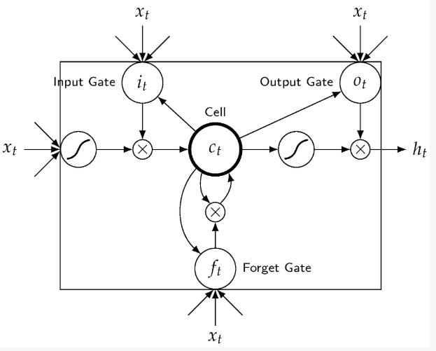
Figure 2.1: LSTM unit route prediction
(Source: Ran et al., 2019)
Transferability across different geographic and infrastructural contexts is also missing in many algorithms, thereby reducing generalization performance [16]. The computational complexity of handling high-dimensional geospatial data is another limitation and requires substantial processing power for real-time inference [13]. Safety-oriented route prediction is underdeveloped, as most frameworks optimise efficiency instead of risk or contextual awareness [15]. Privacy issues on large-scale mobility data collection restrict the training and deployment of adaptive models [16]. Hybrid and deep learning methods have evolved in recent times, though these models have overfitting and interpretability issues [14]. The absence of robust benchmark datasets and unified evaluation metrics is another reason that restricts comparative analysis amongst competing algorithms [13]. Altogether, these gaps emphasise the urgent need for adaptive AI-driven geospatial modelling so as to bring improvements in navigation resiliency and accuracy [15].

2.3 Adaptive and Environment-Aware Artificial Intelligence Systems
Adaptive AI systems, using reinforcement learning, sensor fusion, and contextual data, revolutionise geospatial navigation by dynamically optimising route decisions through real-time interaction with the environment.[17] Environment-aware systems consider multiple inputs for robust predictions, while reinforcement learning systems like deep Q-networks and actor-critic models enable continuous self-improvement in uncertain situations.[18] Recent research has indicated the potential of adaptive routing in vehicular networks involving a reduction in latency and an improvement in reliability of 35%.[19] Environment-aware digital twins further improve decision-making by including climate data and simulating spatial interaction virtually. In UAV navigation, adaptive auto-encoders dynamically adjust the complexity of the network to the noise level conditions in the environment and any changes that may occur in it.[20]
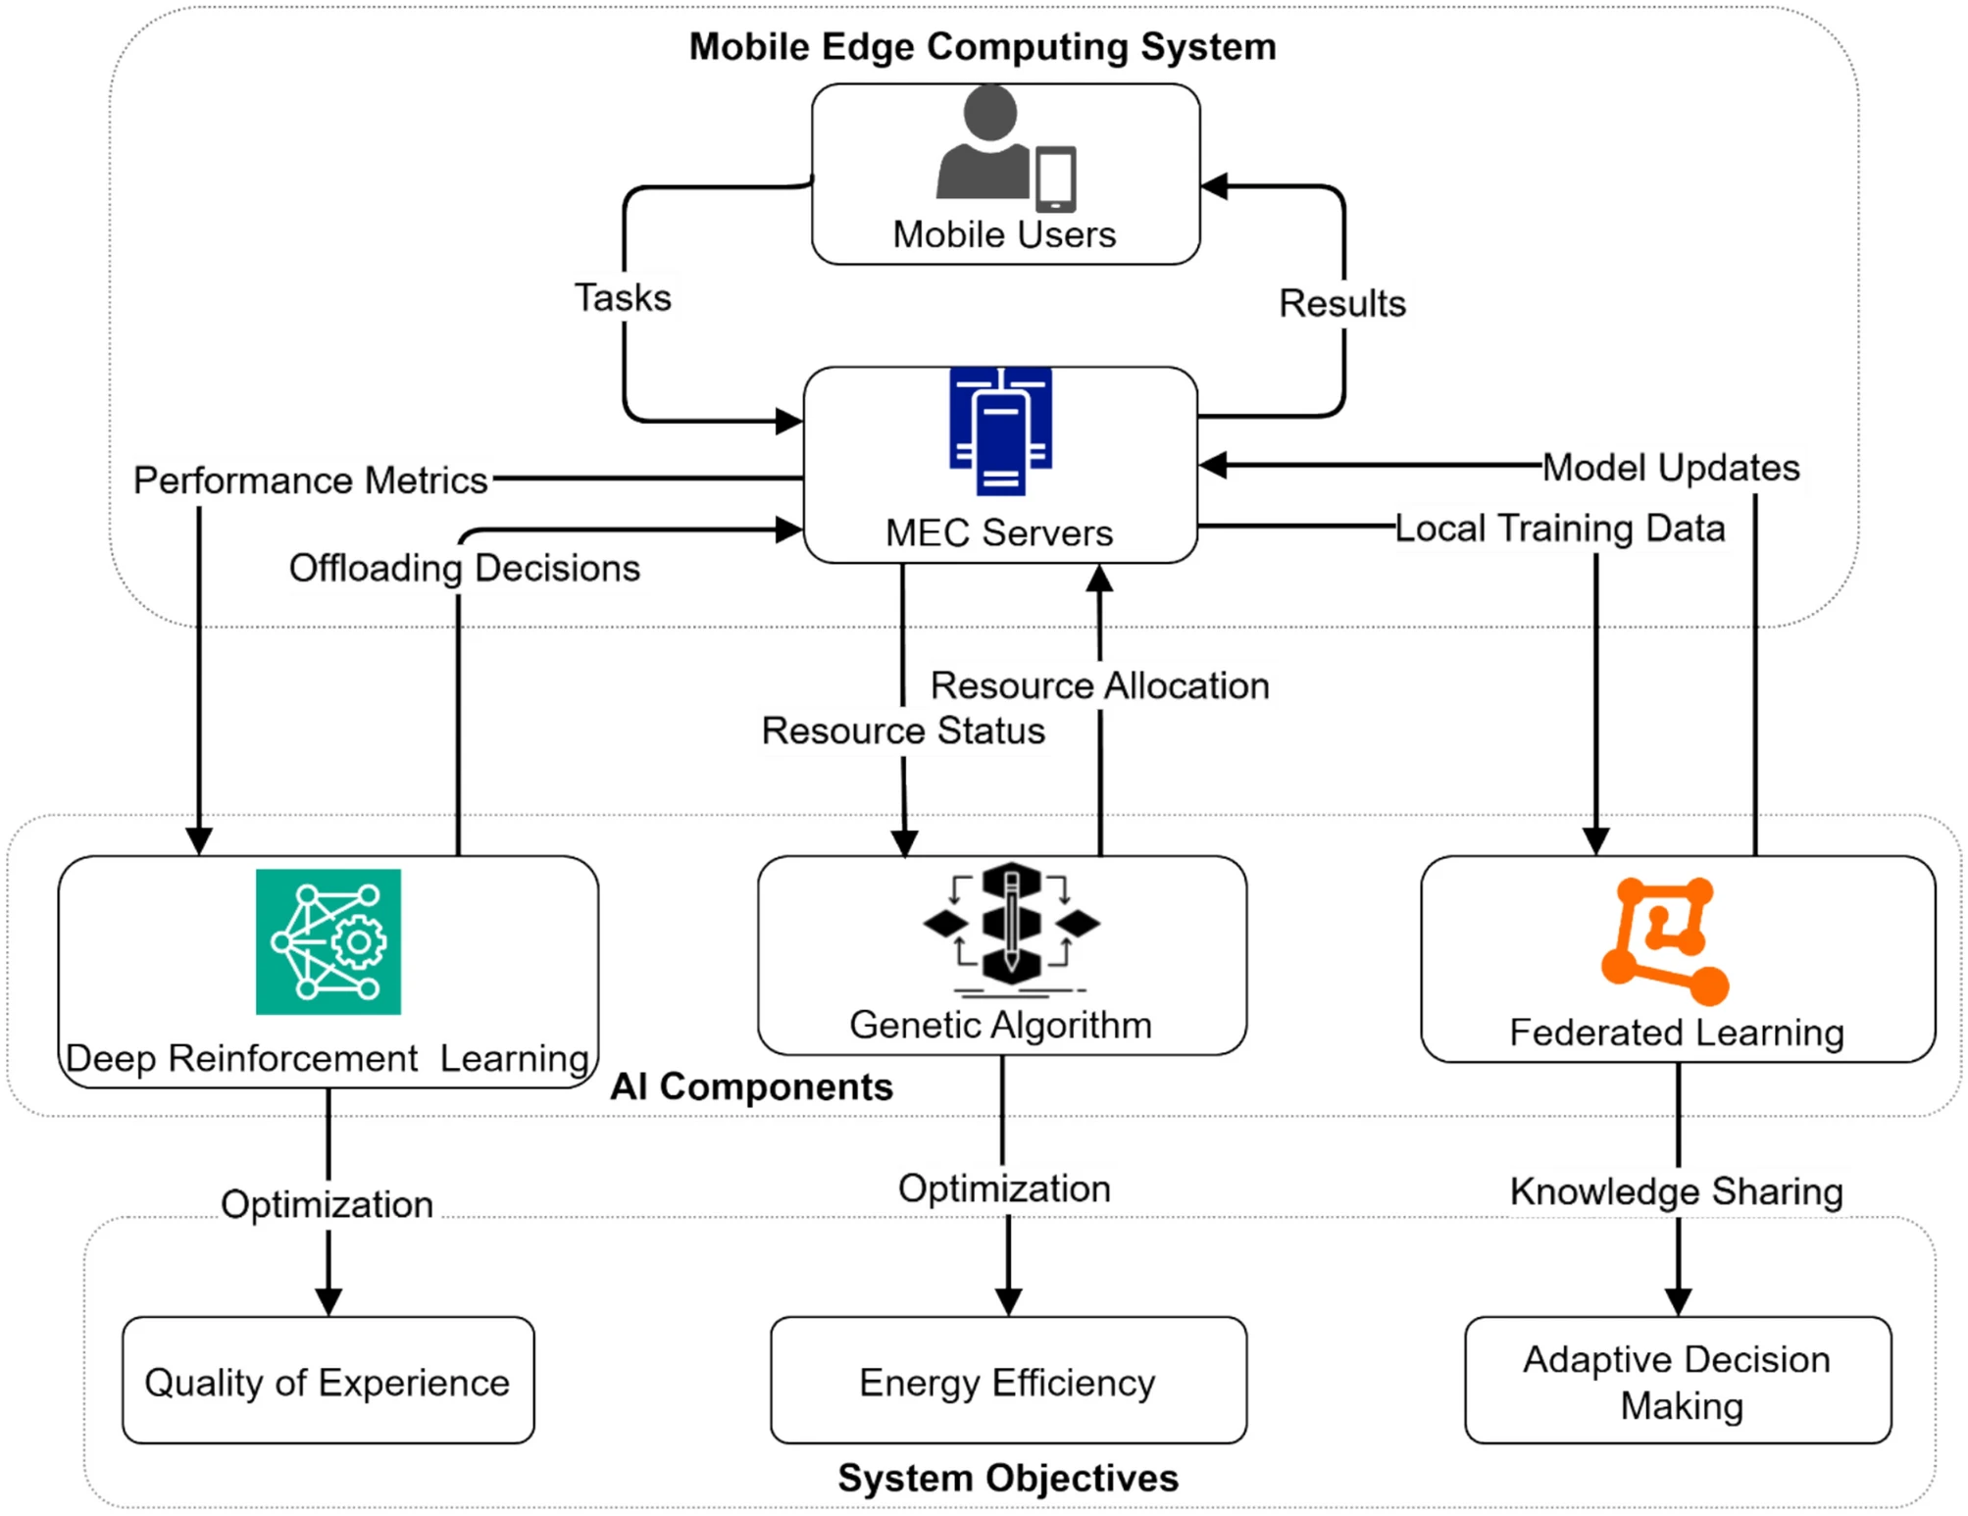
Figure 2.2: Adaptive AI-enhanced computation
(Source: Nishad et al., 2025)
Therefore, systems can be versatile in different prevailing conditions of the environment they are operating in while using computational resources sparingly. Multi-scale feature extraction methods improve the accuracy of traffic flow predictions and others by considering operations at both micro and macro levels of dynamics [19]. Contextual awareness is used to promote the resilience of routing solutions in changing geospatial environments that are dynamically changing. In addition, the use of advanced computation aids in shared learning, which renders higher scalability and agility up to the real world. However, lots of training information or energy applications are still required, and its extended availability is a large issue [20]. It can be stated that, intelligent, adaptable, environmentally conscious AI systems provide a platform on which the rigid intelligent steering could learn and adjust appropriately to the context both in the work and functionality.

2.4 Simulation and Data Analysis for Accuracy Evaluation
Simulation and data analysis can best be used to test smart navigation systems. One of the opportunities provided by the developed modelling tools is the ability to simulate numerous environmental conditions and evaluate the stability of models built by the researchers [21]. They have quantified the uncertainty presented by sensors and the uncertainty caused by noise in data using Monte Carlo simulations [22]. Probabilistic approaches are useful to understand the variations in the performance of systems across different operational environments or across different data distributions. The data-based simulation features assist in the iterative process of modelling by the discovery of patterns indicating the types of prediction errors and patterns of the applicable degrees of freedom [23]. The use of data mining technologies increases the prospects for forecasting routes by facilitating far-reaching pattern recognition for spatial and temporal realms.
The recent hybrid simulation paradigms combining physical models with data subtraction techniques enhance the quality of predictability available. The incorporation of uncertainty analysis leads to greatly enhanced confidence in the model outputs and provides indications of the source of error in the models. In addition, however, the simulation models allow for safe evaluation of the algorithms prior to practical implementation of the systems, thereby diminishing risk and cost. In geospatial terms, simulations simulate the dynamic conditions of, e.g., loss of signal, shifting terrain, disruption of sensors, etc.[24] Evaluation of the models through appropriate diagnostic evaluations of the regression techniques, and evaluations of the propagation of error through those systems facilitates the determination of the degree of consistency of the function of the evaluative models. Furthermore, in the cloud-based world, the ability to analyse multi-dimensional data through comprehensive databases leads to evaluative criteria being available for the assessment of the navigation systems in real time. Empirical evidence has indicated that an increase in fidelity of simulation is directly proportional to an increased percentage of operational reliability in applied AI models.[22] Thus, the cogency of the requisite criteria for simulation and data analysis will be found to be commensurate with the rigorousness of the same dimensions in their utility for verification of the accuracy and reliability of adaptive geospatial navigational systems.

2.5 Real-World Applications and Implementation of AI-Driven Navigation Systems
Navigation technologies based on artificial intelligence (AI) are finding use in various real-world fields where notable improvements have occurred in their capacity for quality of performance and adaptability.[25] The systems employ real-time data computing, learning capability of machines and geospatial analysis to enhance the performance in the areas of route data accuracy and the quality of decisions made.[26] In particular, in autonomous vehicle technologies, robots employing artificial intelligence systems are becoming more efficacious in terms of the safety of vision learnt of the general environment around them and detecting the presence of obstacles. This has resulted in a 40% improvement in the hazard of collision in the restricted controlled testing [27].
An AI-based series of enhancements of systems like NaviGPT is rendering assistive navigation to aid the visually impaired in their capacity for movement by the use of multimodal supplements. This has the effect of showing how artificial intelligence can improve the area of navigation whilst at the same time preserving the awareness of the situation around them. The employment of cloud-based systems and Internet of Things (IoT) sensors enables organic databases of naturalistic situational data and real-time data transfer and exchange. Furthermore, this could be taken a further step of supplying improved computations of the questioning route's efficacy and efficiency of travel. Studies have shown that the adaptive AI navigation algorithms can operate 25% more accurately in terms of mobility in urban areas than systems which rely upon traditional forms of satellite navigation operating on the same type of input conditions (GPS). [25]Thus, the AI systems of navigation can be shown to be of attention with regard to issues of sustainable, inclusive and intelligent mobility, but they remain problematic as they relate to ethical issues regarding data public domain, reliability of information, privacy and transparency. Real-life testing can now show the ability of AI learning from environmental and human data.

2.6 Key Contributions and Gaps
Journals pertaining to the advancement of AI-enabled models in geospatial modelling and navigation have seen important recent developments. Previous research focused on the incorporation of AI and geospatial use of remote sensing, allowing for enhanced environmental scale mapping and improved options. Javaid et al. [3] developed explainable AI approaches to UAV navigation that improve the reliability and interpretability in changing environments. Studies also adapted reinforcement learning for adaptive route optimisation, which allows for a greater responsiveness to real-time changes in the environment. Previous studies also focused on developing dynamic models to provide environment-aware traffic flows, providing improved accuracy and scalable approaches. Studies also the advancement of real-world applications to autonomous vehicles and assistive devices that have aligned university advances with societal knowledge. Therefore, there are many gaps that remain with respect to GPS denied environments, real-time incorporation of adaptive capacity, and ethical approaches to implementation, which demonstrate the need for comprehensive, adaptive, and universally applicable and relevant AI-enabled geospatial navigation solutions.

2.7 Theoretical and technical frameworks
The theoretical framework of geospatial modelling and navigation by AI is mainly based on two important theories: Reinforcement Learning Theory and GIS Theory. Reinforcement Learning Theory, based on the work of Sutton and Barto, states that an intelligent agent learns optimal decision-making strategies through trial-and-error interaction with the environment [28]. This theory is the basis of adaptive navigation systems in which the AI system continually refines its models of route prediction based on feedback from actual data. It provides self-learning and context-aware decision-making, which are important when rendering decisions about navigation in dynamic, uncertain terrains.
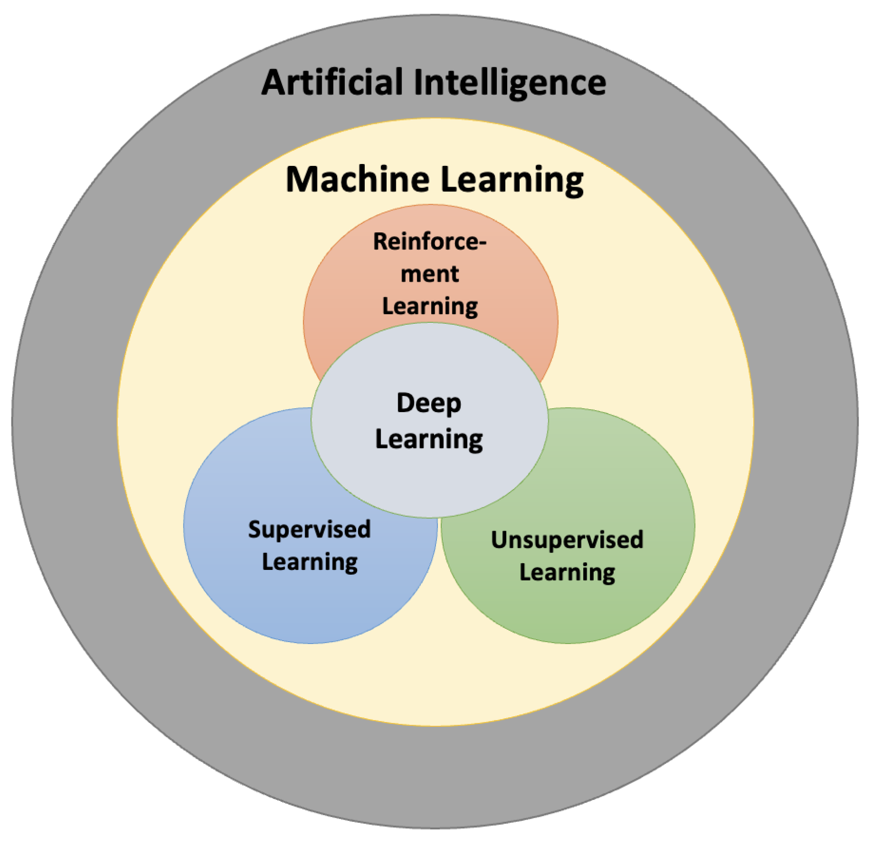
Figure 2.3: Reinforcement Learning Theory
(Source: Fahad Mon et al., 2023)
GIS Theory provides the theoretical basis for the collection, management, and viewing of spatial data. It requires the integration of multi-source geospatial data (satellite imagery and remote sensing data) to make a proper mapping and spatial analysis of the environment [29]. It can be stated that, with regard to the technology employed, studies in this topic frequently utilise deep reinforcement learning, convolutional neural networks (CNN) in feature extraction, and graph neural networks (GNN) in route optimisation. Python, TensorFlow or ArcGIS are commonly used in this field to accomplish algorithmic modelling and processing of spatial data.
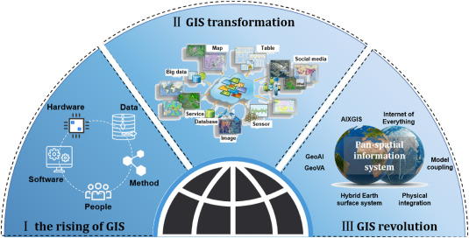
Figure 2.4: GIS Theory
(Source: Zhou, 2025)
Simulation-based assessment, Monte Carlo techniques, and composite analysis of big data will be needed when it is necessary to validate the reliability and validity of the model. Collectively, these frameworks contribute to making intelligent, scalable and context-sensitive navigation systems, which show spatial intelligence and adaptive AI learning.

2.8 Relation to your study
This study builds upon the existing body of literature by advancing the integration of artificial intelligence and geospatial modelling to enhance map navigation accuracy, particularly in complex and GPS-denied environments. While the research before demonstrated the utility of AI in route optimisation and remote sensing, this study takes these findings further because it presents a dynamic, evolving framework that is constantly learning from an evolving environmental landscape, thanks to its ability to learn in real-time. Unlike traditional GPS-based systems, the proposed model refers to reinforcement learning and data-driven geospatial analysis for the sake of continuous model adaptability to different terrains. The research also stresses ethical and sustainable implementation, addressing gaps for data transparency, privacy and inclusivity that were often missed in earlier studies. Furthermore, the paper provides a mixed approaches simulation-based evaluation methodology utilising accuracy testing alongside travel data validation in the real world. By connecting technical advancement and usage scenarios, this research sheds new light on how the intelligent navigation system is designed, and brings scalable, reliable and socially responsible advancements into dealing with the modern mobility problems.

2.9 Literature summary
The reviewed literature shows major progress in geospatial modelling using AI's adaptive learning, routing optimisation, and real-life navigation use cases. The combination of reinforcement learning and GIS integration has brought about improvements in accuracy and awareness of the environment. However, there are still big holes in GPS-denied situations, in-time adaptability and ethical implementation. This research overcomes these limitations by proposing a dynamic, sustainable and data-driven Artificial Intelligence model to improve the accuracy and reliability of navigation in different environments.

3. Research Design and Methodology

3.1 Research Design
The study is based on a quantitative and experimental design science approach, which proposes to develop and evaluate an AI (Artificial Intelligence)-driven geospatial model that will help navigate a map with higher accuracy. This solution is suitable as it focuses on artefact development (AI model) and empirical validation (simulation and performance testing) [30]. Design Science Research (DSR) is an appropriate approach for computing research that requires the delivery of a technological solution to a defined problem, as it aims at delivering artefacts that are practically useful and scientifically rigorous.
The artefact of the project - the proposed adaptive geospatial AI model - will combine reinforcement learning and the open-source spatial data to enhance route prediction and dynamic adaptability. The experimental part of the design allows for controlled testing of the model performance in terms of accuracy, efficiency and responsiveness under simulated different types of navigation conditions [31]. This will enable the proposed solution to not only satisfy theoretical expectations but also be proven to improve significantly under real-world environments.
The DSR framework conforms to the Hevner guidelines, which stress relevance, design as an artefact and rigorous evaluation [32]. Within this framework, the study is carried out in an iterative way involving the stages of problem identification, design and development of the AI model, demonstration by simulating, assessing the performance, and communicating the results at the final stage. This cyclical program ensures the focus and flexibility to continually improve upon the successful outcomes of performance.
The experimental part's rationale is derived from the fact that the experimental datasets consist of reproducible datasets from OpenStreetMap and Kaggle, which allow systematic test different algorithmic configurations (e.g. learning rates, environment parameters, reinforcement mechanisms, etc). Through this design, the research makes up for the gap between theoretical modelling and the application of artificial intelligence (AI) navigation solutions. This proposed research method helps in fulfilling the primary aim and all four objectives of the research by systematically developing, testing, and refining an adaptive AI-based geospatial model that is trained and modified using environmental data in order to enhance the reliability and accuracy of route prediction accuracy in real-world navigation.

3.2 Research Methods and Materials

3.2.1 Methods
This research paper has taken the quantitative experimental approach along with simulation-based validation to analyse AI-driven route prediction. The quantitative method enables a proper evaluation of such criteria as accuracy, computational efficiency, and learning convergence [33]. The experimental design, which can be termed a software development and simulation-based approach, allows for controlled manipulation of variables of interest (e.g. the complexity of the terrain and the presence of GPS) to study the effects of such variables on the performance. A system architecture based on the use of a modular pipeline consisting of:
- Data Acquisition Layer: sourcing the spatial data from OpenStreetMap, Kaggle and Australian transport firms.
- Preprocessing Layer: cleans and prepares data before training the model
- Model Training Layer: Implementation of the Reinforcement Learning and A* algorithms in Python and TensorFlow.
- Simulation Layer: performs copious simulations of virtual navigation scenarios to be tested.
- Evaluation Layer: Metrics are used to evaluate the performance.
This structure enhances issues of scalability, reproducibility and controlled experimentation.
- Data Analysis and Evaluation Methods
Analysis of data is both statistical and computational. Route prediction accuracy is measured by deviation measures, and time efficiency and convergence rate are used to evaluate optimisation [34]. Reinforcement learning is measured in terms of cumulative rewards, the MSE/RMSD is used to measure precision. Generalizability is ensured with the cross-validation on the real travel data. Results will be presented as descriptive statistics and performance graphs, and will be fully validated in reliability and flexibility of applications.

3.2.2 Materials
- Research Data
This research makes use of open source geospatial data for transparency, reproducibility, and ethical purposes. Primary sources from road networks, as OpenStreetMap (OSM), Kaggle Geospatial Repositories for environmental data and for route prediction, and the Australian Transit Data for high-level regional analysis [35]. The data will be taken from the Kaggle website. Data cleaning, normalisation and feature engineering will be performed to preprocess in order to enhance model accuracy and deployability to different types of terrains and connectivity patterns.
- Ethical Considerations
Ethical research is a core part of all research stages. The study utilises only the open-access anonymised datasets in accordance with GDPR and institutional ethics [36]. It focuses on Responsible AI principles such as understanding, being transparent and accountable, with fairness, along with incorporating bias detection mechanisms to reduce discrimination based on data. No personal or sensitive information will be collected and any use of any third-party data will be approved ethically.
- Software and Tools
Key tools include Python, TensorFlow, PyTorch, ArcGIS, QGIS and such libraries as NumPy or Pandas, Scikit-learn and NetworkX. Gym and SUMO will be used for simulation of adaptive routing.
- Hardware Requirements
The work will leverage high-performance systems (Intel i7/AMD Ryzen 7, RTX 3060 GPU, 32GB RAM) and Cloud resources (Google Colab or AWS EC2) for performing scalable and efficient deep learning and simulation.

4. Expected outcome
The expected result of this research project is to develop an adaptive AI-based geospatial model that can predict routes and improve the GPS-based systems with noticeable accuracy and efficiency. It is anticipated that the system should be dynamically able to adapt to varying environmental and connectivity conditions using the reinforcement learning framework, especially in GPS-denied or rural areas. The findings are expected to indicate improved route optimisation in terms of route navigation accuracy, route deviation error, and faster convergence time. Theoretical contributions will include using adaptive learning operating in environmental awareness to expand upon and enhance the current conceptual understanding of geospatial AI. Practically, the model could be used with improved applications in the transportation logistics, tourism and emergency response systems by providing real-time and contextual navigation. Furthermore, the research will contribute to a sustainable and ethical development of AI based on spatial data science. However, there are a few constraints to theoretical possibilities, such as computational complexity, proprietary data, and performance variability are not observed under extreme and untested environmentally-related conditions and not yet optimised or tested in bulk.

5. Timeline

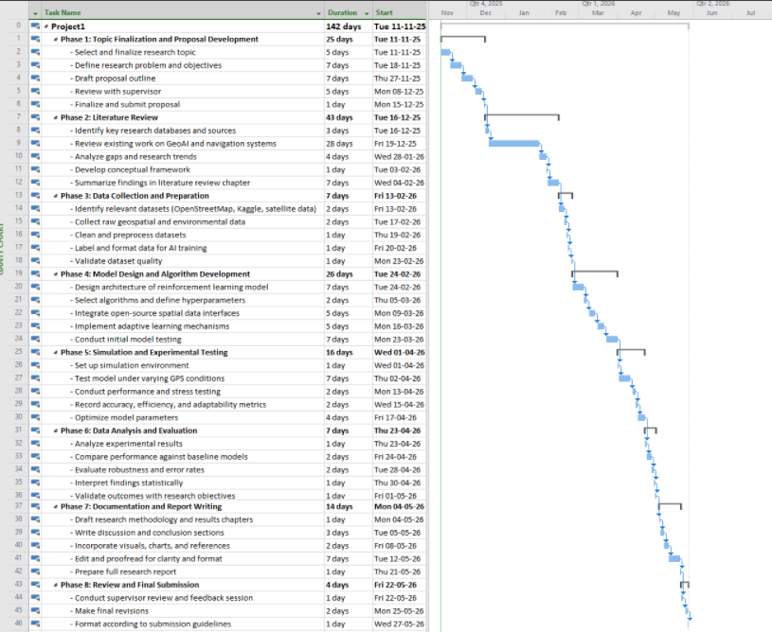

Figure 5.1: Project Timeline

(Source: MS Project)

References
[1] Boutayeb, A., Lahsen-Cherif, I. and El Khadimi, A., 2025. When Machine Learning Meets Geospatial Data: A Comprehensive GeoAI Review. IEEE Journal of Selected Topics in Applied Earth Observations and Remote Sensing.https://ieeexplore.ieee.org/iel8/4609443/10766875/10994795.pdf
[2] Liu, R., Wu, J., Lu, W., Miao, Q., Zhang, H., Liu, X., Lu, Z. and Li, L., 2024. A review of deep Learning-Based methods for road extraction from High-Resolution remote sensing images. Remote Sensing, 16(12), p.2056.https://www.mdpi.com/2072-4292/16/12/2056
[3] Ang, K.L.M., Seng, J.K.P., Ngharamike, E. and Ijemaru, G.K., 2022. Emerging technologies for smart cities’ transportation: geo-information, data analytics and machine learning approaches. ISPRS International Journal of Geo-Information, 11(2), p.85.https://www.mdpi.com/2220-9964/11/2/85
[4] Dao, T., Harima, K., Carter, B., Currie, J., McClusky, S., Brown, R., Rubinov, E. and Choy, S., 2022. Regional ionospheric corrections for high accuracy GNSS positioning. Remote Sensing, 14(10), p.2463.https://www.mdpi.com/2072-4292/14/10/2463
[5] Zhang, X. and Wu, Y., 2023. Analysis of public transit operation efficiency based on multi-source data: A case study in Brisbane, Australia. Research in Transportation Business & Management, 46, p.100859.https://research-repository.griffith.edu.au/bitstreams/8151bd2a-ee58-417d-ab1b-9a2995a80d08/download
[6] Chai, R., Niu, H., Carrasco, J., Arvin, F., Yin, H. and Lennox, B., 2022. Design and experimental validation of deep reinforcement learning-based fast trajectory planning and control for mobile robot in unknown environment. IEEE Transactions on Neural Networks and Learning Systems, 35(4), pp.5778-5792.https://research.manchester.ac.uk/files/232462104/Runqi_Hanlin_TNNLS_Draft.pdf
[7] Kassas, Z.M., Khalife, J., Abdallah, A.A. and Lee, C., 2022. I am not afraid of the GPS jammer: Resilient navigation via signals of opportunity in GPS-denied environments. IEEE Aerospace and Electronic Systems Magazine, 37(7), pp.4-19.Kassas, Z.M., Khalife, J., Abdallah, A.A. and Lee, C., 2022. I am not afraid of the GPS jammer: Resilient navigation via signals of opportunity in GPS-denied environments. IEEE Aerospace and Electronic Systems Magazine, 37(7), pp.4-19.
[8] Armanini, E. (2024). Concern for travellers not driving to conditions on unsealed roads, led astray by GPS technology. [online] Abc.net.au. Available at: https://www.abc.net.au/news/2024-12-04/unsealed-roads-following-gps-directions-rural-south-australia/104660214
[9] Khan, S.Z., Mohsin, M. and Iqbal, W., 2021. On GPS spoofing of aerial platforms: a review of threats, challenges, methodologies, and future research directions. PeerJ Computer Science, 7, p.e507.https://peerj.com/articles/cs-507/?trk=public_post_main-feed-card-text
[10] Austroads (2023). Webinar: Practical Approaches for Managing Regional Road Safety Priorities. [online] Austroads.gov.au. Available at: https://austroads.gov.au/publications/road-safety/web-r691-23.
[11] Siddique, I., 2024. Machine learning empowered geographic information systems: Advancing Spatial analysis and decision making. World Journal of Advanced Research and Reviews, 22(1), pp.10-30574.https://papers.ssrn.com/sol3/Delivery.cfm?abstractid=4892563
[12] Oluoch, I., 2024. Crossing boundaries: The ethics of AI and geographic information technologies. ISPRS International Journal of Geo-Information, 13(3), p.87.https://www.mdpi.com/2220-9964/13/3/87
[13] Abdi, A. and Amrit, C., 2021. A review of travel and arrival-time prediction methods on road networks: classification, challenges and opportunities. PeerJ Computer Science, 7, p.e689.https://peerj.com/articles/cs-689.pdf
[14] Madjid, N.A., Ahmad, A., Mebrahtu, M., Babaa, Y., Nasser, A., Malik, S., Hassan, B., Werghi, N., Dias, J. and Khonji, M., 2025. Trajectory prediction for autonomous driving: Progress, limitations, and future directions. arXiv preprint arXiv:2503.03262.https://arxiv.org/pdf/2503.03262?
[15] Sohrabi, S., Weng, Y., Das, S. and Paal, S.G., 2022. Safe route-finding: A review of literature and future directions. Accident Analysis & Prevention, 177, p.106816.https://www.researchgate.net/profile/Subasish-Das/publication/363579614_Safe_route-finding_A_review_of_literature_and_future_directions/links/63234bb570cc936cd30e5186/Safe-route-finding-A-review-of-literature-and-future-directions.pdf
[16] Chekol, A.G. and Fufa, M.S., 2022. A survey on next location prediction techniques, applications, and challenges. EURASIP Journal on Wireless Communications and Networking, 2022(1), p.29.https://link.springer.com/content/pdf/10.1186/s13638-022-02114-6.pdf
[17] Jiang, Y., Zhu, J. and Yang, K., 2023. Environment-aware adaptive reinforcement learning-based routing for vehicular ad hoc networks. Sensors, 24(1), p.40.https://www.mdpi.com/1424-8220/24/1/40
[18] Dale, K.I., Pope, E.C., Hopkinson, A.R., McCaie, T. and Lowe, J.A., 2023. Environment-aware digital twins: Incorporating weather and climate information to support risk-based decision-making. Artificial Intelligence for the Earth Systems, 2(4), p.e230023.https://journals.ametsoc.org/view/journals/aies/2/4/AIES-D-23-0023.1.pdf
[19] Yuan, L. and Zhao, X.Y., 2025. Traffic Flow Prediction Based on Dynamic Environment-Aware and Adaptive Multi-Scale Feature Extraction. IEEE Access.https://ieeexplore.ieee.org/iel8/6287639/6514899/11119713.pdf
[20] Zeng, H., Wang, H., Wang, K., Yu, X. and Zhang, Z., 2025. An Adaptive Environment-Aware Transformer Autoencoder for UAV-FSO with Dynamic Complexity Control. arXiv preprint arXiv:2508.16918.https://arxiv.org/pdf/2508.16918
[21] Zhang, L. and Leach, M., 2022, May. Evaluate the impact of sensor accuracy on model performance in data-driven building fault detection and diagnostics using Monte Carlo simulation. In Building Simulation (Vol. 15, No. 5, pp. 769-778). Beijing: Tsinghua University Press.https://www.osti.gov/pages/servlets/purl/1820573
[22] Ekström, T., Burke, S., Wiktorsson, M., Hassanie, S., Harderup, L.E. and Arfvidsson, J., 2021. Evaluating the impact of data quality on the accuracy of the predicted energy performance for a fixed building design using probabilistic energy performance simulations and uncertainty analysis. Energy and Buildings, 249, p.111205.https://www.sciencedirect.com/science/article/pii/S0378778821004898
[23] Fathi, M., Haghi Kashani, M., Jameii, S.M. and Mahdipour, E., 2022. Big data analytics in weather forecasting: A systematic review. Archives of Computational Methods in Engineering, 29(2), pp.1247-1275.https://www.researchgate.net/profile/Mostafa-Haghi-Kashani/publication/352810110_Big_Data_Analytics_in_Weather_Forecasting_A_Systematic_Review/links/65d8b942e7670d36abd7a5c3/Big-Data-Analytics-in-Weather-Forecasting-A-Systematic-Review.pdf
[24] Hassan, M., Awan, F.M., Naz, A., deAndrés-Galiana, E.J., Alvarez, O., Cernea, A., Fernández-Brillet, L., Fernández-Martínez, J.L. and Kloczkowski, A., 2022. Innovations in genomics and big data analytics for personalized medicine and health care: a review. International journal of molecular Sciences, 23(9), p.4645.https://www.nature.com/articles/s41598-021-97432-y.pdf
[25] Abbas, F., 2024. Evaluating the Performance of AI-Driven Systems in Real-World Applications. Journal of AI Range, 1(3), pp.18-26.https://researchcorridor.org/index.php/jair/article/download/277/265
[26] Farooqi, S.A., Memon, A., Zamir, S., Malik, K., Batool, W. and Zahid, H., 2024. Navigating AI in the real world: Transformations, regulations, and challenges. Policy Research Journal, 2(4), pp.1083-1099.https://www.researchgate.net/profile/Shaista-Ashraf-Farooqi/publication/386454336_NAVIGATING_AI_IN_THE_REAL_WORLD_TRANSFORMATIONS_REGULATIONS_AND_CHALLENGES/links/6751bafbd150ab4db318590e/NAVIGATING-AI-IN-THE-REAL-WORLD-TRANSFORMATIONS-REGULATIONS-AND-CHALLENGES.pdf
[26] Zhang, H., Falletta, N.J., Xie, J., Yu, R., Lee, S., Billah, S.M. and Carroll, J.M., 2025, January. Enhancing the travel experience for people with visual impairments through multimodal interaction: NaviGPT, a real-time AI-driven mobile navigation system. In Companion Proceedings of the 2025 ACM International Conference on Supporting Group Work (pp. 29-35).https://pmc.ncbi.nlm.nih.gov/articles/PMC11727231/
[27] Mohammed, R., 2022. Artificial intelligence-driven robotics for autonomous vehicle navigation and safety. NEXG AI Review of America, 3(1), pp.21-47.https://www.researchgate.net/profile/Rahimoddin-Mohammed/publication/383659067_Artificial_Intelligence-Driven_Robotics_for_Autonomous_Vehicle_Navigation_and_Safety/links/66d5997c2390e50b2c26aa71/Artificial-Intelligence-Driven-Robotics-for-Autonomous-Vehicle-Navigation-and-Safety.pdf
[28] Alkam, T. and Tarshizi, E., Reinforcement Learning in Cognitive Science: Foundations and Applications. Available at SSRN 5055984.https://papers.ssrn.com/sol3/Delivery.cfm?abstractid=5055984
[29] Truong, T.X., Nhu, V.H., Phuong, D.T.N., Nghi, L.T., Hung, N.N., Hoa, P.V. and Bui, D.T., 2023. A new approach based on TensorFlow deep neural networks with ADAM optimizer and GIS for spatial prediction of forest fire danger in tropical areas. Remote Sensing, 15(14), p.3458.https://www.mdpi.com/2072-4292/15/14/3458/pdf
[30] Hasan, K.M., 2024. Quantitative methods in social science research: Systematic review of content analysis, survey and experiment methodologies. Survey and Experiment Methodologies (January 17, 2024).https://papers.ssrn.com/sol3/Delivery.cfm?abstractid=4698175
[31] Szelangiewicz, T., Żelazny, K., Antosik, A. and Szelangiewicz, M., 2021. Application of measurement sensors and navigation devices in experimental research of the computer system for the control of an unmanned ship model. Sensors, 21(4), p.1312.https://www.mdpi.com/1424-8220/21/4/1312
[32] Hevner, A.R. and vom Brocke, J., 2023. A proficiency model for design science research education. Journal of Information Systems Education, 34(3), pp.264-278.https://www.researchgate.net/profile/Jan-Vom-Brocke/publication/371721402_A_Proficiency_Model_for_Design_Science_Research_Education/links/6491b5ce95bbbe0c6edd25d6/A-Proficiency-Model-for-Design-Science-Research-Education.pdf
[33] Zhou, J., Gandomi, A.H., Chen, F. and Holzinger, A., 2021. Evaluating the quality of machine learning explanations: A survey on methods and metrics. Electronics, 10(5), p.593.https://www.mdpi.com/2079-9292/10/5/593/pdf
[34] Ulvi, H., Yerlikaya, M.A. and Yildiz, K., 2024. Urban traffic mobility optimization model: A novel mathematical approach for predictive urban traffic analysis. Applied Sciences, 14(13), p.5873.https://www.mdpi.com/2076-3417/14/13/5873
[35] Da, L., Chen, T., Li, Z., Bachiraju, S., Yao, H., Li, L., Dong, Y., Hu, X., Tu, Z., Wang, D. and Zhao, Y., 2025. Generative ai in transportation planning: A survey. arXiv preprint arXiv:2503.07158.https://arxiv.org/pdf/2503.07158?
[36] Vlahou, A., Hallinan, D., Apweiler, R., Argiles, A., Beige, J., Benigni, A., Bischoff, R., Black, P.C., Boehm, F., Céraline, J. and Chrousos, G.P., 2021. Data sharing under the General Data Protection Regulation: time to harmonize law and research ethics?. Hypertension, 77(4), pp.1029-1035.https://www.ahajournals.org/doi/pdf/10.1161/HYPERTENSIONAHA.120.16340
[37] Ran, X., Shan, Z., Fang, Y. and Lin, C. (2019). An LSTM-Based Method with Attention Mechanism for Travel Time Prediction. Sensors, 19(4), p.861. doi:https://doi.org/10.3390/s19040861.
[38] Nishad, D.K., Verma, V.R., Rajput, P., Gupta, S., Dwivedi, A. and Shah, D.R. (2025). Adaptive AI-enhanced computation offloading with machine learning for QoE optimization and energy-efficient mobile edge systems. Scientific Reports, 15(1). doi:https://doi.org/10.1038/s41598-025-00409-4.
[39] Fahad Mon, B., Wasfi, A., Hayajneh, M., Slim, A. and Abu Ali, N. (2023). Reinforcement Learning in Education: A Literature Review. Informatics, [online] 10(3), p.74. doi:https://doi.org/10.3390/informatics10030074.
[40] Zhou, C. (2025). Exploring Future GIS Visions in the Era of the Scientific and Technological Revolution. Information Geography, 1(1), p.100007. doi:https://doi.org/10.1016/j.infgeo.2025.100007.

